Apelin (APLN) is a biomarker contributing to the diagnosis and prognosis of hepatocellular carcinoma

Xi Mao^{1,2†}, Xiaoya Zhu^{1†}, Tong Pan¹, Zehui Liu¹, Pingping Shangguan¹, Yi Zhang¹, Yingle Liu^{1,2*}, Xiwen Jiang^{3*}, Qi Zhang^{1*}

Table of contents
Fig. S1. The diagnostic models built with machine learning algorithms.
Fig. S2. The prognostic models built with machine learning algorithms.
Fig. S3. Comprehensive analysis of endothelial cells in the scRNA-seq dataset.
Fig. S4. Detailed analysis of immune infiltration and tumor burden.
Fig. S5. Survival outcomes influenced by age, gender, and T stage.

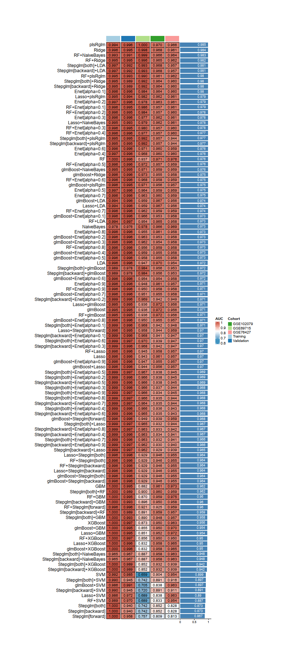
Fig. S1. The diagnostic models built with machine learning algorithms. Models are sorted in descending order of score.

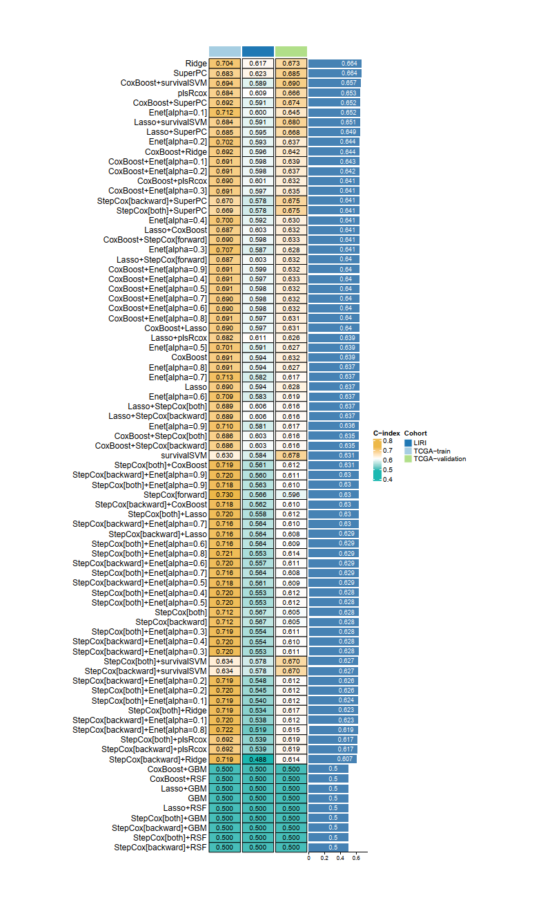
Fig. S2. The prognostic models built with machine learning algorithms. Models are sorted in descending order of score.

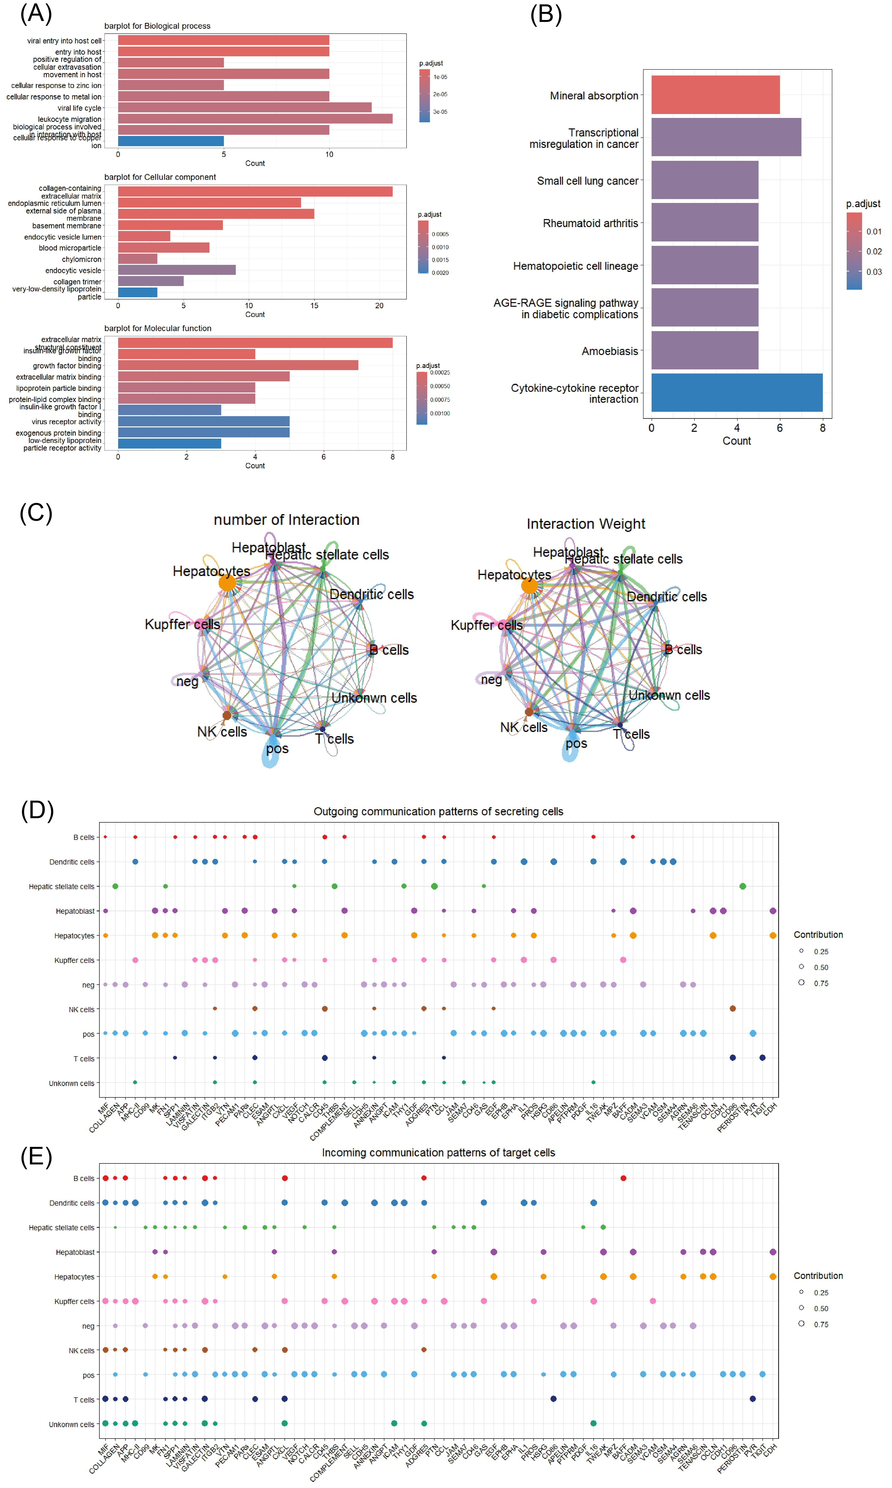
Fig. S3. Comprehensive analysis of endothelial cells in the scRNA-seq dataset. (A) GO enrichment analysis of differentially expressed genes in the endothelial cells. (B) KEGG enrichment analysis of differentially expressed genes in the endothelial cells. (C) Quantification of cell-cell communication intensity among various cell types. (D) Identification of key signaling outgoing molecules in different cell types. (E) Identification of key signaling incoming molecules in different cell types.

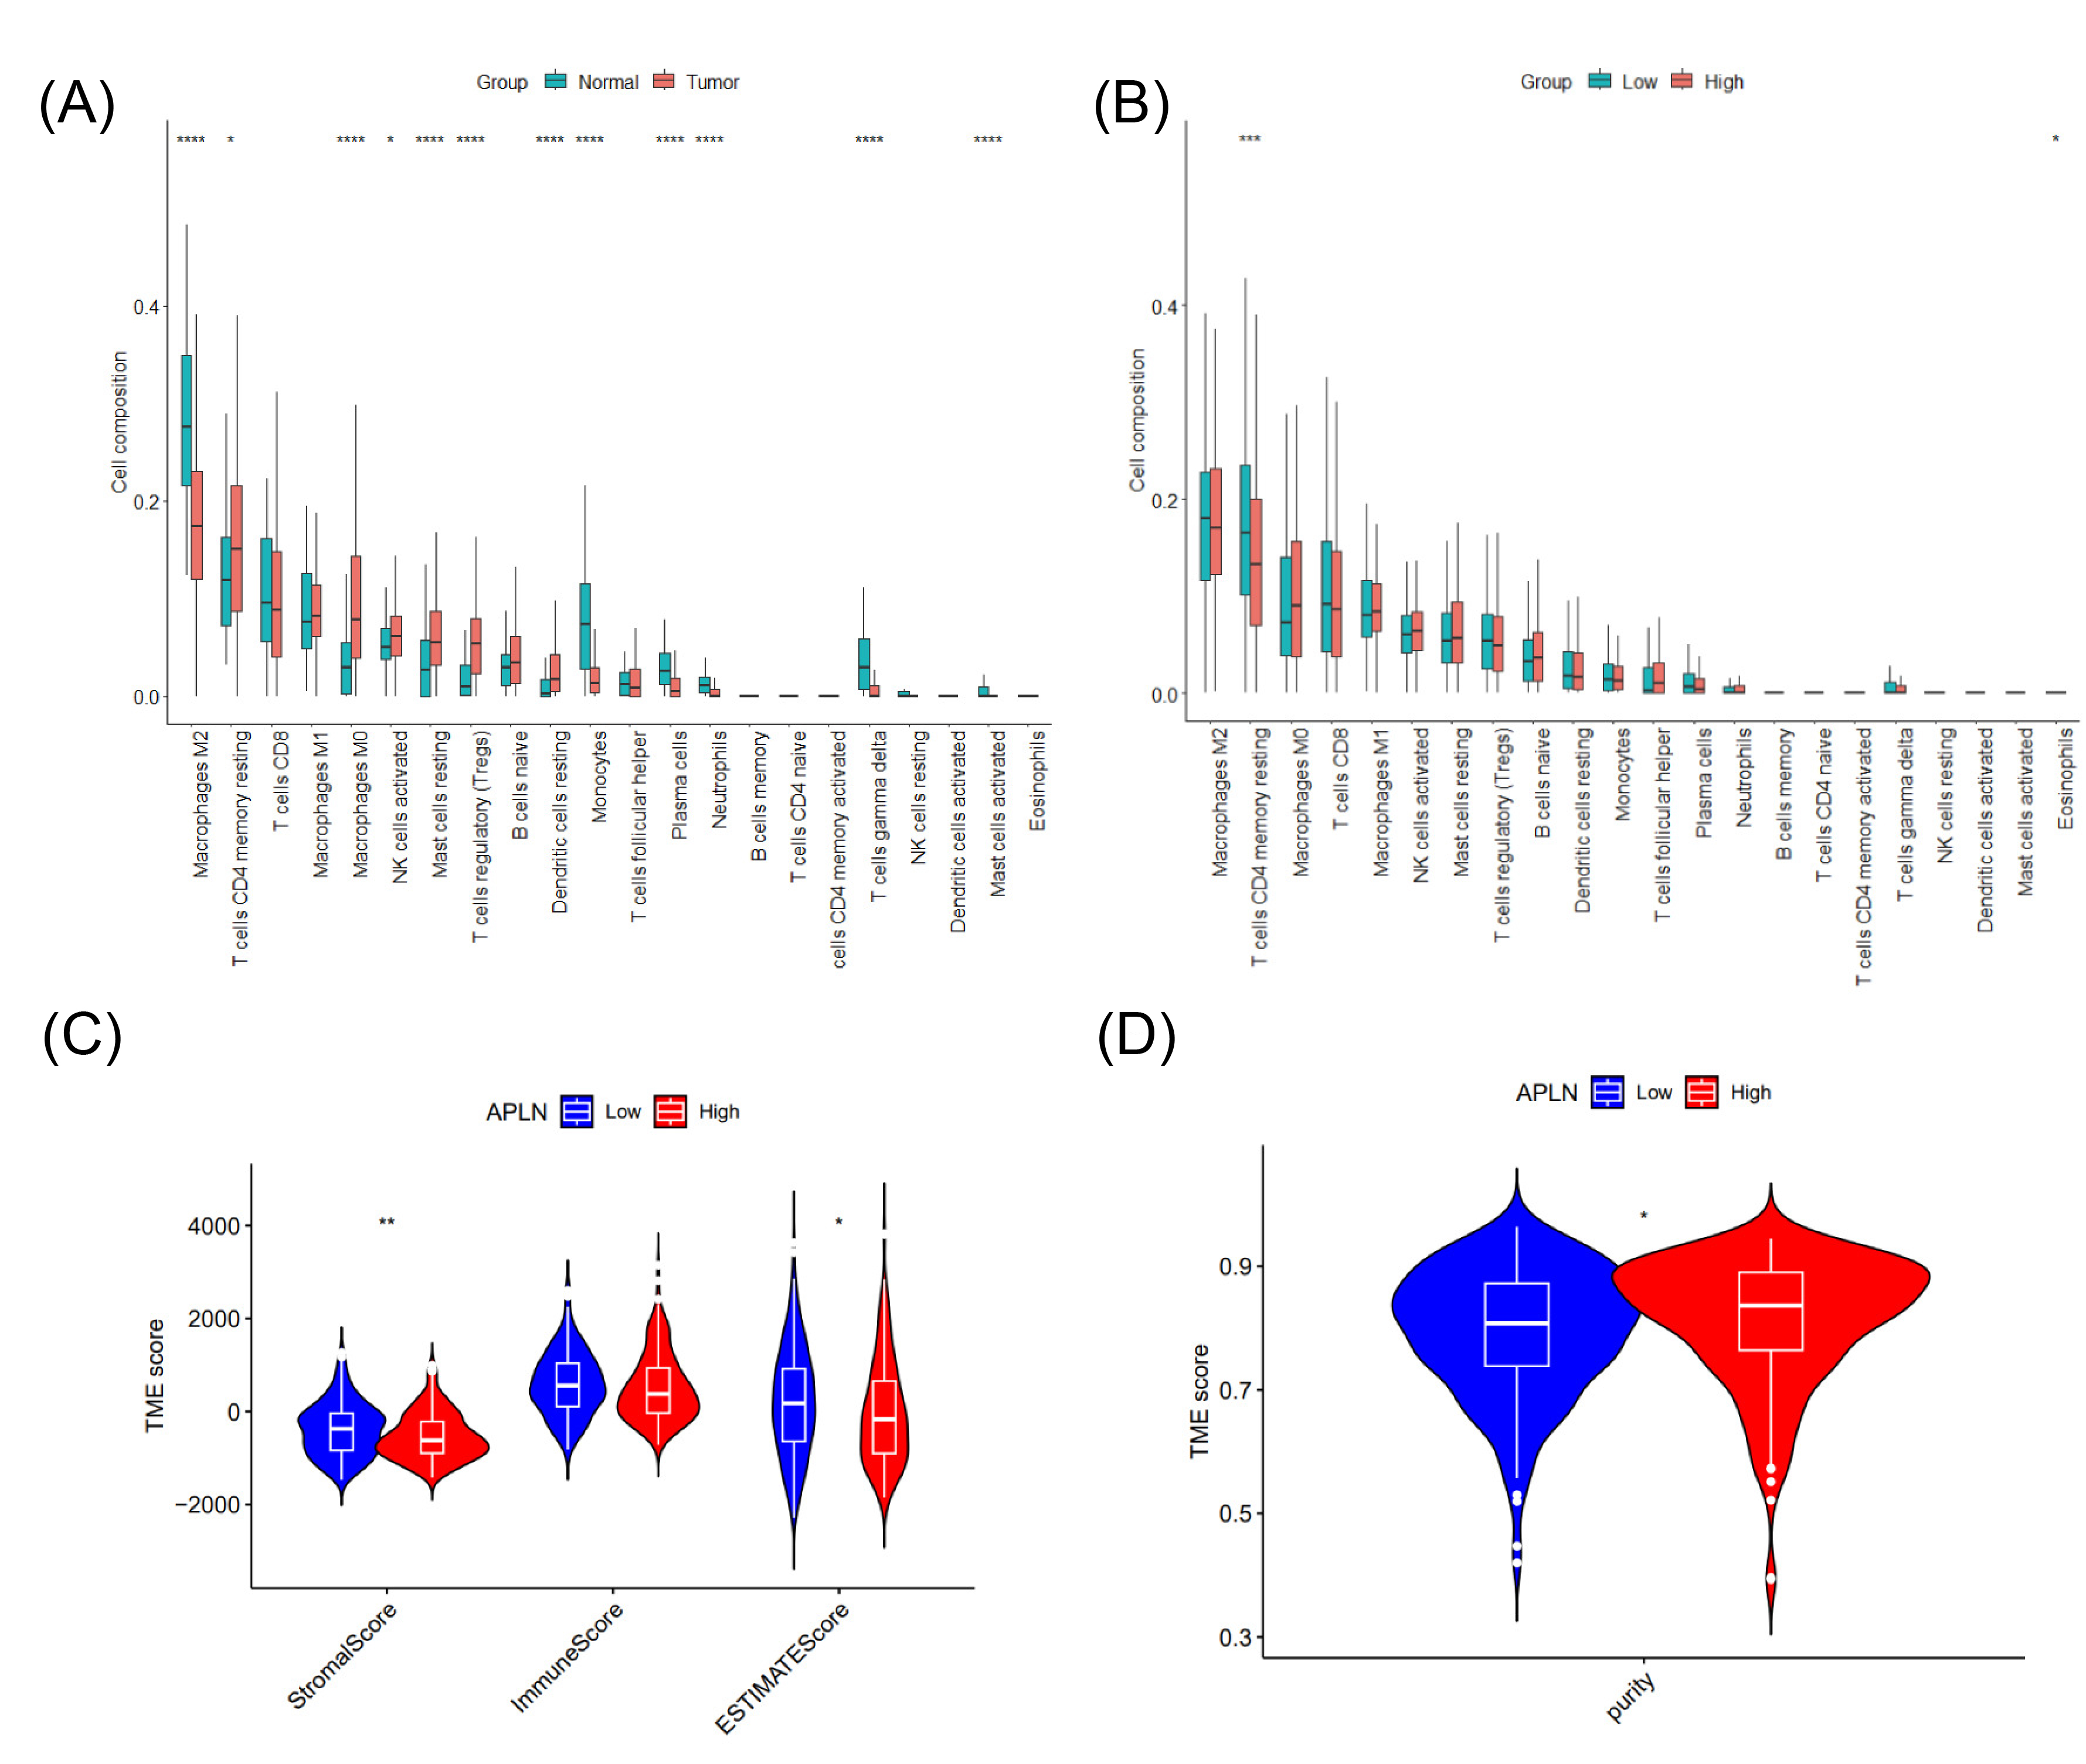
Fig. S4. Detailed analysis of immune infiltration and tumor burden. (A) Comparative immune cell infiltration analysis between normal and tumor tissues. (B) Comparative immune cell infiltration analysis between tumor patients with high APLN expression and those with low APLN expression. (C) Comparative tumor immune score evaluation between tumor patients with high APLN expression and those with low APLN expression. (D) Comparative tumor purity evaluation between tumor patients with high APLN expression and those with low APLN expression.

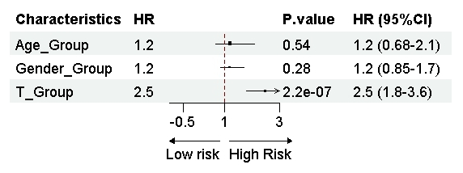
Fig. S5. Survival outcomes influenced by age, gender, and T stage. Patient samples were stratified into groups based on gender (male or female), age (young: under 45 years; middle-aged: 45 to 65 years; elderly: over 65 years), and T stage (early-stage: T1 and T2; advanced-stage: T3 and T4).

