Supplemental FIgure
Lipidomics Profiling and Circulating Triglyceride Concentrations in African Individuals
Amy R. Bentley; Ayo P. Doumatey; Jie Zhou; Lin Lei; Karlijn A.C. Meeks; Elisabeth F. Heuston; Charles N. Rotimi; and Adebowale A. Adeyemo

Supplemental Figure 1: Measured Metabolites along Phosphatidylcholine Biosynthesis (CDP-choline pathway) and Catabolism Pathways among East Africans. Shown are the distributions of measured metabolites in these pathways in individuals in quartiles 1 and 4 of TG among East African samples. Metabolites presented were selected to match those in the figure for West Africans (Figure 2) where possible: neither ceramide nor palmitoyl-oleoyl-glycerol were available in this dataset (palmitoyl-oleoyl-glycerol is replaced with oleoyl-oleoyl-glycerol in the above). A bolded metabolite label indicates statistical significance based on the main linear model. Abbreviations: CCT: CTP:choline-phosphate cytidylyltransferase; CEPT1: choline/ethanolaminephosphotransferase1; CHKA: choline kinase alpha; CHKB: choline kinase beta; G3PP: glycerol-3-phosphate phosphatase; GK: glycerol kinase; GPCPD: glycerophosphocholine diesterase; LCAT: phosphatidylcholine-sterol acyltransferase; LPCAT: lysophospholipid acyltransferase; PLA2: phospholipase A2; PEMT: phosphatidylethanolamine N-methyltransferase; PLD1: phospholipase D; SGMS1: sphingomyelin synthase

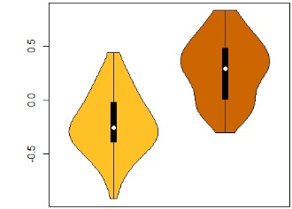
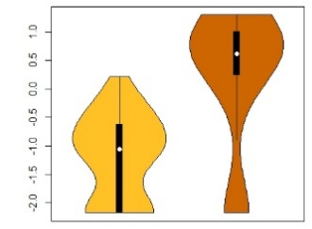
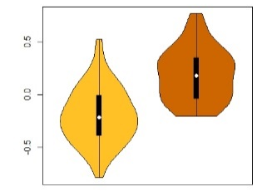
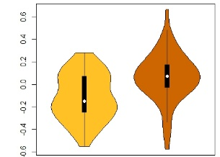
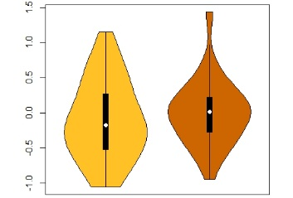
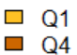
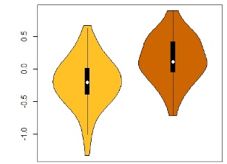
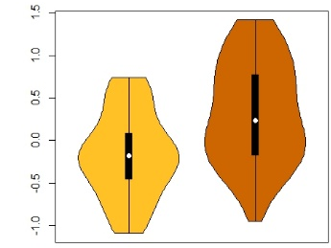
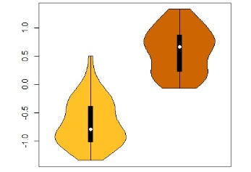
CCT
CEPT1
Choline
Glycerophosphocholine
Lysophosphatidylcholine
Phosphatidylcholine
phosphocholine
GPCPD
CHKA/
CHKB
LPCAT
LCAT/
PLA2
PLA2
Glycerol 3-Phosphate
Glycerol
G3PP
GK
Choline
1-palmitoleoyl-GPC
1-stearoyl-2-oleoyl-GPC
Glycerophosphorylcholine
PLD1/2
Glycerol
Ceramide
Sphingomyelin
SGMS
Oleoyl-oleoyl-glycerol
Sphingomyelin
cytidine
diphosphate choline
Diacylglycerol
Phosphatidylethanolamine
Phosphatidyl-dimethylethanolamine
Phosphatidyl-monomethylethanolamine
PEMT
1-stearoyl-2-oleoyl-GPE
PEMT
PEMT

