Supplementary Materials for
“Non-invasive temporal interference brain stimulation reduces preference on morphine-induced conditioned place preference in rats”
Zohre Mojiri¹, Ehsan Rouhani¹, Amir Akhavan^{1*}, Zahra Jokar², Hojjatallah Alaei²
¹ Department of Electrical and Computer Engineering, Isfahan University of Technology, Isfahan 84156-83111, Iran.
² Department of Physiology, Faculty of Medicine, Isfahan University of Medical Sciences, Isfahan, Iran

Appendix A. Details of the CPP model
This appendix presents detailed information about the CPP protocol for morphine, saline-stimulation, and saline-sham groups in the conditioning stage. For the rats in the morphine group, in the morning of the first day, at 8:00 a.m., the animal is administered morphine and then placed in the non-preferred compartment for a duration of 30 min. Following a five hours’ period, at 13:00 p.m., the animal is administered a saline injection and then positioned within its preferred compartment for a duration of 30 min. On the second day, during the morning session, the animals are administered saline and subsequently positioned within their preferred compartments for a duration of 30 min. In the afternoon session, they receive subcutaneous morphine injections and are then placed within their non-preferred compartments for a duration of 30 min. The procedures implemented on the third day are similar to those conducted on the first day.
The protocol for the saline-stimulation and saline-sham groups consists of TI (sham) stimulation for a duration of 10 min at 8:00 a.m., injection of saline at 8:10 a.m., positioning in the non-preferred chamber for a duration of 30 min, saline injection at 13:00 p.m. and finally positioning in the preferred chamber for a duration of 30 min on the first day; saline injection at 8:00 a.m., positioning in the preferred chamber for a duration of 30 min, TI (sham) stimulation at 13:00 p.m., saline injection at 13:10 p.m. and finally positioning in the non-preferred chamber for a duration of 30 min on the second day; and the protocol for the third day of the experiment is repeated exactly with the same protocol of the first day.

Appendix B. Exploring the distribution of the TI-induced electric field for two different positions of the positive stimulation electrodes
This appendix presents the results of the distribution of the TI-induced electric field for different positions of the positive stimulation electrodes. The details of the electrode placement for this experiment and the results are shown in Fig. S1(A) and (B), respectively. In Fig. S1(A), the negative stimulation electrodes were fixed in the cheek area, positive stimulation electrodes were positioned in two different locations (AP = 3 mm, ML1 = -2.3 mm, ML2 = 0.7 mm with red squares and AP = 3 mm, ML1 = -3.8 mm, ML2 = 2.2 mm with blue squares), and the amplitude of the envelope oscillation in AP = 3 mm, ML = -0.8 mm and different DV from 0 to 5 mm was measured. The results indicate that the shorter the mediolateral distance between the positive stimulation electrodes, the larger mean amplitude of the envelope oscillation.

(A)
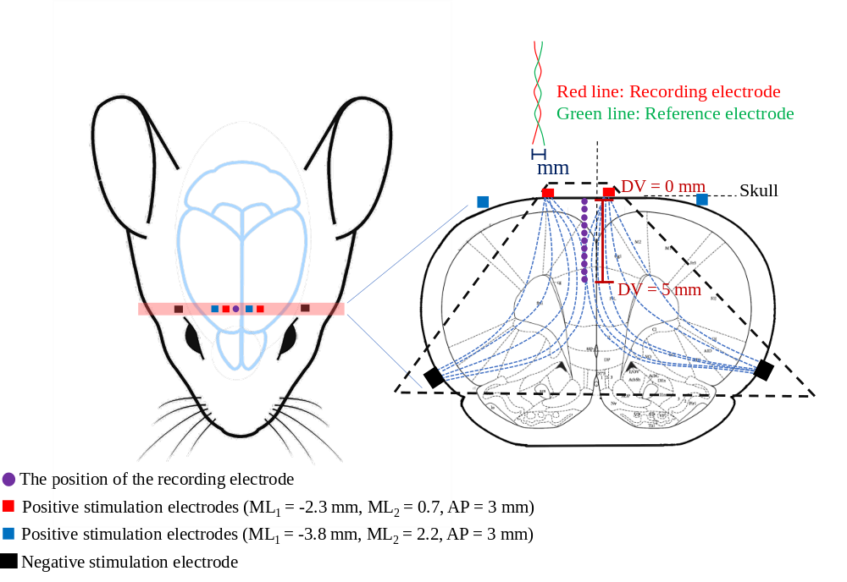
(B)
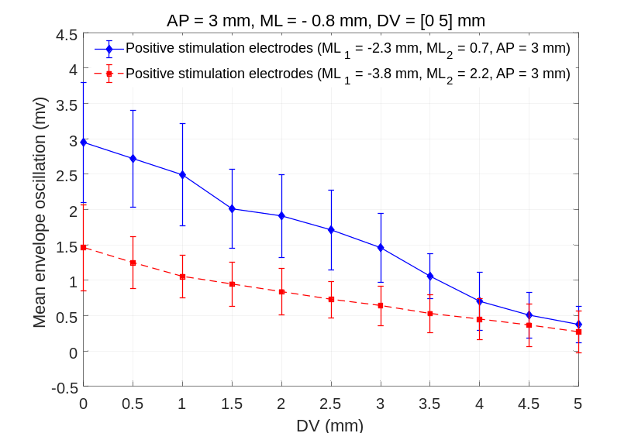
Figure S1. (A) Schematic of the trapezoidal arrangement of the positive stimulation electrodes in two different configurations (ML₁ = -2.3 mm, ML₂ = 0.7 mm, AP = 3 mm with red squares and ML₁ = -3.8 mm, ML₂ = 2.2 mm, AP = 3 mm with blue squares) and the position of the recording electrode in AP = 3 mm, ML = -0.8 mm and different DV from 0 to 5 mm from the bregma. (B) The mean amplitude and standard deviation of envelope oscillation through TI stimulation in five rats for two different positions of positive stimulation electrodes in (A) by changing the position of the recording electrode in AP = 3 mm, ML = -0.8 mm and the DV direction from 0 to 5 mm.

Appendix C. Raw data of CPP
Tables S1-S5 summarize the raw data of the time spent in the non-preferred (highlighted by gray color) and preferred chambers and the total distance traveled in the postconditioning phase for morphine (Table S1), morphine-sham (Table S2), saline-sham (Table S3), morphine-stimulation (Table S4), and saline-stimulation (Table S5) groups. In order to calculate the CPP score (equation (1)) for each animal, the raw data of column 1 (Trial 1/1 - white zone, preconditioning phase), column 2 (Trial 1/1 - black zone, preconditioning phase), column 3 (Trial 1/2 - white zone, postconditioning phase), and column 4 (Trial 1/2 - black zone, postconditioning phase) were used in each row of the Tables S3-S7. Additionally, for the total distance traveled (left column for the preconditioning and right column for the postconditioning), the raw data of right column were used to compute the total distance traveled index.
Table S1. Data of CPP score and total distance traveled indexes of the morphine group.
Time spent in the non-preferred (highlighted by gray color) and preferred chambers* (s) |  |  |  | CPP score  (%)
Trial 1/1 – White zone | Trial 1/1 – Black zone | Trial 1/2 – White zone | Trial 1/2 – Black zone | CPP score  (%)
102.4 | 169.0 | 528.0 | 132.2 | 42.25
123.0 | 189.8 | 540.4 | 159.0 | 37.94
326.5 | 156.9 | 90.0 | 459.5 | 51.16
176.8 | 258.1 | 200.3 | 94.5 | 27.29
235.9 | 327.1 | 232.8 | 253.5 | 5.97
41.2 | 766.4 | 68.6 | 153.1 | 25.84
Total distance traveled (cm)
Trial 1/1 |  | Trial 1/2
1322 |  | 905.4
1637.4 |  | 1989.4
1159.9 |  | 1483
2340.7 |  | 1391.2
1646.4 |  | 1731.3
1620.1 |  | 1150.1
* Note that the preferred and non-preferred chambers are assigned based on the time spent in the white (column 1) and black (column 2) zones in the preconditioning phase (Trial 1/1).

Table S3. Data of CPP score and total distance traveled indexes of the saline-sham group.
Time spent in the non-preferred (highlighted by gray color) and preferred chambers (s) |  |  |  | CPP score  (%)
Trial 1/1 – White  zone | Trial 1/1 – Black zone | Trial 1/2 – White zone | Trial 1/2 – Black zone | CPP score  (%)
77.5 | 400.3 | 84.5 | 479.3 | -1.23
77.9 | 175.4 | 170.5 | 178.7 | 18.07
328.6 | 325.7 | 123.9 | 161.2 | 6.76
211.2 | 200.3 | 267.0 | 154.0 | -12.10
243.6 | 381.1 | 208.7 | 330.7 | -0.30
338.6 | 329.5 | 216.7 | 416.2 | 16.44
Total distance traveled (cm)
Trial 1/1 |  | Trial 1/2
1020.5 |  | 999.6
1362.2 |  | 1895.7
2657.8 |  | 1724.8
2188.2 |  | 2654.7
2702.9 |  | 2308.5
3018.6 |  | 2868.6

Table S2. Data of CPP score and total distance traveled indexes of the morphine-sham group.
Time spent in the non-preferred (highlighted by gray color) and preferred chambers (s) |  |  |  | CPP score  (%)
Trial 1/1 – White zone | Trial 1/1 – Black zone | Trial 1/2 – White zone | Trial 1/2 – Black zone | CPP score  (%)
87.7 | 223.6 | 481.9 | 166.1 | 46.20
149.1 | 187.7 | 171.7 | 274.6 | -5.80
402.1 | 159.7 | 64.3 | 766.7 | 63.84
395.8 | 285.6 | 129.0 | 522.5 | 38.29
480.5 | 379.5 | 192.7 | 180.0 | 4.17
141.7 | 622.7 | 91.8 | 120.1 | 24.78
Total distance traveled (cm)
Trial 1/1 |  | Trial 1/2
1744.5 |  | 1325.4
2171.3 |  | 1213.1
2403 |  | 1001.5
2470.4 |  | 1794.6
2304.3 |  | 1847.7
1506.9 |  | 1106.2

Table S5. Data of CPP score and total distance traveled indexes of the saline-stimulation group.
Time spent in the non-preferred (highlighted by gray color) and preferred chambers (s) |  |  |  | CPP score  (%)
Trial 1/1 – White  zone | Trial 1/1 – Black zone | Trial 1/2 – White zone | Trial 1/2 – Black zone | CPP score  (%)
224.5 | 390.5 | 144.0 | 544.5 | -15.59
99.4 | 532.9 | 89.6 | 657.1 | -3.72
280.8 | 396.1 | 170.9 | 133.0 | 14.75
232.2 | 475.2 | 157.6 | 361.1 | -2.44
153.0 | 425.1 | 157.0 | 352.8 | 4.33
259.3 | 316.1 | 239.9 | 411.6 | -8.24
Total distance traveled (cm)
Trial 1/1 |  | Trial 1/2
1301.5 |  | 941.2
1633.2 |  | 1732.5
2649.5 |  | 1570.7
2276 |  | 1893.9
1592.6 |  | 1805
2805.4 |  | 2620.6

Table S4. Data of CPP score and total distance traveled indexes of the morphine-stimulation group.
Time spent in the non-preferred (highlighted by gray color) and preferred chambers (s) |  |  |  | CPP score  (%)
Trial 1/1 – White  zone | Trial 1/1 – Black zone | Trial 1/2 – White zone | Trial 1/2 – Black zone | CPP score  (%)
246.9 | 409.9 | 65.0 | 201.8 | -13.23
205.1 | 268.9 | 44.1 | 72.3 | -5.38
266.0 | 356.8 | 110.3 | 143.7 | 0.71
223.2 | 318.1 | 277.0 | 208.6 | 15.81
211.7 | 347.9 | 93.9 | 319.9 | -15.14
335.7 | 351.0 | 165.6 | 622.5 | -27.87
166.2 | 435.0 | 168.0 | 496.8 | -2.37
199.2 | 454.8 | 129.6 | 239.4 | 4.66
Total distance traveled (cm)
Trial 1/1 |  | Trial 1/2
2436.3 |  | 1121.5
2419.9 |  | 978.5
2256.5 |  | 975.1
2109.5 |  | 1685.2
2012.4 |  | 1304
1842.5 |  | 1434.5
1940.13 |  | 1531.85
2021.95 |  | 1351.3

