Supporting Information
To ensure accurate measurement and control of the light intensity used during the procedure, we employed a power meter to quantify the intensity of the light being delivered to the cornea. During the crosslinking process, a collimator was utilized to provide focused illumination, directing the light into a narrow beam. In this case, the collimator was positioned above the cornea, allowing the light to be precisely directed onto the treatment area.

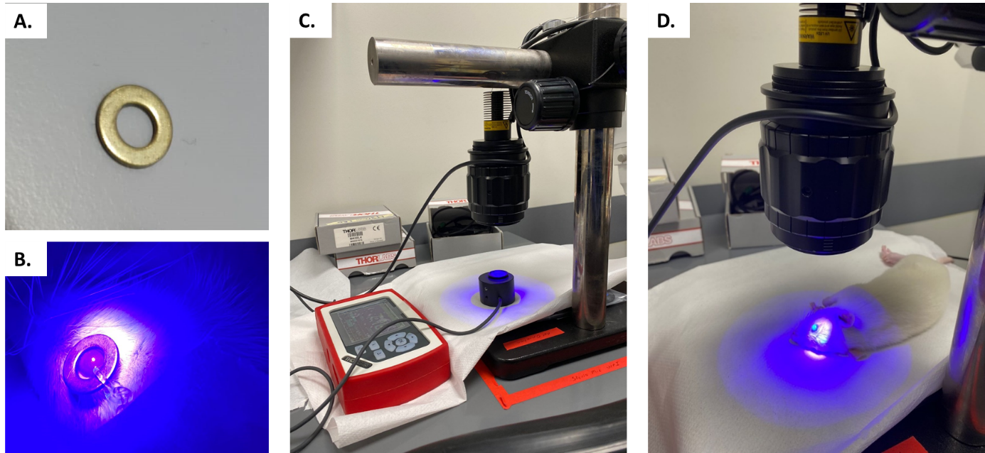
Supp. Figure 1. Overview of corneal crosslinking setup. (A) Metal ring 7 mm prepared to protect the limbus, the sclera, and conjunctiva, (B) Position of the ring on the eye during light illumination, (C) Irradiation dose in the lightning setup was measured with a power meter to ensure the correct amount of light given, (D) Application of light illumination on cornea to accelerate crosslinking procedure.

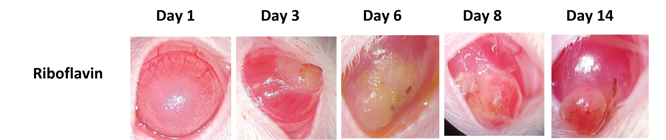
Supp. Figure 2: Macroscopic image of the riboflavin group treated with 1.8 J/cm2 UV-A (n=6). Severe complication with corneal perforation observed due to UV-A irradiation in rat corneas. Eyes were treated with antibiotics until the rats were euthanized.

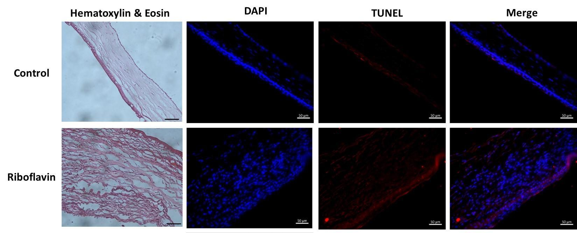Supp. Figure 3: Histological and cell death examination of control and the riboflavin group treated with 1.8 J/cm2 UV-A. Corneal fibrosis was observed as a response to injury in the riboflavin group. Irregular collagen fiber and neovascularization were also found with hematoxylin and eosin staining. Increase in the cell death following 1.8 J/cm2 UV-A. Scale bars represent 50 µm.

To assess the crosslinking efficiency of Ruthenium at 3mW for 5 minutes, we also conducted dynamic rheometer experiments on ex-vivo bovine corneas and compared the results with those of control corneas. The crosslinking procedure was performed similarly to that in the in vivo study. Briefly, corneal epithelium was removed with a scalpel blade, and 8 mm central corneal buttons were isolated from bovine eyes with an 8 mm trephine blade. Then, a 1 mM ruthenium and SPS solution was carefully dropped onto the cornea, followed by a 10-minute incubation period. Afterwards, 430 nm visible light (3 mW/cm²) was applied to the samples for 5 min. The average storage modulus of corneas crosslinked with 1mM Ruthenium reached 90 Pa in 5 minutes, while the average storage modulus of control corneas was only 17.6 Pa, as illustrated in Supp. Figure 4 A.
To further validate these findings, we performed enzymatic digestion of the crosslinked corneas, as depicted in Supp. Figure 4 B. Both Ruthenium crosslinked and control corneas were immersed in 0.1% collagenase, and their weights were measured every hour. The results indicated that corneas treated with 1mM Ruthenium remained intact in the solution after 24 hours, whereas control corneas were completely digested.

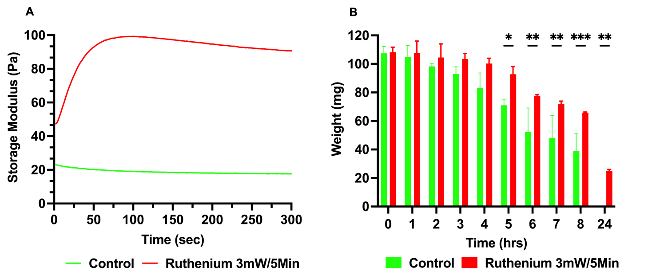
Supp. Figure 4 (A). Dynamic rheometer results for control and ruthenium-induced crosslinked corneas. [Ru(bpy)₃]²⁺-SPS mixture leads to significantly higher storage modulus in 5 min, compared to control. (B) Weight loss due to enzymatic digestion test results for control and ruthenium crosslinked corneas.

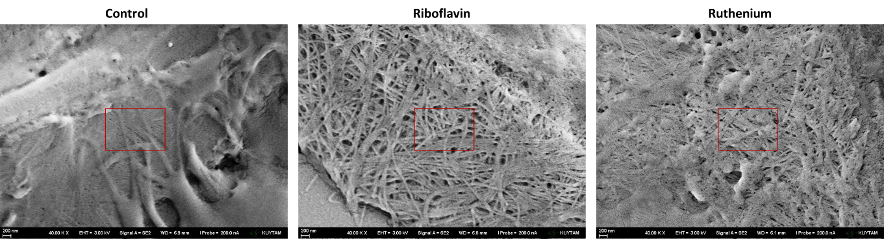Supplementary Figure 5. SEM images of cornea sections showing the stroma at higher magnification.

