Supplementary Figures

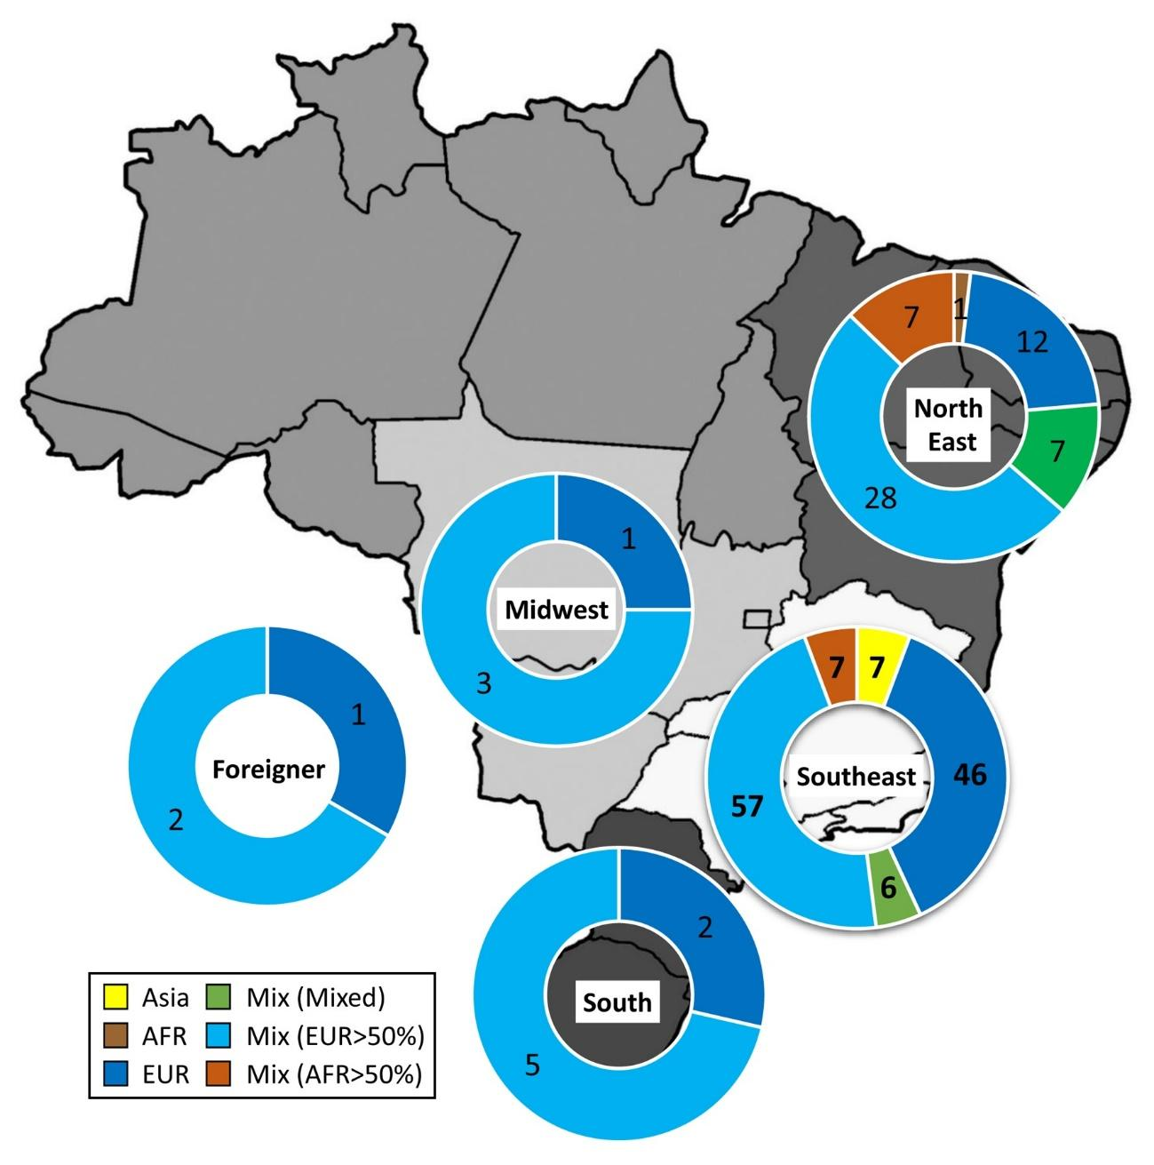
Supplementary Figure 1: Number of patients according with six categorical genetic ancestry distributed in four Brazilian regions

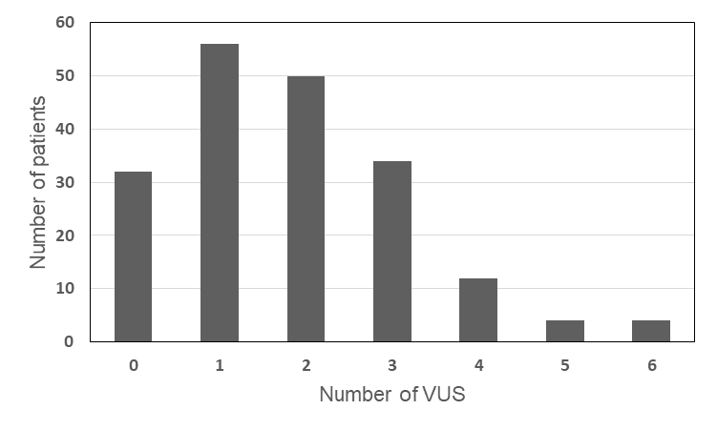
Supplementary Figure 2: Number of patients according with the number of VUS.

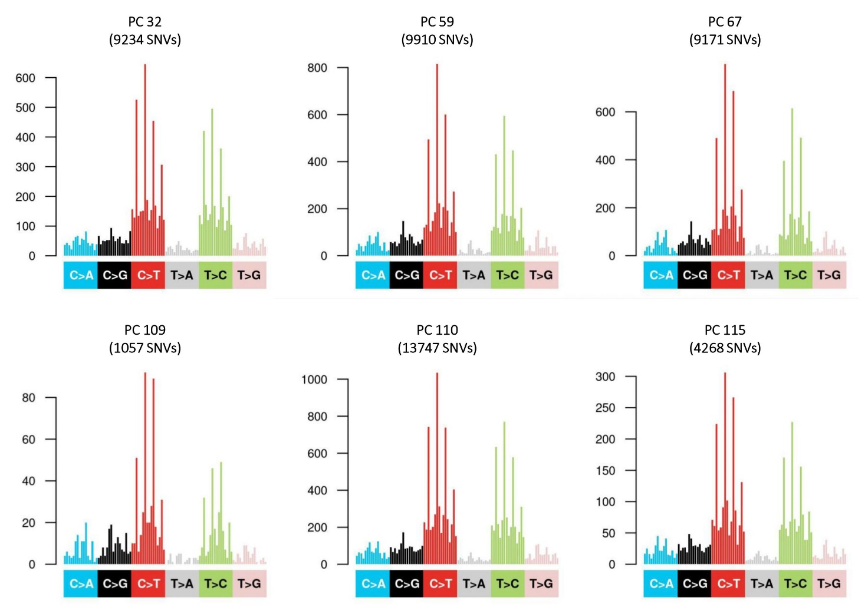
Supplementary Figure 3: Single Base Substitution (SBS) signatures acrros six whole-exome-sequenced tumor sample
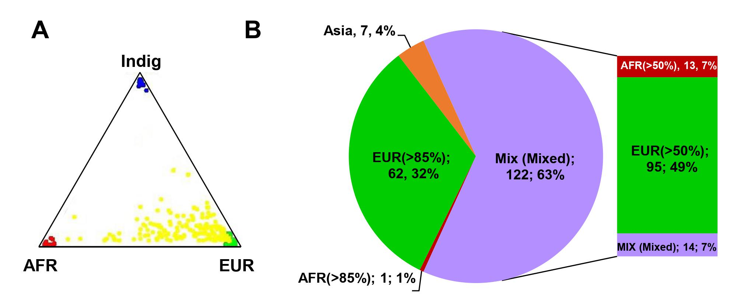
Supplementary Figure 4: 4A-Triangle plot of genomic proportions of African, Indigenous and European ancestries. 4B-Categorical classification of individuals according with genomic ancestry proportions (number and percentage of the cohort). EUR: European predominance (>85%European genomic ancestry); non-European predominance - Mix: EUR (50% ≤ x < 85% European genomic ancestry); AFR: (50% ≤ x < 85% African genomic ancestry) Mix (mixed) (EUR<50% & AFR <50% & Indig – Indigenous <50%); AFR: African predominance: >85% African genomic ancestry); Asia predominance (self-declared Japanese ancestry).

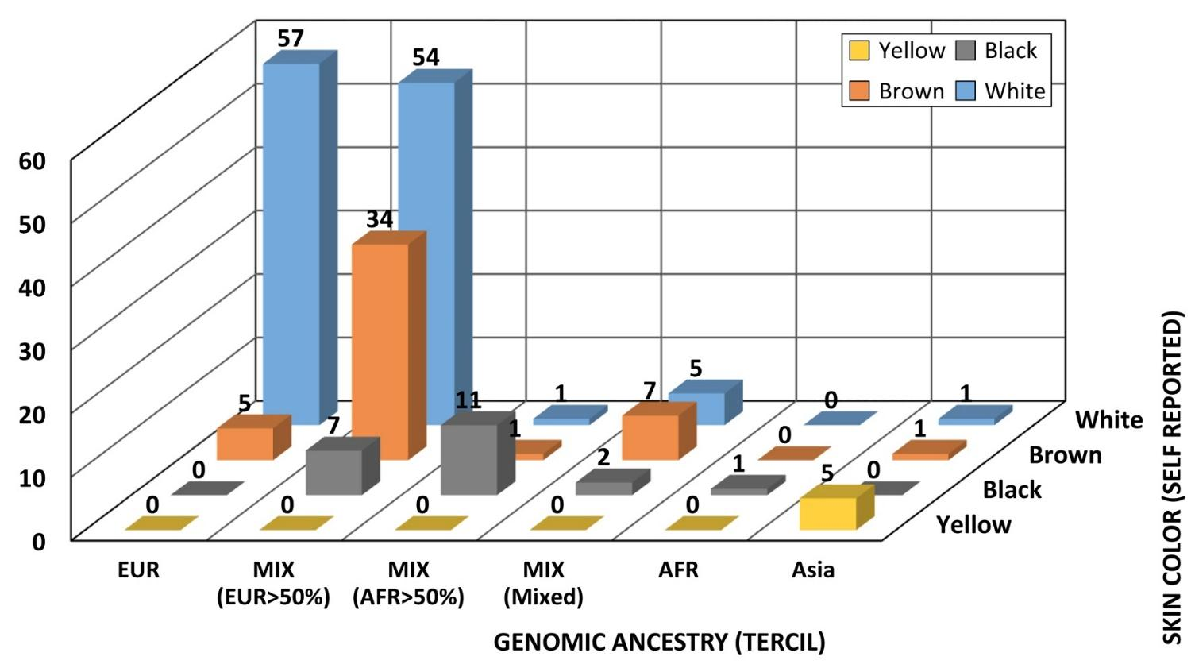

Supplementary Figure 5 : Association of categorized genomic ancestry (as described in methods) and self-declared skin color. Number of patients appear on the top of the columns.

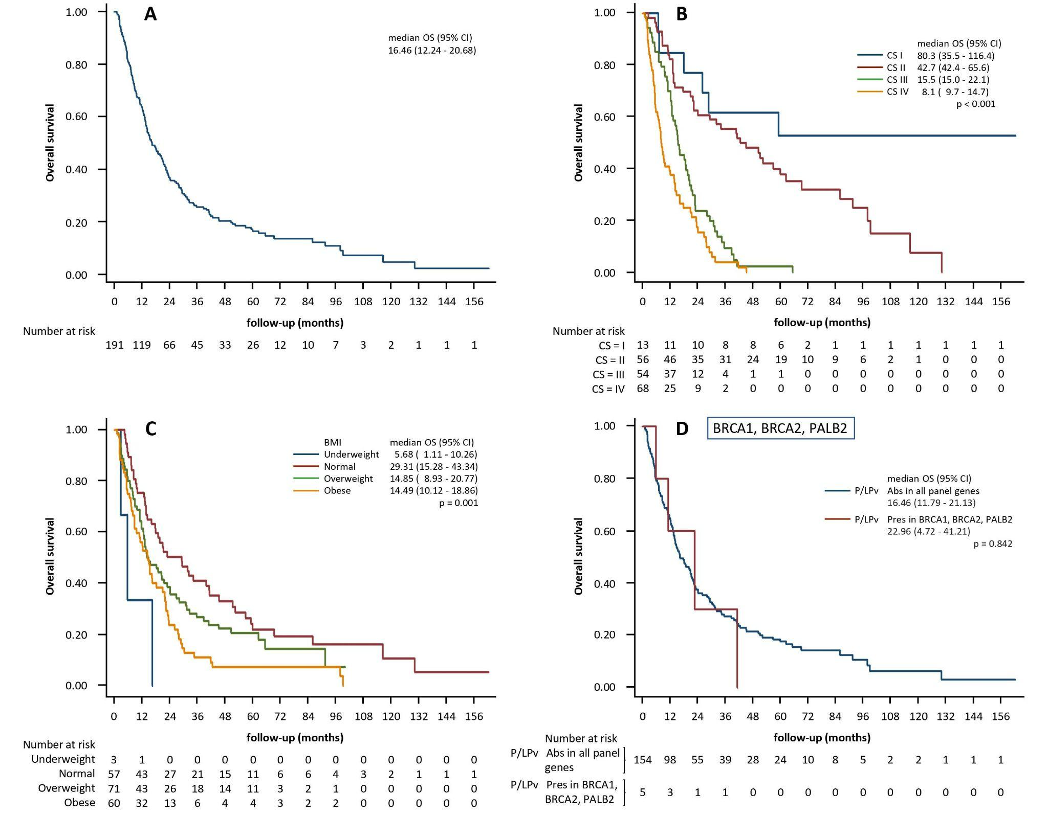
Supplementary Figure 6. Overall survival. A) all patients; B) all patients according with clinical stage; C) all patients according with BMI; D) Patients divided in BRCA1, BRCA2, PALB2 PGV carriers (P/LP variants present) and non-carriers (P/LP variants absent).

Supplementary Table 2. VUS and clinical characteristics of carriers.
gene | coding change | protein change | dbsnp | consequence | ancestry | age | FHC | zygosity
RECQL4 | c.2747C>T | p.(Pro916Leu) | rs375049839 | missense | EUR_pred | 56 | (mother) bowel | het
SDHA | c.704T>C | p.(Ile235Thr) | rs144513891 | missense | EUR_pred | 53 | (mother) pancreas, (sister) melanoma | het
RECQL4 | c.308C>T | p.(Pro103Leu) | rs199543866 | missense | EUR_pred | 53 | (mother) pancreas, (sister) melanoma | het
BLM | c.808G>A | p.(Glu270Lys) | rs762053925 | missense | EUR_pred | 53 | (mother) pancreas, (sister) melanoma | het
MUTYH | c.588G>C | p.(Glu196Asp) | rs587781645 | missense | EUR_pred | 53 | (mother) pancreas, (sister) melanoma | het
FANCA | c.2467A>T | p.(Thr823Ser) | rs1292223325 | missense | EUR_pred | 57 | (mother) breast, (father) bowel | het
CDH1 | c.1876T>G | p.(Phe626Val) | rs876660603 | missense | EUR_pred | 57 | (mother) breast, (father) bowel | het
PDGFRA | c.46A>T | p.(Thr16Ser) | rs587778596 | missense | EUR_pred | 56 |  | het
ERCC2 | c.47A>G | p.(Tyr16Cys) | rs147972150 | missense | EUR_pred | 42 | (brother) leukemia | het
FANCF | c.95G>A | p.(Arg32His) | rs996275860 | missense | EUR_pred | 42 | (brother) leukemia | het
APC | c.6637A>G | p.(Met2213Val) | rs186926737 | missense | EUR_pred | 67 | (sister) breast | het
POLE | c.3722A>C | p.(Glu1241Ala) | rs755166232 | missense | EUR_pred | 67 | (sister) breast | het
RAD50 | c.1062G>T | p.(Gln354His) | new | missense | EUR_pred | 67 | (sister) breast | het
FLCN | c.520A>T | p.(Thr174Ser) | rs2047176361 | missense | EUR_pred | 75 | (mother) breast and (father) trachea (no promt, (sister) skin) | het
FANCD2 | c.3710T>C | p.(Val1237Ala) | rs767806932 | missense | EUR_pred | 53 | (mother) skin | het
ATM | c.5612C>T | p.(Thr1871Ile) | rs538452060 | missense | EUR_pred | 75 | (mother) breast and (father) trachea (no promt, (sister) skin) | het
ATM | c.6096A>T | p.(Arg2032Ser) |  | missense | EUR_pred | 72 | 2 (son)s colorectal, (brother) bowel, (brother) throat, (mother) bowel grandmother breast, (father) bowel | het
MET | c.50C>T | p.(Thr17Ile) | rs747777018 | missense | EUR_pred | 72 | 2 (son)s colorectal, (brother) bowel, (brother) throat, (mother) bowel grandmothe breast, (father) bowel | het
RAD51 | c.340A>T | p.(Thr114Ser) | rs180732786 | missense | EUR_pred | 72 | 2 (son)s colorectal, (brother) bowel, (brother) throat, (mother) bowel grandmothe breast, (father) bowel | het
CEBPA | c.122A>C | p.(Gln41Pro) | new | missense | EUR_pred | 67 |  | het
RUNX1 | c.751C>T | p.(Pro251Ser) | rs767251526 | missense | EUR_pred | 67 |  | het
RAD50 | c.379G>A | p.(Val127Ile) | rs28903086 | missense | EUR_pred | 66 | (father) larynx | het
EPCAM | c.40G>C | p.(Ala14Pro) | rs1671160790 | missense | EUR_pred | 56 |  | het
EPCAM | c.65C>T | p.(Ala22Val) | rs894237303 | missense | EUR_pred | 56 |  | het
RUNX1 | c.1265A>G | p.(Glu422Gly) | rs2056451758 | missense | EUR_pred | 35 | (father) bowel, lymphoma NH and CEC skin | het
NBN | c.643C>T | p.(Arg215Trp) | rs34767364 | missense | EUR_pred | 35 | (father) bowel, lymphoma NH and CEC skin | het
DDB2 | c.1040G>A | p.(Arg347His) | rs761752334 | missense | EUR_pred | 35 | (father) bowel, lymphoma NH and CEC skin | het
TP53 | c.800G>A | p.(Arg267Gln) | rs587780075 | missense | Mix | 64 |  | het
SLX4 | c.3477G>C | p.(Glu1159Asp) | rs1349173708 | missense | Mix | 64 |  | het
POLE | c.577A>G | p.(Ser193Gly) | rs760588718 | missense | Mix | 65 |  | het
DIS3L2 | c.1722G>T | p.(Glu574Asp) | rs191608083 | missense | ADM_AFR | 61 | (mother) breast, (sister) breast | het
ERCC1 | c.793G>A | p.(Ala265Thr) | rs144868115 | missense | ADM_AFR | 61 | (mother) breast, (sister) breast | het
ERCC5 | c.1273A>G | p.(Thr425Ala) | rs1014584655 | missense | ADM_AFR | 72 |  | het
RET | c.1699G>A | p.(Asp567Asn) | rs147219360 | missense | ADM_EUR | 33 |  | het
GATA2 | c.1348G>A | p.(Gly450Arg) | rs370164300 | missense | ADM_EUR | 33 |  | het
TMEM127 | c.407C>T | p.(Thr136Met) | rs759138897 | missense | ADM_EUR | 27 |  | het
NBN | c.643C>T | p.(Arg215Trp) | rs34767364 | missense | ADM_EUR | 40 |  | het
PTEN | c.882T>G | p.(Ser294Arg) | rs143335584 | missense | ADM_EUR | 40 |  | het
FH | c.4T>C | p.(Tyr2His) | rs112335468 | missense | ADM_EUR | 40 |  | het
FANCA | c.4249C>G | p.(His1417Asp) | rs17227403 | missense | ADM_EUR | 52 |  | het
RUNX1 | c.1265A>G | p.(Glu422Gly) | rs2056451758 | missense | ADM_EUR | 52 |  | het
ERCC2 | c.773G>T | p.(Arg258Leu) | new | missense | ADM_EUR | 52 |  | het
ERCC2 | c.1280C>T | p.(Thr427Ile) | rs563069969 | missense | ADM_EUR | 56 |  | het
FANCA | c.2149A>G | p.(Met717Val) | rs766173155 | missense | ADM_EUR | 56 |  | het
PMS2 | c.932A>G | p.(His311Arg) | rs1562651786 | missense | ADM_EUR | 56 |  | het
BAP1 | c.404C>T | p.(Pro135Leu) | rs374928824 | missense | ADM_EUR | 60 | (mother) breast | het
XRCC2 | c.509A>C | p.(Glu170Ala) | rs778143946 | missense | ADM_EUR | 60 | (mother) breast | het
BRCA2 | c.5729A>T | p.(Asn1910Ile) | rs276174863 | missense | ADM_EUR | 27 |  | het
PMS2 | c.383C>T | p.(Ser128Leu) | rs116373169 | missense | ADM_EUR | 60 |  | het
PMS2 | c.830C>A | p.(Thr277Lys) | rs1805322 | missense | ADM_EUR | 60 |  | het
LZTR1 | c.1055A>C | p.(Tyr352Ser) | rs368649599 | missense | ADM_EUR | 60 |  | het
ERCC5 | c.2891G>A | p.(Arg964Gln) | rs149859074 | missense | ADM_EUR | 60 |  | het
FLCN | c.284A>G | p.(Tyr95Cys) | rs1555610947 | missense | ADM_EUR | 81 | (brother) lung | het
BRIP1 | c.2220G>T | p.(Gln740His) | rs45589637 | missense | ADM_EUR | 61 | (sister) head | het
SLX4 | c.2305G>C | p.(Glu769Gln) | rs150712805 | missense | ADM_EUR | 61 | (sister) head | het
ERCC4 | c.2164A>G | p.(Met722Val) | rs754771000 | missense | ADM_EUR | 61 | (sister) head | het
CDK4 | c.254G>A | p.(Arg85Gln) | rs587778184 | missense | ADM_EUR | 47 | (mother) breast, (father) lymphoma +bladder+lung | het
FANCA | c.754_755delinsAG | p.(Asp252Ser) | rs587778324 | missense | ADM_EUR | 47 | (mother) breast, (father) lymphoma +bladder+lung | het
FANCI | c.1964G>A | p.(Gly655Glu) | new | missense | ADM_EUR | 66 |  | het
XPC | c.1531A>C | p.(Lys511Gln) | rs6413541 | missense | ADM_EUR | 59 | (mother brother) lung | het
PTCH1 | c.3241G>A | p.(Val1081Met) | rs587778629 | missense | ADM_EUR | 59 | (mother brother) lung | het
FANCG | c.478G>A | p.(Ala160Thr) | rs140534765 | missense | ADM_EUR | 59 | (mother brother) lung | het
ERCC4 | c.2164A>G | p.(Met722Val) | rs754771000 | missense | ADM_EUR | 57 | (father) pancreas, (mother) breast and melanoma | het
FANCD2 | c.3278T>A | p.(Val1093Asp) | rs1000254003 | missense | ADM_EUR | 57 | (father) pancreas, (mother) breast and melanoma | het
MSH6 | c.334A>G | p.(Asn112Asp) | rs864622397 | missense | ADM_EUR | 68 | (brother) head | het
BRIP1 | c.2220G>T | p.(Gln740His) | rs45589637 | missense | ADM_EUR | 68 | (brother) head | het
ATM | c.4414T>G | p.(Leu1472Val) | rs539676759 | missense | ADM_EUR | 68 | (brother) head | het
RET | c.1157C>T | p.(Ala386Val) | rs115272158 | missense | AFR_pred | 49 |  | het
FANCF | c.91G>A | p.(Val31Met) | rs11556562 | missense | AFR_pred | 49 |  | het
TERT | c.1609C>T | p.(Arg537Cys) | rs760352197 | missense | AFR_pred | 49 |  | het
NF1 | c.5097G>T | p.(Glu1699Asp) | rs773378630 | missense | EAS_pred | 47 |  | het
BMPR1A | c.1385C>T | p.(Pro462Leu) | rs1418504897 | missense | EAS_pred | 47 |  | het
POLD1 | c.1732G>A | p.(Gly578Ser) | rs753850419 | missense | EAS_pred | 47 |  | het
FANCG | c.458C>G | p.(Ala153Gly) | rs200074432 | missense | EAS_pred | 59 | (sister) bowel | het
CASR | c.3002A>C | p.(Gln1001Pro) | rs1176923284 | missense | EAS_pred | 59 | (sister) bowel | het
TSC2 | c.4349C>T | p.(Pro1450Leu) | rs1279603512 | missense | EAS_pred | 70 | (father) gastric and esophagus | het
CDKN2A | c.302C>T | p.(Pro101Leu) | rs75256133 | missense | EAS_pred | 50 | (father) lung, (mother) bowel | het
MSH6 | c.1636G>C | p.(Glu546Gln) | rs63751172 | missense | EAS_pred | 50 | (father) lung, (mother) bowel | het
KIF1B | c.3638G>A | p.(Ser1213Asn) | rs756530731 | missense | EAS_pred | 65 | (sister) breast | het
CDKN1B | c.581G>A | p.(Arg194Lys) | new | missense | EAS_pred | 50 | (father) lung, (mother) bowel | het
DICER1 | c.3479C>A | p.(Ser1160Tyr) | rs774583162 | missense | EAS_pred | 75 | (mother) bowel and (sister) gastric | het
MSH2 | c.2366C>T | p.(Ala789Val) | rs876660292 | missense | EAS_pred | 74 |  | het
EPCAM | c.298G>A | p.(Asp100Asn) | rs149274310 | missense | EAS_pred | 47 |  | het
MSH6 | c.1505T>C | p.(Ile502Thr) | rs749012012 | missense | EAS_pred | 51 | (sister) thyroid | het
TERF2IP | c.1160C>T | p.(Ala387Val) | rs775948883 | missense | EAS_pred | 51 | (sister) thyroid | het
RECQL4 | c.1930G>A | p.(Ala644Thr) | rs774323224 | missense | EAS_pred | 51 | (sister) thyroid | het
ERCC4 | c.2062A>T | p.(Met688Leu) | rs755577606 | missense | EAS_pred | 51 | (sister) thyroid | het
LZTR1 | c.1541G>A | p.(Arg514Gln) | rs201687217 | missense | EAS_pred | 74 |  | het
MSH6 | c.3727A>T | p.(Thr1243Ser) | rs147453999 | missense | EUR_pred | 55 |  | het
SPINK1 | c.101A>G | p.(Asn34Ser) | rs17107315 | missense | EUR_pred | 75 | (father) kidney, (son) testícles | het
FANCA | c.1340C>T | p.(Ser447Leu) | rs149551759 | missense | EUR_pred | 75 | (father) kidney, (son) testicles | het
FANCA | c.4037C>T | p.(Ala1346Val) | rs201886956 | missense | EUR_pred | 75 | (father) kidney, (son) testicles | het
KIT | c.2663G>A | p.(Arg888Gln) | rs776681643 | missense | EUR_pred | 75 | (father) kidney, (son) testicles | het
SLX4 | c.1231C>T | p.(Arg411Trp) | rs761227900 | missense | EUR_pred | 49 |  | het
MSH6 | c.663A>C | p.(Glu221Asp) | rs41557217 | missense | EUR_pred | 78 | (daughter) bowel | het
PALB2 | c.202A>G | p.(Lys68Glu) | new | missense | EUR_pred | 58 | (father) gastric | het
FANCG | c.154G>T | p.(Gly52Trp) | new | missense | EUR_pred | 70 | (mother) endometrium | het
MLH1 | c.157G>A | p.(Glu53Lys) | rs63751199 | missense | EUR_pred | 70 | (mother) endometrium | het
MUTYH | c.1091G>A | p.(Arg364His) | rs587780741 | missense | EUR_pred | 47 |  | het
ERCC1 | c.619C>T | p.(Arg207Trp) | rs764503289 | missense | EUR_pred | 57 | (father) liver | het
AKT1 | c.406G>A | p.(Val136Met) | rs778376616 | missense | EUR_pred | 57 | (father) liver | het
BRCA2 | c.280C>T | p.(Pro94Ser) | rs80358531 | missense | EUR_pred | 57 | (father) liver | het
BRCA2 | c.8668C>A | p.(Leu2890Ile) | rs80359127 | missense | EUR_pred | 63 | (sister) kidney | het
MSH2 | c.2459G>A | p.(Gly820Asp) | rs794729229 | missense | EUR_pred | 63 | (sister) kidney | het
FANCM | c.5258A>G | p.(His1753Arg) | rs371891604 | missense | EUR_pred | 55 |  | het
MSH6 | c.367A>G | p.(Lys123Glu) | rs1466067357 | missense | EUR_pred | 60 | (mother) uterus | het
XRCC2 | c.574T>C | p.(Phe192Leu) | rs1563026024 | missense | EUR_pred | 55 |  | het
TP53 | c.467G>A | p.(Arg156His) | rs371524413 | missense | EUR_pred | 64 | (father) prostate | het
RHBDF2 | c.895T>G | p.(Ser299Ala) | rs917585157 | missense | EUR_pred | 55 |  | het
BAP1 | c.358A>G | p.(Lys120Glu) | rs774573926 | missense | EUR_pred | 55 |  | het
FANCM | c.1742G>A | p.(Arg581His) | rs748083548 | missense | EUR_pred | 56 |  | het
FANCI | c.1735G>A | p.(Ala579Thr) | rs147963936 | missense | EUR_pred | 57 |  | het
BAP1 | c.905C>T | p.(Pro302Leu) | rs149158790 | missense | EUR_pred | 60 | (mother) uterus | het
BRIP1 | c.2220G>T | p.(Gln740His) | rs45589637 | missense | EUR_pred | 57 |  | het
POLE | c.2927G>A | p.(Arg976His) | rs878854857 | missense | EUR_pred | 57 |  | het
SLX4 | c.2654C>T | p.(Pro885Leu) | rs147492092 | missense | EUR_pred | 64 | (father) prostate | het
FLCN | c.715C>T | p.(Arg239Cys) | rs78683075 | missense | EUR_pred | 64 | (father) prostate | het
RECQL4 | c.886G>A | p.(Glu296Lys) | rs1024635326 | missense | EUR_pred | 57 |  | het
MSH3 | c.711A>G | p.(Ile237Met) | rs375321647 | missense | EUR_pred | 57 |  | het
ERCC1 | c.346G>A | p.(Val116Met) | rs200459924 | missense | EUR_pred | 58 |  | het
POLD1 | c.3257G>A | p.(Arg1086Gln) | rs3219457 | missense | EUR_pred | 64 | (father) prostate | het
TP53 | c.467G>A | p.(Arg156His) | rs371524413 | missense | EUR_pred | 76 |  | het
GATA2 | c.238A>G | p.(Thr80Ala) | rs1274861441 | missense | EUR_pred | 62 | (father) bowel | het
SLX4 | c.822G>C | p.(Gln274His) | rs1367038373 | missense | EUR_pred | 60 |  | het
NF1 | c.169G>A | p.(Gly57Ser) | rs779727341 | missense | EUR_pred | 61 |  | het
FANCM | c.2996C>T | p.(Pro999Leu) | rs148304968 | missense | EUR_pred | 63 |  | het
NF1 | c.7450G>A | p.(Ala2484Thr) | rs786202955 | missense | EUR_pred | 63 |  | het
EPCAM | c.212C>T | p.(Ala71Val) | rs567291767 | missense | EUR_pred | 74 |  | het
RET | c.2975C>T | p.(Pro992Leu) | rs758191409 | missense | EUR_pred | 63 |  | het
MET | c.607T>A | p.(Ser203Thr) | rs200861145 | missense | EUR_pred | 61 | (brother) head and (sister) breast | het
POLE | c.2245C>T | p.(Arg749Trp) | rs751326135 | missense | EUR_pred | 75 | (mother) breast and (father) trachea (no promt, (sister) skin) | het
DICER1 | c.3422C>T | p.(Ser1141Phe) | rs780815020 | missense | EUR_pred | 64 |  | het
ERCC4 | c.1727G>C | p.(Arg576Thr) | rs1800068 | missense | EUR_pred | 56 | (brother) lung, (brother) pancreas | het
PTCH1 | c.3241G>A | p.(Val1081Met) | rs587778629 | missense | EUR_pred | 56 | (brother) lung, (brother) pancreas | het
FANCM | c.527C>T | p.(Thr176Ile) | rs77374493 | missense | EUR_pred | 65 |  | het
HOXB13 | c.356A>G | p.(Glu119Gly) |  | missense | EUR_pred | 65 |  | het
RAD51D | c.568G>A | p.(Ala190Thr) | rs80116829 | missense | EUR_pred | 66 |  | het
BMPR1A | c.118G>A | p.(Asp40Asn) | rs587781556 | missense | EUR_pred | 66 |  | het
APC | c.1925T>C | p.(Val642Ala) | rs759528091 | missense | EUR_pred | 60 | (brother) throat, (brother) gastrointestinal, (sister) gastric | het
RAD51B | c.1063G>A | p.(Ala355Thr) | rs61758785 | missense | EUR_pred | 60 | (brother) throat, (brother) gastrointestinal, (sister) gastric | het
TERT | c.959C>T | p.(Pro320Leu) | rs1751178484 | missense | EUR_pred | 68 |  | het
NF1 | c.6710G>A | p.(Arg2237Gln) | rs786202030 | missense | EUR_pred | 67 | (mother) gastrointestinal | het
FANCD2 | c.1949A>G | p.(Glu650Gly) | new | missense | EUR_pred | 72 | (brother) leukemia and (brother) prostate | het
PMS2 | c.620G>A | p.(Gly207Glu) | rs374704824 | missense | EUR_pred | 72 | (brother) leukemia and (brother) prostate | het
MRE11 | c.1811G>C | p.(Arg604Pro) | rs148637964 | missense | EUR_pred | 69 |  | het
RHBDF2 | c.1467G>C | p.Glu489Asp | rs367660554 | missense | EUR_pred | 69 |  | het
FANCI | c.2518C>T | p.(Arg840Cys) | rs769097886 | missense | EUR_pred | 72 | (brother) leukemia and (brother) prostate | het
PTCH1 | c.3817G>A | p.(Glu1273Lys) | rs749244396 | missense | EUR_pred | 66 | (mother) ovary | het
SPINK1 | c.126A>G | p.(Ile42Met) | rs370266754 | missense | EUR_pred | 66 | (mother) ovary | het
BMPR1A | c.418C>T | p.(Pro140Ser) | rs138478597 | missense | EUR_pred | 66 | (mother) ovary | het
DICER1 | c.1381A>G | p.(Ile461Val) | rs141163928 | missense | EUR_pred | 54 | (father) prostate | het
TSC1 | c.334C>T | p.(Leu112Phe) | rs1554820276 | missense | EUR_pred | 50 | (father) bones and (mother) pancreas | het
ACD | c.377C>G | p.(Ala126Gly) | rs752683720 | missense | EUR_pred | 74 |  | het
MLH1 | c.1453G>T | p.(Asp485Tyr) | rs63750314 | missense | EUR_pred | 50 | (father) bones and (mother) pancreas | het
MSH2 | c.1847C>G | p.(Pro616Arg) | rs587779965 | missense | EUR_pred | 57 |  | het
MLH1 | c.649C>T | p.(Arg217Cys) | rs4986984 | missense | EUR_pred | 55 |  | het
BRCA2 | c.6095C>T | p.(Ala2032Val) | rs786202701 | missense | EUR_pred | 63 | (mother) bowel, (sister) breast, (brother) esophagus, (brother) liver | het
SPINK1 | c.101A>G | p.(Asn34Ser) | rs17107315 | missense | EUR_pred | 47 | (father) colorectal | het
FANCI | c.1573A>G | p.(Met525Val) | rs144908351 | missense | EUR_pred | 47 | (father) colorectal | het
GATA2 | c.1348G>A | p.(Gly450Arg) | rs370164300 | missense | EUR_pred | 47 | (father) colorectal | het
TSC2 | c.4369C>T | p.(Arg1457Trp) | rs746729857 | missense | EUR_pred | 47 | (father) colorectal | het
ERCC5 | c.788G>A | p.(Arg263Gln) | rs61749896 | missense | EUR_pred | 63 | (mother) bowel, (sister) breast, (brother) esophagus, (brother) liver | het
PTCH1 | c.3241G>A | p.(Val1081Met) | rs587778629 | missense | EUR_pred | 63 | (mother) bowel, (sister) breast, (brother) esophagus, (brother) liver | het
FANCI | c.3706G>A | p.(Val1236Ile) | rs377165815 | missense | Mix | 47 |  | het
SUFU | c.1015C>T | p.(Arg339Trp) | rs773037813 | missense | Mix | 47 |  | het
ATM | c.6543G>T | p.(Glu2181Asp) | rs138828590 | missense | Mix | 75 |  | het
FANCA | c.1874G>C | p.(Cys625Ser) | rs139235751 | missense | Mix | 68 | (mother) head | het
FANCF | c.451T>C | p.(Tyr151His) | new | missense | Mix | 68 | (mother) head | het
KIF1B | c.3839A>T | p.(Asp1280Val) | rs879368394 | missense | Mix | 68 | (mother) head | het
PDGFRA | c.1388C>G | p.(Thr463Ser) | rs375047532 | missense | Mix | 61 |  | het
SDHB | c.112C>T | p.(Arg38Cys) | rs202119350 | missense | Mix | 63 |  | het
FANCF | c.241G>T | p.(Ala81Ser) | rs145057187 | missense | Mix | 72 | (father) prostate, (brother) prostate, (sister) breast, (sister) pancreas | het
RAD51B | c.25G>A | p.(Val9Met) | rs34583846 | missense | Mix | 74 | (brother) head and neck and (sister) uterus | het
RECQL4 | c.716C>T | p.(Ala239Val) | rs146709578 | missense | Mix | 74 | (brother) head and neck and (sister) uterus | het
ERCC5 | c.1711C>T | p.(Pro571Ser) | rs141763734 | missense | Mix | 74 | (brother) head and neck and (sister) uterus | het
BRCA2 | c.8420C>T | p.(Ser2807Leu) | rs55763607 | missense | Mix | 68 |  | het
POLE | c.5636G>A | p.(Arg1879His) | rs145621558 | missense | Mix | 68 |  | hom
RUNX1 | c.82_84del | p.(Ser28del) | rs775050403 | inframe | Mix | 68 |  | het
MSH2 | c.187G>A | p.(Val63Met) | rs1553348889 | missense | Mix | 86 |  | het
ATM | c.7375C>G | p.(Arg2459Gly) | rs730881383 | missense | Mix | 60 | (mother) bowel | het
NTHL1 | c.119C>T | p.(Ala40Val) | rs375615004 | missense | Mix | 60 | (mother) bowel | het
MET | c.3218C>T | p.(Pro1073Leu) | rs370529693 | missense | Mix | 62 | (mother) colo de utero, (sister) breast | het
RHBDF2 | c.1174T>G | p.(Cys392Gly) | rs374870347 | missense | Mix | 62 | (mother) colo de utero, (sister) breast | het
FANCM | c.3938G>C | p.(Ser1313Thr) | rs771311008 | missense | Mix | 86 |  | het
ERCC2 | c.1901A>G | p.(Lys634Arg) |  | missense | Mix | 86 |  | het
FANCI | c.2204T>C | p.(Ile735Thr) | rs911033971 | missense | Mix | 86 |  | het
POLE | c.2880T>A | p.(Asn960Lys) |  | missense | Mix | 86 |  | het
FANCM | c.1576C>G | p.(Leu526Val) | rs144215747 | missense | ADM_AFR | 48 |  | het
FANCA | c.377C>T | p.(Thr126Met) | rs139160837 | missense | ADM_AFR | 48 |  | het
NSD1 | c.3389A>G | p.(Glu1130Gly) | rs113856002 | missense | ADM_AFR | 49 |  | het
BMPR1A | c.1433G>A | p.(Arg478His) | rs113849804 | missense | ADM_AFR | 41
FANCI | c.3499T>G | p.(Cys1167Gly) | rs61744917 | missense | ADM_AFR | 38 |  | het
ERCC5 | c.2827G>A | p.(Asp943Asn) | new | missense | ADM_AFR | 38 |  | het
BRIP1 | c.3651G>T | p.(Trp1217Cys) | rs542698396 | missense | ADM_AFR | 65 | (brother) esophagus | het
RHBDF2 | c.1397G>A | p.Arg466Gln | rs149436907 | missense | ADM_AFR | 65 | (brother) esophagus | het
ABRAXAS1 | c.892G>C | p.(Val298Leu) | rs1266518140 | missense | ADM_AFR | 57 | (mother) colo de uterus | het
CDKN1B | c.199C>T | p.(His67Tyr) | rs867208075 | missense | ADM_AFR | 57 | (mother) colo de uterus | het
ATM | c.6543G>T | p.(Glu2181Asp) | rs138828590 | missense | ADM_AFR | 57 | (mother) colo de uterus | het
RAD50 | c.2177G>A | p.(Arg726His) | rs28903092 | missense | ADM_AFR | 87 | (father) colorectal and (brother) unknown | het
ERCC1 | c.793G>A | p.(Ala265Thr) | rs144868115 | missense | ADM_AFR | 87 | (father) colorectal and (brother) unknown | het
DICER1 | c.1036T>G | p.(Leu346Val) | rs1893233162 | missense | ADM_AFR | 87 | (father) colorectal and (brother) unknown | het
FANCF | c.1000G>C | p.(Ala334Pro) | new | missense | ADM_AFR | 87 | (father) colorectal and (brother) unknown | het
FANCF | c.371C>T | p.(Ala124Val) | new | missense | ADM_AFR | 87 | (father) colorectal and (brother) unknown | het
FANCF | c.776_777delinsAA | p.(Leu259Gln) | new | missense | ADM_AFR | 87 | (father) colorectal and (brother) unknown | het
ABRAXAS1 | c.364C>G | p.(Gln122Glu) | rs137876115 | missense | ADM_AFR | 65 | (sister) breast | het
NSD1 | c.3389A>G | p.(Glu1130Gly) | rs113856002 | missense | ADM_AFR | 65 | (sister) breast | het
FANCB | c.592C>G | p.(Gln198Glu) | rs1456376131 | missense | ADM_AFR | 65 | (sister) breast | hom
KIF1B | c.5284C>T | p.(Arg1762Cys) | rs1060501912 | missense | ADM_AFR | 65 | (sister) breast | het
FANCA | c.4244T>G | p.(Phe1415Cys) | rs201658945 | missense | ADM_AFR | 58 |  | het
ATM | c.6543G>T | p.(Glu2181Asp) | rs138828590 | missense | ADM_AFR | 49 |  | het
FANCI | c.3828G>A | p.(Met1276Ile) | rs745401006 | missense | ADM_AFR | 68 | (father) prostate | het
FANCM | c.2452A>G | p.(Ile818Val) | rs199948045 | missense | ADM_AFR | 65 | (2 brothers) Leukemia | het
CHEK2 | c.1582G>A | p.(Glu528Lys) | rs138040612 | missense | ADM_AFR | 65 | (2 brothers) Leukemia | het
FANCM | c.5224A>G | p.(Ile1742Val) | rs143662421 | missense | ADM_EUR | 41 |  | het
GALNT12 | c.907G>A | p.(Asp303Asn) | rs145236923 | missense | ADM_EUR | 41 |  | het
POLE | c.154C>T | p.(Arg52Trp) | rs115452881 | missense | ADM_EUR | 41 |  | het
POLE | c.6065G>A | p.(Ser2022Asn) | rs905858506 | missense | ADM_EUR | 41 |  | het
GALNT12 | c.367C>A | p.(Pro123Thr) | rs1207193475 | missense | ADM_EUR | 41 |  | het
FH | c.4T>C | p.(Tyr2His) | rs112335468 | missense | ADM_EUR | 41 |  | het
FANCB | c.989T>C | p.(Ile330Thr) | rs200161949 | missense | ADM_EUR | 46 |  | hom
TSC1 | c.1163T>C | p.(Leu388Pro) | rs377598226 | missense | ADM_EUR | 46 |  | het
APC | c.8141G>A | p.(Arg2714His) | rs747362422 | missense | ADM_EUR | 46 |  | het
FANCA | c.1874G>C | p.(Cys625Ser) | rs139235751 | missense | ADM_EUR | 69 | 2 (sister)s breast, (mother) colorectal and (brother) kidney | het
BARD1 | c.1247T>G | p.(Leu416Arg) | rs878853996 | missense | ADM_EUR | 62 | (sister) uterus and (father) lung | het
FANCG | c.739C>A | p.(Gln247Lys) | rs145613634 | missense | ADM_EUR | 43 |  | het
FANCM | c.4858_4860del | p.(Glu1622del) | rs765421461 | inframe | ADM_EUR | 50 |  | het
ERCC2 | c.1901A>G | p.(Lys634Arg) | new | missense | ADM_EUR | 50 |  | het
SLX4 | c.2227G>A | p.(Val743Met) | rs747832147 | missense | ADM_EUR | 49 |  | het
NF1 | c.169G>A | p.(Gly57Ser) | rs779727341 | missense | ADM_EUR | 46 |  | het
RUNX1 | c.1187G>C | p.(Arg396Pro) | rs1205896319 | missense | ADM_EUR | 46 |  | het
RECQL4 | c.308C>T | p.(Pro103Leu) | rs199543866 | missense | ADM_EUR | 62 | (sister) uterus and (father) lung | het
FANCM | c.5478A>C | p.(Glu1826Asp) | rs1890053191 | missense | ADM_EUR | 48 |  | het
KIF1B | c.1133G>A | p.(Arg378His) | rs753524217 | missense | ADM_EUR | 38 |  | het
SMARCB1 | c.366A>T | p.(Glu122Asp) | rs1060503018 | missense | ADM_EUR | 38 |  | het
RECQL4 | c.1708C>T | p.(Arg570Trp) | rs373178405 | missense | ADM_EUR | 45 |  | het
PDGFRA | c.2306A>T | p.(Lys769Met) | rs373061721 | missense | ADM_EUR | 45 |  | het
RHBDF2 | c.956G>A | p.Arg319Gln | rs760515370 | missense | ADM_EUR | 45 |  | het
STK11 | c.894C>A | p.(Phe298Leu) | rs199681533 | missense | ADM_EUR | 75 |  | het
XPC | c.1001C>A | p.(Pro334His) | rs74737358 | missense | ADM_EUR | 73 | (sister)s liver and breast | het
POLD1 | c.883G>A | p.(Val295Met) | rs199545019 | missense | ADM_EUR | 51 |  | het
PALB2 | c.100C>T | p.(Arg34Cys) | rs373483056 | missense | ADM_EUR | 60 | (sister) unknown | het
BRIP1 | c.728T>C | p.(Ile243Thr) | rs587781860 | missense | ADM_EUR | 51 |  | het
ATM | c.1595G>A | p.(Cys532Tyr) | rs35963548 | missense | ADM_EUR | 51 |  | het
ERCC3 | c.2111C>T | p.(Ser704Leu) | rs4150521 | missense | ADM_EUR | 67 | (mother) gastric, (father) prostate | het
FANCA | c.1874G>C | p.(Cys625Ser) | rs139235751 | missense | ADM_EUR | 67 | (mother) gastric, (father) prostate | het
TERT | c.2666G>A | p.(Arg889Gln) | rs532158398 | missense | ADM_EUR | 60 | (sister) unknown | het
KIT | c.532G>A | p.(Ala178Thr) | rs115585711 | missense | ADM_EUR | 53 |  | het
FANCE | c.929C>A | p.(Pro310Gln) | rs139600847 | missense | ADM_EUR | 53 |  | het
SDHB | c.455C>T | p.(Ser152Phe) | rs200414835 | missense | ADM_EUR | 53 |  | het
SLX4 | c.467C>A | p.(Thr156Lys) | rs144614070 | missense | ADM_EUR | 54 |  | het
APC | c.1762G>A | p.(Val588Ile) | rs372416031 | missense | ADM_EUR | 55 |  | het
ERCC3 | c.2080G>A | p.(Ala694Thr) | rs151216904 | missense | ADM_EUR | 61 | (sister) lymphoma NH, (sister) breast | het
SLX4 | c.2305G>C | p.(Glu769Gln) | rs150712805 | missense | ADM_EUR | 55 |  | het
POLE | c.4582G>A | p.(Ala1528Thr) | rs373468985 | missense | ADM_EUR | 55 |  | het
SDHA | c.1786G>C | p.(Asp596His) | rs371304688 | missense | ADM_EUR | 55 |  | het
GALNT12 | c.889C>T | p.(Arg297Trp) | rs149726976 | missense | ADM_EUR | 61 | (sister) lymphoma NH, (sister) breast | het
NTHL1 | c.763C>T | p.(Arg255Cys) | rs779992803 | missense | ADM_EUR | 56 |  | het
ATM | c.749G>A | p.(Arg250Gln) | rs56123940 | missense | ADM_EUR | 59 |  | het
ATM | c.5185G>C | p.(Val1729Leu) | rs3092907 | missense | ADM_EUR | 58 | (sister) breast and (mother) unknown | het
TSC2 | c.3962A>T | p.(Glu1321Val) | rs587778736 | missense | ADM_EUR | 63 | (brother) lung | het
ATM | c.1411A>C | p.(Asn471His) | rs2080104786 | missense | ADM_EUR | 58 | (sister) breast and (mother) unknown | het
FANCA | c.2390C>T | p.(Ala797Val) | rs138248569 | missense | ADM_EUR | 57 |  | het
XRCC2 | c.613T>G | p.(Ser205Ala) | rs56103026 | missense | ADM_EUR | 57 |  | het
RAD51D | c.70A>G | p.(Arg24Gly) | rs781611267 | missense | ADM_EUR | 57 |  | het
SUFU | c.1297C>T | p.(Leu433Phe) | rs368920108 | missense | ADM_EUR | 57 |  | het
RAD50 | c.3253A>G | p.(Ile1085Val) | rs143189763 | missense | ADM_EUR | 38 | (father) prostate | het
ERCC2 | c.431C>T | p.(Ala144Val) | rs776313922 | missense | ADM_EUR | 38 | (father) prostate | het
MSH6 | c.2561A>T | p.(Lys854Met) | rs34374438 | missense | ADM_EUR | 46 |  | het
BRIP1 | c.3104G>A | p.(Arg1035His) | rs367816363 | missense | ADM_EUR | 38 | (father) prostate | het
RECQL4 | c.1684C>T | p.(Arg562Trp) | rs61759892 | missense | ADM_EUR | 59 | (son) SNC | het
RAD51D | c.919G>A | p.(Glu307Lys) | rs115031549 | missense | ADM_EUR | 58 | (sister) breast and (mother) unknown | het
BRCA2 | c.3755C>A | p.(Ser1252Tyr) | rs1361496246 | missense | ADM_EUR | 46 |  | het
MSH3 | c.2480A>G | p.(His827Arg) | rs138339194 | missense | ADM_EUR | 58 | (sister) breast and (mother) unknown | het
RAD51B | c.25G>A | p.(Val9Met) | rs34583846 | missense | ADM_EUR | 58 | (sister) breast and (mother) unknown | het
APC | c.6857C>T | p.(Ala2286Val) | rs200587641 | missense | ADM_EUR | 58 | (sister) breast and (mother) unknown | het
ERCC1 | c.793G>A | p.(Ala265Thr) | rs144868115 | missense | ADM_EUR | 59 |  | het
FANCM | c.53G>A | p.(Arg18Gln) | rs146609069 | missense | ADM_EUR | 59 |  | het
DIS3L2 | c.1970G>A | p.(Arg657His) | rs757443947 | missense | ADM_EUR | 59 |  | het
RAD51 | c.138C>G | p.(Phe46Leu) | rs1298742495 | missense | ADM_EUR | 59 |  | het
KIT | c.839C>T | p.(Ala280Val) | rs386833402 | missense | ADM_EUR | 68 | (father) neck and (brother) bowel | het
DICER1 | c.1053C>G | p.(Phe351Leu) | rs1358609309 | missense | ADM_EUR | 69 | (father) gastric and (brother) bowel | het
ATM | c.5185G>C | p.(Val1729Leu) | rs3092907 | missense | ADM_EUR | 52 | (son) bones | het
POLE | c.1015G>A | p.(Asp339Asn) | rs149029910 | missense | ADM_EUR | 60 |  | het
BRIP1 | c.3559G>A | p.(Ala1187Thr) | rs367610893 | missense | ADM_EUR | 60 |  | het
MUTYH | c.1141G>T | p.(Gly381Trp) | rs587778539 | missense | ADM_EUR | 60 |  | het
BRIP1 | c.1721C>T | p.(Pro574Leu) | rs377302300 | missense | ADM_EUR | 60 |  | het
KIT | c.391G>A | p.(Asp131Asn) | rs1044091916 | missense | ADM_EUR | 60 |  | het
WT1 | c.1048T>C | p.(Cys350Arg) | rs142059681 | missense | ADM_EUR | 83 | (son) bowel | het
BLM | c.2333C>G | p.(Ser778Cys) | rs139610577 | missense | ADM_EUR | 83 | (son) bowel | het
POLD1 | c.2926G>A | p.(Glu976Lys) | rs750457028 | missense | ADM_EUR | 55 | (mother) pancreas, (brother) gastrointestinal and 2 (sister)s gastric | het
RECQL4 | c.3017C>T | p.(Ala1006Val) | rs1291700234 | missense | ADM_EUR | 64 | (sister) thyroid and skin, (mother) bowel, (father) brain | het
POLE | c.1274A>G | p.(Lys425Arg) | rs757186755 | missense | ADM_EUR | 64 | (sister) thyroid and skin, (mother) bowel, (father) brain | het
NF1 | c.6083A>T | p.(Lys2028Met) |  | missense | ADM_EUR | 77 | (mother) uterus, (sister) uterus | het
NTHL1 | c.68T>C | p.(Leu23Pro) | rs781328762 | missense | ADM_EUR | 74 | (daughter) thyroid, (sister) peritoneum (provavel meta de unknown), (mother) liver, (father) bowel | het
FH | c.346A>T | p.(Ile116Phe) | rs201532589 | missense | ADM_EUR | 74 | (daughter) thyroid, (sister) peritoneum (provavel meta de unknown), (mother) liver, (father) bowel | het
ERCC4 | c.1870C>T | p.(Arg624Trp) | rs766395322 | missense | ADM_EUR | 63 |  | hom
MSH6 | c.905G>C | p.(Arg302Thr) | rs587781510 | missense | ADM_EUR | 64 | (sister) thyroid and skin, (mother) bowel, (father) brain | het
BRCA1 | c.381T>G | p.(Ser127Arg) | rs945168715 | missense | ADM_EUR | 64 | (sister) thyroid and skin, (mother) bowel, (father) brain | het
RB1 | c.20G>C | p.(Arg7Pro) | new | missense | ADM_EUR | 52 | (father) pancreas | het
RECQL4 | c.3392G>A | p.(Arg1131Lys) | rs201369291 | missense | ADM_EUR | 54 | (father) gastric | het
BLM | c.1601A>G | p.(Asn534Ser) | rs35224686 | missense | ADM_EUR | 54 | (father) gastric | het
SUFU | c.50C>T | p.(Ala17Val) | rs12780580 | missense | ADM_EUR | 63 | (brother) throat | het
BLM | c.2477T>C | p.(Val826Ala) | new | missense | ADM_EUR | 63 | (brother) throat | het
FH | c.649G>A | p.(Ala217Thr) | rs1370459100 | missense | ADM_EUR | 76 | (brother) bladder | het
TSC1 | c.334C>T | p.(Leu112Phe) | rs1554820276 | missense | ADM_EUR | 56 | (mother) skin | het
MRE11 | c.1475C>A | p.(Ala492Asp) | rs61749249 | missense | ADM_EUR | 68 |  | het
SMARCA4 | c.76G>A | p.(Ala26Thr) | rs145867502 | missense | ADM_EUR | 68 |  | het
BRIP1 | c.139C>G | p.(Pro47Ala) | rs28903098 | missense | ADM_EUR | 68 |  | het
RINT1 | c.310C>G | p.(Arg104Gly) | rs777242801 | missense | ADM_EUR | 68 |  | het
APC | c.5801C>T | p.(Pro1934Leu) | rs587780600 | missense | ADM_EUR | 68 |  | het
POLE | c.3865C>T | p.(Arg1289Cys) | rs770036124 | missense | ADM_EUR | 68 |  | het
FANCF | c.91G>A | p.(Val31Met) | rs11556562 | missense | ADM_EUR | 68 |  | het
RAD51B | c.1063G>A | p.(Ala355Thr) | rs61758785 | missense | ADM_EUR | 82 | (sister) pancreas and (sister) bowel | het
POLE | c.296C>T | p.(Pro99Leu) | rs5744739 | missense | ADM_EUR | 68 | (brother) leukemia | het
RAD50 | c.379G>A | p.(Val127Ile) | rs28903086 | missense | ADM_EUR | 84 | (sister) breast | het
FANCA | c.595A>G | p.(Ser199Gly) | new | missense | ADM_EUR | 84 | (sister) breast | het
RECQL4 | c.3062G>A | p.(Arg1021Gln) | rs34666647 | missense | ADM_EUR | 52 | (sister) breast | het
DDB2 | c.857C>T | p.(Pro286Leu) | rs373044335 | missense | ADM_EUR | 52 | (sister) breast | het
KIT | c.2663G>A | p.(Arg888Gln) | rs776681643 | missense | ADM_EUR | 52 | (sister) breast | het
RAD51B | c.1063G>A | p.(Ala355Thr) | rs61758785 | missense | ADM_EUR | 52 | (sister) breast | het
GATA2 | c.1348G>A | p.(Gly450Arg) | rs370164300 | missense | ADM_EUR | 72 | (mother) bowel, 2 (sister)s bowel and (brother) bowel | het
ERCC3 | c.1082G>C | p.(Cys361Ser) | rs775716891 | missense | ADM_EUR | 72 | (mother) bowel, 2 (sister)s bowel and (brother) bowel | het
TP53 | c.31G>C | p.(Glu11Gln) | rs201382018 | missense | ADM_EUR | 68 | (father) esophagus | het
PTCH1 | c.86G>T | p.(Gly29Val) | rs200842963 | missense | ADM_EUR | 68 | (father) esophagus | het
SLX4 | c.4972G>A | p.(Gly1658Arg) | rs200507644 | missense | ADM_EUR | 68 | (father) esophagus | het
RB1 | c.784C>T | p.(Arg262Trp) | rs556201144 | missense | ADM_EUR | 69 | (mother) uterus and (brother) gastric | het
ERCC4 | c.404G>C | p.(Arg135Thr) | rs772606808 | missense | ADM_EUR | 74 |  | het
APC | c.6546A>C | p.(Glu2182Asp) | new | missense | ADM_EUR | 74 |  | het
RUNX1 | c.259G>T | p.(Gly87Cys) | rs561166961 | missense | ADM_EUR | 69 | (mother) uterus and (brother) gastric | het
FLCN | c.611C>T | p.(Ala204Val) | rs766401197 | missense | ADM_EUR | 69 | (mother) uterus and (brother) gastric | het
POLD1 | c.532G>A | p.(Gly178Arg) | rs140707092 | missense | ADM_EUR | 69 | (mother) uterus and (brother) gastric | het
FANCM | c.685G>T | p.(Val229Leu) | rs572322789 | missense | ADM_EUR | 69 | (mother) uterus and (brother) gastric | het
CDKN2A | c.400G>C | p.(Ala134Pro) | rs372599739 | missense | ADM_EUR | 69 | (mother) uterus and (brother) gastric | het
APC | c.4609A>G | p.(Thr1537Ala) | rs781328009 | missense | ADM_EUR | 69 | (mother) ovary, (sister) SNC, (brother) lung and liver | het
POLE | c.154C>T | p.(Arg52Trp) | rs115452881 | missense | ADM_EUR | 58 | (sister) uterus and (father) prostate | het
FH | c.1303G>A | p.(Val435Met) | rs147528200 | missense | ADM_EUR | 58 | (sister) uterus and (father) prostate | het
FANCB | c.1996G>A | p.(Gly666Ser) | rs145110602 | missense | ADM_EUR | 75 |  | het
MET | c.1772G>A | p.(Arg591Gln) | rs775965879 | missense | ADM_EUR | 75 |  | het
FANCI | c.797A>T | p.(His266Leu) | new | missense | ADM_EUR | 68 | (brother) kidney or lung and (half-brother) prostate | het
RUNX1 | c.1265A>G | p.(Glu422Gly) | rs2056451758 | missense | ADM_EUR | 75 |  | het
SLX4 | c.3607C>G | p.(Pro1203Ala) | rs745508761 | missense | ADM_EUR | 75 |  | het
ATM | c.1082C>A | p.(Thr361Asn) | rs1565378803 | missense | ADM_EUR | 58 | (sister) uterus and (father) prostate | het
KIT | c.2867G>A | p.(Arg956Gln) | rs139694927 | missense | ADM_EUR | 75 |  | het
FANCM | c.1225T>G | p.(Phe409Val) | new | missense | ADM_EUR | 51 | (father) kidney | het
RAD51D | c.886G>A | p.(Ala296Thr) | new | missense | ADM_EUR | 65 | (father) prostate | het
RHBDF2 | c.2293G>A | p.(Gly765Ser) | rs747226196 | missense | ADM_EUR | 65 | (father) prostate | het
MSH3 | c.3350A>G | p.(Gln1117Arg) | rs946137864 | missense | ADM_EUR | 58 | (sister) breast, (brother) lung, (mother) colo uterus | het
KIT | c.1051A>G | p.(Met351Val) | rs1720845704 | missense | ADM_EUR | 58 | (sister) breast, (brother) lung, (mother) colo uterus | het

Supplementary Table 3. Sequencing data and evaluation of Loss of heterozygosity (LOH)
Gene | HGVS coding | HGVS protein | Patient ID | dbSNP | Read Depth |  |  | VAF |  | Tumor Sample  % Malignant cells | LOHGIC  AIC Weight | Pure CN  CNVkit
 |  |  |  |  | Mononuclear | Tumor |  | Mononuclear | Tumor | Tumor Sample  % Malignant cells | LOHGIC  AIC Weight | Pure CN  CNVkit
ACD | c.599_600del | p.(Pro200Argfs*28) | PC 59# | rs777476880 | 242 | 24 |  | 0.49 | 0.64 | 50 | 0.08 | -
BRIP1 | c.290_293del | p.(Asn97Metfs) | PC 115 | rs763009188 | 240 | 16 |  | 0.36 | 0.64 | 40 | 0.06 | -
MRE11 | c.350A>G | p.(Asn117Ser) | PC 32 | rs137852760 | 255 | 21 |  | 0.51 | 0,54 | 50 | 0.15 | ND
POLE | c.3721G>T | p.(Glu1241Ter) | PC 110 | rs779261309 | 1071 | 32 |  | 0.44 | 0.47 | 40 | 0.11 | *
RAD51C | c.3G>A | p.(Met1?) | PC 59# | rs769053886 | 73 | 38 |  | 0.56 | 0.54 | 50 | 0.13 | -
SDHA | c.666delG | p.(Asp223Ilefs*3) | PC 109 | rs587782077 | 839 | 25 |  | 0.49 | 0.60 | 60 | 0.18 | -
TERF2IP | c.1152_1153del | p.(Lys384fs) | PC 67 | rs1010679336 | 307 | 4 |  | 0.40 | - | 80 | - | -
ND: not detected; *: potential LOH on chromosome 12 (POLE); FLAG of weak evidence, due to low number of evidence SNPs. chr12 37269601-12:3613219 q 2 0 WHOLE ARM COPY-NEUTRAL LOH. Loss of heterozygosity in tumor samples from carriers of variants in ACD, BRIP1, MRE11, POLE, RAD51C, SDHA, TERF2IP. LOH was evaluated through the tools LOHGIC Akaike Information Criteria weight (AIC eight < 0.7 are ambiguous)¹; PureCN and CNVKit ^{2,3}.

Supplementary Methods
DNA extraction from blood samples
Genomic DNA was isolated from peripheral blood mononuclear samples using a QIAamp DNA Blood Mini (Qiagen, Germany), according to the manufacturer's instructions. Samples were prepared by combining 100 μl of buffy coat with 100 μl of phosphate-buffered saline. This sample mixture was combined with 200 μl of buffer AL and 20 μl of proteinase K, followed by incubation at 56°C for 10 min. After incubation, 200 μl of ethanol (96 to 100%) was added, samples were mixed by vortexing, loaded onto a QIAamp spin column, and washed with 500 μl of Buffer AW1 and Buffer AW2 in accordance to the manufacturer's instructions. AE buffer (100 μl) was added to the column and incubated for 5 min, and DNA was eluted by centrifugation at 6,000 ×g for 1 min.
DNA quantity and purity were checked on a Nanodrop Spectrophotometer (Thermo Fisher Scientific, Massachusetts, USA), and the 260/280 ratio varied from 1.51 to 1.92. DNA quantity was also checked by fluorometry on a Qubit® 3.0 Fluorometer (Invitrogen, Carlsbad, California, USA) with a Qubit® dsDNA BR Assay kit.

DNA extraction from Formalin-Fixed Paraffin-Embedded (FFPE) tumor samples
DNA was isolated from FFPE tumor samples using a QIAamp DNA FFPE Advanced kit (Qiagen, Germany), following the manufacturer's protocol. Four FFPE sections of 10 µm thickness were placed in a 1.5 ml microcentrifuge tube, and 300 µl Deparaffinization Solution were added, followed by incubation at 56°C for 3 min. The reaction was then allowed to cool to room temperature. Afterward, 25 µl Buffer FTB, 55 µl RNase-free Water, and 20 µl Proteinase K 200 were added, and were mixed by vortexing. The mixture was incubated for 1 h at 56°C and 1000 rpm, then for 1 h at 90°C, without shaking. Subsequently, the blue phase was carefully removed and discarded, then 150 µl RNase-free Water, and 2 μl RNase A were added, vortexed, and incubated for 2 min at room temperature. Therafter, 20 µl Proteinase K was added, vortexed, and incubated for 15 min at 65°C and 450 rpm. After incubation, 250 μl Buffer AL and 250 μl ethanol (96–100%) were added to each sample and were mixed thoroughly by vortexing. The lysate was transferred to the QIAamp UCP MinElute column and washed with Buffer AW1, Buffer AW2, and ethanol (96–100%) in accordance with the manufacturer’s instructions. Afterward, 40 μl Buffer ATE were applied to the center of the membrane, and incubated at room temperature for 1 min, then centrifuged at full speed for 1 min to elute the DNA.
DNA concentration was assessed using Qubit 3.0 Fluorometer and Qubit dsDNA HS Assay Kit (Invitrogen by Thermo Fisher Scientific, USA).
Next-generation Sequencing
To characterize the spectrum and frequency of germline variants in cancer predisposition genes of 192 patients with pancreatic cancer, the TruSight Hereditary Cancer Panel V2 (Illumina 20029551) was used. This enrichment system targeted 113 genes associated with hereditary cancer syndromes. The Exome Panel V1.2 (Illumina, 15050026) was used to analyze the somatic mutations.
Libraries were generated using Illumina® DNA Prep (S) Tagmentation and Enrichment Reagents kit (Illumina 20025520/20025523).
Briefly, 500 ng gDNA or 99-250 ng DNA extracted from FFPE were treated with 20µL of the Enrichment Bead-Linked Transposomes to tagment DNA, which is a process that fragments and tags the DNA with an adapter for 5 min at 55°C, ending with a holding period at 10°C in a Veriti Thermal Cycler (Thermo Fisher Scientific). The reaction was stopped with 10 μL of Stop Tagment Buffer and incubated for 5 minutes at room temperature.
Afterward, the plate was placed in a 96-weel magnetic plate and incubated for 3 minutes or until the liquid cleared. The supernatant was removed carefully and discarded without disturbing the pellet. The plate was moved off the magnetic stand, the beads were fully resuspended with the Tagmentation Wash Buffer (100 μL) and then the plate was placed on the magnetic stand. After the liquid cleared, the supernatant was removed and discarded (total of two washes).
The plate was removed from the magnetic stand and 40 μL of PCR Master mix and 10 μL of pre-paired Index 1 (i7) and Index 2 (i5) index adapters were added; the plate was placed on the thermal cycler at 72°C for 3 min, 98°C for 3 min, followed by nine-cycles of 98°C for 20 sec, 60°C for 30 sec, and 72°C for 1 min, 1 cycle at 72°C for 3 min, ending with a holding period at 10°C.
Afterward, two rounds of bead purification (Agencourt XP AMPure beads; Beckman Coulter/A63881) were performed to clean up the amplified libraries and remove unwanted products. The plate was placed on the magnetic stand to wait until the liquid was clear. Then, 45 μL of supernatant were transferred from each well of the PCR plate to the corresponding well of a MIDI plate. After that, 77 μL of nuclease-free water and 88 μL AMPure beads were added to each well containing supernatant and were mixed and incubated at room temperature for 5 minutes.
The MIDI plate was placed on the magnetic stand for 5 min. Then, 200 μL supernatant from each well were transferred to new MIDI plate and, 20 μL AMPure beads were added to each well containing supernatant and were mixed and incubated at room temperature for 5 minutes. The MIDI plate was placed on the magnetic stand for 5 minutes. Without disturbing the beads, the supernatant was removed and discarded. With the plate on the magnetic stand, 200 μL fresh 80% ethanol was added, incubated for 30 seconds, removed, and discarded (two times). The beads were air‐dried at room temperature for 5 minutes. Next, the MIDI plate was removed from the magnetic stand and, 17 µl of Resuspension Buffer were added to each library, were mixed, and incubated at room temperature for 2 minutes. After that, the plate was placed on the magnetic stand, incubated for 2 minutes or until the solution was cleared. After, 15 µl supernatant of each sample was transferred to a new 96-well PCR plate.
After the cleanup, indexed DNA libraries were analyzed for appropriate size on a TapeStation 4150 (Agilent Technologies, Inc.) with the High Sensitivity DNA Kit (Agilent Technologies). The pre-enriched libraries also were quantitated using a Qubit® 3.0 Fluorometer (Invitrogen, Carlsbad, California, USA) with a Qubit® dsDNA BR Assay kit (Invitrogen, Carlsbad, California, USA) before normalization and pooling.
A minimum of 500 ng indexed DNA libraries was used for pooling 8 or 12 samples (30 µl), in each pool, and 50 µl Hybridize Buffer 2 + IDT NXT Blockers, 10 µl Enrichment probe panel, 10 µl Enrichment Hybridize Buffer 2, were added and mixed by pipetting. The 8-strip tube was placed on the thermal cycler at 95°C for 5 min, and held for 16 hours at 58°C. Each sample from the 8-strip tube was transferred to the corresponding well of a new MIDI plate. This step used 250 µl streptavidin magnetic beads to capture probes hybridized to the targeted regions of interest. The plate was sealed and shacked at 1200 rpm for 4 minutes at room temperature. The plate was placed on the MIDI heat block insert on the microheating system and incubated for 15 minutes at 58°C.
Immediately after, the plate was placed on a magnetic stand. After waiting the liquid was clear (~2 minutes), the supernatant was removed carefully and discarded without disturbing the pellet. Then the plate was removed from the magnetic stand, and 200 µl preheated Enhanced Enrichment Wash (58°C) were added to wash the beads to remove any non-specific bound products (three rounds of wash were repeated).
The purified products were eluted from the beads by adding 23 µl Enrichment Elution Buffer 1 (EE1) + 2N NaOH (HP3), and incubated at room temperature for 2 minutes. Immediately after, the MIDI plate was placed on a magnetic stand to wait until the liquid was clear (~2 minutes). Next, 21 µl supernatant from the MIDI plate was transferred to new 8-tube strip. Then, 4 µl Elute Target Buffer 2 (ET2) + 5 µl PCR Primer Cocktail (PPC) + 20 µl Enhanced PCR Mix (EPM) were added and, the 8-tube strip was placed on the thermal cycler (98°C for 30 sec, followed by 12 cycles of 98°C for 10 sec, 60°C for 30 sec, and 72°C for 30 sec, 1 cycle at 72°C for 5 min, ending with a holding period at 10°C). The amplified enriched library (50 µl) was purified again with 45 µl AMPure XP Beads, washed two times with 200 µl fresh 80% ethanol. Lastly, it was added 32 µl RBS, incubated at room temperature for 2 minutes. Immediately after, the tubes were placed on a magnetic stand, to wait until the liquid was clear (~2 minutes). Next, 30 µl supernatant was transferred to new 1.5 ml microcentrifuge tube.
Afterwards, the concentration and quality, using the Qubit® 3.0 Fluorometer and the TapeStation 4150 (High Sensitivity DNA Kit - Agilent Technologies) of the amplified enriched libraries were checked.
Samples were loaded on flow cell MiSeq Kit v3 (600-cycle), NextSeq 500/550 Mid Output Kit v2.5 (300 Cycles) or NovaSeq6000 Kit SP v1.5 (300 cycles) using a Plataforma Illumina, according to the manufacturer’s instructions.
Base calling was performed in BaseSpace Sequence Hub and data were analyzed using Varstation Platform (VarsOmics, version 2.0, São Paulo, Brazil; https://varsomics.com/varstation/), which is a personalized pipeline, that considers mapping according to the human genome of reference GRCh37/UCSC hg19 using BWA-MEM⁴, variants call generated by GATK HaplotypeCaller (https://gatk.broadinstitute.org/hc/en-us)⁵ and annotation performed by Varstation.

Multiplex ligation-dependent probe amplification (MLPA)
Patients were investigated for large rearrangements of ATM, CHEK2, FANCA and SMAD4 using the Multiplex ligation-dependent probe amplification (MLPA) commercial kits: ATM/CHEK2 SALSA® MLPA® P190 probemix; FANCA SALSA® MLPA® P031 and P032; SMAD4/PTEN/BMPR1A SALSA® MLPA® P158 JPS Prpbemix (MRC-Holland, Amsterdam, Netherlands), At first, 80 ng of genomic DNA in 2,5 μl ultrapure water was denatured for ten minutes at 98°C after which 1,5 μl of the probemix mixture was added (0,75 μl of MLPA probe and 0,75 μl of MLPA buffer). The sample DNA and probemix mixture were heated at 95°C for 1 minute and incubated at 60°C overnight (17 h).
Afterward, ligation was performed with 1,5 μl of ligase buffer A, 1,5 μl of ligase buffer B, 0,5 μl of Ligase-65, and 12,5 μl of water and maintained at 54°C for 15 minutes. Then ligase was inactivated by incubation for five minutes at 98°C. Amplification was performed by adding 5 μl Mix Polymerase (1 μl of SALSA PCR primers, 0,25 μl of SALSA polymerase, and 3,75 μl of water) and heated at 95°C for 1 minute. PCR was carried out for 35 cycles (30 secs at 95°C, 30 secs at 60°C and 60 secs at 72°C) followed by 20 minutes at 72°C in a GeneAmp 9700 Thermal Cycler (Applied Biosystems). Afterward, 1 μl of PCR product was diluted 1:10 in water, 0,075 μl GeneScan™ 600 LIZ® dye Size Standard v2.0 (Applied Biosystems - 4408399), and 9 μl Hi-Di Formamide (Applied Biosystems - 4440753) and incubated at 80°C for 2 minutes in a GeneAmp 9700 Thermal Cycler (Applied Biosystems).
The fragments were analyzed on an Applied Biosystems 3500 Genetic Analyzer (Applied Biosystems; Thermo Fisher Scientific, Inc., Waltham, Massachusetts, United States) or ABI 3730 DNA Analyzer (Applied Biosystems; Thermo Fisher Scientific, Inc., Waltham, Massachusetts, United States) with the Gene Mapper Module (Applied Biosystems; Thermo Fisher Scientific, Inc.). The analysis was performed using Coffalyser.Net MLPA Analysis Software (MRC Holland, Amsterdam, Netherlands).
To normalize the data, at least three genomic DNA samples were obtained from the peripheral blood cells of participants that were analyzed in previous assays and did not showed alterations and were always run as controls in each analysis. Normal values were considered when the ratio was between 0.8 and 1.2.

Genomic ancestry analysis
To estimate genetic ancestry components of this cohort, 46 ancestry-informative markers (AIMs) of small insertion-deletion (INDEL) polymorphisms (Supplementary Table 2), that were previously shown to distinguish four continental population groups (African, European, East Asian, and Native American), were used, as described by Pereira et al., 2012.⁶
The 46 AIM-INDELs were amplified by multiplex PCR using 0.5 μl mix of 46 primers pairs (1 µM each), 2.5 μl QIAGEN multiplex PCR Master mix 2x, 0.5 μl DNA (0.5-5 ng/ μl), 0.5 μl mix of 7 primers booster pairs# (1 µM each), and 1 µL water ultra-pure (total volume of 5 µL). The PCR cycling consisted of 1 cycle at 95°C for 30 sec, 28 cycles at 94°C for 30 sec, 60°C for 90 sec, 72°C for 45 sec, and 1 cycle at 72°C for 60 min, ending with a holding period at 4°C. Afterward, 1 μl of the PCR product was mixed with 8.8 μl Hi-Di™ Formamide (Applied Biosystems), 0.2 μl GeneScan™ 500 LIZ® dye Size Standard v2.0 (Applied Biosystems), and were incubated at 95°C for 5 minutes in a GeneAmp 9700 Thermal Cycler (Applied Biosystems). Capillary electrophoresis was performed using a 3130 Genetic Analyzer prepared with DS-33 matrix standard, POP-7™ polymer and applying virtual filter G5 (Applied Biosystems).
The capillary electrophoresis results were interpreted by the GeneMapper Software (Applied Biosystems; Thermo Fisher Scientific, Inc., Waltham, Massachusetts, United States). For practical reasons INDEL short alleles were coded as 1 and long alleles as 2. Then, the alleles of each individual for each marker were grouped with the known alleles for these same markers from another 296 control individuals, which already had the parental population defined by the Human Genome Diversity Project (HGDP-CEPH)⁷. These 46 INDELs were mainly used to estimate ancestry proportions in admixed populations.
At first, a preliminary analysis was performed to estimate ancestry prediction based on four population groups (k=4). After identifying and excluding East Asian individuals in the population under study, mainly associated with Japanese ancestry, a second analysis followed, based on three groups analysis, to estimate the proportion of Amerindian (Native American), African and European genomic ancestry (ie, k=3).
Data were plotted in the STRUCTURE v2.3.4 program⁸, which uses a cluster analysis based on a Bayesian model to inform the proportion of genomic ancestry of individuals based on their genotypes. Thus, the allele frequencies were correlated with the control individuals (active POPFLAG). STRUCTURE runs consisted of 100,000 for burning length and 100,000 Markov Chain Monte Carlo (MCMC) iterations.
For the ancestry model, the Admixture model was used, and for the allele frequency model, the correlated option. The Q matrix was generated with 20 iterations. Finally, ancestry proportions were categorically based on the value of tercile distribution of the markers^{9,10}.

Supplementary Table 4. PCR primer sequences used in the Genomic ancestry analysis.

MID | dbSNP | Chr Position (bp) |  | dbSNP |  |  | Labeled primer |  | Unlabeled primer*
MID-1470 | rs2307666 |  | 11:64729920 |  | -/GTTAC | 6FAM-GAGTCTGACCCTTCATAAGC |  | gCCATGGTGATATTACGTCCC
MID-777 | rs1610863 |  | 16:6551830 |  | -/GAA | 6FAM-TGGAAGACACGTCCTAAGAG |  | gTATTCCTCCAGGCTCTTTGC
MID-196 | rs16635 |  | 6:99789775 |  | -/CAT | 6FAM-CCAAGTTCTAGCCATATGGA |  | gtttcttGACTATCTTCTCTGACCATC
MID-881 | rs1610965 |  | 5:79746093 |  | -/ACTT | 6FAM-TTGGCTCCCTATGATAATCC |  | gtttcTTGTGTTCCCAAAGTTCTCC
MID-3122 | rs35451359 |  | 18:45110983 |  | -/ATCT | 6FAM-TCACAAGTCCGGAATACCAG |  | gAGTTATGGGATGGGAAGGAG
MID-548 | rs140837 |  | 6:3708909 |  | -/CT | 6FAM-AGTCAGGACTGAAGAAACCC |  | gtttCAGTAAAACAAGAGCCCGTG
MID-659 | rs1160893 |  | 2:224794577 |  | -/CT | 6FAM-CACTGCATCAGACTGACTTC |  | gtttcttGGCTGCTTTGCTTTGAATTG
MID-2011 | rs2308203 |  | 2:109401291 |  | -/CTAGA | 6FAM-TGAGAAACTAGGAGCTCTGG |  | gtTTCCTAAGAGCCACTGACAT
MID-2929 | rs33974167 |  | 8:87813725 |  | -/TA | 6FAM-TGTGATGTGGATAGGCAAGG |  | gAGGCTCCATTTGTTAAGAGG
MID-593 | rs1160852 |  | 6:137345857 |  | -/TT | 6FAM-TGCTCACTTTAGTGGAGACC |  | gtTTGCGTTTAGGTCCCTTCTG
MID-798 | rs1610884 |  | 5:56122323 |  | -/GGGAAA | 6FAM-ACGACAGTGTTCACAAAGAG |  | gCTGTTGTCTGACCTGTGAAG
MID-1193 | rs2067280 |  | 5:89818959 |  | -/AT | 6FAM-GCTGGGTAGTTTTTTCCTCC |  | gtTCCACCATCTACCTTCTATG
MID-1871 | rs2308067 |  | 7:127291541 |  | -/TT | 6FAM-TTGTAGTCAGAGAGTGTGCC |  | gAGCCTTTTCCCTAACGTCAC
MID-17 | rs4183 |  | 3:3192524 |  | -/TAAC | 6FAM-AGAAACTGCAACCCTCCAAG |  | GATCCCAGACACTGAAGATG
MID-2538 | rs3054057 |  | 15:86010538 |  | -/AACA | 6FAM-CTCGCAAAGTAGGCAAGTTC |  | gACACCAACAATCTTGGCACC
MID-1644 | rs2307840 |  | 1:36099090 |  | -/GT | 6FAM-ACACCACTGAAGATCTGACC |  | GGTCTAAAGTCAGTGCACAG
MID-3854 | rs60612424 |  | 6:84017514 |  | -/TCTA | VIC-TCACCCTTATTCAGGGTTGC |  | GCCAGGGATTTAGTGTAGAG
MID-2275 | rs3033053 |  | 14:42554496 |  | -/TCAGCAG | VIC-CTACCTGACTACCACCTATG |  | gACCCAGCCTATCTGACTTTG
MID-94 | rs16384 |  | 22:42045009 |  | -/AAC | VIC-TGGTGGCTCATGCACTTTTG |  | gtttACAGGGTCTCGCTATGATGC
MID-3072 | rs34611875 |  | 18:67623917 |  | -/GCCCCCA | VIC-AGCTTTTTCCGGCAACTCTC |  | gttTGGATGTGTCTGAGCTCAAC
MID-772 | rs1610859 |  | 5:128317275 |  | -/TAG | VIC-GTCTCRTTTTCCTGCAGTAG |  | gtttcttATCCTTCTGCTCACTCTACC
MID-2313 | rs3045215 |  | 1:234740917 |  | -/ATTATAACT | VIC-GCACACATGCAGAAATGCAG |  | GTTGTAACATCTGTGAGGTC
MID-397 | rs25621 |  | 6:139858158 |  | -/TTCT | VIC-TGGGCTTCTTCTGGGAAAAC |  | gCCACATTCAGGCGTTTTGTC
MID-1636 | rs2307832 |  | 1:55590789 |  | -/AA | VIC-TTAGGAAGAGGTGCTATGGG |  | gCCTCCTTTGAAGACACACAG
MID-51 | rs16343 |  | 4:17635560 |  | -/TTTAT | VIC-AAGATTGGAGGGAAAAGTGC |  | gCGTCCTCCACCTTCTTTTTC
MID-2431 | rs3031979 |  | 8:73501951 |  | -/ATTG | VIC-AGGAGGAGCTGATAGACTTC |  | GCAGTGTTGCAACTGATACG
MID-2264 | rs34122827 |  | 13:63778778 |  | -/AAGT | VIC-CTTTGGCTATCCTGTCTCAC |  | GTAGGAGACCACTCACATTC
MID-2256 | rs133052 |  | 22:41042364 |  | -/CAT | NED-ATCGAACCGTTCCTAAGGAC |  | GCAAGAAAAGGAATCCAGGC
MID-128 | rs6490 |  | 12:108127168 |  | -/ATT | NED-ATCAGGAGACAATCCAGCAG |  | gTCCAGCCATTCAGACAAAGG
MID-15 | rs4181 |  | 2:42577803 |  | -/AAATACACAC | NED-GGGTTATTTGCCTCATCTCC |  | gtttctAGGTATTCTCTGTTCCCACG
MID-2241 | rs3030826 |  | 6:67176774 |  | -/GTCCAATA | NED-ACATACACGTGGAAGACTGC |  | gttACTGTCGACTGATCCAATAG
MID-419 | rs140708 |  | 6:170720016 |  | -/AATGGCA | NED-CAGGAAAGTATGGCCCATTC |  | GTCCATGTTTTCTTTGAGCATC
MID-943 | rs1611026 |  | 5:82545545 |  | -/TGAT | NED-TCTTCCTACCCCTGTTAGTG |  | GACAAGATCACTAGCTTGAC
MID-159 | rs16438 |  | 20:25278470 |  | -/CCCCA | NED-ACCAGAGCACTACAGCCTTT |  | gCAAGGYAGTAACAATGAGGG
MID-2005 | rs2308161 |  | 10:69800909 |  | -/AACAAT | NED-TGTAGCGGCAATATAGGCAG |  | GAAAGTTGTGGCTTAACTGG
MID-250 | rs16687 |  | 7:83887882 |  | -/CA | NED-ATGGAGCAGTAAAGCAGCAC |  | GTCACTTTGGTTTTTGCAGG
MID-1802 | rs2307998 |  | 5:7814345 |  | -/GGA | NED-ACGGTCAACTTTGTAGCTCC |  | gCCAGTTGAGAATCACTGCAC
MID-1607 | rs2307803 |  | 3:108981031 |  | -/TG | NED-TGTTGCAGAAGAACTCAACC |  | GATAAGCACCTAACTCCCAG
MID-1734 | rs2307930 |  | 6:84476378 |  | -/CCAT | PET-TTCGTGTTCTCACACTGTCC |  | GTGCATCCCATACAACTGAC
MID-406 | rs25630 |  | 6:14734341 |  | -/AG | PET-TGGCTGCTGTAGATTGTAGG |  | gACAAATGGACAACGGCCAAG
MID-1386 | rs2307582 |  | 1:247768775 |  | -/AAACTATTCA TTTTTCACCCT | PET-AGAGGATCATGGAGACCAAC |  | gtttATGTTCCAAGTCAGCAGCAC
MID-1726 | rs2307922 |  | 1:39896964 |  | -/CAAGAACTAT AAT/CACTATCTATTAT | PET-GGTCCAAATGCACCACAATC |  | GCTCTGCTATTTTGGTTTGC
MID-3626 | rs11267926 |  | 15:45526069 |  | -/AATATAATT TCTCCA | PET-TGTTGGTTCTCTCCTTTTCC |  | GGTGACCCCTTCTTTATCTC
MID-360 | rs25584 |  | 12:112145217 |  | -/AA | PET-AGATCAACTGCCAATCTGGG |  | gCTCAAGTGACCAACCCACCT
MID-1603 | rs2307799 |  | 5:70828427 |  | -/TTGT | PET-TTACAATTTCAAGCCTCCGC |  | GGAGCTGTTAGTCTGAGTAG
MID-2719 | rs34541393 |  | 20:30701405 |  | -/AACT | PET-GTCAGGAGTCTAGAAACTTC |  | GGGTGATGAAATGTTCCGAA
#PCR primer booster used in the Genomic ancestry analysis: MID-196 (rs16635 ), MID-881 (rs1610965), MID-3854 (rs60612424), MID-772 (rs1610859), MID-943 (rs1611026), MID-3626 (rs11267926), and MID-2719 (rs34541393).
References
- Khiabanian, H. et al. Inference of Germline Mutational Status and Evaluation of Loss of Heterozygosity in High-Depth, Tumor-Only Sequencing Data. JCO Precis Oncol 1–15 (2018) doi:10.1200/PO.17.00148.
- Talevich, E., et al. CNVkit: Genome-Wide Copy Number Detection and Visualization from Targeted DNA Sequencing. PLoS Comput Biol 12, e1004873 (2016).
- Riester, M. et al. PureCN: copy number calling and SNV classification using targeted short read sequencing. Source Code Biol Med 11, 13 (2016).
- Li, H. Aligning sequence reads, clone sequences and assembly contigs with BWA-MEM. arXiv, arXiv:1303.3997 (2013).
- HaplotypeCaller. GATK (2023).https://gatk.broadinstitute.org/hc/en-us/articles/360037225632-HaplotypeCaller
- Pereira, R.et al.Straightforward Inference of Ancestry and Admixture Proportions through Ancestry-Informative Insertion Deletion Multiplexing. PLoS One 7, e29684 (2012).
- Cann, H. M.et al.A Human Genome Diversity Cell Line Panel. Science 296, 261–262 (2002).
- Pritchard, J. K., Stephens, M. & Donnelly, P. Inference of Population Structure Using Multilocus Genotype Data. Genetics 155, 945–959 (2000).
- Durães, R. O.et al. c.541-3C>T Role of Genetic Ancestry in 1,002 Brazilian Colorectal Cancer Patients From Barretos Cancer Hospital. Front Oncol 10, (2020).
- da Costa Vieira, R. A. et al. Genetic Ancestry of 1127 Brazilian Breast Cancer Patients and Its Correlation With Molecular Subtype and Geographic Region. Clin Breast Cancer 23, 527–537 (2023).

