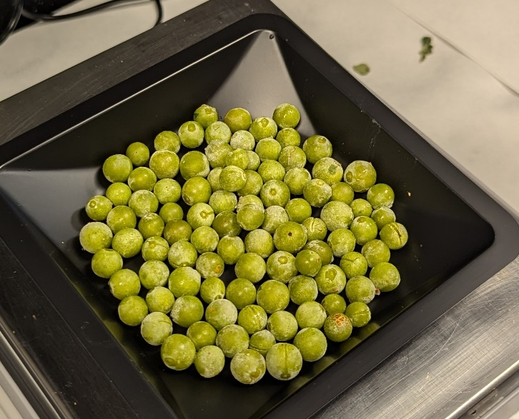
Pre-veraison Merlot grape berries.

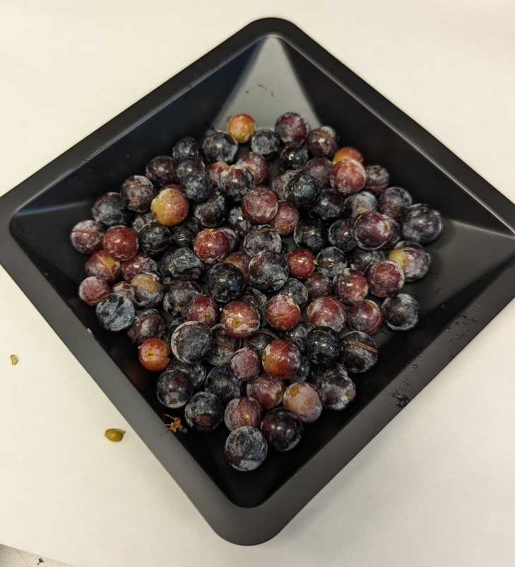
Post veraison Merlot grape berries.

