Supplemental Figure 1. Adults and children/adolescents included in the analysis of vaccine effectiveness and body mass index in the US Flu VE Network, 2011-12 through 2017-18

Abbreviations: BMI, body mass index
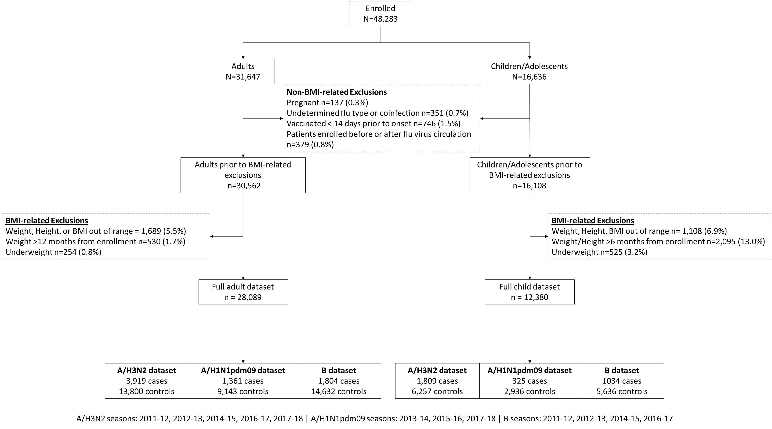

Supplemental Table 1. Sensitivity analysis models evaluating the effect of BMI on influenza vaccine effectiveness among adults in the US Flu VE Network, 2011-12 through 2017-18
 | Normal BMI  aVE (95% CI) |  | Overweight BMI  aVE (95% CI) |  |  | Obesity BMI  aVE (95% CI) |  | Number of enrollments |  |  | Interaction term p value
Excluding 2014-15 season
A/H3N2 | 20 (4, 33) |  | 38 (28, 47) |  |  | 25 (15, 34) |  | n=12 866 |  |  | 0.06
Only >65 years of age*
A/H3N2 | 10 (-40, 41) |  | 14 (-20, 38) |  |  | 20 (-4, 39) |  | n=3 736 |  |  | 0.87
A/H1N1pdm09 | 32 (-64, 72) |  | 64 (32, 81) |  |  | 45 (8, 68) |  | n=1 996 |  |  | 0.43
B | 28 (-25, 58) |  | 56 (33, 71) |  |  | 38 (7, 58) |  | n=3 326 |  |  | 0.3
4 Level BMI Variable |  | Normal BMI aVE (95% CI) |  | Overweight BMI  aVE (95% CI) | Obesity BMI  aVE (95% CI) |  | Class 3 Obesity BMI  aVE (95% CI) |  | Number of enrollments | Interaction term p value
A/H3N2 |  | 16 (3, 28) |  | 31 (21, 39) | 17 (6, 26) |  | 32 (16, 45) |  | N=17 719 | 0.09
A/H1N1 |  | 46 (30, 58) |  | 54 (42, 63) | 57 (47, 65) |  | 38 (11, 57) |  | N=10 504 | 0.24
B |  | 44 (31, 55) |  | 57 (48, 64) | 50 (41, 58) |  | 48 (29, 62) |  | M=16 436 | 0.33
Models adjusted for Season, Site, and age spline
*Adjusted for continuous age vs. spline

Supplemental Table 2. Sensitivity analysis models evaluating the effect of BMI on influenza vaccine effectiveness among children in the US Flu VE Network, 2011-12 through 2017-18
Excluding 2014-15 season | Normal BMI  aVE (95% CI) | Overweight BMI  aVE (95% CI) | Obesity BMI  aVE (95% CI) | Number of enrollments | Interaction term p value
A/H3N2 | 44 (34, 52) | 37 (13, 55) | 38 (16, 55) | n=5 579 | 0.75
Model adjusted for Season, Site, and age (categories 2 to <9 years, 9-17 years)

