Instructions: In the original gel/ spot figures, some figures do not match the numbers in the manuscript. The main reason is that the SH3RF1 has three transcripts, the molecular weight of the transcribed protein is different, but the two transcripts encoding the protein are transcribed 891aa and 836aa, which is consistent with the gel/spot figure position. At the same time, we reviewed the antibody manual and some related literature again, and the observed molecular weight of SH3RF1 was 93-100 kda, which was the same as our results.

Supplementary Fig,1 Hippocampus
The first repetition
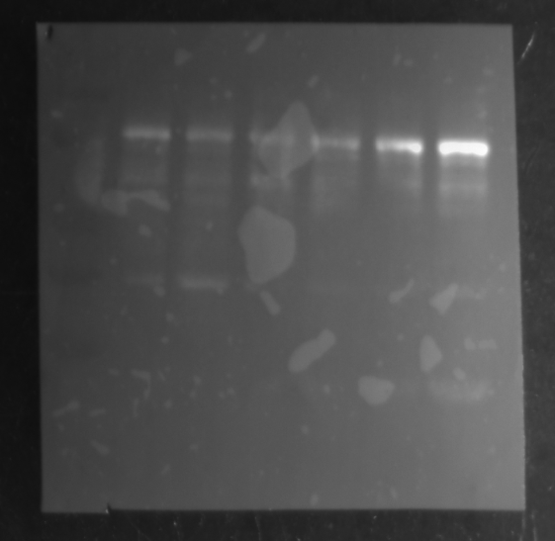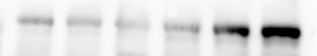
SH3RF1
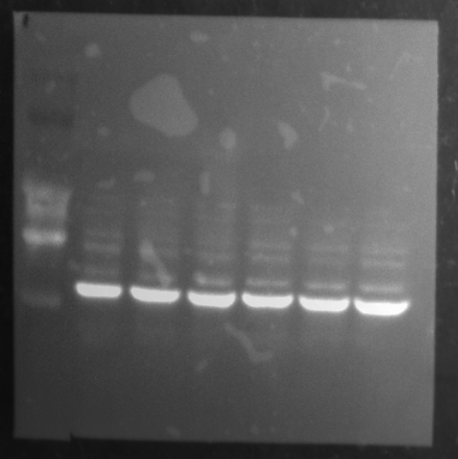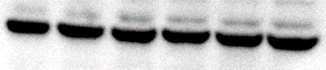
β-ACTIN

The second repetiton
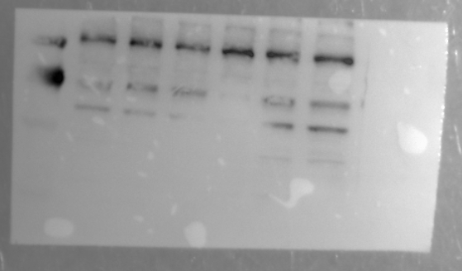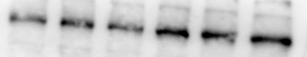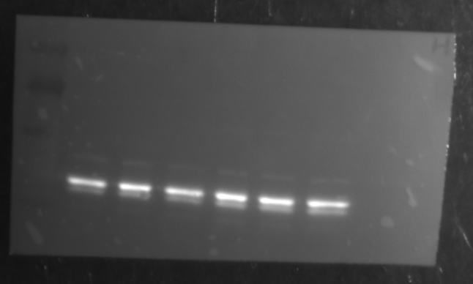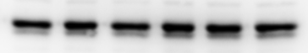
β-ACTIN

SH3RF1

The third repetition

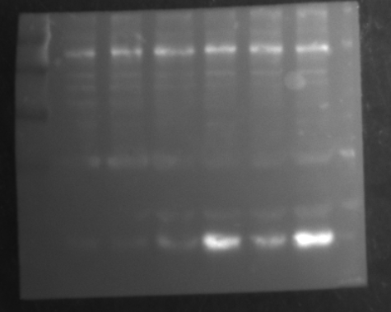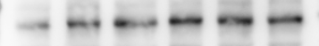
SH3RF1
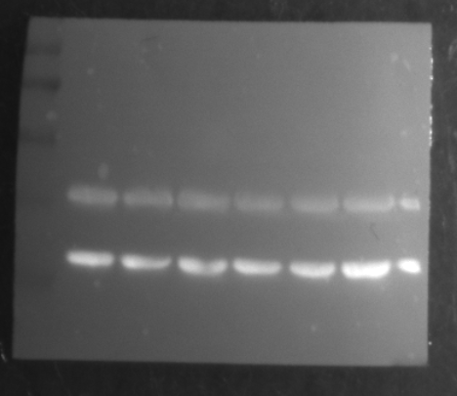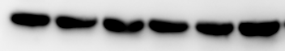
β-ACTIN

Supplementary Fig,2 Cerebral cortex
The first repetition
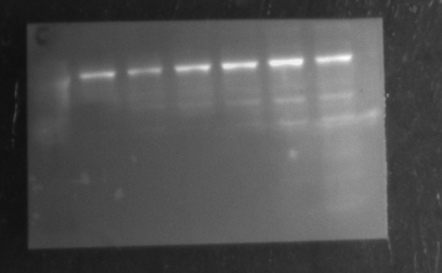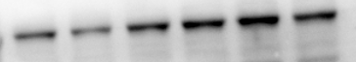
SH3RF1
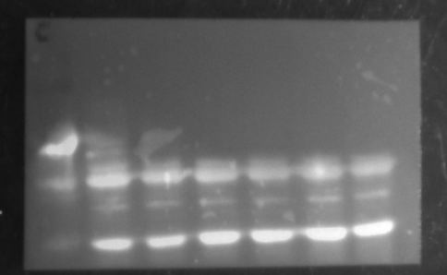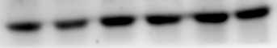
β-ACTIN

The second repetition
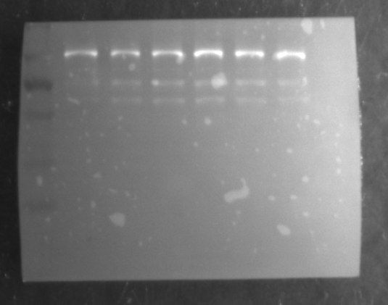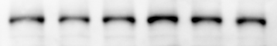
SH3RF1
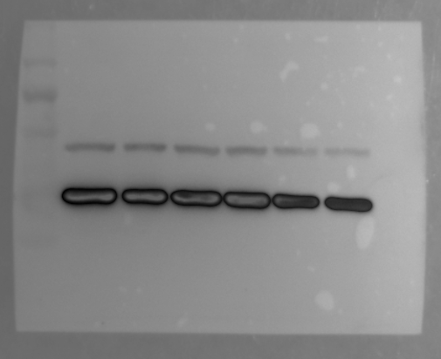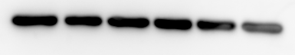
β-ACTIN

The third repetition
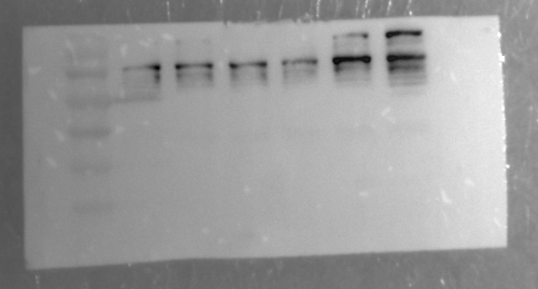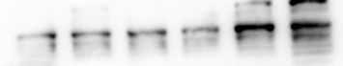
SH3RF1

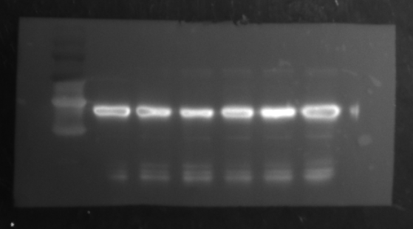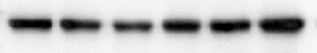
β-ACTIN

Supplementary Fig,3 kidney
The first repetition
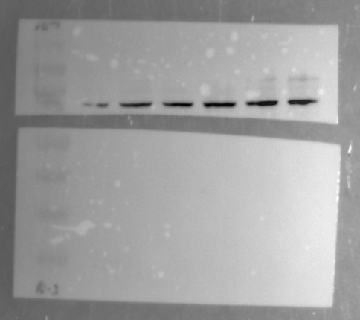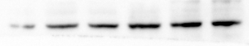
SH3RF1

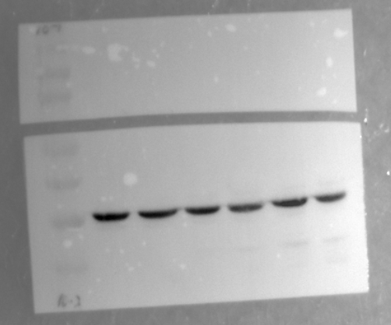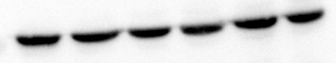
β-ACTIN

The second repetition
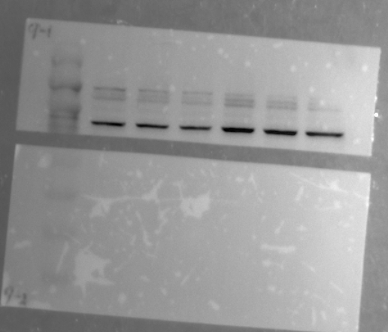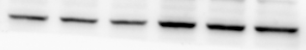
SH3RF1

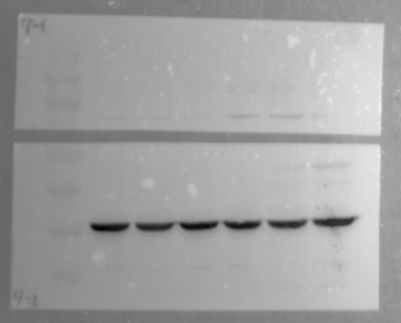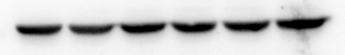
β-ACTIN

The third repetition
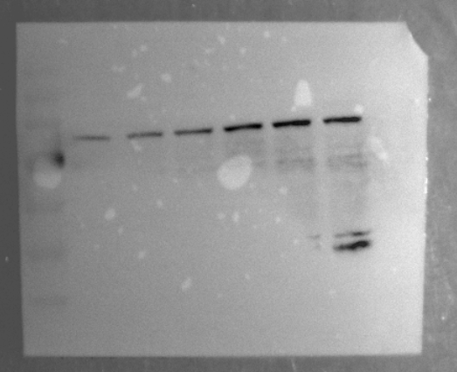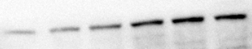
SH3RF1

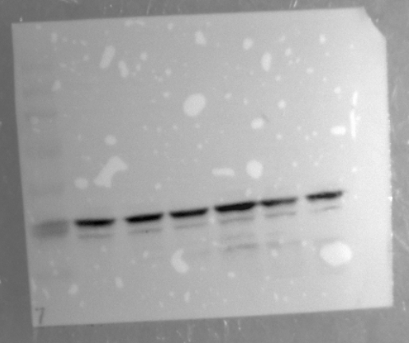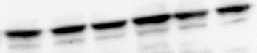
β-ACTIN

