Supplement 2:
Simulation results of epidemic simulation function in different months (The risk index increases from white to black).
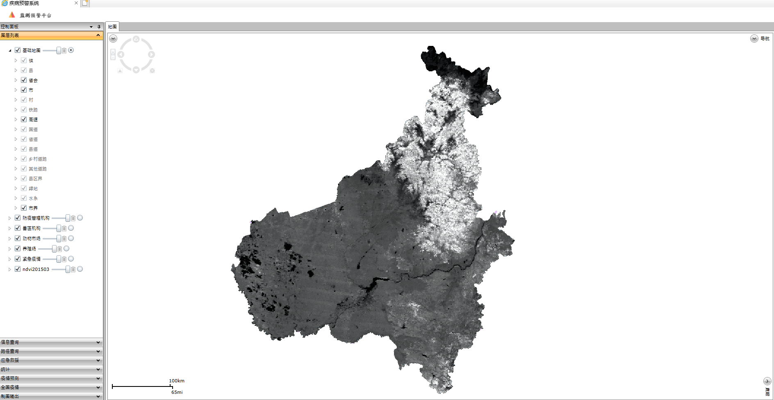
Fig. 1. Simulation results of epidemic simulation function in January.
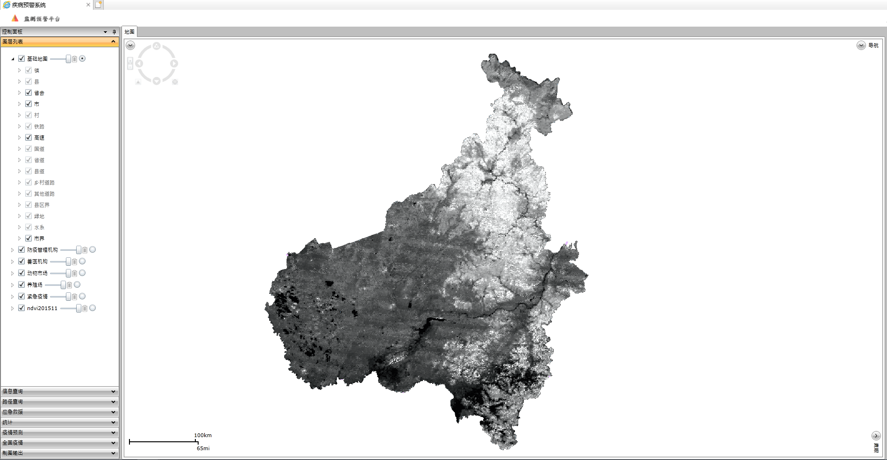
Fig. 2. Simulation results of epidemic simulation function in April.
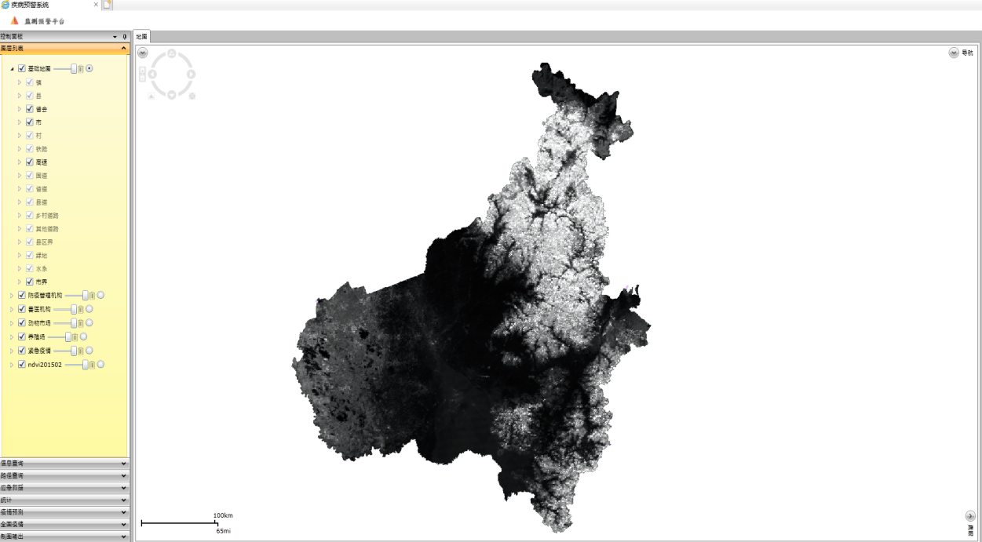
Fig. 3. Simulation results of epidemic simulation function in June.
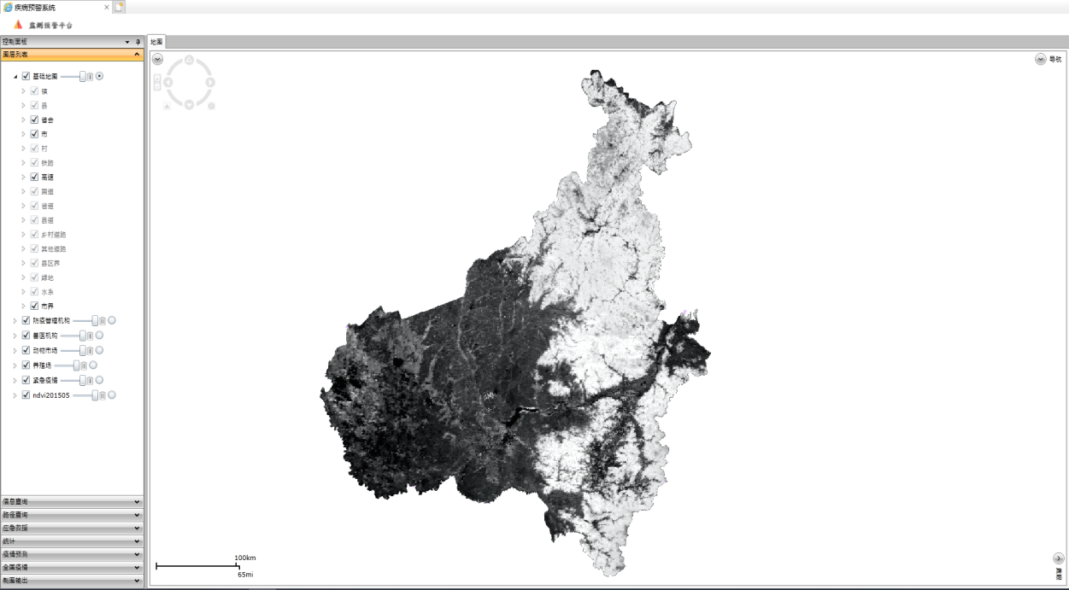
Fig. 4. Simulation results of epidemic simulation function in October.

