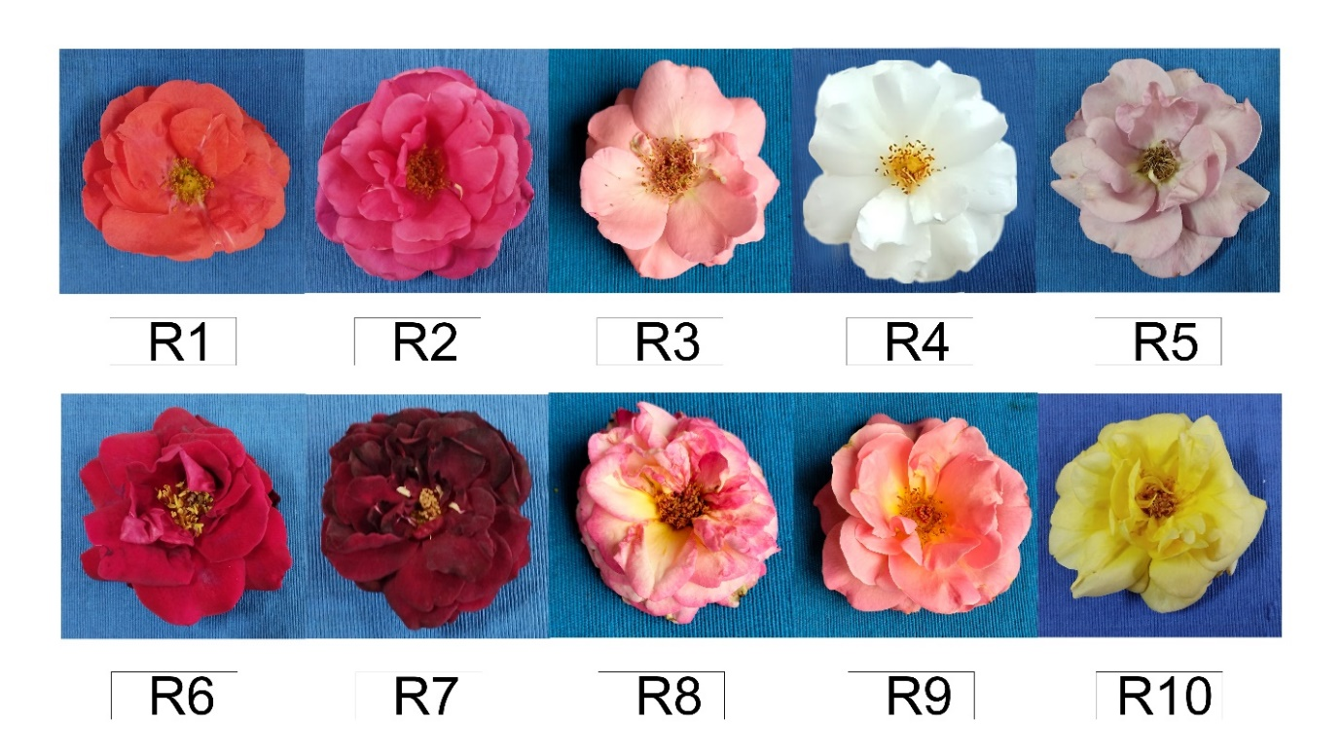

Supplementary Figure 1. Ten rose genotypes flowers’ used for analysis of color parameters and secondary metabolites.

