Supplementary Materials

ROS exhaustion reverses the effects of hyperbaric oxygen on hemorrhagic transformation through reactivating microglia in post-stroke hyperglycemic mice

Table of Contents
Supplementary Figures 2
Supplementary Figure S1. Early HBO treatment attenuated infarction and improved neurological behavior in the hyperglycemic tMCAO mice 2
Supplementary Figure S2. HBO treatment inhibited the expression of multiple pro-inflammatory factors in the LPS/Nigericin stimulated primary microglia 3
Supplementary Figure S3. HBO treatment increased cellular ROS levels in microglia 4
Supplementary Figure S4. Diagram of the experiment flowchart 5
Full western blot images 6
Figure 1d 6
Figure 5a 8
Antibody validation 10

Supplementary Figures

Supplementary Figure S1. Early HBO treatment attenuated infarction and improved neurological behavior in the hyperglycemic tMCAO mice
(a) Representative images of 2,3,5-triphenyl tetrazolium chloride (TTC) staining of the coronal brain sections at 24 h post-reperfusion to show the infarct area (white area) (n= 4-8). (b) The infarct area ratio in each group as indicated. (c-e) Bederson (c) general (d) and focal (e) neurological deficits scores with indicated treatment (n = 4-7). The results are represented as mean ± s.d., *P < 0.05, **P < 0.01. Statistical analyses were conducted by one-way ANOVA followed by Tukey’s multiple comparisons test.

Supplementary Figure S2. HBO treatment inhibited the expression of multiple pro-inflammatory factors in the LPS/Nigericin stimulated primary microglia
(a-c) Relative Tnfa (a), Il6 (b) and Nos2 (c) mRNA levels in the L/N stimulated primary microglia (n = 5-7). The oxygen treatments were applied under indicated pressures.

Supplementary Figure S3. HBO treatment increased cellular ROS levels in microglia
(a) The representative image of cellular ROS level in microglia labeled by ROS probe CellROX. The pressures of oxygen treatment are indicated in the figure, while H₂O₂ (2 μM) was used as a positive control. (b) Quantification of the CellROX fluorescent intensity (n = 6). The results are represented as mean ± s.d., *P < 0.05, **P < 0.01. Statistical analyses were conducted by one-way ANOVA followed by Tukey’s multiple comparisons test.

Supplementary Figure S4. Diagram of the experiment flowchart
(a) The flowchart of the animal experiments. Red represents ischemia duration, and blue represents HBO (2.5 ATA) treatment time. The arrows represent the indicated operation time points. (b) The flowchart of the cell experiments. Red represents LPS treatment time, green represents nigericin (Nig) stimulation time, blue represents HBO treatment time, and yellow represents edaravone/NAC treatment time. The arrow represents the sample collection time point. Abbreviations: HBO, hyperbaric oxygen; Con, control; LPS, Lipopolysaccharide; Nig, nigericin; Eda, edaravone; NAC, N-Acetyl-L-Cysteine.

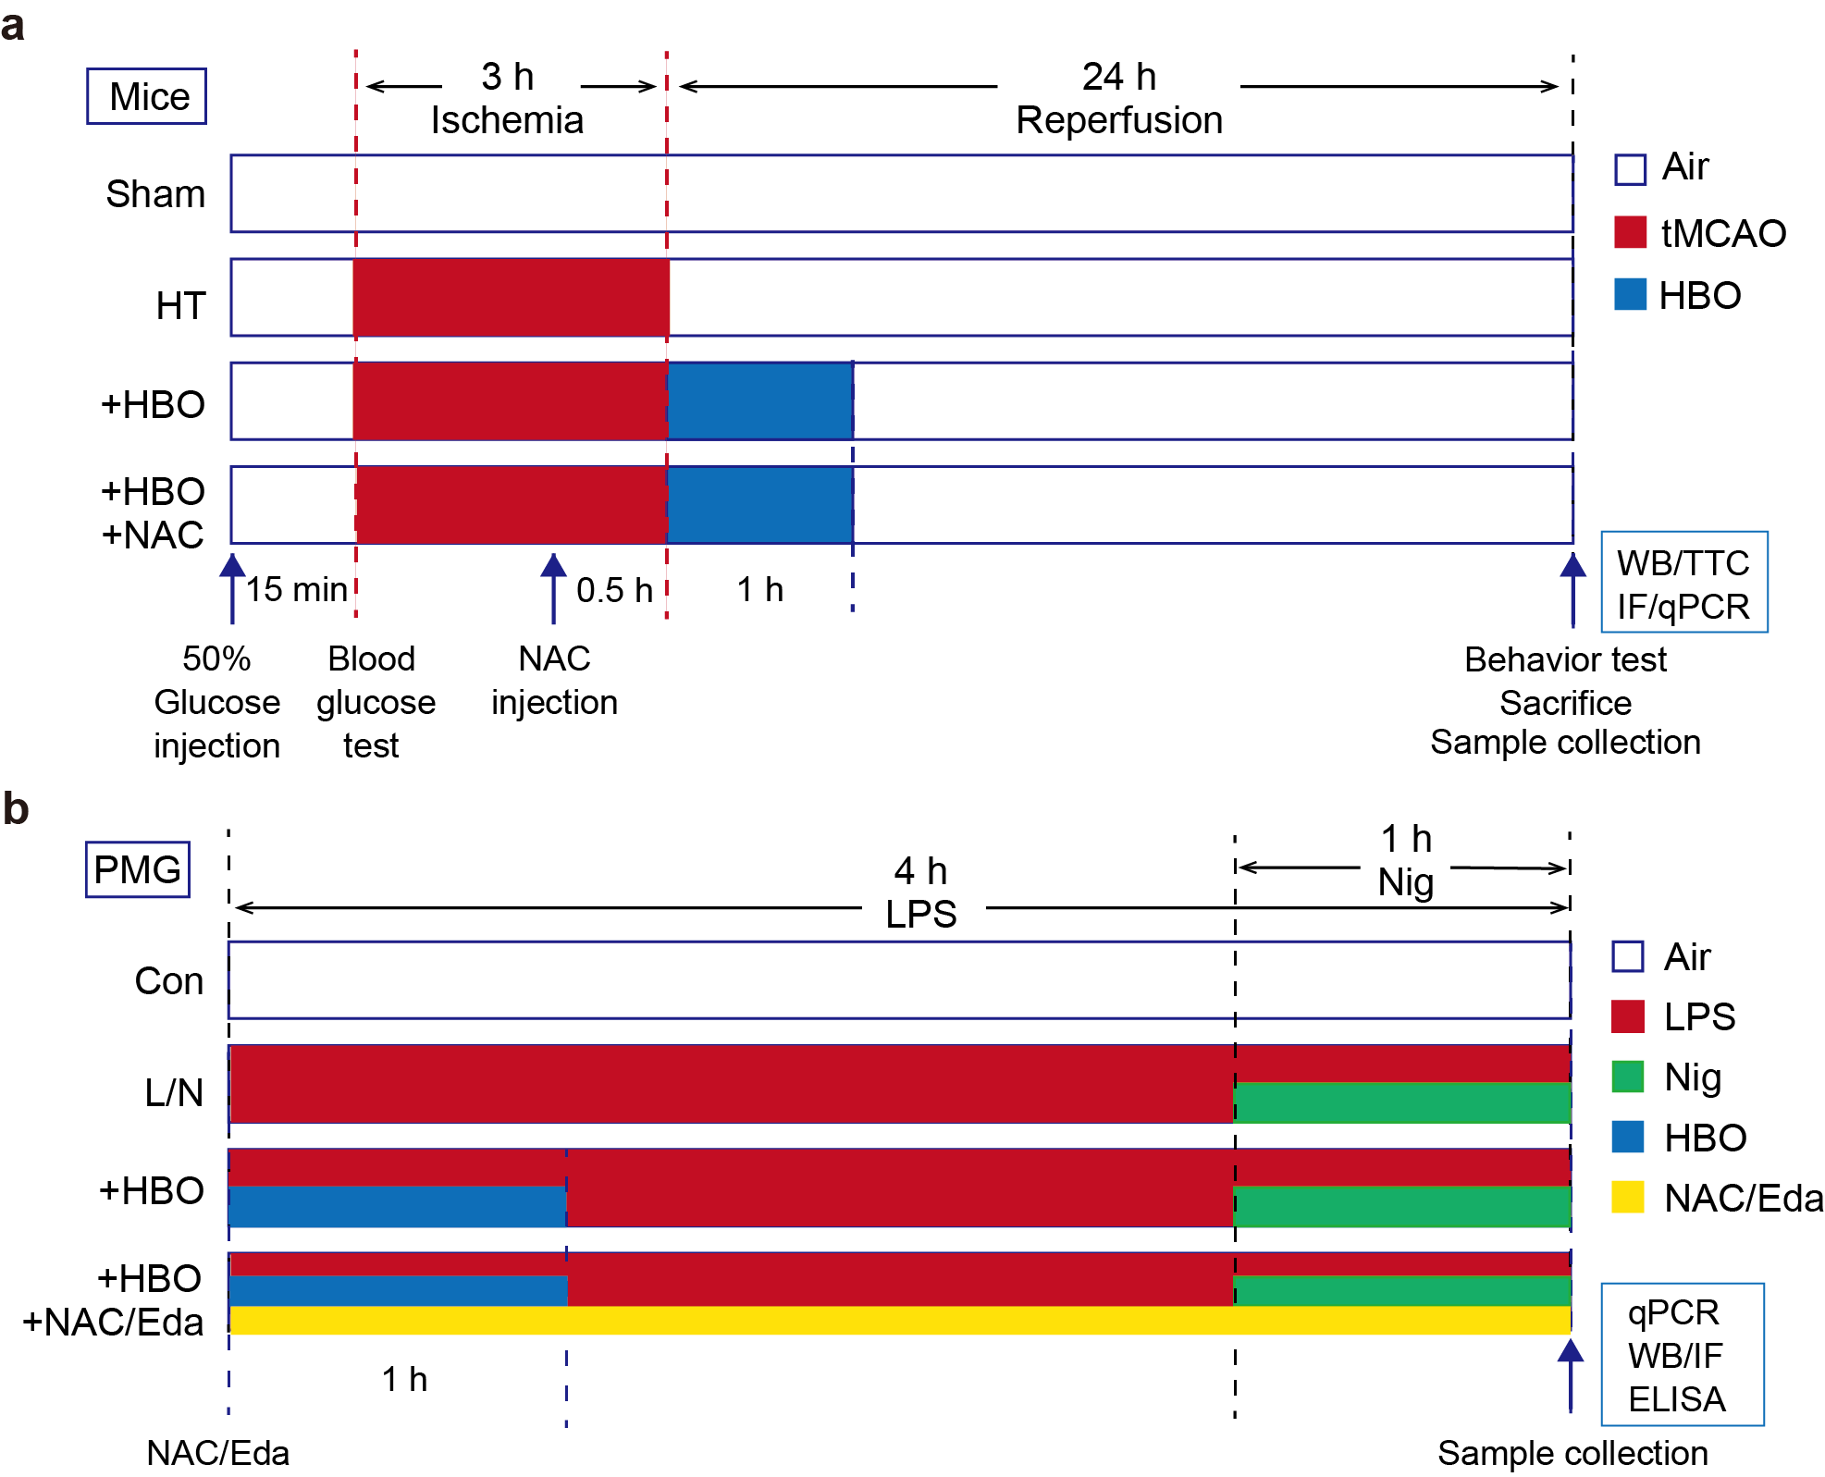

Full western blot images

Figure 1d

ZO-1 batch 1

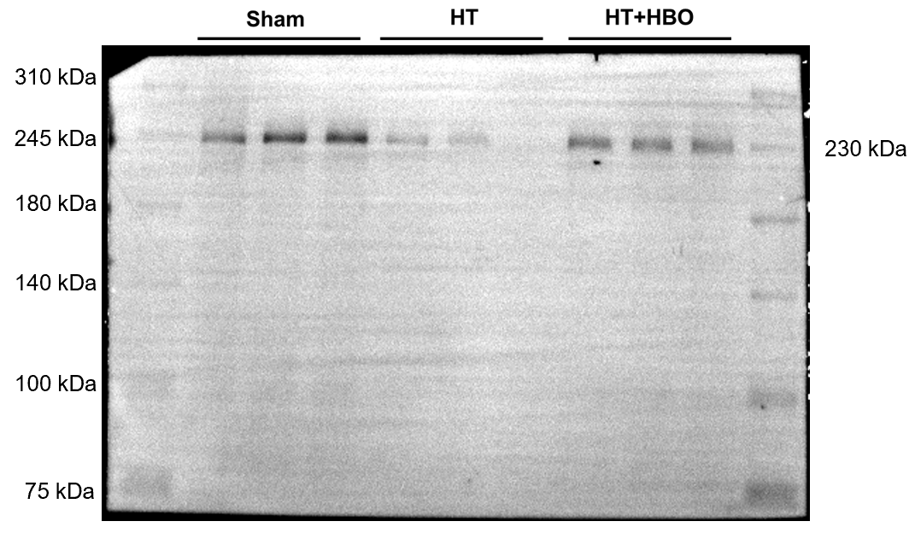

β-actin batch 1

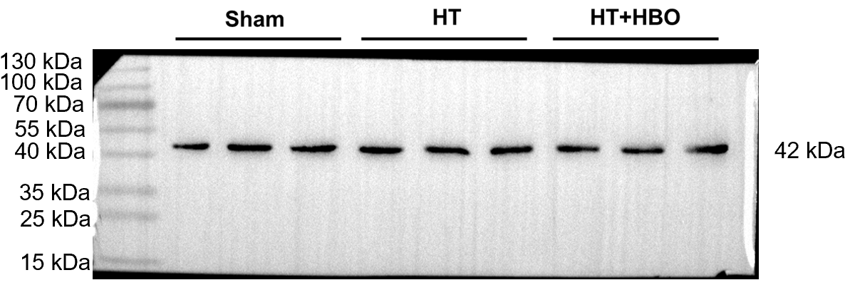

ZO-1 batch 2

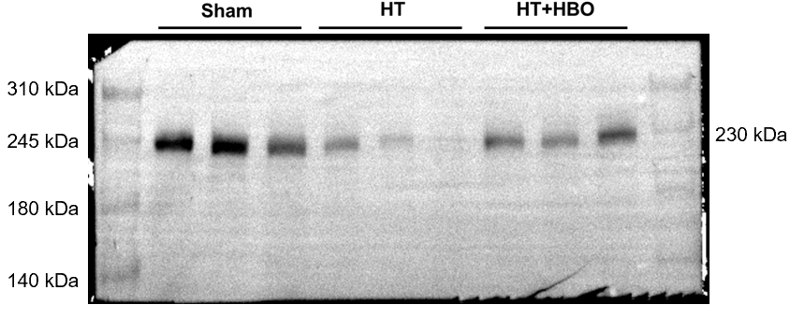

β-actin batch 2

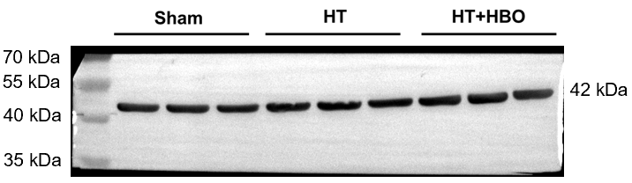

Figure 5a

NLRP3 batch 1

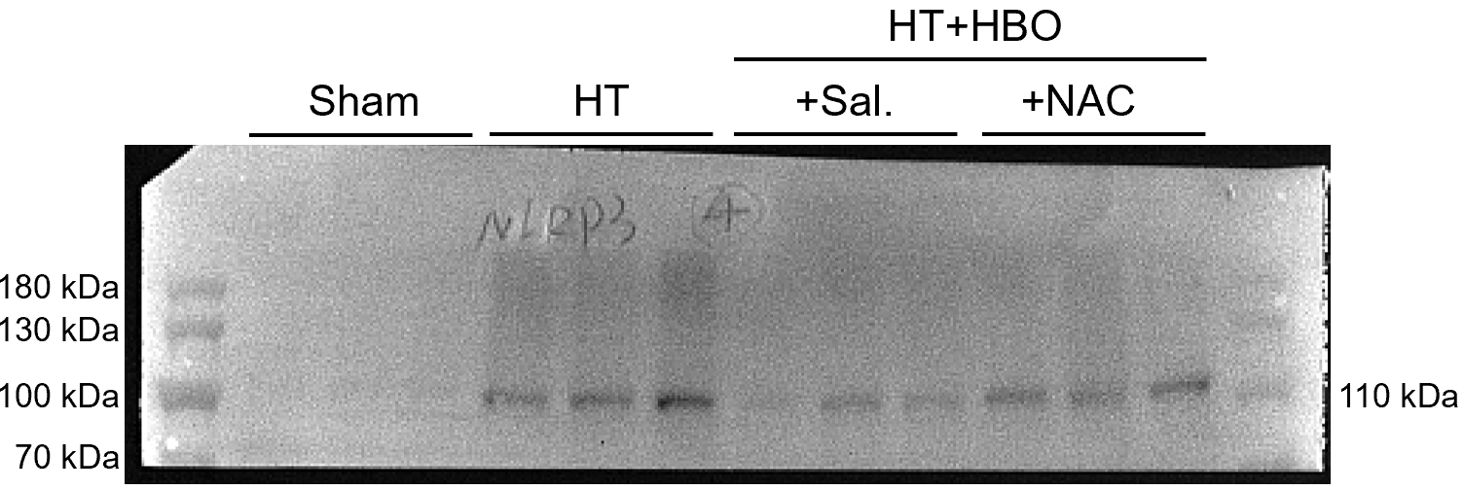

ASC batch 1

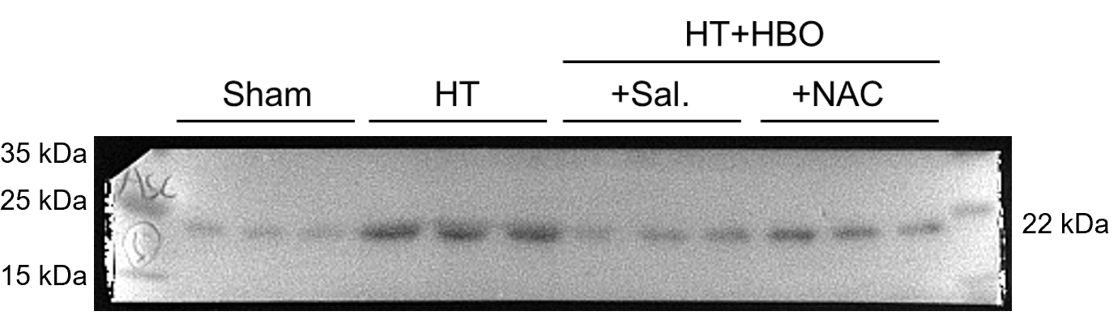

cl-IL-1β batch 1

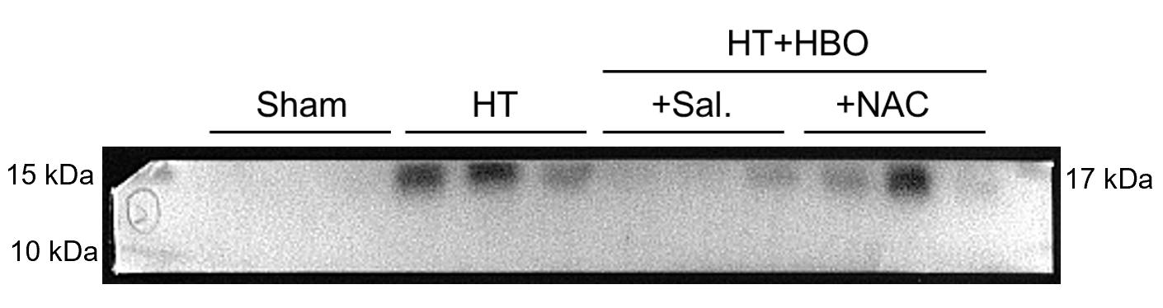

β-actin batch 1

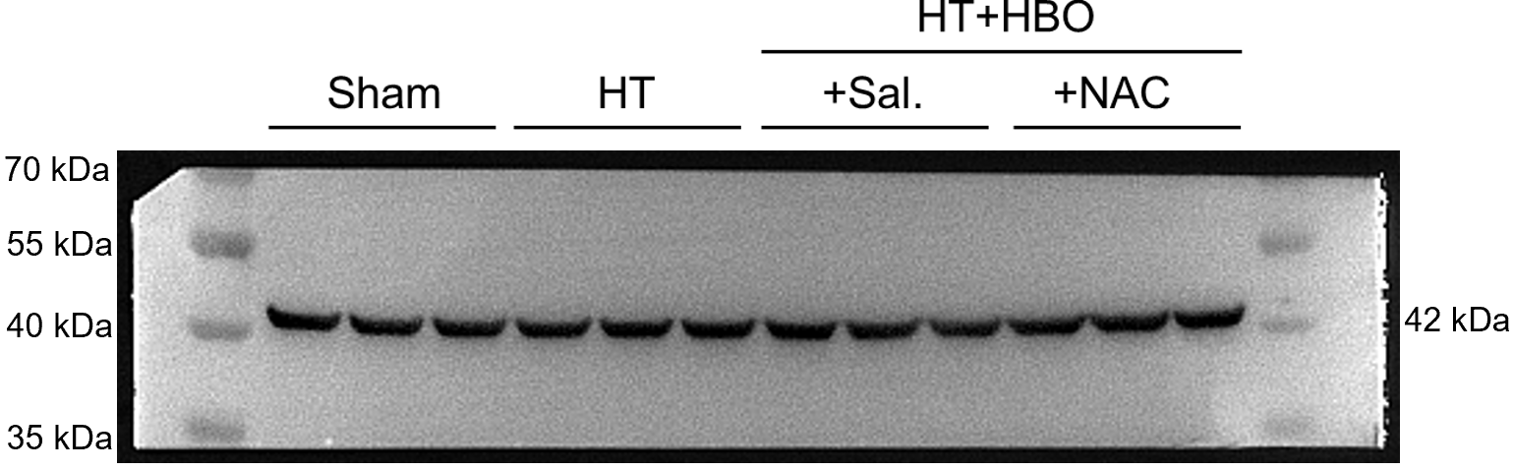

NLRP3 batch 2

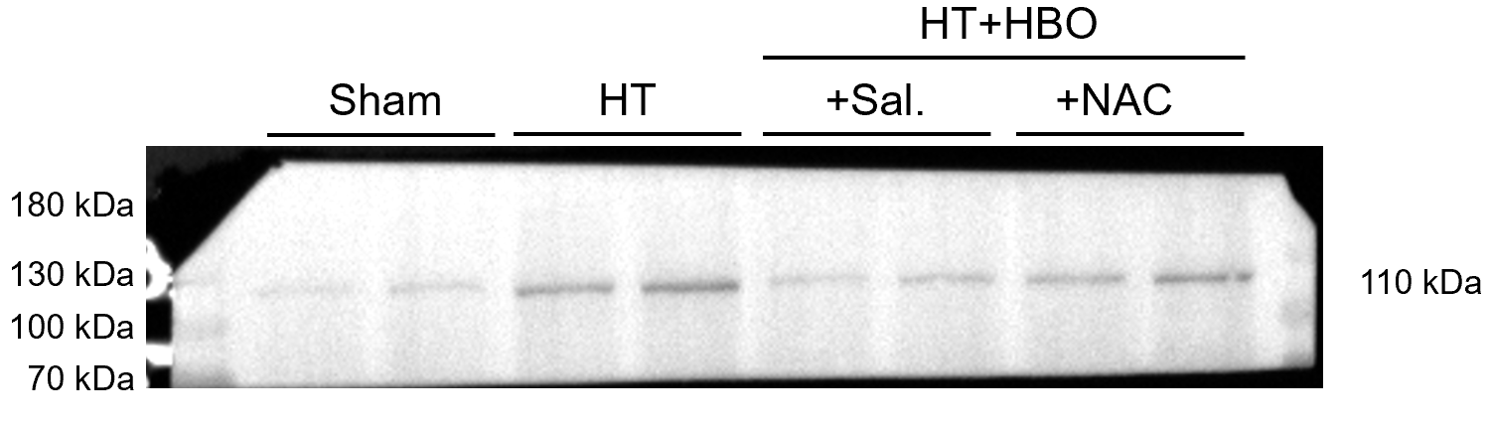

ASC batch 2

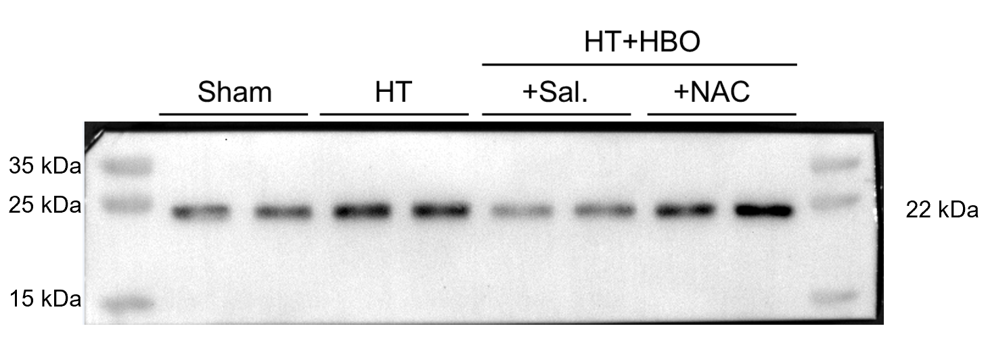

cl-IL-1β batch 2

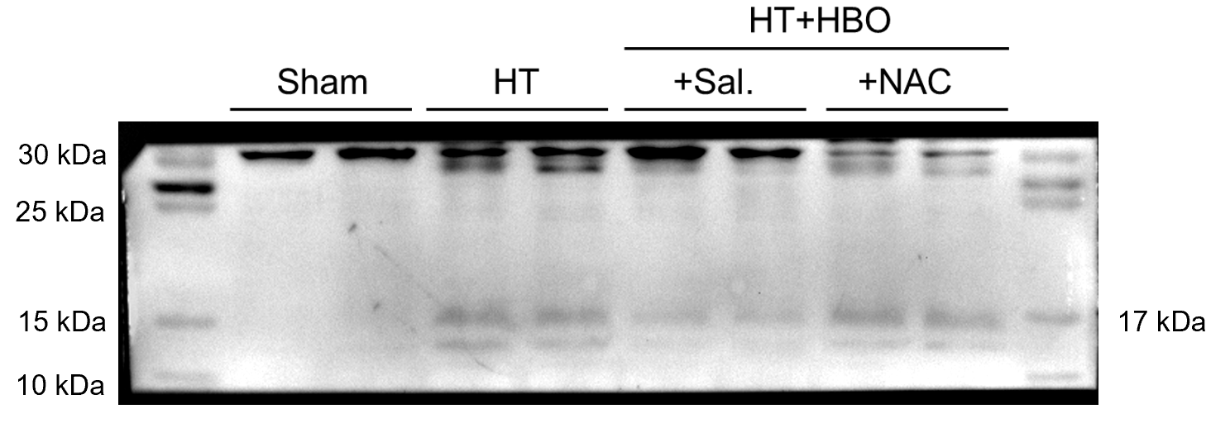

β-actin batch 2

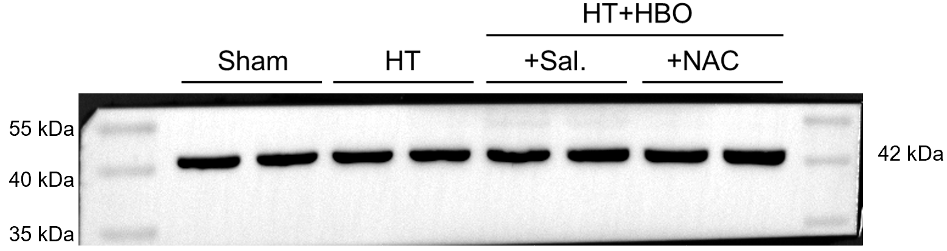

Antibody validation

ZO-1 NLRP3
Sample: mouse brain from sham group Sample: mouse brain from HT group

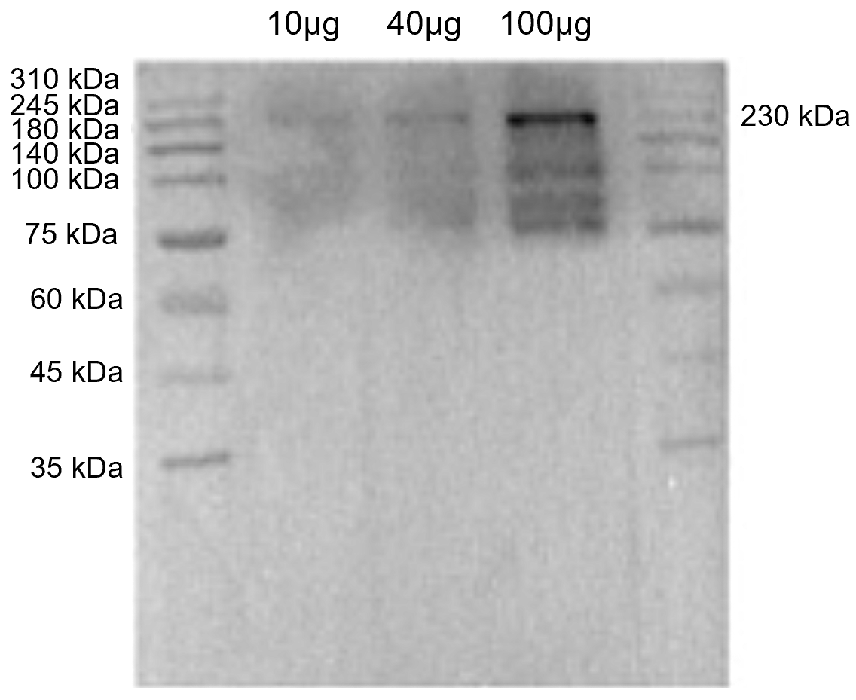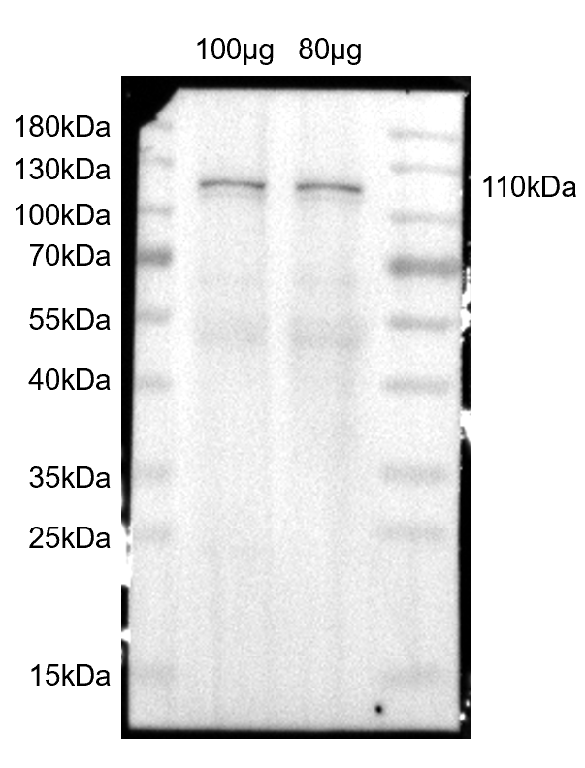

ASC cl-IL-1β
Sample: mouse brain from HT group Sample: mouse brain from HT group

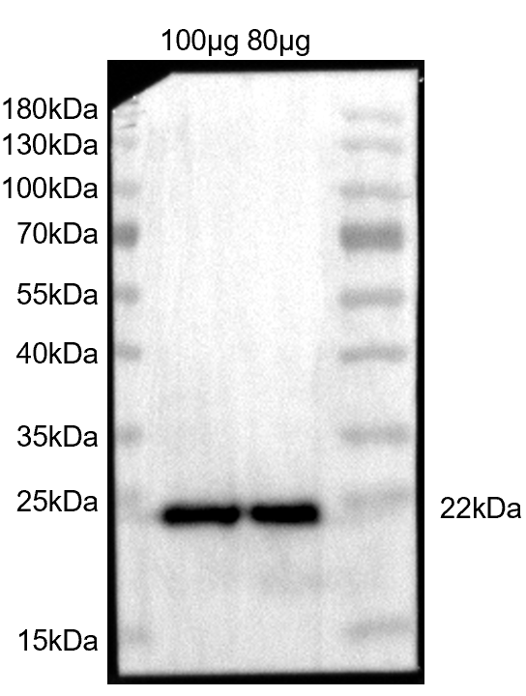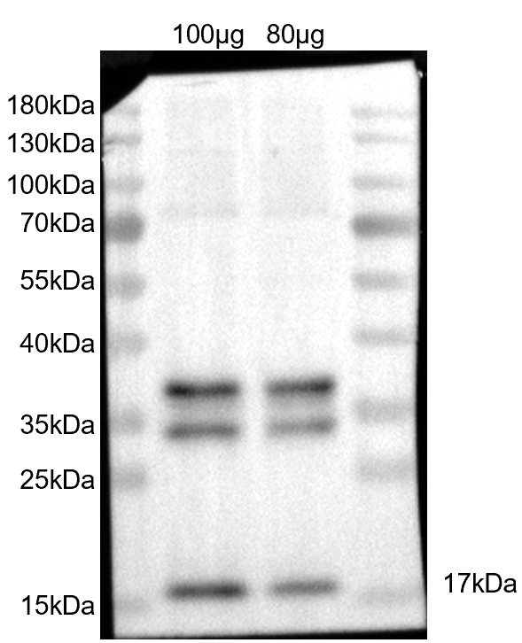

β-actin
Sample: mouse brain from sham group

