Supplementary sheet 1. Network interaction of predicted pathways of glioblastoma and target genes from the KEGG pathway
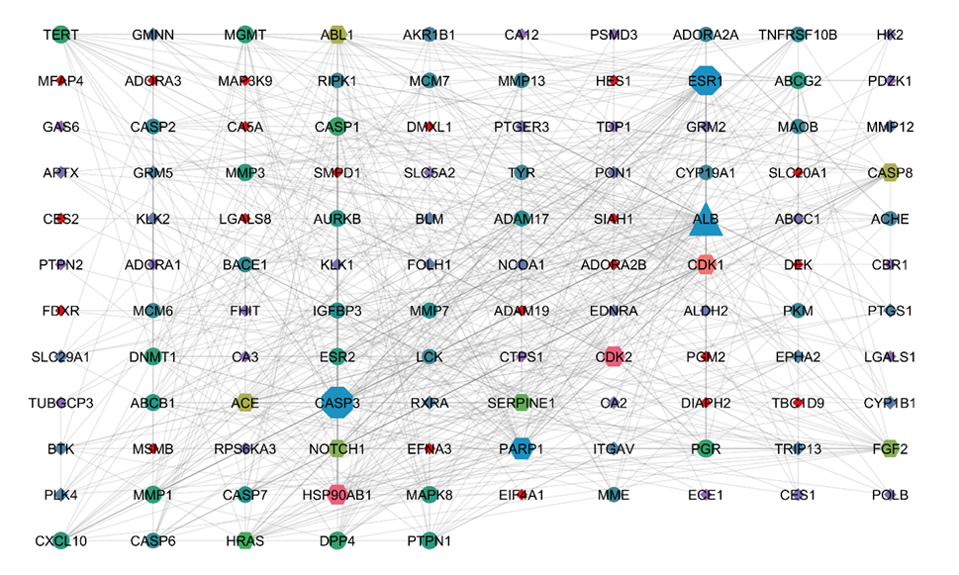
Figure S1. Network interaction of predicted pathways of glioblastoma and target genes from the KEGG pathway

