Supplementary sheet 2. KEGG identified a pathway of naringin against GBM
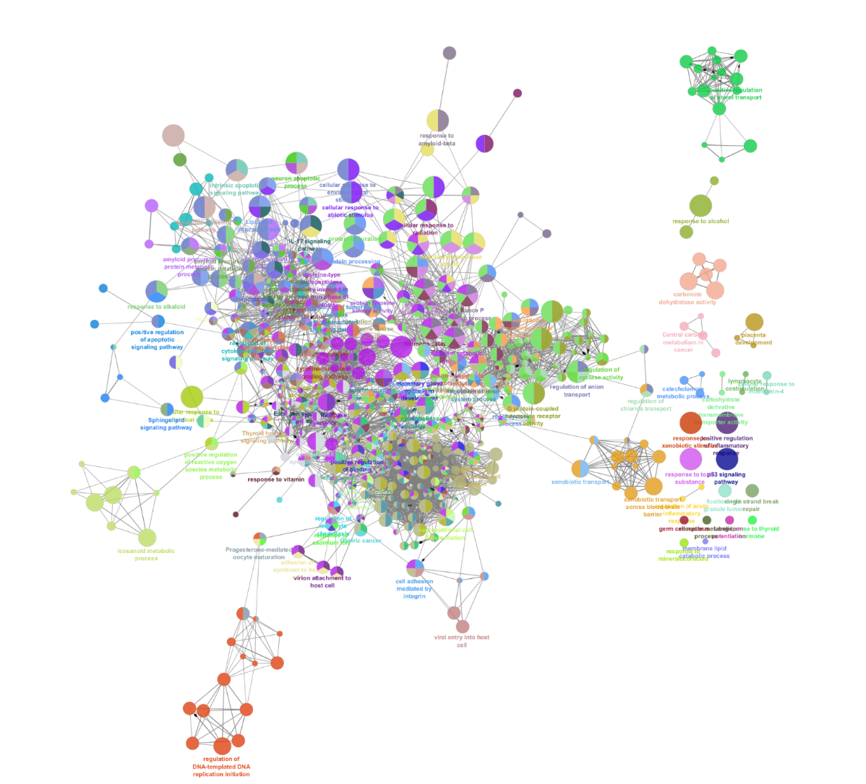
Figure S2. KEGG identified a pathway of naringin against GBM

