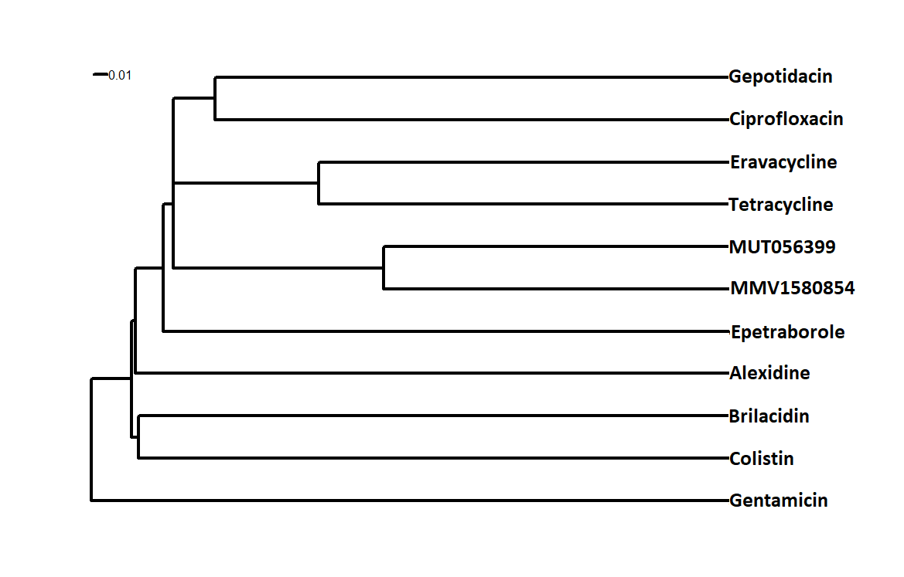
Figure S1. Hierarchical clustering analysis. The analysis was performed using ChemmineR software and highlights the structural similarities between the Pandemic response box compounds with anti- A. baumannii activity and commonly known antibacterial drugs (ciprofloxacin, tetracycline, colistin and gentamicin). Dissimilarity is reported using a scale unit of 0.01.

