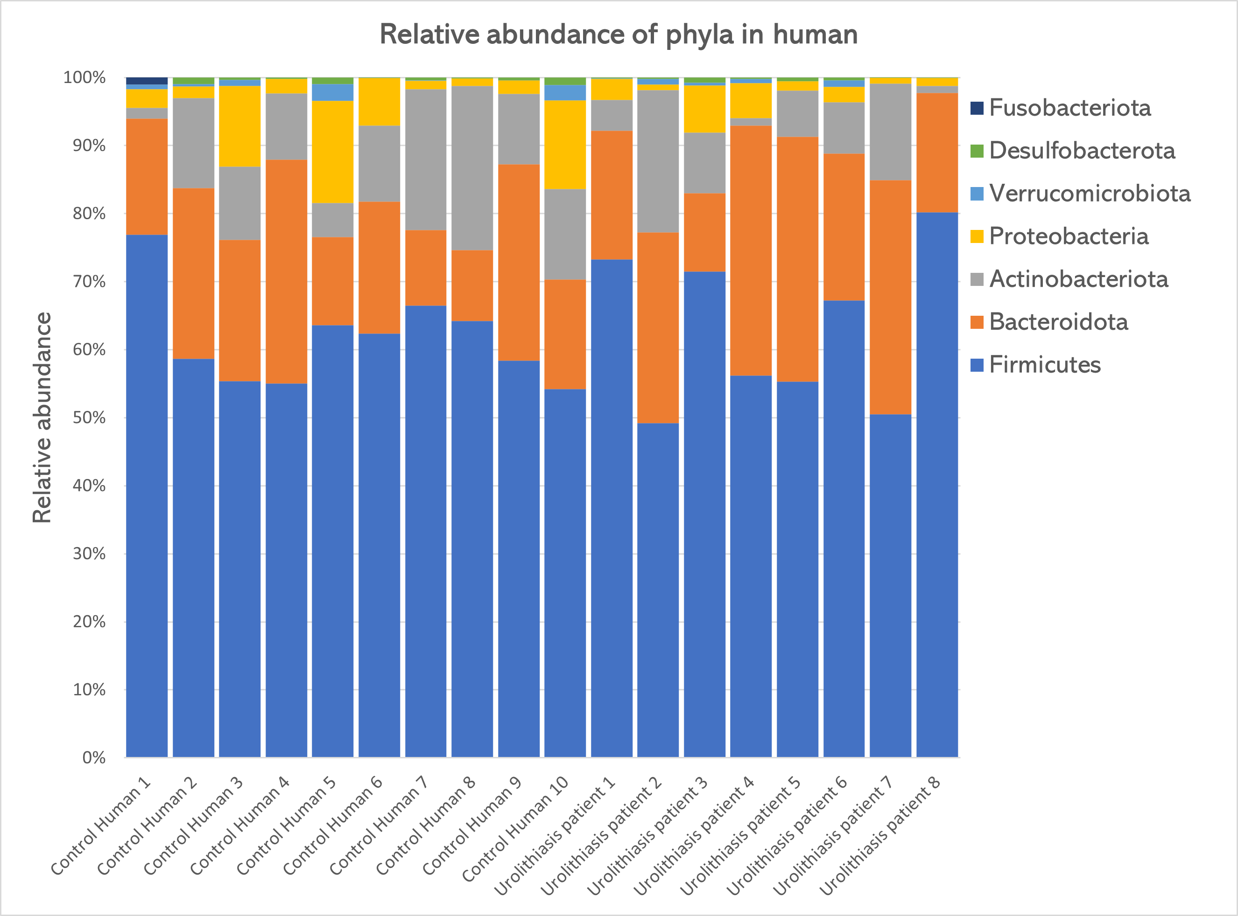
Figure S1. The relative abundance of gut microbiota among human participants (phylum levels)
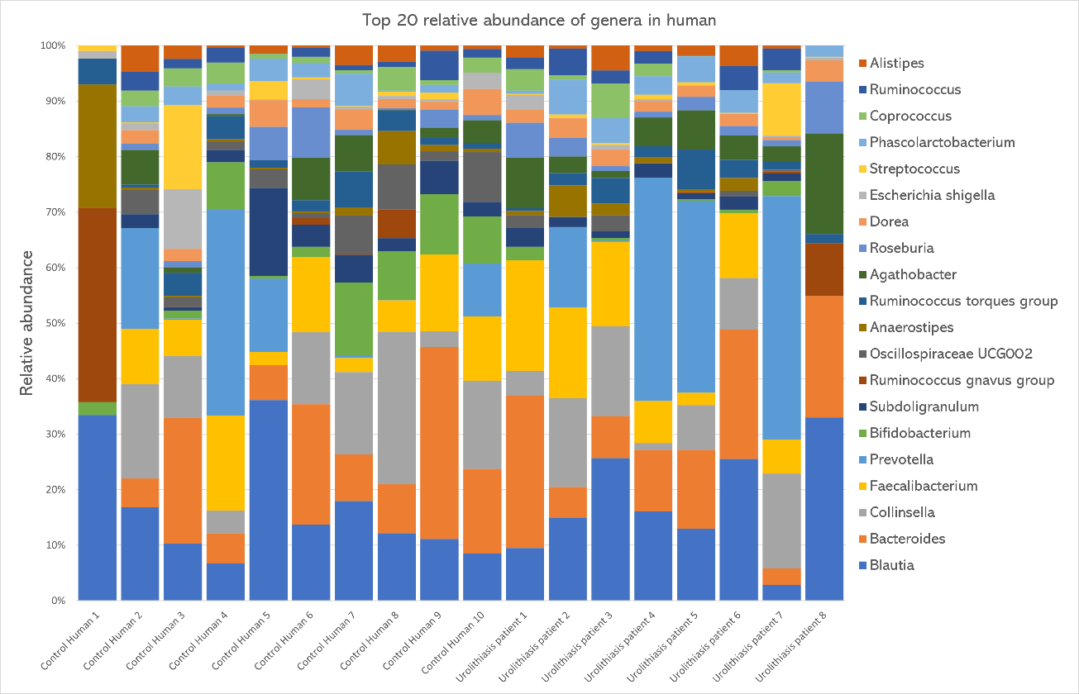
Figure S2. The relative abundance of gut microbiota among human participants (genus levels)

Table S1. Comparison of the relative abundance of gut microbiota between healthy volunteer and urolithiasis patients
Relative abundance | Control Human  (Median (IQR)) | Urolithiasis Human  (Median (IQR)) | P-value
Phyla
Firmicutes | 60.4000 (9.630) | 61.560 (20.890) | 1.000
Bacteroidota | 14.260 (11.855) | 24.770 (16.240)* | 0.021
Actinobacteriota | 10.900 (6.606) | 6.863 (10.838) | 0.155
Proteobacteria | 2.470 (10.444) | 1.766 (3.667) | 0.248
Verrucomicrobiota | 0.221 (1.245) | 0.263 (0.786) | 0.633
Desulfobacterota | 0.357 (0.848) | 0.168 (0.725) | 0.515
Euryarchaeota | 0 | 0 | 1.000
Fusobacteriota | 0.053 (0.234) | 0 | 0.360
Elusimicrobiota | 0 | 0 | 1.000
Synergistota | 0 | 0 | 1.000
Cyanobacteria | 0 | 0 | 1.000
Patescibacteria | 0 | 0 | 1.000
Thermoplasmatota | 0 | 0 | 1.000
Genera
Blautia | 8.970 (7.506) | 9.595 (8.944) | 0.929
Bacteroides | 5.460 (12.041) | 8.261(12.859) | 1.000
Collinsella | 8.192 (8.753) | 5.544 (6.213) | 0.408
Faecalibacterium | 5.397 (8.201) | 5.759 (5.625) | 0.965
Prevotella | 0.258 (9.12) | 3.558 (25.857) | 0.633
Bifidobacterium | 2.848 (5.4909) | 0.184 (1.135)* | 0.027
Subdoligranulum | 1.687 (2.380) | 0.925 (1.130) | 0.173
Ruminococcus_gnavus_group | 0.026 (1.448) | 0.016 (0.231) | 0.897
Oscillospiraceae UCG002 | 1.608 (3.607) | 0.126 (1.069)* | 0.016
Anaerostipes | 0.321 (1.393) | 0.589 (1.167) | 0.965
Ruminococcus torques group | 1.850 (2.183) | 1.319 (1.080) | 0.696
Agathobacter | 1.019 (4.230) | 3.132 (3.552) | 0.122
Roseburia | 0.825 (2.289) | 1.314 (2.404) | 0.408
Dorea | 1.555 (1.364) | 1.329 (0.365) | 0.829
Escherichia-Shigella | 0.746 (1.414) | 0.200 (0.323)* | 0.043
Streptococcus | 0.389 (1.065) | 0.215 (0.357) | 0.965
Phascolarctobacterium | 1.450 (2.306) | 2.076 (1.484) | 0.274
Coprococcus | 1.088 (1.986) | 0.336 (2.039) | 0.237
Ruminococcus | 0.967 (1.555) | 1.393 (2.351) | 0.633
Alistipes | 0.741 (1.664) | 0.899 (1.440) | 1.000

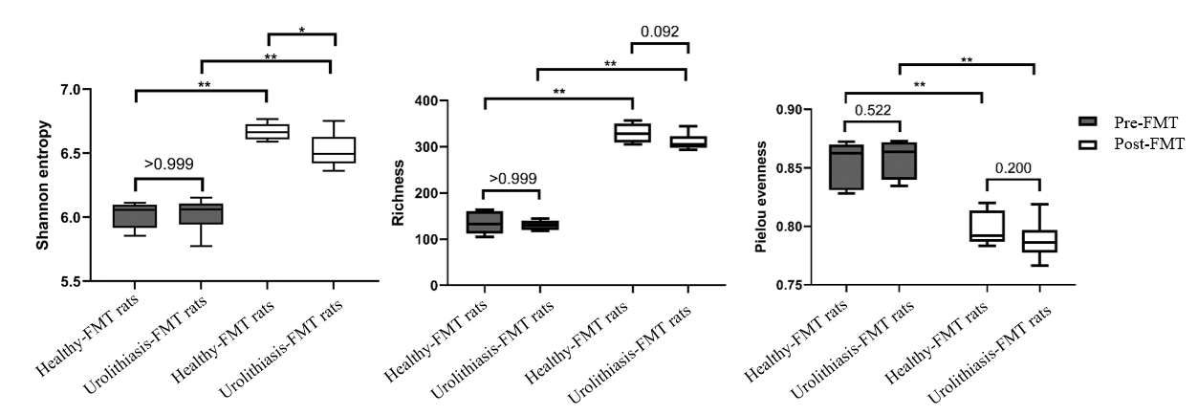
Figure S3. The comparisons of alpha-diversity of rats’ gut microbiota between healthy-FMT rats versus urolithiasis-FMT rats, at pre-FMT (post antibiotic knock out) and post-FMT period. * p < 0.05, ** P < 0.001

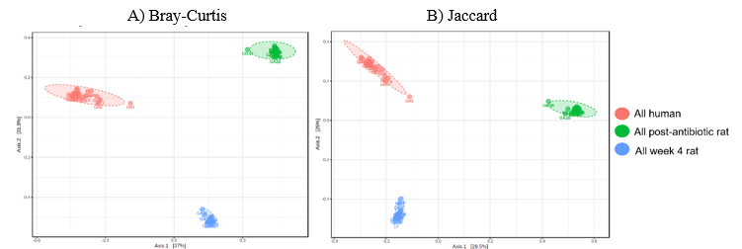
Figure S4. The comparisons of beta-diversity of fecal microbiota between human, post-antibiotic knock out (pre-FMT) rats, and post-FMT (week-4 rats). A) Bray-Curtis dissimilarity showed significant differences in beta-diversity (F-value: 42.001, R-squared: 0.683, p < 0.0) B) Jaccard index showed significant differences in beta-diversity (F-value: 5.479, R-squared: 0.302, p < 0.01)

