Supplementary file

Pharmacokinetics of pulmonary indacaterol in rat lung using molecular imprinting solid-phase extraction coupled with RP-UPLC
Mohamed Tarek^{1, 2}, Nermine S. Ghoniem^{3*}, Maha A. Hegazy⁴, Hebatallah A. Wagdy^{1, 2**}
¹Pharmaceutical Chemistry Department, Faculty of Pharmacy, The British University in Egypt (BUE), Cairo, Egypt.
²Health Research Center of Excellence; Drug Research and Development Group, Faculty of Pharmacy, The British University in Egypt, Cairo, Egypt.
³Analytical Chemistry Department, Faculty of Pharmacy, Cairo University, Kasr-El Aini Street, 11562 Cairo, Egypt.
⁴Pharmaceutical Chemistry Department, Faculty of Pharmacy, Future University in Egypt, Cairo 11835, Egypt.
* Corresponding Author
Nermine S. Ghoniem
Department of Analytical Chemistry, Faculty of Pharmacy, Cairo University.
E-mail address: nermine.ghoniem@pharma.cu.edu.eg
** Corresponding Author
Hebatallah A. Wagdy
Department of Pharmaceutical Chemistry, Faculty of Pharmacy, The British University in Egypt.
E-mail address: Hebatallah.wagdy@bue.edu.eg

List of tables
Table S1: Intra-day and inter-day accuracy and precision of the LLOQ and QCs of indacaterol
Table S2: Stability of the lung samples spiked with indacaterol standard under different conditions.
Table S3: Extraction recovery of indacaterol from lung samples.
Table S4: Effect of solvent on the rebinding of indacaterol to the polymer.
Table S5: Binding kinetics of indacaterol polymer.
Table S6: K_{D} and Q_{max}, for lower and higher affinity binding sites of the MIP at equilibrium conditions.
Table S7: Adsorption isotherms parameters for MIP.
Table S8: Binding selectivity of the prepared polymer.

List of figures
Fig. S1.: Calibration curve of indacaterol in lung tissue sample in the concentrations ranging from 0.10 to 100.0 µg mL⁻¹ using salbutamol as IS.
Fig. S2: Binding kinetics of indacaterol polymer.
Fig. S3: (a) Scatchard plot and (b) Freundlich and (c) Langmuir adsorption isotherms models for molecular imprinting polymer.
Fig. S4: Fourier transform infrared spectra of (a) extracted molecular imprinting polymer, (b) non-imprinted polymer, (c) indacaterol and (d) non-extracted molecular imprinting polymer.
Fig. S5: Effect of polymer weight on the loading % of indacaterol.
Fig. S6: Effect of different concentrations of indacaterol on the % loaded to molecular imprinting solid-phase extraction cartridge.
Fig. S7: Effect of type of loading solvent on the % loaded of indacaterol to molecular imprinting solid-phase extraction cartridge.
Fig. S8: Effect of type of washing solvent on the % washed of indacaterol from molecular imprinting solid-phase extraction cartridge.
Fig. S9: Effect of type of eluting solvent on the % eluted of indacaterol from molecular imprinting solid-phase extraction cartridge.
Fig. S10: Recovery of (a) indacaterol, glycopyrronium and mometasone mixture of concentration 40.0 µg mL⁻¹ from molecular imprinting polymer and non-imprinting polymer after loading, (b) washing with 1.0 mL acetonitrile: water (20 :80; by volume) and (c) elution with 1.0 mL methanol: acetic acid (90: 10; by volume) using 20.0 mg of indacaterol polymer.
Fig. S11: Recovery of (a) indacaterol and salbutamol mixture of concentration 40.0 µg mL⁻¹ from molecular imprinting polymer and non-imprinting polymer after loading, (b) washing with 1.0 mL acetonitrile: water (20 :80; by volume) and (c) elution with 1.0 mL methanol: acetic acid (90: 10; by volume) using 20.0 mg of indacaterol polymer.

Table S1: Intra-day and inter-day accuracy and precision of the LLOQ and QCs of indacaterol
 | Concentration  (µg mL⁻¹) | Intra-day accuracy  % R* | Inter-day accuracy  % R* | Intra-day precision  % RSD* | Inter-day precision  % RSD*
LLOQ | 0.10 | 112.00 | 113.05 | 4.34 | 5.02
QCL | 0.30 | 106.00 | 107.12 | 2.14 | 3.53
QCM | 35.00 | 104.58 | 105.32 | 2.04 | 3.21
QCH | 70.00 | 101.36 | 102.17 | 1.95 | 2.19
*Average of 6 determinations

Table S2: Stability of the lung samples spiked with indacaterol standard under different conditions
Item | % deviation from fresh sample
Short-term stability
LLOQ | -11.30±3.50
QCL | -5.74±2.25
QCM | -4.14±2.61
QCH | -2.89±1.94
Auto-sampler stability
LLOQ | -12.05±4.20
QCL | -5.98±2.58
QCM | -4.02±2.34
QCH | -1.71±2.67
Freeze and thaw stability
LLOQ | -13.26±4.85
QCL | -4.80±3.26
QCM | -4.30±2.81
QCH | -2.20±2.25
Long-term stability
LLOQ | -13.10±5.89
QCL | -4.40±3.88
QCM | -3.90±2.22
QCH | -3.28±1.32
% Deviation: (% R of stability samples - % R of fresh samples/ % R of fresh samples) × 100.

Table S3: Extraction recovery of indacaterol from lung samples
 | Concentration (µg mL⁻¹) | % R±SD*
LLOQ | 0.10 | 111.58±4.98
QCL | 0.30 | 105.28±2.54
QCM | 35.00 | 103.73±2.08
QCH | 70.00 | 100.71±1.86
*Average of 6 determinations

Table S4: Effect of solvent on the rebinding of indacaterol to the polymer
Type of solvent | Q_{MIP} (µg g⁻¹)* | Q_{NIP} (µg g⁻¹)* | IF*
Acetonitrile | 9840±0.86 | 2172±0.74 | 4.53±0.12
Methanol | 3285±0.42 | 1314±0.36 | 2.50±0.06
Ethanol | 3420±0.67 | 1352±0.33 | 2.53±0.34
Water | 928±0.21 | 890±0.60 | 1.04±0.39
Chloroform | 22±0.32 | 23±0.22 | 0.96±0.10
Di-chloromethane | 12±0.36 | 13.10±0.47 | 0.92±0.11
Dimethyl sulfoxide | 8±0.54 | 8.52±0.66 | 0.94±0.12
*Average of three times ± SD

Table S5: Binding kinetics of indacaterol polymer
Time (min) | Q_{MIP} (µg g⁻¹)* | Q_{NIP} (µg g⁻¹)* | IF*
5 | 758±0.98 | 195±0.36 | 3.89±0.62
15 | 1245±0.24 | 318±0.54 | 3.92±0.3
30 | 3014±0.47 | 752±0.72 | 4.01±0.25
60 | 5065±0.35 | 1248±0.36 | 4.06±0.01
120 | 9840±0.86 | 2172±0.74 | 4.53±0.12
240 | 6512±0.75 | 1637±0.11 | 3.98±0.64
360 | 3125±0.36 | 783±0.25 | 3.99±0.11
480 | 1542±0.21 | 398±0.36 | 3.87±0.15
1080 | 1024±0.36 | 272±0.82 | 3.76±0.46
1200 | 945±0.87 | 244±0.75 | 3.87±0.12
1440 | 942±0.21 | 240±0.47 | 3.92±0.26
*Average of three times ± SD

Table S6: K_{D} and Q_{max}, for lower and higher affinity binding sites of the MIP at equilibrium conditions
 | Line 1: high affinity region | Line 2: low affinity region
Linear regression line equation | $y=$−0.9708$x+4499.9$ | $$y=0.0691x+218.39$$
R² | 0.9857 | 0.9825
Equilibrium dissociation constant K_{D} (μg) | 1.03±0.12 | 14.47±0.67
Maximum binding sites Q_{max} (μg g⁻¹) | 4635±0.13 | 3160±0.32

Table S7: Adsorption isotherms parameters for MIP.
Freundlich |  |  | Langmuir
K_{F} (µg^{1-1/n} mL^{1/n} g⁻¹) | n | R² | Q_{max} (µg g⁻¹) | K_{L} (mL µg ⁻¹) | R²
171.5 | 1.1 | 0.9342 | 10000 | 0.043 | 0.8287

Table S8: Binding selectivity of the prepared polymer
Concentration  (µg mL⁻¹) | Competitive binding between indacaterol, glycopyrronium and mometasone to indacaterol polymer
Concentration  (µg mL⁻¹) | Indacaterol |  |  |  |  | Glycopyrronium |  |  |  | Mometasone
Concentration  (µg mL⁻¹) | Q_{MIP}  (µg g⁻¹)* | Q_{NIP}  (µg g⁻¹)* |  | IF* |  | Q_{MIP}  (µg g⁻¹)* | Q_{NIP}  (µg g⁻¹)* | IF* |  | Q_{MIP}  (µg g⁻¹)* | Q_{NIP}  (µg g⁻¹)* |  | IF*
40.0 | 6247±0.36 | 1671±0.66 |  | 3.73±0.3 |  | 45±0.21 | 43±0.61 | 1.05±0.4 |  | 51±0.91 | 50±0.42 |  | 1.02±0.4
40.0 | Competitive binding between indacaterol and salbutamol to indacaterol polymer
40.0 | Indacaterol |  |  |  |  |  | Salbutamol
40.0 | Q_{MIP}  (µg g⁻¹)* |  | Q_{NIP}  (µg g⁻¹)* |  | IF* |  | Q_{MIP}  (µg g⁻¹)* |  | Q_{NIP}  (µg g⁻¹)* |  |  | IF*
40.0 | 6252±0.35 |  | 1654±0.61 |  | 3.78±0.26 |  | 94±0.54 |  | 92±0.68 |  |  | 1.02±0.14
*Average of three times ± SD

Fig. S1

NIP

MIP

Fig. S2

Low affinity binding region

High affinity binding region

a

c

b

Fig. S3

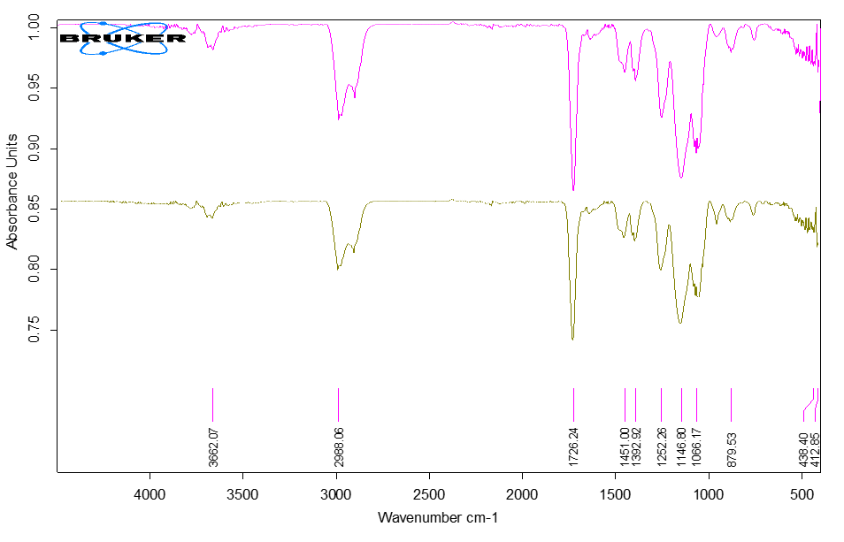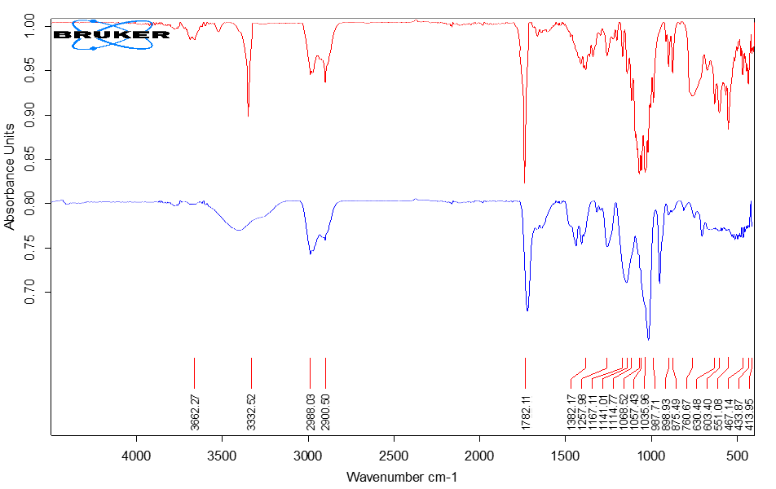
c

a

b

d

Fig. S4

Fig. S5

Fig. S6

Fig. S7

Fig. S8

Fig. S9
a

b

c

Fig. S10
c

b

a

Fig. S11

