Supplementary:

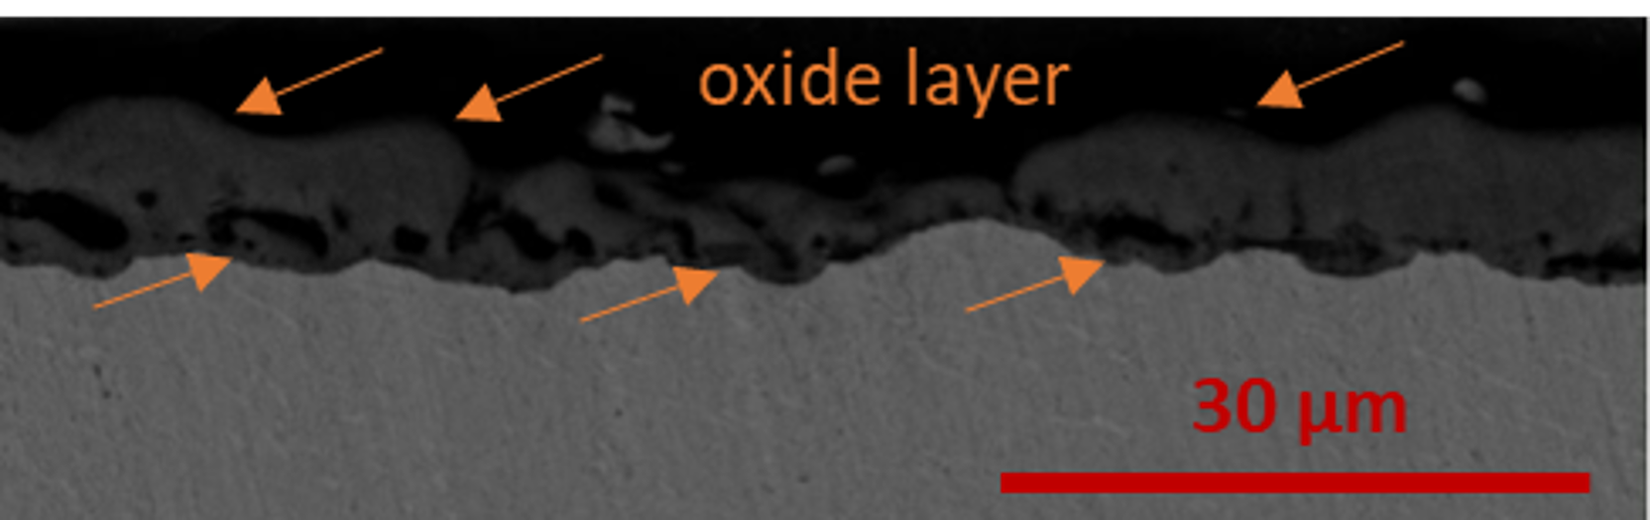

S1. Scheme of the bone wedge surface treatment to obtain the ceramic- polymer layer and methods of the implant surface and biocompatibility analysis. Image created with Biorender.com

