Supplementary tables:

Table S1 Primers used in the current study

Target | Primer Name | Primer Sequence (5'-3') | References
Total bacteria | UnivF  UnivR | TCCTACGGGAGGCAGCAGT  GGACTACCAGGGTATCTATCCTGTT | 28
Bifidobacterium | Bif-F  Bif-R | TCGCGTC[C/T]GGTGTGAAAG  CCACATCCAGC[A/G]TCCAC | 27
B. longum | B. longum F  B. longum R | CAG TTG ATC GCA TGG TCT T  TAC CCG TCG AAG CCA C | 27
Lactobacillus | Lacto-F  Lacto-R | AGCAGTAGGGAATCTTCCA  CACCGCTACACATGGAG | 26
L. plantarum | L. plantarum F  L. plantarum R | ATTCATAGTCTAGTTGGAGGT  CCTGAACTGAGAGAATTTGA | 26
L. reuteri | L. reuteri F  L. reuteri R | GAAGATCAGTCGCAYTGGCCCAA  TCCATTGTGGCCGATCAG | 26

Table S2 Comparison between males and females according to the psychobiotic bacteria in TD group. (n= 36)
Bacteria | Group |  | U | p-value
Bacteria | Male (n = 20)  Median (IQR) | Female (n = 16)  Median (IQR) | U | p-value
Lactobacillus | 3.66E-3 (2.51E-2) | 3.03E-3 (5.18E-2) | 160.00 | 1.000
L. reuteri | 7.99E-5 (3.60E-4) | 6.39E-5 (2.17E-4) | 134.50 | 0.422
L. plantarum | 1.46E-5 (4.20E-5) | 1.64E-5 (8.17E-4) | 136.00 | 0.459
Bifidobacterium | 1.25E-1 (2.40E-1) | 2.91E-2 (6.67E-2) | 84.00* | 0.015*
B. longum | 1.44E-2 (3.09E-2) | 5.51E-3 (1.75E-2) | 149.00 | 0.741
IQR: Inter quartile range
U: Mann Whitney test.
p-value: p value for comparing between the two studied groups
*: Statistically significant at p ≤ 0.05

Table S3 Comparison between males and females according to the psychobiotic bacteria in ASD children. (n= 87)
Bacteria | Group |  | U | p-value
Bacteria | Male (n = 58)  Median (IQR) | Female (n = 29)  Median (IQR) | U | p-value
Lactobacillus | 3.79E-3 (1.05E-2) | 3.10E-3 (1.46E-2) | 789.00 | 0.640
L. reuteri | 2.14E-5 (5.59E-5) | 1.30E-5 (3.46E-5) | 692.00 | 0.180
L. plantarum | 6.70E-6 (3.16E-5) | 1.04E-5 (2.16E-5) | 793.00 | 0.665
Bifidobacterium | 4.22E-2 (1.04E-1) | 7.91E-2 (1.28E-1) | 646.00 | 0.079
B. longum | 7.45E-3 (1.52E-2) | 5.41E-3 (3.35E-2) | 816.00 | 0.822
IQR: Inter quartile range
U: Mann Whitney test.
p-value: p value for comparing between the two studied groups
*: Statistically significant at p ≤ 0.05

Table S4 Clinical characteristics of the ASD cases.
Metric | CARS | Total ATEC | Total SSP | Total GIS
Mean | 33.64 | 79.26 | 127.94 | 3.37
SD | 5.14 | 24.35 | 16.07 | 2.23
Median | 33.00 | 80.00 | 131.00 | 3.00
Range | 34.00 | 77.00 | 98.00 | 10.00
IQR | 5.00 | 40.00 | 20.50 | 3.00
IQR : Inter quartile range SD: Standard deviation

Table S5 Descriptive analysis of ASD children according to ATEC subscale

ATEC subscales | Min. – Max. | Mean ± SD. | Median (IQR)
Speech/Language/Communication | 0.0 – 28.0 | 18.26 ± 6.56 | 20.0 (16.0 – 22.50)
Sociability | 4.0 – 31.0 | 18.83 ± 6.97 | 19.0 (15.0 – 23.0)
Sensory/Cognitive Awareness | 6.0 – 30.0 | 18.26 ± 6.34 | 18.0 (14.50 – 23.50)
Health/Physical/Behavior | 6.0 – 54.0 | 24.29 ± 13.21 | 21.0 (15.0 – 33.0)
Total ATEC | 41.0 – 118.0 | 79.63 ± 24.88 | 80.0 (59.0 – 99.0)
IQR: Inter quartile range SD: Standard deviation

Table S6 Distribution of the studied cases according to SSP subscales in ASD (n = 87)
SSP subscales | No. | %
Tactile
Definite difference (7 – 26) | 59 | 67.8
Probable difference (27 – 29) | 12 | 13.8
Typical performance (30 – 35) | 16 | 18.4
Min. – Max. | 11.0 – 35.0
Mean ± SD. | 24.20 ± 5.39
Median (IQR) | 23.0 (20.0 – 27.5)
Taste/smell
Definite difference (4 – 11) | 31 | 35.6
Probable difference (12 – 14) | 21 | 24.1
Typical performance (15 – 20) | 35 | 40.2
Min. – Max. | 4.0 – 20.0
Mean ± SD. | 13.20 ± 4.42
Median (IQR) | 13.0 (9.50 – 17.0)
Movement
Definite difference (3 – 10) | 17 | 19.5
Probable difference (11 – 12) | 20 | 23.0
Typical performance (13 – 15) | 50 | 57.5
Min. – Max. | 3.0 – 15.0
Mean ± SD. | 12.64 ± 3.13
Median (IQR) | 15.0 (11.0 – 15.0)
Under responsive
Definite difference (7 – 23) | 79 | 90.8
Probable difference (24 – 26) | 6 | 6.9
Typical performance (27 – 35) | 2 | 2.3
Min. – Max. | 7.0 – 31.0
Mean ± SD. | 16.93 ± 5.04
Median (IQR) | 16.0 (13.0 – 20.50)
Auditory
Definite difference (6 – 19) | 57 | 65.5
Probable difference (20 – 22) | 17 | 19.5
Typical performance (23 – 30) | 13 | 14.9
Min. – Max. | 6.0 – 28.0
Mean ± SD. | 17.66 ± 4.53
Median (IQR) | 18.0 (14.0 – 20.50)
Low Energy
Definite difference (6 – 23) | 32 | 36.8
Probable difference (24 – 25) | 11 | 12.6
Typical performance (26 – 30) | 44 | 50.6
Min. – Max. | 6.0 – 30.0
Mean ± SD. | 24.34 ± 6.38
Median (IQR) | 26.0 (20.50 – 30.0)
Visual
Definite difference (5 – 15) | 16 | 18.4
Probable difference (16 – 18) | 17 | 19.5
Typical performance (19 – 25) | 54 | 62.1
Min. – Max. | 5.0 – 25.0
Mean ± SD. | 18.98 ± 4.80
Median (IQR) | 20.0 (17.0 – 22.0)
IQR: Inter quartile range SD: Standard deviation

Table S7 Relation between 6-GSI total score and bacteria in ASD children
Bacteria | 6-GSI Total score |  |  | H | p | r_{s} | p
Bacteria | No GIT Symptoms (0)  (n = 10) | Moderate (1 – 3)  (n = 35) | Severe (≥4)  (n = 42)
Lactobacilli |  |  |  |  |  | 0.031 | 0.778
Min. – Max. | 9.31E-5 – 7.43E-2 | 1.68E-5 – 3.94E-1 | 5.12E-5 – 2.50E-1 | 1.835 | 0.400 | 0.031 | 0.778
Mean ± SD. | 1.28E-2 ± 2.36E-2 | 4.26E-2 ± 9.15E-2 | 2.58E-2 ± 5.39E-2
Median | 3.97E-4 | 3.91E-3 | 3.38E-3
IQR | 2.77E-4 – 1.66E-2 | 1.40E-3 – 1.38E-2 | 6.32E-4 – 1.05E-2
L. reuteri |  |  |  |  |  | -0.001 | 0.989
Min. – Max. | 1.76E-6 – 1.90E-3 | 0.0E+0 – 7.44E-3 | 0.0E+0 – 7.27E-2 | 0.022 | 0.989 | -0.001 | 0.989
Mean ± SD. | 2.08E-4 ± 5.95E-4 | 6.42E-4 ± 1.74E-3 | 1.81E-3 ± 1.12E-2
Median | 1.52E-5 | 1.50E-5 | 1.69E-5
IQR | 3.25E-6 – 4.04E-5 | 2.89E-6 – 9.94E-5 | 4.14E-6 – 4.21E-5
L. plantarum |  |  |  |  |  | -0.039 | 0.720
Min. – Max. | 0.0E+0 – 1.29E-4 | 0.0E+0 – 8.48E-2 | 0.0E+0 – 1.91E-4 | 0.508 | 0.776 | -0.039 | 0.720
Mean ± SD. | 1.87E-5 ± 3.92E-5 | 2.78E-3 ± 1.44E-2 | 2.60E-5 ± 4.89E-5
Median | 6.70E-6 | 1.02E-5 | 5.42E-6
IQR | 1.92E-6 – 1.04E-5 | 1.24E-6 – 3.96E-5 | 1.56E-6 – 2.85E-5
Bifidobacteria |  |  |  |  |  | 0.099 | 0.359
Min. – Max. | 2.07E-3 – 1.38E-1 | 1.05E-3 – 3.46E-1 | 1.27E-3 – 3.97E-1 | 4.313 | 0.116 | 0.099 | 0.359
Mean ± SD. | 3.14E-2 ± 3.94E-2 | 9.79E-2 ± 1.05E-1 | 9.29E-2 ± 9.94E-2
Median | 2.13E-2 | 7.03E-2 | 5.67E-2
IQR | 9.76E-3 – 3.06E-2 | 9.98E-3 – 1.28E-1 | 2.48E-2 – 1.28E-1
B. longum |  |  |  |  |  | 0.086 | 0.429
Min. – Max. | 1.91E-4 – 1.27E-2 | 2.20E-4 – 2.92E-1 | 4.72E-5 – 1.92E-1 | 6.405* | 0.041* | 0.086 | 0.429
Mean ± SD. | 3.84E-3 ± 4.23E-3 | 2.83E-2 ± 5.37E-2 | 2.15E-2 ± 3.87E-2
Median | 2.58E-3 | 8.49E-3 | 6.89E-3
IQR | 7.69E-4 – 4.65E-3 | 4.05E-3 – 3.32E-2 | 2.06E-3 – 1.80E-2
Significance between Subgroups. | p₁=0.011*, p₂=0.038*, p₃=0.437
IQR: Inter quartile range SD: Standard deviation
H: H for Kruskal Wallis test, Pairwise comparison bet. each 2 groups was done using Post Hoc Test (Dunn's for multiple comparisons test)
p: p value for comparing between the three sub groups of GSI Total Score
p₁: p value for comparing between Normal (0) and Moderate (1 – 3)
p₂: p value for comparing between Normal (0) and Severe (≥4)
p₃: p value for comparing between Moderate (1 – 3) and Severe (≥4)
*: Statistically significant at p ≤ 0.05

Supplementary figures:

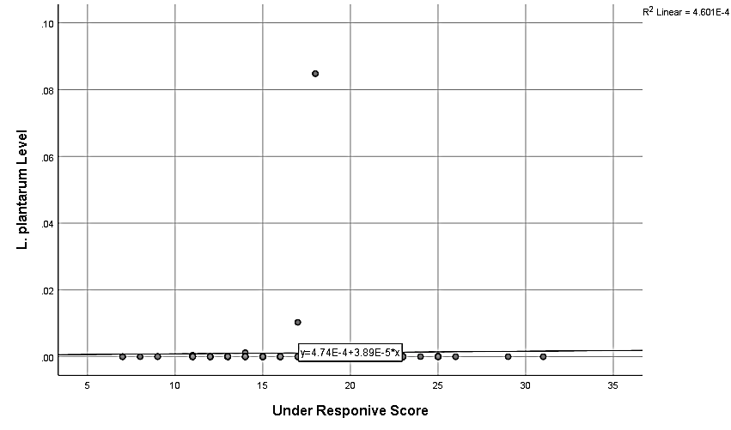
Figure S1: The correlation between under-responsive scores and L. plantarum levels.

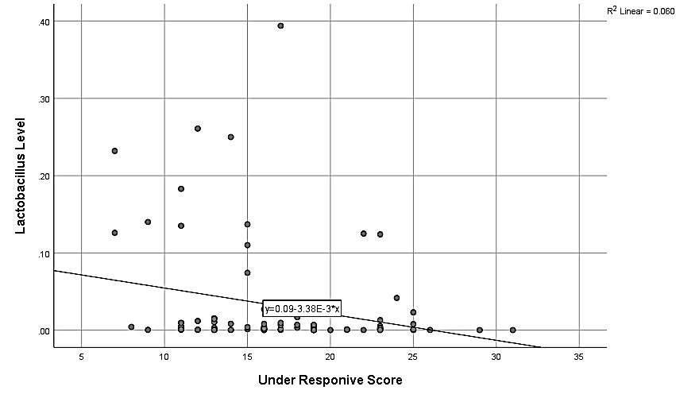
Figure S2: The correlation between under-responsive scores and Lactobacillus levels.

