Supporting information for
Diffuse reflectance spectroscopy and RGB-imaging: a comparative study of non-invasive haemoglobin assessment
Boris Yakimov^{1,2,3,*}, Kirill Buiankin¹, Georgy Denisenko^{2,4}, Yuliya Shitova⁵, Andrey Shkoda³, Evgeny Shirshin^{1,2,*}
¹Faculty of Physics, M.V.Lomonosov Moscow State University, 1-2 Leninskie Gory, 119234 Moscow, Russia
²Laboratory of Clinical Biophotonics, Biomedical Science and Technology Park, Sechenov First Moscow State Medical University, Trubetskaya 8, Moscow, 119048, Russia
³Moscow State Budgetary Institution of Healthcare “L.A. Vorohobov City Clinical Hospital No. 67 MHD”, Moscow, Salama Adil str., 2/44, 123423, Russia
⁴Institute for Regenerative Medicine, Sechenov First Moscow State Medical University (Sechenov University), Moscow 119991, Russia
⁵Medeum LLC, Vysokovoltny proezd 1/20, Moscow, 127566, Russia
*Corresponding author. E-mail addresses: Boris Yakimov (bp.jakimov@physics.msu.ru), Evgeny Shirshin (eshirshin@gmail.com)

Section S1. Evaluation of melanin interference on the blood Hb assessment
Melanin is another dominant chromophore that, besides haemoglobin, impacts the absorptive properties of skin in the visible and near-infrared spectral regions. There are at least two ways to reduce influence of the melanin on the diffuse reflectance spectrum of tissues: 1) use melanin-free tissue areas, 2) compensate for the contribution of melanin to diffuse reflection using the fact that the absorption of melanin decreases monotonically with increasing absorption wavelength.
As nail plate is the melanin-free site [1], we believe that in the case of using optical response from it, the influence of melanin is negligible. On the contrary, in the case of using the response from the skin of the forearm and fingers, the contribution of melanin cannot be neglected. To evaluate the effects of different skin tones on hemoglobin prediction, we additionally check the model trained with DRS on data on patients grouped by their skin tonality.
In order to estimate skin tonality in our dataset (and corresponding Fitzpatrick skin types), we used the method described in [2,3]. Namely, we assessed an individual typology angle (ITA) based on color coordinates of the segmented images of skin regions obtained via RGB-imaging allowing us to categorize patients into skin tones from very light (Fitzpatrick skin type I, FPI) to dark (Fitzpatrick skin type VI, FPVI). The distribution of patients with various skin tones in the presented dataset is shown in Table S1. As one can see, our dataset simultaneously presents patients with low pigmentation and with intermediate skin tonality values, and lacks the group with very dark skin (FP VI).
Table S1 — Distribution of the number of patients in the dataset by skin type.
Skin tone  (Fitzpatrick type) | Very light  (FP I) | Light  (FP II) | Intermediate  (FP III) | Tanned  (FP IV) | Brown  (FP V)
Number of patients | 80 | 82 | 47 | 25 | 6

For patients of different groups, grouped by skin color, we calculated the average diffuse reflectance spectra of the skin on the inner side of the forearm. As can be seen, indeed, with increasing skin type on the Fitzpatrick scale, the optical density increases throughout the entire spectral range from 500 to 700 nm (Fig. S1A), due to the influence of the melanin. Using average OD spectra for each skin tone, we evaluated the impact of the preprocessing methods employed — linear correction and subtraction of optical density within the range of 630–650 nm (Fig. 2A of the manuscript) — to estimate how good they compensate for melanin differences observed in OD spectra.
As can be seen (Fig. S1B,C), both subtraction of the average OD at 630-650 nm (Fig. S1B) and “linear correction” at wavelengths of 510 and 610 nm leads to compensation of the absorption associated with melanin: hemoglobin absorption band amplitude for average spectra becomes nearly the same for different skin tonalities. Thus, we believe that this preprocessing can compensate for the influence of melanin on determining the hemoglobin level from diffuse reflectance data in the skin.
Note that earlier works used similar preprocessing methods to compensate for melanin content [4,5], showing that the area under OD spectrum in the range 520-580 nm after linear correction, will mainly depend on the hemoglobin content and is not affected by melanin.

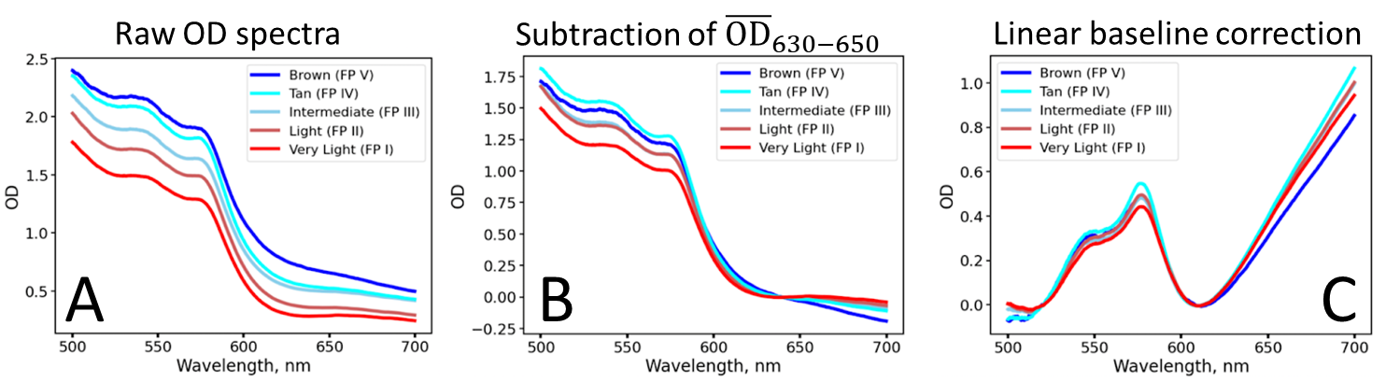
Figure S1 — Optical density spectra of skin of the inner forearm averaged for patients of the same skin tonalities presented in the dataset. A) Raw OD spectra, B) OD spectra after subtraction of the averaged OD value in 630-650 nm range. С) OD spectra after “linear correction” — subtraction of linear baseline, estimated using data of OD at 510 ± 5 nm and 610 ± 5 nm.

The justification for the linear correction procedure used in our work also stems from the following considerations. In contrast to the absorption spectra of “usual” molecular chromophores, such as haemoglobin, the scattering coefficient of tissues and the absorption coefficient of melanin smoothly and monotonically decreases with wavelength in the visible and near-IR range, without having peaks in the range of 500-600 nm (in the region where hemoglobin has intense absorption), and having non-zero values in the range of 600-700 nm (Fig.S2). Thus, its contribution (as well as contribution for scattering) could be fitted as linear or low order polynomial function.
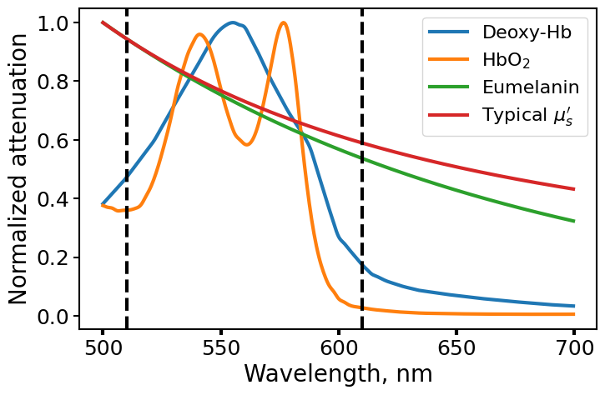
Figure S2 — Normalized attenuation coefficient spectra for deoxyhemoglobin, oxyhemoglobin, eumelanin and reduced scattering coefficient of dermis from [6].
As the last step, we evaluated the accuracy of a classifier trained using DRS features for skin areas on the forearm (model #6 from Table 1) in case when the model is trained on data from patients of certain skin tonalities and makes predictions for other skin tonalities.
To do this, we grouped the dataset into the following categories:
- Very light skin tone group (FP I) — 80 patients;
- (2) Light skin tone group (FP II) — light — 82 patients;
- (3) Brown skin tone group (FP III, IV, V) — 78 patients (see distribution in Fig. S3A).
We assessed the quality of the classification model when one of the groups was used as validation and the rest were used for training. The performance quality of the classifier for each group is shown in Figure S3B. As we can see, there are no significant differences in classification quality for different skin tones — ROC-AUC values varied from 0.7 to 0.8. We also note that our dataset did not include patients with skin tone FPVI. Evaluating the impact of melanin in cases of high pigmentation necessitates additional experiments.
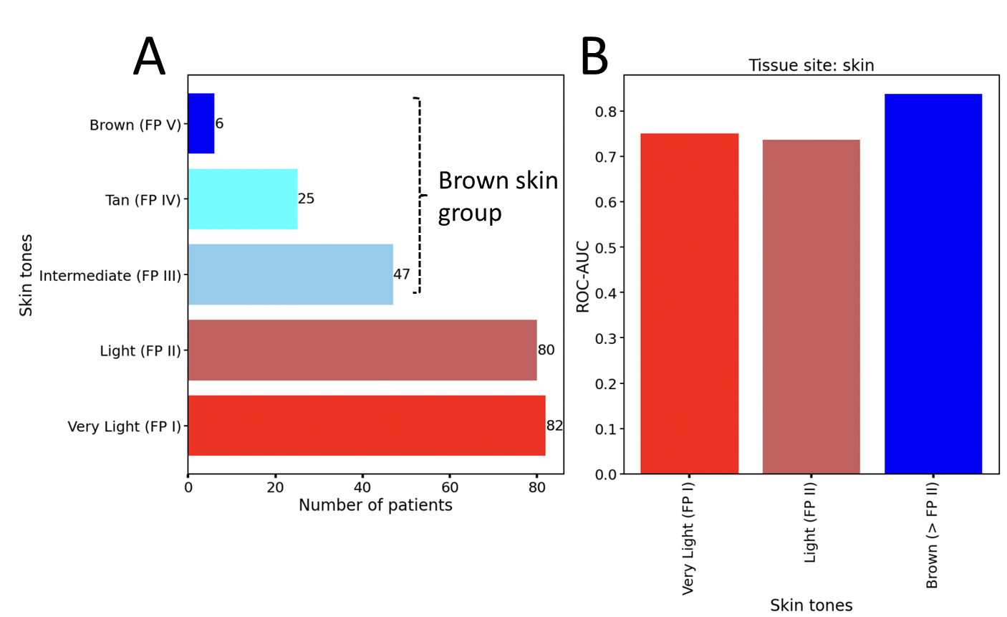
Figure S3 — A) Distribution of patients over skin tones in the dataset B) ROC-AUC values of the classification model trained using diffuse reflectance data of forearm skin of different tonality.

Section S2. Combined model quality evaluation
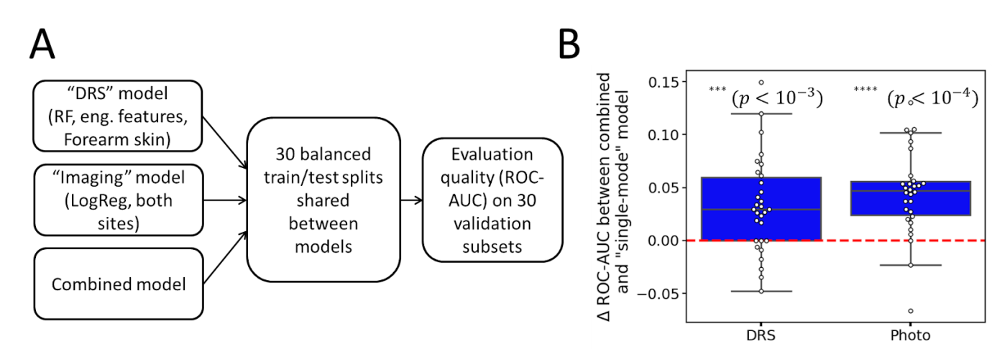
Figure S4 – A) Flow diagram of the experiment to evaluate the quality of the combined model. B) Pairwise difference between the metrics of the combined model and the “single-model” model that uses only one data source (diffuse reflectance spectra or imaging data).

References
[1] Mannino, Robert G., et al. "Smartphone app for non-invasive detection of anemia using only patient-sourced photos." Nature communications 9.1 (2018): 4924.
[2] Wilkes, Marcus, et al. "Fitzpatrick skin type, individual typology angle, and melanin index in an African population: steps toward universally applicable skin photosensitivity assessments." JAMA dermatology 151.8 (2015): 902-903.
[3] Wu, Yue, Toshiyuki Tanaka, and Makio Akimoto. "Utilization of individual typology angle (ITA) and hue angle in the measurement of skin color on images." bioimages 28 (2020): 1-8.
[4] Dolotov, L. E., et al. "Design and evaluation of a novel portable erythema‐melanin‐meter." Lasers in Surgery and Medicine 34.2 (2004): 127-135.
[5] Dawson, J. B., et al. "A theoretical and experimental study of light absorption and scattering by in vivo skin." Physics in Medicine & Biology 25.4 (1980): 695.
[6] Jacques, Steven L. "Optical properties of biological tissues: a review." Physics in Medicine & Biology 58.11 (2013): R37.

