Supplementary Materials:

1 Method validation
The method for extracting retinol from the skin and stratum corneum has good specificity, good precision and accuracy, and a high recovery rate, which can reach 100 - 112%. In addition, the calibration curves showed good linearity within the concentration range of 0.1 - 1.6 μg/mL, the limit of quantitation was 0.0731 μg/mL, and the detection limit was 0.0237 μg/mL. In addition, the plasma sample extraction method is highly specific, the method recovery rate is 89 - 110%, and the precision and accuracy are good.
Table S1. Method validation
 | Skin | Tape |  | Plasma
Linear | y = 69784x - 1257.8 |  |  | y = 1.6926x - 0.149
R² | 0.9998 |  |  | 0.9950
Recovery rate | 0.3μg/ml: 107.38%  0.6μg/ml: 105.72%  1.2μg/ml: 102.73% | 0.3μg/ml: 101.72%  0.6μg/ml: 99.07%  1.2μg/ml: 93.46% |  | 0.6μg/ml: 110.14%  0.9μg/ml: 95.99%  1.5μg/ml: 83.36%
RSD | 6.12% |  | 6.24% | 8.84%

2 The appearance, composition, microscopic observation and in vitro release study of ROL-C1 and ROL-C2
ROL-C1 is a pale-yellow cream containing small particles visible to the naked eye, and ROL-C2 is a yellow opaque cream. SEM observation was performed by using a Hitachi FlexSEM1000 SEM (Tokyo, Japan). From the SEM and polarized microscope images of Figure S1, it can be seen that the particles in ROL - C1 are smoother and in the shape of a standing sphere, whereas in ROL - C2 the particles are covered with flakes on the surface and in the shape of an ellipse. For the composition of ROLs, please refer to table S2. Moreover, the viscosity of ROL-C2 is 21250 mps, and the viscosity of ROL-C1 is 29800 mps.

Table S2. The composition table of ROLs
 | aqueous phase | oil phase
ROL-C1 | water, acrylic acid (ester) copolymer sodium, carbomer, arginine, acrylic acid (ester) / C10-30 alkanol acrylate cross-linked polymer | Pentaerythritol tetra (ethylhexanoate) ester, olive oil, caprylic acid / capric acid glycerides, polydimethylsiloxane, behenic alcohol, lecithin, hydrogenated lecithin,  behenic acid
ROL-C2 | Water, carbomer, arginine, acrylic acid (ester) copolymer sodium, acryloyl dimethyl taurine ammonium / behen alcohol polyether-25 methacrylate crosslinked polymer. | Polydimethylsiloxane, PEG-9 polydimethylsiloxane, polydimethylsiloxane PEG-10 / 15 crosslinked polymer, lecithin, olive oil

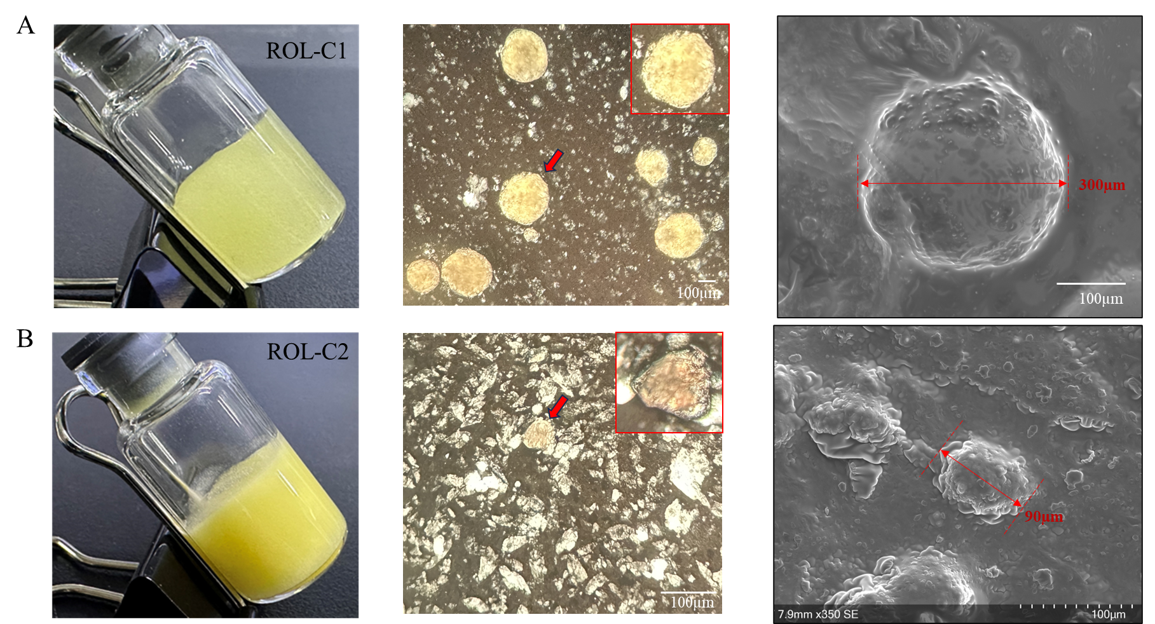
Figure S1. The appearance, polarizing microscope, scanning electron microscope observation of ROL-C1 and ROL-C2. (A) ROL-C1: The appearance, polarized light microscope image, and SEM image. (B) ROL-C2: The appearance, polarized light microscope image, and SEM image.

3 Rheology of ROLs
The rheological properties of ROLs were assessed using a DHR-2 rheometer (TA, USA). The results show that the viscosity of ROLs gradually decreases with increasing shear rate, and ROL-C1 has a higher viscosity than ROL-C2.
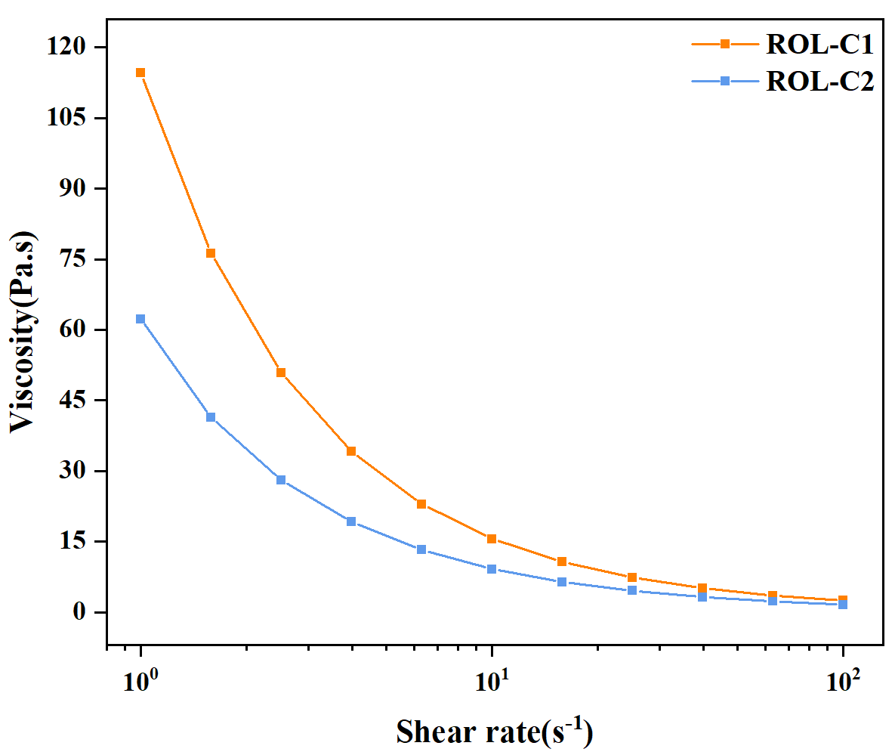
Figure S2. Analysis of viscosity of ROLs.

4 HPLC chromatogram of untreated blank plasma from mice
Figure S3. HPLC chromatogram of untreated blank plasma from mice.

