Supplementary Information
Elucidating Drug Dependence Progression in a Methamphetamine Self-Administration Rat Model via Targeted and Non-targeted Metabolomics Analyses

Sang-Hoon Song^{1,#}, Suji Kim^{1,#}, Won-Jun Jang¹, In Soo Ryu², Chul-Ho Jeong^{1,*}, Sooyeun Lee^{1,*}
¹College of Pharmacy, Keimyung University, 1095 Dalgubeoldaero, Dalseo-gu, Daegu 42601, Republic of Korea
²BIORCHESTRA Co., Ltd., Techno4-ro 17, Daejeon 34013, Republic of Korea

#These authors contributed equally to this study.
*Corresponding authors:
Prof. Chul-Ho Jeong
Tel.: +82 53 580 6638; Fax: +82 53 580 5164
E-mail: chjeong75@kmu.ac.kr
Prof. Sooyeun Lee
Tel.: +82 53 580 6651; Fax: +82 53 580 5164
E-mail: sylee21@kmu.ac.kr
Table S1 Metabolites quantified in rat plasma via HPLC-MS/MS analysis
Metabolite group | Total number of metabolites | Number of (semi-) quantified metabolites | Number of metabolites showing significant changes
Acylcarnitines | 40 | 9 | 8
Amino acids and biogenic amines | 42 | 32 | 22
Glycerophospholipids | 90 | 81 | 58
Sphingolipids | 15 | 15 | 3
Monosaccharides | 1 | 0 | 0
TCA intermediates | 10 | 9 | 8
Total | 198 | 146 | 99
TCA, tricarboxylic acid.

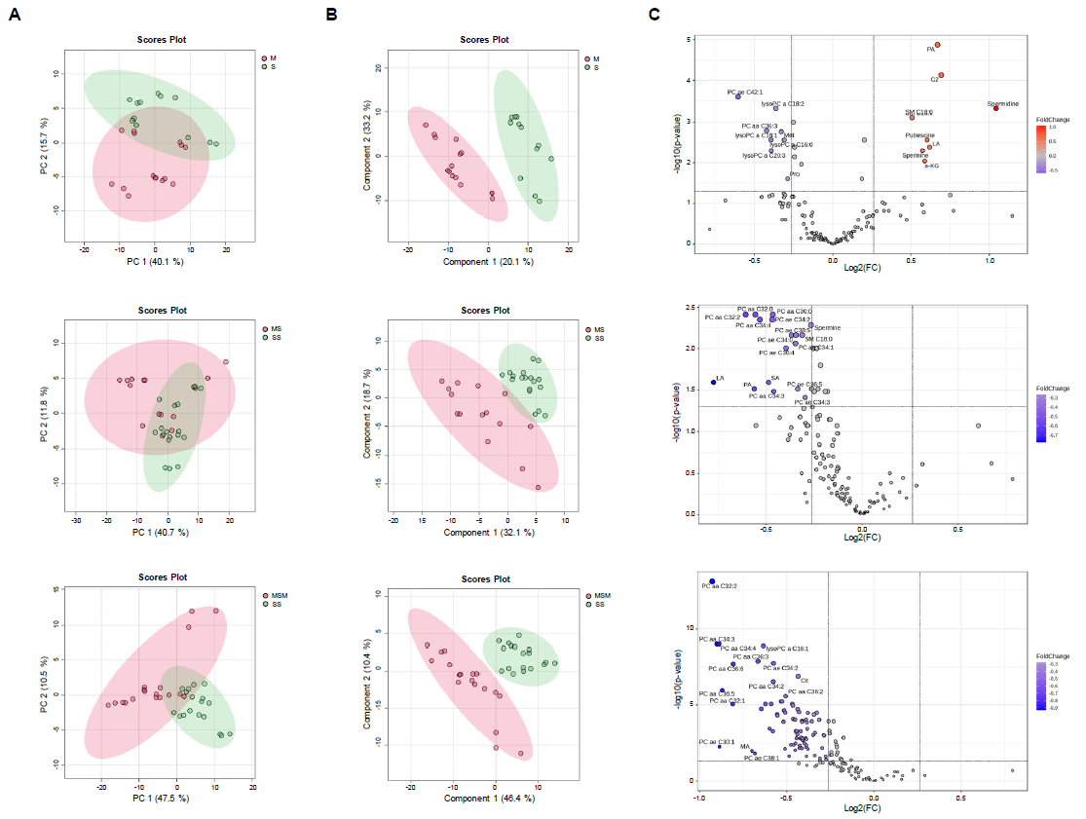
Fig. S1 Statistical results of the targeted metabolomics analysis
(A) Principal component analysis score plots. (B) Partial least squares-discrimination analysis score plots. Green circle: Group S, and SS; red circle: Group M, MS, and MSM. (C) Volcano plot. Red (fold change > 1.2) and blue circles (fold change < -1.2) are metabolites significant at p < 0.05.

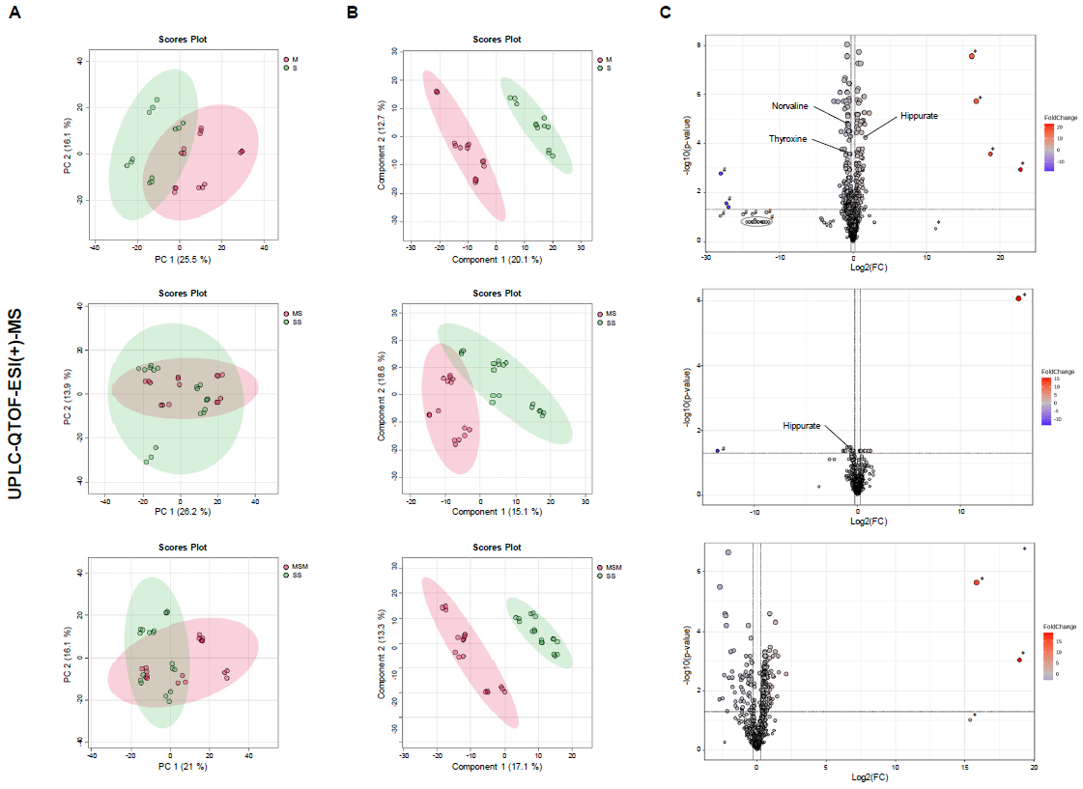
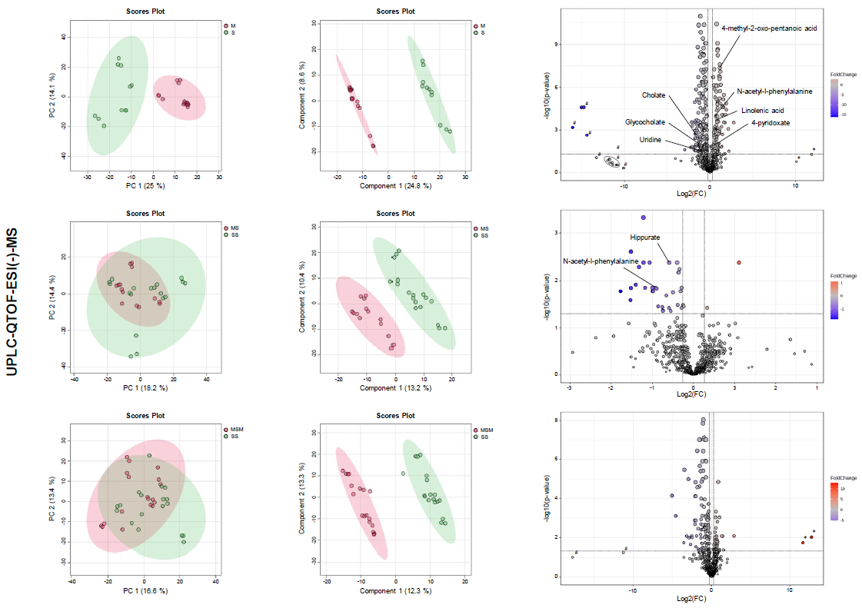
Fig. S2 Statistical results of the non-targeted metabolomics analysis
(A) Principal component analysis score plots. (B) Partial least squares-discrimination analysis score plot. Green circle: Groups S and SS; red circle: Groups M, MS, and MSM. (C) Volcano plots. Red (fold change > 1.2) and blue circles (fold change < -1.2) are metabolites significant at p < 0.05. ND: not detected. *, + ND; #, - ND.

