Supplementary information
Integrating user- and data-driven weather forecasts to develop legitimate, credible, and salient information services for smallholders in the Global South
Spyridon Paparrizos, Raffaele Vignola, Samuel J. Sutanto
Earth Systems and Global Change Group, Wageningen University and Research, P.O. Box 47, 6700 AA, Wageningen, The Netherlands
Corresponding author: spyros.paparrizos@wur.nl

The Supplementary information comprises one Supplementary note, two Supplementary Figures, one Supplementary Table, Supplementary References, and example questionnaire from the Ghana case study.
Supplementary Note
Study locations
The FSapp and DROP app were implemented and tested in the Panajachel region of Guatemala (five communities), the Tamale region of Ghana (two communities), and across Bangladesh (5 regions, in total 16 communities). These communities predominantly rely on rainfed agriculture for their livelihoods, making agricultural production crucial to well-being. Supplementary Figure 1 shows the locations of the three study areas and the farmers’ communities within each area. In Guatemala, the five farmer communities were combined into two regions: region 1 (Nahuala, Solola, and San Marcos) and region 2 (Yataz and Toliman). In Ghana, the Yapalzi and Nanpakzoo communities were combined into one, while no communities were combined in Bangladesh. The forecast skills were evaluated by averaging all the farmer locations within each country, representing the forecast skills at the national level.

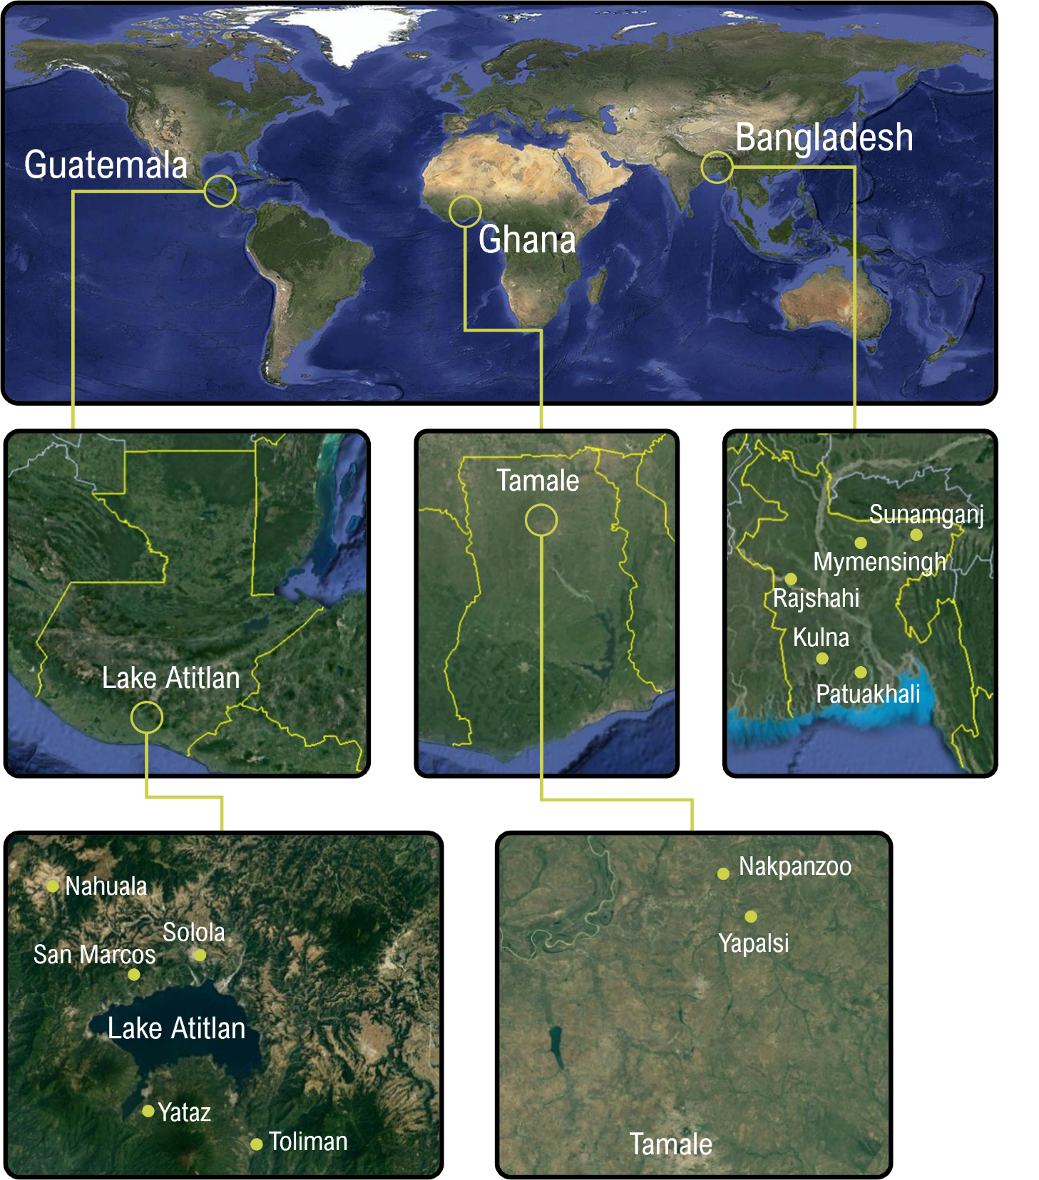

Supplementary Figure 1. Locations where the FSapp and DROP app have been implemented: Guatemala (Google Maps, "Lake Atitlan"), Ghana (Google Maps, "Tamale"), and Bangladesh (Google Maps, "Bangladesh").

All the farmer communities in Guatemala are situated around the volcanoes of Lake Atitlan. The climate in the Panajachel region is classified as subtropical highland, with an average annual temperature of 17 °C. The rainy season typically spans from May to the beginning of July, and from August to October. The study location primarily comprises rural areas characterised by small to medium-sized farms, predominantly practicing rainfed agriculture¹. Due to the varying altitudes around the lake, a diverse range of crops can be cultivated, with major crops including coffee, maize (a wide variety in species), avocado, beans, onion, tomato, carrots, potato, and banana.
During the WATERAPPS and WAGRINNOVA projects, three farmer communities were established in the Tamale district of Ghana. Situated in the northern region of Ghana, this district is home to many smallholder farmers predominantly engaged in rainfed agriculture. Renowned as the rice granary, the district boasts the highest rice production in the country. The rainy season spans from May to October, with total rainfall typically below 1,250 mm. Major crops cultivated in this region include rice, maize, pepper, soybean, and groundnuts.
Bangladesh, situated in a hot and humid subtropical climate zone, experiences four distinct hydroclimatic seasons: Winter (December-February), pre-monsoon summer (March-June), monsoon (July-September), and post-monsoon (October-November). Two farmer communities, Khulna and Patuakhali, are located in the Bengal Delta, renowned as one of the most populous deltas globally. Rajshahi, situated in the northwest, serves as a hub for agricultural production in the country. Mymensingh and Sunamganj lie in the Haor basin, characterized by large to medium floodplain depressions and wetland ecosystems. The primary crops cultivated in Bangladesh include rice, fruits, and vegetables.
Farmers’ demographics and characteristics
The demographics and characteristics of farmers who participated in the Farmers Field Schools (FFSs) are presented in Supplementary Table 1. Predominantly, male participants constituted over 60% of the total in all regions. In Guatemala, more than 30% of the participating farmers fell within the age brackets of 30 to 40 years and 51 to 60 years. However, in Ghana and Bangladesh, instead of documenting farmers' age, we recorded their farming experience. The majority of respondents in Ghana reported higher farming experience (5-10 years) compared to those in Bangladesh (1-10 years).
Regarding education, approximately 33% of respondents in Guatemala had primary education, while around 54% of respondents in Ghana had no formal education, and about 49% of respondents in Bangladesh had completed secondary education. In Guatemala, approximately 38% of respondents cultivated agriculture on cultivable land ranging between 2 and 10 hectares. In contrast, most participating farmers in Ghana and Bangladesh cultivated land of less than 2 hectares. It's noteworthy that in Bangladesh, we only documented farm size in the Khulna region.

Supplementary Table 1. The characteristics of the experimental farmers in Guatemala, Ghana, and Bangladesh presented in percentages. An asterisk (*) next to the farm size for Bangladesh indicates that the data is only for the Khulna region.
Demography |  | Guatemala | Demography |  | Ghana | Demography |  | Bangladesh
Sex |  |  | Sex |  |  | Sex
 | M | 66.7 |  | M | 81.2 |  | M | 60
 | F | 33.3 |  | F | 18.8 |  | F | 40
Age |  |  | Farm experience |  |  | Farm experience
 | <30 | 19.0 |  | <5 | 9.4 |  | 1-10 | 51
 | 30-40 | 38.1 |  | 5-10 | 56.3 |  | 11-20 | 25
 | 41-50 | 4.8 |  | 11-15 | 12.5 |  | >20 | 24
 | 51-60 | 33.3 |  | 16-20 | 6.3
 | >60 | 4.8 |  | >20 | 15.6
Education |  |  | Education |  |  | Education
 | No education | 9.5 |  | No education | 54.2 |  | No education | 14
 | Primary | 33.3 |  | Primary | 25.0 |  | Primary | 22
 | Secondary | 28.6 |  | Secondary | 14.6 |  | Secondary | 49
 | Higher education | 28.6 |  | Higher education | 6.3 |  | Higher education | 16
Farm size (ha) |  |  | Farm size (ha) |  |  | Farm size (ha)*
 | <2 | 14.3 |  | <2 | 70.0 |  | <2 | 82
 | 2-10 | 38.1 |  | 2-10 | 30.0 |  | 2-10 | 18
 | 11-20 | 0 |  | 11-20 | 0 |  | 11-20 | 0
 | 21-30 | 28.6 |  | 21-30 | 0 |  | 21-30 | 0
 | >30 | 19.0 |  | >30 | 0 |  | >30 | 0

Integration framework
Supplementary Figure 2 illustrates the framework designed to integrate local and scientific weather forecasts, creating an information service tailored to the needs of smallholder farmers in the global south. The framework encompasses engaging the agricultural community in the development of hybrid weather forecasts, ensuring credibility by leveraging diverse scientific (data-driven) and local knowledge (user-driven) sources. Additionally, it emphasizes salience by providing actionable knowledge for adaptive decision-making and establishing trust through a co-production process, thereby fostering the perception that the information is legitimately owned by farmers.
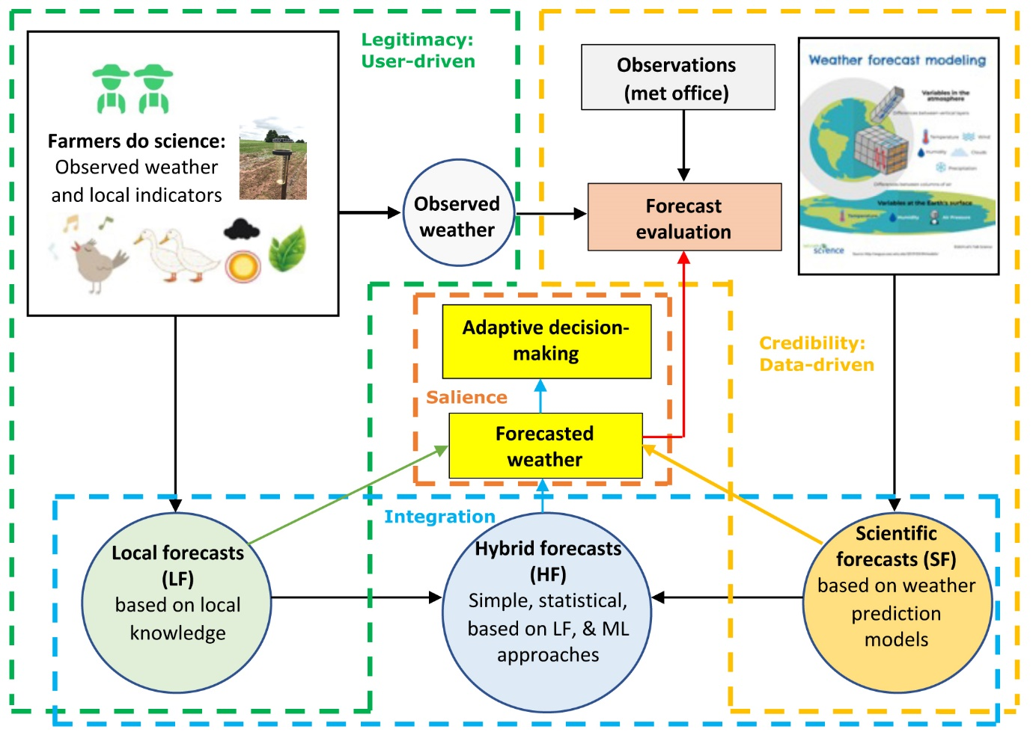

Supplementary Figure 2. Framework to co-produce hybrid weather forecasts that are salient, credible and legitimate.

Supplementary References
- Sirin Ruyán, L. L. Informe final de diagnóstico, investigación y servicios desarrollados bajo el convenio CUC-Action Aid, FAUSAC y el programa de Extensión Rural del Ministerio de Agricultura, Ganadería y Alimentación en las regiones de Suchitepéquez y Sololá, Guatemala, C.A. Doctoral dissertation, Universidad de San Carlos de Guatemala, http://www.repositorio.usac.edu.gt/7880/ (2017).
- Kida, S. & Yamazaki, D. The mechanism of the freshwater outflow through the Ganges–Brahmaputra–Meghna delta, Water Resour. Res. 56, e2019WR026412 (2020).

Example Questionnaire from the Ghana case study
You are kindly being asked to participate in a study on the identification of weather and climate forecast users and their needs in Tamale, Ghana. This is a study to fulfil requirements of a master’s degree program in International Land and Water Management with WUR, Netherlands. Participating in this study is voluntary and all information you will provide will be kept anonymous and confidential. In case of any questions about the study, please do not hesitate to contact me by phone or email. Phone no: xxxx (whatsapp), xxxxx (messages/phone); Email: xxxx@wur.nl
I want to help by filling this questionnaire Yes/No

A. Personal and demographic information

GPS location of households: Latitude__________________ Longitude_____________________

Your name (optional) ______________________________Mobile No. ___________________

Village___________________Union______________________Upazila______________________

Gender Male / Women

Age (years)___________________Farming experience (years)____________________________

What is your highest education level?
- Primary
- Secondary
- Professional diploma
- Bachelor or Higher
- Basic literacy (can sign) / no formal education

Farm income (%) _______________________ Off-farm income (%)_______________________

Household size_______________ No of Male________________ No of Female________________

No of earning members in your households____________________________

Did you receive training on weather/climate information services? Yes / No

If yes, who provided and what was the training duration? __________________________________

B. Changes in agricultural decision-making

Did you use forecast information for changing any of the decisions to adjust/adapt to weather phenomena/or for adaptive agricultural decisions? Yes/No

If yes, map the changes that you did based on forecasts information from the Drop app:
Decisions points | Yes/No/NA | Identify specific example and link with impacts
Change of sowing or planting date
Change date of weeding
Change decision for buying inputs
Change date of fertilizer application
Change date of pesticide application
Change date of harvest
If no, why not? Give reasons
C. Local Weather Forecast Indicators
Date  Community | :  :

What local weather forecast parameters do you observe?

Date  Variable  If rainfall  If Soil moisture, which level  Indicator(s)  Indicator’s signal(s)  When will it happen | :  : Rainfall  : low (<5mm),  high (10-20mm),  : bad (0% - 25%),  good (50% - 75%),  :  :  : | Soil Moisture  medium (5-10mm),  very high (>20mm)  moderate (25% - 50%),  very good ( 75% - 100%)

