Synthesis of Schiff bases based on Chitosan, thermal stability and evaluation of antimicrobial and antitumor activities
Abdullah Ali Alamri ¹, Rita M. A. Borik ¹, Ashraf H. F. Abd El-Wahab ¹, Hany M. Mohamed ¹, Khatib S. Ismail ², Mohamed R. El-Assar ³, Al-Anood M. Al-Dies ⁴, Ahmed M. El-Agrody ^{5,} *
¹ Department of Physical Sciences, Chemistry Division, College of Science, Jazan University, P.O. Box. 114, Jazan 45142, Kingdom of Saudi Arabia
² Department of Biology, College of Science, Jazan University, P.O. Box. 114, Jazan 45142, Kingdom of Saudi Arabia
³ Department of Chemistry, College of Science, Jouf University, Sakaka, 2014 , Kingdom of Saudi Arabia
⁴ Chemistry Department, Umm Al-Qura University,Al-Qunfudah University College, Al-Qunfudah 21912, Saudi Arabia.
⁵ Department of Chemistry, Faculty of Science, Al-Azhar University, Nasr City 11884, Cairo, Egypt
* Corresponding author: Ahmed M. El-Agrody (elagrody_am@azhar.edu.eg), ORCID ID:
0000-0001-7019-411X

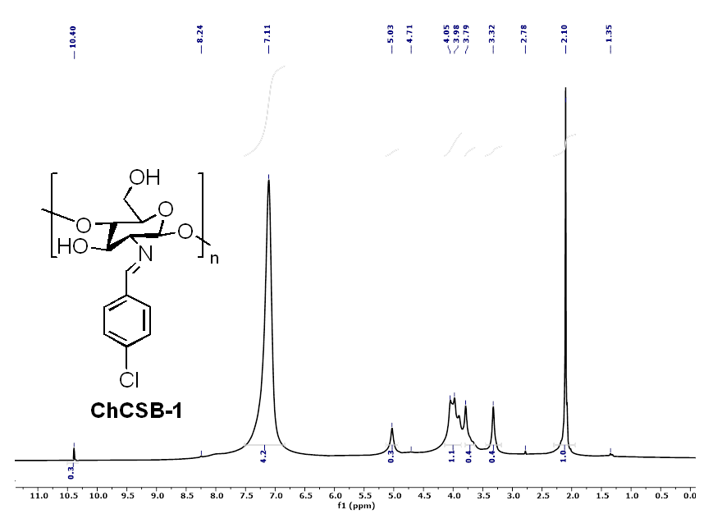

Figure S1: ¹H NMR spectrum of compound (3a, ChCSB-1)

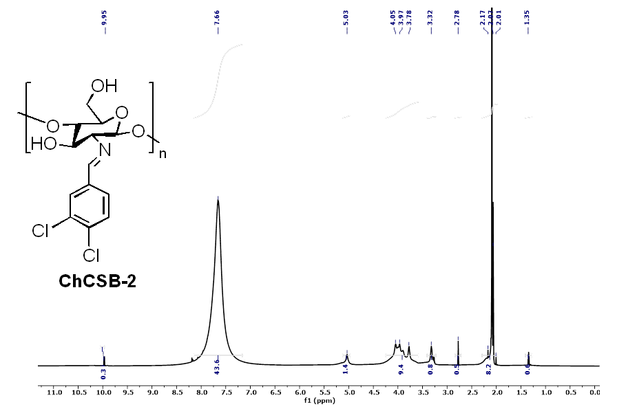
Figure S2: ¹H NMR spectrum of compound (3b, ChCSB-2)

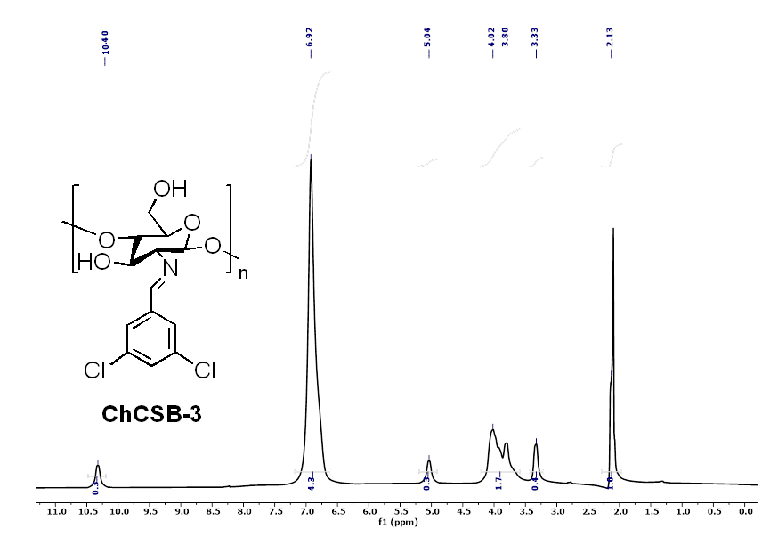
Figure S3: ¹H NMR spectrum of compound (3c, ChCSB-3)
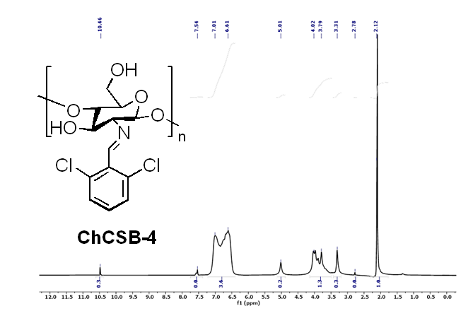
Figure S4: ¹H NMR spectrum of compound (3d, ChCSB-4)

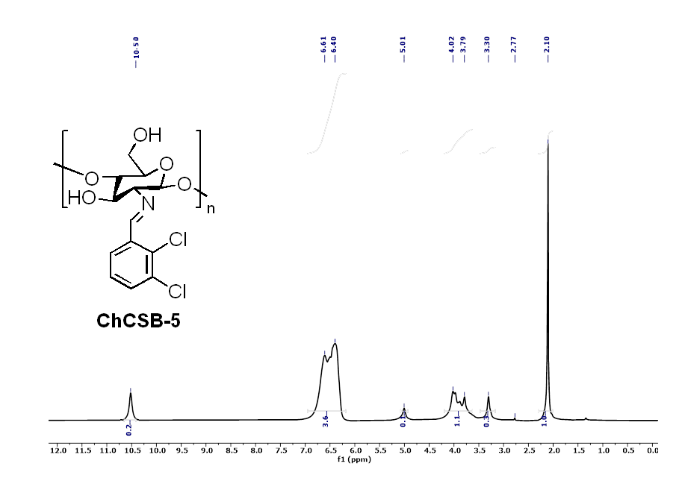Figure S5: ¹H NMR spectrum of compound (3e, ChCSB-5)
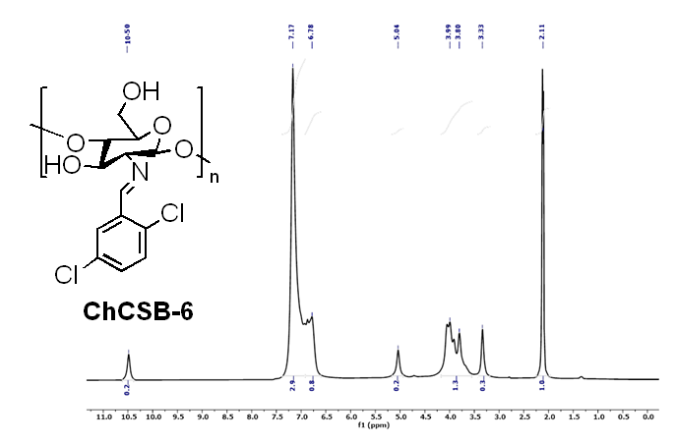

Figure S6: ¹H NMR spectrum of compound (3f, ChCSB-6)

