Supplementary information and material of

A first-of-its-kind 3D biomimetic artificial mouth capable of reproducing the oral processing of soft foods
Avila-Sierra, Alejandro^{1*}, Bugarin-Castillo, Yurixy¹, Glumac, Miodrag¹, Bussiere, Jérôme¹, Saint-Eve, Anne¹, Mathieu, Vincent², Kobayashi, Yoshikazu³, Ramaioli, Marco¹

¹ Université Paris-Saclay, INRAe, AgroParisTech, UMR SayFood, 91120 Palaiseau, France
² INRAE, Institut Agro, STLO, 35042 Rennes, France
³ Department of Dentistry and Oral-Maxillofacial Surgery, Fujita Health University, School of Medicine, Toyoake, Aichi 470-1192, Japan

Corresponding author: Alejandro Avila-Sierra (alejandro.avila-sierra@inrae.fr)

Supplementary Information:
- Table SI.1. Statistical analysis conducted using One-Way ANOVA comparing the characteristics of model foods and ready-to-swallow food boli formed in vivo.
- Table SI.2. Statistical analysis conducted using One-Way ANOVA comparing the characteristics of the ready-to-swallow food boli formed both in vivo and in vitro.
- Table SI.3. Commercial name and composition of the model foods.
- Fig. SI.1. Shear viscosity data of both the model foods and the ready-to-swallow in vivo food boli.
- Fig. SI.2. Relationship between textural parameters (firmness and cohesion work) and the time required for in vivo compression of each model food.
- Fig. SI.3. Back Extrusion Test (BET) rig and the methodology for data extraction.
- Fig. SI.4. Manufacturing process of the artificial tongue and control system of the artificial mouth.
Supplementary Materials:
- Video SI.1. Representative US recording of oral processing of the viscous liquid.
- Video SI.2. Representative US recording of oral processing of the aerated soft solid.
- Video SI.3. Representative US recording of oral processing of the soft solid.
- Video SI.4. A representative video of the motions of the artificial tongue.

Table SI. 1. Statistical analysis conducted using One-Way ANOVA comparing the characteristics of model foods and ready-to-swallow food boli formed in vivo. The examined parameters encompass textural attributes such as Firmness, Cohesion Work (W_{Cohesion}), Adhesion Work (W_{Adhesion}), Maximum Adhesion Force (F_{Adh. Max}), water content, and rheological properties such as shear viscosity (η) at orally relevant shear rates (50 s⁻¹). Additional parameters like Food-to-Saliva Ratio (H_{w}), Food Oral Processing (FOP) time, and the stimulated saliva flow rate are also included. In vivo food boli underwent three repetitions across three different panellists (n=3x3), whereas in vitro food boli were subjected to at least three repetitions. A significance level of p < 0.05 was employed to determine statistical disparities between datasets. When p-value corresponding to the F-statistic of one-way ANOVA was lower than 0.05, suggesting that one or more pairs of treatments are significantly different, post-hoc Tukey's HSD test was applied (results denoted by letters in Fig. 1).
Condition | Factor levels | Firmness | W_{Cohesion} | W_{Adhesion} | F_{Adh. Max} | Water content | H_{w} | η (50s⁻¹) | FOP time | Saliva flow rate
Food product | VL  ASS  SS | F=99.9  p<0.001 | F=28.8  p<0.001 | F=23.5  p=0.002 | F=85.7  p<0.001 | F=1287.7  p<0.001 | NA | F=8.6  p=0.02 | NA | NA
In vivo boli | VL  ASS  SS | F=75.9  p<0.001 | F=132.1  p<0.001 | F=89.7  p<0.001 | F=130.8  p<0.001 | NA | F=0.0  p=0.98 | F=550.2  p<0.001 | F=1.6  p=0.22 | F=0.2  p=0.84
VL | Product  Bolus | F=315.6  p<0.001 | F=905.3  p<0.001 | F=360.3  p<0.001 | F=192.5  p<0.001 | NA | NA | F=1114.6  p<0.001 | NA | NA
ASS | Product  Bolus | F=644.0  p<0.001 | F=651.0  p<0.001 | F=226.5  p<0.001 | F=699.3  p<0.001 | NA | NA | F=26.3483  p<0.001 | NA | NA
SS | Product  Bolus | F=343.1  p<0.001 | F=61.2  p<0.001 | F=19.1  p=0.001 | F=156.8  p<0.001 | NA | NA | F=248.1  p<0.001 | NA | NA

NOTE: NA denotes Not Applicable.
Table SI.2. Statistical analysis conducted using One-Way ANOVA comparing the characteristics of the ready-to-swallow food boli formed both in vivo and in vitro. The examined parameters encompass textural attributes such as Firmness, Cohesion Work (W_{Cohesion}), Adhesion Work (W_{Adhesion}), Maximum Adhesion Force (F_{Adh. Max}), and Food-to-Saliva Ratio (H_{w}), along with rheological properties including shear viscosity at pertinent oral and oropharyngeal shear rates (10, 50, 300, 1000 s⁻¹). A significance level of p < 0.05 was employed to determine statistical disparities between datasets. In vivo food boli underwent three repetitions across three different panellists (n=3x3), whereas in vitro food boli were subjected to at least three repetitions.
Food boli | Factor levels | Firmness | W_{Cohesion} | W_{Adhesion} | F_{Adh. Max} | H_{w} | Shear viscosity
 |  |  |  |  |  |  | 10 s⁻¹ | 50 s⁻¹ | 300 s⁻¹ | 1000 s⁻¹
Viscous liquid | In vivo  In vitro | F=0.109  p=0.749 | F=1.335  p=0.275 | F=1.851  p=0.204 | F=0.053  p=0.823 | F=1.371  p=0.269 | F=4.821  p=0.053 | F=4.917  p=0.051 | F=3.404  p=0.095 | F=0.129  p=0.727
Aerated soft solid | In vivo  In vitro | F=1.013  p=0.338 | F=5.023  p=0.049 | F=1.347  p=0.273 | F=2.282  p=0.162 | F=1.381  p=0.267 | F=35.197  p<0.001 | F=10.944  p=0.001 | F=3.088  p=0.109 | F=0.624  p=0.448
Soft solid | In vivo  In vitro | F=3.010  p=0.113 | F=0.590  p=0.460 | F=0.000  p=0.988 | F=0.151  p=0.706 | F=0.000  p=0.995 | F=2.916  p=0.119 | F=0.041  p=0.844 | F=5.823  p=0.037 | F=5.164  p=0.046

Table SI.3. Commercial name and composition of the model foods.
Commercial name | Description of composition | Name in this work
Les 2 vaches | Semi-skimmed milk (80.9%), cane sugar (12%), cocoa powder (4%), cream (milk) (2.4%), stabiliser (carrageenan (E407)), corn starch | Soft solid (SS)
Danette cream | Skimmed milk (72%), sugar, cream (milk), chocolate (2.2%) (sugar, cocoa paste, lean cocoa powder, emulsifier: soy lecithin, flavouring) low-fat cocoa powder, thickeners: E1442 (processed starch), E407 (carrageenan), whey permeate powder, starch. | Viscous liquid (VL)
Danette mousse | Whole milk (67.5%), chocolate (9.4%) (paste of cocoa, sugar, emulsifier (soy lecithin), flavouring), chocolate powder (6.6%) (cocoa powder, sugar), sugar (6.5%), cream (milk) (6.1%), emulsifier (lactic esters of mono- and diglycerides of fatty acids) (E472b), gelatine bovine, lean cocoa, thickener (processed corn starch (E1442)), salt. | Aerated soft solid (ASS)

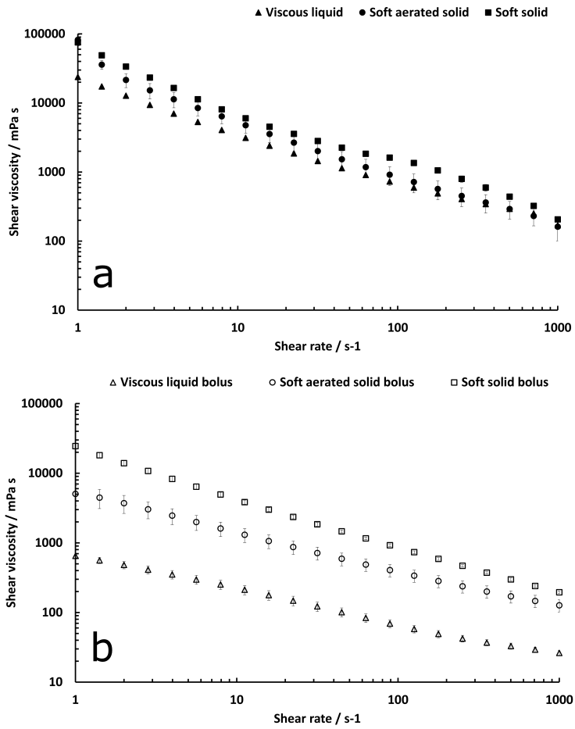

Figure SI.1. Shear viscosity data of both the model foods (a) and the ready-to-swallow in vivo food boli (b). Averaged data along with corresponding standard deviations are shown. Model foods were subjected to three repetitions (n=3), while food boli were analysed through three repetitions across three different panellists (n=3x3). Shear viscosity of both the model foods and the in vivo food boli (right after collection) were assessed with a Modular Compact Rheometer 702 (Anton Paar GmbH, Graz, Austria) at 20°C in a range of shear rates between 1 and 1000 reciprocal seconds, using a parallel-plate geometry (PP25, with rough surface) and Concentrical Cilinder (CC27) geometry for the model foods and the food boli, respectively. Both VL and ASS exhibited shear thinning behaviours with comparable flow abilities (1.1 ± 0.0 Pa.s and 1.4 ± 0.4 Pa.s at 50 s⁻¹, respectively). In contrast, SS demonstrated significantly higher resistance to flow (2.1 ± 0.1 Pa.s), exhibiting two similar shear thinning phases, with a less pronounced shear thinning phase occurring between 50 and 100 s⁻¹. The resistance to flow of the shear thinning food boli at the orally relevant shear rate (50 s⁻¹) also showed notable differences, being the most pronounced one the decrease observed for VL, with a shear viscosity plummeting from 1.2 ± 0.0 Pa.s to 0.1 ± 0.0 Pa.s. This was followed by ASS with a 60% reduction and SS with a comparatively lower decrease of 36%. In the case of SS, the shear viscosity decreased from 2.1 ± 0.1 Pa.s to 1.4 ± 0.1 Pa.s, indicating the least pronounced reduction among the analysed samples.

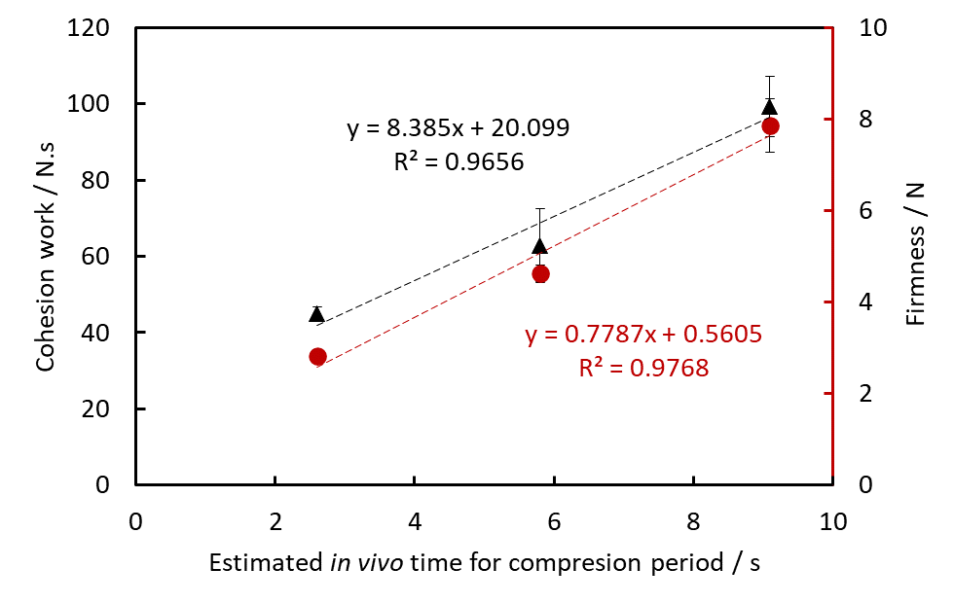
Figure SI.2. Relationship between textural parameters (firmness and cohesion work) and the time required for in vivo compression of each model food. Averaged textural data along with corresponding standard deviations are shown. Model foods were subjected to three repetitions (n=3).

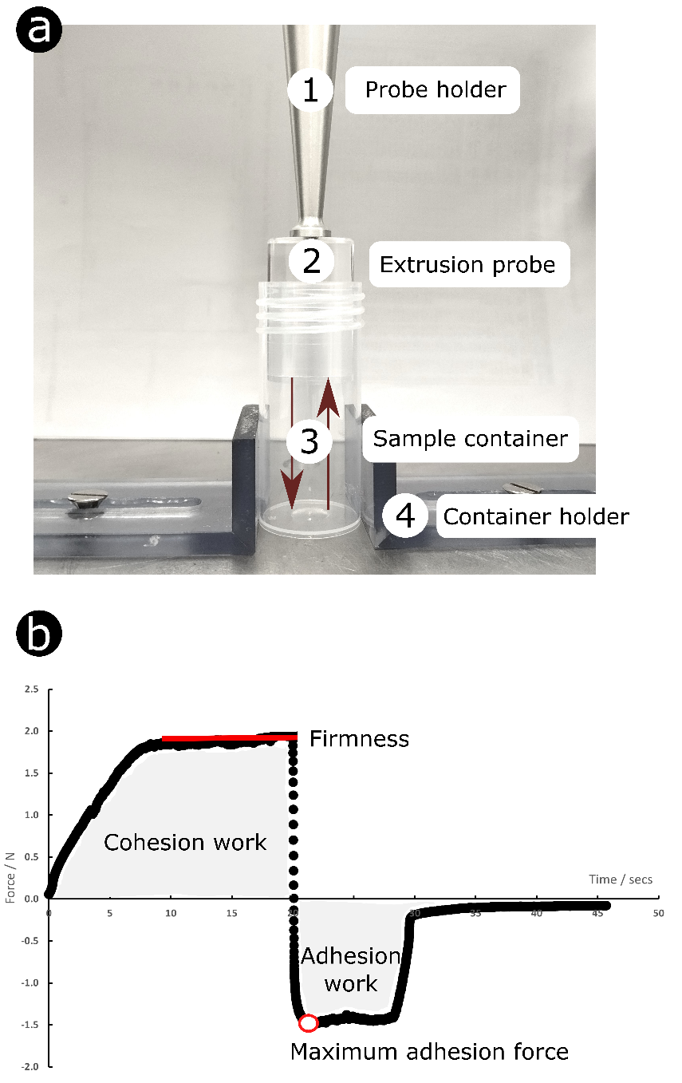
Figure SI.3. Back Extrusion Test (BET) rig (a) and the methodology for data extraction (b). During the downward movement of the holder with the extrusion probe, depicted by the positive segment of the back extrusion graph, the maximum compressive force is generated. This force is essential for inducing deformation and flow in the food, thereby indicating the firmness of the product. Moreover, the area above zero on the graph reflects the cohesive properties of the material. A higher value in this region signifies a denser consistency of the sample. Upon the return of the disk to its initial position, the upward movement initiates the negative segment of the graph. Here, the area below zero represents the adhesiveness and resistance of the sample during separation from the piston, indicating the maximum adhesion force. A higher value in this context indicates a greater amount of energy required to disengage the sample from the disk surface, thus indicating a higher level of adhesiveness in the food sample.

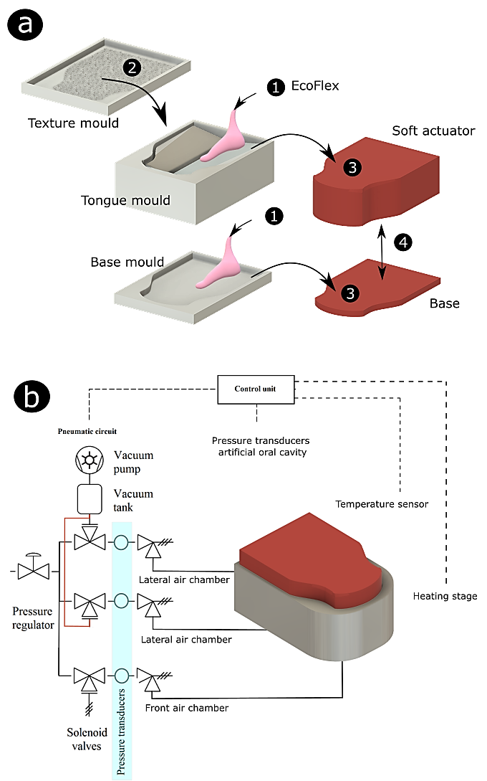
Figure SI.4. Manufacturing process of the artificial tongue (a) and control system of the artificial mouth (b) ^{[62]}. Manufacturing process stages: (1) pouring of the Ecoflex mixture into the 3D printed moulds, (2) adding the surface texturing mould, (3) de-moulding of the cured soft actuator and its base, and (4) final glueing of both parts. The biomimetic texturing of the surface of the soft actuator is based on the topographical in vivo data (average size and papillae density) of the human tongue as described in Materials & Methods. The surface texturing mould was 3D printed in resin using an ElegooMars 2P printer. The control algorithm responsible for orchestrating the inflation and deflation of the air chambers was implemented in LabVIEW, using an Arduino Uno board (Arduino AG, Chiasso, Switzerland) for precise control over the pumping sequence. Through a pneumatic system, the artificial tongue deformation is regulated by finely adjusted solenoid valves and a rotary vane vacuum pump. To monitor and maintain optimal air pressure within the lines, pressure transducers are employed, with the maximum inflation pressures being adjusted as required using needle valves.

