Supplemental Material: Analyses of whole-genome sequences from 185 North American Thoroughbred horses, spanning 2-6 generations

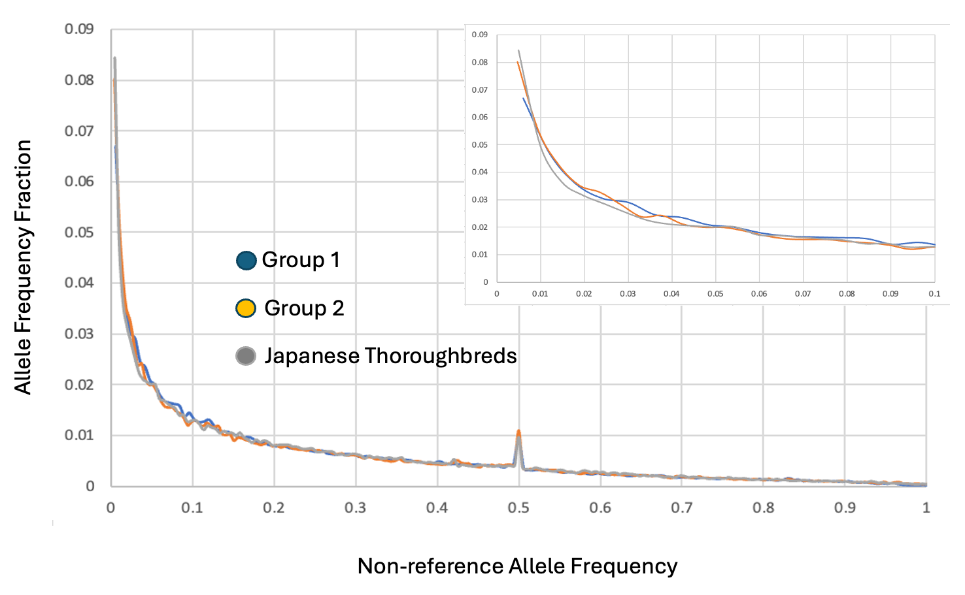

Figure S1. The frequency distribution of variants found in the 2 US Groups and the Japanese Thoroughbreds²¹. The inset shows those non-reference alleles with a frequency <0.1. The peak observed at maf=0.5 is often recorded and is an artifact due to duplicated regions that are fixed in the population but are collapsed to a single representation in the genome assembly. Variation between the duplicated regions will be reported as heterozygous genotypes in all animals, resulting in an artifactual maf of 0.5.

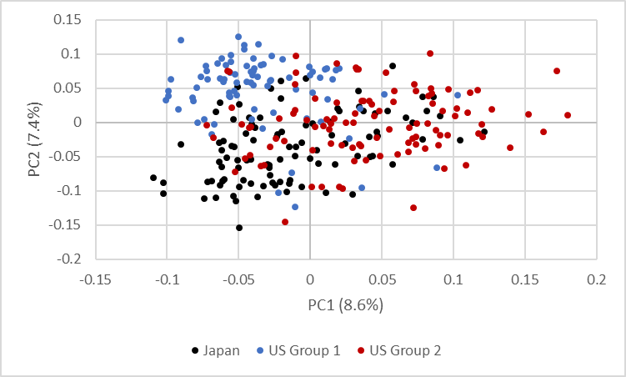

Figure S2. Principal component bi-plot utilizing 9,044 variants chosen at random (every 250kb) to reduce bias due to LD of the 185 US horses and data from Tozaki et al. (2021)²¹ colored by sample. PCs 1 and 2 explain 8.6 and 7.4% of the variation, respectively.

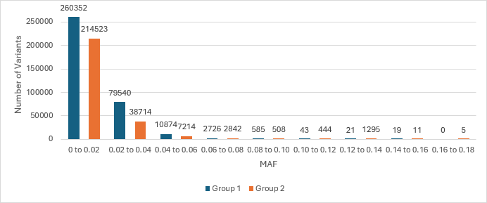

Figure S3. Minor allele frequency distribution of unique variants defined as those loci for which the alternative allele was observed 2 or more times in one Group while no alternative alleles were observed in the other.

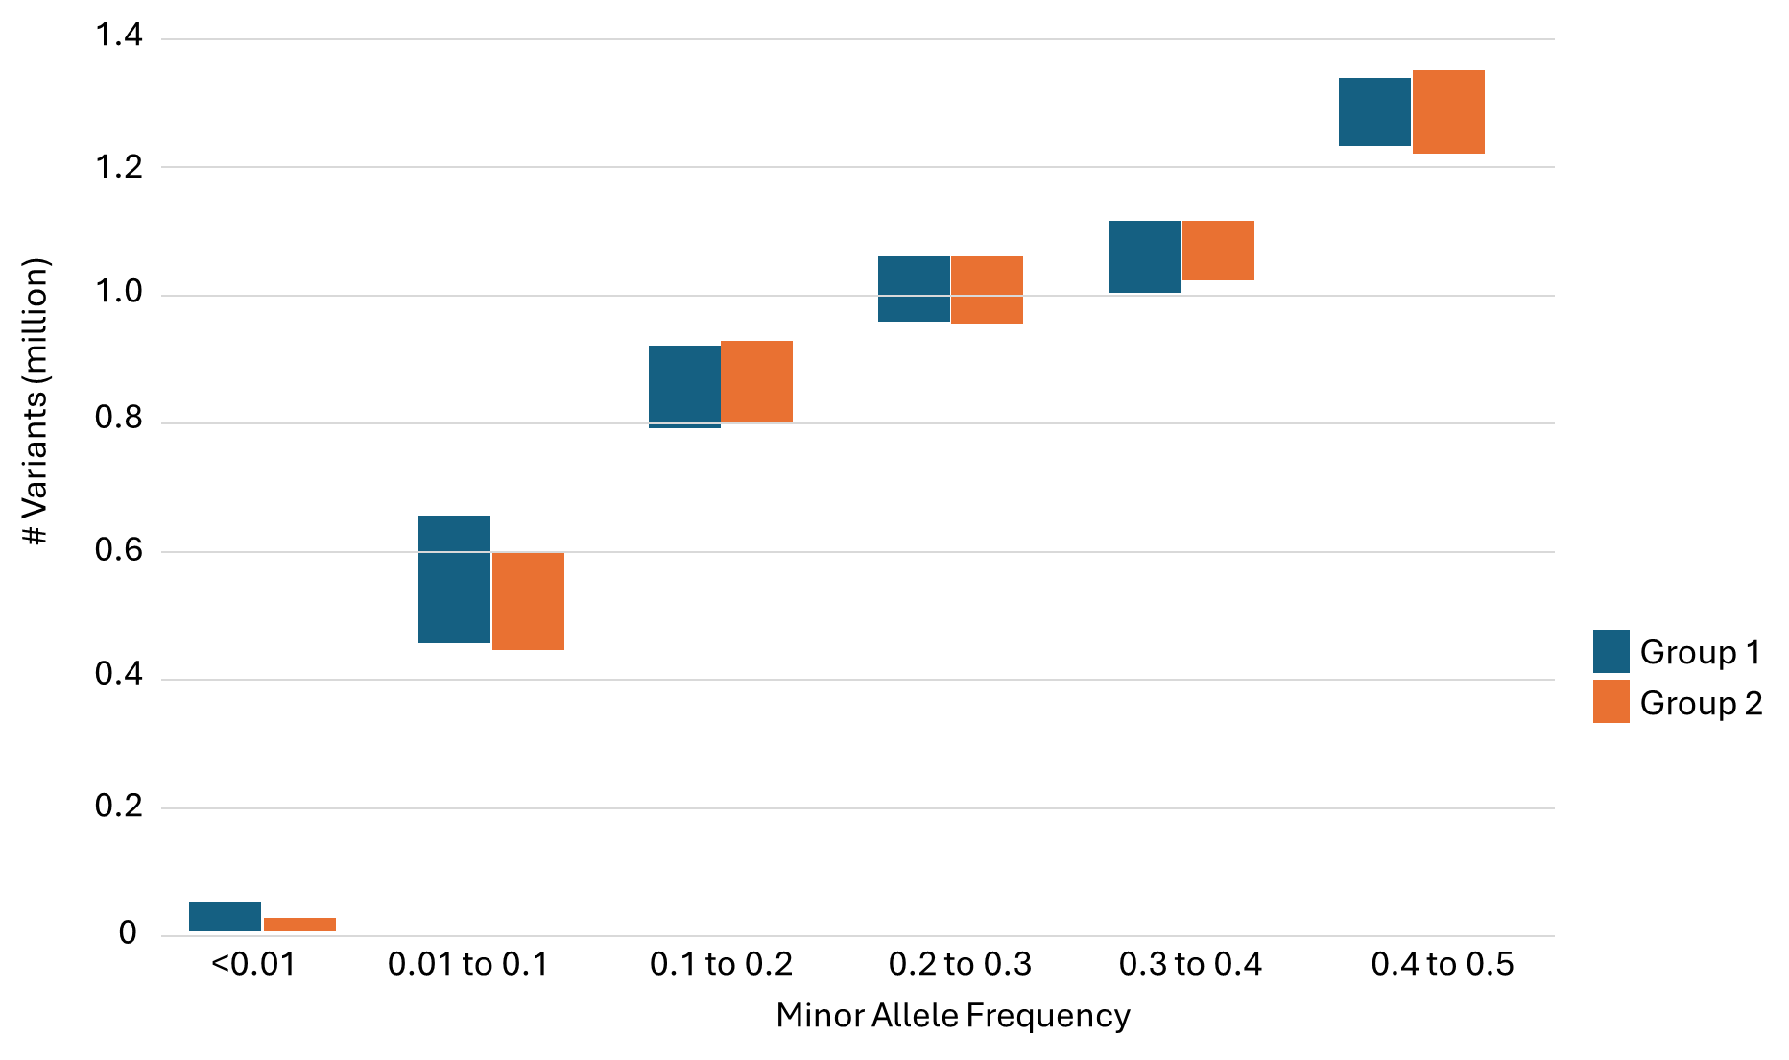

Figure S4. Counts of variants per group classified by minor allele frequency of the allele within that group.

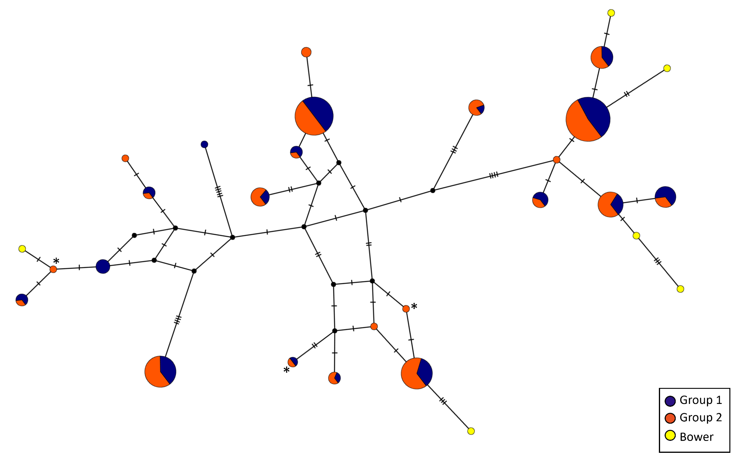
Figure S5. Neighbor joining network of D-loop (346 bp) mtDNA haplotypes of the 185 US horses (colored by Group). Except for three haplotypes designated by an asterisk, all others were previously identified (Bower et al. 2013)³⁴. Those identified in Bower et al.,³⁴ or Hill et al.³³ that were not present in the sample of US horses are shown in yellow.
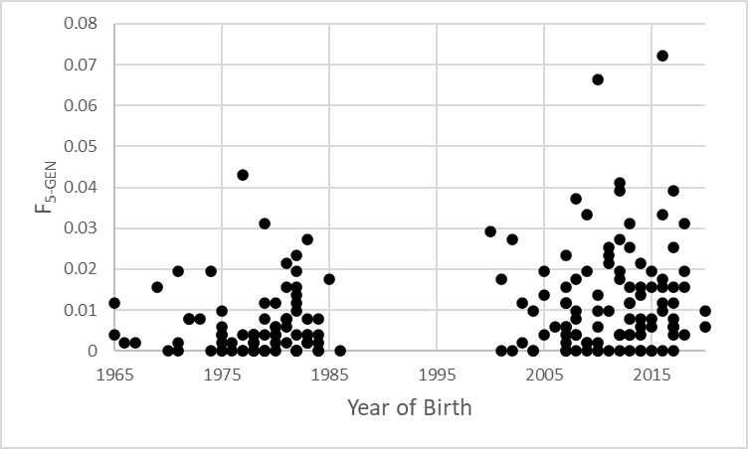
Figure S6. Estimated inbreeding coefficient from 5-generations of pedigree data of the 185 study horses. Average inbreeding in Group 1 horses (0.006) was significantly greater than that of Group 2 horses (0.012).
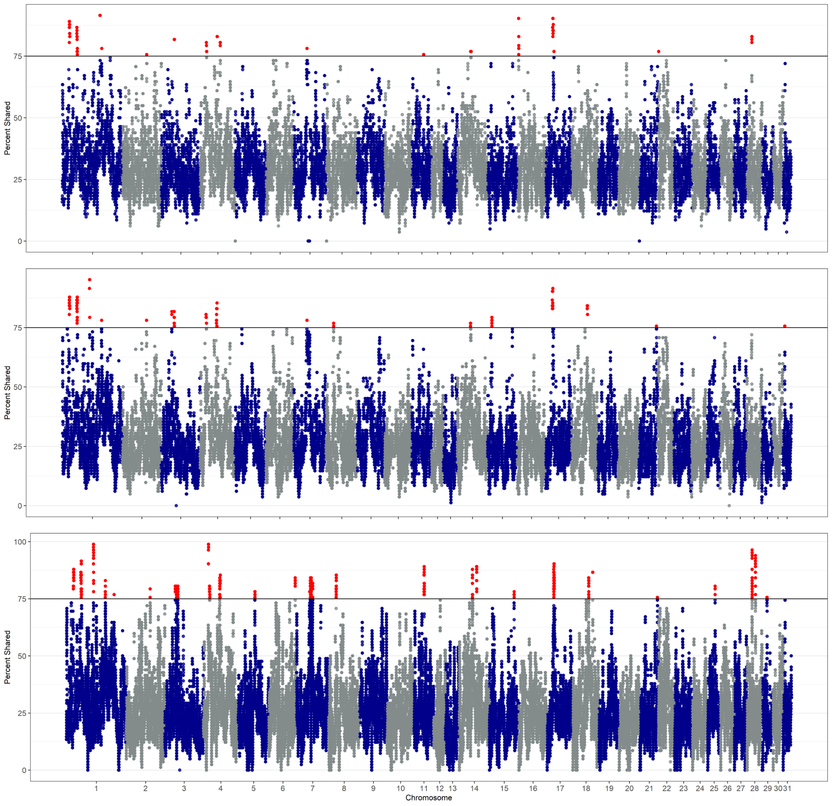

Figure S7. ROH for Group 1 based upon loci in the GGP (top) and HD (middle) arrays, as well as that identified from the WGS (bottom). Loci in ROH that are shared by 75% or more of the horses in the sample are shown in red.

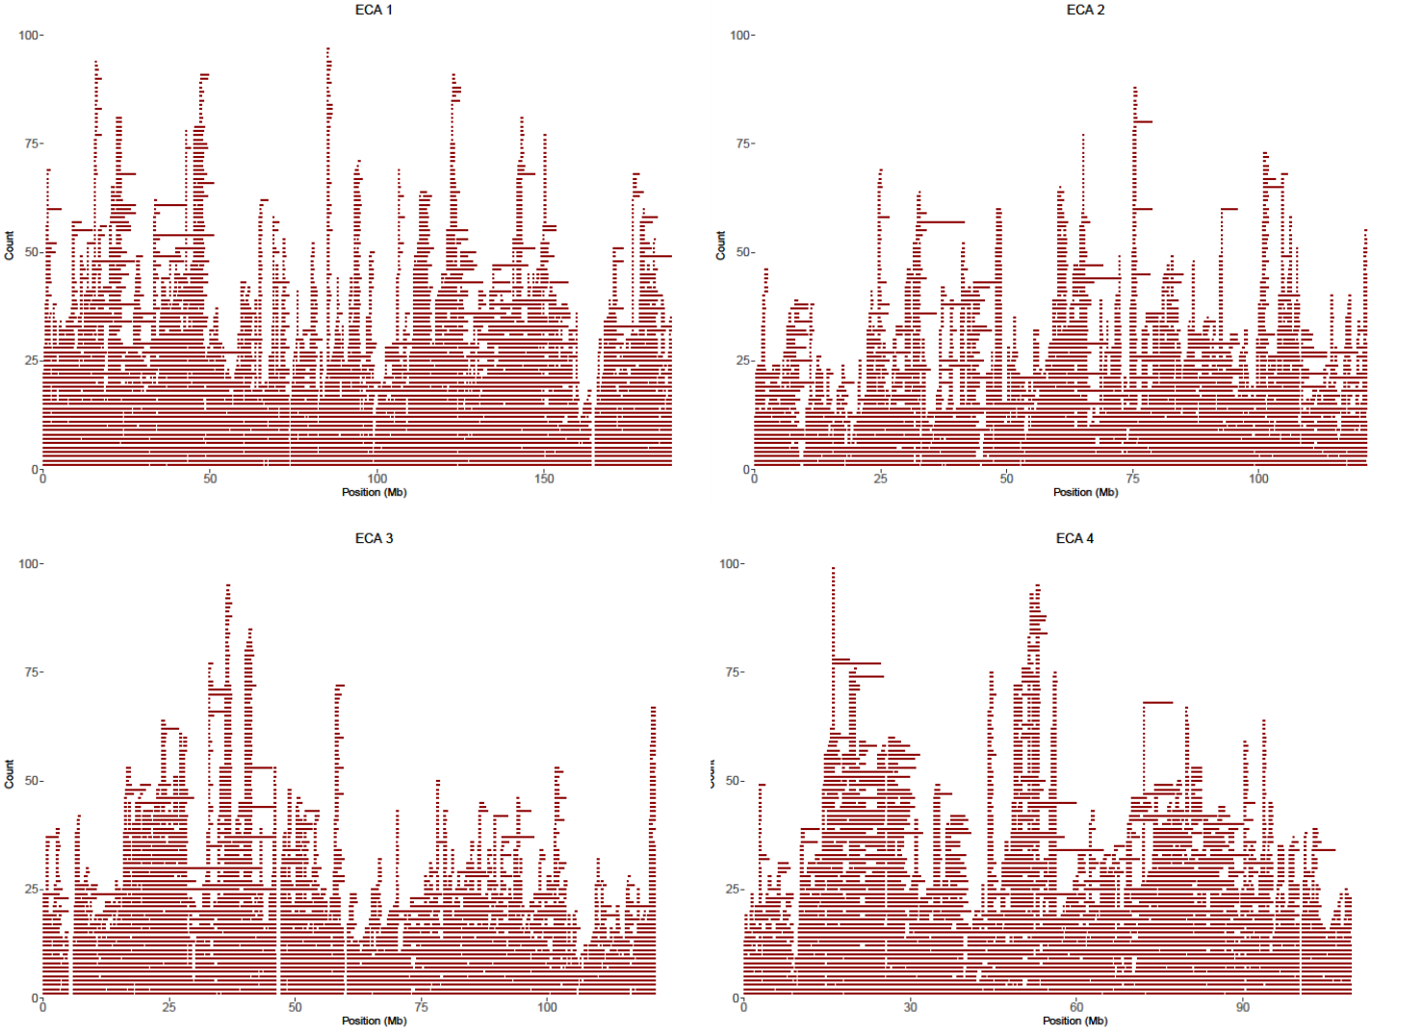
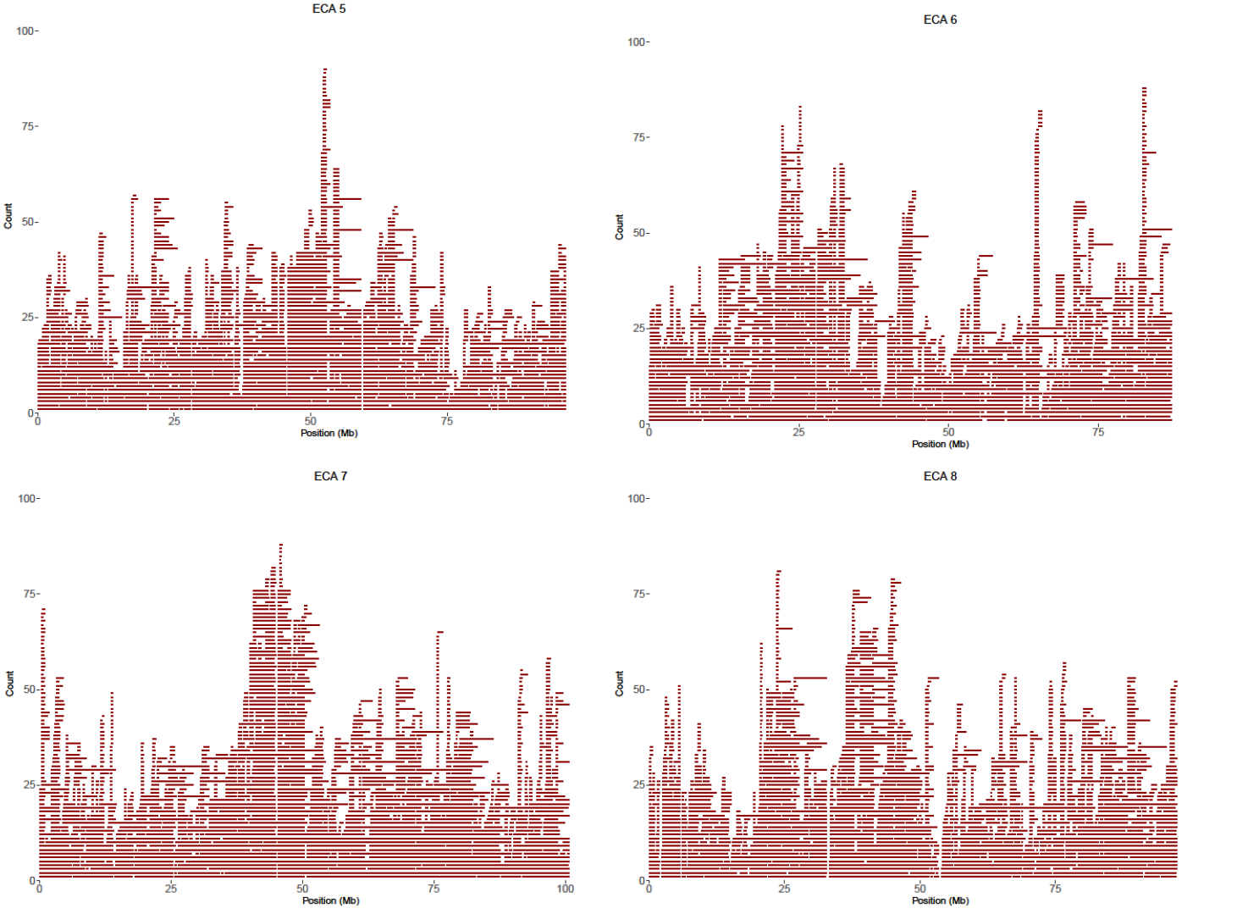
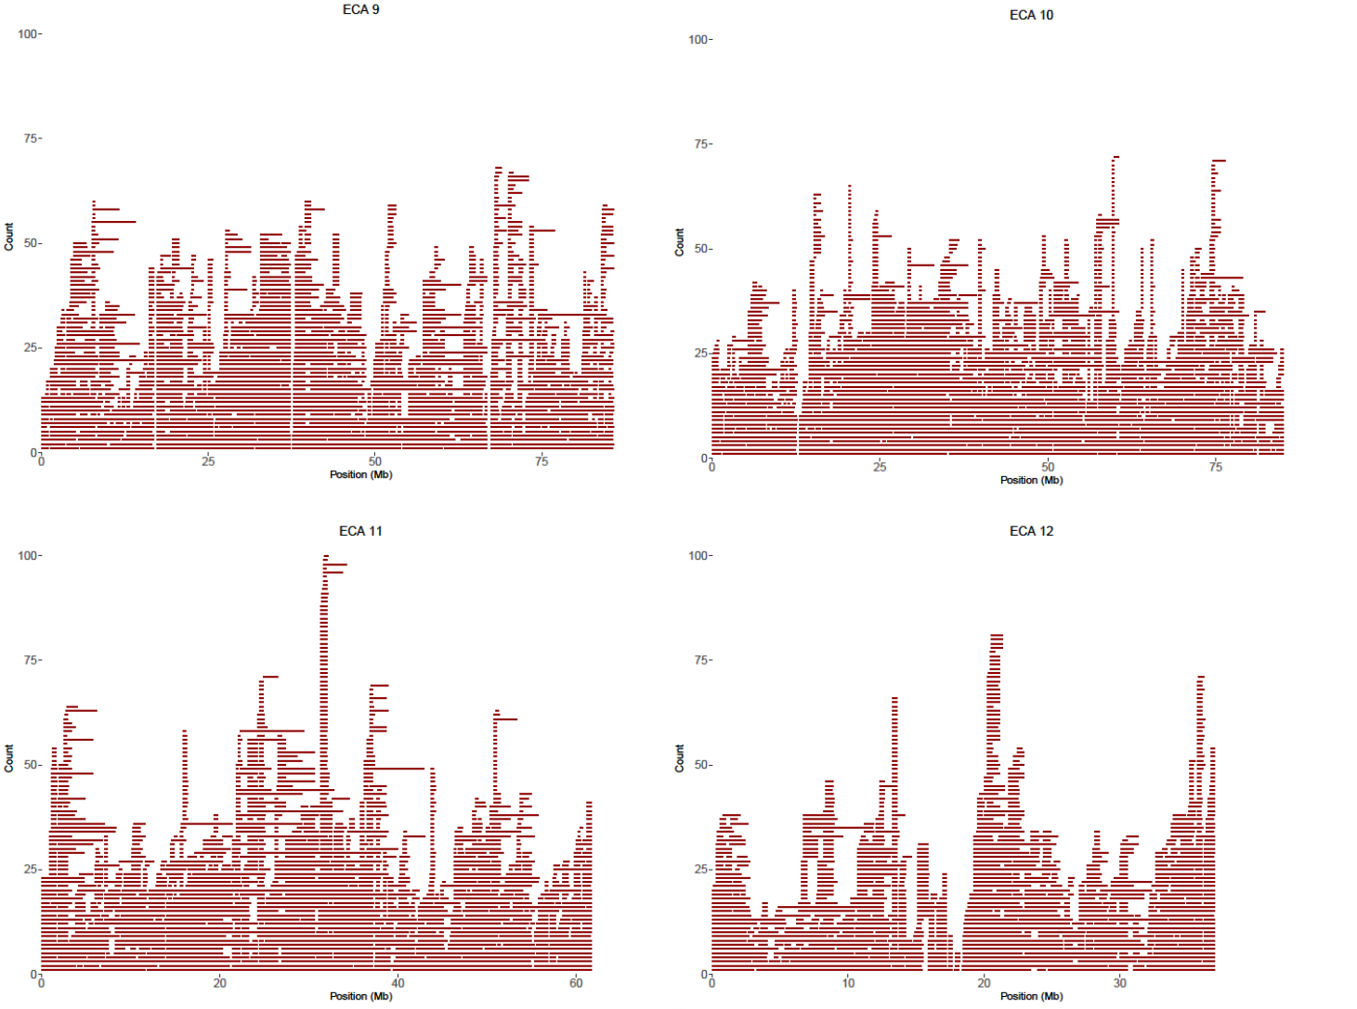
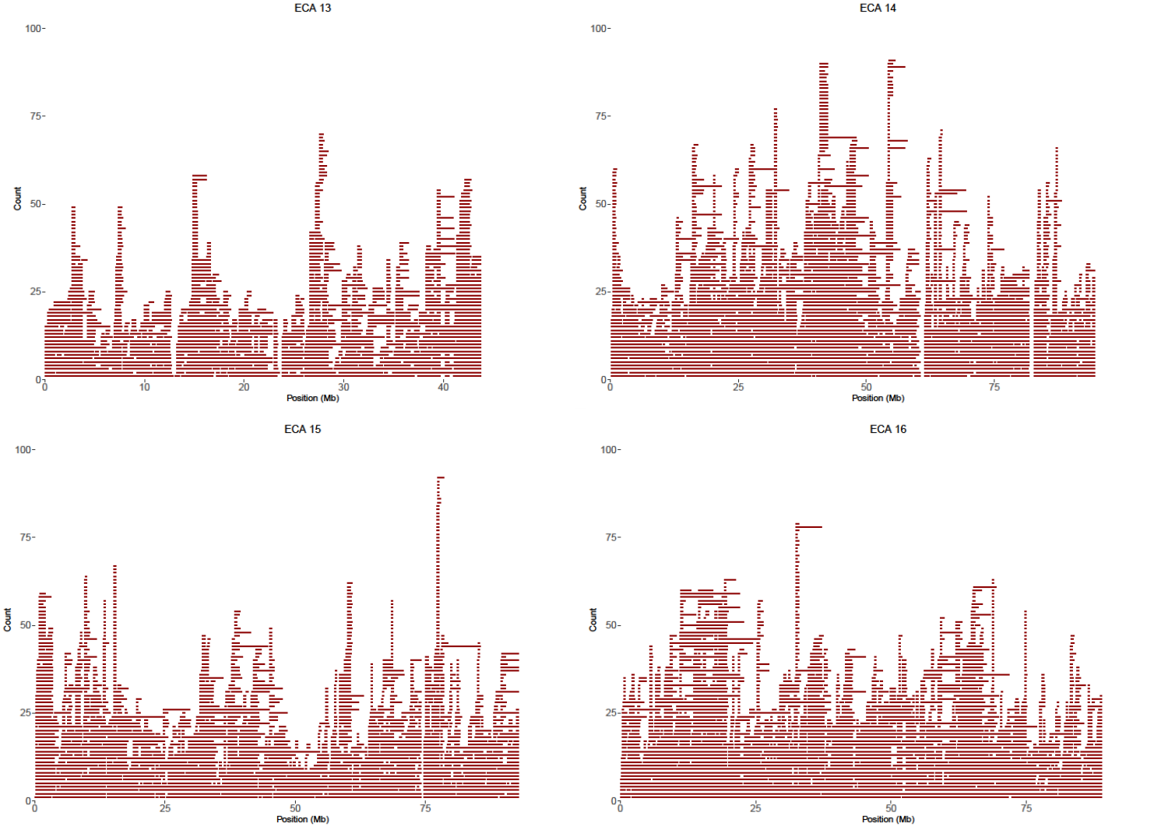
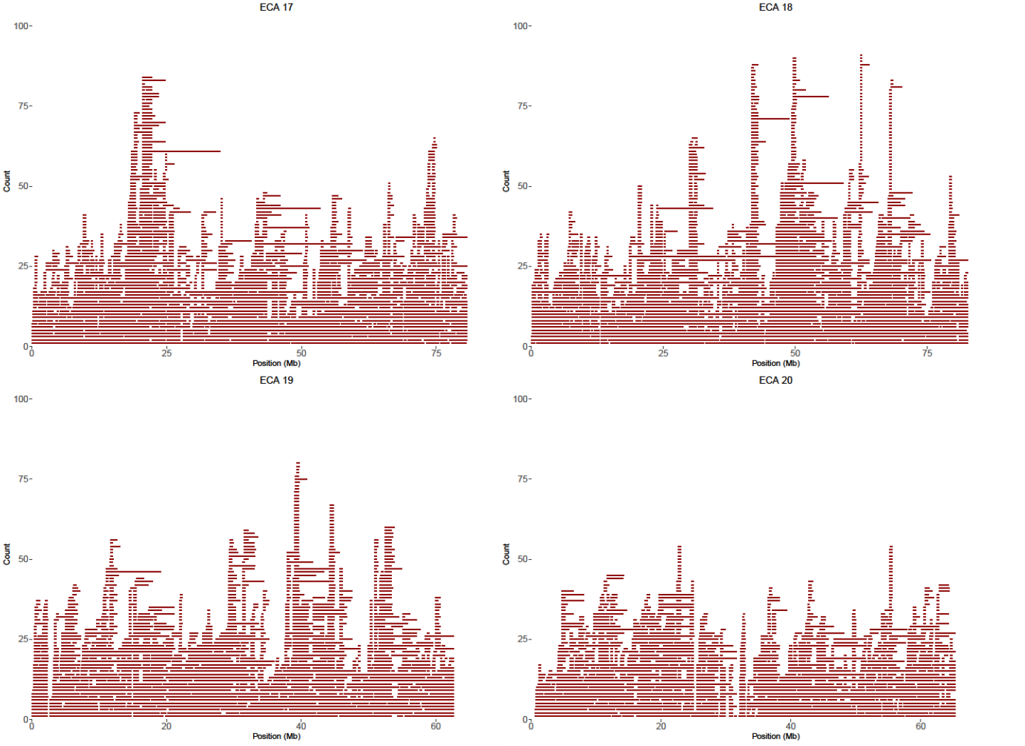
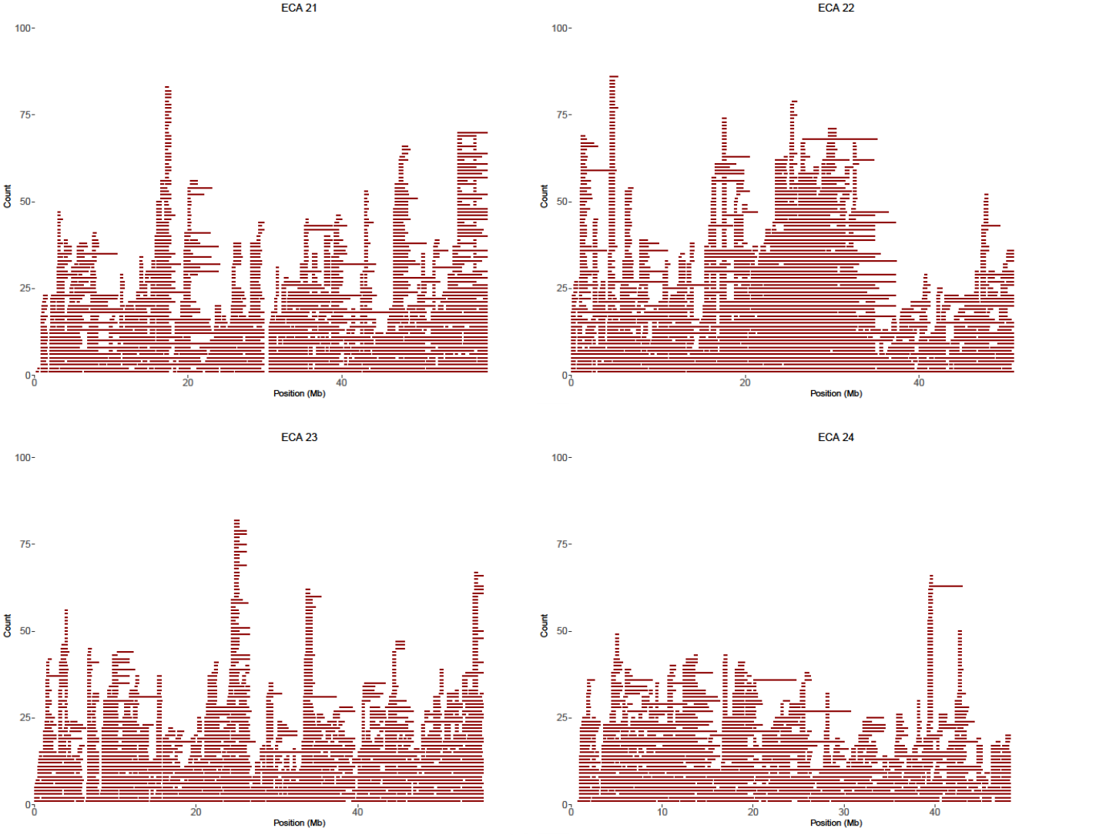
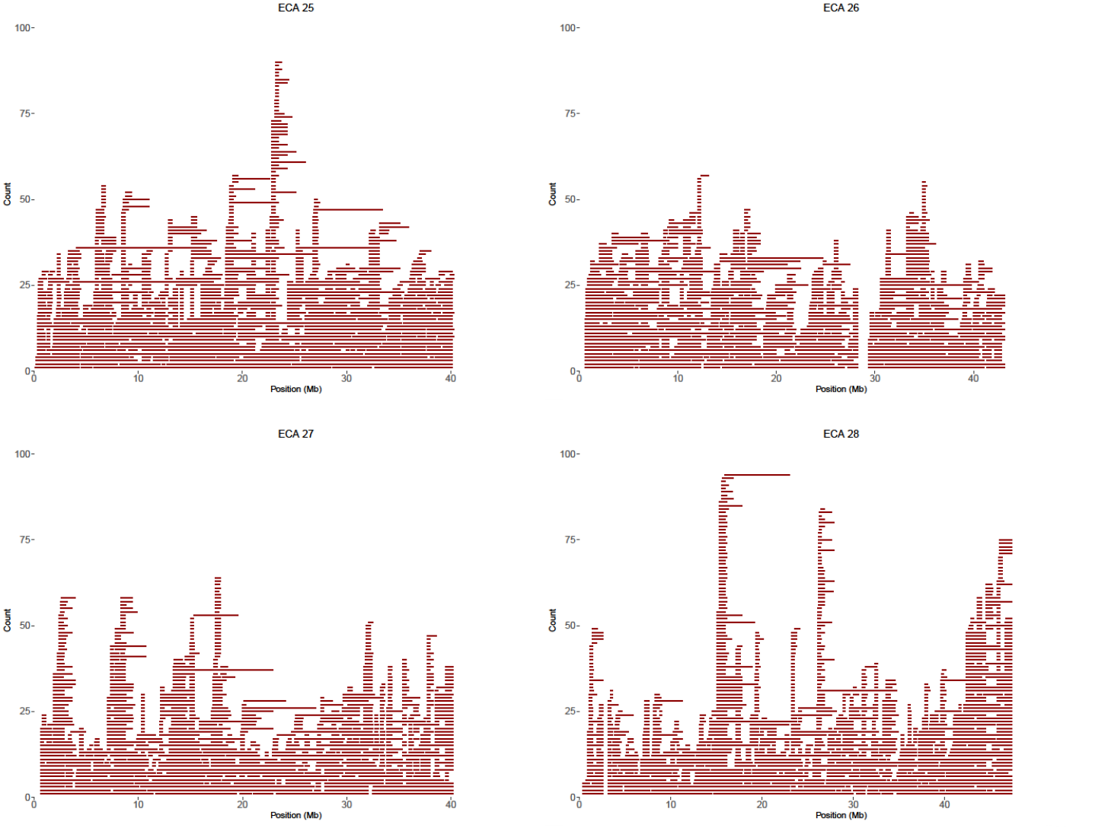
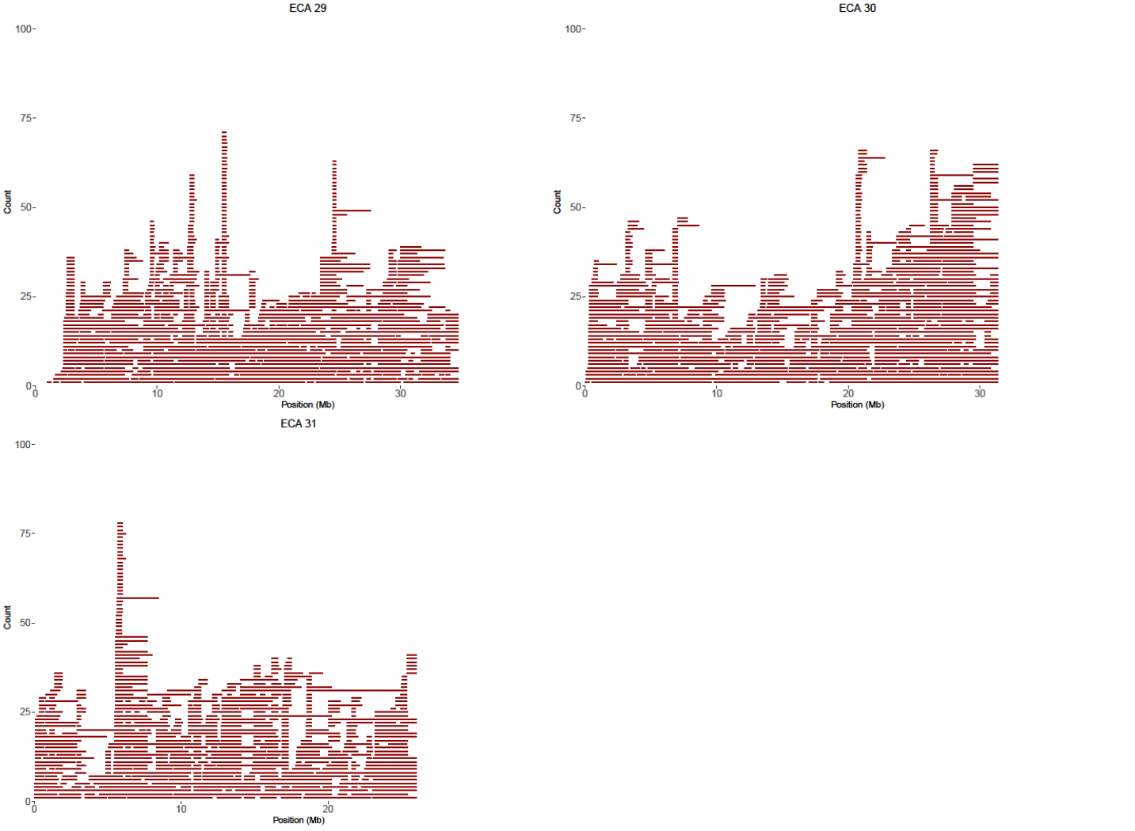
Figure S8. ROH (count of 103 horses) for each autosome observed in Group 2.

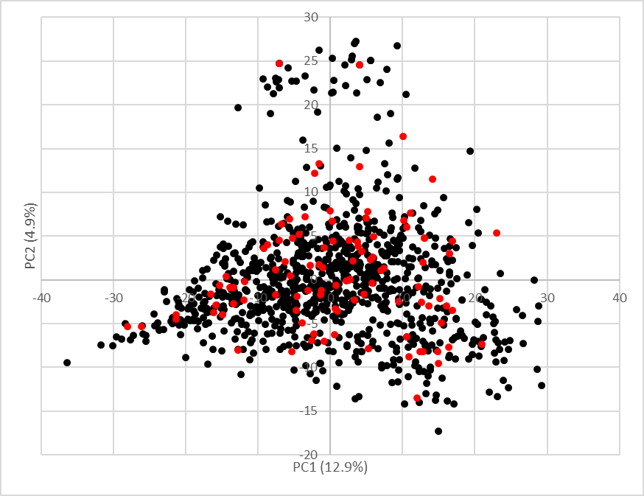

Figure S9. Principal component bi-plot of the connectedness among pedigrees of 1,009 Thoroughbreds born between 2000 and 2020 from which a DNA sample was obtained (Group 2). PCs 1 and 2 explain 12.9 and 4.9% of the variation, respectively. Red points indicate samples included in sequence analyses.

 |  | SNP |  |  | Indel
Group | Sample ID | Heterozygous | Homozygous | Total | Heterozygous | Homozygous | Total | Total Variants
Group 1 | KY0299 | 3187223 | 1198382 | 4385605 | 289559 | 129664 | 419223 | 4804828
Group 1 | XX105 | 3253110 | 1183902 | 4437012 | 295391 | 124973 | 420364 | 4857376
Group 1 | XX106 | 3125667 | 1250492 | 4376159 | 286123 | 133574 | 419697 | 4795856
Group 1 | XX108 | 3161766 | 1176912 | 4338678 | 288652 | 129655 | 418307 | 4756985
Group 1 | XX110 | 3100368 | 1347860 | 4448228 | 282980 | 141610 | 424590 | 4872818
Group 1 | XX111 | 3200770 | 1185838 | 4386608 | 291220 | 128039 | 419259 | 4805867
Group 1 | KY0295 | 3254267 | 1159808 | 4414075 | 295360 | 126260 | 421620 | 4835695
Group 1 | KY1216 | 3227528 | 1234086 | 4461614 | 294745 | 131675 | 426420 | 4888034
Group 1 | KY1325 | 3123017 | 1255148 | 4378165 | 287178 | 132000 | 419178 | 4797343
Group 1 | KY0282 | 3273694 | 1165372 | 4439066 | 299095 | 126214 | 425309 | 4864375
Group 1 | KY1189 | 3248554 | 1320626 | 4569180 | 296386 | 139228 | 435614 | 5004794
Group 1 | KY0333 | 3157645 | 1278011 | 4435656 | 289272 | 133700 | 422972 | 4858628
Group 1 | KY0283 | 3365637 | 1216648 | 4582285 | 305920 | 129755 | 435675 | 5017960
Group 1 | KY0608 | 3214265 | 1199980 | 4414245 | 291633 | 128019 | 419652 | 4833897
Group 1 | KY0241 | 3125099 | 1188753 | 4313852 | 282477 | 131451 | 413928 | 4727780
Group 1 | KY0311 | 3195903 | 1234623 | 4430526 | 290302 | 132641 | 422943 | 4853469
Group 1 | KY0325 | 3135476 | 1246052 | 4381528 | 283612 | 130708 | 414320 | 4795848
Group 1 | KY1218 | 2864120 | 1261670 | 4125790 | 258959 | 136298 | 395257 | 4521047
Group 1 | KY1228 | 3239490 | 1180742 | 4420232 | 296539 | 126687 | 423226 | 4843458
Group 1 | KY1257 | 3083508 | 1200182 | 4283690 | 279030 | 130274 | 409304 | 4692994
Group 1 | KY1335 | 3347123 | 1146831 | 4493954 | 304620 | 124301 | 428921 | 4922875
Group 1 | KY0313 | 3110635 | 1241097 | 4351732 | 280656 | 133987 | 414643 | 4766375
Group 1 | KY1175 | 3320015 | 1169634 | 4489649 | 304012 | 125470 | 429482 | 4919131
Group 1 | KY0289 | 3261759 | 1227274 | 4489033 | 297178 | 129752 | 426930 | 4915963
Group 1 | KY0463 | 3260114 | 1167100 | 4427214 | 295104 | 127086 | 422190 | 4849404
Group 1 | KY0646 | 2975680 | 1333674 | 4309354 | 272475 | 141753 | 414228 | 4723582
Group 1 | KY1220 | 3302849 | 1110603 | 4413452 | 300151 | 120492 | 420643 | 4834095
Group 1 | KY0250 | 3189240 | 1283736 | 4472976 | 290882 | 132922 | 423804 | 4896780
Group 1 | KY0280 | 3154150 | 1252552 | 4406702 | 286413 | 132993 | 419406 | 4826108
Group 1 | KY0287 | 3209593 | 1188926 | 4398519 | 290929 | 127314 | 418243 | 4816762
Group 1 | KY0293 | 3232630 | 1283949 | 4516579 | 295493 | 134122 | 429615 | 4946194
Group 1 | KY0298 | 3065971 | 1156480 | 4222451 | 280520 | 125481 | 406001 | 4628452
Group 1 | KY0461 | 3212232 | 1172128 | 4384360 | 289983 | 126314 | 416297 | 4800657
Group 1 | KY0607 | 3248265 | 1223108 | 4471373 | 295532 | 128787 | 424319 | 4895692
Group 1 | KY1191 | 3231058 | 1204744 | 4435802 | 292027 | 128852 | 420879 | 4856681
Group 1 | KY1203 | 3294403 | 1217288 | 4511691 | 299232 | 127356 | 426588 | 4938279
Group 1 | KY0240 | 3318263 | 1190712 | 4508975 | 302576 | 128952 | 431528 | 4940503
Group 1 | KY0248 | 3324791 | 1200756 | 4525547 | 301563 | 126429 | 427992 | 4953539
Group 1 | KY0285 | 3103023 | 1188760 | 4291783 | 279030 | 128867 | 407897 | 4699680
Group 1 | KY0291 | 3158769 | 1195134 | 4353903 | 287099 | 128653 | 415752 | 4769655
Group 1 | KY0319 | 3237181 | 1256335 | 4493516 | 295377 | 133915 | 429292 | 4922808
Group 1 | KY0465 | 3163389 | 1212710 | 4376099 | 291207 | 132652 | 423859 | 4799958
Group 1 | KY1259 | 3232218 | 1250031 | 4482249 | 294456 | 132521 | 426977 | 4909226
Group 1 | KY0243 | 3295053 | 1196762 | 4491815 | 300402 | 128967 | 429369 | 4921184
Group 1 | KY0244 | 3198819 | 1187716 | 4386535 | 290341 | 129062 | 419403 | 4805938
Group 1 | KY0245 | 3206067 | 1170655 | 4376722 | 290462 | 130409 | 420871 | 4797593
Group 1 | KY0276 | 3231481 | 1220421 | 4451902 | 294967 | 131070 | 426037 | 4877939
Group 1 | KY0621 | 3232674 | 1180683 | 4413357 | 291280 | 126825 | 418105 | 4831462
Group 1 | KY1224 | 3340907 | 1154200 | 4495107 | 302743 | 123812 | 426555 | 4921662
Group 1 | KY1321 | 3140386 | 1198268 | 4338654 | 282484 | 129883 | 412367 | 4751021
Group 1 | KY0247 | 3335097 | 1134346 | 4469443 | 300688 | 122470 | 423158 | 4892601
Group 1 | KY0278 | 3146359 | 1172346 | 4318705 | 286546 | 127489 | 414035 | 4732740
Group 1 | KY0303 | 3150010 | 1250918 | 4400928 | 288580 | 132977 | 421557 | 4822485
Group 1 | KY1205 | 3133143 | 1320349 | 4453492 | 286037 | 136260 | 422297 | 4875789
Group 1 | KY1235 | 3108253 | 1286817 | 4395070 | 282062 | 136438 | 418500 | 4813570
Group 1 | KY1249 | 3034115 | 1296759 | 4330874 | 274341 | 135784 | 410125 | 4740999
Group 1 | KY1281 | 3313413 | 1172036 | 4485449 | 300690 | 125525 | 426215 | 4911664
Group 1 | KY0309 | 3320254 | 1205622 | 4525876 | 304386 | 128816 | 433202 | 4959078
Group 1 | KY0323 | 3250284 | 1174826 | 4425110 | 292959 | 129259 | 422218 | 4847328
Group 1 | KY0469 | 3152187 | 1256171 | 4408358 | 287477 | 134976 | 422453 | 4830811
Group 1 | KY0474 | 3245098 | 1172214 | 4417312 | 294765 | 126552 | 421317 | 4838629
Group 1 | KY0477 | 3150425 | 1218658 | 4369083 | 287289 | 129164 | 416453 | 4785536
Group 1 | KY0606 | 3350468 | 1126539 | 4477007 | 304232 | 124553 | 428785 | 4905792
Group 1 | KY0620 | 3229576 | 1190941 | 4420517 | 292821 | 129153 | 421974 | 4842491
Group 1 | KY1181 | 3009351 | 1351512 | 4360863 | 272913 | 143987 | 416900 | 4777763
Group 1 | KY1230 | 3414994 | 1180911 | 4595905 | 308538 | 126736 | 435274 | 5031179
Group 1 | KY1323 | 3121627 | 1340378 | 4462005 | 283333 | 138899 | 422232 | 4884237
Group 1 | KY2439 | 3249863 | 1221024 | 4470887 | 297091 | 129015 | 426106 | 4896993
Group 1 | KY0274 | 3135317 | 1281872 | 4417189 | 285665 | 138922 | 424587 | 4841776
Group 1 | KY0331 | 3167236 | 1170797 | 4338033 | 287307 | 126279 | 413586 | 4751619
Group 1 | KY0604 | 3191076 | 1255046 | 4446122 | 292447 | 134079 | 426526 | 4872648
Group 1 | KY1226 | 3221618 | 1145407 | 4367025 | 294411 | 125316 | 419727 | 4786752
Group 1 | KY1266 | 3168498 | 1219036 | 4387534 | 287379 | 131322 | 418701 | 4806235
Group 1 | KY1319 | 3157611 | 1152169 | 4309780 | 284859 | 123271 | 408130 | 4717910
Group 1 | KY1327 | 3231925 | 1209351 | 4441276 | 294054 | 129149 | 423203 | 4864479
Group 1 | KY0329 | 3188818 | 1237278 | 4426096 | 289873 | 131255 | 421128 | 4847224
Group 1 | KY1172 | 3179025 | 1210256 | 4389281 | 290319 | 128826 | 419145 | 4808426
Group 1 | KY1211 | 3235005 | 1192982 | 4427987 | 295272 | 129304 | 424576 | 4852563
Group 1 | KY1222 | 3278476 | 1270283 | 4548759 | 301379 | 133490 | 434869 | 4983628
Group 1 | KY1275 | 3266197 | 1193776 | 4459973 | 296332 | 127622 | 423954 | 4883927
Group 1 | KY1207 | 3191540 | 1257522 | 4449062 | 291148 | 134696 | 425844 | 4874906
Group 1 | KY1183 | 3055668 | 1294145 | 4349813 | 277885 | 136970 | 414855 | 4764668
Group 2 | RC003 | 3183327 | 1197169 | 4380496 | 290165 | 131089 | 421254 | 4801750
Group 2 | RC015 | 3135034 | 1216516 | 4351550 | 284533 | 133746 | 418279 | 4769829
Group 2 | RC051 | 3282696 | 1126067 | 4408763 | 298348 | 122166 | 420514 | 4829277
Group 2 | RC014 | 3119252 | 1232798 | 4352050 | 284429 | 133735 | 418164 | 4770214
Group 2 | SRR19364641 | 3222207 | 1151242 | 4373449 | 295830 | 125549 | 421379 | 4794828
Group 2 | RC032 | 3145357 | 1191079 | 4336436 | 285746 | 129633 | 415379 | 4751815
Group 2 | RC075 | 3011345 | 1249148 | 4260493 | 273023 | 136885 | 409908 | 4670401
Group 2 | SRR19364580 | 3212263 | 1200349 | 4412612 | 294631 | 131953 | 426584 | 4839196
Group 2 | RC017 | 3143921 | 1168382 | 4312303 | 283154 | 126619 | 409773 | 4722076
Group 2 | RC071 | 3104424 | 1226330 | 4330754 | 282471 | 132718 | 415189 | 4745943
Group 2 | SRR19364619 | 3176922 | 1220781 | 4397703 | 294518 | 130043 | 424561 | 4822264
Group 2 | RC033 | 3115761 | 1180380 | 4296141 | 286559 | 128567 | 415126 | 4711267
Group 2 | RC035 | 3100069 | 1264129 | 4364198 | 282573 | 137154 | 419727 | 4783925
Group 2 | SRR19364593 | 3308583 | 1119993 | 4428576 | 306193 | 121189 | 427382 | 4855958
Group 2 | SRR19364628 | 2940498 | 1263319 | 4203817 | 270968 | 137792 | 408760 | 4612577
Group 2 | RC006 | 3267442 | 1174806 | 4442248 | 296666 | 128612 | 425278 | 4867526
Group 2 | RC007 | 3115021 | 1293729 | 4408750 | 284596 | 135363 | 419959 | 4828709
Group 2 | RC008 | 2982798 | 1266477 | 4249275 | 271370 | 136093 | 407463 | 4656738
Group 2 | RC076 | 3219098 | 1259779 | 4478877 | 291677 | 136184 | 427861 | 4906738
Group 2 | RC078 | 3139410 | 1203990 | 4343400 | 283876 | 130177 | 414053 | 4757453
Group 2 | RC094 | 3194527 | 1188989 | 4383516 | 290051 | 130207 | 420258 | 4803774
Group 2 | SRR19364613 | 3143775 | 1279445 | 4423220 | 290786 | 137488 | 428274 | 4851494
Group 2 | SRR19364627 | 3269869 | 1224612 | 4494481 | 300920 | 132208 | 433128 | 4927609
Group 2 | SRR19364632 | 3171990 | 1186118 | 4358108 | 293000 | 128397 | 421397 | 4779505
Group 2 | SRR19364654 | 3069257 | 1258506 | 4327763 | 284013 | 138164 | 422177 | 4749940
Group 2 | RC016 | 2991802 | 1219380 | 4211182 | 271919 | 133935 | 405854 | 4617036
Group 2 | RC026 | 3193947 | 1165731 | 4359678 | 292532 | 130523 | 423055 | 4782733
Group 2 | RC029 | 3142073 | 1205570 | 4347643 | 288736 | 132890 | 421626 | 4769269
Group 2 | RC077 | 3074993 | 1244461 | 4319454 | 279986 | 136843 | 416829 | 4736283
Group 2 | RC096 | 3182550 | 1208558 | 4391108 | 291659 | 130868 | 422527 | 4813635
Group 2 | SRR19364602 | 3229556 | 1243554 | 4473110 | 297058 | 134886 | 431944 | 4905054
Group 2 | SRR19364605 | 3140536 | 1259396 | 4399932 | 289611 | 137756 | 427367 | 4827299
Group 2 | RC009 | 3305088 | 1208930 | 4514018 | 301613 | 130116 | 431729 | 4945747
Group 2 | RC031 | 3122087 | 1210412 | 4332499 | 286787 | 130111 | 416898 | 4749397
Group 2 | RC036 | 3253644 | 1160966 | 4414610 | 297965 | 126358 | 424323 | 4838933
Group 2 | RC039 | 3054952 | 1209305 | 4264257 | 278626 | 132761 | 411387 | 4675644
Group 2 | SRR19364644 | 3297463 | 1141444 | 4438907 | 302464 | 126719 | 429183 | 4868090
Group 2 | RC041 | 3141203 | 1225693 | 4366896 | 284434 | 132989 | 417423 | 4784319
Group 2 | RC080 | 3213838 | 1209455 | 4423293 | 292198 | 132487 | 424685 | 4847978
Group 2 | RC082 | 3109000 | 1239481 | 4348481 | 282030 | 134486 | 416516 | 4764997
Group 2 | SRR19364586 | 3153601 | 1235612 | 4389213 | 288290 | 133437 | 421727 | 4810940
Group 2 | SRR19364587 | 3221974 | 1157277 | 4379251 | 295912 | 126801 | 422713 | 4801964
Group 2 | SRR19364629 | 3366938 | 1158681 | 4525619 | 308679 | 126219 | 434898 | 4960517
Group 2 | RC001 | 3254958 | 1179975 | 4434933 | 297975 | 130654 | 428629 | 4863562
Group 2 | RC013 | 2992453 | 1307244 | 4299697 | 271962 | 142641 | 414603 | 4714300
Group 2 | RC068 | 3244796 | 1192114 | 4436910 | 296440 | 130106 | 426546 | 4863456
Group 2 | RC079 | 3137011 | 1206077 | 4343088 | 284193 | 129902 | 414095 | 4757183
Group 2 | SRR19364583 | 3170848 | 1190831 | 4361679 | 292710 | 129769 | 422479 | 4784158
Group 2 | RC022 | 3185464 | 1188640 | 4374104 | 290541 | 126724 | 417265 | 4791369
Group 2 | RC023 | 3103593 | 1215917 | 4319510 | 285313 | 133802 | 419115 | 4738625
Group 2 | RC028 | 3243966 | 1139443 | 4383409 | 298032 | 124444 | 422476 | 4805885
Group 2 | RC044 | 3176583 | 1196819 | 4373402 | 290163 | 129674 | 419837 | 4793239
Group 2 | RC060 | 3050536 | 1231052 | 4281588 | 276364 | 131844 | 408208 | 4689796
Group 2 | RC065 | 2987662 | 1210138 | 4197800 | 269048 | 133695 | 402743 | 4600543
Group 2 | RC074 | 2891562 | 1242461 | 4134023 | 262449 | 134614 | 397063 | 4531086
Group 2 | RC093 | 3117847 | 1213489 | 4331336 | 282668 | 130550 | 413218 | 4744554
Group 2 | SRR19364645 | 3176316 | 1175674 | 4351990 | 293399 | 126066 | 419465 | 4771455
Group 2 | RC002 | 3097675 | 1219039 | 4316714 | 281581 | 133356 | 414937 | 4731651
Group 2 | RC018 | 3076792 | 1212229 | 4289021 | 279599 | 133195 | 412794 | 4701815
Group 2 | RC020 | 3062638 | 1269352 | 4331990 | 280490 | 135985 | 416475 | 4748465
Group 2 | RC038 | 3163934 | 1205593 | 4369527 | 287510 | 132984 | 420494 | 4790021
Group 2 | RC042 | 2989824 | 1187213 | 4177037 | 271869 | 130380 | 402249 | 4579286
Group 2 | RC058 | 3147422 | 1168208 | 4315630 | 286834 | 127235 | 414069 | 4729699
Group 2 | RC069 | 3224424 | 1243994 | 4468418 | 294630 | 135253 | 429883 | 4898301
Group 2 | RC091 | 3096525 | 1276279 | 4372804 | 281190 | 135184 | 416374 | 4789178
Group 2 | SRR19364589 | 3196603 | 1187303 | 4383906 | 294429 | 128043 | 422472 | 4806378
Group 2 | RC021 | 3179811 | 1257488 | 4437299 | 294791 | 134645 | 429436 | 4866735
Group 2 | RC059 | 3077437 | 1213862 | 4291299 | 278635 | 133938 | 412573 | 4703872
Group 2 | RC061 | 3220997 | 1130686 | 4351683 | 293766 | 121408 | 415174 | 4766857
Group 2 | RC072 | 3050751 | 1253068 | 4303819 | 278410 | 134476 | 412886 | 4716705
Group 2 | RC092 | 3031641 | 1276366 | 4308007 | 275104 | 139192 | 414296 | 4722303
Group 2 | RC095 | 3211066 | 1201467 | 4412533 | 289769 | 128042 | 417811 | 4830344
Group 2 | RC097 | 3131653 | 1236085 | 4367738 | 287020 | 135471 | 422491 | 4790229
Group 2 | SRR19364621 | 3104948 | 1230387 | 4335335 | 284604 | 134228 | 418832 | 4754167
Group 2 | RC010 | 3128705 | 1228703 | 4357408 | 284386 | 132375 | 416761 | 4774169
Group 2 | RC012 | 3171994 | 1236060 | 4408054 | 289093 | 134539 | 423632 | 4831686
Group 2 | RC025 | 3113402 | 1272642 | 4386044 | 285005 | 136742 | 421747 | 4807791
Group 2 | RC067 | 3237054 | 1234276 | 4471330 | 294900 | 133186 | 428086 | 4899416
Group 2 | RC070 | 3157827 | 1198859 | 4356686 | 285995 | 130123 | 416118 | 4772804
Group 2 | SRR19364585 | 3243341 | 1197342 | 4440683 | 296164 | 128485 | 424649 | 4865332
Group 2 | RC005 | 3098415 | 1215554 | 4313969 | 283713 | 135239 | 418952 | 4732921
Group 2 | RC011 | 3241932 | 1201221 | 4443153 | 295251 | 129484 | 424735 | 4867888
Group 2 | RC024 | 3185455 | 1182841 | 4368296 | 292905 | 129708 | 422613 | 4790909
Group 2 | RC027 | 2979217 | 1319299 | 4298516 | 273744 | 137433 | 411177 | 4709693
Group 2 | RC040 | 3022357 | 1307681 | 4330038 | 276336 | 139622 | 415958 | 4745996
Group 2 | RC043 | 2994912 | 1218113 | 4213025 | 272394 | 132148 | 404542 | 4617567
Group 2 | RC064 | 2828099 | 1354855 | 4182954 | 258640 | 145288 | 403928 | 4586882
Group 2 | RC019 | 3061549 | 1273941 | 4335490 | 278603 | 135769 | 414372 | 4749862
Group 2 | RC037 | 3107099 | 1196823 | 4303922 | 281211 | 130924 | 412135 | 4716057
Group 2 | RC066 | 3045713 | 1268009 | 4313722 | 277040 | 137571 | 414611 | 4728333
Group 2 | RC073 | 3083377 | 1293414 | 4376791 | 283173 | 140223 | 423396 | 4800187
Group 2 | RC084 | 3016718 | 1244733 | 4261451 | 272553 | 134546 | 407099 | 4668550
Group 2 | RC085 | 3011802 | 1304712 | 4316514 | 273438 | 138286 | 411724 | 4728238
Group 2 | RC088 | 3190449 | 1178670 | 4369119 | 291891 | 127355 | 419246 | 4788365
Group 2 | RC089 | 3126613 | 1341301 | 4467914 | 287871 | 144295 | 432166 | 4900080
Group 2 | RC090 | 3083065 | 1199524 | 4282589 | 278800 | 129536 | 408336 | 4690925
Group 2 | SRR19364658 | 3329224 | 1231478 | 4560702 | 318395 | 126748 | 445143 | 5005845
Group 2 | RC081 | 3054389 | 1236904 | 4291293 | 277278 | 136358 | 413636 | 4704929
Group 2 | RC083 | 3060498 | 1213984 | 4274482 | 277480 | 132076 | 409556 | 4684038
Group 2 | RC086 | 3134619 | 1241496 | 4376115 | 284687 | 134757 | 419444 | 4795559
Group 2 | RC087 | 3138387 | 1209199 | 4347586 | 289314 | 133814 | 423128 | 4770714
Group 2 | RC062 | 3126867 | 1242570 | 4369437 | 283195 | 136102 | 419297 | 4788734
Group 2 | RC063 | 3037692 | 1306281 | 4343973 | 274209 | 139734 | 413943 | 4757916

Table S1. Count of autosomal variants identified by WGS (SNP and indel) for each of the 185 horses.

 |  | Population MAF
Group | Sample ID | < 0.01 | 0.01 to 0.1 | 0.1 to 0.2 | 0.2 to 0.3 | 0.3 to 0.4 | 0.4 to 0.5
Group1 | KY0299 | 40284 | 582354 | 879162 | 973032 | 1044379 | 1285617
Group1 | XX105 | 19979 | 523208 | 881893 | 1053498 | 1086088 | 1292710
Group1 | XX106 | 36660 | 609362 | 883437 | 983557 | 1033393 | 1249447
Group1 | XX108 | 33375 | 595705 | 843947 | 987452 | 1041730 | 1254776
Group1 | XX110 | 18584 | 546463 | 878031 | 1041129 | 1084891 | 1303720
Group1 | XX111 | 37529 | 609573 | 858688 | 987078 | 1049203 | 1263796
Group1 | KY0295 | 36661 | 591653 | 870625 | 1005199 | 1054013 | 1277544
Group1 | KY1216 | 21674 | 600432 | 871628 | 1007985 | 1079487 | 1306828
Group1 | KY1325 | 28087 | 561538 | 863402 | 1003476 | 1063935 | 1276905
Group1 | KY0282 | 34064 | 544084 | 884480 | 1025589 | 1083878 | 1292280
Group1 | KY1189 | 26028 | 623151 | 912136 | 1033165 | 1102803 | 1307511
Group1 | KY0333 | 26078 | 589059 | 889272 | 1012865 | 1061337 | 1280017
Group1 | KY0283 | 43870 | 627349 | 897688 | 1017424 | 1099714 | 1331915
Group1 | KY0608 | 22683 | 579725 | 866463 | 1018785 | 1065158 | 1281083
Group1 | KY0241 | 28035 | 542605 | 847868 | 987629 | 1047743 | 1273900
Group1 | KY0311 | 29769 | 606532 | 896071 | 1000943 | 1048668 | 1271486
Group1 | KY0325 | 19590 | 554621 | 875671 | 1016057 | 1046360 | 1283549
Group1 | KY1218 | 24926 | 461690 | 797791 | 963879 | 1031546 | 1241215
Group1 | KY1228 | 26234 | 548987 | 875791 | 1009920 | 1084928 | 1297598
Group1 | KY1257 | 22777 | 540987 | 845508 | 967008 | 1061684 | 1255030
Group1 | KY1335 | 30225 | 570454 | 888920 | 1038039 | 1091787 | 1303450
Group1 | KY0313 | 35162 | 587260 | 842510 | 996510 | 1037274 | 1267659
Group1 | KY1175 | 36242 | 644037 | 916979 | 993763 | 1058259 | 1269851
Group1 | KY0289 | 25668 | 578033 | 879337 | 1026701 | 1093067 | 1313157
Group1 | KY0463 | 31909 | 620276 | 867065 | 997591 | 1060803 | 1271760
Group1 | KY0646 | 14872 | 519584 | 858817 | 1002559 | 1059580 | 1268170
Group1 | KY1220 | 35115 | 549444 | 865580 | 999607 | 1069671 | 1314678
Group1 | KY0250 | 32629 | 607680 | 889537 | 992094 | 1074987 | 1299853
Group1 | KY0280 | 30072 | 557558 | 858667 | 1005183 | 1082069 | 1292559
Group1 | KY0287 | 25850 | 548213 | 846147 | 1017079 | 1071835 | 1307638
Group1 | KY0293 | 38933 | 630927 | 916316 | 1010625 | 1061779 | 1287614
Group1 | KY0298 | 23767 | 506177 | 817922 | 984840 | 1039876 | 1255870
Group1 | KY0461 | 20928 | 580126 | 853028 | 1001773 | 1061187 | 1283615
Group1 | KY0607 | 23977 | 620004 | 865279 | 1009384 | 1077662 | 1299386
Group1 | KY1191 | 22826 | 568723 | 901313 | 1021292 | 1054027 | 1288500
Group1 | KY1203 | 31151 | 639071 | 886311 | 1017319 | 1074819 | 1289608
Group1 | KY0240 | 20432 | 508745 | 882332 | 1065409 | 1121193 | 1342392
Group1 | KY0248 | 32783 | 657696 | 858445 | 1039527 | 1068751 | 1296337
Group1 | KY0285 | 17731 | 508734 | 846959 | 981798 | 1058175 | 1286283
Group1 | KY0291 | 24429 | 568397 | 845080 | 995239 | 1044195 | 1292315
Group1 | KY0319 | 27925 | 544144 | 907525 | 1038632 | 1099059 | 1305523
Group1 | KY0465 | 12699 | 475823 | 875132 | 1021174 | 1090002 | 1325128
Group1 | KY1259 | 33981 | 622642 | 883179 | 1013968 | 1068648 | 1286808
Group1 | KY0243 | 21876 | 538535 | 874725 | 1042119 | 1111737 | 1332192
Group1 | KY0244 | 26746 | 559709 | 891809 | 1006017 | 1042994 | 1278663
Group1 | KY0245 | 20964 | 504463 | 843346 | 1036527 | 1087475 | 1304818
Group1 | KY0276 | 16728 | 540176 | 915410 | 1043715 | 1069550 | 1292360
Group1 | KY0621 | 24231 | 547339 | 870874 | 1003894 | 1077306 | 1307818
Group1 | KY1224 | 35268 | 596468 | 886319 | 1019125 | 1077129 | 1307353
Group1 | KY1321 | 31071 | 601965 | 883742 | 969161 | 1007229 | 1257853
Group1 | KY0247 | 22134 | 562231 | 897140 | 1032734 | 1078713 | 1299649
Group1 | KY0278 | 18691 | 540625 | 850756 | 992861 | 1059466 | 1270341
Group1 | KY0303 | 17634 | 532914 | 845402 | 1027452 | 1093320 | 1305763
Group1 | KY1205 | 21953 | 592805 | 878529 | 1020048 | 1081067 | 1281387
Group1 | KY1235 | 25735 | 575359 | 891463 | 999582 | 1054993 | 1266438
Group1 | KY1249 | 31407 | 596280 | 860505 | 964167 | 1051529 | 1237111
Group1 | KY1281 | 49741 | 601718 | 869054 | 1015502 | 1088281 | 1287368
Group1 | KY0309 | 28084 | 551549 | 920330 | 1058181 | 1090917 | 1310017
Group1 | KY0323 | 19177 | 549716 | 882938 | 1015056 | 1072063 | 1308378
Group1 | KY0469 | 23976 | 520405 | 870342 | 1021242 | 1087207 | 1307639
Group1 | KY0474 | 22891 | 504399 | 889861 | 1017944 | 1093175 | 1310359
Group1 | KY0477 | 18728 | 529454 | 855585 | 1022059 | 1074799 | 1284911
Group1 | KY0606 | 33181 | 556470 | 877168 | 1025016 | 1088906 | 1325051
Group1 | KY0620 | 18225 | 550593 | 884593 | 1031171 | 1078448 | 1279461
Group1 | KY1181 | 24578 | 524297 | 867732 | 1002759 | 1065206 | 1293191
Group1 | KY1230 | 57078 | 659724 | 925802 | 1015455 | 1082814 | 1290306
Group1 | KY1323 | 33793 | 597330 | 877452 | 1007173 | 1069873 | 1298616
Group1 | KY2439 | 24124 | 573123 | 899075 | 1026627 | 1079018 | 1295026
Group1 | KY0274 | 38949 | 572747 | 870296 | 996607 | 1074704 | 1288473
Group1 | KY0331 | 33113 | 543467 | 871639 | 1004809 | 1049248 | 1249343
Group1 | KY0604 | 24687 | 545931 | 874206 | 1019102 | 1095212 | 1313510
Group1 | KY1226 | 30709 | 538328 | 859536 | 1002545 | 1056899 | 1298735
Group1 | KY1266 | 26291 | 553423 | 854777 | 1000043 | 1078837 | 1292864
Group1 | KY1319 | 19948 | 484036 | 863727 | 1016533 | 1072639 | 1261027
Group1 | KY1327 | 36551 | 641515 | 903540 | 975815 | 1043077 | 1263981
Group1 | KY0329 | 30128 | 568584 | 878938 | 1010283 | 1070249 | 1289042
Group1 | KY1172 | 25075 | 535891 | 858389 | 1024510 | 1071019 | 1293542
Group1 | KY1211 | 30437 | 574578 | 880073 | 998342 | 1066311 | 1302822
Group1 | KY1222 | 37129 | 603729 | 901196 | 1025157 | 1092943 | 1323474
Group1 | KY1275 | 31486 | 514245 | 894282 | 1032603 | 1097330 | 1313981
Group1 | KY1207 | 17923 | 515651 | 869447 | 1050521 | 1099348 | 1322016
Group1 | KY1183 | 23107 | 546035 | 840690 | 1003258 | 1065030 | 1286548
Group 2 | RC003 | 16259 | 472465 | 851313 | 1031792 | 1094419 | 1335502
Group 2 | RC015 | 16237 | 483134 | 875594 | 1017090 | 1071654 | 1306120
Group 2 | RC051 | 21943 | 537060 | 887463 | 1018439 | 1072609 | 1291763
Group 2 | RC014 | 15468 | 477576 | 851089 | 1016764 | 1087245 | 1322072
Group 2 | SRR19364641 | 24846 | 550106 | 877799 | 1022467 | 1038633 | 1280977
Group 2 | RC032 | 21132 | 529411 | 893665 | 985782 | 1054586 | 1267239
Group 2 | RC075 | 20656 | 492186 | 833564 | 997590 | 1063696 | 1262709
Group 2 | SRR19364580 | 21690 | 529019 | 853683 | 1006022 | 1097661 | 1331121
Group 2 | RC017 | 29517 | 575104 | 827970 | 991232 | 1032872 | 1265381
Group 2 | RC071 | 14011 | 494612 | 845990 | 1016529 | 1076572 | 1298229
Group 2 | SRR19364619 | 32393 | 542158 | 838374 | 1003570 | 1089142 | 1316627
Group 2 | RC033 | 19041 | 524356 | 845903 | 1009869 | 1050351 | 1261747
Group 2 | RC035 | 21170 | 503691 | 864808 | 1007722 | 1078164 | 1308370
Group 2 | SRR19364593 | 25463 | 523249 | 890517 | 1023423 | 1092560 | 1300746
Group 2 | SRR19364628 | 24318 | 499508 | 808589 | 983006 | 1039432 | 1257724
Group 2 | RC006 | 19118 | 521296 | 901787 | 1011063 | 1090073 | 1324189
Group 2 | RC007 | 26814 | 540138 | 883228 | 1013388 | 1062168 | 1302973
Group 2 | RC008 | 17559 | 454192 | 826177 | 1006353 | 1057181 | 1295276
Group 2 | RC076 | 19621 | 500309 | 884820 | 1056671 | 1110843 | 1334474
Group 2 | RC078 | 14479 | 503176 | 867909 | 1018694 | 1054329 | 1298866
Group 2 | RC094 | 18816 | 472360 | 874434 | 1025231 | 1104924 | 1308009
Group 2 | SRR19364613 | 27528 | 526855 | 912531 | 1006956 | 1081602 | 1296022
Group 2 | SRR19364627 | 21036 | 565714 | 913947 | 1042869 | 1077543 | 1306500
Group 2 | SRR19364632 | 31711 | 520810 | 842181 | 1001072 | 1073796 | 1309935
Group 2 | SRR19364654 | 23838 | 507660 | 834488 | 1008671 | 1076500 | 1298783
Group 2 | RC016 | 13941 | 471128 | 817550 | 968543 | 1052306 | 1293568
Group 2 | RC026 | 16130 | 517398 | 865418 | 1005373 | 1089139 | 1289275
Group 2 | RC029 | 26333 | 519559 | 862275 | 1013086 | 1061989 | 1286027
Group 2 | RC077 | 17064 | 478885 | 874621 | 1002171 | 1065059 | 1298483
Group 2 | RC096 | 20725 | 556601 | 894574 | 996945 | 1062128 | 1282662
Group 2 | SRR19364602 | 20995 | 564829 | 931375 | 1033168 | 1073014 | 1281673
Group 2 | SRR19364605 | 23462 | 501626 | 855366 | 1021087 | 1095573 | 1330185
Group 2 | RC009 | 26545 | 602769 | 887102 | 1016042 | 1100847 | 1312442
Group 2 | RC031 | 20164 | 536861 | 848111 | 987646 | 1062907 | 1293708
Group 2 | RC036 | 17625 | 515412 | 862449 | 1031062 | 1082531 | 1329854
Group 2 | RC039 | 17284 | 463694 | 844972 | 987901 | 1049036 | 1312757
Group 2 | SRR19364644 | 30312 | 548986 | 883998 | 1027111 | 1082449 | 1295234
Group 2 | RC041 | 21748 | 481743 | 874324 | 1014736 | 1090816 | 1300952
Group 2 | RC080 | 17777 | 536012 | 885283 | 1005740 | 1079666 | 1323500
Group 2 | RC082 | 18185 | 490390 | 841452 | 1026983 | 1082678 | 1305309
Group 2 | SRR19364586 | 25985 | 564011 | 854355 | 1007628 | 1065695 | 1293266
Group 2 | SRR19364587 | 21622 | 506161 | 865989 | 1019879 | 1088328 | 1299985
Group 2 | SRR19364629 | 21324 | 563873 | 888151 | 1052255 | 1094644 | 1340270
Group 2 | RC001 | 20952 | 544653 | 898584 | 1016976 | 1076093 | 1306304
Group 2 | RC013 | 18528 | 449748 | 839083 | 1006011 | 1088005 | 1312925
Group 2 | RC068 | 25624 | 537511 | 870830 | 1037476 | 1092857 | 1299158
Group 2 | RC079 | 17051 | 485801 | 868132 | 1016474 | 1069614 | 1300111
Group 2 | SRR19364583 | 21224 | 505988 | 859418 | 1015663 | 1070674 | 1311191
Group 2 | RC022 | 25027 | 533899 | 849966 | 993169 | 1071786 | 1317522
Group 2 | RC023 | 16577 | 478954 | 879431 | 981656 | 1070482 | 1311525
Group 2 | RC028 | 32943 | 525755 | 858271 | 1008008 | 1073405 | 1307503
Group 2 | RC044 | 13287 | 461915 | 870548 | 1027904 | 1091921 | 1327664
Group 2 | RC060 | 14325 | 477316 | 847828 | 982353 | 1071164 | 1296810
Group 2 | RC065 | 16113 | 465231 | 833699 | 968364 | 1043553 | 1273583
Group 2 | RC074 | 20591 | 459451 | 807080 | 963268 | 1036066 | 1244630
Group 2 | RC093 | 23287 | 505054 | 856362 | 1002065 | 1066436 | 1291350
Group 2 | SRR19364645 | 30246 | 583605 | 845943 | 991559 | 1056039 | 1264063
Group 2 | RC002 | 15024 | 467306 | 857208 | 1007066 | 1082983 | 1302064
Group 2 | RC018 | 14814 | 464910 | 837101 | 997940 | 1081088 | 1305962
Group 2 | RC020 | 23835 | 533939 | 862128 | 1003434 | 1050647 | 1274482
Group 2 | RC038 | 23540 | 536979 | 876180 | 1005467 | 1062159 | 1285696
Group 2 | RC042 | 17996 | 512809 | 825057 | 968233 | 1029631 | 1225560
Group 2 | RC058 | 16275 | 504123 | 856802 | 987126 | 1064267 | 1301106
Group 2 | RC069 | 15262 | 537969 | 883979 | 1030755 | 1107076 | 1323260
Group 2 | RC091 | 17241 | 465881 | 834056 | 1034820 | 1099885 | 1337295
Group 2 | SRR19364589 | 18699 | 492259 | 867666 | 1030940 | 1085313 | 1311501
Group 2 | RC021 | 17664 | 529480 | 886993 | 1044779 | 1082992 | 1304827
Group 2 | RC059 | 12978 | 469180 | 840051 | 1015203 | 1067206 | 1299254
Group 2 | RC061 | 15558 | 515773 | 859610 | 1023656 | 1070962 | 1281298
Group 2 | RC072 | 20402 | 498159 | 816542 | 994714 | 1076965 | 1309923
Group 2 | RC092 | 16203 | 485293 | 825160 | 998933 | 1074969 | 1321745
Group 2 | RC095 | 19935 | 540029 | 867831 | 1016667 | 1078723 | 1307159
Group 2 | RC097 | 16729 | 483279 | 853456 | 1015392 | 1093963 | 1327410
Group 2 | SRR19364621 | 30354 | 512180 | 835871 | 1020130 | 1061143 | 1294489
Group 2 | RC010 | 19705 | 522102 | 869676 | 1020910 | 1057275 | 1284501
Group 2 | RC012 | 19967 | 510271 | 869583 | 1033089 | 1081232 | 1317544
Group 2 | RC025 | 16886 | 517056 | 871681 | 1001555 | 1082269 | 1318344
Group 2 | RC067 | 13797 | 545678 | 885890 | 1040106 | 1102641 | 1311304
Group 2 | RC070 | 18742 | 492957 | 858455 | 1016435 | 1071922 | 1314293
Group 2 | SRR19364585 | 26057 | 545727 | 905055 | 1044401 | 1065853 | 1278239
Group 2 | RC005 | 14590 | 470110 | 858932 | 1010220 | 1069711 | 1309358
Group 2 | RC011 | 17471 | 512639 | 867961 | 1041247 | 1092596 | 1335974
Group 2 | RC024 | 15756 | 468013 | 866741 | 1006846 | 1096368 | 1337185
Group 2 | RC027 | 16813 | 499737 | 873596 | 992728 | 1049546 | 1277273
Group 2 | RC040 | 17479 | 499739 | 861476 | 991416 | 1073396 | 1302490
Group 2 | RC043 | 21908 | 500847 | 818583 | 959642 | 1041254 | 1275333
Group 2 | RC064 | 19965 | 491788 | 814960 | 983737 | 1028207 | 1248225
Group 2 | RC019 | 16280 | 463222 | 846904 | 1018975 | 1102480 | 1302001
Group 2 | RC037 | 26082 | 514916 | 825121 | 1002733 | 1054813 | 1292392
Group 2 | RC066 | 17294 | 495804 | 859059 | 1016826 | 1072301 | 1267049
Group 2 | RC073 | 19372 | 452543 | 842814 | 1029296 | 1105736 | 1350426
Group 2 | RC084 | 17782 | 495769 | 823534 | 993370 | 1048011 | 1290084
Group 2 | RC085 | 13040 | 463024 | 864701 | 999717 | 1075431 | 1312325
Group 2 | RC088 | 18666 | 519244 | 860598 | 1016541 | 1065724 | 1307592
Group 2 | RC089 | 17339 | 559588 | 878272 | 1035333 | 1091116 | 1318432
Group 2 | RC090 | 20826 | 470936 | 834126 | 1000780 | 1068116 | 1296141
Group 2 | SRR19364658 | 22322 | 538430 | 906192 | 1064198 | 1120244 | 1354459
Group 2 | RC081 | 17081 | 476160 | 806348 | 1024804 | 1072701 | 1307835
Group 2 | RC083 | 19906 | 476177 | 841084 | 996635 | 1061762 | 1288474
Group 2 | RC086 | 16395 | 493547 | 865364 | 1022315 | 1095268 | 1302670
Group 2 | RC087 | 24747 | 537058 | 886141 | 986838 | 1064319 | 1271611
Group 2 | RC062 | 24393 | 538541 | 849773 | 1002697 | 1069654 | 1303676
Group 2 | RC063 | 17466 | 501986 | 851807 | 986959 | 1078236 | 1321462
Table S2. Count of variants per horse classified by minor allele frequency (maf) of the locus across the entire sample of 185 horses.

 |  |  |  |  |  | Complete mtDNA |  |  | Pedigree | D-Loop Family Designation
Group | Sample | Country of Birth | Birth Location | Sex | YOB | Achilli et al, 2012 |  | This study (Contig) | Lowe Family # | Bower et al. 2013 Lineage/Sub-lineage(s)
1 | KY0240 | USA | Kentucky | F | 1979 | L |  | 14 | 3 | 3-15
1 | KY0241 | USA | Kentucky | F | 1975 | N |  | 32* | 1 | 1
1 | KY0243 | USA | Florida | F | 1980 | B |  | 4 | 21 | 21
1 | KY0244 | USA | Kentucky | F | 1980 | L |  | 15 | 16 | 2-8-16
1 | KY0245 | Canada | Ontario | F | 1980 | N |  | 28 | 1 | 1
1 | KY0247 | USA | Florida | F | 1981 | L |  | 22* | 2 | 2-8-16
1 | KY0248 | USA | Kentucky | F | 1979 | L |  | 15 | 8 | 2-8-16
1 | KY0250 | USA | Florida | F | 1978 | L |  | 16 | 2 | 2-8-16
1 | KY0274 | USA | Kentucky | F | 1983 | B |  | 5 | 5 | 26
1 | KY0276 | USA | Kentucky | F | 1980 | L |  | 16 | 2 | 2-8-16
1 | KY0278 | USA | Kentucky | F | 1981 | L |  | 23* | 16 | 2-8-16
1 | KY0280 | USA | Kentucky | F | 1978 | N |  | 29e | AM10 | 25
1 | KY0282 | USA | Kentucky | F | 1972 | B |  | 4 | 21 | 21
1 | KY0283 | USA | Kentucky | F | 1974 | L |  | 15 | 5 | 2-8-16
1 | KY0285 | USA | Kentucky | F | 1979 | L |  | 16 | 2 | 2-8-16
1 | KY0287 | USA | Florida | F | 1978 | L |  | 15 | 8 | 2-8-16
1 | KY0289 | USA | Virginia | F | 1977 | B |  | 4 | 21 | 21
1 | KY0291 | USA | Kentucky | F | 1979 | N |  | 28 | 1 | 1
1 | KY0293 | USA | Kentucky | F | 1978 | L |  | 16 | 2 | 2-8-16
1 | KY0295 | USA | Kentucky | F | 1971 | D |  | 6^{b} | 5 | 5
1 | KY0298 | USA | Maryland | F | 1978 | L |  | 17 | 2 | 9-12
1 | KY0299 | Ireland |  | F | 1965 | N |  | 28 | 1 | 1
1 | KY0303 | USA | Kentucky | F | 1981 | G |  | 7 | 9 | 9
1 | KY0309 | USA | Kentucky | F | 1982 | G |  | 7 | 9 | 9
1 | KY0311 | USA | California | F | 1975 | L |  | 18 | 22 | 7-17-22
1 | KY0313 | USA | Kentucky | F | 1976 | M |  | 27 | 23 | 6-20-23
1 | KY0319 | USA | Kentucky | F | 1979 | N |  | 29e | AM10 | 25
1 | KY0323 | USA | Kentucky | F | 1982 | N |  | 30 | 1 | 1
1 | KY0325 | USA | Virginia | F | 1975 | L |  | 15 | 8 | 2-8-16
1 | KY0329 | USA | Kentucky | F | 1984 | I |  | 10^{c} | 4 | 4-11-13
1 | KY0331 | USA | Kentucky | F | 1983 | L |  | 16 | 2 | 2-8-16
1 | KY0333 | USA | Kentucky | F | 1973 | N |  | 28 | 1 | 1
1 | KY0461 | USA | Kentucky | F | 1978 | N |  | 31 | 1 | 1
1 | KY0463 | USA | Kentucky | F | 1977 | L |  | 24* | 8 | 2-8-16
1 | KY0465 | USA | Kentucky | F | 1979 | N |  | 31 | 1 | 1
1 | KY0469 | USA | Kentucky | F | 1982 | L |  | 14 | 3 | 3-15
1 | KY0474 | USA | Pennsylvania | F | 1982 | I |  | 10^{c} | 4 | 4-11-13
1 | KY0477 | USA | Kentucky | F | 1982 | L |  | 19^{d} | 5 | 10-14-42
1 | KY0604 | USA | Kentucky | F | 1983 | N |  | 28 | 1 | 1
1 | KY0606 | USA | Kentucky | F | 1982 | G |  | 7 | 9 | 9
1 | KY0607 | USA | Kentucky | F | 1978 | L |  | 16 | 2 | 2-8-16
1 | KY0608 | USA | Kentucky | F | 1974 | L |  | 16 | 2 | 2-8-16
1 | KY0620 | USA | Kentucky | F | 1982 | L |  | 14 | 14 | 10-14-42
1 | KY0621 | Ireland |  | F | 1980 | L |  | 20 | 10 | 10-14-42
1 | KY0646 | USA | Florida | F | 1977 | I |  | 10^{c} | 4 | 4-11-13
1 | KY1172 | USA | Florida | F | 1984 | L |  | 18 | 22 | 7-17-22
1 | KY1175 | USA | Kentucky | F | 1976 | N |  | 31 | 1 | 1
1 | KY1181 | USA | Florida | F | 1982 | G |  | 7 | 9 | 9
1 | KY1183 | USA | New York | F | 1986 | I |  | 10^{c} | 1 | N/A
1 | KY1189 | USA | Kentucky | F | 1972 | L |  | 14 | 3 | 3-15
1 | KY1191 | USA | Florida | F | 1978 | N |  | 30 | 1 | 1
1 | KY1203 | USA | Virginia | F | 1978 | N |  | 30 | 1 | 1
1 | KY1205 | USA | Kentucky | F | 1981 | L |  | 14 | 3 | 3-15
1 | KY1207 | USA | Maryland | F | 1985 | M |  | 27 | 23 | 6-20-23
1 | KY1211 | USA | Kentucky | F | 1984 | B |  | 5 | 5 | 26
1 | KY1216 | USA | Kentucky | F | 1971 | L |  | 14 | 3 | 3-15
1 | KY1218 | USA | Kentucky | F | 1975 | L |  | 18 | 17 | 7-17-22
1 | KY1220 | Argentina |  | F | 1977 | G |  | 7 | 9 | 9
1 | KY1222 | USA | Kentucky | F | 1984 | G |  | 7 | 9 | 9
1 | KY1224 | USA | Kentucky | F | 1980 | I |  | 11 | 20 | 20
1 | KY1226 | USA | Maryland | F | 1983 | N |  | 28 | 1 | 1
1 | KY1228 | Argentina |  | F | 1975 | L |  | 15 | 1 | 2-8-16
1 | KY1230 | USA | Virginia | F | 1982 | L |  | 15 | 8 | 2-8-16
1 | KY1235 | USA | Maryland | F | 1981 | H |  | 8 | 19 | 19
1 | KY1249 | USA | Virginia | F | 1981 | I |  | 10^{c} | 4 | 4-11-13
1 | KY1257 | USA | Maryland | F | 1975 | I |  | 10^{c} | 13 | 4-11-13
1 | KY1259 | USA | Maryland | F | 1979 | L |  | 21 | 8 | 2-8-16
1 | KY1266 | USA | Virginia | F | 1983 | N |  | 31 | 1 | 1
1 | KY1275 | USA | Maryland | F | 1984 | I |  | 10^{c} | 13 | 4-11-13
1 | KY1281 | USA | Kentucky | F | 1981 | G |  | 7 | 9 | 9
1 | KY1319 | USA | Virginia | F | 1983 | L |  | 17 | 2 | 9-12
1 | KY1321 | USA | Maryland | F | 1980 | A |  | 2ª | AM16 | 12b
1 | KY1323 | USA | Virginia | F | 1982 | L |  | 16 | AM24 | 2-8-16
1 | KY1325 | USA | Kentucky | F | 1971 | L |  | 14 | 3 | 3-15
1 | KY1327 | USA | Virginia | F | 1983 | B |  | 4 | 21 | 21
1 | KY1335 | USA | Maryland | F | 1975 | N |  | 28 | 1 | 1
1 | KY2439 | USA | Kentucky | F | 1982 | L |  | 17 | 9 | 9-12
1 | XX105 | USA | Kentucky | F | 1965 | L |  | 19^{d} | 5 | 10-14-42
1 | XX106 | France |  | F | 1966 | A |  | 1 | 12A | 12b
1 | XX108 | Canada |  | F | 1967 | I |  | 12 | 4 | 4-11-13
1 | XX110 | USA | Kentucky | F | 1969 | G |  | 7 | 9 | 9
1 | XX111 | USA | Kentucky | F | 1970 | L |  | 18 | 17 | 7-17-22
2 | RC001 | USA | Kentucky | F | 2011 | L |  | 16 | 2 | 2-8-16
2 | RC002 | USA | Kentucky | F | 2013 | M |  | 27 | 23 | 6-20-23
2 | RC003 | USA | Kentucky | F | 2000 | M |  | 27 | 23 | 6-20-23
2 | RC005 | USA | California | F | 2016 | L |  | 15 | 16 | 2-8-16
2 | RC006 | Ireland |  | F | 2007 | N |  | 30 | 1 | 1
2 | RC007 | USA | Kentucky | M | 2007 | N |  | 30 | 1 | 1
2 | RC008 | Ireland |  | F | 2007 | I |  | 12 | 4 | 4-11-13
2 | RC009 | USA | Kentucky | F | 2009 | G |  | 7 | 9 | 9
2 | RC010 | France |  | F | 2015 | L |  | 19^{d} | 4 | 10-14-42
2 | RC011 | USA | Kentucky | F | 2016 | I |  | 10^{c} | 4 | 4-11-13
2 | RC012 | USA | Kentucky | F | 2015 | N |  | 30 | 1 | 1
2 | RC013 | USA | Kentucky | F | 2011 | I |  | 10^{c} | 13 | 4-11-13
2 | RC014 | USA | California | F | 2002 | I |  | 10^{c} | 23 | 23
2 | RC015 | USA | Kentucky | F | 2001 | L |  | 17 | 9 | 9-12
2 | RC016 | USA | Kentucky | F | 2008 | I |  | 10^{c} | 4 | 4-11-13
2 | RC017 | Brazil |  | F | 2004 | L |  | 14 | 3 | 3-15
2 | RC018 | USA | Kentucky | F | 2013 | L |  | 18 | 22 | 7-17-22
2 | RC019 | USA | Kentucky | F | 2017 | G |  | 7 | 9 | 9
2 | RC020 | South Africa |  | F | 2013 | G |  | 7 | 9 | 9
2 | RC021 | USA | Pennsylvania | F | 2014 | L |  | 15 | 16 | 2-8-16
2 | RC022 | Argentina |  | F | 2012 | I |  | 10^{c} | 11 | 4-11-13
2 | RC023 | USA | Kentucky | F | 2012 | H |  | 8 | 19 | 19
2 | RC024 | USA | Kentucky | F | 2016 | H |  | 8 | 19 | 19
2 | RC025 | USA | Kentucky | F | 2015 | N |  | 31 | 1 | 1
2 | RC026 | USA | Kentucky | F | 2008 | G |  | 7 | 9 | 9
2 | RC027 | United Kingdom/Great Britain |  | F | 2016 | L |  | 15 | 16 | 2-8-16
2 | RC028 | USA | Kentucky | F | 2012 | G |  | 7 | 9 | 9
2 | RC029 | USA | Kentucky | F | 2008 | I |  | 10^{c} | 19 | N/A
2 | RC031 | USA | Kentucky | M | 2009 | L |  | 14 | 2 | 10-14-42
2 | RC032 | United Kingdom/Great Britain |  | M | 2003 | N |  | 33* | 7 | 25
2 | RC033 | USA | Kentucky | F | 2005 | L |  | 14 | 14 | 10-14-42
2 | RC035 | USA | Kentucky | M | 2005 | M |  | 27 | 23 | 6-20-23
2 | RC036 | USA | Illinois | M | 2009 | I |  | 11 | 20 | 20
2 | RC037 | USA | Florida | M | 2017 | I |  | 10^{c} | 13 | 4-11-13
2 | RC038 | USA | Pennsylvania | M | 2013 | L |  | 15 | 8 | 2-8-16
2 | RC039 | USA | Kentucky | M | 2009 | A |  | 3* | 20 | 3-18
2 | RC040 | USA | Kentucky | F | 2016 | L |  | 15 | 16 | 8c
2 | RC041 | USA | Kentucky | F | 2010 | B |  | 5 | 5 | N/A
2 | RC042 | USA | Kentucky | F | 2013 | G |  | 7 | 9 | 9
2 | RC043 | USA | New York | F | 2016 | N |  | 29e | AM4 | A4
2 | RC044 | USA | New York | F | 2012 | L |  | 16 | 2 | 2-8-16
2 | RC051 | USA | Louisiana | F | 2001 | I |  | 10^{c} | 10 | 4-11-13
2 | RC058 | USA | Louisiana | F | 2013 | I |  | 10^{c} | 4 | 4-11-13
2 | RC059 | USA | Kentucky | F | 2014 | N |  | 34* | 1 | 1
2 | RC060 | USA | Kentucky | F | 2012 | L |  | 21 | 6 | 2-8-16
2 | RC061 | USA | Kentucky | F | 2014 | N |  | 30 | 1 | 1
2 | RC062 | USA | Kentucky | F | 2020 | L |  | 25* | 8 | 2-8-16
2 | RC063 | USA | Kentucky | M | 2020 | L |  | 17 | 9 | 9-12
2 | RC064 | USA | Kentucky | F | 2016 | G |  | 7 | 9 | 9
2 | RC065 | USA | Kentucky | F | 2012 | G |  | 7 | 9 | 9
2 | RC066 | Unknown |  | F | 2017 | G |  | 7 | 9 | 9
2 | RC067 | USA | Kentucky | F | 2015 | H |  | 9* | 19 | 19
2 | RC068 | USA | Kentucky | F | 2011 | N |  | 30 | 1 | 1
2 | RC069 | USA | Louisiana | F | 2013 | L |  | 20 | 10 | 10-14-42
2 | RC070 | Argentina |  | F | 2015 | I |  | 10^{c} | 4 | 4-11-13
2 | RC071 | USA | Kentucky | F | 2004 | L |  | 15 | 8 | 2-8-16
2 | RC072 | USA | Kentucky | F | 2014 | L |  | 14 | 14 | 10-14-42
2 | RC073 | IRE |  | F | 2017 | I |  | 10^{c} | 13 | 4-11-13
2 | RC074 | USA | Kentucky | F | 2012 | N |  | 30 | 1 | 1
2 | RC075 | New Zealand |  | F | 2003 | N |  | 28 | 13 | 1
2 | RC076 | USA | Kentucky | F | 2007 | L |  | 15 | 8 | 2-8-16
2 | RC077 | USA | Kentucky | F | 2008 | G |  | 7 | 9 | 9
2 | RC078 | USA | Kentucky | F | 2007 | L |  | 15 | 8 | 2-8-16
2 | RC079 | USA | Illinois | F | 2011 | N |  | 31 | 1 | 1
2 | RC080 | USA | Kentucky | F | 2010 | L |  | 18 | 17 | 7-17-22
2 | RC081 | USA | Kentucky | F | 2018 | L |  | 14 | 14 | 10-14-42
2 | RC082 | USA | Illinois | F | 2010 | I |  | 10^{c} | 13 | N/A
2 | RC083 | USA | Kentucky | F | 2018 | L |  | 15 | 16 | 2-8-16
2 | RC084 | USA | Washington | M | 2017 | G |  | 7 | 9 | 9
2 | RC085 | USA | Kentucky | F | 2017 | N |  | 28 | 1 | 1
2 | RC086 | USA | Indiana | M | 2018 | L |  | 15 | 16 | 2-8-16
2 | RC087 | USA | Kentucky | M | 2018 | L |  | 20 | 10 | 10-14-42
2 | RC088 | USA | Kentucky | F | 2017 | I |  | 10^{c} | 4 | 4-11-13
2 | RC089 | USA | Kentucky | M | 2017 | I |  | 10^{c} | 13 | 4-11-13
2 | RC090 | USA | Kentucky | F | 2017 | H |  | 8 | 19 | 19
2 | RC091 | USA | Kentucky | F | 2013 | L |  | 26* | 7 | 7-17-22
2 | RC092 | USA | Kentucky | F | 2014 | L |  | 18 | 22 | 7-17-22
2 | RC093 | USA | Kentucky | F | 2012 | N |  | 30 | 1 | 1
2 | RC094 | USA | Kentucky | F | 2007 | L |  | 15 | 16 | 2-8-16
2 | RC095 | USA | Kentucky | F | 2014 | G |  | 7 | 9 | 9
2 | RC096 | USA | Kentucky | F | 2008 | L |  | 18 | 17 | 7-17-22
2 | RC097 | USA | Kentucky | F | 2014 | L |  | 15 | 16 | 2-8-16
2 | SRR19364580 | USA | Arizona | G | 2003 | B |  | 5 | 19 | 26
2 | SRR19364583 | USA | California | G | 2011 | N |  | 31 | 1 | 1
2 | SRR19364585 | USA | Kentucky | G | 2015 | I |  | 13* | 20 | 20
2 | SRR19364586 | AUS |  | G | 2010 | L |  | 20 | 22 | 10-14-42
2 | SRR19364587 | USA | California | G | 2010 | N |  | 30 | 1 | 1
2 | SRR19364589 | USA | Kentucky | F | 2013 | L |  | 15 | 16 | 2-8-16
2 | SRR19364593 | USA | California | F | 2005 | N |  | 30 | 1 | 1
2 | SRR19364602 | USA | Kentucky | F | 2008 | N |  | 29e | AM4 | A4
2 | SRR19364605 | USA | California | G | 2008 | L |  | 14 | 3 | 3-15
2 | SRR19364613 | USA | California | F | 2007 | I |  | 10^{c} | 13 | 4-11-13
2 | SRR19364619 | USA | California | F | 2004 | L |  | 16 | 2 | 2-8-16
2 | SRR19364621 | USA | California | G | 2014 | L |  | 20 | 10 | 10-14-42
2 | SRR19364627 | USA | California | F | 2007 | L |  | 18 | 22 | 7-17-22
2 | SRR19364628 | USA | Florida | F | 2006 | L |  | 14 | 3 | 3-15
2 | SRR19364629 | USA | California | G | 2010 | L |  | 15 | 8 | 2-8-16
2 | SRR19364632 | Ireland |  | G | 2007 | L |  | 15 | 6 | 2-8-16
2 | SRR19364641 | USA | Kentucky | M | 2002 | M |  | 27 | 23 | 6-20-23
2 | SRR19364644 | USA | California | G | 2009 | L |  | 16 | 2 | 2-8-16
2 | SRR19364645 | USA | California | G | 2012 | L |  | 15 | 8 | 2-8-16
2 | SRR19364654 | USA | California | F | 2007 | M |  | 27 | 23 | 6-20-23
2 | SRR19364658 | USA | Kentucky | G | 2017 | A |  | 1 | 12A | 12b
*Haplotype unique to one individual in this study.
ªIdentical to JN398381.1, JN398378.1
^{b}Identical to JN398398.1
^{c}Identical to JN398417.1
^{d}Identical to JN398429.1
^{e}Identical to JN398440.1, JN398441.1

Table S3: Comparison of mitochondrial clade assignment and tail-female lines for Group 1 and 2 horses (N=185). Given are clade assignments with respect to Achilli et al., 2012³² (A-R); Bower et al.,³⁴ (Lineages), clusters identified in this study (1-34) and dam family (Bruce Lowe number). F=female, M = male (stallion) and G = male (gelding).

