Supplemental information

Supplementary Table S1. CAMTA family genes in Kitaake rice.
Supplementary Table S2. Comparison of rice CAMTAs (Oryza sativa L. ssp. japonica).
Supplementary Table S3. Missense SNPs in the CAMTA haplotypes.
Supplementary Table S4. OsCAMTA protein interactors.
Supplementary Table S5. SNPs comparison between haplotype1 and haplotype5.
Supplementary Table S6. Primers used for RT-qPCR.
Supplementary Figure S1. Sequence-based analysis of CAMTAs.
Supplementary Figure S2. Haplotype analysis of all seven CAMTAs.
Supplementary Figure S3. CAMTA haplotype network.
Supplementary Figure S4. Expression profiles of OsCAMTAs in different tissues.
Supplementary Figure S5. GO enrichment analysis of each CAMTA module.
Supplementary Tables

Supplementary Table S1. CAMTA family genes in Kitaake rice.
Gene name | Locus ID | Chr. no. | Genomic sequence length (bp) | CDS length (bp) | Protein length (aa) | MW (Da) | Theoretical pI
OsCAMTA1 | OsKitaake01g452600 | 1 | 5967 | 2637 | 878 | 99356.02 | 7.26
OsCAMTA2 | OsKitaake03g201500 | 3 | 9257 | 3078 | 1025 | 114821.34 | 5.91
OsCAMTA3 | OsKitaake03g070000 | 3 | 7982 | 3090 | 1029 | 115005.63 | 5.64
OsCAMTA4 | OsKitaake04g106000 | 4 | 7683 | 3012 | 1003 | 112062.09 | 5.87
OsCAMTA5 | OsKitaake07g145500 | 7 | 12904 | 2784 | 927 | 103614.10 | 7.40
OsCAMTA6 | OsKitaake07g234600 | 7 | 7507 | 3126 | 1041 | 115786.89 | 5.58
OsCAMTA7 | OsKitaake10g076600 | 10 | 7483 | 3072 | 1023 | 114122.77 | 5.76

Supplementary Table S2. Comparison of rice CAMTAs (Oryza sativa L. ssp. japonica).
Kitaake  Phytozome database | Strand | Alternative form | Nipponbare  MSU and Phytozome database | Strand | Alternative form | Nipponbare  NCBI database* | Strand* | Alternative form*
OskCAMTA1 | + | OsKitaake01g452600.1 | OsCAMTA1 | + | LOC_Os01g69910.1 | OsCAMTA1 | - | OsCAMTA1.1
 |  | OsKitaake01g452600.2 |  |  | LOC_Os01g69910.2 |  |  | OsCAMTA1.2
 |  | OsKitaake01g452600.3 |  |  | LOC_Os01g69910.3 |  |  | OsCAMTA1.3
 |  | OsKitaake01g452600.4
 |  | OsKitaake01g452600.5
OskCAMTA2 | + | OsKitaake03g201500.1 | OsCAMTA2 | + | LOC_Os03g27080.1 | OsCAMTA3b | + | OsCAMTA3b.1
 |  |  |  |  | LOC_Os03g27080.2 |  |  | OsCAMTA3b.2
 |  |  |  |  |  |  |  | OsCAMTA3b.3
OskCAMTA3 | - | OsKitaake03g070000.1 | OsCAMTA3 | - | LOC_Os03g09100.1 | OsCAMTA3a | - | OsCAMTA3a.1
 |  |  |  |  |  |  |  | OsCAMTA3a.2
 |  |  |  |  |  |  |  | OsCAMTA3a.3
OskCAMTA4 | + | OsKitaake04g106000.1 | OsCAMTA4 | + | LOC_Os04g31900.1 | OsCAMTA4 | - | OsCAMTA4.1
 |  |  |  |  |  |  |  | OsCAMTA4.2
OskCAMTA5 | - | OsKitaake07g145500.1 | OsCAMTA5 | - | LOC_OS07g30774.1 | OsCAMTA7a | - | OsCAMTA7a.1
 |  |  |  |  |  |  |  | OsCAMTA7a.2
OskCAMTA6 | - | OsKitaake07g234600.1 | OsCAMTA6 | - | LOC_Os07g43030.1 | OsCAMTA7b | - | OsCAMTA7b.1
 |  |  |  |  |  |  |  | OsCAMTA7b.2
OskCAMTA7 | + | OsKitaake10g076600.1 | OsCAMTA7 | + | LOC_Os10g22950.1 | OsCAMTA10 | + | OsCAMTA10.1
 |  |  |  |  |  |  |  | OsCAMTA10.2
 |  |  |  |  |  |  |  | OsCAMTA10.3
* The last three columns were retrieved from a previous study on rice CAMTA (Gain et al., 2022.).

Supplementary Table S3. Missense SNPs in the CAMTA haplotypes.
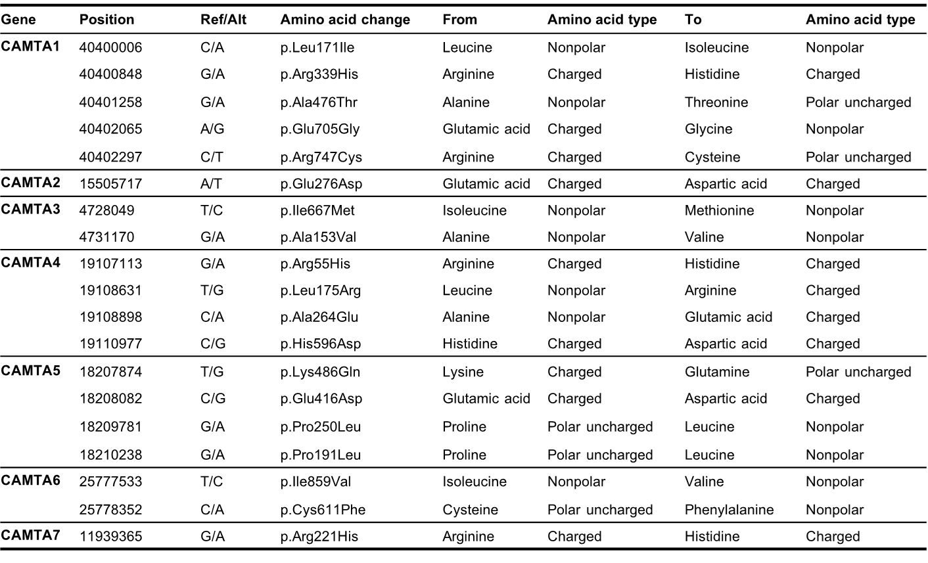

Supplementary Table S4. OsCAMTA protein interactors.
OskCAMTA interactors | RAP ID | MSU ID | Description
CAM1 | Os01g0267900 | LOC_Os01g16240 | OsCam1-3 - Calmodulin
ELP3 | Os04g0484900 | LOC_Os04g40840 | Elongator complex protein 3
HK3 | Os01g0923700 | LOC_Os01g69920 | Histidine kinase 3, cytokinin receptor
OS01T0276800-01 | Os01g0276800 | LOC_Os01g16970 | glucosidase II beta subunit-like domain containing protein
OS01T0360600-01 | Os01g0360600 | LOC_Os01g25880 | dephospho-CoA kinase
OS01T0921200-01 | Os01g0921200 | LOC_Os01g69210 | mannosyl-oligosaccharide glucosidase
OS01T0923300-01 | Os01g0923300 | LOC_Os01g69900 | cystathionine β-synthase (CBS) domain containing protein
OS02T0134000-00 | Os02g0134000 | LOC_Os02g04120 | cytidylyltransferase domain containing protein
OS03T0216600-01 | Os03g0216600 | LOC_Os03g11720 | glycosyl hydrolase, family 31
OS03T0713000-00 | Os03g0713000 | LOC_Os03g50510 | threonine dehydratase biosynthetic, chloroplast precursor
OS03T0797700-01 | Os03g0797700 | LOC_Os03g58340 | rRNA-processing protein EFG1 domain containing protein
OS04T0431200-01 | Os04g0431200 | LOC_Os04g35190 | OsFBX133, F-box domain containing protein
OS04T0602200-01 | Os04g0602200 | LOC_Os04g51310 | putrescine-binding periplasmic protein-related
OS07T0179400-01 | Os07g0179400 | LOC_Os07g08210 | cytidylyltransferase domain containing protein
OS07T0563700-01 | Os07g0563700 | LOC_Os07g37640 | IKI3 family protein
OS07T0687200-02 | Os07g0687200 | LOC_Os07g48780 | OsCaM1-2
OS09T0533100-01 | Os09g0533100 | LOC_Os09g36270 | pantothenate kinase
OS12T0409000-01 | Os12g0409000 | LOC_Os12g22030 | serine hydroxymethyltransferase
OsJ_04382 | Os01g0893400 | LOC_Os01g66890 | BTBZ1
OsJ_04589 | Os01g0923200 | LOC_Os01g69890 | Similar to AT.I.24-6 protein (Fragment), GPI-anchored protein
OsJ_04594 | Os01g0923800 | LOC_Os01g69930 | dnaJ domain containing protein, heat shock protein like
OsJ_08897 | Os02g0819700 | LOC_Os02g57430 | zinc finger domain containing protein
OsJ_22107 | Os06g0639600 | LOC_Os06g43280 | paxneb-related protein
OsJ_23969 | Os07g0417400 | LOC_Os07g23450 | C₂H₂ zinc finger protein
OsJ_25984 | Os08g0138700 | LOC_Os08g04420 | Serine/threonine protein kinase-related domain containing protein, tyrosine protein kinase domain containing protein
OsJ_27778 | Os08g0493900 | LOC_Os08g38570 | WD domain, G-beta repeat domain containing protein
P0465E03.8 | Os09g0407900 | LOC_Os09g24250 | ubiquitin carboxyl-terminal hydrolase domain containing protein
PRR95 | Os09g0532400 | LOC_Os09g36220 | pseudo-response regulator
SERR | Os04g0555900 | LOC_Os04g46930 | Serine racemase
SL1 | Os01g0129200 | LOC_Os01g03840 | STAMENLESS 1, C₂H₂ zinc finger protein

Supplementary Table S5. SNPs comparison between haplotype1 and haplotype5.
Haplotype |  |  |  |  | cis-element
CHR | POS | ALLELE | H001 | H005 | Position | Strand | Similar Score | Binding sequence | TF family
Chr1 | 40395888 | C/T | C | DEL | 40395885 | + | 0.75 | TGTCC | TCP
Chr1 | 40395901 | T/C | T | DEL | 40395900 | + | 0.97 | tgTGACGact | Homeodomain; TALE
Chr1 | 40395912 | G/A | A | DEL | 40395914 | - | 0.75 | CGTCC | TCP
Chr1 | 40395917 | G/A | G | DEL | 40395914 | + | 0.75 | CGTCC | TCP
Chr1 | 40395945 | C/T | T | DEL | 40395940 | + | 0.92 | ccGGGCCcac | TCP
Chr1 | 40396016 | G/A | G | A | 40396012 | + | 0.999 | cACACTt | C2H2
Chr1 | 40396188 | C/A | A | C | 40396184 | + | 0.75 | GGACG | TCP
Chr1 | 40396199 | G/A | G | A | 40396195 | + | 0.75 | CGACC | TCP
Chr1 | 40396210 | G/A | A | G | 40396210 | - | 0.999 | TTTTTtccc | AT-Hook
Chr1 | 40396217 | C/G | C | G | 40396217 | + | 1 | CCAAT | NF-YB
Chr1 | 40396249 | A/G | G | A | 40396250 | - | 0.8 | ATTGT | NF-YB
Chr1 | 40396538 | T/A | T | A | 40396542 | - | 0.8 | GCATC | B3
Chr1 | 40396572 | T/G | T | G | 40396574 | - | 1 | ATTTTtat | AT-Hook
Chr1 | 40396613 | T/G | T | G | 40396609 | + | 0.857 | AATTAag | Alpha-amylase
Chr1 | 40396746 | C/T | C | T | 40396738 | + | 0.982 | taaGTCAAtg | WRKY
Chr1 | 40396787 | T/C | C | T | 40396785 | + | 0.857 | AATTAta | Alpha-amylase
Chr1 | 40396965 | C/T | T | C | 40396966 | - | 0.991 | aaATTATt | Homeodomain; HD-ZIP

Supplementary Table S6. Primers used for RT-qPCR.
Primer name | Sequence (5’ - 3’)
CAMTA1-F | ATCGTCAGCGACTCACCATTCG
CAMTA1-R | AGCCTGTGTGTATCAAATCCTTGC
CAMTA2-F | AGCAAGAGAACAGTACCGTAGGC
CAMTA2-R | AGCATCTCGTCCTGCATCATCC
CAMTA3-F | ACAGGAGGCCCAGGAATTGAATC
CAMTA3-R | GTACCACTTGCATTTGGAATCTGC
CAMTA4-F | GGAATTTCGACAAGCCACTGCTG
CAMTA4-R | ACTGTAGACAGCTCCGTGATCG
CAMTA5-F | ACAAGGCACAACAGGAGTACCG
CAMTA5-R | GCCCTTCACTGAACTCAATCTTGG
CAMTA6-F | AGCAAGCCGAAGGCAGATTACAG
CAMTA6-R | CATCCTGAATCATCATCGCCTGAG
CAMTA7-F | GATGTAGAACCATTCTGGCAGCTC
CAMTA7-R | TGGACGCTGTTCTCTGTTGCAG
OsEF1α – F | ATGGTTGTGGAGACCTTC
OsEF1α – R | TCACCTTGGCACCGGTTG

Supplementary Figures

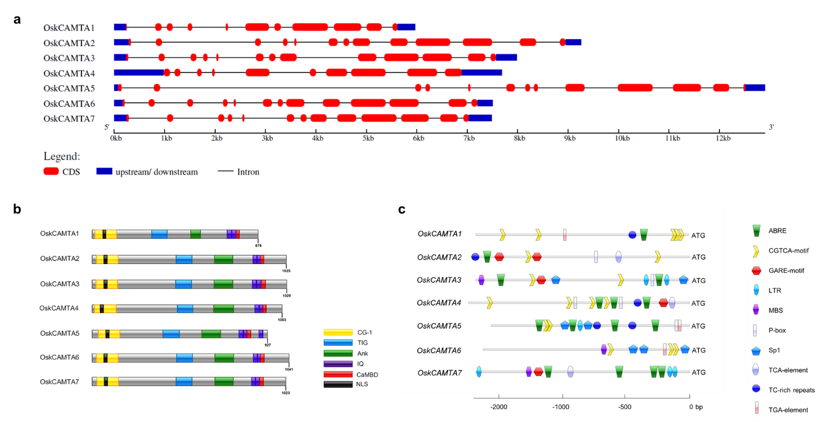
Supplementary Figure S1. Sequence-based analysis of CAMTAs. (a) Gene structure. (b) Conserved domains. (c) cis-element analysis.
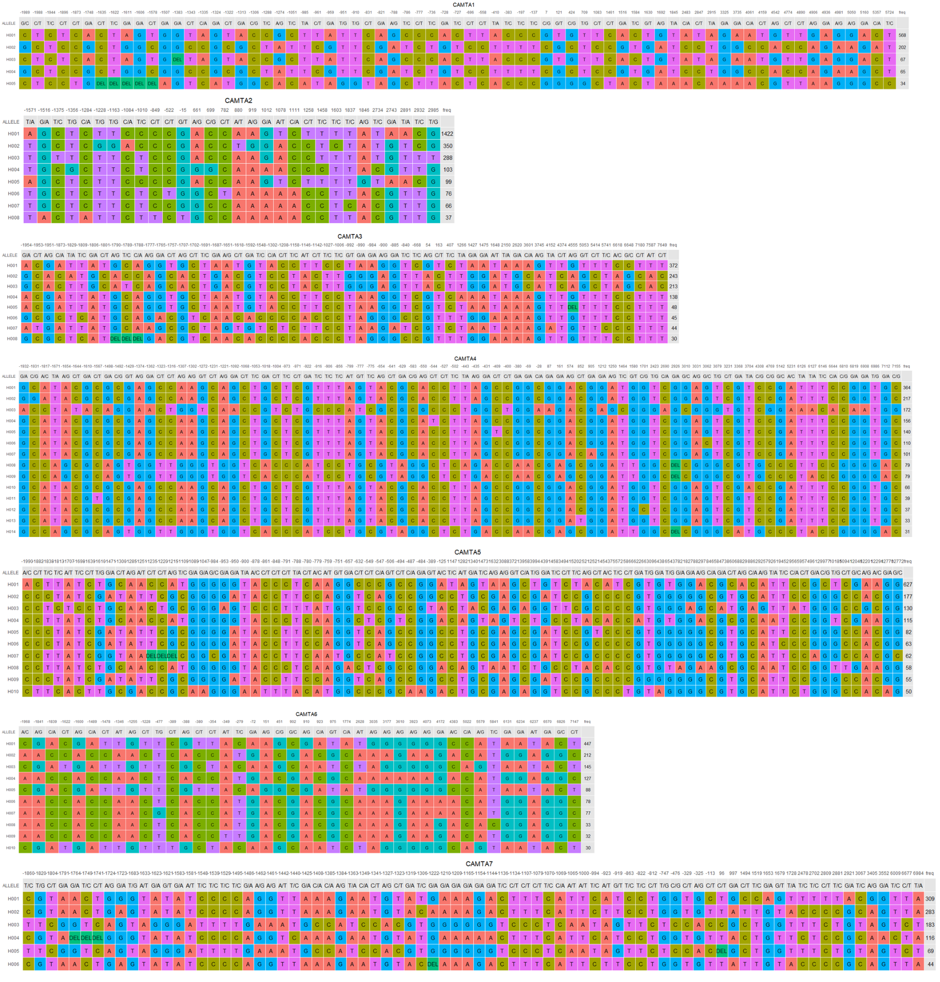
Supplementary Figure S2. Haplotype analysis of all seven CAMTAs. The ATG position was set to 0.
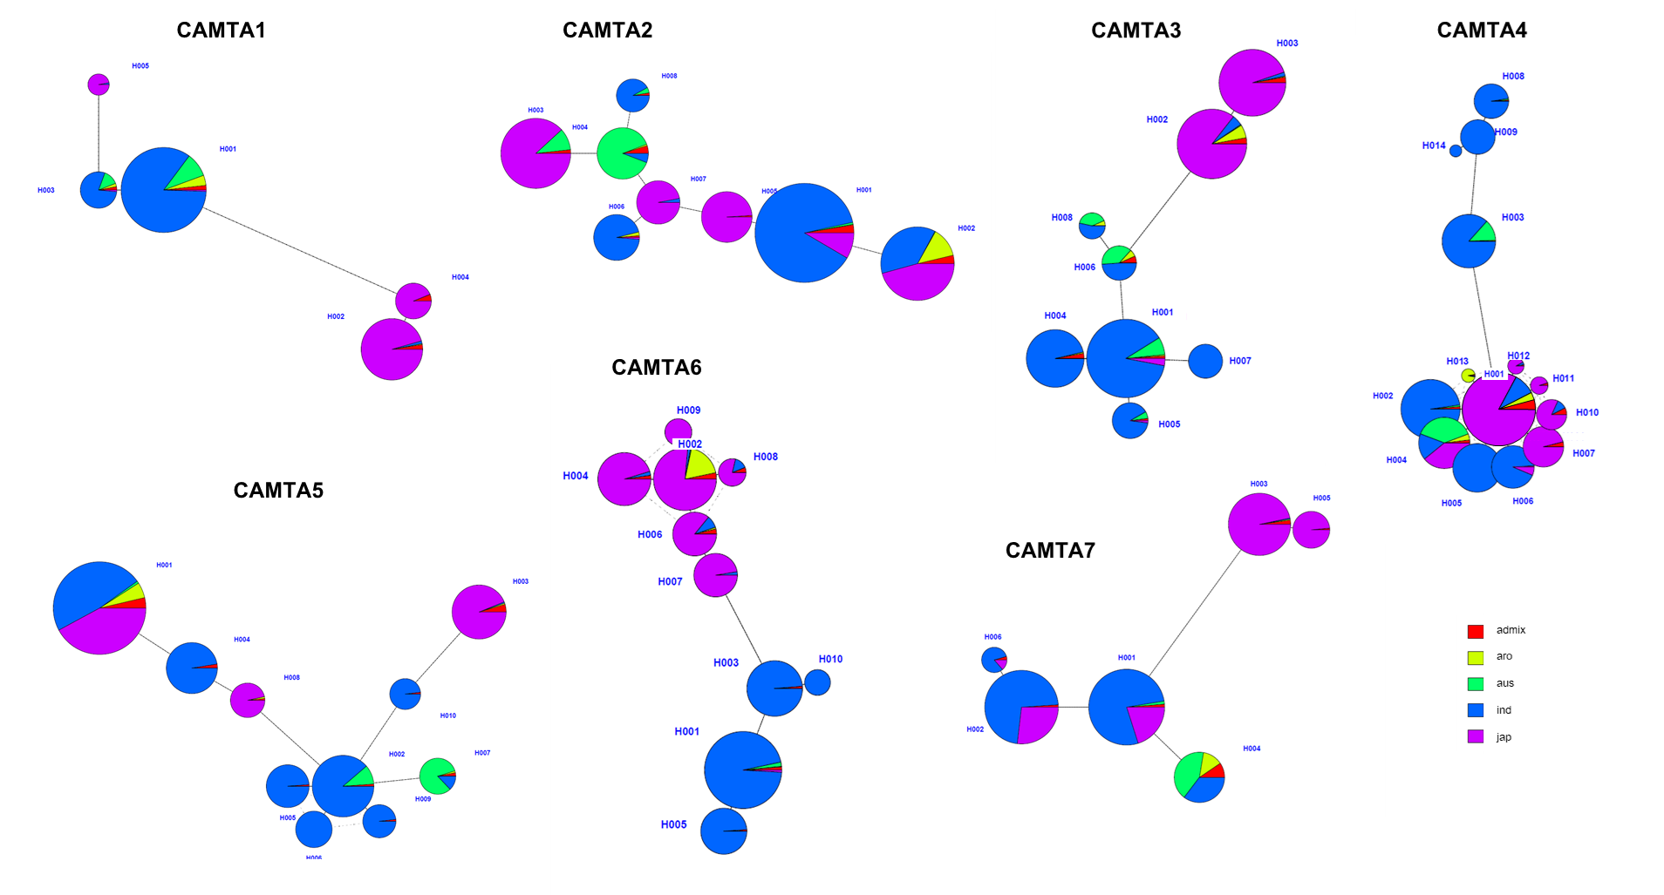
Supplementary Figure S3. CAMTA haplotype network. Each circle represents a haplotype, the circle size indicates the number of individuals, and the dots/short lines along the links represent variants between the haplotypes.

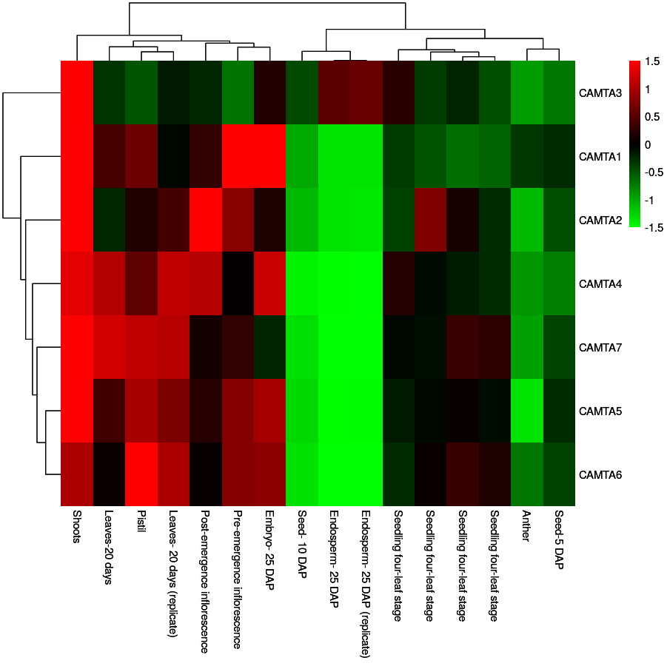

Supplementary Figure S4. Expression profiles of OsCAMTAs in different tissues.

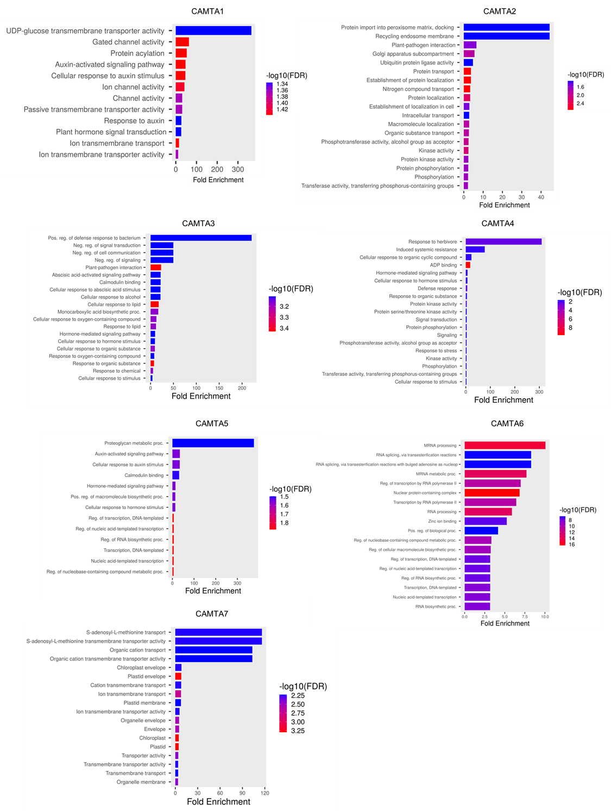

Supplementary Figure S5. GO enrichment analysis of each CAMTA module.

