Supplements
Supplement 1. ROC curves of manual BMD (m-BMD) and automated BMD (DL-BMD) for diagnosis of low-BMD and osteoporosis in Guro hospital (N=189). The total AUC values were evaluated for diagnosing low-BMD (A) and osteoporosis (B) based on the dual-energy x-ray absorptiometry (DXA)-BMD.
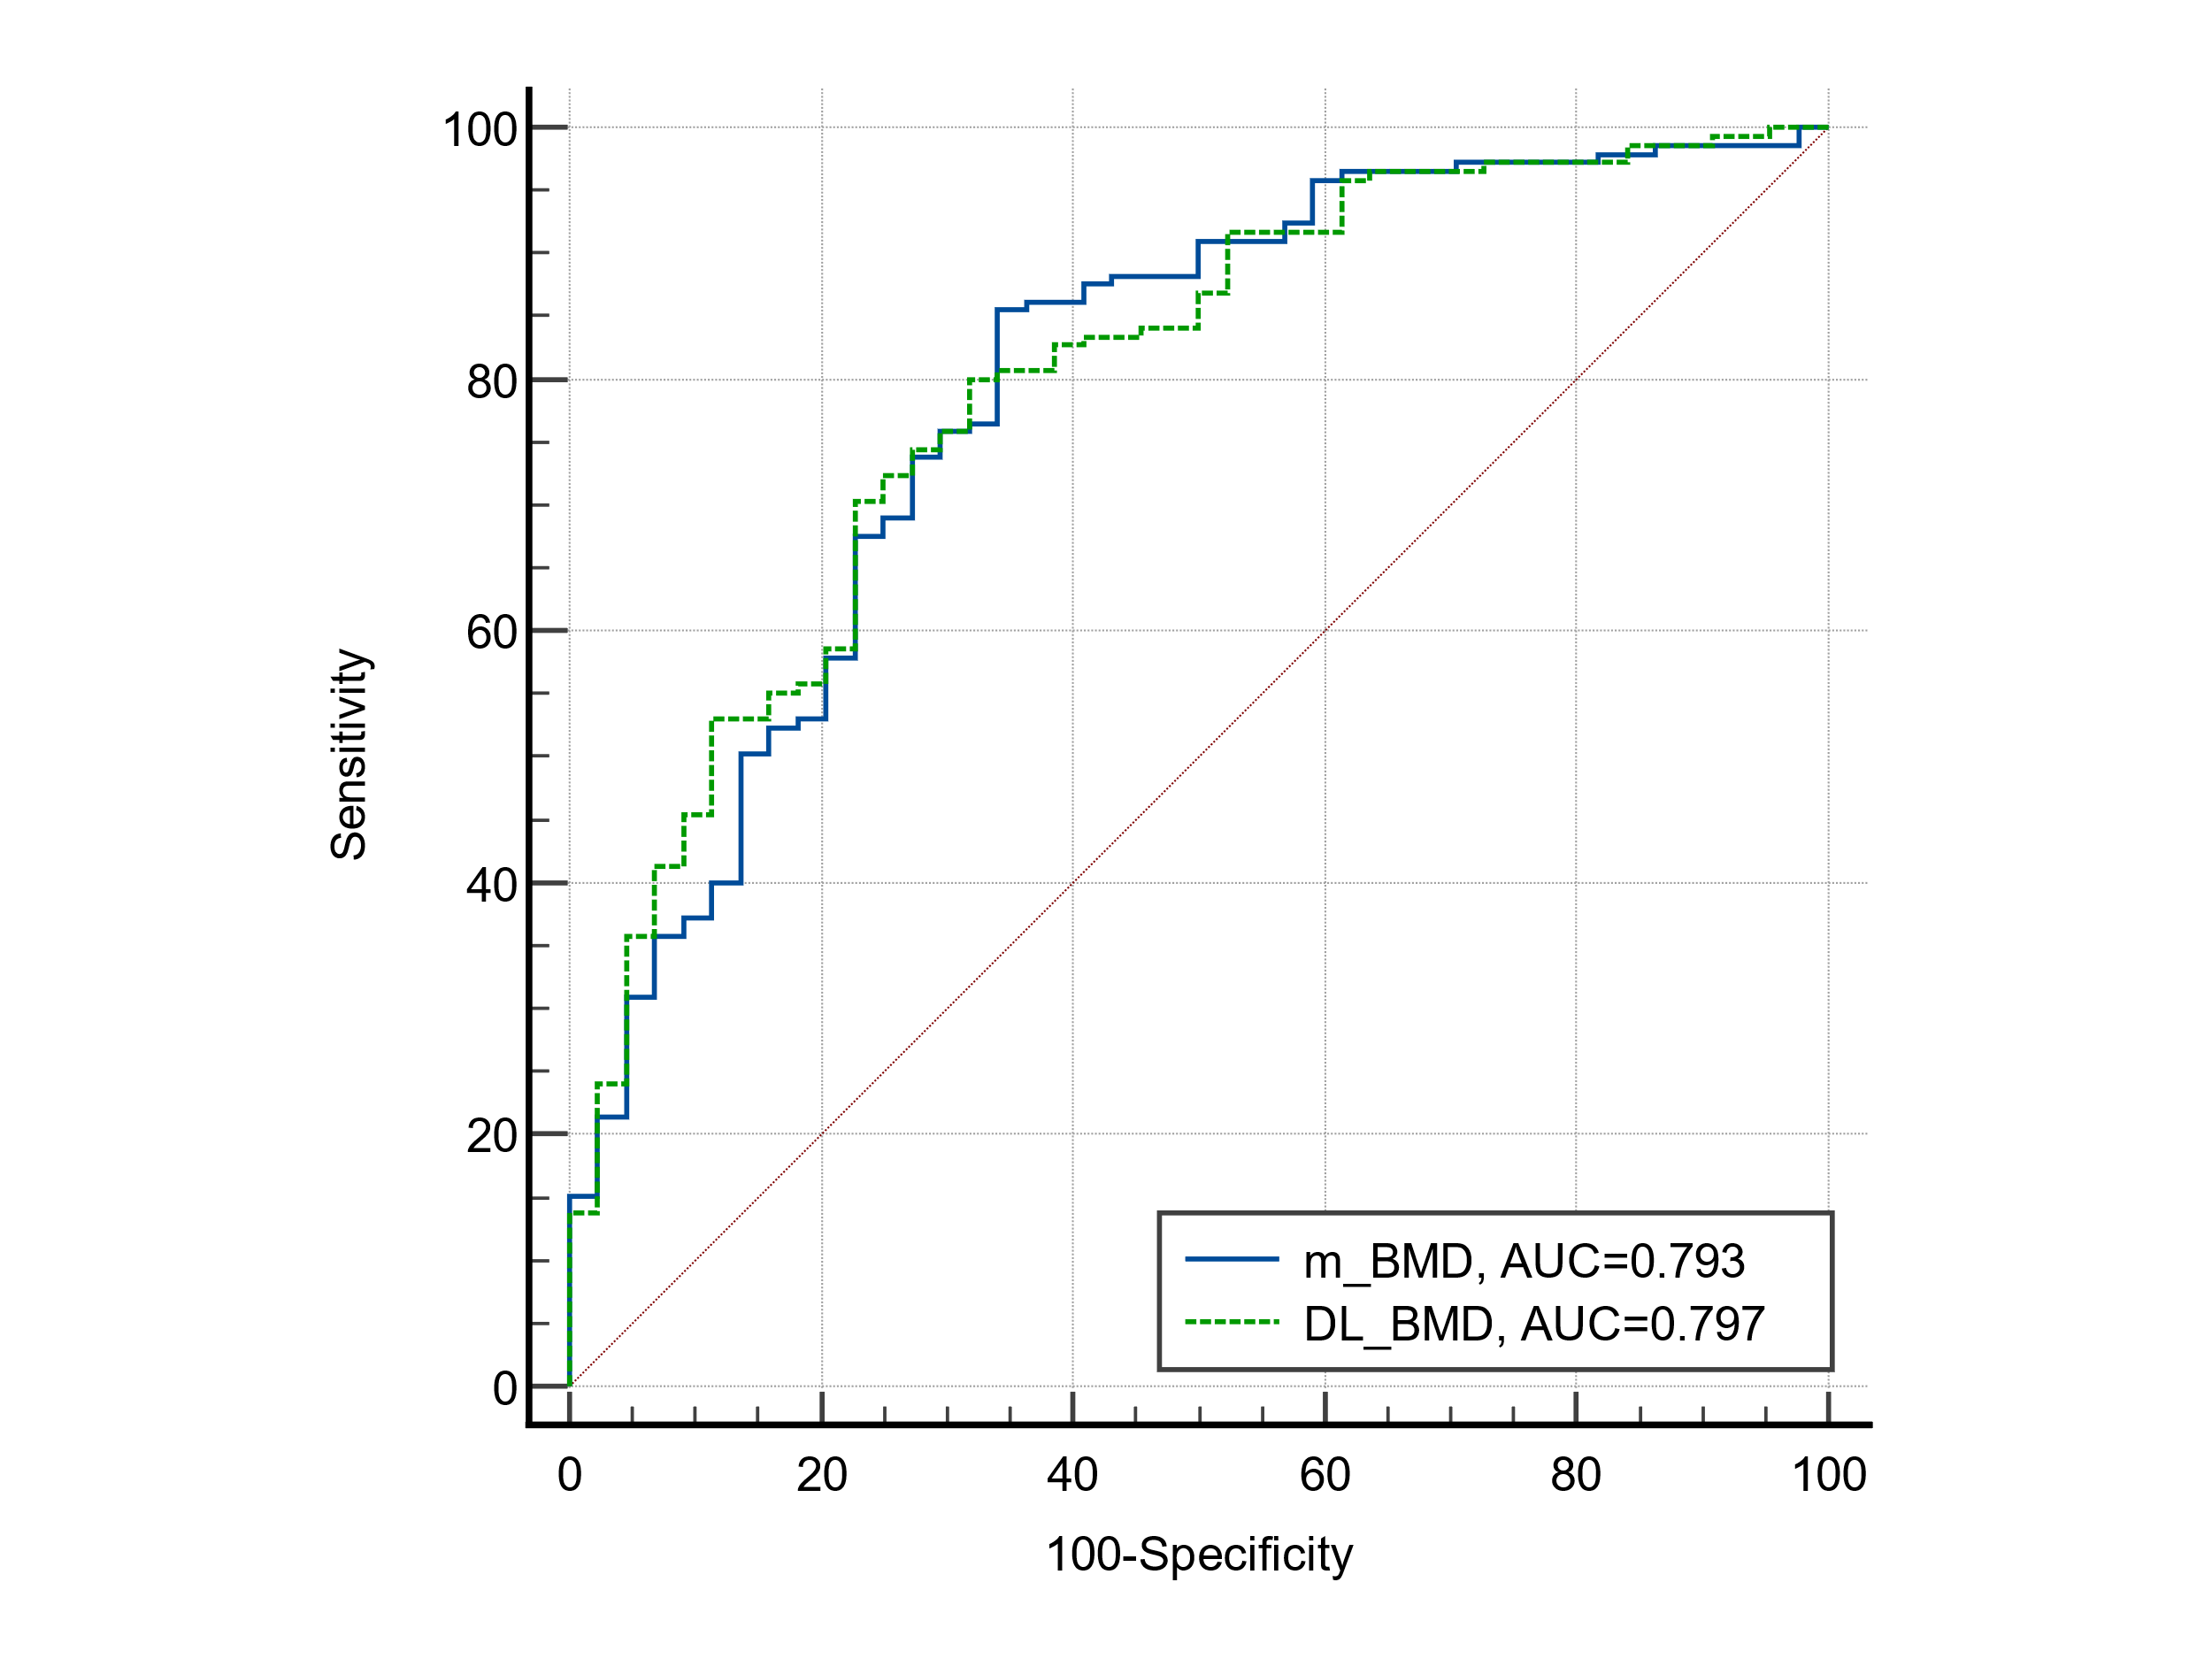
(A)
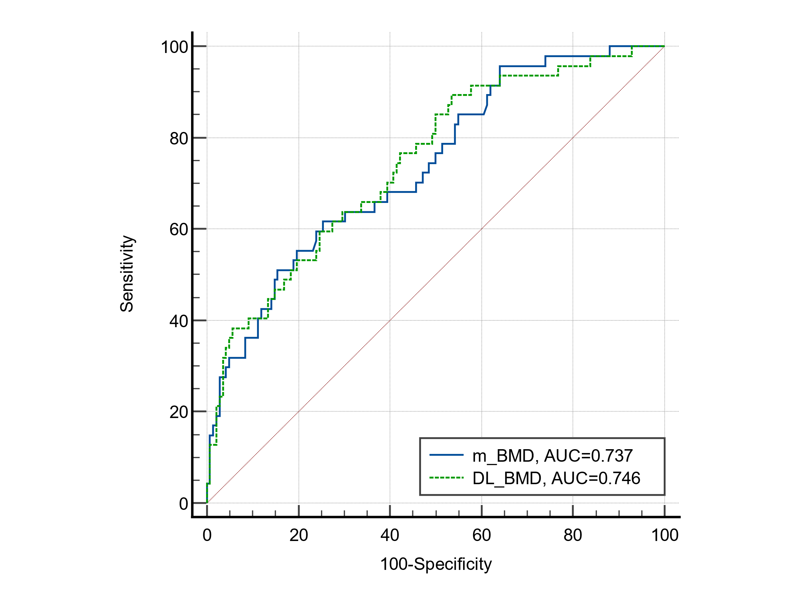
(B)

Supplement 2. ROC curves of manual BMD (m-BMD) and automated BMD (DL-BMD) for diagnosis of low-BMD and osteoporosis in Ansan hospital (N=52). The total AUC values were evaluated for diagnosing low-BMD (A) and osteoporosis (B) based on the dual-energy x-ray absorptiometry (DXA)-BMD.
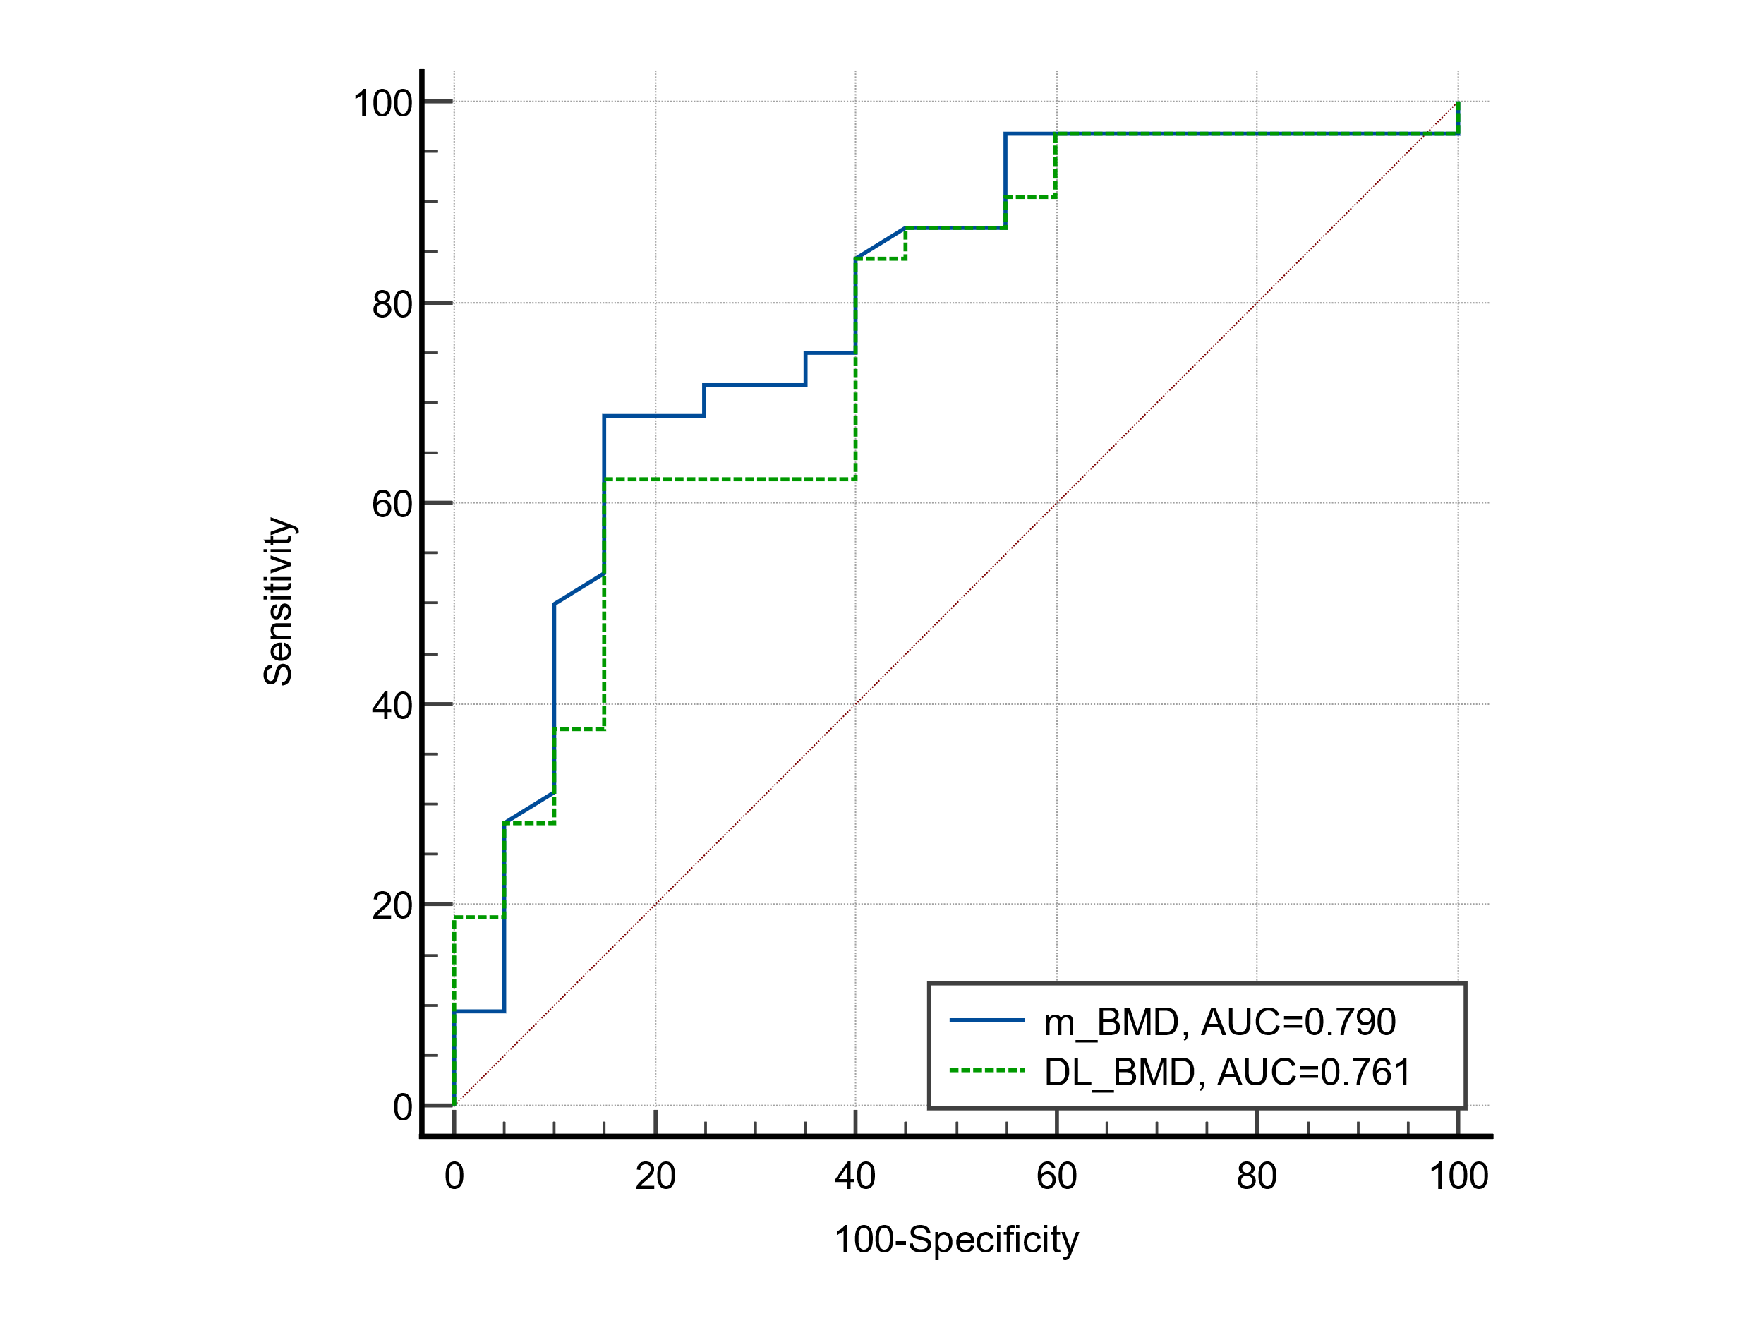
(A)
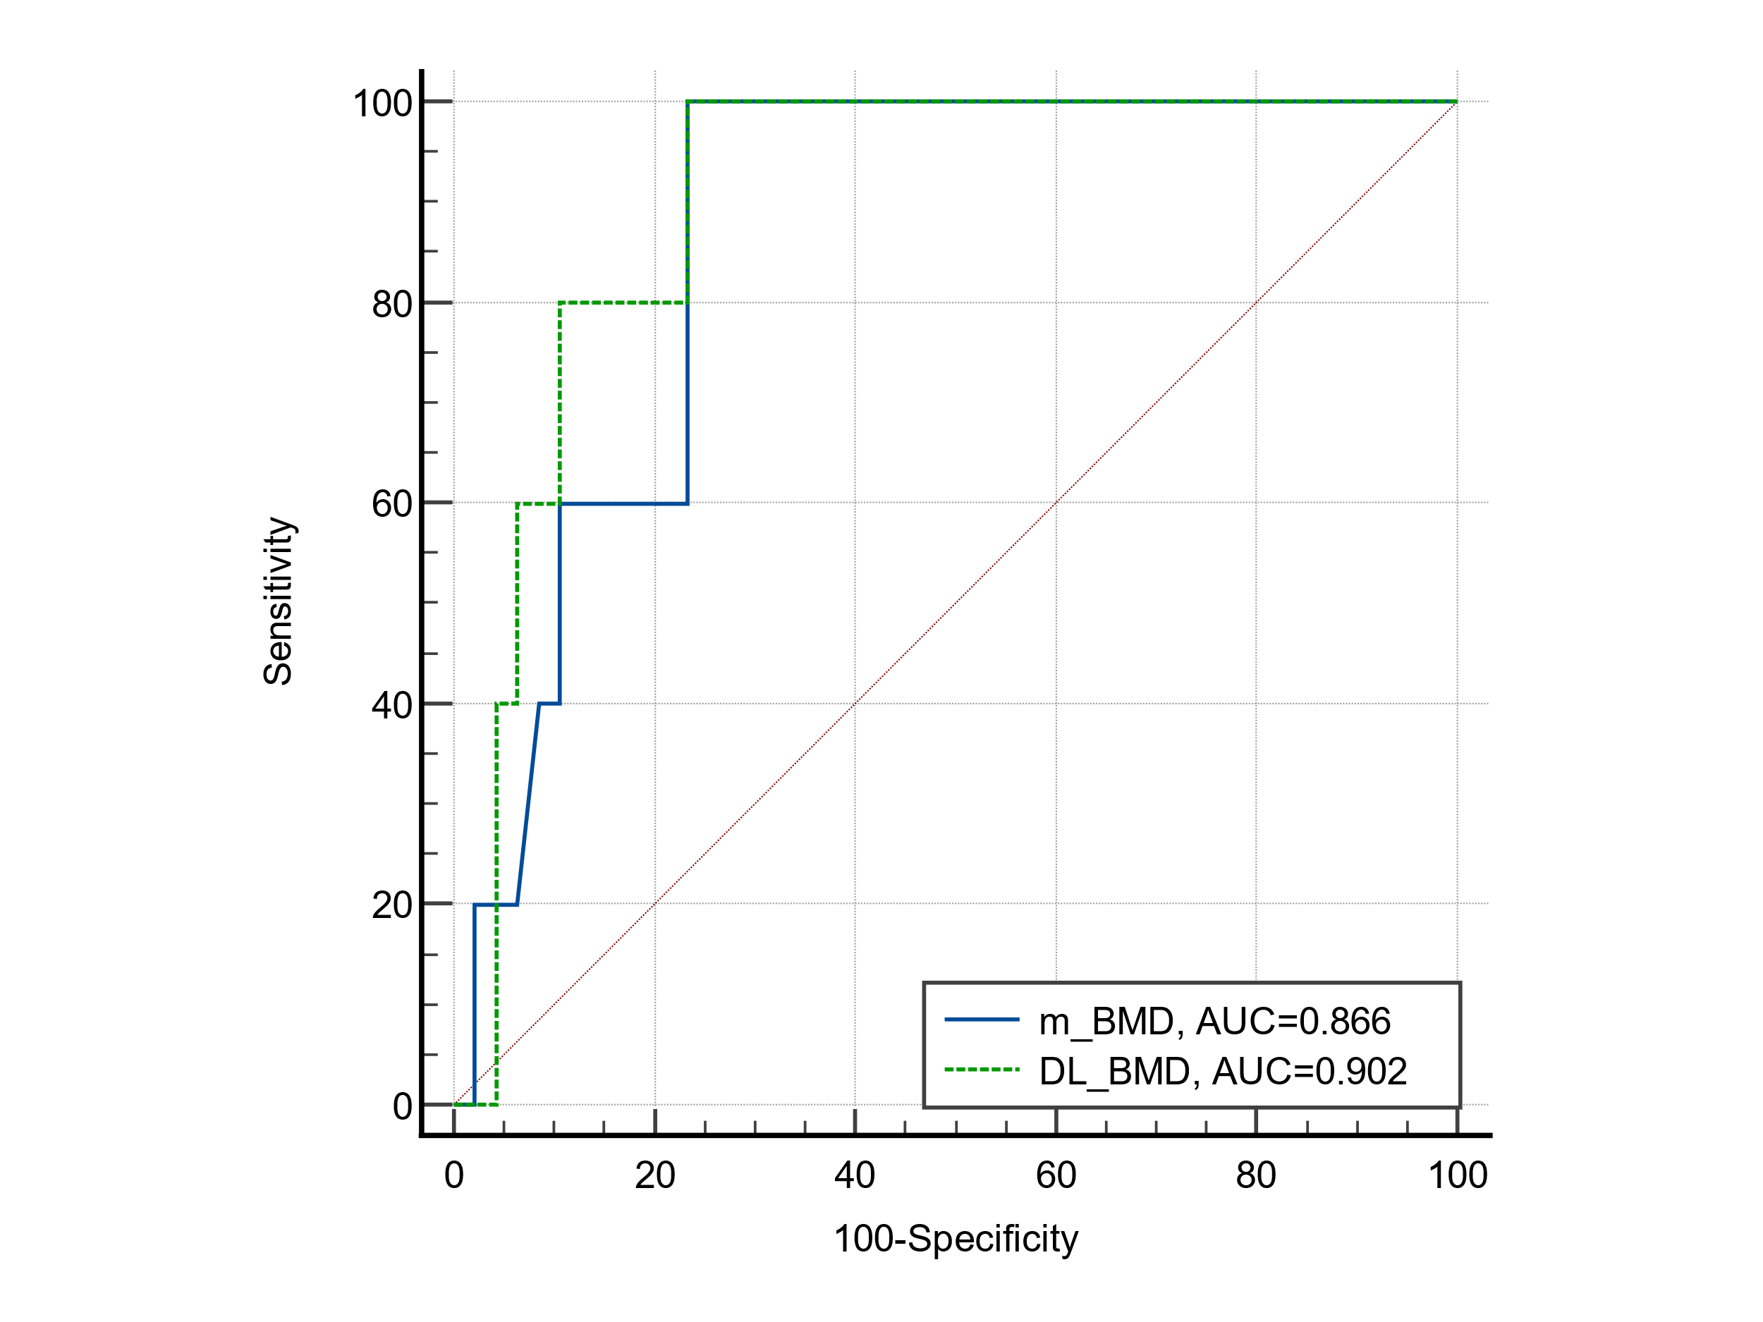
(B)

Supplement 3. Bone Density Distribution of CT scans Based on DXA and automated BMD (DL-BMD) in whole vendors in medical center 1&2*.
 |  | DL-BMD (Vendor 1, Canon)
 |  | Normal | Osteopenia | Osteoporosis | Total
DXA BMD | Normal | 10 | 9 | 1 | 20
DXA BMD | Osteopenia | 9 | 21 | 19 | 49
DXA BMD | Osteoporosis | 2 | 6 | 13 | 21
DXA BMD | Total | 21 | 36 | 33 | 90
 |  | DL-BMD (Vendor 2, Siemens)
 |  | Normal | Osteopenia | Osteoporosis | Total
DXA BMD | Normal | 12 | 7 | 4 | 23
DXA BMD | Osteopenia | 11 | 18 | 20 | 49
DXA BMD | Osteoporosis | 2 | 8 | 17 | 27
DXA BMD | Total | 25 | 33 | 41 | 99

 |  | DL-BMD (Vendor 3, GE)
 |  | Normal | Osteopenia | Osteoporosis | Total
DXA BMD | Normal | 2 | 0 | 1 | 3
DXA BMD | Osteopenia | 3 | 4 | 5 | 12
DXA BMD | Osteoporosis | 0 | 0 | 2 | 2
DXA BMD | Total | 5 | 4 | 8 | 17
 |  | DL-BMD (Vendor 4, Philips)
 |  | Normal | Osteopenia | Osteoporosis | Total
DXA BMD | Normal | 10 | 6 | 2 | 18
DXA BMD | Osteopenia | 0 | 11 | 3 | 14
DXA BMD | Osteoporosis | 0 | 1 | 2 | 3
DXA BMD | Total | 10 | 18 | 7 | 35

* This BMD data were obtained from vendors in Guro (N=189) and Ansan (N=52) Hospitals with DXA.

Supplement 4. Diagnostic performance of manual BMD (m-BMD) based on DXA-BMD from whole vendors in medical center 1&2*.
 |  | Vendor 1 (Canon) | Vendor 2 (Siemens) | Vendor 3 (GE) | Vendor4 (Philips) | Total
Sensitivity (%) | Osteoporosis | 57.1 (34.0, 78.2) | 61.5 (40.6, 79.8) | 100.0 (15.8, 100.0) | 33.3 (0.8, 90.6) | 59.6 (45.1, 73.0)
Sensitivity (%) | Low BMD | 77.1 (65.6, 86.3) | 82.7 (72.2, 90.4) | 66.7 (38.4, 88.2) | 82.5 (56.6, 96.2) | 79.1 (72.4, 84.8)
Specificity (%) | Osteoporosis | 84.1 (73.3, 91.8) | 65.8 (53.7, 76.5) | 60.0 (32.3, 83,7) | 90.6 (75.0, 98.0) | 76.2 (69.5, 82.1)
Specificity (%) | Low BMD | 75.0 (50.9, 91.3) | 58.3 (36.6, 77.9 | 50.0 (1.3, 98.7) | 61.1 (35.7, 82.7) | 64.1 (51.1, 75.7)
Accuracy (%) | Osteoporosis | 77.8 (67.8, 85.9) | 64.7 (54.4, 74.0) | 64.7 (66.4, 100.0) | 85.7 (69.7, 95.2) | 72.6 (66.5, 78.1)
Accuracy (%) | Low BMD | 76.7 (66.6, 84.9) | 76.8 (67.2, 84.7) | 64,7 (38.3, 85.8) | 71.4 (53.7, 85.4) | 75.1 (69.1, 80.4)
AUC (95% CI) | Osteoporosis | 0.746 (0.644, 0.832) | 0.717 (0.618, 0.803) | 0.850 (0.596, 0.974) | 0.917 (0.773,0.983) | 0.755 (0.696, 0.808)
AUC (95% CI) | Low BMD | 0.846 (0.755, 0.914) | 0.763 (0.667, 0.843) | 0.619 (0.357, 0.838) | 0.838 (0.675,0.940) | 0.795 (0.739, 0.844)

* These analyses were performed using the data from whole vendors in Guro and Ansan Hospital dataset with DXA.

Supplement 5. Diagnostic performance of automated BMD (DL-BMD) based on DXA-BMD from whole vendors in medical center 1&2*.
 |  | Vendor 1 (Canon) | Vendor 2 (Siemens) | Vendor 3 (GE) | Vendor4 (Philips) | Total
Sensitivity (%) | Osteoporosis | 61.9 (38.4, 81.9) | 66.7 (54.6, 77.3) | 100.0 (15.8, 100.0) | 66.7 (9.4, 99.2) | 65.4 (50.9, 78.0)
Sensitivity (%) | Low BMD | 84.3 (73.6, 91.9) | 52.2 (30.6, 73.2) | 73.3 (44.9, 92.2) | 100.0 (80.5, 100.0) | 80.8 (74.2, 86.3)
Specificity (%) | Osteoporosis | 71.0 (58.8, 81.3) | 63.0 (42.4, 80.6) | 60.0 (32.3, 83,7) | 84.4 (67.2, 94.7) | 70.9 (63.8, 77.3)
Specificity (%) | Low BMD | 50.0 (27.2, 72.8) | 82.9 (72.5, 90.6) | 50.0 (1.3, 98.7) | 55.6 (30.8, 78.5) | 56.3 (43.4, 68.6)
Accuracy (%) | Osteoporosis | 68.9 (58.3, 78.2) | 65.7 (55.4, 74.9) | 64.7 (66.4, 100.0) | 82.9 (66.4, 93.4) | 69.7 (63.5, 75.4)
Accuracy (%) | Low BMD | 76.7 (66.6, 84.9) | 75.8 (66.1, 83.8) | 70.6 (44.0, 89.7) | 77.1 (59.9, 89.6) | 74.3 (68.3, 79.7)
AUC (95% CI) | Osteoporosis | 0.754 (0.652, 0.838) | 0.735 (0.637, 0.819) | 0.833 (0.577, 0.966) | 0.938 (0.801,0.991) | 0.769 (0.710, 0.820)
AUC (95% CI) | Low BMD | 0.811 (0.714, 0.886) | 0.788 (0.695, 0.864) | 0.714 (0.449, 0.902) | 0.837 (0.673,0.939) | 0.790 (0.733, 0.839)

* These analyses were performed using the data from whole vendors in Guro and Ansan Hospital dataset with DXA.

Supplement 6. CT scanning parameters are used in each vendor.
 | CT protocol | Tube voltage (kVp) | Tube current (mA) | Collimation (mm) | Pitch | Kernel | Section thickness | Contrast (M, ml/sec)
Vendor 1 (Canon Aquilion ONE) | Abdomen CT | 120 | automatic | 0.5*80 | PF 0.813, HP 65 | FC 19 | 5 | 3.5ML/SEC 120ML (300mg ~ 370mg/ml)
Vendor 1 (Canon Aquilion ONE) | Chest CT | 120 | automatic | 0.5*80 | PF 0.813, HP 65 | FC 04-H | 3 | None
Vendor 1 (Canon Aquilion ONE) | Lumbar spine CT | 120 | automatic | 0.5*80 | PF0.637  HP51.0 | FC81 | 3 | None
Vendor 2 (SOMATOM Force) | Abdomen CT | automatic | automatic | 0.6*192 | 0.6 | Br40  Abdomen | 5 | 3.5ML/SEC 120ML (300mg ~ 370mg/ml)
Vendor 2 (SOMATOM Force) | Chest CT | automatic | automatic | 0.6*192 | 0.7 | Br54  Mediastinum | 3 | None
Vendor 2 (SOMATOM Force) | Lumbar spine CT | automatic | automatic | 0.6*192 | 1.0 | Br64  Bone | 3 | None
Vendor 3  (GE Revolution) | Abdomen CT | 120 | automatic | 0.625 | 0.992 | STANDARD | 3 | None
Vendor 3  (GE Revolution) | Chest CT | 120 | automatic | 0.625 | 1.531 | STANDARD | 3 | None
Vendor 3  (GE Revolution) | Lumbar spine CT | 120 | automatic | 0.625 | 0.992 | STANDARD | 3 | None
Vendor4 (Philips iQon) | Abdomen CT | 120 | automatic | 0.625 | 0.891 | STANDARD(B) | 3 | None
Vendor4 (Philips iQon) | Chest CT | 120 | automatic | 0.625 | 0.609 | Y-SHARP(YC) | 3 | None
Vendor4 (Philips iQon) | Lumbar spine CT | 120 | automatic | 0.625 | 0.891 | STANDARD(B) | 3 | None

