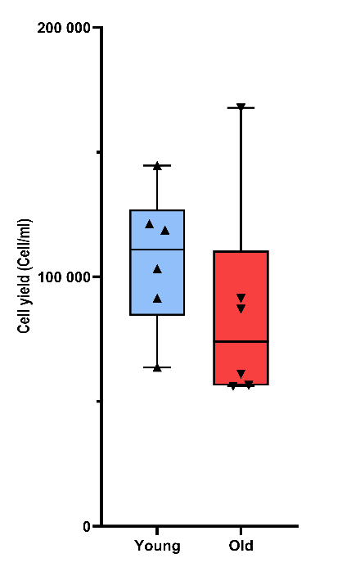
Supplementary figure 2 – Cell yield (cells/ml of fat) according to age category. N=6 donors for each category. Unpaired Wilcoxon test was used to test the significance.

