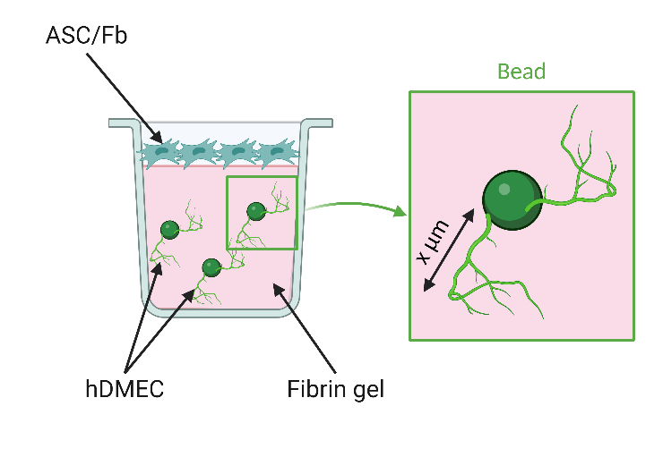
Supplementary figure 1 – Experimental design of sprouting assay with Cytodex© beads. Cytodex© beads are coated with endothelial cells (hDMEC) and embedded into fibrin gel. Stimulating cells (ASC or fibroblasts) are seeded on top of the gel. hDMEC grow and organize to form sprouts for 7 days. At the end of the assay, the gels are fixed and stained with phalloidin to assess total length of the newly formed vascular sprouts. (Created with BioRender.com)

