Resistance patterns, virulence determinants, and biofilm genes of multidrug-resistant Pseudomonas aeruginosa isolated from fish and fish handlers
Rasha M. M. Abou Elez¹*, Eman Mohamed Fayek Zahra², Rasha M. A. Gharieb¹, Mohamed Elsayed Mohamed Mohamed¹, Mohamed Samir¹, Alaaeldin Mohamed Saad¹, Abdallah Mohamed Amin Merwad¹

¹ Department of Zoonoses, Faculty of Veterinary Medicine, Zagazig University, Egypt.

* Correspondence:
Rasha M. M. Abou Elez (rmmohamed@zu.edu.eg)

Table S 1. Primers' sequences and PCR cycling conditions used in this study.

Target gene | Primers' sequences  5\-3\ | Amplified product (bp) | Primary  denaturation | Amplification (35 cycles) |  |  | Final extension | Reference
 |  |  |  | Secondary denaturation | Annealing | Extension | Final extension | Reference
16S rDNA | GGGGGATCTTCGGACCTCA | 956 | 94˚C  5 min. | 94˚C  30 sec. | 52˚C  40 sec. | 72˚C  50 sec. | 72˚C  10 min. | Spilker et al. ²⁷
16S rDNA | TCCTTAGAGTGCCCACCCG
lasB | ACAGGTAGAACGCACGGTTG | 1220 | 94˚C  5 min. | 94˚C  30 sec. | 54˚C  40 sec. | 72˚C  1min. | 72˚C  12 min. | Finnan et al. ²⁰
lasB | GATCGACGTGTCCAAACTCC
toxA | GACAACGCCCTCAGCATCACCAGC | 396 | 94˚C  5 min. | 94˚C  30 sec. | 55˚C  40 sec. | 72˚C  40 sec. | 72˚C  10 min. | Matar et al. ³³
toxA | CGCTGGCCCATTCGCTCCAGCGCT
exoU | CCGTTGTGGTGCCGTTGAAG | 134 | 94˚C  5 min. | 94˚C  30 sec. | 55˚C  30 sec. | 72˚C  30 sec. | 72˚C  12 min. | Winstanley et al. ³⁴
exoU | CCAGATGTTCACCGACTCGC
oprL | ATGGAAATGCTGAAATTCGGC | 504 | 94˚C  5 min. | 94˚C  30 sec. | 55˚C  40 sec. | 72˚C  40 sec. | 72˚C  10 min. | Xu et al. ³⁵
oprL | CTTCTTCAGCTCGACGCGACG
pslA | TCCCTACCTCAGCAGCAAGC | 656 | 94˚C  5 min. | 94˚C  30 sec. | 60˚C  40 sec. | 72˚C  45 sec. | 72˚C  10 min. | Ghadaksaz et al. ³⁶
pslA | TGTTGTAGCCGTAGCGTTTCTG
pelA | CATACCTTCAGCCATCCGTTCTTC | 786 | 94˚C  5 min. | 94˚C  30 sec. | 60˚C  40 sec. | 72˚C  45 sec. | 72˚C  10 min. | Ghadaksaz et al. ³⁶
pelA | TCCCTACCTCAGCAGCAAGC
lasR | CTGTGGATGCTCAAGGACTAC | 133 | 94˚C  5 min. | 94˚C  30 sec. | 55˚C  30 sec. | 72˚C  30 sec. | 72˚C  7 min. | Saleh et al. ³⁷
lasR | AACTGGTCTTGCCGATGG
lasI | ATGATCGTACAAATTGGTCGGC | 606 | 94˚C  5 min. | 94˚C  30 sec. | 56˚C  40 sec. | 72˚C  45 sec. | 72˚C  10 min. | Bratu et al. ³⁸
lasI | GTCATGAAACCGCCAGTCG
rhlR | GCCAGCGTCTTGTTCGG | 160 | 94˚C  5 min. | 94˚C  30 sec. | 60˚C  30 sec. | 72˚C  30 sec. | 72˚C  7 min. | Saleh et al. ³⁷
rhlR | CGGTCTGCCTGAGCCATC

Table S 2. Prevalence and distribution of Pseudomonas spp. isolates (%) in fish and fish handlers.

Host | Examined number | liver | Muscle | total
Nile tilapia | 53 | 17 (32.1) | 15 (28.3) | 32 (60.4)
Golden grey mullet | 52 | 19 (36.5) | 15 (28.8) | 34 (65.4)
Total | 105 | 36 (34.3) | 30 (2.9) | 66 (62.9)
Mediterranean horse mackerel | 50 | 17 (34) | 12 (24) | 29 (58)
Striped red mullet | 71 | 32 (45.1) | 10 (14.1) | 42 (59.2)
Total | 121 | 49 (40.5) | 22 (18.2) | 71 (58.7)
Grand Total | 226 | 85 (37.6) | 52 (23) | 137 (60.6)
Human | 50 |  |  | 23 (46)

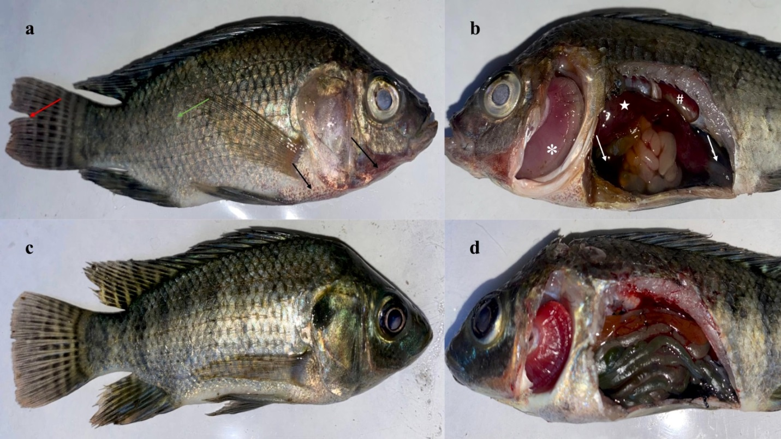
Figure S2. Clinical and post-mortem examination of artificially infected fish (a) Nile tilapia showing scattered spots of hemorrhages, especially at the ventral part of the head and abdomen (black arrows), fins erosion (red arrow), and detached scales (green arrow), (b) on external body surfaces, especially at the ventral part of the abdomen and around the vent (white arrows), (b) Nile tilapia showing necrotic gills (✽), serous fluid exudate (white arrows), friable liver (★), and congested kidney (^{#)}), (c) and (d) Control apparent healthy Nile tilapia .

