Comparative analyses of plastomes in Allaeanthus and Malaisia: structure, evolution, and phylogeny
Li-Na Zhou¹, Lang-Xing Yuan², Pan Li³, Bo-Liang Wei⁴, Jin-Rui Lei⁵, Zong-Zhu Chen⁵, Zhi-Hua Zhang⁶, Xin-Jie Jin^{1*}, Yi-Qing Chen^{5*}, Yong-Hua Zhang^{1*}

Supplementary information

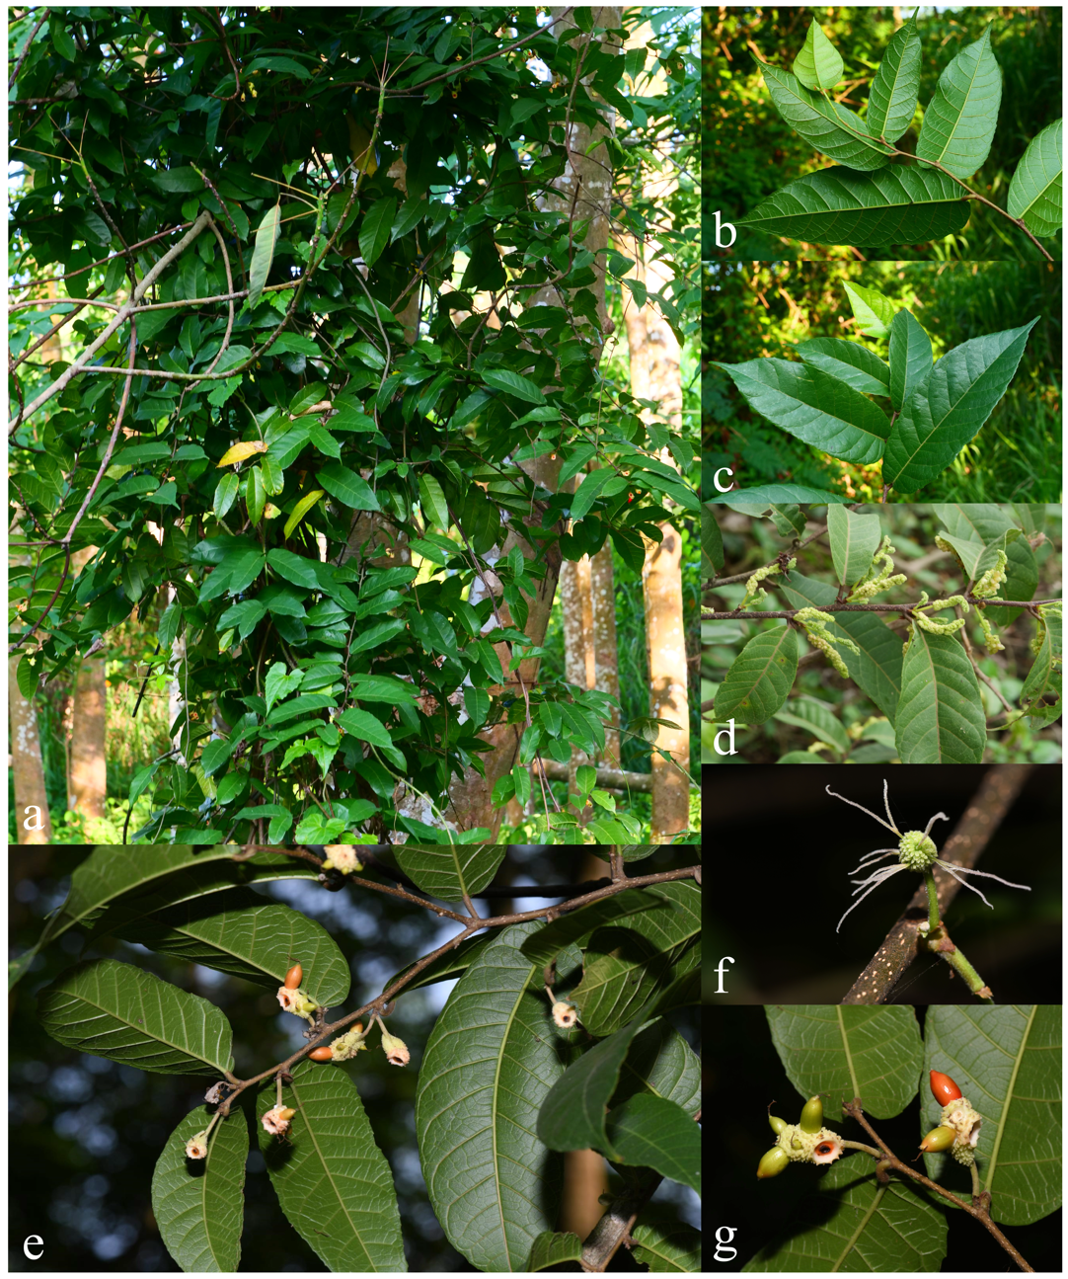
Supplementary Figure S1: Morphology of Malaisia scandens (Photos from Lang-Xing Yuan): (a) Malaisia scandens plant. (b) Leaf dorsal surface. (c) Leaf ventral surface. (d) Staminate inflorescences. (e) Syncarps. (f) Pistillate inflorescences. (g) Detailed view of syncarps.
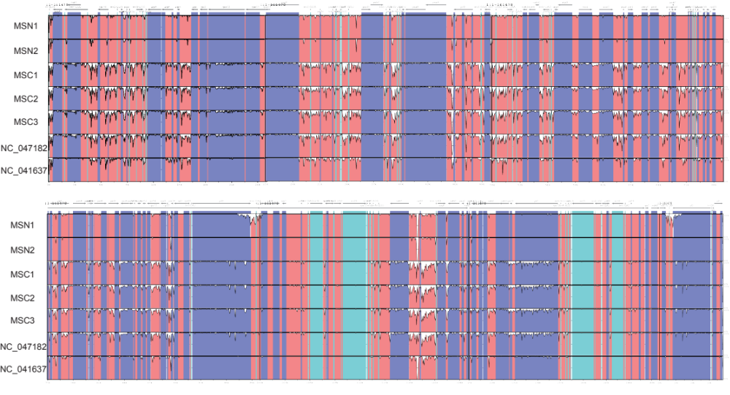
Supplementary Figure S2: Perform a comparative analysis of plastomes of A. kurzii and M. scandens using mVISTA.

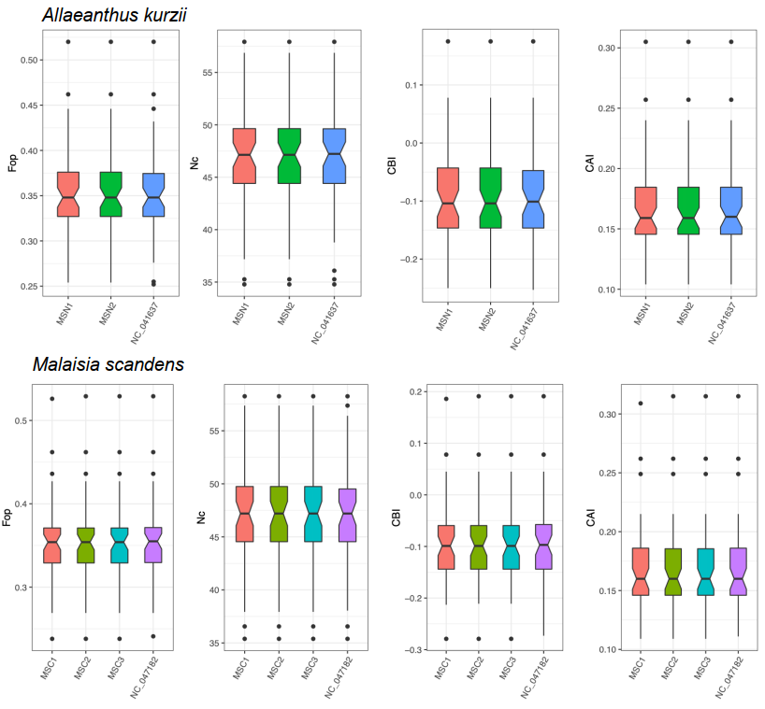
Supplementary Figure S3: Comparison of differences in Fop, Nc, CAI, and CBI of A. kurzii and M. scandens plstomes.
Supplementary Table S1: Basic information of species and samples involved in this study.
Tribe | Species Name | GenBank Accession No. | Experiment Number | Latitude | Longitude | Elevation  (m) | Acquisition Date | Locality
Dorstenieae | Allaeanthus kurzii | PP584575 | MSN1 | 19°0′19.1″ N | 109°5′26.04″ E | 334 | 2021.08.12 | Exianling, Changjiang li Autonomous County, Hainan Provience, China
Dorstenieae | Allaeanthus kurzii | PP577929 | MSN2 | 18°59′52.84″ N | 109°10′52.46″ E | 275 | 2021.12.15 | Langlun Village, Wangxia town, Changjiang li Autonomous County, Hainan Provience, China
Dorstenieae | Malaisia scandens | PP584597 | MSC1 | 19°30′47.75″ N | 109°30′5.57″ E | 127 | 2022.03.20 | Hainan Tropical Botanical Garden, Danzhou City, Hainan Provience, China
Dorstenieae | Malaisia scandens | PP577928 | MSC2 | 18°54′57.03″ N | 108°55′16.23″ E | 180 | 2022.03.28 | Bacha Village, Guanba town, Dongfang City, Hainan Provience, China
Dorstenieae | Malaisia scandens | PP728628 | MSC3 | 18°56′35.46″ N | 109°13′1.06″ E | 356 | 2022.04.15 | Donglcai Village, Wangxia town, Changjiang li Autonomous County, Hainan Provience, China
Dorstenieae | Allaeanthus kurzii | NC_041637 | / | / | / | / | / | Kamphaengphet-Wai, Thailand
Dorstenieae | Malaisia scandens | NC_047182 | / | / | / | / | / | Leelongshan, Pingtung, Taiwan Province, China
Dorstenieae | Broussonetia papyrifera | NC_035569 | / | / | / | / | / | /
Dorstenieae | Broussonetia monoica | NC_047181 | / | / | / | / | / | /
Dorstenieae | Broussonetia kaempferi | NC_047183 | / | / | / | / | / | /
Dorstenieae | Allaeanthus luzonicus | NC_047180 | / | / | / | / | / | /
Ficeae | Ficus maxima | CRR034468 | / | / | / | / | / | /
Ficeae | Ficus cyathistipula | CRR116979 | / | / | / | / | / | /
Ficeae | Ficus carica | NC_035237 | / | / | / | / | / | /
Moreae | Morus celtidifolia | NC_047236 | / | / | / | / | / | /
Moreae | Morus indica | NC_008359 | / | / | / | / | / | /
Moreae | Morus alba | MN102359 | / | / | / | / | / | /
Artocarpeae | Artocarpus hypargyreus | NC_057287 | / | / | / | / | / | /
Artocarpeae | Artocarpus integer | MT900597 | / | / | / | / | / | /
Artocarpeae | Artocarpus communis | NC_059002 | / | / | / | / | / | /
Olmedieae | Antiaris toxicaria | NC_042884 | / | / | / | / | / | /
Olmedieae | Olmedia aspera | NC_057293 | / | / | / | / | / | /
Outgroup | Boehmeria nivea | NC_056894 | / | / | / | / | / | /
Outgroup | Cannabis sativa | KP274871 | / | / | / | / | / | /

Supplementary Table S2: List of genes in plastomes of A. kurzii and M. scandens. (Note: The gene ψrps19 is only present in A. kurzii and is bolded).
Gene category | Groups | Name
Self-replication | Transfer RNA | trnA-UGC^{a*},b(×2), trnC-GCA, trnD-GUC, trnE-UUC, trnF-GAA, trnG-UCC, trnG-UCC^{a*}, trnH-GUG, trnI-CAU^{b}(×2), trnI-GAU^{a*,b}(×2), trnK-UUU^{a*}, trnL-CAA^{b}(×2), trnL-UAA^{a*}, trnL-UAG, trnM-CAU(×2), trnN-GUU^{b}(×2), trnP-UGG, trnQ-UUG, trnR-ACG^{b}(×2), trnR-UCU, trnS-GCU, trnS-GGA, trnS-UGA, trnT-GGU, trnT-UGU, trnV-GAC^{b}(×2), trnV-UAC^{a*}, trnW-CCA, trnY-GUA
Self-replication | Ribosome RNA | rrn4.5^{b(×2)}, rrn5^{b}(×2), rrn16^{b}(×2), rrn23^{b}(×2)
Self-replication | Large subunit | rpl2^{a*,b}(×2), rpl14, rpl16^{a*}, rpl20, rpl22, rpl23^{b}(×2), rpl32, rpl33, rpl36
Self-replication | Small subunit | rps2, rps3, rps4, rps7^{b}(×2), rps8, rps11, rps12^{a**,b}(×2), rps14, rps15, rps16^{a*}, rps18, rps19
Self-replication | RNA polymerase | rpoA, rpoB, rpoC1^{a*}, rpoC2
Photosynthesis | ATP synthase | atpA, atpB, atpE, atpF^{a*}, atpH, atpI
Photosynthesis | NADH dehydrogenase | ndhA^{a*}, ndhB^{a*,b}(×2), ndhC, ndhD, ndhE, ndhF, ndhG, ndhH, ndhI, ndhJ, ndhK
Photosynthesis | Cytochrome | petA, petB^{a*}, petD^{a*}, petG, petL, petN
Photosynthesis | Photosystem I | psaA, psaB, psaC, psaI, psaJ
Photosynthesis | Photosystem II | psbA, psbB, psbC, psbD, psbE, psbF, psbH, psbI, psbJ, psbK, psbL, psbM, psbN, psbT, psbZ
Other genes | Rubisco | rbcL
Other genes | Acetyl-CoA carboxylase | accD
Other genes | C-Type cytochrome synthesis | ccsA
Other genes | Envelop membrane protein | cemA
Other genes | Maturase | matK
Other genes | Protease | clpP^{a**}
Other genes | Hypothetical reading frames | ycf1^{b}, Ψycf1^{b}, ycf2^{b}(×2), ycf3^{a**}, ycf4, ycf15^{b}(×2),  Ψycf15^{b} (×2)，ycf68^{a**,b}(×2)，Ψrps19

Supplementary Table S3 Features of plastomes of 3 A. kurzii samples and 4 M. scandens samples.
Species Name | Experiment Number | Total (bp) | LSC (bp) | SSC (bp) | IR (bp) | CDS (bp) | Gene | CDS | Pseudo | tRNA | rRNA
Allaeanthus kurzii | MSN1 | 162140 | 90160 | 20146 | 25917 | 79302 | 137 | 88 | 4 | 37 | 8
Allaeanthus kurzii | MSN2 | 162134 | 90154 | 20146 | 25917 | 79302 | 137 | 88 | 4 | 37 | 8
Malaisia scandens | MSC1 | 161478 | 89801 | 20037 | 25820 | 79560 | 136 | 88 | 3 | 37 | 8
Malaisia scandens | MSC2 | 162055 | 89828 | 19873 | 26177 | 79518 | 136 | 88 | 3 | 37 | 8
Malaisia scandens | MSC3 | 161235 | 89722 | 19873 | 25820 | 79560 | 136 | 88 | 3 | 37 | 8
Malaisia scanden | NC_047182 | 161313 | 89792 | 19883 | 25819 | 79554 | 136 | 88 | 3 | 37 | 8
Malaisia scandens | NC_041637 | 162170 | 90174 | 20150 | 25923 | 79623 | 137 | 88 | 4 | 37 | 8

Supplementary Table S4: Comparison of GC content of each part of plastomes of 3 A. kurzii samples and 4 M. scandens samples.
Species Name | Experiment Number | GC content of whole genome | GC content of LSC | GC content of SSC | GC content of IRs | GC content of CDS
Allaeanthus kurzii | MSN1 | 35.7 | 33.2 | 28.5 | 42.7 | 37.2
Allaeanthus kurzii | MSN2 | 35.7 | 33.2 | 28.5 | 42.7 | 37.2
Malaisia scandens | MSC1 | 35.9 | 33.5 | 28.8 | 42.8 | 37.3
Malaisia scandens | MSC2 | 35.9 | 33.5 | 28.9 | 42.7 | 37.3
Malaisia scandens | MSC3 | 35.9 | 33.5 | 28.9 | 42.8 | 37.3
Malaisia scanden | NC_047182 | 35.9 | 33.5 | 28.9 | 42.8 | 37.3
Malaisia scandens | NC_041637 | 35.7 | 33.2 | 28.5 | 42.7 | 37.2

Supplementary Table S5: The number and types of repeat sequences in the plastid genome of three A. kurzii samples and four M. scandens samples, as well as the distribution regions and quantities of Microsatellite sequences (SSR), dispersed repeat sequences (DRS), and tandem repeat sequences (TRS).
Experiment Number | Total SSRs | SSRs number and percentage |  |  | SSRs types |  |  |  |  |  | CDS | IGS | Total genomic repeat sequences | Genomic repeat sequences types
Experiment Number | Total SSRs | LSC | IR | SSC | Di | Mono | Penta | Tetra | Tri | Hex | CDS | IGS | Total genomic repeat sequences | Tandem | Forward | Reverse | Complement | Palindromic
MSC1 | 91 | 61 | 6 | 24 | 53 | 13 | 6 | 11 | 8 | 0 | 31 | 60 | 140 | 79 | 28 | 12 | 1 | 20
MSC2 | 91 | 62 | 6 | 23 | 54 | 13 | 6 | 11 | 7 | 0 | 31 | 60 | 123 | 71 | 21 | 4 | 5 | 22
MSC3 | 89 | 60 | 6 | 23 | 52 | 13 | 6 | 11 | 7 | 0 | 31 | 58 | 116 | 71 | 20 | 3 | 2 | 20
MSN2 | 106 | 83 | 2 | 21 | 68 | 14 | 8 | 12 | 4 | 0 | 35 | 71 | 96 | 50 | 17 | 3 | 1 | 25
MSN1 | 106 | 83 | 2 | 21 | 68 | 14 | 8 | 12 | 4 | 0 | 35 | 71 | 96 | 50 | 17 | 3 | 1 | 25
NC_041637 | 106 | 82 | 2 | 22 | 66 | 14 | 8 | 13 | 3 | 2 | 35 | 71 | 104 | 54 | 20 | 3 | 1 | 26
NC_047182 | 92 | 62 | 6 | 24 | 57 | 11 | 6 | 11 | 7 | 0 | 34 | 58 | 116 | 72 | 20 | 3 | 1 | 20
Total | 681 | 493 | 30 | 158 | 418 | 92 | 48 | 81 | 40 | 2 | 232 | 449 | 791 | 447 | 143 | 31 | 12 | 158
Percentage | 100% | 72.39% | 4.40% | 23.20% | 61.38% | 13.51% | 7.05% | 11.89% | 5.87% | 0.29% | 34.07% | 65.93% | 100 | 56.52% | 18.08% | 3.92% | 1.52% | 19.97%

