Supplementary Information

Table 1. Sampling site in Makassar Strait and south of Lombok Strait.
Station | Sample ID | Leg | Coordinate |  | Depth  (m) | Location
Station | Sample ID | Leg | Latitude | Longitude | Depth  (m) | Location
33 | 5 | 2 | -9.054333 | 115.616533 | 1,000 | South of Lombok Strait
48 | 12 | 2 | -3.5453 | 118.545533 | 1,000 | Makassar Strait
50 | 13 | 2 | -1.9998 | 118.833233 | 1,000 | Makassar Strait

Table 2. Environmental physicochemical oceanographic condition

Station | Depth (m) |  |  |  | Environmental parameter
Station | Depth (m) | Press  (MPa) | Temp(̊C) | Salinity (PSU) |  | pH | Chlorophyl-a (ug/L) |  | DO (mg/L) | NO₃  (µmol/l) |  | PO₄  (µmol/l)
33 | 1000 | 10 | 4.87 | 34.63 |  | 8 |  | 0.34 | 2.98 | 3.61 |  | 5.78
48 | 1000 | 10 | 4.51 | 34.56 |  | 8 |  | 0.27 | 2.85 | 3.91 |  | 6.27
50 | 1000 | 10 | 4.66 | 34.56 |  | 8.2 |  | 0.27 | 2.88 | 2.04 |  | 6.92
Average |  | 10 | 4.68 | 34.58 |  | 8.06 |  | 0.29 | 2.90 | 3.19 |  | 6.32

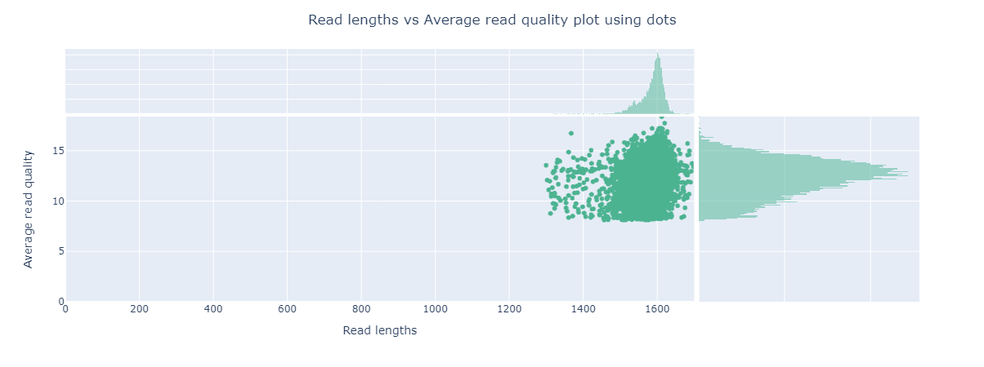

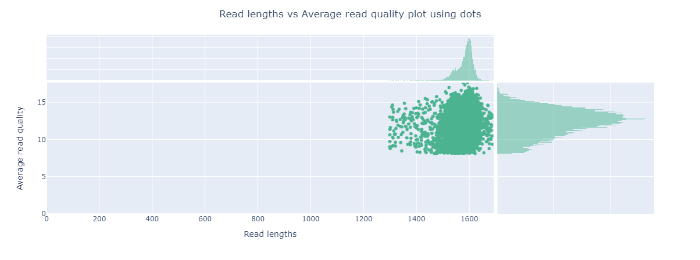

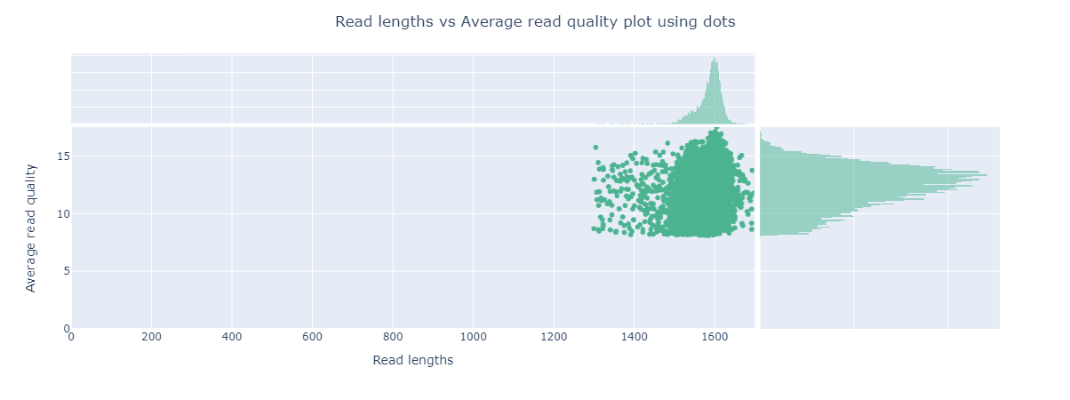

Figure 1. Read lengths vs Average read quality plot using dots a) station 33, (b) station 48, (c)station 50

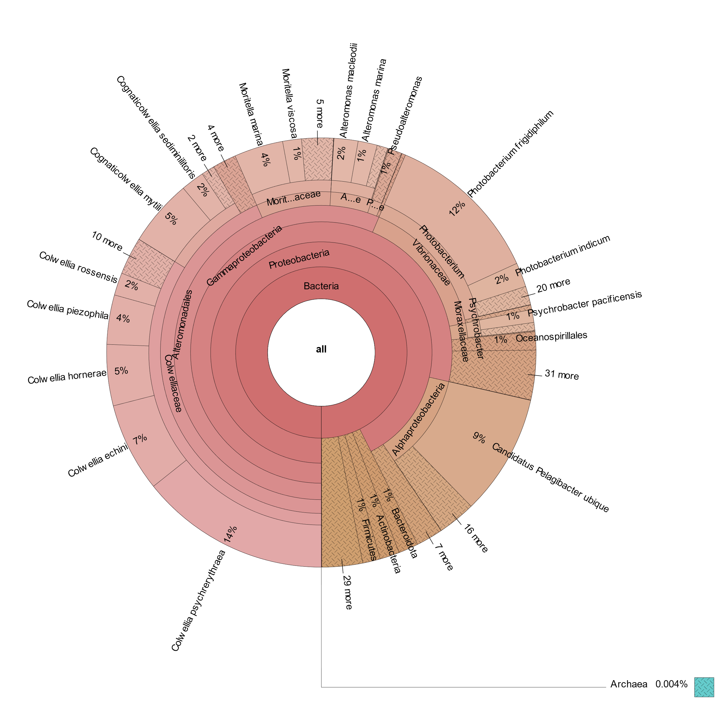
(a)
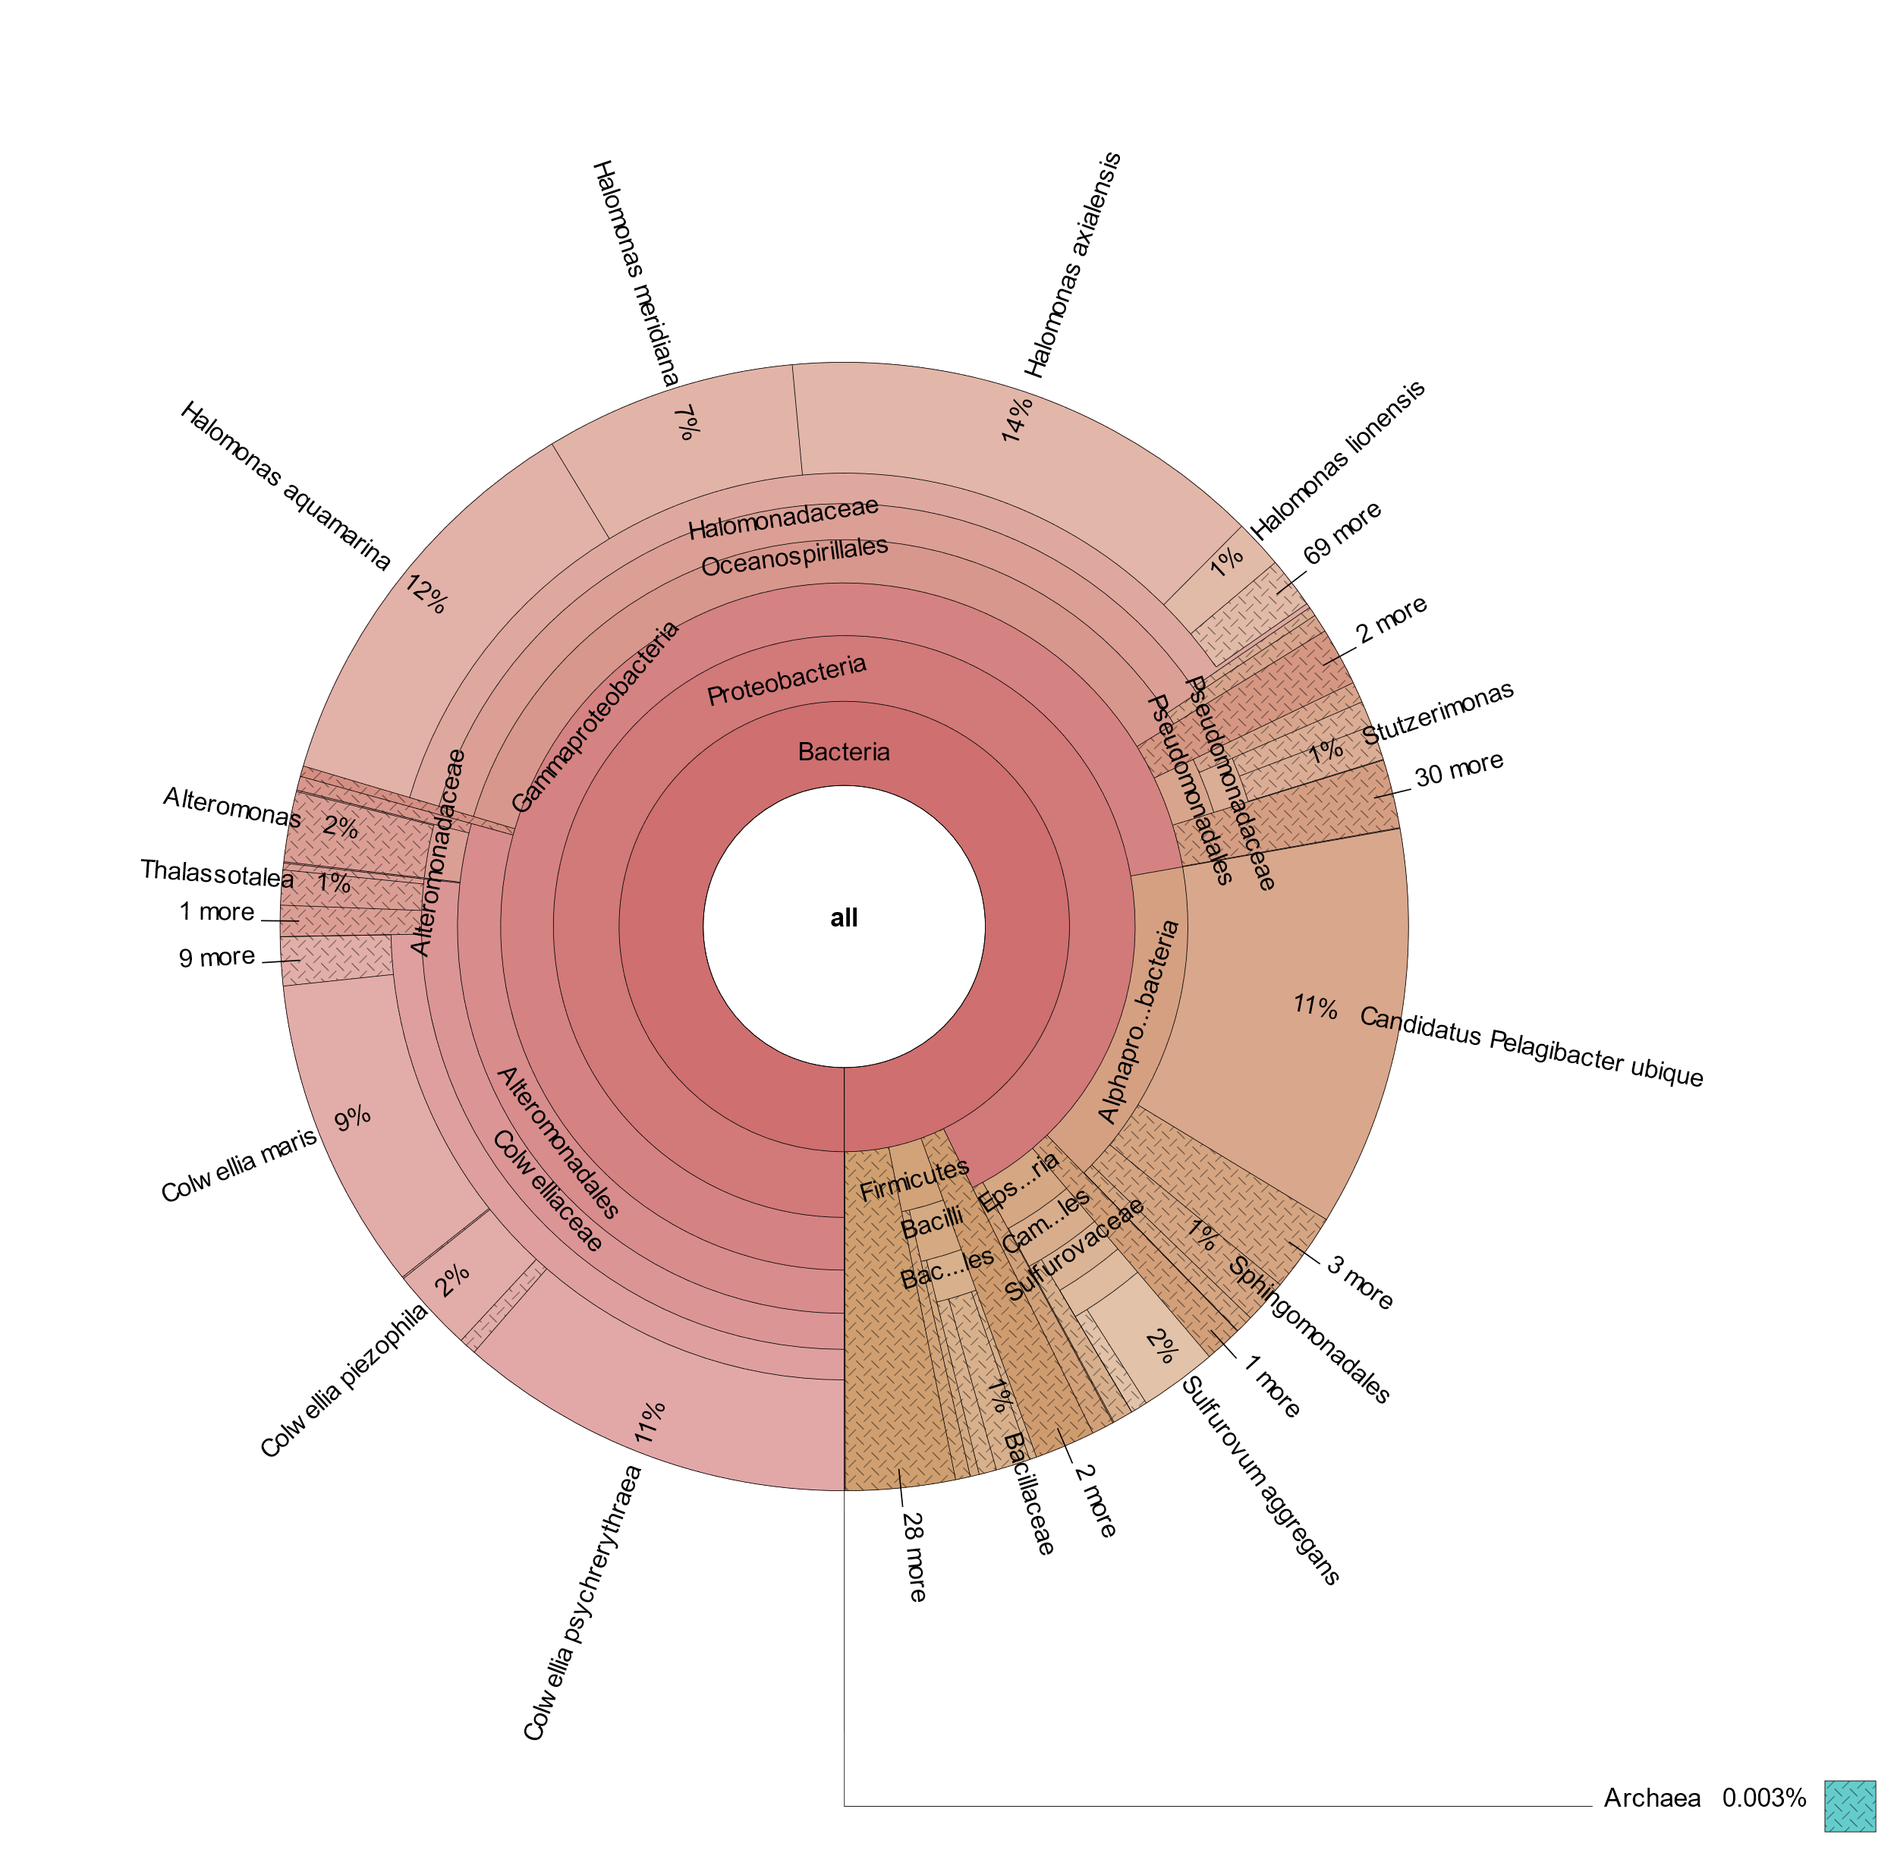
(b)

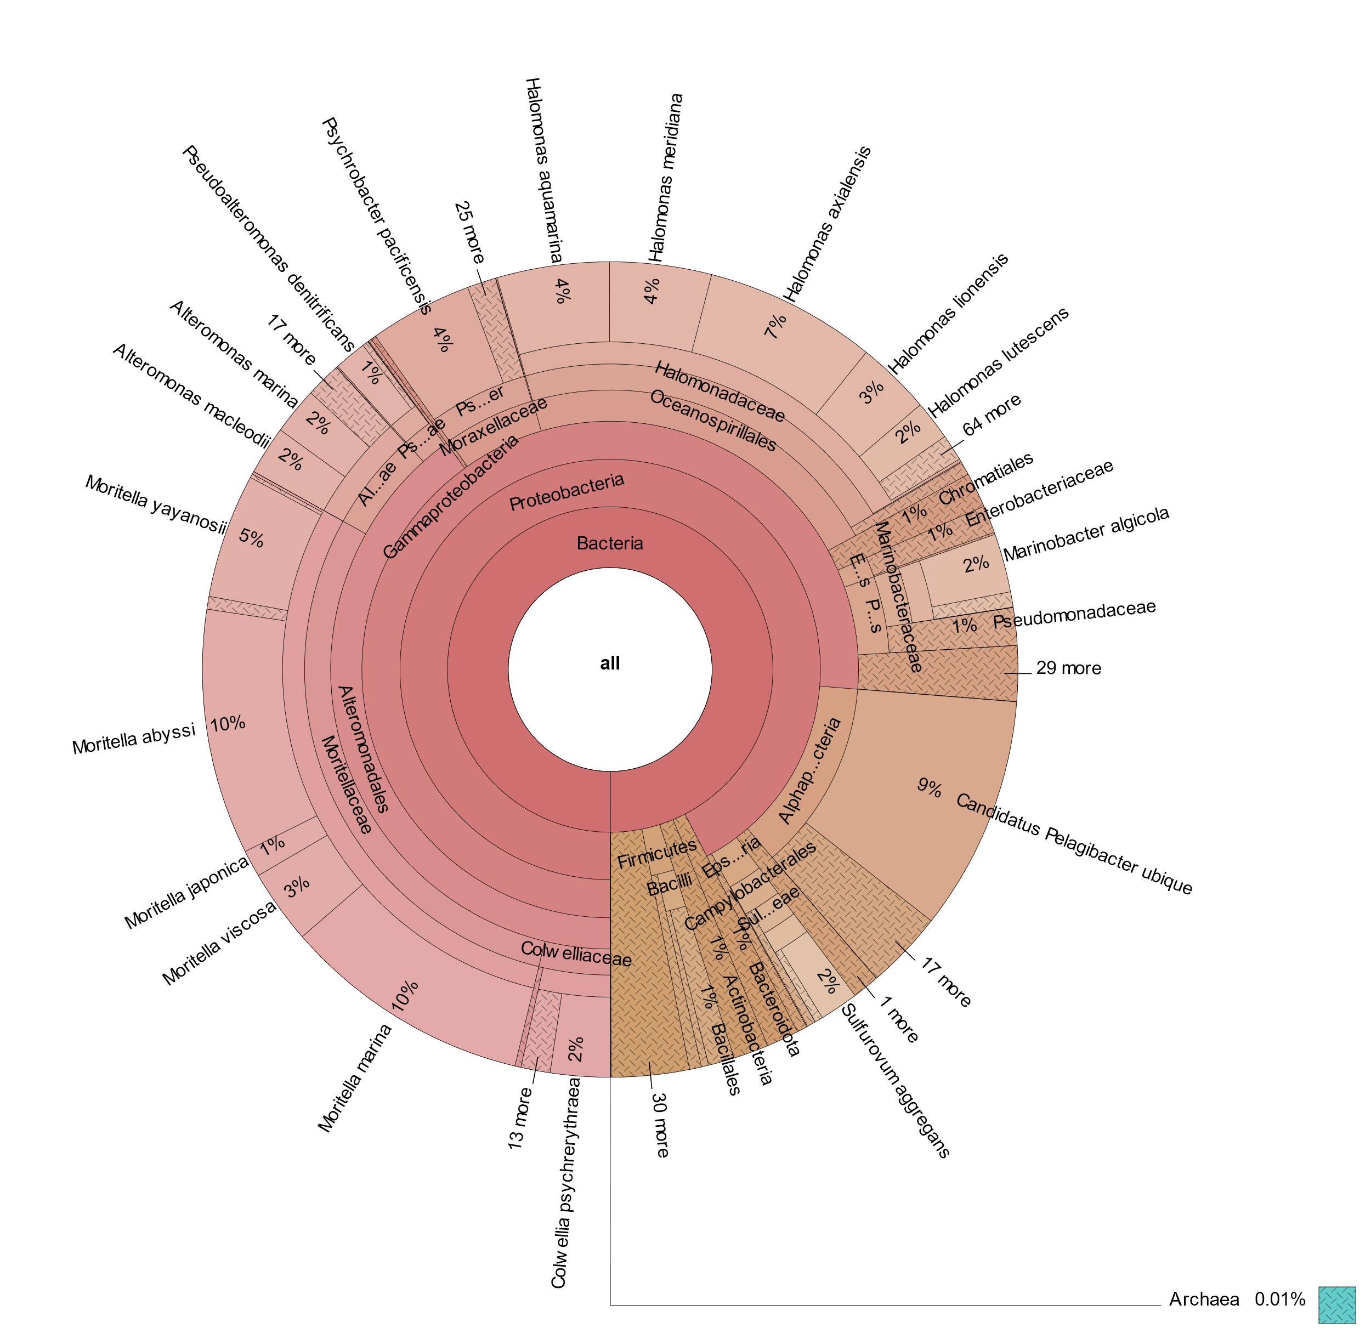
(c)
Figure 2. Krona Visualization (a)Station 33, (b)Station 48, (c)Station 50

