Supplementary materials

Supplementary Table S1 Description of carotid-femoral pulse wave velocity_{subtracted distance} (cfPWV_{subtracted distance}) according to the age category in the female and male reference population.

 |  | Female reference population |  |  |  | Male reference population |  |  | P-value
 | Age category (years) | N | Mean ± 2 SD | Median (10% - 90%) |  | N | Mean -+ 2 SD | Median (10% - 90%) | P-value
cfPWV_{subtracted distance} (m/sec) | 18-30 | 696 | 5.5 (3.7 - 7.4) | 5.5 (4.4 - 6.8) |  | 626 | 5.8 (3.6 - 8) | 5.6 (4.6 - 7.1) | <0.001
cfPWV_{subtracted distance} (m/sec) | 30-40 | 606 | 6 (3.8 - 8.2) | 5.8 (4.8 - 7.3) |  | 574 | 6.3 (4.1 - 8.6) | 6.2 (5 - 7.8) | <0.001
cfPWV_{subtracted distance} (m/sec) | 40-50 | 767 | 6.5 (4.2 - 8.8) | 6.4 (5.1 - 7.9) |  | 575 | 6.9 (4.4 - 9.4) | 6.7 (5.4 - 8.5) | <0.001
cfPWV_{subtracted distance} (m/sec) | 50-60 | 601 | 7 (4.1 - 9.9) | 6.7 (5.4 - 9) |  | 446 | 7.3 (4.4 - 10.2) | 7.1 (5.6 - 9.1) | <0.001
cfPWV_{subtracted distance} (m/sec) | 60-70 | 361 | 7.7 (4.6 - 10.8) | 7.4 (6 - 9.7) |  | 205 | 8.1 (4.4 - 11.7) | 7.9 (6 - 10.5) | 0.7
cfPWV_{subtracted distance} (m/sec) | >=70 | 139 | 8.8 (5.2 - 12.4) | 8.7 (6.6 - 11.1) |  | 66 | 9 (5.2 - 12.9) | 9 (6.3 - 11.8) | 0.4
SD: standard deviation; 10 pc: the 10th percentile; 90 pc: the 90th percentile.

Supplementary Table S2 The age-adjusted equations for predicted values of the median (M), the variability around the median (S) and the skewness (L) for carotid-femoral pulse wave velocity_{subtracted distance} (cfPWV_{subtracted distance}) in females and males, extracted by LMS method.
Variable | Sex | M (Median) | S (Variability around the Median) | L (Skewness)
cfPWV_{subtracted distance}  (m/sec) | Female | Exp (1.534 + 0.0081 * Age) | Exp (-1.946 + 0.0057 * Age) | -0.5142
cfPWV_{subtracted distance}  (m/sec) | Male | Exp (1.489 + 0.0080 * Age) | Exp (-2.033 + 0.0067 * Age) | -0.5773

Supplementary Fig. S1 Distribution of carotid-femoral pulse wave velocity_{subtracted distance} (cfPWV_{subtracted distance}) according to the age in females (n=3170) and males (n=2492)
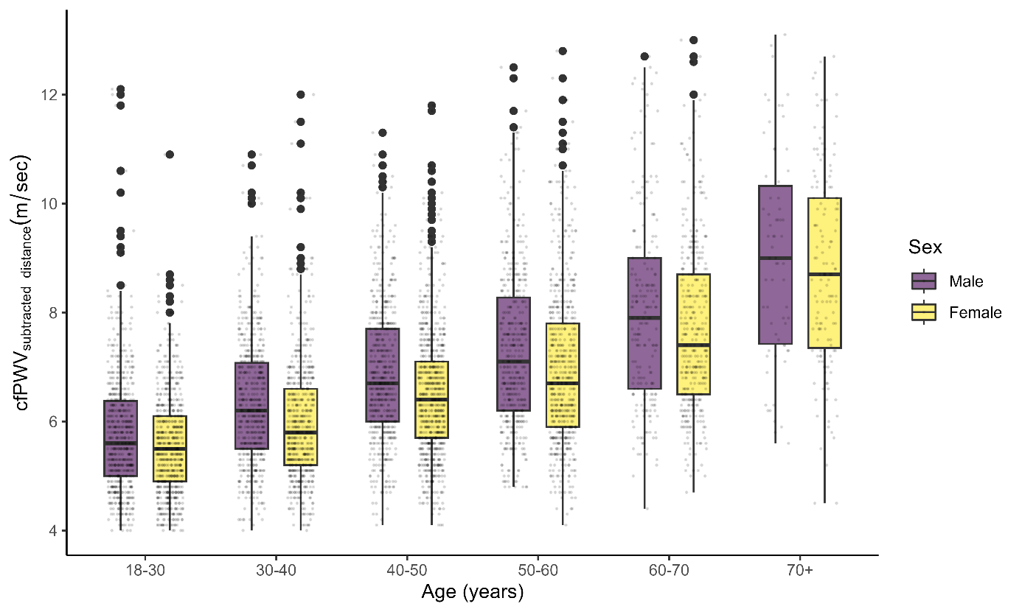

Supplementary Fig. S2 Adjusted-age percentile curves for carotid-femoral pulse wave velocity_{subtracted distance} (cfPWV_{subtracted distance}) in female and male participants in the reference population. Green, blue, and red lines indicate 10th, 50th, and 90th percentile, respectively
