Supplementary Information
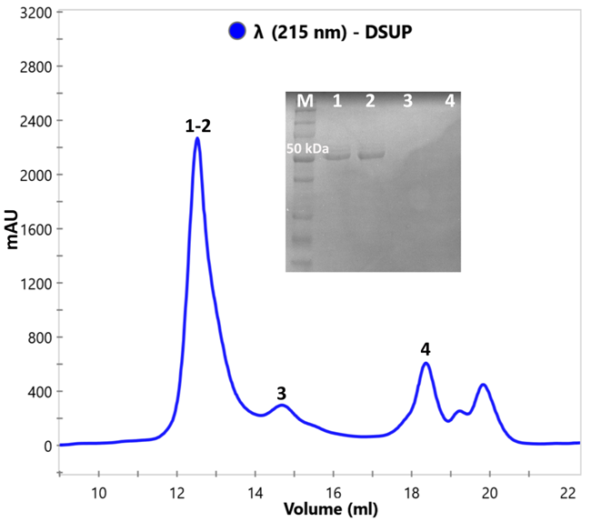
Figure S1. SEC chromatogram of Dsup protein (the absorbance at 215 nm was measured) and results of SDS‐polyacrylamide gel electrophoresis for selected SEC fractions (in the insert, the original gel is presented in Figure S5). The designations of fractions after SEC (1-4) coincide with designations of samples loaded in the gel. M – molecular weight marker

Figure S2. Das-Pappu diagram created by CIDER (http://pappulab.wustl.edu/CIDER). The physicochemical properties of each colored zone are explained in the insert. Dsup protein is marked with black dot.
Figure S3. CD wavelength scans of Dsup protein in PBS and 50% trifluoroethanol indicate the formation of α-helical regions.
Figure S4. Application of EOM to SAXS data of Dsup in H₂O. (a) – Fit of EOM ensemble to Dsup solution in H₂O; (b) – Distribution of R_{g} for the pool of random models Dsup (grey) and optimized ensemble (blue); (c) – Ensemble of 6 conformations of Dsup that fit the SAXS curve (see figure (a)). For a qualitative description of the Dsup structure in H₂O solution, we used the EOM program (see Methods section). The ensemble of 6 Dsup conformations was obtained (shown in Fig. S4c) whose average calculated scattering curves fit SAXS data with lowest χ² = 1.342. The probability distribution for R_{g} for the ensemble of protein conformations is shown in Fig. S4b. The averaged R_{g} of pool of all conformations is 60 Å that is close to values obtained by Fourier transform and Gauss coil model (Table 1). The distributions for the optimized ensemble are bimodal. The distribution for R_{g} has maximums at ~50 and ~100 Å. The first value is less than one for the pool and obtained by other methods, while the average value is noticeably higher and equal to 80 Å. This overestimation is caused by the presence of the second mode in the histogram. The bimodality can indicate on two major conformations that the Dsup can adopt: more compact with R_{g} about 50 Å and more extended with R_{g} about 100 Å.
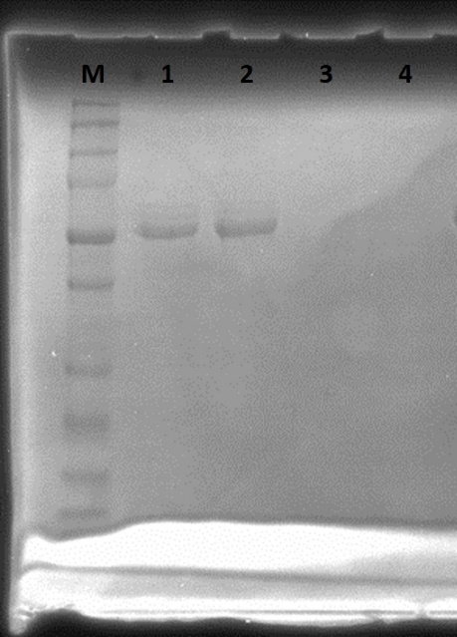
Figure S5. Original SDS-PAGE gel for 1-4 SEC fractions obtained after Dsup protein purification. M – molecular weight marker

Table S1. Parameters used for calculating molecular weight MW of Dsup according equation (2) (see section Methods). Protein concentration c was calculated using the dilution coefficients when preparing protein solutions from stocks; whereas the concentration of protein in stock solutions was measured by Qubit assay (see section Methods). I₀ was estimated from Fourier transform performed by GNOM program; Specific partial volume of Dsup η was calculated by averaging values calculated by software and presented in literature ^{1–5}; average scattering density of Dsup $\overline{ρ}$ was calculated using the SLD calculator built in program SasFit ⁶ (formula for Dsup C₁₇₇₉N₅₉₂O₆₈₃S₃H₂₉₆₄ and energy of X-ray 8 keV); average scattering density of solvent ρ_{s} calculated according to equation (3); mass density of the solvent ρ_{m} was measured by densitometer Anton Paar 5000M (see section Methods).
# The error value for the molecular weight was taken of 10% as estimated in work ⁷.
Sample  Parameter | Sample 1  Dsup in PBS | Sample 2  Dsup in PBS | Sample 3  Dsup in H₂O | Sample 4  Dsup in H₂O
Protein concentration c, mg/ml | 1.76 | 2.16 | 3.85 | 1.8
I₀, cm⁻¹  (from distance distribution function) | 0.086 | 0.111 | 0.152 | 0.065
Specific partial volume of Dsup η, cm³ /g | 0.721
Average scattering density of Dsup $\overline{ρ}$, 10¹⁰ cm⁻² | 12.60
Average scattering density of solvent ρ_{s}, 10¹⁰ cm⁻² | 9.489 | 9.489 | 9.432 | 9.432
Mass density of the solvent ρ_{m}, g /cm³ | 1.006253 | 1.006253 | 0.998330 | 0.998335
Experimental molecular weight#, kDa | 59±6 | 61±6 | 57±6 | 42±4
Experimental molecular weight/43.7 (calculated molecular weight), kDa | 1.3 | 1.4 | 1.3 | 0.95

Table S2. Secondary structure content of Dsup protein obtained from CD-spectroscopy data analyzed by the DichroWeb server.
Algorithm of calculations | α, % | β, % | random coil, % |  |  | NRMSD
Dsup in PBS
ContinLL | 9 | 31 | 60 |  |  | 0.13
CDSSTR (Set 4) | 10 | 29 | 61 |  |  | 0.025
CDSSTR (Set 7) | 5 | 24 | 71 |  |  | 0.029
CDSSTR (Set 180) | 4 | 40 | 56 |  |  | 0.042
Dsup in H₂O
ContinLL | 7 | 34 | 59 |  |  | 0.115
CDSSTR (Set 4) | 6 | 33 | 61 |  |  | 0.01
CDSSTR (Set 7) | 2 | 18 | 79 |  |  | 0.009
CDSSTR (Set 180) | 4 | 33 | 63 |  |  | 0.011
Dsup-DNA in H₂O
ContinLL | 11 | 27 | 62 |  |  | 0.076
CDSSTR (Set 4) | 9 | 32 | 59 |  |  | 0.021
CDSSTR (Set 7) | 4 | 26 | 70 |  |  | 0.024
CDSSTR (Set 180) | 5 | 34 | 61 |  |  | 0.034

Table S3. DNA binding IDPs and associated biological processes
DNA-binding IDP Protein, PONDR® VSL2 mean disorder score and % IDR |  | Molecular function | Molecular weight, kDa (a.a. residues) | DNA-binding properties | Examples of biological processes
Transcriptional regulation (leading function)

NUPR1  (Nuclear protein 1) ^{8,9}  0.9422  100% | Transcriptional regulation, antioxidant response |  | 8.873 (82) | Forms fuzzy complex.  Non-specific binding DNA, mainly to the small-groove of DNA. Partial homology and similarity of biochemical properties to High Mobility Group proteins (HMG). Helix-loop-helix AT-hook-containing HMG proteins. Tendency to order to disorder transitions. | Stress response and resistance, antioxidant response, cell-cycle, DNA repair, apoptosis, cancer resistance, response to genotoxic stress
HMGN proteins^{10,11}  0.9193  100% | Transcriptional regulation, non-histone chromatin architectural protein |  | 10.659 (100) | Non-specific DNA-binding IDPs. Nuclesome-binding protein Genome-wide HMGNs preferentially localize to chromatin regulatory sites. HMGN –reduces chromatin compaction. High tendency to undergo order-to-disorder transitions. | Modulate chromatin remodeling, DNA repair, regulation of histone posttranslational modifications (PTMs) and maintenance of cell identity  Interactions with histone proteins. Affects stress-response
p53 ^{12,13}  0.6849  68.19% | Transcriptional regulation, maintaining the genome integrity, controlling apoptosis, cell-cycle regulation and arrest, DNA repair |  | 43.7 (393) | DNA-binding protein that forms homotetramer that recognizes specific response elements with DNA-binding core domain. The protein-DNA complex is compact | Acts as a tumor suppressor in many tumor types; induces growth arrest or apoptosis depending on the physiological circumstances and cell type
MeCP2 ^{14,15}  0.8854  93.42% | Transcriptional regulation, architectural protein |  | 52.4 (486) | Monomer with preferential binding to nucleosomes. Binds to methylated DNA, specifically to a single methyl-CpG pair. Undergoes order-to-disorder transitions upon binding to DNA. | Mediates transcriptional repression. Neural system regulation, brain development, neuro-developmental disease, autism spectrum disorders
ETS-1  ^{16,17}  0.4405  42.86% | Transcriptional regulation, immunity |  | 50.4 (441) | DNA-binding of monomer or homodimer. Mainly specifically binds to Ets-binding sites (EBS), comprising a 50-GGAA/T-30 core motif. Fuzzy complex formation. Inserts into the DNA major groove. Undergoes order-to-disorder transitions. | Controls the expression of cytokine and chemokine genes in a wide variety of different cellular contexts, including cancer progression, immune response, T cells development
FUS ^{18–20}  0.8894  90.68% | Transcriptional regulation, RNA splicing, DNA damage response signaling, DNA repair and damage response |  | 53.4 (526) | DNA/RNA-binding protein. Weaker binding to DNA than to FUS. Binding specificity to some RNA sequences. Contains unstructured “prion”-like domain (PLD) | Neural system functioning, associated diseases and neurodegeneration as amyotrophic lateral sclerosis/ frontemporal dementia (ALS/FTD). Sarcoma and cancer progression. Response to DNA damage and being one of the earliest proteins recruited to DNA lesions
Tau ^{21,22}  0.8580  99.08% | Transcriptional regulation. DNA damage response. Microtubule assembly and stability, organization and integrity of the neuronal cytoskeleton, neural system development. |  | 78.9 (758) | Binds to double-stranded DNA and mainly to minor groove. Some rate of specificity ti binding with AG-rich DNA motif, especially 5’-AGAGAGAGAG-3’, and overlap with DNA sequences coding for lncRNAs. | Neural system functioning, neurodegeneration process, Alzheimer's disease etc. Participates in protection of DNA damage prevention.
TDP-43 ^{23,24}  0.5866  57.25% | Transcriptional regulation. RNA splicing factor and RNA processing.  Chromatin condensation. Response to DNA damage. |  | 44.7 (414) | DNA/RNA-binding protein. RNA-binding is sequence specific and occur to GU-repeats of RNA molecules predominantly localized within long introns and in the 3'UTR of mRNAs | Neurodegenerative disorders. Response to DNA damage.
MAX ²⁵  0.8189  96.88% | Transcriptional regulation |  | 18.3 (160) | DNA-binding to specific sequences as 5’-CAC[GA]TG-3’, which occures upon formation of heterodimers MAC-MYC (activator), MAX-MAD (repressor). MAX is classified as helix-loop-helix protein. | Abnormalities of cellular development and proliferation, apoptosis. Associated with progression multiple types of cance.
DNA and RNA machinery

NPM1 ^{26,27}  0.6614  61.22% | Ribosome biogenesis, centrosome duplication, protein chaperoning, histone assembly, cell proliferation. |  | 32.6 (294) | DNA/RNA-binding protein participating in fuzzy interactions upon complex formation. NPM1 has a modular structure with folded N-terminal and C-terminal domains linked by an intrinsically disordered region. NPM1 can form homo- or hetero-oligomers through its N-terminal region, and bind DNA and RNA through its C-terminal region. | An aberrant cytoplasmic accumulation of the protein in leukemic cells leads to Acute Myeloid Leukemia (AML). Cancer progression process
Ddx4 ^{28,29}  0.5137  45.03% | Helicase-mediated RNA metabolism (e.g., piRNA biogenesis), piRNA-dependent retrotransposon control and repression of transposable elements, germ granule formation, |  | 79.3 (724) | DNA/RNA-binding protein. DEAD-box helicases containing protein. Complex is still not comprehensively investigated | Cell cycle progression of cancer cells. Germline integrity and spermatogenesis
SSB ^{30,31}  0.6032  57.30% | DNA replication, recombination and repair |  | 19.0 (178) | Single stranded DNA-binding protein, without significant sequence specificity. Acts as a sliding platform that migrates on DNA via reptation. Protein undergoes compaction upon binding to DNA. Forms homotetramer.
Others

PaaA2 ^{32,33}  0.2828  11.96% | Type II toxin-antitoxin system RelE/ParE family toxin. |  | 10.7 (92) | Binding of PaaA2 to ParE2 through conformational selection, oligomerization of the toxin-antitoxin complex, the formed heterododecamer may recognize and bind the operator DNA | Antitoxins from prokaryotic type II toxin-antitoxin modules. Modulation of metabolic activity, persistence, virulence and pathogenicity

References

1. Fleming, P. J. & Fleming, K. G. HullRad: Fast Calculations of Folded and Disordered Protein and Nucleic Acid Hydrodynamic Properties. Biophys. J. 114, 856–869 (2018).
2. Sołtys, K. & Ożyhar, A. Ordered structure-forming properties of the intrinsically disordered AB region of hRXRγ and its ability to promote liquid-liquid phase separation. J. Steroid Biochem. Mol. Biol. 198, (2020).
3. Mansouri, A. L. et al. Folding propensity of intrinsically disordered proteins by osmotic stress. Mol. Biosyst. 12, 3695–3701 (2016).
4. Banks, A., Qin, S., Weiss, K. L., Stanley, C. B. & Zhou, H. X. Intrinsically Disordered Protein Exhibits Both Compaction and Expansion under Macromolecular Crowding. Biophys. J. 114, 1067–1079 (2018).
5. Schramm, A. et al. An arsenal of methods for the experimental characterization of intrinsically disordered proteins – How to choose and combine them? Arch. Biochem. Biophys. 676, 108055 (2019).
6. Kohlbrecher, J., Breßler, I. & Barty, A. Updates in SASfit for fitting analytical expressions and numerical models to small-angle scattering patterns. J. Appl. Crystallogr. 55, 1677–1688 (2022).
7. Mylonas, E. & Svergun, D. I. Accuracy of molecular mass determination of proteins in solution by small-angle X-ray scattering. J. Appl. Crystallogr. 40, 245–249 (2007).
8. Neira, J. L. et al. Dynamics of the intrinsically disordered protein NUPR1 in isolation and in its fuzzy complexes with DNA and prothymosin α. Biochim. Biophys. Acta - Proteins Proteomics 1867, 140252 (2019).
9. Urrutia, R. et al. Evidence supporting the existence of a NUPR1-like family of helix-loop-helix chromatin proteins related to, yet distinct from, AT hook-containing HMG proteins. J. Mol. Model. 20, (2014).
10. Nanduri, R., Furusawa, T. & Bustin, M. Biological functions of HMGN chromosomal proteins. Int. J. Mol. Sci. 21, 1–27 (2020).
11. Rochman, M. et al. Effects of HMGN variants on the cellular transcription profile. Nucleic Acids Res. 39, 4076–4082 (2011).
12. Wells, M. et al. Structure of tumor suppressor p53 and its intrinsically disordered N-terminal transactivation domain. Proc. Natl. Acad. Sci. U. S. A. 105, 5762–5767 (2008).
13. Tidow, H. et al. Quaternary structures of tumor suppressor p53 and a specific p53-DNA complex. Proc. Natl. Acad. Sci. U. S. A. 104, 12324–12329 (2007).
14. Hite, K. C., Kalashnikova, A. A. & Hansen, J. C. Coil-to-helix transitions in intrinsically disordered methyl CpG binding protein 2 and its isolated domains. Protein Sci. 21, 531–538 (2012).
15. Yang, C., Van Der Woerd, M. J., Muthurajan, U. M., Hansen, J. C. & Luger, K. Biophysical analysis and small-angle X-ray scattering-derived structures of MeCP2-nucleosome complexes. Nucleic Acids Res. 39, 4122–4135 (2011).
16. Lamber, E. P. et al. Regulation of the transcription factor Ets-1 by DNA-mediated homo-dimerization. EMBO J. 27, 2006–2017 (2008).
17. Lee, G. M. et al. The structural and dynamic basis of Ets-1 DNA binding autoinhibition. J. Biol. Chem. 280, 7088–7099 (2005).
18. Wang, X., Schwartz, J. C. & Cech, T. R. Nucleic acid-binding specificity of human FUS protein. Nucleic Acids Res. 43, 7535–7543 (2015).
19. Yamaguchi, A. & Takanashi, K. FUS interacts with nuclear matrix-associated protein SAFB1 as well as Matrin3 to regulate splicing and ligand-mediated transcription. Sci. Rep. 6, 1–14 (2016).
20. Wang, W. Y. et al. Interaction of FUS and HDAC1 regulates DNA damage response and repair in neurons. Nat. Neurosci. 16, 1383–1391 (2013).
21. Wei, Y. et al. Binding to the minor groove of the double-strand, Tau protein prevents DNA damage by peroxidation. PLoS One 3, (2008).
22. Benhelli-Mokrani, H. et al. Genome-wide identification of genic and intergenic neuronal DNA regions bound by Tau protein under physiological and stress conditions. Nucleic Acids Res. 46, 11405–11422 (2018).
23. Liu, E. Y. et al. Loss of Nuclear TDP-43 Is Associated with Decondensation of LINE Retrotransposons. Cell Rep. 27, 1409-1421.e6 (2019).
24. Chang, C. ke et al. The N-terminus of TDP-43 promotes its oligomerization and enhances DNA binding affinity. Biochem. Biophys. Res. Commun. 425, 219–224 (2012).
25. Nair, S. K. & Burley, S. K. X-Ray Structures of Myc-Max and Mad-Max Recognizing DNA. Cell 112, 193–205 (2003).
26. Mitrea, D. M. et al. Self-interaction of NPM1 modulates multiple mechanisms of liquid-liquid phase separation. Nat. Commun. 9, 1–13 (2018).
27. Saluri, M. et al. A “grappling hook” interaction connects self-assembly and chaperone activity of Nucleophosmin 1. PNAS Nexus 2, 1–9 (2023).
28. Xu, C., Cao, Y. & Bao, J. Building RNA-protein germ granules: insights from the multifaceted functions of DEAD-box helicase Vasa/Ddx4 in germline development. Cell. Mol. Life Sci. 79, 1–15 (2022).
29. Brady, J. P. et al. Structural and hydrodynamic properties of an intrinsically disordered region of a germ cell-specific protein on phase separation. Proc. Natl. Acad. Sci. U. S. A. 114, E8194–E8203 (2017).
30. Green, M., Hatter, L., Brookes, E., Soultanas, P. & Scott, D. J. Defining the Intrinsically Disordered C-Terminal Domain of SSB Reveals DNA-Mediated Compaction. J. Mol. Biol. 428, 357–364 (2016).
31. Kozlov, A. G., Cox, M. M. & Lohman, T. M. Regulation of single-stranded DNA binding by the C termini of Escherichia coli single-stranded DNA-binding (SSB) protein. J. Biol. Chem. 285, 17246–17252 (2010).
32. Sterckx, Y. G. J. et al. Small-angle X-ray scattering- and nuclear magnetic resonance-derived conformational ensemble of the highly flexible antitoxin PaaA2. Structure 22, 854–865 (2014).
33. Sterckx, Y. G. J. et al. A unique hetero-hexadecameric architecture displayed by the Escherichia coli O157 PaaA2-ParE2 antitoxin-toxin complex. J. Mol. Biol. 428, 1589–1603 (2016).
34. Zarubin, M. et al. The tardigrade Dsup protein enhances radioresistance in Drosophila melanogaster and acts as an unspecific repressor of transcription. iScience 26, (2023).

