Supplementary information for

Gaseous emissions from brake wear can form secondary particulate matter
Anil Patel^{1,2,a}, Sneha Aggarwal^{1,2}, Lucas Bard³, Olivier Durif⁴, Micol Introna¹, Ana Teresa Juárez-Facio¹, Minghui Tu³, Karine Elihn¹, Barbara Nozière⁴, Ulf Olofsson³, Sarah S. Steimer^{1,2*}
¹Department of Environmental Science, Stockholm University, Stockholm, 11418, Sweden
² Bolin Centre for Climate Research, Stockholm, 11418, Sweden
³Department of Machine Design, KTH Royal Institute of Technology, 10044, Stockholm, Sweden
⁴ Department of Chemistry, KTH Royal Institute of Technology, 10044, Stockholm, Sweden
ªnow at: Department of Atmospheric and Oceanic Sciences, University of California at Los Angeles, Los Angeles, CA 90095-1565, USA

*Corresponding author. Email address: sarah.steimer@aces.su.se

This supplement contains three figures;

Figure S1: Development of the number size distribution in the PAM reactor over the tribometer running time
Figure S2: A schematic drawing of the tribometer
Figure S3: The PAM reactor settings, e.g., Relative Humidity (% RH), Temperature (ºC), and Ozone (ppb), over the tribometer running time

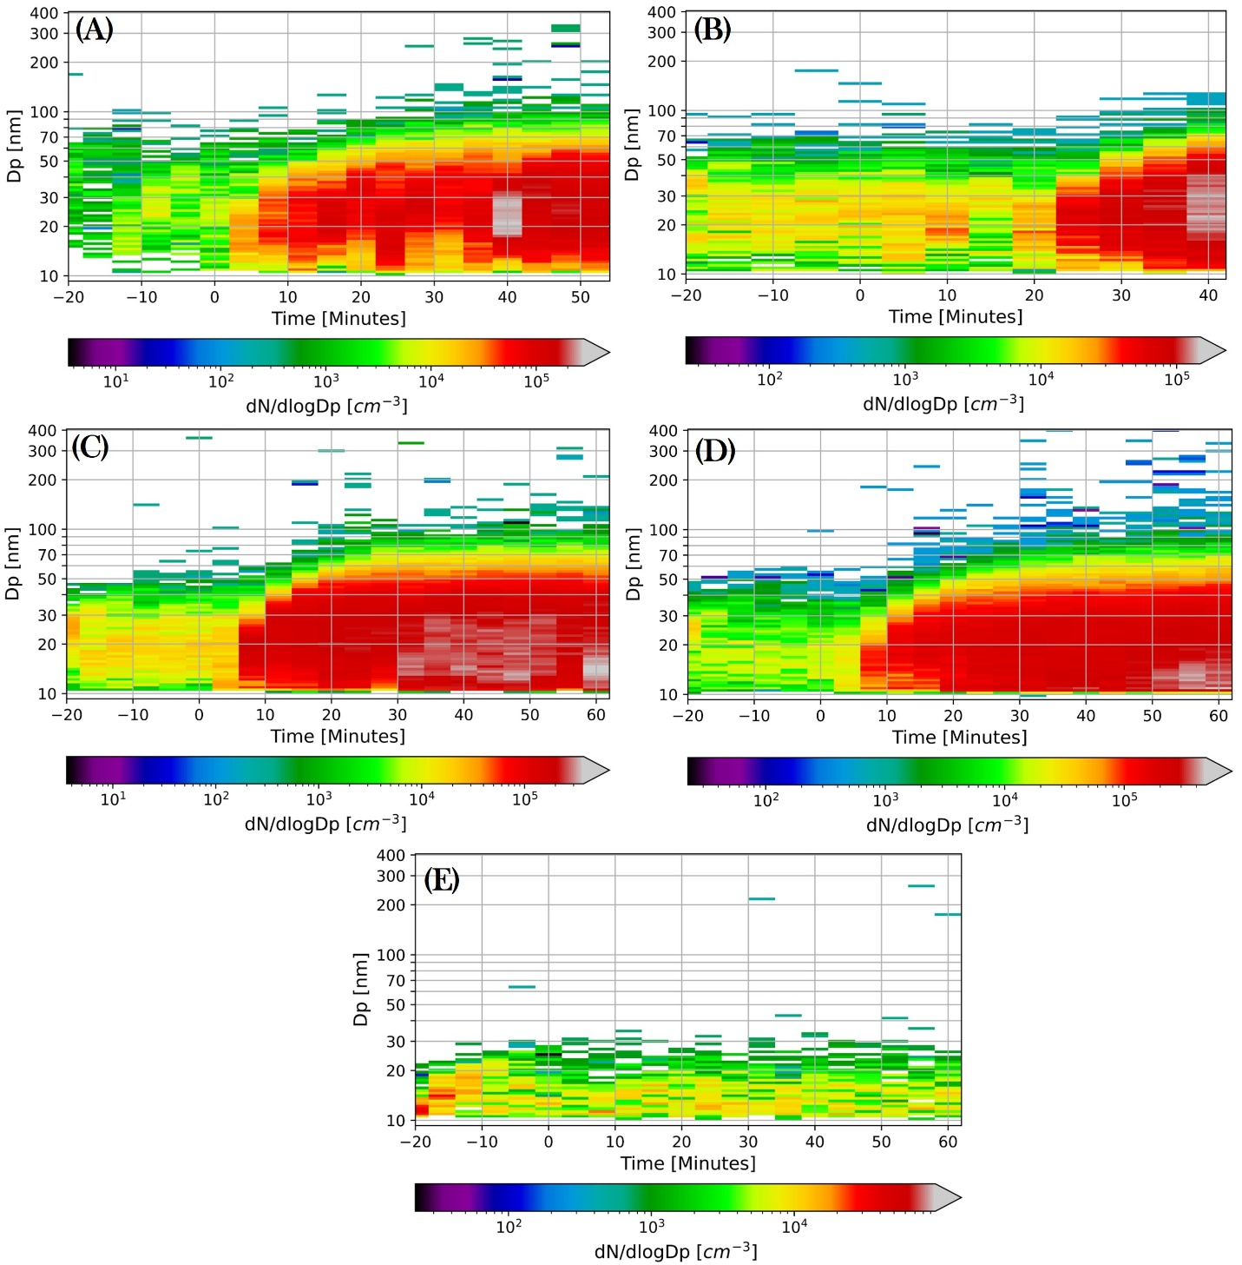
Figure S1: Development of the number size distribution in the PAM reactor over the tribometer running time for experiments obtained with (A) 7 days and (C) 9 days equivalent aging. B and D show the replicate of each equivalent aging time (7 respective 9 days). E shows the control experiment where the tribometer was run without a brake pin. Time 0 min marks the time when the tribometer was turned on (i.e. start of the generation of wear emissions for all experiments).

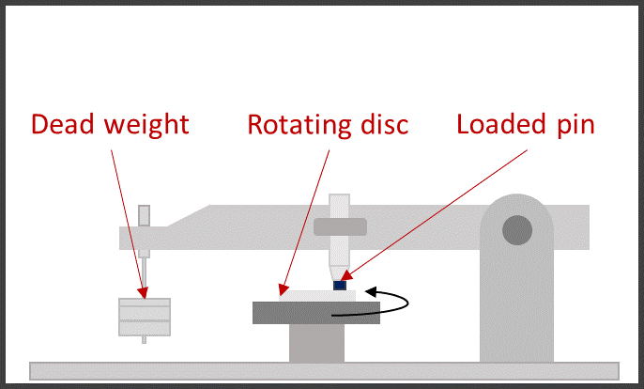
Figure S2: Schematic drawing of the pin-on-disc tribometer. Wear emissions are generated through contact between the dead-weight-loaded pin sample and the horizontal rotating disc sample. The dead-weight can be adjusted to generate different contact pressures. The tribometer machine body is enclosed in a chamber.

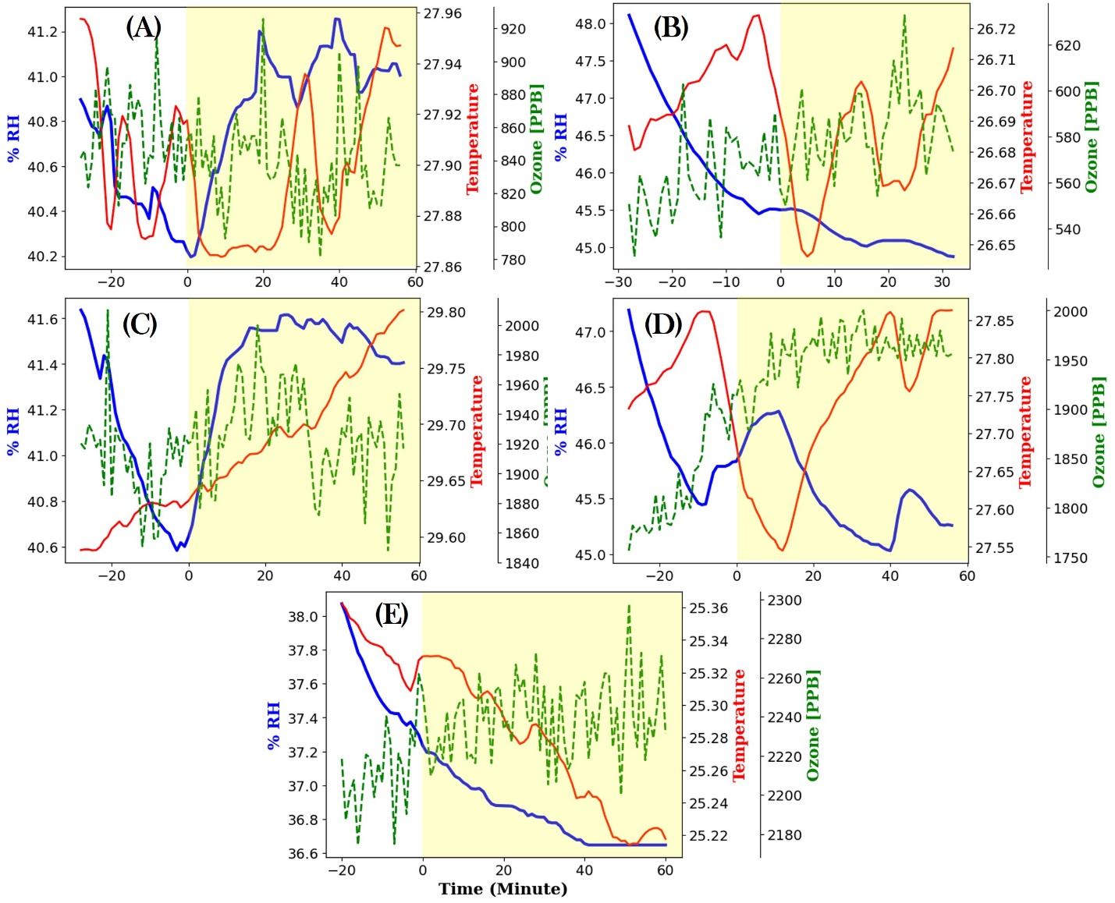
Figure S3: The PAM reactor settings, e.g., Relative Humidity (% RH, solid blue line), Temperature (ºC, solid red line), and Ozone (ppb, dashed green line), over the tribometer running time for experiments obtained with (A) 7 days and (C) 9 days equivalent aging. B and D show the replicate at each equivalent aging time (7 respective 9 days). E shows the control experiment where the tribometer was run without a brake pin. The yellow shading indicates the time periods during which the tribometer was running (i.e. wear emissions were generated).

