Supplementary Materials for
Association of Heat and Cold Waves with Cause-specific Mortality in Iran: A Systematic Review and Meta-analysis

List of keywords
‘heat wave’ OR ‘heatwave*’ OR ‘cold wave’ OR ‘coldwave*’ OR ‘warm spell’ OR ‘cold spell’ OR ‘hot wave’ OR ‘extreme temperature’ OR ‘extreme weather’ OR ‘temperature*’ OR ‘weather’ OR ‘climat*’ OR ‘season*’ OR ‘heat*’ OR ‘wet bulb’
AND
‘mortality’ OR ‘mortalit*’ OR ‘death*’ OR ‘health effect*’ OR 'years of life lost' OR 'life expectancy' OR 'yll' OR 'hyperthermia' OR 'heat stroke' OR 'thermal stress'
AND
‘iran’

Table S1. Guidance on assessing risk of bias in individual studies
Adapted from: Office of Health Assessment and Translation (OHAT) Risk of Bias Rating Tool for Human and Animal Studies and modified by Dimitrova et al. (2021)
 | Judgement criteria
Selection: Did selection of study participants result in appropriate comparison groups?
Definitely Low risk of bias | - There is direct evidence that inclusion of deaths in each time period (e.g. day/week/month) is not based on any factor associated with exposure (ie. Inclusion of deaths varies during summer/holidays).
Probably Low risk of bias | - There is indirect evidence that inclusion of deaths in each time period (e.g. day/week/month) is not based on any factor associated with exposure
Probably High risk of bias | - There is indirect evidence that the inclusion of deaths in each time period (e.g. day/week/month) is based on some factor associated with exposure.  OR  - There is insufficient information provided about the consistency of inclusion of deaths over the study period (record “NR” as basis for answer).
Definitely High risk of bias | - There is direct evidence that the inclusion of deaths is based on some factor associated with exposure.
Confounding: Did the study design or analysis account for important confounding and modifying variables?
Definitely Low risk of bias | - There is direct evidence that appropriate adjustments or explicit considerations were made for primary covariates and confounders in the final analyses through the use of statistical models to reduce research-specific bias including standardization, matching, adjustment in multivariable model, stratification, propensity scoring, or other methods that were appropriately justified.  AND  - There is direct evidence that primary covariates and confounders were assessed using valid and reliable measurements,  AND  - There is direct evidence that other exposures anticipated to bias results were not present or were appropriately measured and adjusted.
Probably Low risk of bias | - There is indirect evidence that appropriate adjustments were made,  OR  - It is deemed that not considering or only considering a partial list of covariates or confounders in the final analyses would not appreciably bias results.  AND  - There is evidence (direct or indirect) that primary covariates and confounders were assessed using valid and reliable measurements,  OR  - It is deemed that the measures used would not appreciably bias results (i.e., the authors justified the validity of the measures from previously published research),  AND  - There is evidence (direct or indirect) that other co-exposures anticipated to bias results were not present or were appropriately adjusted for,  OR  - It is deemed that co-exposures present would not appreciably bias results.
Probably High risk of bias | - The study did not account for any or accounted for some but not all of the primary confounders  AND  - This lack of accounting may have introduced substantial bias,  OR  - There is indirect evidence that primary covariates and confounders were assessed using measurements of unknown validity,  OR  - There is insufficient information provided about the measurement techniques used to assess primary covariates and confounders (record “NR” as basis for answer).
Definitely High risk of bias | - The study did not account for any or evaluate important potential confounders  AND  - There is direct evidence that this lack of accounting may have introduced substantial bias  OR  - There is direct evidence that primary covariates and confounders were assessed using non valid measurements.
Exposure assessment: Can we be confident in the exposure characterization?
Definitely Low risk of bias | - There is direct evidence that the exposure was consistently assessed using well-established methods that directly measure exposure,  OR  - Exposure was assessed using indirect measures (e.g., questionnaire or occupational exposure assessment by a certified industrial hygienist) that have been validated or empirically shown to be consistent with methods that directly measure exposure (i.e., inter-methods validation: one method vs. another).  AND  - Quality control procedure on the temperature series has been carried out, e.g. data have been explored for missing values and these have been handled in the initial data processing (employing rules, algorithms or models to impute missing values).  AND  - If there are missing observations from the time series, there is evidence that missingness is not related to exposure (e.g missing data during unusual weather).
Probably Low risk of bias | - There is indirect evidence that exposure was consistently assessed using well established methods that directly measure exposure,  OR  - Exposure was assessed using indirect measures that have been validated or empirically shown to be consistent with methods that directly measure exposure (i.e., inter-method validation).
Probably High risk of bias | - There is indirect evidence that the exposure was assessed using poorly validated methods that directly measure exposure,  OR  - There is direct evidence that the exposure was assessed using indirect measures that have not been validated or empirically shown to be consistent with methods that directly measure exposure,  OR  - There is insufficient information provided about the exposure assessment, including validity and reliability, but no evidence for concern about the method used.
Definitely High risk of bias | - There is direct evidence that the exposure was assessed using methods with poor validity,  OR  - Evidence of exposure misclassification.
Outcome assessment: Can we be confident in the outcome assessment?
Definitely Low risk of bias | - Outcome data on all cause mortality stem from a reliable data source  AND  - Studies provide evidence of quality assurance of outcome data.
Probably Low risk of bias | - There is indirect evidence that the outcome was assessed using acceptable methods,  OR  - It is deemed that the outcome assessment methods used would not appreciably bias results.
Probably High risk of bias | - There is indirect evidence that the outcome assessment method is an insensitive instrument.  OR  - There is insufficient information provided to judge that deaths were correctly recorded (record “NR” as basis for answer).
Definitely High risk of bias | - There is direct evidence that the outcome assessment method is an insensitive instrument.
Selective reporting: Were all measured outcomes reported?
Definitely Low risk of bias | - There is direct evidence that all of the study’s measured outcomes (primary and secondary) outlined in the protocol, methods, abstract, and/or introduction (that are relevant for the evaluation) have been reported. This would include outcomes reported with sufficient detail to be included in meta-analysis or fully tabulated during data extraction and analyses had been planned in advance.
Probably Low risk of bias | - There is indirect evidence that all of the study’s measured outcomes (primary and secondary) outlined in the protocol, methods, abstract, and/or introduction (that are relevant for the evaluation) have been  reported,  OR  - Analyses that had not been planned in advance (i.e., retrospective unplanned subgroup analyses) are clearly indicated as such and it is deemed that the unplanned analyses were appropriate and selective reporting would not appreciably bias results (e.g., appropriate analyses of an unexpected effect). This would include outcomes reported with insufficient detail such as only reporting that results were statistically significant (or not).
Probably High risk of bias | - There is indirect evidence that all of the study’s measured outcomes (primary and secondary) outlined in the protocol, methods, abstract, and/or introduction (that are relevant for the evaluation) have not been reported,  OR  - There is indirect evidence that unplanned analyses were included that may appreciably bias results,  OR  - There is insufficient information provided about selective outcome reporting (record “NR” as basis for answer).
Definitely High risk of bias | - There is direct evidence that all of the study’s measured outcomes (primary and secondary) outlined in the protocol, methods, abstract, and/or introduction (that are relevant for the evaluation) have not been reported. In addition to not reporting outcomes, this would include reporting outcomes based on composite score without individual outcome components or outcomes reported using measurements, analysis methods or subsets of the data (e.g., subscales) that were not pre-specified or reporting outcomes not pre-specified, or that unplanned analyses were included that would appreciably bias results.
Other bias: Were statistical methods appropriate?
Definitely Low risk of bias | - There is direct evidence that the statistical method used was appropriate.
Probably Low risk of bias | - There is indirect evidence that the statistical method used was appropriate.
Probably High risk of bias | - There is indirect evidence that the statistical method used was not appropriate.  OR  - There is insufficient information (e.g., not reported or “NR”) provided to judge the appropriateness of the statistical method.
Definitely High risk of bias | - There is direct evidence that the statistical method used was not appropriate for addressing the research question.

Table S2. Risk of bias assessment of eligible studies
Articles | Selection | Confounding | Exposure assessment | Outcome assessment | Selective reporting | Other bias
Aboubakri et al. (2019) | PL | DL | DL | DL | DL | PL
Ahmadnezhad et al. (2013) | PL | PL | PL | PL | PL | PL
Sharafkhani et al. (2020) | DL | DL | DL | DL | DL | DL
Shoraka et al. (2022) | PL | DL | PL | PL | PL | PL
Aghababaeian et al. (2023) | DL | DL | DL | DL | PL | DL

All-cause mortality: heterogeneity and publication bias
Heterogeneity
Method: Sidik-Jonkman tau2 = 0.0142
I2 (%) = 60.98
H2 = 2.56

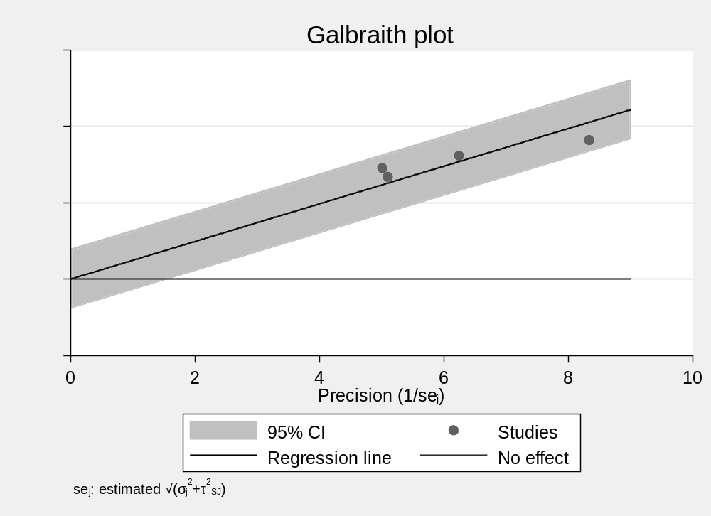

Publication bias
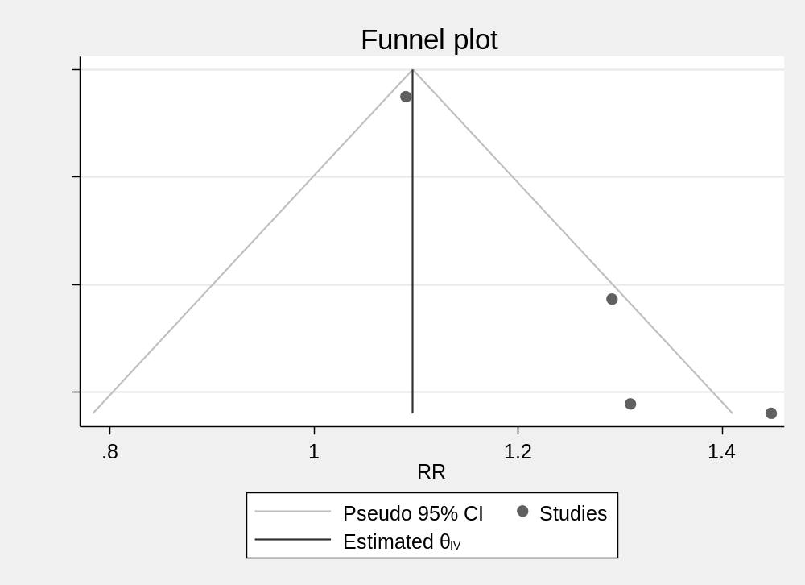

. meta bias, egger random(sjonkman)

Effect-size label: RR
Effect size: central
Std. err.: _meta_se

Regression-based Egger test for small-study effects
Random-effects model
Method: Sidik–Jonkman

H0: beta1 = 0; no small-study effects
beta1 = 2.03
SE of beta1 = 0.749
z = 2.71
Prob > |z| = 0.0067

CVD mortality: heterogeneity and publication bias
Heterogeneity
Method: Inverse-variance I2 (%) = 0.00
H2 = 1.00

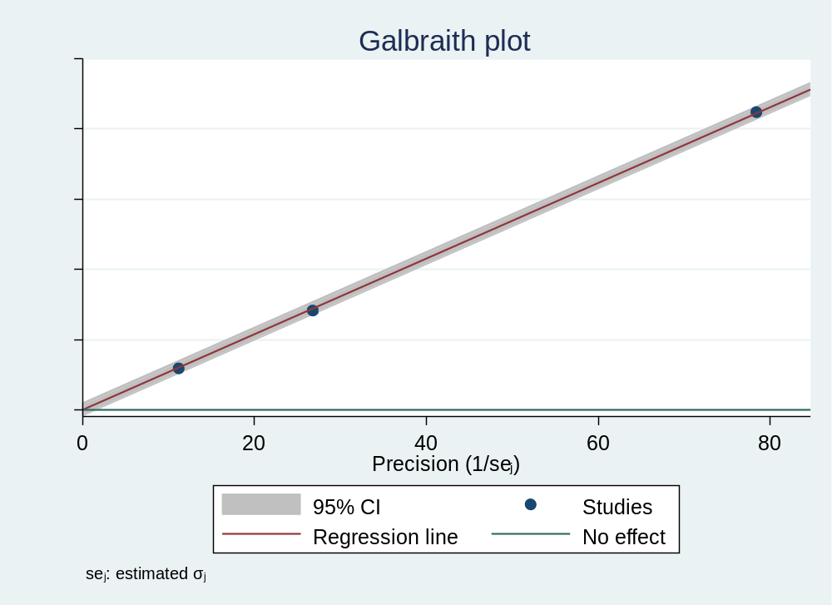
Publication bias
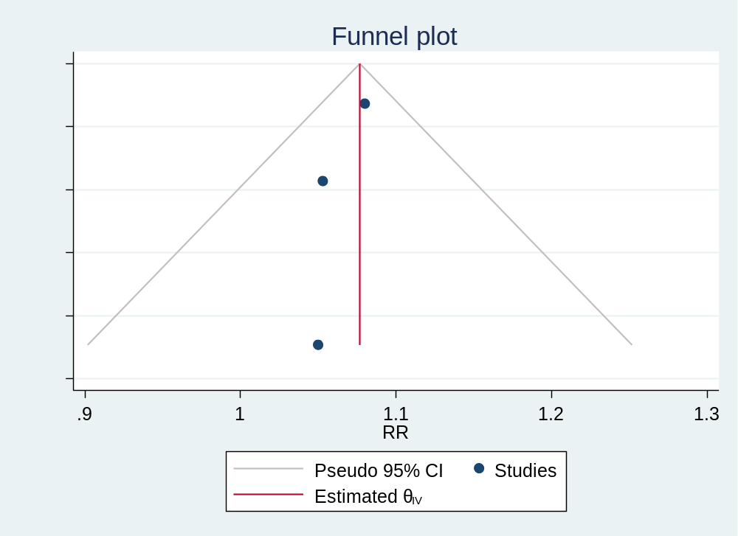

.
. meta bias, egger fixed

Effect-size label: RR
Effect size: central
Std. err.: _meta_se

Regression-based Egger test for small-study effects
Fixed-effects model
Method: Inverse-variance

H0: beta1 = 0; no small-study effects
beta1 = -0.63
SE of beta1 = 0.970
z = -0.65
Prob > |z| = 0.5131

Respiratory mortality: heterogeneity and publication bias
Heterogeneity
Method: Sidik-Jonkman tau2 = 0.0357
I2 (%) = 95.22
H2 = 20.90
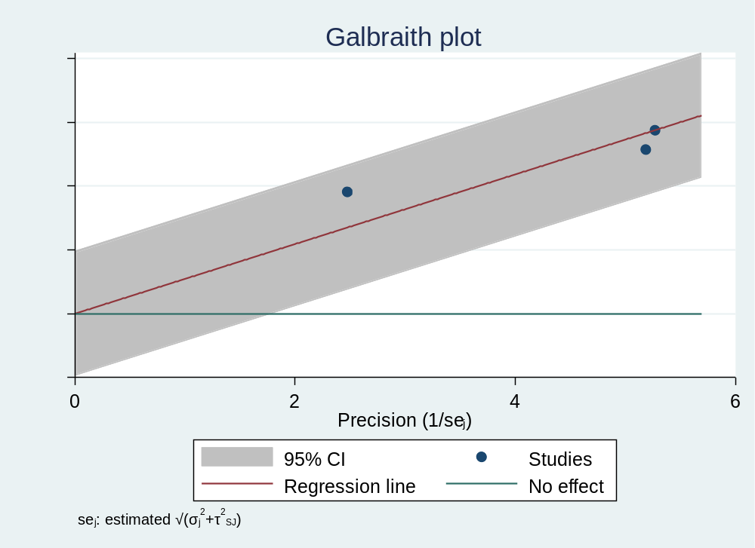

Publication bias
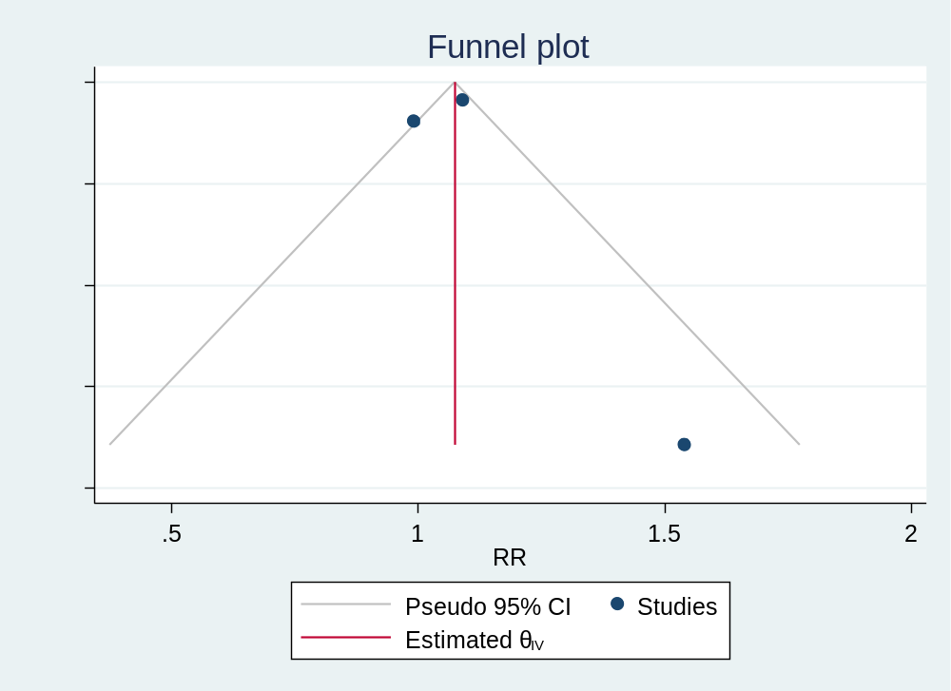
. meta bias, egger random(sjonkman)

Effect-size label: RR
Effect size: central
Std. err.: _meta_se

Regression-based Egger test for small-study effects
Random-effects model
Method: Sidik–Jonkman

H0: beta1 = 0; no small-study effects
beta1 = 1.32
SE of beta1 = 1.120
z = 1.18
Prob > |z| = 0.2382

Mortality in old people: heterogeneity and publication bias
Heterogeneity
Method: Sidik-Jonkman tau2 = 0.0404
I2 (%) = 62.72
H2 = 2.68
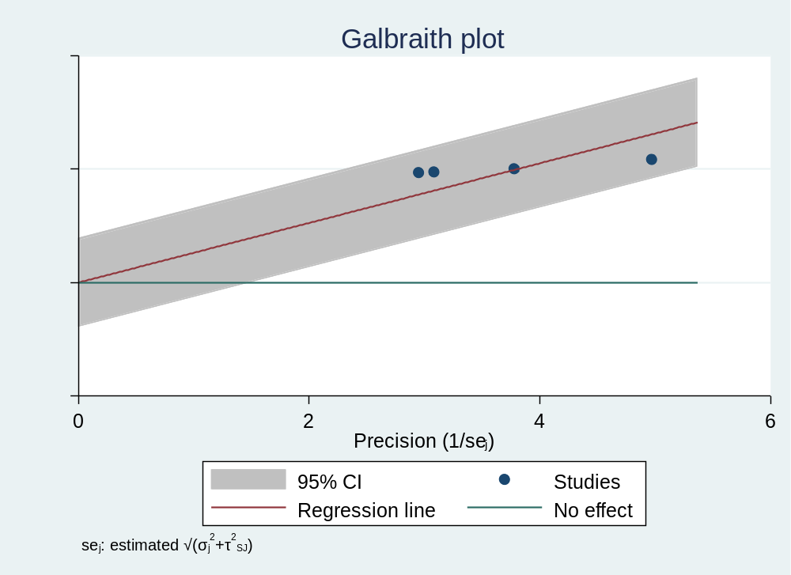

Publication bias
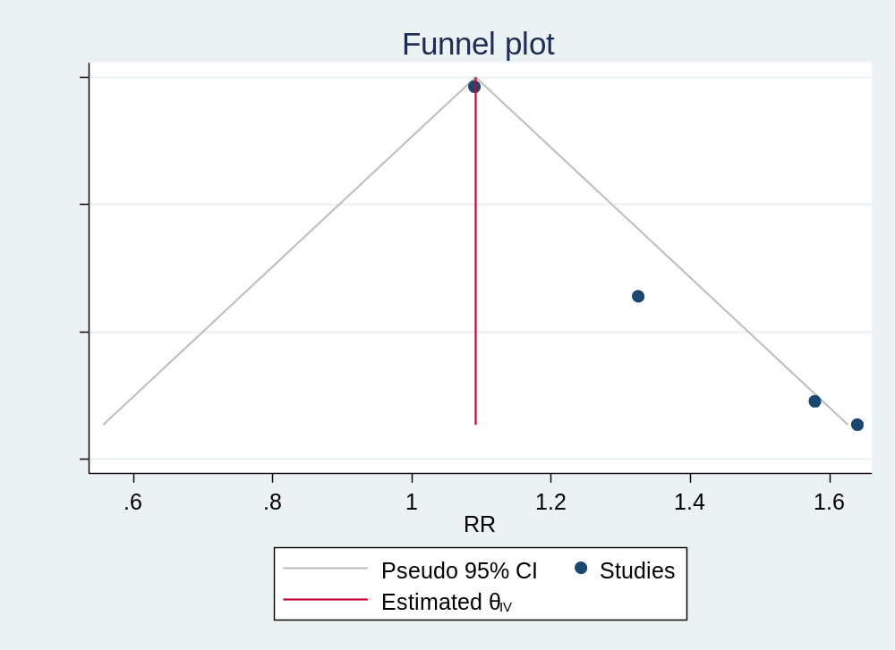

. meta bias, egger random(sjonkman)

Effect-size label: RR
Effect size: central
Std. err.: _meta_se

Regression-based Egger test for small-study effects
Random-effects model
Method: Sidik–Jonkman

H0: beta1 = 0; no small-study effects
beta1 = 1.85
SE of beta1 = 0.649
z = 2.84
Prob > |z| = 0.0045

Mortality in young people: heterogeneity and publication bias
Heterogeneity
Method: Sidik-Jonkman tau2 = 0.0152
I2 (%) = 70.04
H2 = 3.34

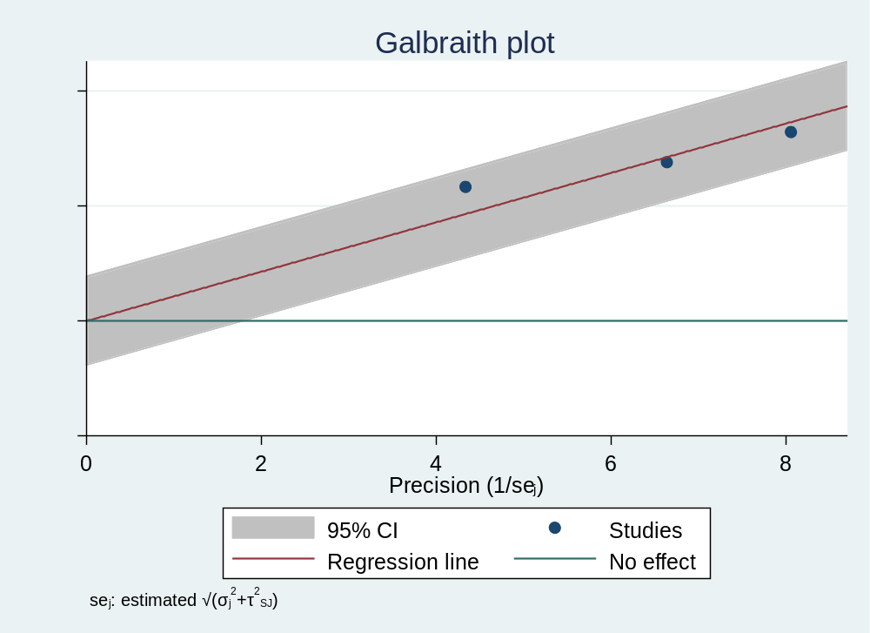

Publication bias
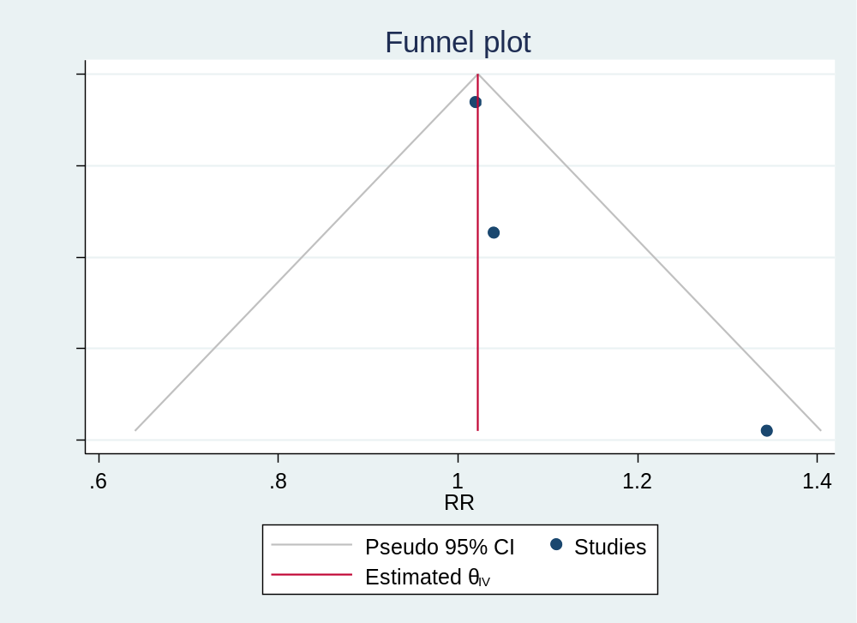

. meta bias, egger random(sjonkman)

Effect-size label: RR
Effect size: central
Std. err.: _meta_se

Regression-based Egger test for small-study effects
Random-effects model
Method: Sidik–Jonkman

H0: beta1 = 0; no small-study effects
beta1 = 1.43
SE of beta1 = 1.122
z = 1.27
Prob > |z| = 0.2034

Mortality in men: heterogeneity and publication bias
Heterogeneity
Method: Sidik-Jonkman tau2 = 0.0404
I2 (%) = 69.03
H2 = 3.23
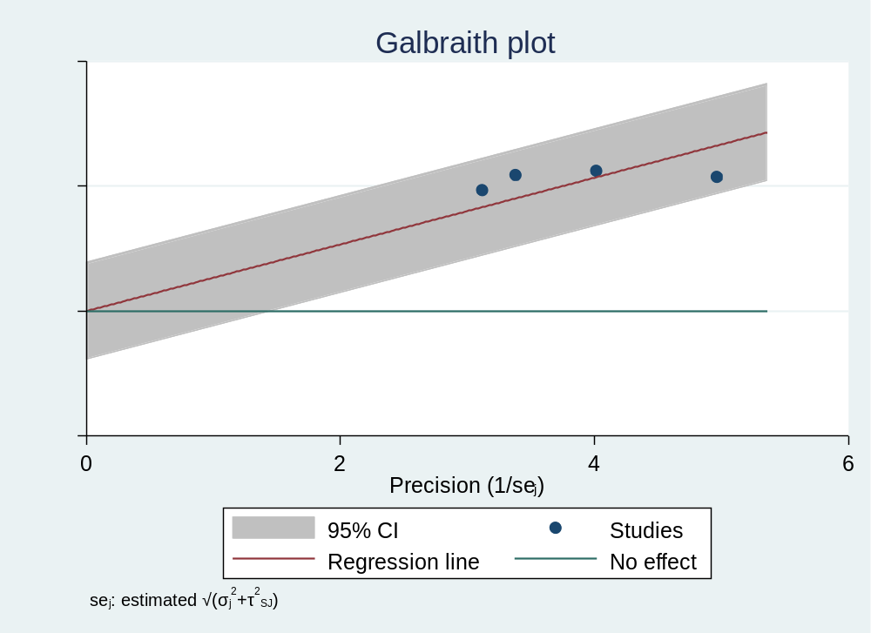

Publication bias
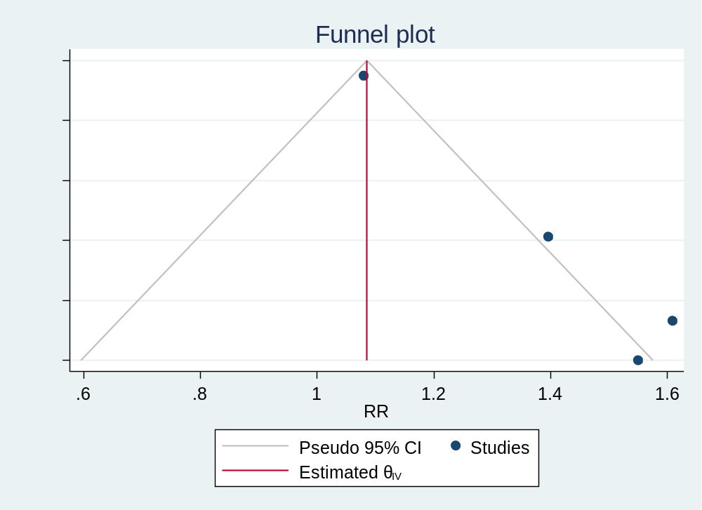

. meta bias, egger random(sjonkman)

Effect-size label: RR
Effect size: central
Std. err.: _meta_se

Regression-based Egger test for small-study effects
Random-effects model
Method: Sidik–Jonkman

H0: beta1 = 0; no small-study effects
beta1 = 2.30
SE of beta1 = 0.681
z = 3.38
Prob > |z| = 0.0007

Mortality in women: heterogeneity and publication bias
Heterogeneity
Method: Sidik-Jonkman tau2 = 0.0248
I2 (%) = 96.95
H2 = 32.81

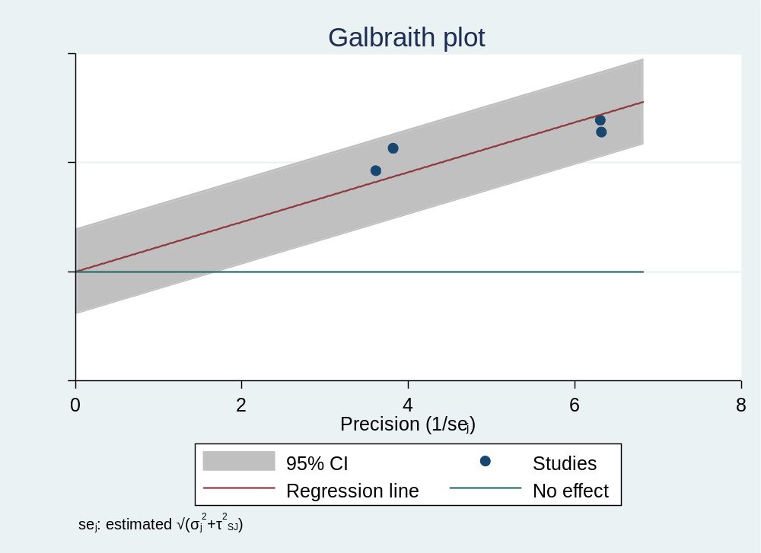

Publication bias
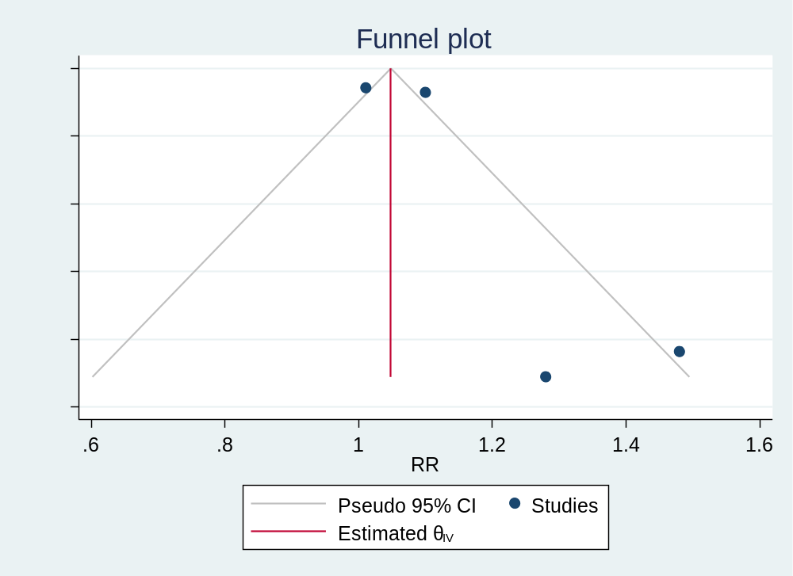

. meta bias, egger random(sjonkman)

Effect-size label: RR
Effect size: central
Std. err.: _meta_se

Regression-based Egger test for small-study effects
Random-effects model
Method: Sidik–Jonkman

H0: beta1 = 0; no small-study effects
beta1 = 1.63
SE of beta1 = 0.871
z = 1.87
Prob > |z| = 0.0610

.

