Supporting Information

Multilayer patch functionalized microfibrillated cellulosic paper sensor for sweat glucose monitoring

Zoheb Karim^{1*}, Mohd Jahir Khan², Afzal Hussain³, Faheem Ahmed4⁵, Zishan Husain Khan⁴

¹MoRe Research Örnsköldsvik AB, SE-891 22 Örnsköldsvik, Sweden
²Department of Chemical Engineering, Faculty of Engineering, Mahidol University, Nakhon Pathom 73170, Thailand
³Department of Pharmacognosy, College of Phamacy, King Saud University, PO Box 2457, Riyadh 11451, Saudia Arabia
⁴Department of Applied Sciences and Humanities. Faculty of Engineering and Technology, Jamia Milia Islamia, New Delhi 110025, India

Email: zoheb.karim@gmail.com; zoheb.karim@alfalaval.com
Phone: +45 26847924

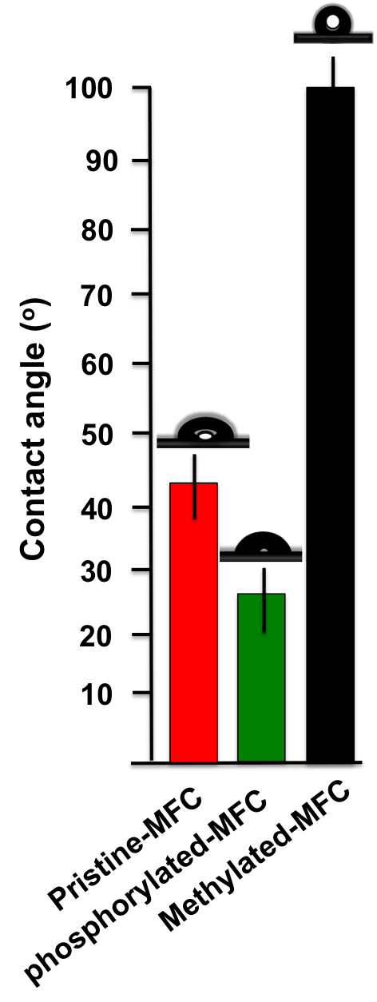
Figure S1: Contact angle measurement of control and modified MFCs.

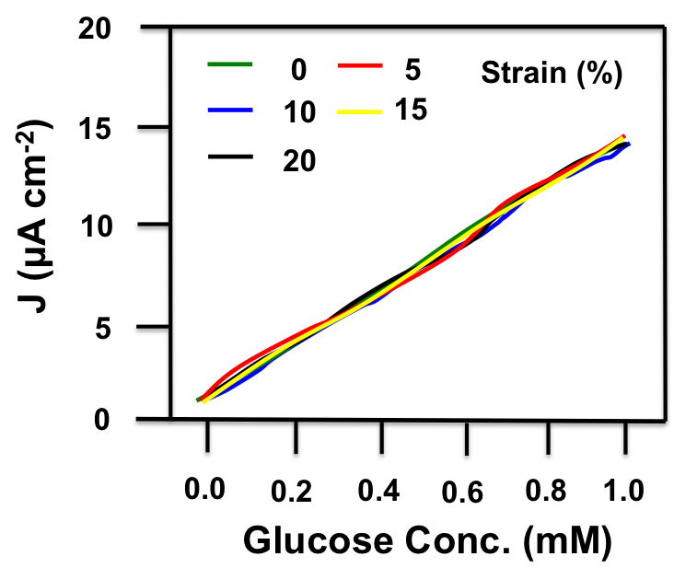
Figure S2: Calibration curve of glucose sensor at different applied strains

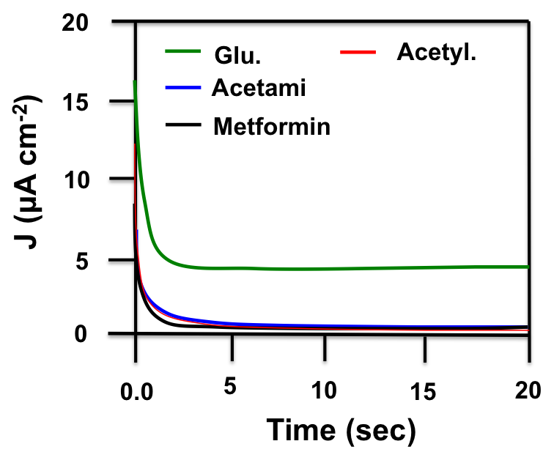
Figure S3: Chronoamperometric response of glusoce sensor to PBS, 0.1 mM glucose, 132 μM acetaminophen (Acetami), and 774 μM metformin

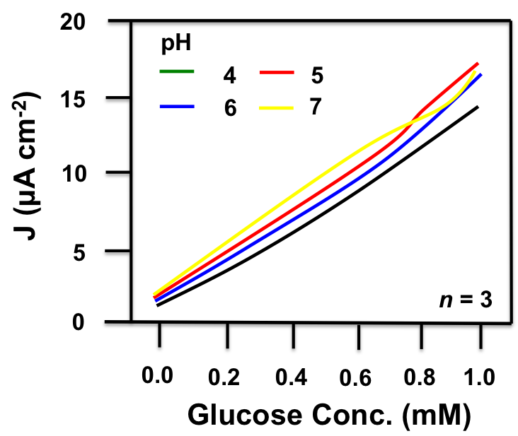

Figure S4: Calibration curve of the glucose sensor at different pH levels

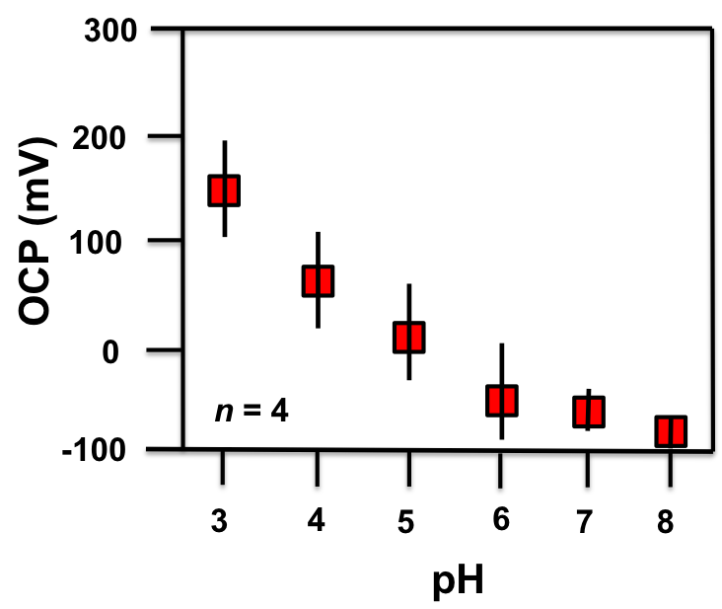

Figure S5: OCP changes of the pH sensor

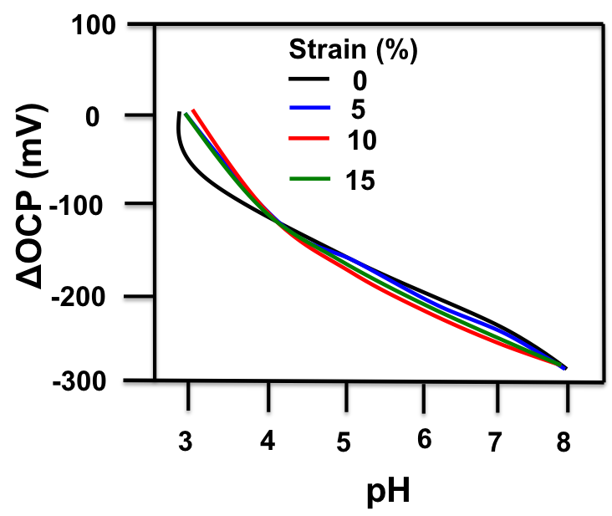
Figure S6: pH dependent OCP changes of the pH sensor at different strains

