Supplementary table 1: Antibacterial activity of biogenic CuO NPs against tested isolates
Isolate | Inhibition zone diameter (mm)
Isolate | CuO NPs biosynthesized by
Isolate | Ethanolic Neem extract | Ethanolic Jojoba extract
Acinetobacter spp. | 34 ± 4.24 | 28 ± 2.82
MRSA | 32 ± 2.12 | 28 ± 2.12
E. coli | 24 ± 3.53 | 23 ± 0.70
Klebsiella spp | 35 ± 2.82 | 24 ± 2.82
Pseudomonas spp. | 27 ± 3.53 | 19 ± 2.12
Stenotrophomonas spp. | 30 ± 2.12 | 30 ± 0.70

Supplementary table 2: Antibiofilm activity of biosynthesized CuO NPs against bacterial strains
Bacterial isolates | Concentrations (μg/ml)
Bacterial isolates | CuO NPs biosynthesized by ethanolic Neem extract
Bacterial isolates | 500 | 250 | 125 | 62.5 | 31.25 | 15.62 | 7.81
E. coli | 97.7 | 93 | 92.9 | 92 | 88.7 | 73.8 | 72.4
Klebsiella pneumoniae | 98 | 98.5 | 95.6 | 94.7 | 94 | 93 | 34.5
Acinetobacter spp | 95 | 93.9 | 93.5 | 90.5 | 87.9 | 85.8 | 84.1
MRSA | 81.1 | 75.1 | 74.2 | 62.2 | 57.5 | 51.9 | 53.6
CuO NPs biosynthesized by ethanolic Jojoba Extract
E. coli | 93.3 | 91.1 | 90.2 | 89.2 | 72.8 | 67.7 | 67.2
Klebsiella pneumoniae | 99.1 | 97.5 | 95 | 93.7 | 86.6 | 81.5 | 79.8
Acinetobacter spp | 95.2 | 94.8 | 91.5 | 91.4 | 88.5 | 88.3 | 72.1
MRSA | 95.7 | 93.8 | 93.4 | 87.2 | 75.9 | 68.8 | 63.2

Supplementary table 3: MTT assay using different concentrations of CuO NPs biosynthesized by ethanolic Neem extract treated HBF-4 cells.

Conc. (μg/mL) | Mean | SD | Viability %
500 | 0.212333 | 0.004631 | 28.73252143
250 | 0.668333 | 0.00786 | 90.43752819
125 | 0.737 | 0.001 | 99.72936401
62.5 | 0.738 | 0.002517 | 99.864682
31.25 | 0.738667 | 0.002404 | 99.954894
15.62 | 0.735333 | 0.002186 | 99.50383401

Supplementary table 4: MTT assay using different concentrations of CuO NPs biosynthesized by ethanolic Jojoba extract treated HBF-4 cells.
Conc. (μg/mL) | Mean | SD | Viability %
500 | 0.175333 | 0.006119 | 23.72575553
250 | 0.635333 | 0.00491 | 85.97203428
125 | 0.733333 | 0.003528 | 99.23319802
62.5 | 0.737667 | 0.00348 | 99.819576
31.25 | 0.733667 | 0.001202 | 99.27830401
15.62 | 0.738667 | 0.001453 | 99.954894
Conc.: conentrations; SD: standard Deviation

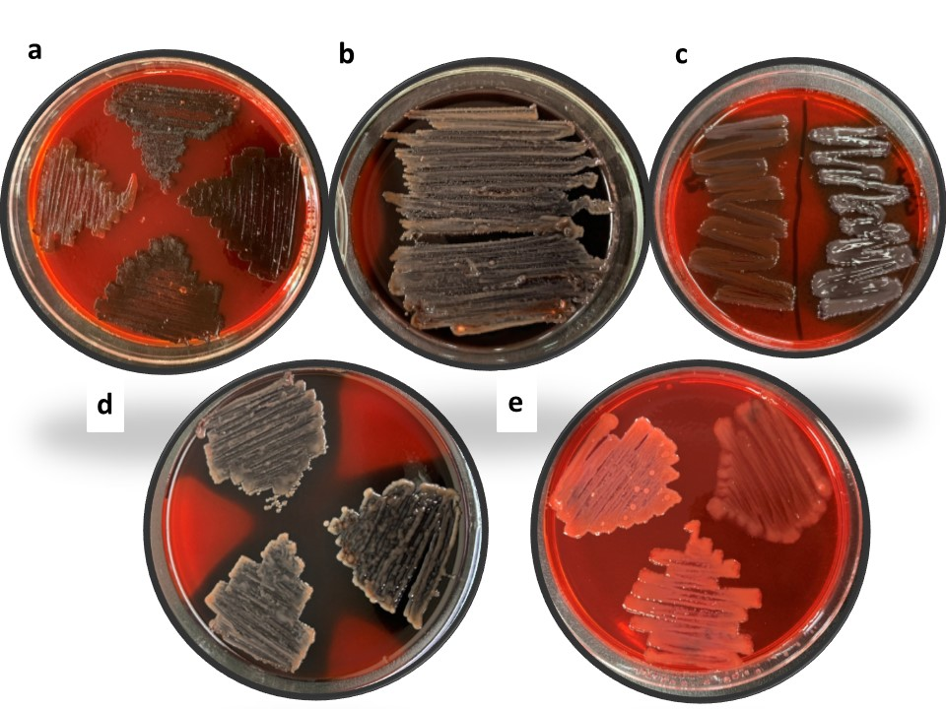
Supplementary figure 1: Screening of biofilm production for (a) Acinetobacter spp., (b) K. pneumoniae, (C) E. coli, (d) MRSA, and (e) Pseudomonas aeruginosa. all bacterial strains inoculated on Congo agar plates, then incubated at 37 °C for 24 h, biofilm producers bacteria appear as black colonies with a dry crystalline consistency while non-biofilm producers bacteria remained pink colonies.

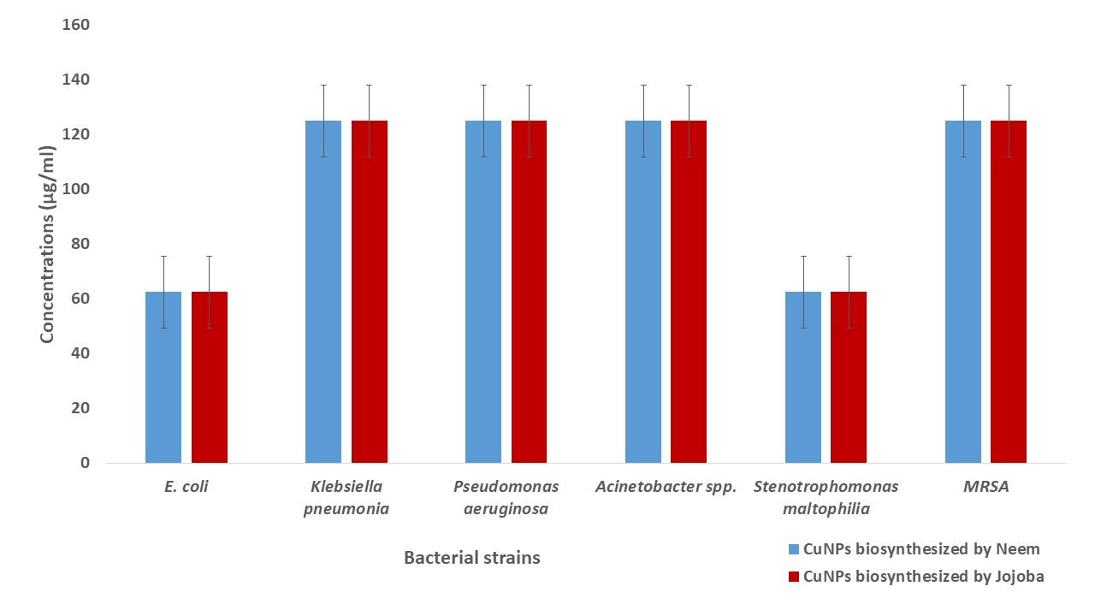
Supplementary figure 2: MIC of biosynthesized CuO NPs against bacterial strains at different concentrations. MIC of biosynthesized CuO NPs measured by broth dilution method against bacterial strains, initial concentration (1000µg/ml) was diluted using double fold serial dilution by adding 100µl CuO NPs samples to100µl sterile nutrient broth. Each concentration inoculated in duplicates with with 5µl of the standardized bacterial suspension and incubated at 37 °C for 24 h.

