Supporting Information

Solvent-mediated synthesis of multicolor narrow bandwidth emissive carbon quantum dots and their potential in white light-emitting diodes

Mohamed Sami^{1, *}, Mohamed E. El-Khouly², and Mohsen Ghali^{1, *}

¹ Energy Materials Program, Institute of Basic and Applied Sciences, Egypt-Japan University of Science and Technology, New Borg El-Arab City, Alexandria, 21934, Egypt
² Nanoscience Program, Institute of Basic and Applied Sciences, Egypt-Japan University of Science and Technology, New Borg El-Arab City, Alexandria, 21934, Egypt

Corresponding authors: | Mohamed.Sami@ejust.edu.eg
 | Mohsen.Ghali@ejust.edu.eg

Figure D1 presents TEM and HR-TEM images of the C-CQDs, G-CQDs, and Y-CQDs, further emphasizing the amorphous spherical nature of these multicolor carbon quantum dots.

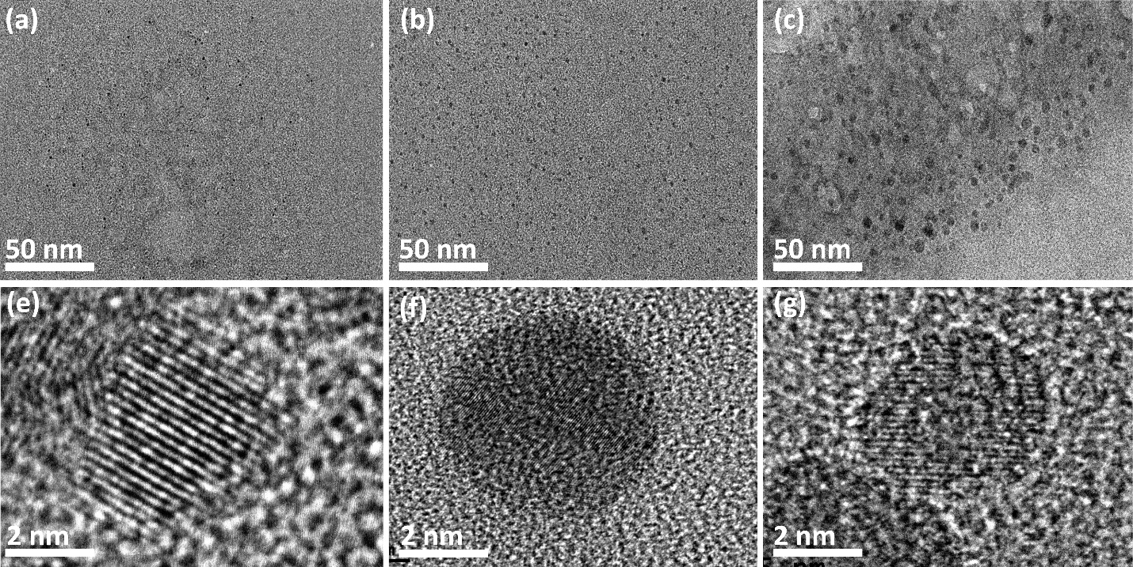
Figure S1 shows the TEM and HR-TEM images of (a, e) C-CQDs, (b, f) G-CQDs, and (c, g) Y-CQDs.

Figure S2 XPS survey for (a) G-CQDs and (b) Y-CQDs

Figure S3 High-resolution XPS spectra of G-CQDs. (a) C 1s, (b) O 1s, (c) N 1s, and (d) B 1s
Figure S4 High-resolution XPS spectra of Y-CQDs. (a) C 1s, (b) O 1s, (c) N 1s, and (d) B 1s

Figure S5 PL stability of (a) C-CQDs, (b) G-CQDs, (c) Y-CQDs, and (d) relative emissions for C-, G-, Y-CQDs over time

Table S1 comparison of the optical properties of the synthesized multicolor CQDs and other CQDs reported in literature.
 | Excitation (nm) | Emission (nm) | Size (nm) | Quantum Yield (%) | Ref
M-CQDs  O-CQDs | 500  450 | 605  611 | ---  5.6 | ---  16.7 | 1
N-doped CQDs | 420 | 475 | 2.4 | 51.4 | 2
b-CQDs  yg-CQDs  R-CQDs | 355  440  600 | 450  540  665 | 1.71  1.95  2.42 | 25  72  47 | 3
G-CQDs | 410 | 521 | 3.8 | 48.8 | 4
C-CQDs  G-CQDs  Y-CQDs | 462  505  535 | 482  527  560 | 1.7  2.6  3.8 | 65  50  55 | This work

Figure S6 PL emission of C-CQDs at different concentrations.

Figure S7 (a) transmission spectra of the fabricated multicolor CQDs films, (b) Blue blocking ratio of same CQDs films

References

1. Kumari, R. & Kumar Sahu, S. Synthesis of Longer-Wavelength-Emissive Carbon Quantum Dots for WLEDs and Investigation of Their Photoluminescence Properties. ChemistrySelect 3, 12998–13005 (2018).
2. Feng, X. T. et al. Luminescent carbon quantum dots with high quantum yield as a single white converter for white light emitting diodes. Appl Phys Lett, 107, (2015).
3. Wang, L. et al. Full-Color Fluorescent Carbon Quantum Dots. Sci. Adv, 6, (2020).
4. Qiu, H. et al. Green-light-emitting carbon dots via eco-friendly route and their potential in ferric-ion detection and WLEDs. Mater Adv 3, 7339–7347 (2022).

