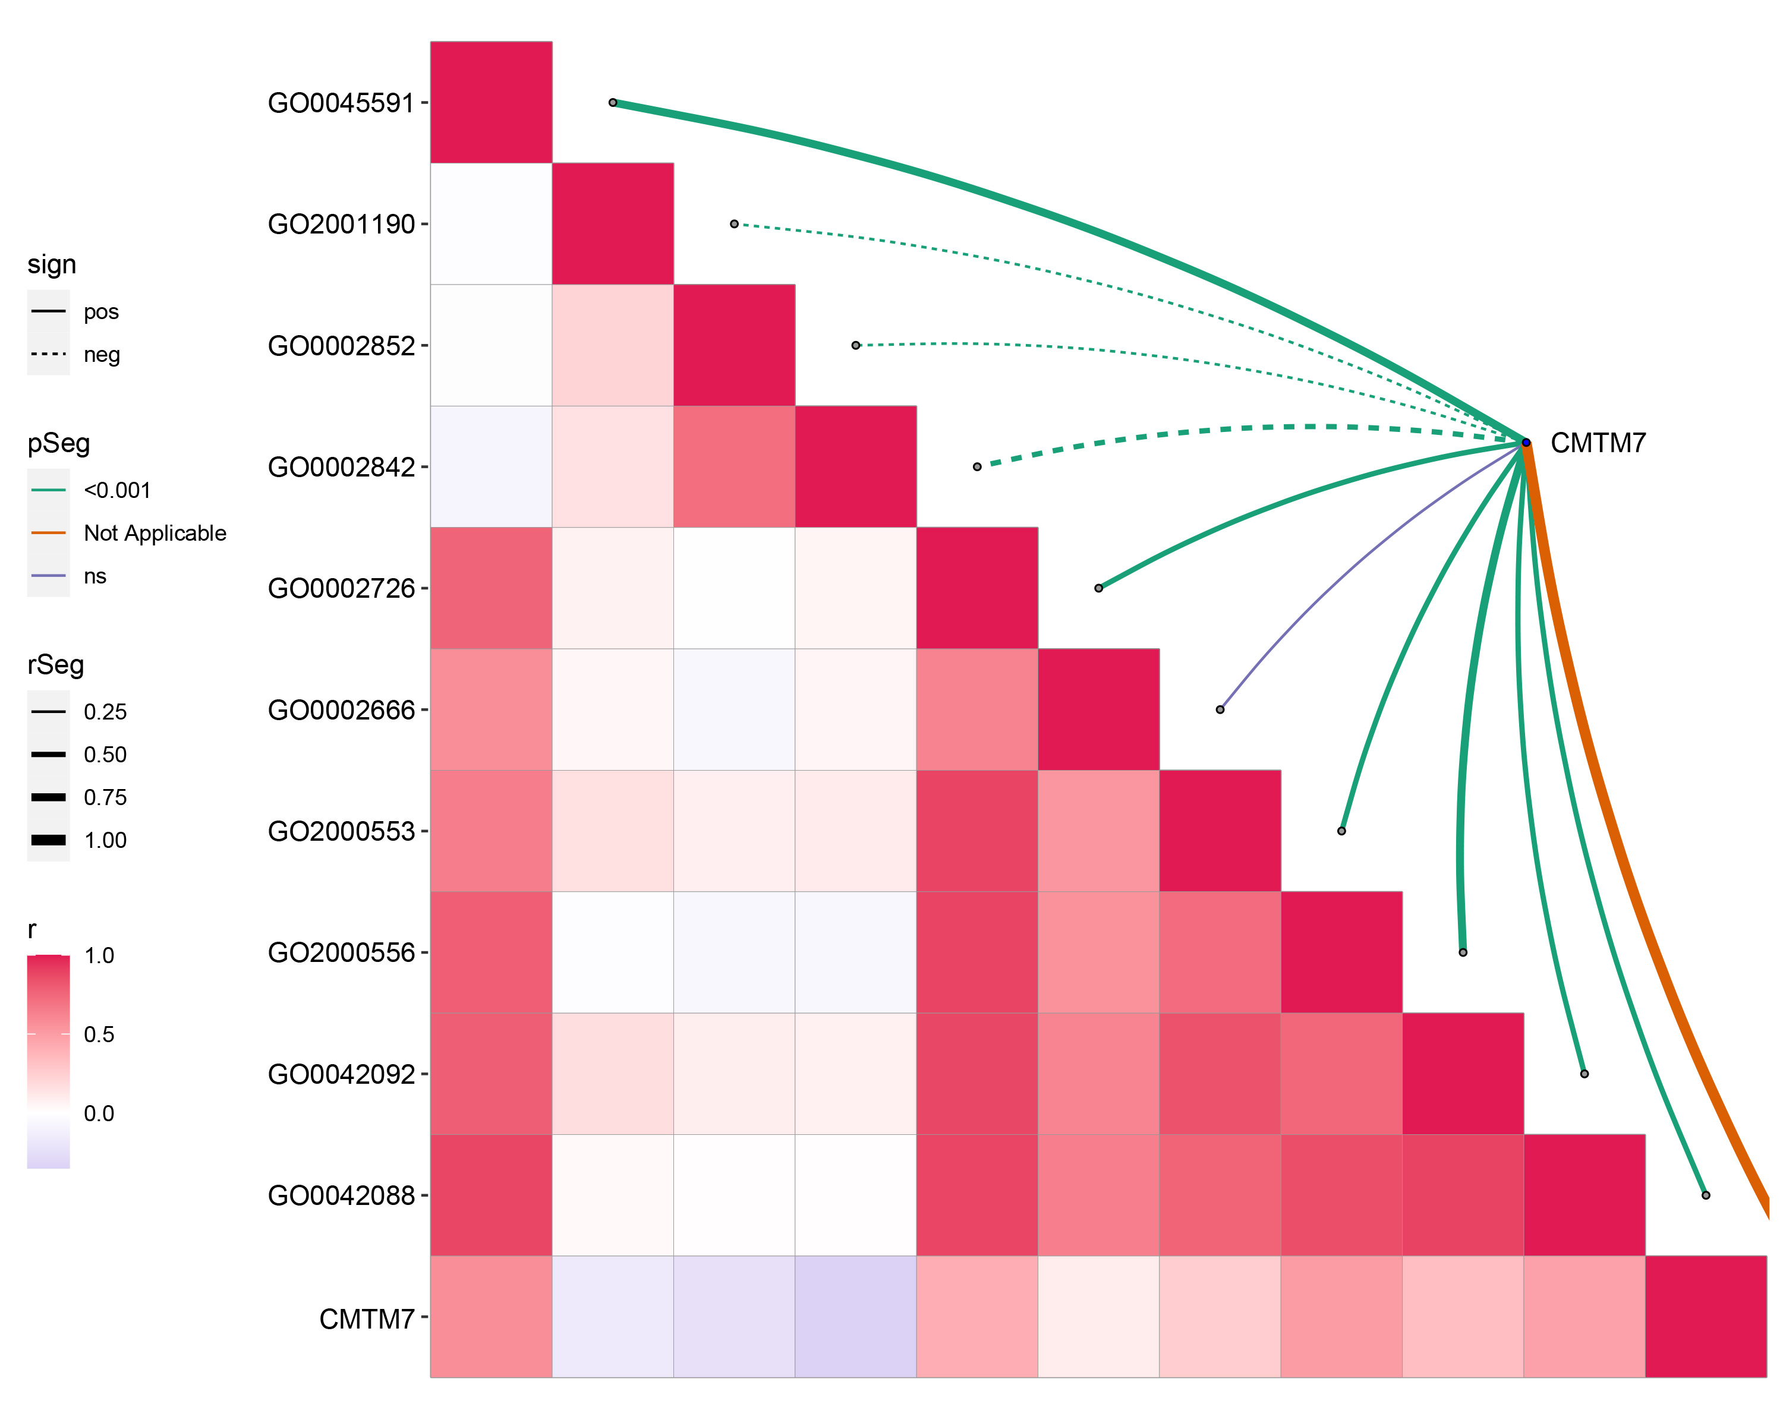
Supplementary Figure 1: Correlations between CMTM7 expression and enrichment scores for T cell immunity.

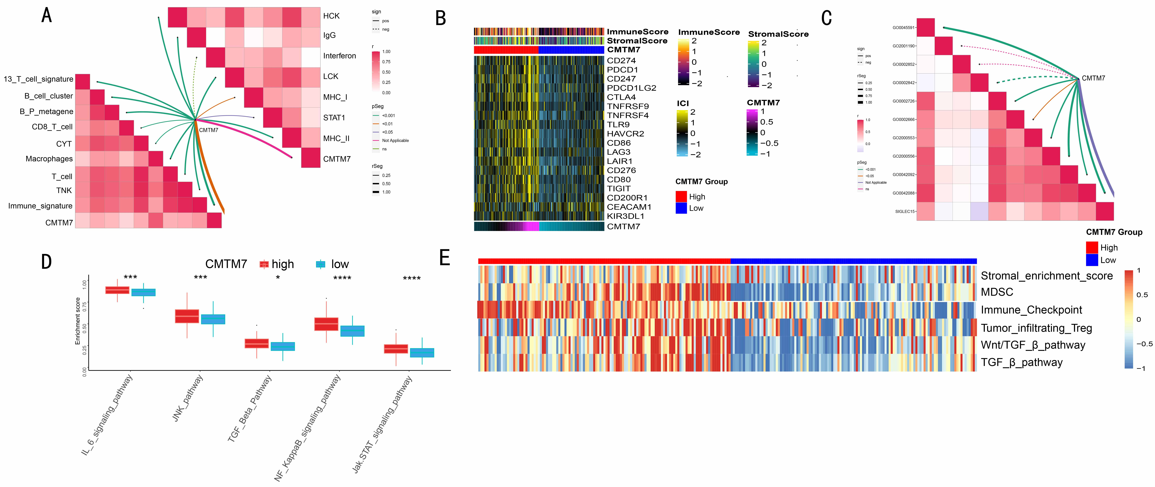
Supplementary Figure 2: CMTM7 was involved in chronic inflammation and cancer immune infiltration based on ICGC dataset. (A) Correlations between CMTM7 and the enrichment scores of immunocytes, inflammatory activation functions. (B) Heatmap showing the expression of genes involved in immune checkpoint targets. (C) Correlations between CMTM7 and the enrichment scores of T cell immunity. (D) Differences in enrichment scores of chronic inflammation-related pathways between CMTM7-high and low subgroup. (E) Heatmap showing the immunosuppressive profile between CMTM7-high and low subgroup.

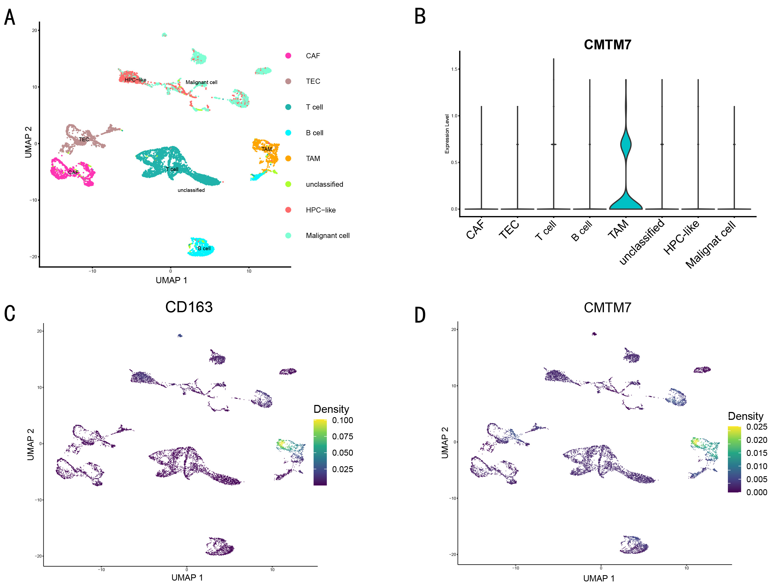
Supplementary Figure 3: CMTM7 was the marker of M2 macrophage. (A) UMAP visualization of 11,187 cells. Each color represents one celltype. (B) Violin plot showing the distribution of CMTM7 among the different celltypes. (C) UMAP visualization show the expression distributions of CD163. (D) UMAP visualization show the expression distributions of CMTM7.

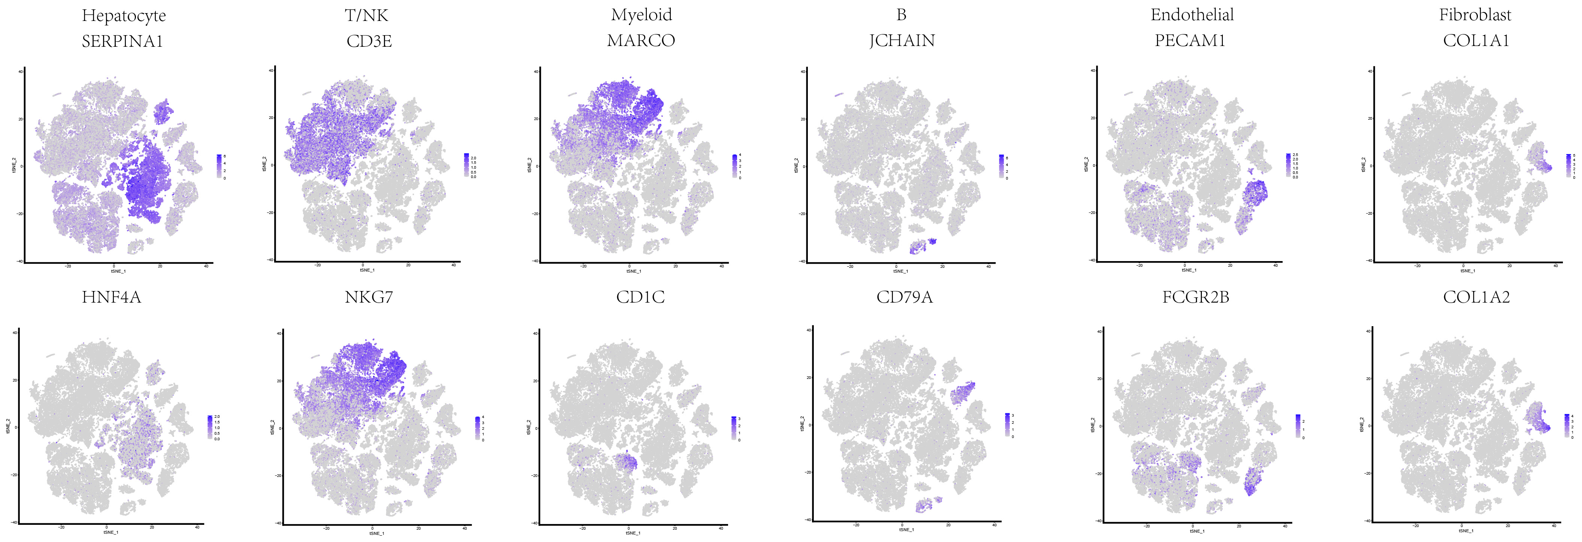
Supplementary Figure 4: The tSNE plots showing the expression levels of signature genes of six major cell types, colored by gene expression.

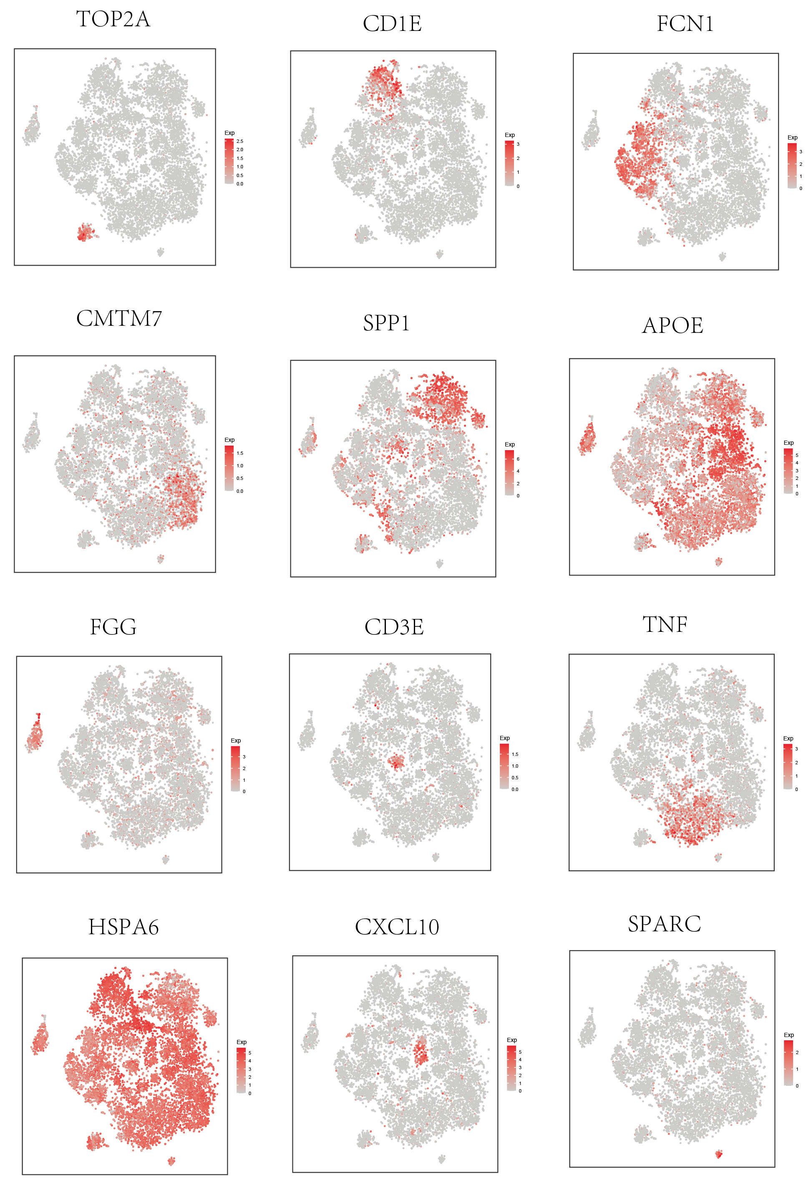
Supplementary Figure 5: The tSNE plots showing the expression levels of signature genes of thirteen Myeloid cell types, colored by gene expression.

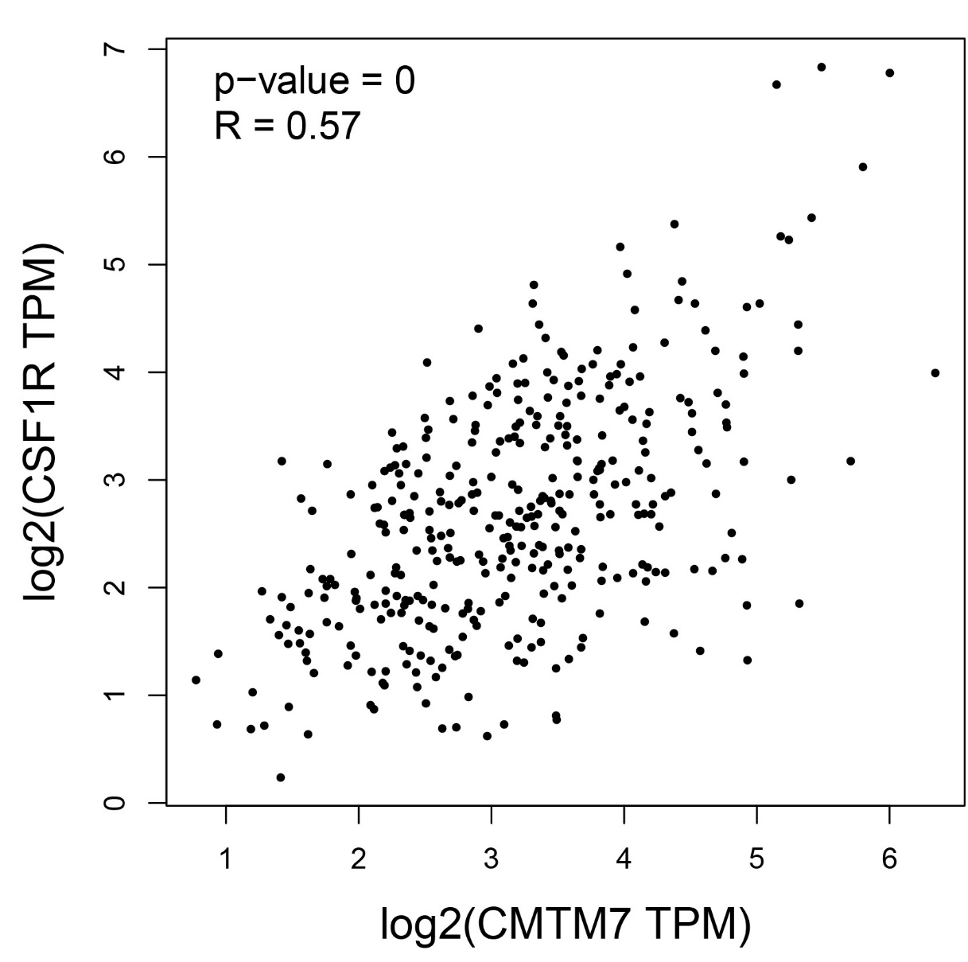
Supplementary Figure 6: The correlations between CMTM7 and CSF1R based on TCGA dataset.

