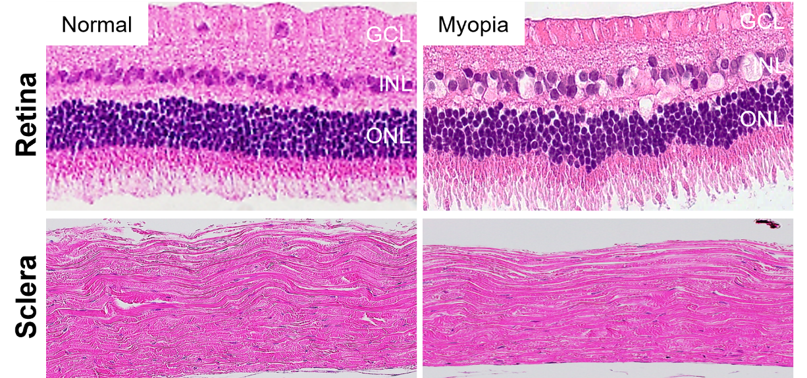
Supplementary Figure S1. Representative photomicrographs of retinal and scleral sections stained with H&E in normal and form-deprivation myopia (FDM) eyes.

Supplementary Figure S2. Detailed regional protein-protein interaction (PPI) networks in CD29-positive Müller cells. This figure further explores the PPI networks specific to the central and peripheral regions of the retina, showing consistent patterns with those observed in the comprehensive analysis (Figure 5c).

Supplementary Figure S3. Validation of PKM and LDHA mRNA expression levels using qPCR in central and peripheral retina tissues. Quantitative PCR (qPCR) analysis was performed to validate the expression levels of PKM and LDHA in both central and peripheral retina tissues from myopic and control rabbit eyes. The relative expression levels were normalized to GAPDH as an internal control. (a) PKM mRNA levels were found to be significantly reduced in both the central and peripheral retina of myopic eyes compared to controls. (b) LDHA mRNA levels showed a significant reduction in the peripheral retina of myopic eyes compared to controls, while no significant difference was observed in the central retina. Error bars represent the mean ± standard error of the mean (SEM) of three independent experiments. Statistical significance was determined using paired t-test (*p < 0.05, **p < 0.01).

Gene | Primer sequences
PKM2 | Forward: CCTCCAGTCACTCCACAGACCT
 | Reverse: CTGCCAGACTCCGTCAGAACTA
LDHA | Forward: GTTAGGCACCGATGCAGACAA
 | Reverse: ATGCACCCTCCTGAGATTCTTC
GAPDH | Forward: TTCCAGTATGATTCCACCCACG
 | Reverse: GGGCTGAGATGATGACCCTTTT

Supplementary Table S2. Primer sequences used for real-time quantitative reverse transcriptase polymerase chain reaction (qRT-PCR).

