Supplementary Online Materials

Stroop and practice effects in cognitive dysfunction of Long COVID and Myalgic Encephalomyelitis / Chronic Fatigue Syndrome

James N Baraniuk, Kiran Thapaliya, Maira Inderyas, Zack Shan, Leighton Barnden

SOM Table S1. Tests of between subjects effects on response times (Rt) for the entire data set.
Source |  | Type III Sum of Squares | df | Mean Square | F | Sig. | Partial Eta Squared | Noncent. Parameter | Observed Power^{i}
Intercept | Hypothesis | 9378.780 | 1 | 9378.780 | 161.832 | 0.00017 | 0.975 | 161.832 | 1.000
 | Error | 241.503 | 4.167 | 57.954ª
Times | Hypothesis | 121.295 | 1 | 121.295 | 267.062 | 1.58E-59 | 0.017 | 267.062 | 1.000
 | Error | 6960.775 | 15326 | .454^{b}
Disease | Hypothesis | 199.880 | 2 | 99.940 | 87.830 | 0.00027 | 0.975 | 175.659 | 1.000
 | Error | 5.043 | 4.432 | 1.138^{c}
prestimulus | Hypothesis | 215.761 | 2 | 107.881 | 43.380 | 0.00100 | 0.949 | 86.760 | 1.000
 | Error | 11.528 | 4.636 | 2.487^{d}
Stimulus | Hypothesis | 15.491 | 2 | 7.745 | 2.903 | 0.143 | 0.530 | 5.805 | 0.344
 | Error | 13.715 | 5.140 | 2.668e
Disease * prestimulus | Hypothesis | 2.521 | 4 | 0.630 | 1.850 | 0.211 | 0.475 | 7.401 | 0.347
 | Error | 2.788 | 8.186 | .341^{f}
Disease * Stimulus | Hypothesis | 3.404 | 4 | 0.851 | 2.498 | 0.124 | 0.549 | 9.993 | 0.458
 | Error | 2.793 | 8.197 | .341^{g}
prestimulus * Stimulus | Hypothesis | 9.003 | 4 | 2.251 | 6.304 | 0.0054 | 0.672 | 25.218 | 0.930
 | Error | 4.385 | 12.283 | .357^{h}
Disease * prestimulus * Stimulus | Hypothesis | 2.717 | 8 | 0.340 | 0.748 | 0.649 | 0.000 | 5.983 | 0.356
 | Error | 6960.775 | 15326 | .454^{b}
a. .249 MS(DiseaseGroup) + .291 MS(prestimulus) + .292 MS(STIMULUS) - .248 MS(DiseaseGroup * prestimulus) - .248 MS(DiseaseGroup * STIMULUS) - .290 MS(prestimulus * STIMULUS) + .246 MS(DiseaseGroup * prestimulus * STIMULUS) + .707 MS(Error)
b. MS(Error)
c. .996 MS(DiseaseGroup * prestimulus) + .996 MS(DiseaseGroup * STIMULUS) - .987 MS(DiseaseGroup * prestimulus * STIMULUS) - .005 MS(Error)
d. .851 MS(DiseaseGroup * prestimulus) + .994 MS(prestimulus * STIMULUS) - .843 MS(DiseaseGroup * prestimulus * STIMULUS) - .002 MS(Error)
e. .849 MS(DiseaseGroup * STIMULUS) + .991 MS(prestimulus * STIMULUS) - .841 MS(DiseaseGroup * prestimulus * STIMULUS) + .001 MS(Error)
f. .991 MS(DiseaseGroup * prestimulus * STIMULUS) + .009 MS(Error)
g. .991 MS(DiseaseGroup * prestimulus * STIMULUS) + .009 MS(Error)
h. .848 MS(DiseaseGroup * prestimulus * STIMULUS) + .152 MS(Error)
i. Computed using alpha = .05
End SOM Table S1

SOM Table S2. Estimated marginal means for Disease Group for responses times (Rt).
Disease | Mean | Std. Error | 95% Confidence Interval
 |  |  | Lower Bound | Upper Bound
HC | 1.368 | 0.01 | 1.348 | 1.387
LC | 1.68 | 0.015 | 1.651 | 1.709
ME | 1.595 | 0.007 | 1.58 | 1.609
a Covariates appearing in the model are evaluated at the following values: sT450_B = 428.9790.
Pairwise Comparisons
Dependent Variable: RT
(I) Disease | (J) Disease | Mean Difference (I-J) | Std. Error | Sig.b | 95% Confidence Interval for Difference b
 |  |  |  |  | Lower Bound | Upper Bound
HC | LC | -.313* | 0.018 | <.001 | -0.355 | -0.27
 | ME | -.227* | 0.012 | <.001 | -0.257 | -0.197
LC | HC | .313* | 0.018 | <.001 | 0.27 | 0.355
 | ME | .085* | 0.016 | <.001 | 0.046 | 0.125
ME | HC | .227* | 0.012 | <.001 | 0.197 | 0.257
 | LC | -.085* | 0.016 | <.001 | -0.125 | -0.046
Based on estimated marginal means
* The mean difference is significant at the .05 level.
b Adjustment for multiple comparisons: Sidak.
End SOM Table S2.

SOM Table S3. Estimated marginal means for prestimulus response times (Rt).
prestimulus | Mean | Std. Error | 95% Confidence Interval
 |  |  | Lower Bound | Upper Bound
c | 1.504 | 0.012 | 1.481 | 1.528
i | 1.731 | 0.011 | 1.71 | 1.752
n | 1.407 | 0.011 | 1.386 | 1.428
a Covariates appearing in the model are evaluated at the following values: sT450_B = 428.9790.
Pairwise Comparisons
Dependent Variable: RT
(I) prestimulus | (J) prestimulus | Mean Difference (I-J) | Std. Error | Sig.b | 95% Confidence Interval for Difference b
 |  |  |  |  | Lower Bound | Upper Bound
c | i | -.226* | 0.016 | <.001 | -0.265 | -0.188
 | n | .097* | 0.016 | <.001 | 0.059 | 0.136
i | c | .226* | 0.016 | <.001 | 0.188 | 0.265
 | n | .324* | 0.015 | <.001 | 0.287 | 0.36
n | c | -.097* | 0.016 | <.001 | -0.136 | -0.059
 | i | -.324* | 0.015 | <.001 | -0.36 | -0.287
Based on estimated marginal means
* The mean difference is significant at the .05 level.
b Adjustment for multiple comparisons: Sidak.
End SOM Table S3

SOM Table S4. Estimated marginal means for Disease x prestimulus Rt and calculation of Stroop Effect, Faciltation and Interference.
Disease | prestimulus | Mean | Std. Error |  | 95% Confidence Interval
 |  |  |  |  | Lower | Upper Bound
HC | c | 1.328 | 0.018 |  | 1.292 | 1.364
 | i | 1.527 | 0.017 |  | 1.494 | 1.56
 | n | 1.248 | 0.017 |  | 1.214 | 1.281
LC | c | 1.629 | 0.028 |  | 1.575 | 1.684
 | i | 1.879 | 0.024 |  | 1.831 | 1.927
 | n | 1.532 | 0.024 |  | 1.484 | 1.58
ME | c | 1.556 | 0.013 |  | 1.529 | 1.582
 | i | 1.786 | 0.012 |  | 1.762 | 1.811
 | n | 1.442 | 0.013 |  | 1.417 | 1.467
a Covariates appearing in the model are evaluated at the following values: sT450_B = 428.9790.
Pairwise Comparisons
Dependent Variable: RT
prestimulus | (I) Disease | (J) Disease | Mean Difference (I-J) |  | Std. Error | Sig.b |  | 95% Confidence Interval for Difference b
 |  |  |  |  |  |  |  | Lower Bound |  | Upper Bound
c | HC | LC | -.301* |  | 0.033 | <.001 |  | -0.38 |  | -0.222
c | HC | ME | -.228* |  | 0.023 | <.001 |  | -0.282 |  | -0.173
c | LC | HC | .301* |  | 0.033 | <.001 |  | 0.222 |  | 0.38 |  | c LC > HC
c | LC | ME | .074* |  | 0.031 | 0.05 |  | 7.74E-05 |  | 0.147 |  | c LC > ME
c | ME | HC | .228* |  | 0.023 | <.001 |  | 0.173 |  | 0.282 |  | c ME > HC
c | ME | LC | -.074* |  | 0.031 | 0.05 |  | -0.147 |  | -7.74E-05
i | HC | LC | -.352* |  | 0.03 | <.001 |  | -0.423 |  | -0.282
i | HC | ME | -.260* |  | 0.021 | <.001 |  | -0.309 |  | -0.21
i | LC | HC | .352* |  | 0.03 | <.001 |  | 0.282 |  | 0.423 |  | i LC > HC
i | LC | ME | .093* |  | 0.027 | 0.002 |  | 0.027 |  | 0.158 |  | i LC > ME
i | ME | HC | .260* |  | 0.021 | <.001 |  | 0.21 |  | 0.309 |  | i ME > HC
i | ME | LC | -.093* |  | 0.027 | 0.002 |  | -0.158 |  | -0.027
n | HC | LC | -.285* |  | 0.03 | <.001 |  | -0.356 |  | -0.214
n | HC | ME | -.195* |  | 0.021 | <.001 |  | -0.246 |  | -0.144
n | LC | HC | .285* |  | 0.03 | <.001 |  | 0.214 |  | 0.356 |  | n LC > HC
n | LC | ME | .090* |  | 0.027 | 0.003 |  | 0.024 |  | 0.155 |  | n LC > ME
n | ME | HC | .195* |  | 0.021 | <.001 |  | 0.144 |  | 0.246 |  | n ME > HC
n | ME | LC | -.090* |  | 0.027 | 0.003 |  | -0.155 |  | -0.024
Based on estimated marginal means
* The mean difference is significant at the .05 level.
b Adjustment for multiple comparisons: Sidak.
LC c > n |  |  |  | ME c > n |  |  |  |  | HC c > n
LC i > c |  |  |  | ME i > c |  |  |  |  | HC i > c
LC i > n |  |  |  | ME i > n |  |  |  |  | HC i > n
c LC > HC |  |  |  | i LC > HC |  |  |  |  | n LC > HC
c LC > ME |  |  |  | i LC > ME |  |  |  |  | n LC > ME
c ME > HC |  |  |  | i ME > HC |  |  |  |  | n ME > HC
Stroop Effect |  |  |  | Stroop Facilitation |  |  |  |  | Stroop Interference
Rti – Rtc |  |  |  | Rtn – Rtc |  |  |  |  | Rti – Rtn
0.199 |  |  |  | -0.08 |  |  |  |  | 0.279
0.25 |  |  |  | -0.097 |  |  |  |  | 0.347
0.23 |  |  |  | -0.114 |  |  |  |  | 0.344
End of SOM Table S4.

SOM Table S5. Estimated marginal means for Stimulus.
Stimulus | Mean | Std. Error | 95% Confidence Interval
 |  |  | Lower Bound | Upper Bound
C | 1.598 | 0.012 | 1.575 | 1.621
I | 1.54 | 0.011 | 1.519 | 1.561
N | 1.504 | 0.011 | 1.483 | 1.526
a Covariates appearing in the model are evaluated at the following values: sT450_B = 428.9790.
Pairwise Comparisons
Dependent Variable: RT
(I) Stimulus | (J) Stimulus | Mean Difference (I-J) | Std. Error | Sig.b | 95% Confidence Interval for Differenceb
 |  |  |  |  | Lower Bound | Upper Bound
C | I | .058* | 0.016 | <.001 | 0.02 | 0.096
 | N | .094* | 0.016 | <.001 | 0.055 | 0.132
I | C | -.058* | 0.016 | <.001 | -0.096 | -0.02
 | N | 0.036 | 0.015 | 0.053 | 0 | 0.073
N | C | -.094* | 0.016 | <.001 | -0.132 | -0.055
 | I | -0.036 | 0.015 | 0.053 | -0.073 | 0
Based on estimated marginal means
* The mean difference is significant at the .05 level.
b Adjustment for multiple comparisons: Sidak.
End SOM Table S5

SOM Table S6. Estimated marginal means for Disease x Stimulus.
Disease | Stimulus |  | Mean | Std. Error |  | 95% Confidence Interval
 |  |  |  |  |  | Lower Bound | Upper Bound
HC | C |  | 1.404 | 0.018 |  | 1.368 | 1.439
HC | I |  | 1.375 | 0.017 |  | 1.342 | 1.407
HC | N |  | 1.324 | 0.017 |  | 1.29 | 1.358
LC | C |  | 1.769 | 0.027 |  | 1.715 | 1.822
LC | I |  | 1.642 | 0.024 |  | 1.594 | 1.689
LC | N |  | 1.63 | 0.025 |  | 1.582 | 1.679
ME | C |  | 1.622 | 0.013 |  | 1.596 | 1.648
ME | I |  | 1.604 | 0.012 |  | 1.58 | 1.628
ME | N |  | 1.558 | 0.013 |  | 1.533 | 1.583
a Covariates appearing in the model are evaluated at the following values: sT450_B = 428.9790.
Pairwise Comparisons |  |  |  |  |  |  | STIM
Dependent Variable: RT
Stimulus | (I) Disease |  | (J) Disease | Mean Difference (I-J) |  | Std. Error | Sig.b | 95% Confidence Interval for Difference b
 |  |  |  |  |  |  |  | Lower Bound |  | Upper Bound
C | HC |  | LC | -.365* |  | 0.033 | <.001 | -0.443 |  | -0.286
C | HC |  | ME | -.218* |  | 0.023 | <.001 | -0.272 |  | -0.164
C | LC |  | HC | .365* |  | 0.033 | <.001 | 0.286 |  | 0.443 | C LC > HC
C | LC |  | ME | .147* |  | 0.031 | <.001 | 0.074 |  | 0.22 | C LC > ME
C | ME |  | HC | .218* |  | 0.023 | <.001 | 0.164 |  | 0.272 | C ME > HC
C | ME |  | LC | -.147* |  | 0.031 | <.001 | -0.22 |  | -0.074
I | HC |  | LC | -.267* |  | 0.029 | <.001 | -0.337 |  | -0.197
I | HC |  | ME | -.230* |  | 0.021 | <.001 | -0.279 |  | -0.18
I | LC |  | HC | .267* |  | 0.029 | <.001 | 0.197 |  | 0.337 | I LC > HC
I | LC |  | ME | 0.037 |  | 0.027 | 0.426 | -0.028 |  | 0.102
I | ME |  | HC | .230* |  | 0.021 | <.001 | 0.18 |  | 0.279 | I ME > HC
I | ME |  | LC | -0.037 |  | 0.027 | 0.426 | -0.102 |  | 0.028
N | HC |  | LC | -.306* |  | 0.03 | <.001 | -0.378 |  | -0.234
N | HC |  | ME | -.234* |  | 0.022 | <.001 | -0.285 |  | -0.182
N | LC |  | HC | .306* |  | 0.03 | <.001 | 0.234 |  | 0.378 | N LC > H
N | LC |  | ME | .072* |  | 0.028 | 0.028 | 0.006 |  | 0.139 | N LC > ME
N | ME |  | HC | .234* |  | 0.022 | <.001 | 0.182 |  | 0.285 | N ME > HC
N | ME |  | LC | -.072* |  | 0.028 | 0.028 | -0.139 |  | -0.006
Based on estimated marginal means
* The mean difference is significant at the .05 level.
b Adjustment for multiple comparisons: Sidak.
LC C > I |  | LC I > N |  |  | LC C > N
ME C > I |  |  |  |  | HC C> N
C LC > HC |  | I LC > HC |  |  | N LC > H
C LC > ME |  | I ME > HC |  |  | N LC > ME
C ME > HC |  |  |  |  | N ME > HC
 |  | Stroop Effect |  |  | Stroop Facilitation |  |  |  | Stroop Interference
 |  | RtI – RtC |  |  | RtN – RtC |  |  |  | RtI – RtN
HC |  | -0.029 |  |  | -0.08 |  |  |  | 0.051
LC |  | -0.127 |  |  | -0.139 |  |  |  | 0.012
ME |  | -0.018 |  |  | -0.064 |  |  |  | 0.046
End SOM Table 6

SOM Table S7. Estimated marginal means for prestimulus x Stimulus.
prestimulus | Stimulus | Mean | Std. Error | 95% Confidence Interval
 |  |  |  | Lower Bound | Upper Bound
c | C | 1.534 | 0.022 | 1.491 | 1.577
c | I | 1.483 | 0.02 | 1.443 | 1.523
c | N | 1.497 | 0.02 | 1.458 | 1.536
i | C | 1.805 | 0.021 | 1.764 | 1.846
i | I | 1.693 | 0.019 | 1.657 | 1.73
i | N | 1.694 | 0.016 | 1.663 | 1.725
n | C | 1.455 | 0.019 | 1.418 | 1.492
n | I | 1.445 | 0.016 | 1.413 | 1.476
n | N | 1.322 | 0.021 | 1.281 | 1.363
a Covariates appearing in the model are evaluated at the following values: sT450_B = 428.9790.
Pairwise Comparisons
Dependent Variable: RT
Stimulus | (I) prestimulus | (J) prestimulus | Mean Difference (I-J) | Std. Error | Sig.b |  | 95% Confidence Interval for Differenceb
 |  |  |  |  |  |  | Lower Bound |  | Upper Bound
C | c | i | -.271* | 0.03 | <.001 |  | -0.343 |  | -0.199
C | c | n | .079* | 0.029 | 0.019 |  | 0.01 |  | 0.148 |  | cC > nC
C | i | c | .271* | 0.03 | <.001 |  | 0.199 |  | 0.343 |  | iC > cC
C | i | n | .350* | 0.028 | <.001 |  | 0.283 |  | 0.417 |  | iC > nC
C | n | c | -.079* | 0.029 | 0.019 |  | -0.148 |  | -0.01
C | n | i | -.350* | 0.028 | <.001 |  | -0.417 |  | -0.283
I | c | i | -.211* | 0.028 | <.001 |  | -0.276 |  | -0.145
I | c | n | 0.038 | 0.026 | 0.37 |  | -0.024 |  | 0.1
I | i | c | .211* | 0.028 | <.001 |  | 0.145 |  | 0.276 |  | iI > cI
I | i | n | .249* | 0.025 | <.001 |  | 0.19 |  | 0.307 |  | iI > nI
I | n | c | -0.038 | 0.026 | 0.37 |  | -0.1 |  | 0.024
I | n | i | -.249* | 0.025 | <.001 |  | -0.307 |  | -0.19
N | c | i | -.197* | 0.025 | <.001 |  | -0.258 |  | -0.136
N | c | n | .175* | 0.029 | <.001 |  | 0.106 |  | 0.244 |  | cN > nN
N | i | c | .197* | 0.025 | <.001 |  | 0.136 |  | 0.258 |  | iN > cN
N | i | n | .372* | 0.026 | <.001 |  | 0.309 |  | 0.435 |  | iN > nN
N | n | c | -.175* | 0.029 | <.001 |  | -0.244 |  | -0.106
N | n | i | -.372* | 0.026 | <.001 |  | -0.435 |  | -0.309
Based on estimated marginal means
* The mean difference is significant at the .05 level.
b Adjustment for multiple comparisons: Sidak.
End SOM Table S7

SOM Table S8. Estimated marginal means for Disease x prestimulus x Stimulus triple cross product. Data for Figure 2.
Disease | prestimulus | Stimulus | Mean ª | SEM | 95% CI | upper
HC | c | C | 1.339 | 0.033 | 1.274 | 1.403
HC | c | I | 1.333 | 0.031 | 1.272 | 1.393
HC | c | N | 1.312 | 0.031 | 1.251 | 1.373
HC | i | C | 1.586 | 0.032 | 1.523 | 1.650
HC | i | I | 1.506 | 0.029 | 1.449 | 1.562
HC | i | N | 1.487 | 0.026 | 1.437 | 1.537
HC | n | C | 1.284 | 0.029 | 1.227 | 1.341
HC | n | I | 1.284 | 0.026 | 1.232 | 1.336
HC | n | N | 1.173 | 0.033 | 1.108 | 1.238
LC | c | C | 1.682 | 0.051 | 1.582 | 1.782
LC | c | I | 1.568 | 0.047 | 1.476 | 1.661
LC | c | N | 1.636 | 0.046 | 1.547 | 1.726
LC | i | C | 2.019 | 0.048 | 1.925 | 2.114
LC | i | I | 1.811 | 0.043 | 1.728 | 1.895
LC | i | N | 1.808 | 0.035 | 1.740 | 1.876
LC | n | C | 1.606 | 0.043 | 1.522 | 1.691
LC | n | I | 1.547 | 0.035 | 1.478 | 1.616
LC | n | N | 1.445 | 0.047 | 1.352 | 1.537
ME | c | C | 1.581 | 0.024 | 1.533 | 1.629
ME | c | I | 1.546 | 0.023 | 1.502 | 1.591
ME | c | N | 1.540 | 0.023 | 1.495 | 1.586
ME | i | C | 1.809 | 0.024 | 1.763 | 1.855
ME | i | I | 1.763 | 0.021 | 1.721 | 1.805
ME | i | N | 1.787 | 0.019 | 1.750 | 1.824
ME | n | C | 1.475 | 0.022 | 1.432 | 1.518
ME | n | I | 1.503 | 0.019 | 1.465 | 1.541
ME | n | N | 1.347 | 0.025 | 1.299 | 1.395
a. Covariates appearing in the model are evaluated at the following values: Time (s) = 428.8927.
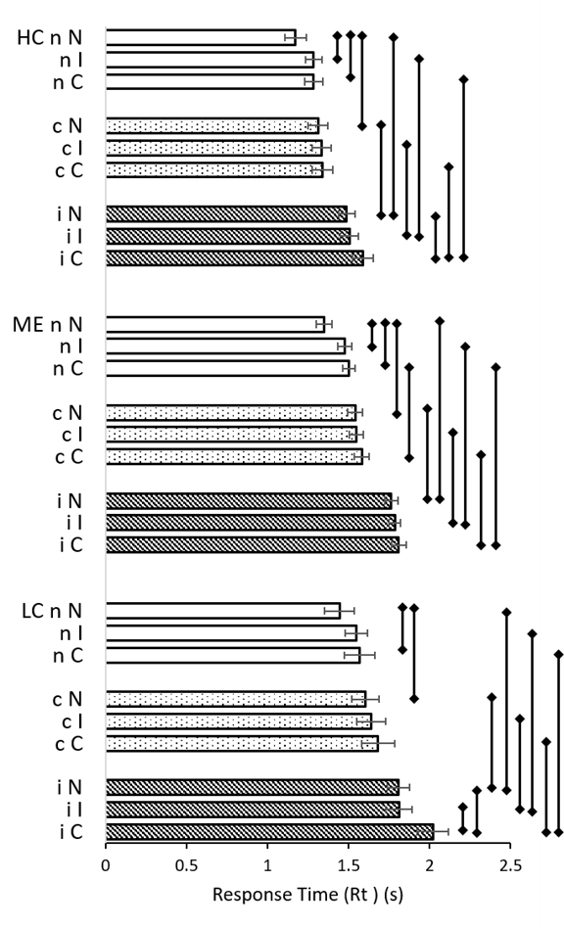
Figure 2. Rt for each pairing and group. Univariate analysis generated mean Rt with 95%CI error bars for neutral (white bars), congruent (dotted bars) and incongruent (diagonal lines) prestimuli in HC, ME and LC groups. Significant differences in Rt within each group were indicated by error lines to the right of data bars (p < 0.05, see SOM Table S4). The predominant significant effect of the incongruent prestimulus was evident. LC and ME had significantly longer Rt than HC for each pairing (not indicated). LC was prolonged compared to ME for iC and nC.

End SOM Table S8.

SOM Table S9. Significant differences for Figure 2.
prestimulus | Stimulus | i Disease | j Disease | Mean Difference (I-J) | Std. Error | Sidak | 95% Confidence Interval for Difference^{b} | Upper Bound | Compare
c | C | LC | HC | .343* | 0.061 | 4.92E-08 | 0.198 | 0.488 | cC LC>ME
c | I | LC | HC | .236* | 0.056 | 8.85E-05 | 0.101 | 0.370 | cI LC>ME
c | N | LC | HC | .325* | 0.055 | 1.24E-08 | 0.193 | 0.456 | cN LC>ME
i | C | LC | ME | .210* | 0.054 | 2.66E-04 | 0.082 | 0.338 | iC LC>ME
i | C | LC | HC | .433* | 0.058 | 2.80E-13 | 0.294 | 0.572 | iC LC>HC
i | I | LC | HC | .306* | 0.052 | 9.52E-09 | 0.183 | 0.429 | iI IC>HC
i | N | LC | HC | .321* | 0.043 | 3.79E-13 | 0.217 | 0.424 | iN LC>HC
n | C | LC | ME | .131* | 0.048 | 0.020 | 0.016 | 0.247 | nC LC>HC
n | C | LC | HC | .322* | 0.052 | 1.89E-09 | 0.198 | 0.446 | nC LC>ME
n | I | LC | HC | .263* | 0.044 | 7.29E-09 | 0.158 | 0.369 | nI LC>HC
n | N | LC | HC | .271* | 0.058 | 7.37E-06 | 0.134 | 0.409 | nN LC>HC
c | C | ME | HC | .242* | 0.041 | 1.03E-08 | 0.144 | 0.340 | cC MR>HC
c | I | ME | HC | .214* | 0.038 | 7.71E-08 | 0.122 | 0.305 | cI ME>HC
c | N | ME | HC | .228* | 0.039 | 1.18E-08 | 0.136 | 0.321 | cN ME>HC
i | C | ME | HC | .223* | 0.040 | 9.03E-08 | 0.127 | 0.319 | iC ME>HC
i | I | ME | HC | .258* | 0.036 | 2.50E-12 | 0.172 | 0.344 | iI ME>HC
i | N | ME | HC | .299* | 0.032 | 0.00E+00 | 0.224 | 0.375 | iN ME>HC
n | C | ME | HC | .191* | 0.036 | 4.90E-07 | 0.104 | 0.278 | nC ME>HC
n | I | ME | HC | .219* | 0.033 | 8.42E-11 | 0.140 | 0.297 | nI ME>HC
n | N | ME | HC | .174* | 0.041 | 6.98E-05 | 0.076 | 0.272 | nN ME>HC
Disease Group | Stimulus | i prestim | j prestim | Mean Difference (I-J) | Std. Error | Sidak | 95% Confidence Interval for Difference^{b} | Upper Bound | Compare
HC | C | i | c | .248* | 0.046 | 2.71E-07 | 0.137 | 0.358 | HC iC > cC
HC | C | i | n | .302* | 0.044 | 1.33E-11 | 0.198 | 0.406 | HC iC > nC
HC | I | i | c | .173* | 0.042 | 1.32E-04 | 0.072 | 0.274 | HC iI > cI
HC | I | i | n | .222* | 0.039 | 4.77E-08 | 0.128 | 0.315 | HC cN > nN
HC | N | c | n | .139* | 0.045 | 0.0069 | 0.030 | 0.247 | HC cN > nN
HC | N | i | c | .176* | 0.040 | 3.99E-05 | 0.079 | 0.272 | HC iN > cN
HC | N | i | n | .314* | 0.042 | 1.88E-13 | 0.214 | 0.414 | HC iN > nN
LC | C | i | c | .338* | 0.070 | 4.42E-06 | 0.170 | 0.505 | LC iC > cC
LC | C | i | n | .413* | 0.065 | 5.20E-10 | 0.259 | 0.568 | LC iC > nC
LC | I | i | c | .243* | 0.064 | 4.08E-04 | 0.091 | 0.395 | LC iI > cI
LC | I | i | n | .264* | 0.055 | 5.65E-06 | 0.132 | 0.396 | LC iI > nN
LC | N | c | n | .192* | 0.066 | 0.0102 | 0.035 | 0.348 | LC cN > nN
LC | N | i | c | .172* | 0.057 | 0.0084 | 0.034 | 0.309 | LC iN > cN
LC | N | i | n | .363* | 0.059 | 1.85E-09 | 0.223 | 0.504 | LC iN > nN
ME | C | c | n | .106* | 0.033 | 0.0035 | 0.028 | 0.184 | ME cC > nC
ME | C | i | c | .228* | 0.034 | 5.50E-11 | 0.147 | 0.309 | ME iC > cC
ME | C | i | n | .334* | 0.032 | 0.00E+00 | 0.257 | 0.411 | ME iC > nC
ME | I | i | c | .217* | 0.031 | 1.20E-11 | 0.142 | 0.292 | ME iI > cI
ME | I | i | n | .261* | 0.029 | 0.00E+00 | 0.192 | 0.330 | ME iI > nI
ME | N | c | n | .193* | 0.034 | 3.02E-08 | 0.113 | 0.273 | ME cN > nN
ME | N | i | c | .246* | 0.030 | 3.33E-16 | 0.175 | 0.318 | ME iN > cN
ME | N | i | n | .439* | 0.031 | 0.00E+00 | 0.365 | 0.513 | ME iN > nN
Disease Group | prestimulus | i Stim | j Stim | Mean Difference (I-J) | Std. Error | Sidak | 95% Confidence Interval for Difference^{b} | Upper Bound | Compare
HC | i | C | N | .099* | 0.041 | 0.049 | 0.00022 | 0.197 | HC iC > iN
HC | n | C | N | .111* | 0.044 | 0.035 | 0.006 | 0.216 | HC nC > nN
HC | n | I | N | .111* | 0.042 | 0.027 | 0.009 | 0.212 | HC nI > nN
LC | i | C | I | .208* | 0.064 | 0.0037 | 0.054 | 0.362 | LC iC > iI
LC | i | C | N | .211* | 0.059 | 0.0012 | 0.069 | 0.353 | LC iC > iN
LC | n | C | N | .162* | 0.064 | 0.034 | 0.009 | 0.314 | LC nC > nN
ME | n | C | N | .127* | 0.033 | 3.23E-04 | 0.049 | 0.206 | ME nC > nN
ME | n | I | N | .155* | 0.031 | 2.09E-06 | 0.081 | 0.230 | ME nI > nN
End SOM Table S9.

SOM Table S10. Analysis of power function curves for practice effects. Values for (-1)*exponent, constant, extrapolated values at 900s, difference (∆Rt, s) and estimated variance (R2) are shown for each pairing and group.
Variable | HC | ME | LC | HC | ME | LC | HC | ME | LC
 | cC |  |  | cI |  |  | cN
(-1)*exponent | 0.015 | 0.019 | 0.093 | 0.088 | 0.112 | 0.173 | 0.04 | 0.02 | 0.07
constant | 1.38 | 1.62 | 2.66 | 2.06 | 2.67 | 3.99 | 1.55 | 1.57 | 2.24
Rt 900s | 1.24 | 1.42 | 1.41 | 1.13 | 1.24 | 1.23 | 1.18 | 1.37 | 1.39
∆Rt | 0.13 | 0.20 | 1.24 | 0.93 | 1.42 | 2.76 | 0.37 | 0.20 | 0.85
R² | 0.0011 | 0.0011 | 0.0406 | 0.0472 | 0.0487 | 0.1724 | 0.0134 | 0.0021 | 0.0419
 | iC |  |  | iI |  |  | iN
(-1)*exponent | 0.053 | 0.072 | 0.129 | 0.081 | 0.093 | 0.233 | 0.07 | 0.052 | 0.106
constant | 2.01 | 2.50 | 3.84 | 2.26 | 2.73 | 6.88 | 2.10 | 2.19 | 3.21
Rt 900s | 1.40 | 1.53 | 1.60 | 1.30 | 1.45 | 1.41 | 1.30 | 1.54 | 1.56
∆Rt | 0.61 | 0.97 | 2.24 | 0.96 | 1.28 | 5.47 | 0.79 | 0.65 | 1.65
R² | 0.0243 | 0.0286 | 0.1427 | 0.0461 | 0.038 | 0.1371 | 0.0198 | 0.0075 | 0.0329
 | nC |  |  | nI |  |  | nN
(-1)*exponent | 0.105 | 0.092 | 0.138 | 0.07 | 0.037 | 0.093 | 0.18 | 0.121 | 0.161
constant | 2.21 | 2.34 | 3.28 | 1.84 | 1.71 | 2.51 | 3.23 | 2.54 | 3.50
Rt 900s | 1.08 | 1.25 | 1.28 | 1.14 | 1.33 | 1.33 | 0.95 | 1.11 | 1.17
∆Rt | 1.13 | 1.09 | 2.00 | 0.70 | 0.38 | 1.18 | 2.28 | 1.42 | 2.33
R² | 0.1182 | 0.0583 | 0.1716 | 0.0331 | 0.0049 | 0.0455 | 0.0878 | 0.0314 | 0.064
End SOM Table S10

SOM Table S11. Data for Figure 3.
Figure 3. Time course of practice effects. Rt (s) in each bin was plotted for HC (black circles and line), LC (orange triangles and line) and ME (grey squares and line) for each Stimulus (A-C), prestimulus (D-F) and differences (∆) in Rt between Stimulus and prestimulus presentations for Congruent, Incongruent and Neutral stimuli (G-I). Error bars indicate SEM. Large circles indicated p<0.05, t>3.0 for >200 degrees of freedom.

Bins are offset so the graphed data do not overlap. Figures are shown below each data set.
quantity | test | bin | HC | LC | ME |  | SEM | t>3.0  200 dof  p<0.002
delta | ∆C-c | 0.9 | 0.151849 |  |  |  | 0.027012 | 5.62162
delta | ∆C-c | 1.9 | -0.05921 |  |  |  | 0.021751 | -2.72239
delta | ∆C-c | 2.9 | 0.126445 |  |  |  | 0.027775 | 4.552438
delta | ∆C-c | 3.9 | 0.077518 |  |  |  | 0.02176 | 3.562406
delta | ∆C-c | 4.9 | 0.092516 |  |  |  | 0.028462 | 3.250477
delta | ∆C-c | 5.9 | 0.010077 |  |  |  | 0.024068 | 0.418703
delta | ∆C-c | 0.95 |  | 0.221532 |  |  | 0.065387 | 3.388035
delta | ∆C-c | 1.95 |  | 0.053759 |  |  | 0.051447 | 1.044948
delta | ∆C-c | 2.95 |  | 0.267172 |  |  | 0.074186 | 3.601391
delta | ∆C-c | 3.95 |  | 0.172511 |  |  | 0.040205 | 4.290773
delta | ∆C-c | 4.95 |  | 0.082407 |  |  | 0.051501 | 1.60012
delta | ∆C-c | 5.95 |  | 0.019872 |  |  | 0.035723 | 0.556271
delta | ∆C-c | 1 |  |  | 0.125552 |  | 0.02701 | 4.648307
delta | ∆C-c | 2 |  |  | -0.03945 |  | 0.021074 | -1.87187
delta | ∆C-c | 3 |  |  | 0.115527 |  | 0.028536 | 4.048459
delta | ∆C-c | 4 |  |  | 0.125817 |  | 0.021578 | 5.830783
delta | ∆C-c | 5 |  |  | 0.039203 |  | 0.02442 | 1.605344
delta | ∆C-c | 6 |  |  | -0.03617 |  | 0.025817 | -1.40088
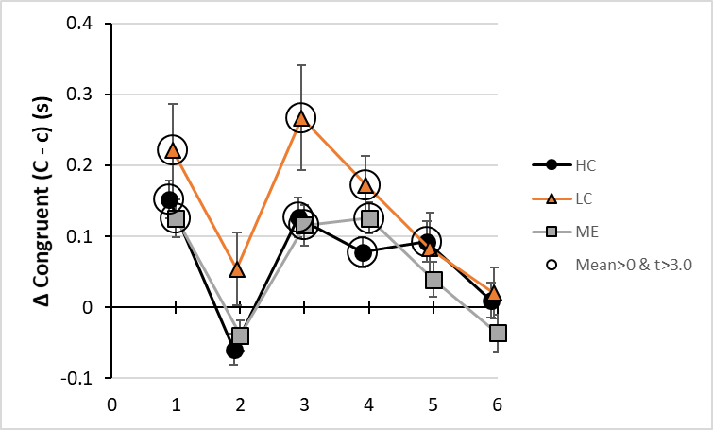
quantity | test | bin | HC | LC | ME |  | SEM | t>3.0  200 dof p<0.002
delta | ∆I-i | 0.9 | -0.07442 |  |  |  | 0.031688 | -2.34841
delta | ∆I-i | 1.9 | -0.04595 |  |  |  | 0.024129 | -1.9042
delta | ∆I-i | 2.9 | -0.20519 |  |  |  | 0.022335 | -9.18706
delta | ∆I-i | 3.9 | -0.11103 |  |  |  | 0.021567 | -5.14806
delta | ∆I-i | 4.9 | -0.15272 |  |  |  | 0.023316 | -6.54991
delta | ∆I-i | 5.9 | -0.17633 |  |  |  | 0.022123 | -7.97062
delta | ∆I-i | 0.95 |  | -0.30044 |  |  | 0.062753 | -4.78763
delta | ∆I-i | 1.95 |  | -0.14476 |  |  | 0.042715 | -3.38897
delta | ∆I-i | 2.95 |  | -0.25991 |  |  | 0.03675 | -7.07238
delta | ∆I-i | 3.95 |  | -0.23852 |  |  | 0.036723 | -6.49514
delta | ∆I-i | 4.95 |  | -0.20516 |  |  | 0.03262 | -6.28941
delta | ∆I-i | 5.95 |  | -0.18313 |  |  | 0.034165 | -5.3602
delta | ∆I-i | 1 |  |  | -0.21002 |  | 0.025921 | -8.10264
delta | ∆I-i | 2 |  |  | -0.10074 |  | 0.026621 | -3.78433
delta | ∆I-i | 3 |  |  | -0.26735 |  | 0.022847 | -11.7016
delta | ∆I-i | 4 |  |  | -0.19545 |  | 0.024424 | -8.00233
delta | ∆I-i | 5 |  |  | -0.17253 |  | 0.021684 | -7.95666
delta | ∆I-i | 6 |  |  | -0.13861 |  | 0.02519 | -5.50256
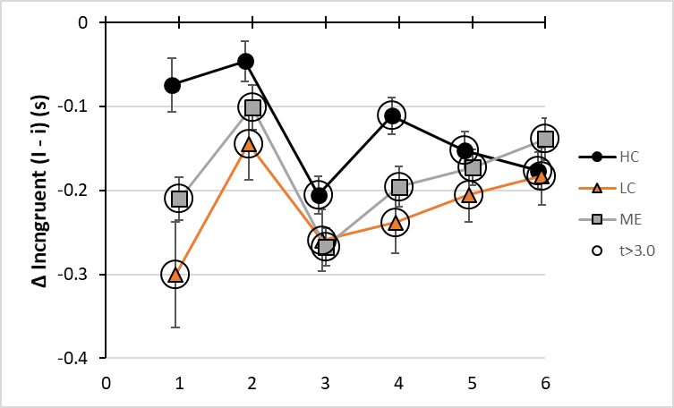

quantity | test | bin | HC | LC | ME |  | SEM | t>3.0  200 dof p<0.002
delta | ∆N-n | 0.9 | -0.02072 |  |  |  | 0.030226 | -0.68545
delta | ∆N-n | 1.9 | 0.077803 |  |  |  | 0.01827 | 4.258537
delta | ∆N-n | 2.9 | 0.162872 |  |  |  | 0.019956 | 8.161595
delta | ∆N-n | 3.9 | 0.025851 |  |  |  | 0.016765 | 1.541933
delta | ∆N-n | 4.9 | 0.09734 |  |  |  | 0.019364 | 5.026915
delta | ∆N-n | 5.9 | 0.231524 |  |  |  | 0.02425 | 9.547347
delta | ∆N-n | 0.95 |  | 0.05058 |  |  | 0.05021 | 1.007366
delta | ∆N-n | 1.95 |  | 0.046058 |  |  | 0.032619 | 1.412013
delta | ∆N-n | 2.95 |  | 0.231889 |  |  | 0.03446 | 6.729168
delta | ∆N-n | 3.95 |  | 0.047411 |  |  | 0.040328 | 1.175645
delta | ∆N-n | 4.95 |  | 0.178817 |  |  | 0.03419 | 5.230073
delta | ∆N-n | 5.95 |  | 0.209926 |  |  | 0.04193 | 5.00661
delta | ∆N-n | 1 |  |  | 0.103202 |  | 0.023736 | 4.347838
delta | ∆N-n | 2 |  |  | 0.102162 |  | 0.018521 | 5.515942
delta | ∆N-n | 3 |  |  | 0.248944 |  | 0.021488 | 11.58503
delta | ∆N-n | 4 |  |  | 0.057495 |  | 0.019889 | 2.890846
delta | ∆N-n | 5 |  |  | 0.154364 |  | 0.021482 | 7.185876
delta | ∆N-n | 6 |  |  | 0.231341 |  | 0.028389 | 8.148885
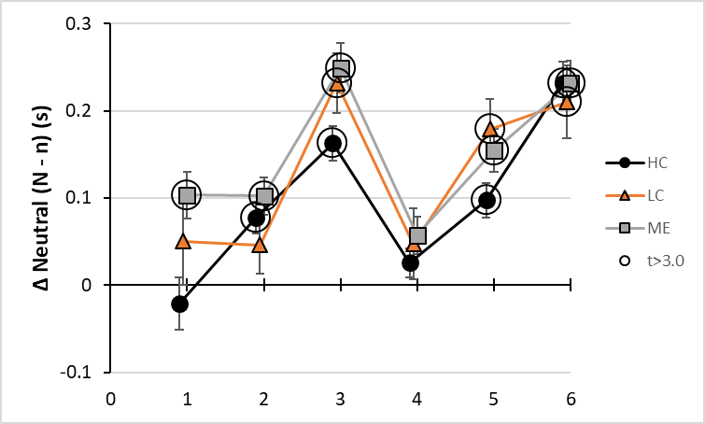

quantity | test | bin | HC | LC | ME |  | SEM | t>3.0  200 dof p<0.002
prestimulus | c | 0.9 | 1.495466 |  |  |  | 0.038021
prestimulus | c | 1.9 | 1.272438 |  |  |  | 0.032381
prestimulus | c | 2.9 | 1.324611 |  |  |  | 0.038093
prestimulus | c | 3.9 | 1.276601 |  |  |  | 0.031505
prestimulus | c | 4.9 | 1.310232 |  |  |  | 0.034594
prestimulus | c | 5.9 | 1.298297 |  |  |  | 0.03588
prestimulus | c | 0.95 |  | 2.14076 |  |  | 0.096593
prestimulus | c | 1.95 |  | 1.520628 |  |  | 0.065459
prestimulus | c | 2.95 |  | 1.505045 |  |  | 0.092828
prestimulus | c | 3.95 |  | 1.49369 |  |  | 0.056614
prestimulus | c | 4.95 |  | 1.586158 |  |  | 0.075648
prestimulus | c | 5.95 |  | 1.480058 |  |  | 0.05099
prestimulus | c | 1 |  |  | 1.797871 |  | 0.039254
prestimulus | c | 2 |  |  | 1.442789 |  | 0.031508
prestimulus | c | 3 |  |  | 1.563497 |  | 0.040093
prestimulus | c | 4 |  |  | 1.471004 |  | 0.030101
prestimulus | c | 5 |  |  | 1.505165 |  | 0.035516
prestimulus | c | 6 |  |  | 1.567212 |  | 0.040215
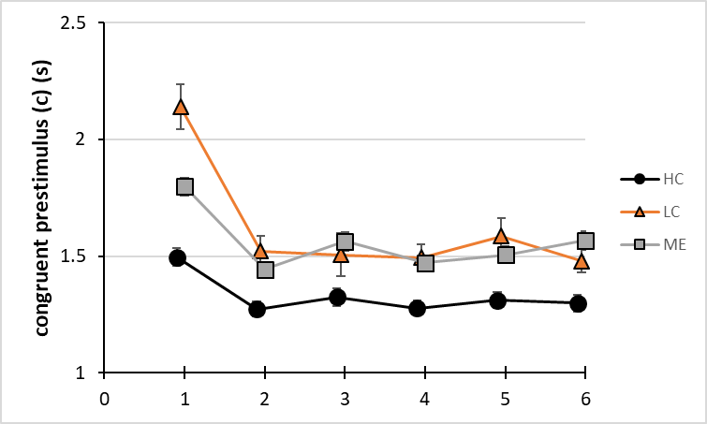
quantity | test | bin | HC | LC | ME |  | SEM | t>3.0  200 dof p<0.002
prestimulus | i | 0.9 | 1.763808 |  |  |  | 0.040813
prestimulus | i | 1.9 | 1.469895 |  |  |  | 0.034148
prestimulus | i | 2.9 | 1.524369 |  |  |  | 0.033991
prestimulus | i | 3.9 | 1.397864 |  |  |  | 0.030666
prestimulus | i | 4.9 | 1.442343 |  |  |  | 0.035766
prestimulus | i | 5.9 | 1.483028 |  |  |  | 0.034084
prestimulus | i | 0.95 |  | 2.378781 |  |  | 0.084506
prestimulus | i | 1.95 |  | 1.887584 |  |  | 0.06482
prestimulus | i | 2.95 |  | 1.860072 |  |  | 0.054127
prestimulus | i | 3.95 |  | 1.739219 |  |  | 0.053826
prestimulus | i | 4.95 |  | 1.66794 |  |  | 0.049686
prestimulus | i | 5.95 |  | 1.669523 |  |  | 0.049419
prestimulus | i | 1 |  |  | 2.045858 |  | 0.038226
prestimulus | i | 2 |  |  | 1.758664 |  | 0.040084
prestimulus | i | 3 |  |  | 1.807569 |  | 0.034102
prestimulus | i | 4 |  |  | 1.687504 |  | 0.03601
prestimulus | i | 5 |  |  | 1.680551 |  | 0.03217
prestimulus | i | 6 |  |  | 1.699228 |  | 0.035521
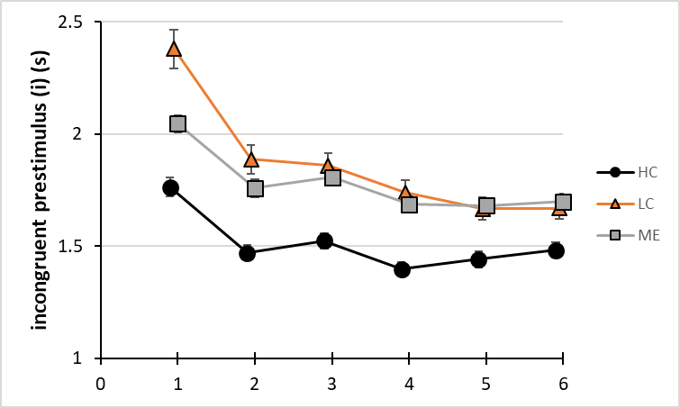
quantity | test | bin | HC | LC | ME |  | SEM | t>3.0  200 dof p<0.002
prestimulus | n | 0.9 | 1.548775 |  |  |  | 0.046884
prestimulus | n | 1.9 | 1.271887 |  |  |  | 0.02473
prestimulus | n | 2.9 | 1.207131 |  |  |  | 0.024512
prestimulus | n | 3.9 | 1.205164 |  |  |  | 0.022472
prestimulus | n | 4.9 | 1.181011 |  |  |  | 0.027116
prestimulus | n | 5.9 | 1.200584 |  |  |  | 0.026103
prestimulus | n | 0.95 |  | 1.880476 |  |  | 0.072093
prestimulus | n | 1.95 |  | 1.558339 |  |  | 0.047429
prestimulus | n | 2.95 |  | 1.456556 |  |  | 0.047634
prestimulus | n | 3.95 |  | 1.498227 |  |  | 0.055473
prestimulus | n | 4.95 |  | 1.431738 |  |  | 0.042563
prestimulus | n | 5.95 |  | 1.423234 |  |  | 0.056989
prestimulus | n | 1 |  |  | 1.666377 |  | 0.030508
prestimulus | n | 2 |  |  | 1.415558 |  | 0.022973
prestimulus | n | 3 |  |  | 1.412865 |  | 0.027331
prestimulus | n | 4 |  |  | 1.406877 |  | 0.02674
prestimulus | n | 5 |  |  | 1.404193 |  | 0.027884
prestimulus | n | 6 |  |  | 1.459621 |  | 0.035643
quantity | test | bin | HC | LC | ME |  | SEM | t>3.0 200 dof p<0.002
Stimulus | C | 0.9 | 1.647315 |  |  |  | 0.038259
Stimulus | C | 1.9 | 1.213223 |  |  |  | 0.029018
Stimulus | C | 2.9 | 1.451056 |  |  |  | 0.040391
Stimulus | C | 3.9 | 1.354119 |  |  |  | 0.030024
Stimulus | C | 4.9 | 1.402747 |  |  |  | 0.045816
Stimulus | C | 5.9 | 1.308374 |  |  |  | 0.032204
Stimulus | C | 0.95 |  | 2.362292 |  |  | 0.088823
Stimulus | C | 1.95 |  | 1.574387 |  |  | 0.079523
Stimulus | C | 2.95 |  | 1.772217 |  |  | 0.114808
Stimulus | C | 3.95 |  | 1.666202 |  |  | 0.057083
Stimulus | C | 4.95 |  | 1.668565 |  |  | 0.06906
Stimulus | C | 5.95 |  | 1.49993 |  |  | 0.050062
Stimulus | C | 1 |  |  | 1.923423 |  | 0.03722
Stimulus | C | 2 |  |  | 1.403342 |  | 0.027956
Stimulus | C | 3 |  |  | 1.679024 |  | 0.040618
Stimulus | C | 4 |  |  | 1.596821 |  | 0.030929
Stimulus | C | 5 |  |  | 1.544368 |  | 0.033471
Stimulus | C | 6 |  |  | 1.531045 |  | 0.032502
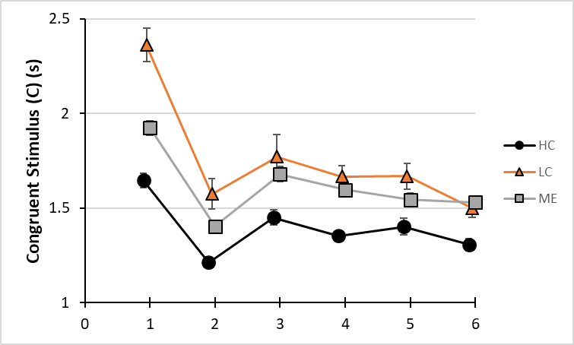
quantity | test | bin | HC | LC | ME |  | SEM | t>3.0  200 dof p<0.002
Stimulus | I | 0.9 | 1.689392 |  |  |  | 0.050217
Stimulus | I | 1.9 | 1.423949 |  |  |  | 0.034097
Stimulus | I | 2.9 | 1.319177 |  |  |  | 0.028878
Stimulus | I | 3.9 | 1.286837 |  |  |  | 0.030334
Stimulus | I | 4.9 | 1.289624 |  |  |  | 0.030009
Stimulus | I | 5.9 | 1.306693 |  |  |  | 0.028257
Stimulus | I | 0.95 |  | 2.07834 |  |  | 0.093563
Stimulus | I | 1.95 |  | 1.742825 |  |  | 0.056498
Stimulus | I | 2.95 |  | 1.600164 |  |  | 0.049665
Stimulus | I | 3.95 |  | 1.500699 |  |  | 0.049359
Stimulus | I | 4.95 |  | 1.462776 |  |  | 0.042384
Stimulus | I | 5.95 |  | 1.48639 |  |  | 0.047274
Stimulus | I | 1 |  |  | 1.835833 |  | 0.034883
Stimulus | I | 2 |  |  | 1.657921 |  | 0.03518
Stimulus | I | 3 |  |  | 1.54022 |  | 0.030346
Stimulus | I | 4 |  |  | 1.492053 |  | 0.032971
Stimulus | I | 5 |  |  | 1.508017 |  | 0.029079
Stimulus | I | 6 |  |  | 1.560616 |  | 0.035721
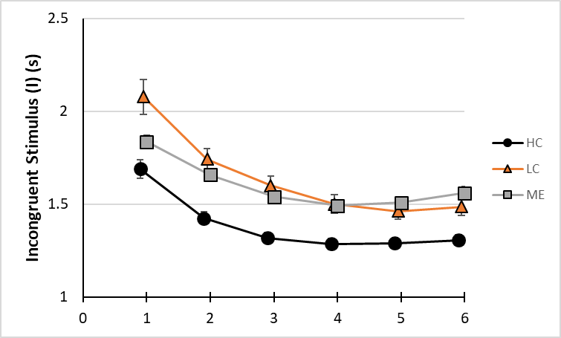
quantity | test | bin | HC | LC | ME |  | SEM | t>3.0 200 dof p<0.002
Stimulus | N | 0.9 | 1.528057 |  |  |  | 0.039489
Stimulus | N | 1.9 | 1.34969 |  |  |  | 0.026879
Stimulus | N | 2.9 | 1.370004 |  |  |  | 0.03143
Stimulus | N | 3.9 | 1.231015 |  |  |  | 0.024894
Stimulus | N | 4.9 | 1.278351 |  |  |  | 0.02763
Stimulus | N | 5.9 | 1.432108 |  |  |  | 0.041465
Stimulus | N | 0.95 |  | 1.931056 |  |  | 0.069866
Stimulus | N | 1.95 |  | 1.604397 |  |  | 0.044504
Stimulus | N | 2.95 |  | 1.688444 |  |  | 0.04981
Stimulus | N | 3.95 |  | 1.545638 |  |  | 0.058247
Stimulus | N | 4.95 |  | 1.610555 |  |  | 0.053173
Stimulus | N | 5.95 |  | 1.63316 |  |  | 0.061848
Stimulus | N | 1 |  |  | 1.769579 |  | 0.036617
Stimulus | N | 2 |  |  | 1.51772 |  | 0.029135
Stimulus | N | 3 |  |  | 1.661809 |  | 0.03306
Stimulus | N | 4 |  |  | 1.464372 |  | 0.029409
Stimulus | N | 5 |  |  | 1.558557 |  | 0.032597
Stimulus | N | 6 |  |  | 1.690962 |  | 0.044519
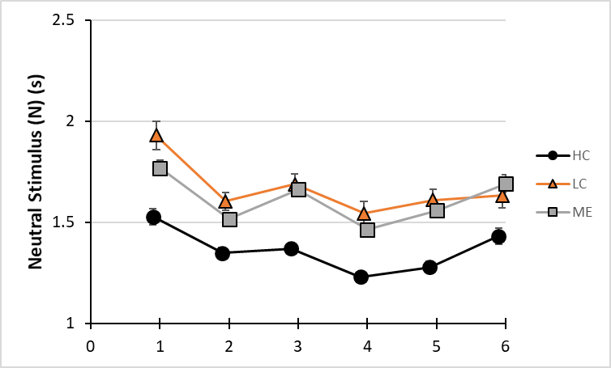
End of SOM Table S11

SOM Table S12. Data for Figure 4.
Figure 4. Time course for Stroop effects of prestimulus and Stimulus. Stroop, Facilitation and Interference effects were shown for Stimulus (upper row, A-C) and prestimulus (lower row, D-F) in HC (black circles and line), LC (orange triangles and line) and ME (grey squares and line) were indicated by positive values that were significantly different from zero (large circles, p<0.05, t>3.0 for >200 degrees of freedom). Error bars indicate SEM.

Bins are offset so the graphed data do not overlap. Figures are shown below each data set.
quantity | test | bin | HC | LC | ME | SEM |  | t>3.0 200 dof p<0.002
i-c | prestimulus Stroop Effect | 0.9 | 0.268342 |  |  | 0.028042 |  | 9.569332
i-c | prestimulus Stroop Effect | 1.9 | 0.197457 |  |  | 0.02357 |  | 8.377442
i-c | prestimulus Stroop Effect | 2.9 | 0.199757 |  |  | 0.025828 |  | 7.734193
i-c | prestimulus Stroop Effect | 3.9 | 0.121263 |  |  | 0.022023 |  | 5.506174
i-c | prestimulus Stroop Effect | 4.9 | 0.132111 |  |  | 0.025546 |  | 5.171482
i-c | prestimulus Stroop Effect | 5.9 | 0.184731 |  |  | 0.024721 |  | 7.472649
i-c | prestimulus Stroop Effect | 0.95 |  | 0.238021 |  | 0.063845 |  | 3.7281
i-c | prestimulus Stroop Effect | 1.95 |  | 0.366956 |  | 0.046075 |  | 7.964398
i-c | prestimulus Stroop Effect | 2.95 |  | 0.355026 |  | 0.047026 |  | 7.549609
i-c | prestimulus Stroop Effect | 3.95 |  | 0.245529 |  | 0.039207 |  | 6.262415
i-c | prestimulus Stroop Effect | 4.95 |  | 0.081782 |  | 0.041644 |  | 1.963825
i-c | prestimulus Stroop Effect | 5.95 |  | 0.189465 |  | 0.035497 |  | 5.337417
i-c | prestimulus Stroop Effect | 1 |  |  | 0.247987 | 0.027442 |  | 9.036895
i-c | prestimulus Stroop Effect | 2 |  |  | 0.315875 | 0.025565 |  | 12.35592
i-c | prestimulus Stroop Effect | 3 |  |  | 0.244072 | 0.026238 |  | 9.302145
i-c | prestimulus Stroop Effect | 4 |  |  | 0.2165 | 0.023299 |  | 9.29211
i-c | prestimulus Stroop Effect | 5 |  |  | 0.175385 | 0.023914 |  | 7.334009
i-c | prestimulus Stroop Effect | 6 |  |  | 0.132016 | 0.02664 |  | 4.955615
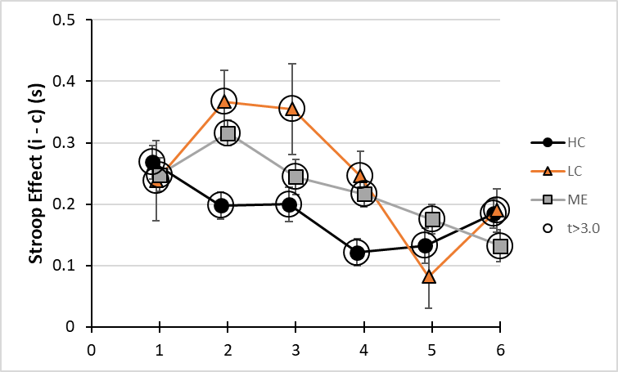

quantity | test | bin | HC | LC | ME | SEM |  | t>3.0 200 dof p<0.002
i-n | prestimulus Interference | 0.9 | 0.215033 |  |  | 0.031161 |  | 6.900672
i-n | prestimulus Interference | 1.9 | 0.198008 |  |  | 0.020387 |  | 9.712568
i-n | prestimulus Interference | 2.9 | 0.317238 |  |  | 0.021622 |  | 14.67208
i-n | prestimulus Interference | 3.9 | 0.1927 |  |  | 0.018893 |  | 10.19961
i-n | prestimulus Interference | 4.9 | 0.261332 |  |  | 0.022474 |  | 11.62823
i-n | prestimulus Interference | 5.9 | 0.282444 |  |  | 0.022501 |  | 12.55245
i-n | prestimulus Interference | 0.95 |  | 0.498305 |  | 0.055169 |  | 9.032291
i-n | prestimulus Interference | 1.95 |  | 0.329245 |  | 0.038335 |  | 8.588646
i-n | prestimulus Interference | 2.95 |  | 0.403516 |  | 0.036735 |  | 10.98439
i-n | prestimulus Interference | 3.95 |  | 0.240992 |  | 0.03868 |  | 6.230458
i-n | prestimulus Interference | 4.95 |  | 0.236202 |  | 0.032883 |  | 7.183071
i-n | prestimulus Interference | 5.95 |  | 0.246289 |  | 0.037396 |  | 6.585938
i-n | prestimulus Interference | 1 |  |  | 0.379481 | 0.024676 |  | 15.37843
i-n | prestimulus Interference | 2 |  |  | 0.343106 | 0.021681 |  | 15.82519
i-n | prestimulus Interference | 3 |  |  | 0.394703 | 0.022437 |  | 17.59166
i-n | prestimulus Interference | 4 |  |  | 0.280627 | 0.022377 |  | 12.54079
i-n | prestimulus Interference | 5 |  |  | 0.276358 | 0.021395 |  | 12.91693
i-n | prestimulus Interference | 6 |  |  | 0.239607 | 0.239607 |  | 9.430975
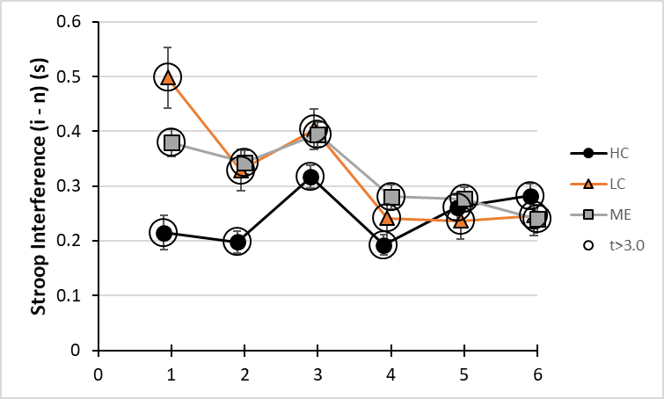

quantity | test | bin | HC | LC | ME | SEM |  | t>3.0 200 dof p<0.002
n-c | prestimulus Facilitation | 0.9 | 0.053309 |  |  | 0.02955 |  | 1.804017
n-c | prestimulus Facilitation | 1.9 | -0.00055 |  |  | 0.019772 |  | -0.02787
n-c | prestimulus Facilitation | 2.9 | -0.11748 |  |  | 0.021073 |  | -5.57481
n-c | prestimulus Facilitation | 3.9 | -0.07144 |  |  | 0.019468 |  | -3.66952
n-c | prestimulus Facilitation | 4.9 | -0.12922 |  |  | 0.021361 |  | -6.04935
n-c | prestimulus Facilitation | 5.9 | -0.09771 |  |  | 0.022709 |  | -4.30283
n-c | prestimulus Facilitation | 0.95 |  | -0.26028 |  | 0.05888 |  | -4.42054
n-c | prestimulus Facilitation | 1.95 |  | 0.037712 |  | 0.038424 |  | 0.98147
n-c | prestimulus Facilitation | 2.95 |  | -0.04849 |  | 0.042545 |  | -1.13973
n-c | prestimulus Facilitation | 3.95 |  | 0.004536 |  | 0.040072 |  | 0.113205
n-c | prestimulus Facilitation | 4.95 |  | -0.15442 |  | 0.038284 |  | -4.03359
n-c | prestimulus Facilitation | 5.95 |  | -0.05682 |  | 0.038125 |  | -1.49048
n-c | prestimulus Facilitation | 1 |  |  | -0.13149 | 0.024569 |  | -5.35202
n-c | prestimulus Facilitation | 2 |  |  | -0.02723 | 0.018818 |  | -1.44711
n-c | prestimulus Facilitation | 3 |  |  | -0.15063 | 0.022912 |  | -6.57438
n-c | prestimulus Facilitation | 4 |  |  | -0.06413 | 0.020237 |  | -3.16879
n-c | prestimulus Facilitation | 5 |  |  | -0.10097 | 0.022033 |  | -4.58278
n-c | prestimulus Facilitation | 6 |  |  | -0.10759 | 0.02709 |  | -3.97154
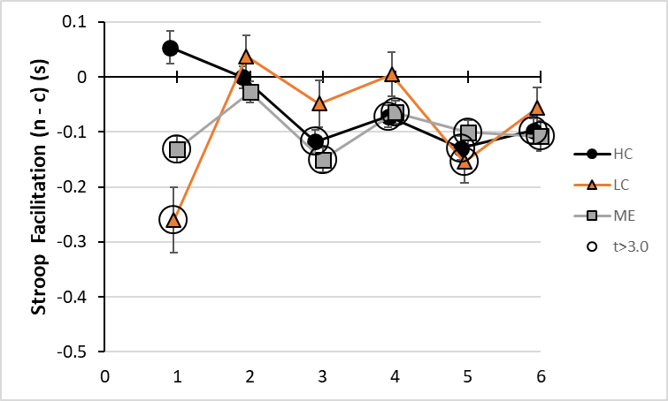
quantity | test | bin | HC | LC | ME | SEM |  | t>3.0 200 dof p<0.002
Stroop Effect=I-C | STIMULUS Stroop Effect | 0.9 | 0.042077 |  |  | 0.030453 |  | 1.38168
Stroop Effect=I-C | STIMULUS Stroop Effect | 1.9 | 0.210726 |  |  | 0.022497 |  | 9.367016
Stroop Effect=I-C | STIMULUS Stroop Effect | 2.9 | -0.13188 |  |  | 0.023507 |  | -5.61014
Stroop Effect=I-C | STIMULUS Stroop Effect | 3.9 | -0.06728 |  |  | 0.021347 |  | -3.15185
Stroop Effect=I-C | STIMULUS Stroop Effect | 4.9 | -0.11312 |  |  | 0.025482 |  | -4.43938
Stroop Effect=I-C | STIMULUS Stroop Effect | 5.9 | -0.00168 |  |  | 0.021284 |  | -0.07898
Stroop Effect=I-C | STIMULUS Stroop Effect | 0.95 |  | -0.28395 |  | 0.064468 |  | -4.40455
Stroop Effect=I-C | STIMULUS Stroop Effect | 1.95 |  | 0.168437 |  | 0.047372 |  | 3.555656
Stroop Effect=I-C | STIMULUS Stroop Effect | 2.95 |  | -0.17205 |  | 0.046177 |  | -3.72599
Stroop Effect=I-C | STIMULUS Stroop Effect | 3.95 |  | -0.1655 |  | 0.038575 |  | -4.29045
Stroop Effect=I-C | STIMULUS Stroop Effect | 4.95 |  | -0.20579 |  | 0.036253 |  | -5.67652
Stroop Effect=I-C | STIMULUS Stroop Effect | 5.95 |  | -0.01354 |  | 0.034374 |  | -0.39391
Stroop Effect=I-C | STIMULUS Stroop Effect | 1 |  |  | -0.08759 | 0.025469 |  | -3.43912
Stroop Effect=I-C | STIMULUS Stroop Effect | 2 |  |  | 0.254579 | 0.022631 |  | 11.24935
Stroop Effect=I-C | STIMULUS Stroop Effect | 3 |  |  | -0.1388 | 0.024312 |  | -5.70939
Stroop Effect=I-C | STIMULUS Stroop Effect | 4 |  |  | -0.10477 | 0.02256 |  | -4.64403
Stroop Effect=I-C | STIMULUS Stroop Effect | 5 |  |  | -0.03635 | 0.021976 |  | -1.65418
Stroop Effect=I-C | STIMULUS Stroop Effect | 6 |  |  | 0.02957 | 0.024452 |  | 1.209299
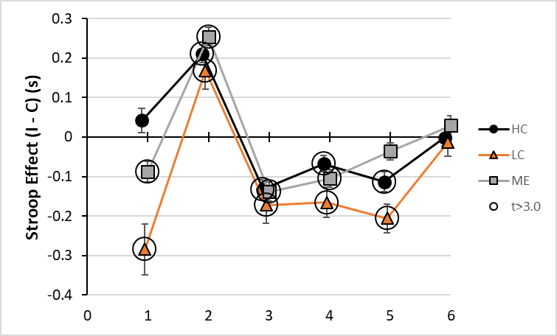

quantity | test | bin | HC | LC | ME | SEM |  | t>3.0 200 dof p<0.002
Stroop Facilitation=N-C | STIMULUS Facilitation | 0.9 | -0.11926 |  |  | 0.027518 |  | -4.33381
Stroop Facilitation=N-C | STIMULUS Facilitation | 1.9 | 0.136467 |  |  | 0.019799 |  | 6.892663
Stroop Facilitation=N-C | STIMULUS Facilitation | 2.9 | -0.08105 |  |  | 0.024815 |  | -3.26626
Stroop Facilitation=N-C | STIMULUS Facilitation | 3.9 | -0.1231 |  |  | 0.019578 |  | -6.2879
Stroop Facilitation=N-C | STIMULUS Facilitation | 4.9 | -0.1244 |  |  | 0.024415 |  | -5.095
Stroop Facilitation=N-C | STIMULUS Facilitation | 5.9 | 0.123734 |  |  | 0.025691 |  | 4.816209
Stroop Facilitation=N-C | STIMULUS Facilitation | 0.95 |  | -0.43124 |  | 0.056292 |  | -7.6607
Stroop Facilitation=N-C | STIMULUS Facilitation | 1.95 |  | 0.03001 |  | 0.040724 |  | 0.736922
Stroop Facilitation=N-C | STIMULUS Facilitation | 2.95 |  | -0.08377 |  | 0.047196 |  | -1.77501
Stroop Facilitation=N-C | STIMULUS Facilitation | 3.95 |  | -0.12056 |  | 0.040909 |  | -2.94712
Stroop Facilitation=N-C | STIMULUS Facilitation | 4.95 |  | -0.05801 |  | 0.042375 |  | -1.36897
Stroop Facilitation=N-C | STIMULUS Facilitation | 5.95 |  | 0.13323 |  | 0.039178 |  | 3.400619
Stroop Facilitation=N-C | STIMULUS Facilitation | 1 |  |  | -0.15384 | 0.026116 |  | -5.89089
Stroop Facilitation=N-C | STIMULUS Facilitation | 2 |  |  | 0.114378 | 0.020521 |  | 5.573774
Stroop Facilitation=N-C | STIMULUS Facilitation | 3 |  |  | -0.01722 | 0.025642 |  | -0.67137
Stroop Facilitation=N-C | STIMULUS Facilitation | 4 |  |  | -0.13245 | 0.02138 |  | -6.19512
Stroop Facilitation=N-C | STIMULUS Facilitation | 5 |  |  | 0.014189 | 0.023576 |  | 0.601812
Stroop Facilitation=N-C | STIMULUS Facilitation | 6 |  |  | 0.159917 | 0.026947 |  | 5.934538
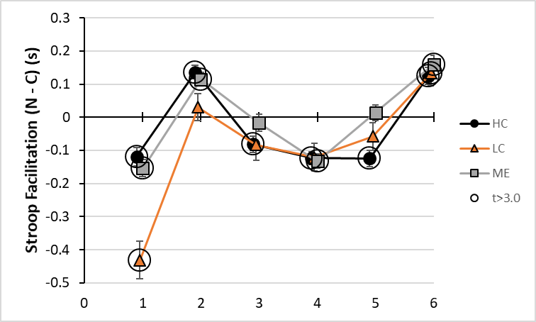
quantity | test | bin | HC | LC | ME | SEM |  | t>3.0 200 dof p<0.002
Stroop Interference=I-N | STIMULUS Interference | 0.9 | 0.161335 |  |  | 0.031169 |  | 5.176124
Stroop Interference=I-N | STIMULUS Interference | 1.9 | 0.074259 |  |  | 0.02121 |  | 3.501219
Stroop Interference=I-N | STIMULUS Interference | 2.9 | -0.05083 |  |  | 0.021266 |  | -2.39007
Stroop Interference=I-N | STIMULUS Interference | 3.9 | 0.055822 |  |  | 0.019558 |  | 2.854243
Stroop Interference=I-N | STIMULUS Interference | 4.9 | 0.011274 |  |  | 0.020393 |  | 0.552819
Stroop Interference=I-N | STIMULUS Interference | 5.9 | -0.12541 |  |  | 0.023839 |  | -5.26095
Stroop Interference=I-N | STIMULUS Interference | 0.95 |  | 0.147284 |  | 0.05692 |  | 2.587549
Stroop Interference=I-N | STIMULUS Interference | 1.95 |  | 0.138427 |  | 0.035073 |  | 3.946838
Stroop Interference=I-N | STIMULUS Interference | 2.95 |  | -0.08828 |  | 0.035336 |  | -2.4983
Stroop Interference=I-N | STIMULUS Interference | 3.95 |  | -0.04494 |  | 0.038236 |  | -1.1753
Stroop Interference=I-N | STIMULUS Interference | 4.95 |  | -0.14778 |  | 0.033853 |  | -4.36535
Stroop Interference=I-N | STIMULUS Interference | 5.95 |  | -0.14677 |  | 0.037756 |  | -3.88736
Stroop Interference=I-N | STIMULUS Interference | 1 |  |  | 0.066254 | 0.025257 |  | 2.623182
Stroop Interference=I-N | STIMULUS Interference | 2 |  |  | 0.140202 | 0.022497 |  | 6.232023
Stroop Interference=I-N | STIMULUS Interference | 3 |  |  | -0.12159 | 0.022356 |  | -5.43884
Stroop Interference=I-N | STIMULUS Interference | 4 |  |  | 0.027681 | 0.022043 |  | 1.255739
Stroop Interference=I-N | STIMULUS Interference | 5 |  |  | -0.05054 | 0.021792 |  | -2.31917
Stroop Interference=I-N | STIMULUS Interference | 6 |  |  | -0.13035 | 0.027888 |  | -4.67389
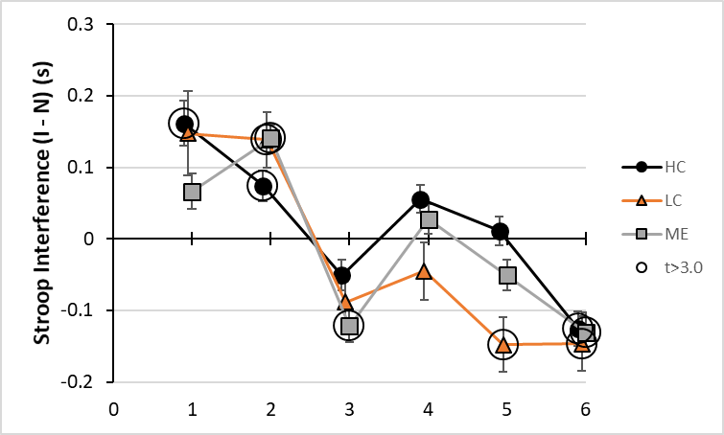

End SOM Table S12

SOM Table S13. Equations for surprise indices. In each case, the index was computed as the Surprise term plus average of (Same) minus average of (Conflict)..
Surprise of Stimulus | Conflict between different prestimulus and Stimulus | Same prestimulus and Stimulus
cI – iI | cI + iC | iI + cC
iC – cC | iC + cI | iI + cC
iN – nN | iN + nI | iI + nN
cN – nN | cN + nC | nN + cC
nI – iI | nI + iN | iI + nN
nC – cC | nC + cN | nN + cC
Effect of Stimulus
Surprise of Stimulus | Conflict between different prestimulus and Stimulus | Same prestimulus and Stimulus
nI + cI - iI – iI | nI + iN + cI +iC | iI + nN + iI + cC
nC + iC - cC - cC | nC + cN + iC + cI | nN + cC + iI + cC
iN + cN - nN - nN | iN + nI + cN + nC | iI + nN + nN + cC
Effect of prestimulus
Surprise of pretimulus | Conflict between different prestimulus and Stimulus | Same prestimulus and Stimulus
iN+iC-iI-iI | iN + nI + nC + cI | iI + nN + iI + cC
cN+cI-cC-cC | cN + nN + cC + iI | cC + nN + cC + iI
nI+nC-nN-nN | nI + iN + nC + cN | nN + iI + nN + cC
End SOM Table S13

SOM Table S14. Data for Figure 5. Surprise index.
group | Comparison | bin | HC | LC | ME | t>3.0 | SEM | t
HC | cI – iI | 0.9 | -0.21256 |  |  | -0.21256 | 0.065177 | -3.26125
HC | cI – iI | 1.9 | -0.19129 |  |  |  | 0.070106 | -2.72863
HC | cI – iI | 2.9 | -0.18465 |  |  | -0.18465 | 0.060414 | -3.05645
HC | cI - iI | 3.9 | -0.0996 |  |  |  | 0.063814 | -1.56078
HC | cI - iI | 4.9 | -0.11166 |  |  |  | 0.068503 | -1.62996
HC | cI - iI | 5.9 | -0.1988 |  |  | -0.1988 | 0.061861 | -3.21371
LC | cI - iI | 0.95 |  | -0.1749 |  |  | 0.114602 | -1.52619
LC | cI - iI | 1.95 |  | -0.41234 |  | -0.41234 | 0.117123 | -3.52058
LC | cI - iI | 2.95 |  | -0.02415 |  |  | 0.091262 | -0.26459
LC | cI - iI | 3.95 |  | -0.35262 |  | -0.35262 | 0.094518 | -3.73071
LC | cI - iI | 4.95 |  | 0.02576 |  |  | 0.104099 | 0.247456
LC | cI - iI | 5.95 |  | -0.13827 |  |  | 0.077122 | -1.79283
ME | cI - iI | 1 |  |  | -0.1643 | -0.1643 | 0.05209 | -3.15422
ME | cI - iI | 2 |  |  | -0.23845 | -0.23845 | 0.058157 | -4.10011
ME | cI - iI | 3 |  |  | -0.13485 |  | 0.04817 | -2.79935
ME | cI - iI | 4 |  |  | -0.17303 | -0.17303 | 0.051864 | -3.33626
ME | cI - iI | 5 |  |  | -0.19467 | -0.19467 | 0.053047 | -3.66981
ME | cI - iI | 6 |  |  | -0.07367 |  | 0.04979 | -1.47968
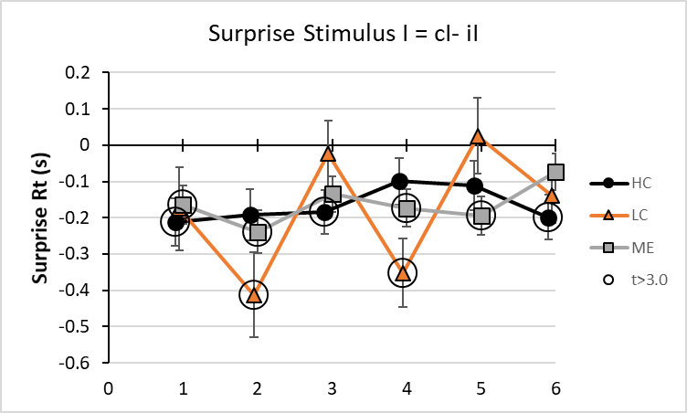
group | Comparison | bin | HC | LC | ME | t>3.0 | SEM | t
HC | cN - nN | 0.9 | -0.11219 |  |  |  | 0.046313 | -2.42246
HC | cN - nN | 1.9 | -0.00457 |  |  |  | 0.052717 | -0.08662
HC | cN - nN | 2.9 | 0.215951 |  |  | 0.215951 | 0.05162 | 4.183511
HC | cN - nN | 3.9 | 0.140784 |  |  | 0.140784 | 0.0457 | 3.080605
HC | cN - nN | 4.9 | 0.208016 |  |  | 0.208016 | 0.051871 | 4.010276
HC | cN - nN | 5.9 | -0.07339 |  |  |  | 0.047052 | -1.55984
LC | cN - nN | 0.95 |  | 0.156946 |  |  | 0.074439 | 2.108398
LC | cN - nN | 1.95 |  | -0.07627 |  |  | 0.086507 | -0.88169
LC | cN - nN | 2.95 |  | 0.421009 |  | 0.421009 | 0.080812 | 5.209711
LC | cN - nN | 3.95 |  | 0.047412 |  |  | 0.069944 | 0.67786
LC | cN - nN | 4.95 |  | 0.30414 |  | 0.30414 | 0.074694 | 4.071838
LC | cN - nN | 5.95 |  | 0.177707 |  | 0.177707 | 0.058919 | 3.016111
ME | cN - nN | 1 |  |  | -0.00929 |  | 0.037608 | -0.24703
ME | cN - nN | 2 |  |  | -0.01797 |  | 0.042567 | -0.4221
ME | cN - nN | 3 |  |  | 0.290519 | 0.290519 | 0.041545 | 6.992824
ME | cN - nN | 4 |  |  | 0.122048 | 0.122048 | 0.037049 | 3.294256
ME | cN - nN | 5 |  |  | 0.20608 | 0.20608 | 0.039823 | 5.17496
ME | cN - nN | 6 |  |  | 0.179889 | 0.179889 | 0.0377 | 4.771536
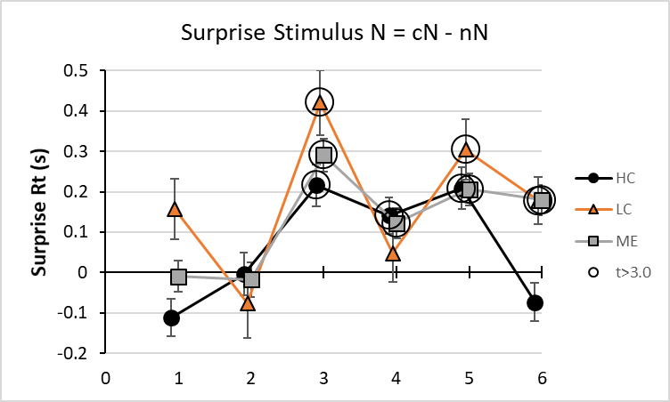
group | Comparison | bin | HC | LC | ME | t>3.0 | SEM | t
HC | cN+cI-cC-cC | 0.9 | 0.068035 |  |  |  | 0.055978 | 1.215386
HC | cN+cI-cC-cC | 1.9 | 0.358067 |  |  | 0.358067 | 0.054134 | 6.614398
HC | cN+cI-cC-cC | 2.9 | -0.16493 |  |  |  | 0.057293 | -2.87877
HC | cN+cI-cC-cC | 3.9 | -0.42176 |  |  | -0.42176 | 0.052746 | -7.99618
HC | cN+cI-cC-cC | 4.9 | -0.31234 |  |  | -0.31234 | 0.060341 | -5.17625
HC | cN+cI-cC-cC | 5.9 | 0.009549 |  |  |  | 0.059133 | 0.161482
LC | cN+cI-cC-cC | 0.95 |  | -0.25507 |  |  | 0.088468 | -2.88318
LC | cN+cI-cC-cC | 1.95 |  | 0.296262 |  | 0.296262 | 0.083057 | 3.56696
LC | cN+cI-cC-cC | 2.95 |  | -0.75458 |  | -0.75458 | 0.095535 | -7.89851
LC | cN+cI-cC-cC | 3.95 |  | -0.47819 |  | -0.47819 | 0.079778 | -5.99401
LC | cN+cI-cC-cC | 4.95 |  | -0.64517 |  | -0.64517 | 0.095676 | -6.74327
LC | cN+cI-cC-cC | 5.95 |  | -0.33443 |  | -0.33443 | 0.074753 | -4.47377
ME | cN+cI-cC-cC | 1 |  |  | -0.01848 |  | 0.045336 | -0.40752
ME | cN+cI-cC-cC | 2 |  |  | 0.308158 | 0.308158 | 0.043111 | 7.148005
ME | cN+cI-cC-cC | 3 |  |  | -0.33264 | -0.33264 | 0.045898 | -7.24726
ME | cN+cI-cC-cC | 4 |  |  | -0.41471 | -0.41471 | 0.042433 | -9.77311
ME | cN+cI-cC-cC | 5 |  |  | -0.10024 |  | 0.047413 | -2.11413
ME | cN+cI-cC-cC | 6 |  |  | -0.28 | -0.28 | 0.048044 | -5.82794
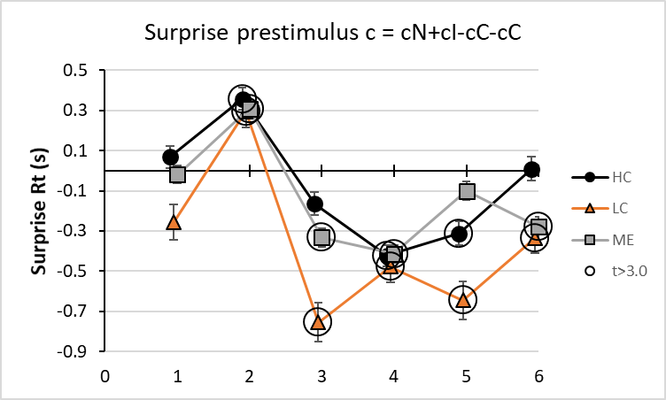
group | Comparison | bin | HC | LC | ME | t>3.0 | SEM | t
HC | iC - cC | 0.9 | 0.212559 |  |  | 0.212559 | 0.062448 | 3.403777
HC | iC - cC | 1.9 | 0.191293 |  |  | 0.191293 | 0.061168 | 3.127315
HC | iC - cC | 2.9 | 0.184652 |  |  | 0.184652 | 0.060101 | 3.072376
HC | iC - cC | 3.9 | 0.0996 |  |  |  | 0.058056 | 1.715565
HC | iC - cC | 4.9 | 0.111658 |  |  |  | 0.058707 | 1.901955
HC | iC - cC | 5.9 | 0.198805 |  |  | 0.198805 | 0.058918 | 3.374254
LC | iC - cC | 0.95 |  | 0.174904 |  |  | 0.098001 | 1.784718
LC | iC - cC | 1.95 |  | 0.41234 |  | 0.41234 | 0.092315 | 4.46665
LC | iC - cC | 2.95 |  | 0.024147 |  |  | 0.085255 | 0.283231
LC | iC - cC | 3.95 |  | 0.352618 |  | 0.352618 | 0.089225 | 3.952021
LC | iC - cC | 4.95 |  | -0.02576 |  |  | 0.083194 | -0.30964
LC | iC - cC | 5.95 |  | 0.138267 |  |  | 0.071699 | 1.928423
ME | iC - cC | 1 |  |  | 0.164304 | 0.164304 | 0.051111 | 3.214625
ME | iC - cC | 2 |  |  | 0.23845 | 0.23845 | 0.051055 | 4.67045
ME | iC - cC | 3 |  |  | 0.134845 |  | 0.050274 | 2.682228
ME | iC - cC | 4 |  |  | 0.173033 | 0.173033 | 0.047643 | 3.631894
ME | iC - cC | 5 |  |  | 0.194673 | 0.194673 | 0.046904 | 4.150432
ME | iC - cC | 6 |  |  | 0.073673 |  | 0.047132 | 1.563116
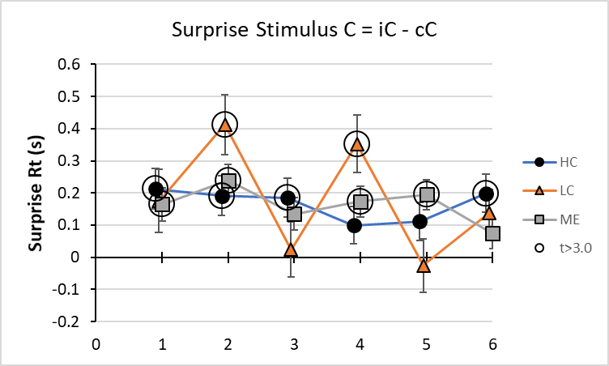
group | Comparison | bin | HC | LC | ME | t>3.0 | SEM | t
HC | iN - nN | 0.9 | 0.242644 |  |  | 0.242644 | 0.040621 | 5.973319
HC | iN - nN | 1.9 | 0.178158 |  |  | 0.178158 | 0.041872 | 4.254836
HC | iN - nN | 2.9 | 0.291672 |  |  | 0.291672 | 0.041543 | 7.020906
HC | iN - nN | 3.9 | 0.19561 |  |  | 0.19561 | 0.039479 | 4.954831
HC | iN - nN | 4.9 | 0.225645 |  |  | 0.225645 | 0.041715 | 5.409214
HC | iN - nN | 5.9 | 0.008747 |  |  |  | 0.04038 | 0.216617
LC | iN - nN | 0.95 |  | 0.400454 |  | 0.400454 | 0.064858 | 6.174311
LC | iN - nN | 1.95 |  | 0.331098 |  | 0.331098 | 0.064521 | 5.131639
LC | iN - nN | 2.95 |  | 0.420906 |  | 0.420906 | 0.062256 | 6.76088
LC | iN - nN | 3.95 |  | 0.362336 |  | 0.362336 | 0.058611 | 6.182004
LC | iN - nN | 4.95 |  | 0.199871 |  | 0.199871 | 0.059685 | 3.348754
LC | iN - nN | 5.95 |  | 0.117264 |  |  | 0.0506 | 2.317464
ME | iN - nN | 1 |  |  | 0.349061 | 0.349061 | 0.033045 | 10.56326
ME | iN - nN | 2 |  |  | 0.305789 | 0.305789 | 0.034205 | 8.940007
ME | iN - nN | 3 |  |  | 0.3459 | 0.3459 | 0.034437 | 10.04449
ME | iN - nN | 4 |  |  | 0.276418 | 0.276418 | 0.031928 | 8.65747
ME | iN - nN | 5 |  |  | 0.248543 | 0.248543 | 0.032466 | 7.655437
ME | iN - nN | 6 |  |  | 0.136131 | 0.136131 | 0.032622 | 4.172936
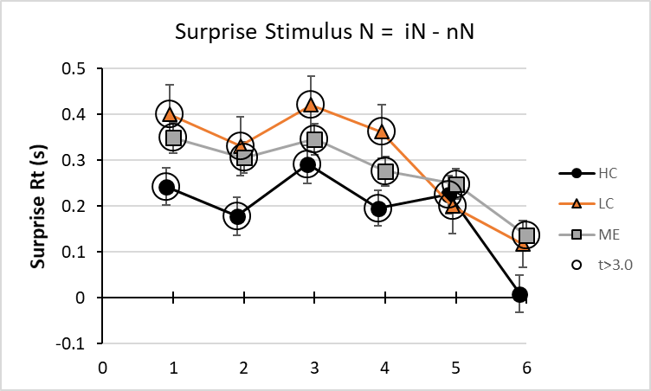
group | Comparison | bin | HC | LC | ME | t>3.0 | SEM | t
HC | iN+cN-nN-nN | 0.9 | 0.106286 |  |  |  | 0.056186 | 1.891682
HC | iN+cN-nN-nN | 1.9 | 0.167318 |  |  | 0.167318 | 0.048025 | 3.483956
HC | iN+cN-nN-nN | 2.9 | 0.627143 |  |  | 0.627143 | 0.050899 | 12.3213
HC | iN+cN-nN-nN | 3.9 | 0.356932 |  |  | 0.356932 | 0.051399 | 6.944351
HC | iN+cN-nN-nN | 4.9 | 0.435822 |  |  | 0.435822 | 0.052455 | 8.308533
HC | iN+cN-nN-nN | 5.9 | -0.20057 |  |  | -0.20057 | 0.059072 | -3.39532
LC | iN+cN-nN-nN | 0.95 |  | 0.433481 |  | 0.433481 | 0.083033 | 5.220612
LC | iN+cN-nN-nN | 1.95 |  | 0.282556 |  | 0.282556 | 0.067739 | 4.171261
LC | iN+cN-nN-nN | 2.95 |  | 0.878902 |  | 0.878902 | 0.075171 | 11.69206
LC | iN+cN-nN-nN | 3.95 |  | 0.457946 |  | 0.457946 | 0.080742 | 5.671728
LC | iN+cN-nN-nN | 4.95 |  | 0.50459 |  | 0.50459 | 0.076515 | 6.594696
LC | iN+cN-nN-nN | 5.95 |  | 0.323546 |  | 0.323546 | 0.075213 | 4.301722
ME | iN+cN-nN-nN | 1 |  |  | 0.297784 | 0.297784 | 0.044361 | 6.712671
ME | iN+cN-nN-nN | 2 |  |  | 0.273145 | 0.273145 | 0.039886 | 6.848098
ME | iN+cN-nN-nN | 3 |  |  | 0.761139 | 0.761139 | 0.042033 | 18.10808
ME | iN+cN-nN-nN | 4 |  |  | 0.441459 | 0.441459 | 0.042101 | 10.48582
ME | iN+cN-nN-nN | 5 |  |  | 0.541268 | 0.541268 | 0.042861 | 12.6284
ME | iN+cN-nN-nN | 6 |  |  | 0.352382 | 0.352382 | 0.048826 | 7.217144
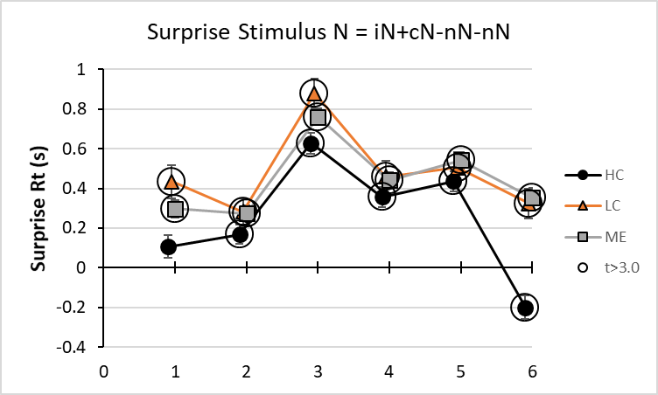
group | Comparison | bin | HC | LC | ME | t>3.0 | SEM | t
HC | iN+iC-iI-iI | 0.9 | -0.10611 |  |  |  | 0.055339 | -1.9175
HC | iN+iC-iI-iI | 1.9 | -0.28482 |  |  | -0.28482 | 0.052241 | -5.45208
HC | iN+iC-iI-iI | 2.9 | 0.159181 |  |  | 0.159181 | 0.049291 | 3.229446
HC | iN+iC-iI-iI | 3.9 | 0.051285 |  |  |  | 0.053869 | 0.952042
HC | iN+iC-iI-iI | 4.9 | 0.044113 |  |  |  | 0.053307 | 0.827521
HC | iN+iC-iI-iI | 5.9 | 0.29195 |  |  | 0.29195 | 0.05516 | 5.292798
LC | iN+iC-iI-iI | 0.95 |  | -0.18268 |  |  | 0.087457 | -2.0888
LC | iN+iC-iI-iI | 1.95 |  | -0.1108 |  |  | 0.076072 | -1.45647
LC | iN+iC-iI-iI | 2.95 |  | 0.231416 |  | 0.231416 | 0.070668 | 3.274696
LC | iN+iC-iI-iI | 3.95 |  | -0.02067 |  |  | 0.080871 | -0.25559
LC | iN+iC-iI-iI | 4.95 |  | 0.309893 |  | 0.309893 | 0.074981 | 4.132947
LC | iN+iC-iI-iI | 5.95 |  | 0.370081 |  | 0.370081 | 0.070747 | 5.231021
ME | iN+iC-iI-iI | 1 |  |  | -0.0838 |  | 0.043204 | -1.93965
ME | iN+iC-iI-iI | 2 |  |  | -0.34971 | -0.34971 | 0.044313 | -7.89185
ME | iN+iC-iI-iI | 3 |  |  | 0.225381 | 0.225381 | 0.040473 | 5.568632
ME | iN+iC-iI-iI | 4 |  |  | 0.084432 |  | 0.044182 | 1.911016
ME | iN+iC-iI-iI | 5 |  |  | 0.041718 |  | 0.04236 | 0.984837
ME | iN+iC-iI-iI | 6 |  |  | 0.270074 | 0.270074 | 0.045407 | 5.947896
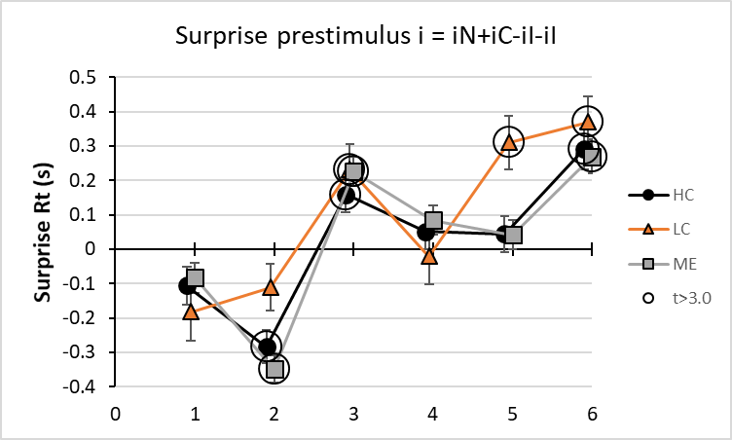
group | Comparison | bin | HC | LC | ME | t>3.0 | SEM | t
HC | nC - cC | 0.9 | -0.01676 |  |  |  | 0.067504 | -0.24827
HC | nC - cC | 1.9 | -0.13576 |  |  |  | 0.053048 | -2.55917
HC | nC - cC | 2.9 | -0.08378 |  |  |  | 0.05175 | -1.61903
HC | nC - cC | 3.9 | -0.16428 |  |  |  | 0.061009 | -2.69266
HC | nC - cC | 4.9 | -0.21811 |  |  | -0.21811 | 0.055161 | -3.95403
HC | nC - cC | 5.9 | -0.16347 |  |  |  | 0.06414 | -2.54868
LC | nC - cC | 0.95 |  | -0.28521 |  |  | 0.095302 | -2.99272
LC | nC - cC | 1.95 |  | -0.09041 |  |  | 0.07301 | -1.23836
LC | nC - cC | 2.95 |  | -0.26979 |  | -0.26979 | 0.070386 | -3.83304
LC | nC - cC | 3.95 |  | -0.05915 |  |  | 0.098328 | -0.60153
LC | nC - cC | 4.95 |  | -0.21179 |  |  | 0.075513 | -2.8047
LC | nC - cC | 5.95 |  | -0.24115 |  |  | 0.081998 | -2.94091
ME | nC - cC | 1 |  |  | -0.13059 |  | 0.050191 | -2.60183
ME | nC - cC | 2 |  |  | -0.16131 | -0.16131 | 0.045249 | -3.56501
ME | nC - cC | 3 |  |  | -0.15824 | -0.15824 | 0.04382 | -3.61112
ME | nC - cC | 4 |  |  | -0.1313 |  | 0.051377 | -2.5557
ME | nC - cC | 5 |  |  | -0.18972 | -0.18972 | 0.045793 | -4.14291
ME | nC - cC | 6 |  |  | -0.22605 | -0.22605 | 0.052985 | -4.2662
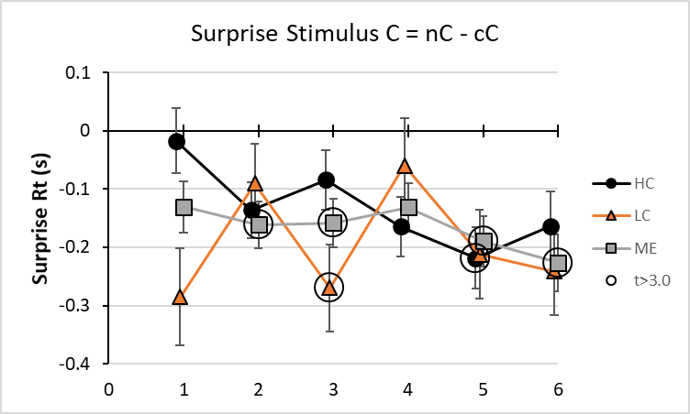
group | Comparison | bin | HC | LC | ME | t>3.0 | SEM | t
HC | nC+iC-cC-cC | 0.9 | 0.370122 |  |  | 0.370122 | 0.055978 | 6.611915
HC | nC+iC-cC-cC | 1.9 | 0.239099 |  |  | 0.239099 | 0.054134 | 4.416753
HC | nC+iC-cC-cC | 2.9 | 0.021368 |  |  |  | 0.057293 | 0.372967
HC | nC+iC-cC-cC | 3.9 | -0.12351 |  |  |  | 0.052746 | -2.34165
HC | nC+iC-cC-cC | 4.9 | -0.13859 |  |  |  | 0.060341 | -2.29677
HC | nC+iC-cC-cC | 5.9 | 0.229493 |  |  | 0.229493 | 0.059133 | 3.88096
LC | nC+iC-cC-cC | 0.95 |  | 0.042397 |  |  | 0.088468 | 0.47924
LC | nC+iC-cC-cC | 1.95 |  | 0.695137 |  | 0.695137 | 0.083057 | 8.369366
LC | nC+iC-cC-cC | 2.95 |  | -0.55857 |  | -0.55857 | 0.095535 | -5.84673
LC | nC+iC-cC-cC | 3.95 |  | 0.227524 |  |  | 0.079778 | 2.851968
LC | nC+iC-cC-cC | 4.95 |  | -0.4493 |  | -0.4493 | 0.095676 | -4.69605
LC | nC+iC-cC-cC | 5.95 |  | -0.07289 |  |  | 0.074753 | -0.97505
ME | nC+iC-cC-cC | 1 |  |  | 0.205655 | 0.205655 | 0.045336 | 4.536217
ME | nC+iC-cC-cC | 2 |  |  | 0.297214 | 0.297214 | 0.043111 | 6.894144
ME | nC+iC-cC-cC | 3 |  |  | -0.16836 | -0.16836 | 0.045898 | -3.668
ME | nC+iC-cC-cC | 4 |  |  | -0.00292 |  | 0.042433 | -0.06882
ME | nC+iC-cC-cC | 5 |  |  | 0.00526 |  | 0.047413 | 0.110933
ME | nC+iC-cC-cC | 6 |  |  | -0.14884 | -0.14884 | 0.048044 | -3.09802
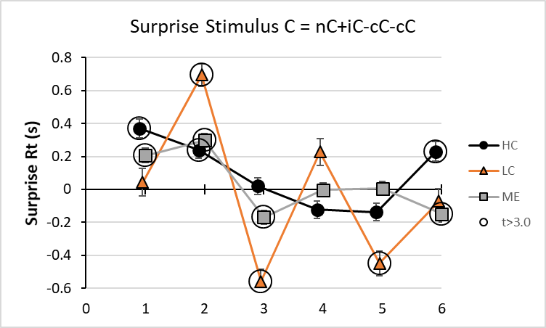
group | Comparison | bin | HC | LC | ME | t>3.0 | SEM | t
HC | nI - iI | 0.9 | -0.24264 |  |  | -0.24264 | 0.056388 | -4.30315
HC | nI - iI | 1.9 | -0.17816 |  |  |  | 0.060912 | -2.92483
HC | nI - iI | 2.9 | -0.29167 |  |  | -0.29167 | 0.05753 | -5.06992
HC | nI - iI | 3.9 | -0.19561 |  |  | -0.19561 | 0.05782 | -3.38307
HC | nI - iI | 4.9 | -0.22564 |  |  | -0.22564 | 0.058514 | -3.85622
HC | nI - iI | 5.9 | -0.00875 |  |  |  | 0.060881 | -0.14367
LC | nI - iI | 0.95 |  | -0.40045 |  | -0.40045 | 0.091927 | -4.35622
LC | nI - iI | 1.95 |  | -0.3311 |  | -0.3311 | 0.085896 | -3.85463
LC | nI - iI | 2.95 |  | -0.42091 |  | -0.42091 | 0.080543 | -5.22588
LC | nI - iI | 3.95 |  | -0.36234 |  | -0.36234 | 0.08662 | -4.18306
LC | nI - iI | 4.95 |  | -0.19987 |  |  | 0.07867 | -2.54061
LC | nI - iI | 5.95 |  | -0.11726 |  |  | 0.079016 | -1.48405
ME | nI - iI | 1 |  |  | -0.34906 | -0.34906 | 0.045612 | -7.65278
ME | nI - iI | 2 |  |  | -0.30579 | -0.30579 | 0.054812 | -5.57884
ME | nI - iI | 3 |  |  | -0.3459 | -0.3459 | 0.045758 | -7.55929
ME | nI - iI | 4 |  |  | -0.27642 | -0.27642 | 0.047468 | -5.82331
ME | nI - iI | 5 |  |  | -0.24854 | -0.24854 | 0.04565 | -5.4445
ME | nI - iI | 6 |  |  | -0.13613 |  | 0.051045 | -2.66688
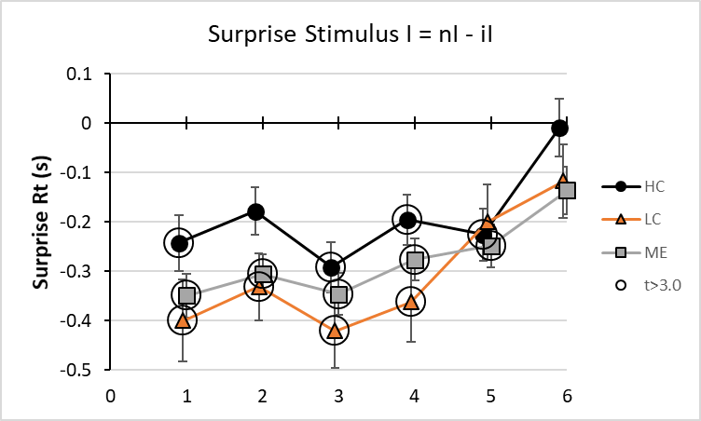
group | Comparison | bin | HC | LC | ME | t>3.0 | SEM | t
HC | nI+cI-iI-iI | 0.9 | -0.45632 |  |  | -0.45632 | 0.055339 | -8.24588
HC | nI+cI-iI-iI | 1.9 | -0.38391 |  |  | -0.38391 | 0.052241 | -7.34879
HC | nI+cI-iI-iI | 2.9 | -0.45177 |  |  | -0.45177 | 0.049291 | -9.16541
HC | nI+cI-iI-iI | 3.9 | -0.30851 |  |  | -0.30851 | 0.053869 | -5.72703
HC | nI+cI-iI-iI | 4.9 | -0.35253 |  |  | -0.35253 | 0.053307 | -6.6132
HC | nI+cI-iI-iI | 5.9 | -0.19193 |  |  | -0.19193 | 0.05516 | -3.4795
LC | nI+cI-iI-iI | 0.95 |  | -0.62161 |  | -0.62161 | 0.087457 | -7.10762
LC | nI+cI-iI-iI | 1.95 |  | -0.60443 |  | -0.60443 | 0.076072 | -7.94551
LC | nI+cI-iI-iI | 2.95 |  | -0.5707 |  | -0.5707 | 0.070668 | -8.07576
LC | nI+cI-iI-iI | 3.95 |  | -0.82164 |  | -0.82164 | 0.080871 | -10.1599
LC | nI+cI-iI-iI | 4.95 |  | -0.21348 |  |  | 0.074981 | -2.8471
LC | nI+cI-iI-iI | 5.95 |  | -0.14033 |  |  | 0.070747 | -1.9836
ME | nI+cI-iI-iI | 1 |  |  | -0.50487 | -0.50487 | 0.043204 | -11.6856
ME | nI+cI-iI-iI | 2 |  |  | -0.57071 | -0.57071 | 0.044313 | -12.8792
ME | nI+cI-iI-iI | 3 |  |  | -0.46663 | -0.46663 | 0.040473 | -11.5293
ME | nI+cI-iI-iI | 4 |  |  | -0.45876 | -0.45876 | 0.044182 | -10.3835
ME | nI+cI-iI-iI | 5 |  |  | -0.40772 | -0.40772 | 0.04236 | -9.62494
ME | nI+cI-iI-iI | 6 |  |  | -0.11792 |  | 0.045407 | -2.5969
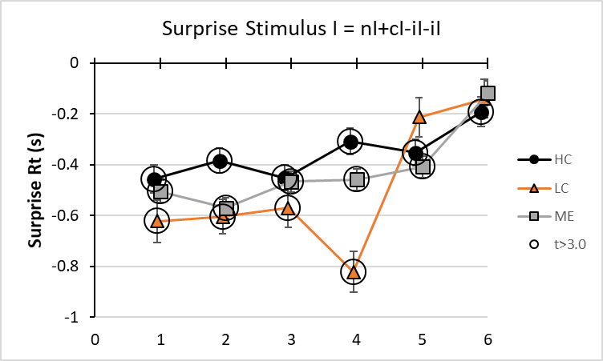
group | Comparison | bin | HC | LC | ME | t>3.0 | SEM | t
HC | nI+nC-nN-nN | 0.9 | 0.058169 |  |  |  | 0.056186 | 1.035292
HC | nI+nC-nN-nN | 1.9 | -0.05074 |  |  |  | 0.048025 | -1.05644
HC | nI+nC-nN-nN | 2.9 | 0.202495 |  |  | 0.202495 | 0.050899 | 3.978354
HC | nI+nC-nN-nN | 3.9 | 0.295389 |  |  | 0.295389 | 0.051399 | 5.747007
HC | nI+nC-nN-nN | 4.9 | 0.212929 |  |  | 0.212929 | 0.052455 | 4.05929
HC | nI+nC-nN-nN | 5.9 | -0.4645 |  |  | -0.4645 | 0.059072 | -7.86331
LC | nI+nC-nN-nN | 0.95 |  | 0.292015 |  | 0.292015 | 0.083033 | 3.51687
LC | nI+nC-nN-nN | 1.95 |  | 0.187797 |  |  | 0.067739 | 2.772373
LC | nI+nC-nN-nN | 2.95 |  | 0.272808 |  | 0.272808 | 0.075171 | 3.629168
LC | nI+nC-nN-nN | 3.95 |  | 0.36269 |  | 0.36269 | 0.080742 | 4.49197
LC | nI+nC-nN-nN | 4.95 |  | 0.17709 |  |  | 0.076515 | 2.314458
LC | nI+nC-nN-nN | 5.95 |  | 0.074672 |  |  | 0.075213 | 0.992799
ME | nI+nC-nN-nN | 1 |  |  | 0.100849 |  | 0.044361 | 2.273351
ME | nI+nC-nN-nN | 2 |  |  | 0.041197 |  | 0.039886 | 1.032857
ME | nI+nC-nN-nN | 3 |  |  | 0.233412 | 0.233412 | 0.042033 | 5.553044
ME | nI+nC-nN-nN | 4 |  |  | 0.310057 | 0.310057 | 0.042101 | 7.364661
ME | nI+nC-nN-nN | 5 |  |  | 0.197332 | 0.197332 | 0.042861 | 4.603976
ME | nI+nC-nN-nN | 6 |  |  | 0.095547 |  | 0.048826 | 1.956908
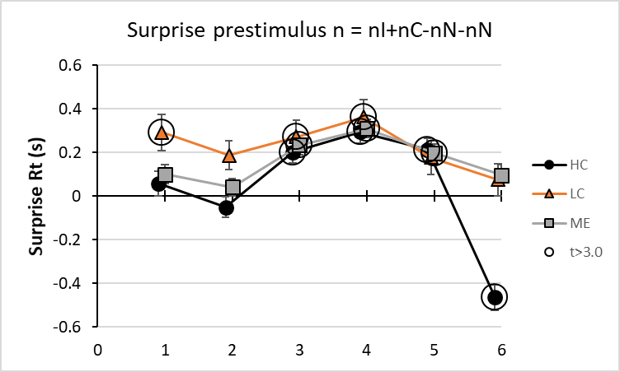
End SOM Table S14.

SOM Table S9. Coordinates for Figures 6, 7 and 8. Log log time series for HC, LC and ME.
prestimulus | Stimulus | Bin | HC log Mean | HC log SD | HC N | LC log Mean | LC log SD | LC N | ME log Mean | ME log SD | ME N
c | C | 1 | 0.1398 | 0.16089 | 67 | 0.3249 | 0.16346 | 27 | 0.2194 | 0.19498 | 119
c | C | 2 | 0.0406 | 0.15577 | 111 | 0.1325 | 0.16298 | 53 | 0.0941 | 0.1645 | 205
c | C | 3 | 0.1276 | 0.1361 | 50 | 0.3029 | 0.11447 | 2 | 0.2078 | 0.18055 | 89
c | C | 4 | 0.1353 | 0.16137 | 83 | 0.1834 | 0.16543 | 53 | 0.1768 | 0.18901 | 157
c | C | 5 | 0.1392 | 0.1493 | 39 | 0.2608 | 0.11565 | 6 | 0.1476 | 0.16535 | 95
c | C | 6 | 0.0837 | 0.13868 | 67 | 0.1847 | 0.15503 | 34 | 0.1829 | 0.19 | 105
c | I | 1 | 0.187 | 0.15019 | 68 | 0.3405 | 0.19873 | 21 | 0.2597 | 0.17364 | 111
c | I | 2 | 0.1223 | 0.15374 | 40 | 0.2519 | 0.22816 | 8 | 0.175 | 0.23752 | 81
c | I | 3 | 0.059 | 0.15778 | 94 | 0.1334 | 0.14793 | 38 | 0.1095 | 0.18282 | 179
c | I | 4 | 0.0413 | 0.15547 | 76 | 0.0485 | 0.12235 | 21 | 0.0929 | 0.18214 | 133
c | I | 5 | 0.0708 | 0.13383 | 70 | 0.129 | 0.15994 | 32 | 0.1067 | 0.17766 | 135
c | I | 6 | 0.082 | 0.16249 | 129 | 0.1244 | 0.14199 | 84 | 0.1332 | 0.19782 | 239
c | N | 1 | 0.1254 | 0.1441 | 112 | 0.2565 | 0.17939 | 56 | 0.1789 | 0.22909 | 205
c | N | 2 | 0.1045 | 0.13904 | 75 | 0.1554 | 0.12543 | 33 | 0.126 | 0.17526 | 136
c | N | 3 | 0.1539 | 0.11322 | 31 | 0.2409 | 0.04672 | 4 | 0.2028 | 0.15711 | 60
c | N | 4 | 0.052 | 0.1576 | 119 | 0.1389 | 0.15337 | 52 | 0.1132 | 0.17422 | 210
c | N | 5 | 0.0878 | 0.14871 | 81 | 0.1863 | 0.16904 | 38 | 0.1606 | 0.18805 | 151
c | N | 6 | 0.0734 | 0.19469 | 50 | 0.1337 | 0.18302 | 36 | 0.1354 | 0.21579 | 90
i | C | 1 | 0.2203 | 0.15103 | 124 | 0.3784 | 0.18268 | 58 | 0.2797 | 0.17747 | 220
i | C | 2 | 0.122 | 0.11476 | 29 | 0.3195 | 0.11554 | 4 | 0.1788 | 0.17029 | 57
i | C | 3 | 0.1714 | 0.16121 | 64 | 0.2326 | 0.14521 | 23 | 0.2109 | 0.19574 | 118
i | C | 4 | 0.13 | 0.13448 | 77 | 0.2163 | 0.12369 | 36 | 0.1957 | 0.17098 | 148
i | C | 5 | 0.1553 | 0.17805 | 71 | 0.2143 | 0.14398 | 40 | 0.1945 | 0.20439 | 151
i | C | 6 | 0.1819 | 0.15812 | 66 | 0.2359 | 0.15346 | 35 | 0.2069 | 0.17952 | 118
i | I | 1 | 0.2259 | 0.16797 | 80 | 0.3547 | 0.14864 | 22 | 0.2788 | 0.19753 | 154
i | I | 2 | 0.1707 | 0.14266 | 90 | 0.2743 | 0.14037 | 39 | 0.2319 | 0.21233 | 165
i | I | 3 | 0.1375 | 0.14845 | 125 | 0.2325 | 0.15427 | 70 | 0.1889 | 0.18794 | 226
i | I | 4 | 0.1191 | 0.15123 | 91 | 0.2313 | 0.11928 | 38 | 0.1812 | 0.19819 | 155
i | I | 5 | 0.1298 | 0.14387 | 85 | 0.1701 | 0.14005 | 36 | 0.1783 | 0.185 | 157
i | I | 6 | 0.1132 | 0.14928 | 72 | 0.1513 | 0.13631 | 44 | 0.1522 | 0.17757 | 132
i | N | 1 | 0.2032 | 0.15517 | 72 | 0.2804 | 0.1332 | 34 | 0.2603 | 0.17083 | 147
i | N | 2 | 0.1269 | 0.14526 | 119 | 0.2311 | 0.1511 | 58 | 0.1835 | 0.18913 | 210
i | N | 3 | 0.1598 | 0.16034 | 139 | 0.2585 | 0.13677 | 74 | 0.2315 | 0.24218 | 266
i | N | 4 | 0.1206 | 0.1244 | 89 | 0.2132 | 0.14568 | 40 | 0.1879 | 0.18067 | 153
i | N | 5 | 0.1125 | 0.15527 | 130 | 0.2018 | 0.14553 | 74 | 0.184 | 0.18438 | 235
i | N | 6 | 0.1408 | 0.1481 | 150 | 0.2034 | 0.14042 | 93 | 0.2017 | 0.18308 | 268
n | C | 1 | 0.1802 | 0.13959 | 82 | 0.2794 | 0.16378 | 35 | 0.217 | 0.17025 | 136
n | C | 2 | 0.0622 | 0.13161 | 84 | 0.1842 | 0.17047 | 36 | 0.1181 | 0.16067 | 156
n | C | 3 | 0.1049 | 0.14037 | 64 | 0.201 | 0.14494 | 21 | 0.1526 | 0.14478 | 121
n | C | 4 | 0.0705 | 0.13018 | 118 | 0.1918 | 0.14234 | 40 | 0.1395 | 0.15933 | 193
n | C | 5 | 0.0588 | 0.1266 | 68 | 0.1582 | 0.12765 | 23 | 0.1026 | 0.15474 | 126
n | C | 6 | 0.0381 | 0.1349 | 121 | 0.0907 | 0.14776 | 89 | 0.0954 | 0.16073 | 217
n | I | 1 | 0.1364 | 0.12611 | 123 | 0.2222 | 0.1657 | 59 | 0.1719 | 0.19019 | 238
n | I | 2 | 0.0932 | 0.13755 | 107 | 0.1789 | 0.12103 | 67 | 0.1199 | 0.26131 | 198
n | I | 3 | 0.069 | 0.1312 | 103 | 0.1336 | 0.12779 | 57 | 0.1305 | 0.16823 | 195
n | I | 4 | 0.0826 | 0.12359 | 91 | 0.1336 | 0.12961 | 44 | 0.1235 | 0.15028 | 163
n | I | 5 | 0.0614 | 0.14853 | 135 | 0.1336 | 0.1344 | 84 | 0.135 | 0.1713 | 250
n | I | 6 | 0.0833 | 0.12194 | 89 | 0.1693 | 0.16202 | 54 | 0.1627 | 0.21607 | 157
End of SOM Table S15.

