Supplementary materials
S1. Information of the mental health and psychological measures 2
S2. Parallel Analysis Scree Plots for five loneliness scales. 8
S3. Associations between total scores of various forms of UCLA loneliness scale with mental well-being and psychosocial qualities. 9

S1. Information of the mental health and psychological measures

Patient Health Questionnaire-9 (PHQ-9)
The PHQ-9 is a 9-item depression screening tool with high internal consistency (α = 0.86 – 0.89) [1]. The Chinese version has also demonstrated good reliability (α = 0.85) among undergraduates [2]. Based on the clinical diagnosis of major depressive disorder, the pooled sensitivity (ranging from 0.82 to 0.89) and specificity (0.83 to 0.89) results reveal no significant differences in the diagnostic properties of the PHQ-9 for cut-off scores between 8 and 11 [3]. We adopted a cut-off score of ≥10 to indicate probable depression, as it is a more commonly used threshold. In the current study, the scale exhibited a McDonald's ω_{t} of 0.91.

Generalised Anxiety Disorder-7 (GAD-7)
The GAD-7 is a 7-item anxiety screening questionnaire [4]. The original GAD-7 demonstrated high sensitivity (89%) and specificity (82%) using a cutoff score of ≥10 [4]. The Chinese version also showed good reliability (α = 0.84 – 0.92) and an optimal cutoff of ≥7, maximised sensitivity (79%) and specificity (81%) in Chinese adolescents when compared to diagnostic interviews [5,6]. In the current study, the scale demonstrated a McDonald’s ω_{t} of 0.95, and we adopted a cutoff of ≥7 to indicate probable anxiety.

Liebowitz Social Anxiety Scale (LSAS)
The LSAS is a 24-item measure designed to assess fear and avoidance of social situations [7]. This scale exhibits excellent internal consistency (α = 0.91) and demonstrates convergent and discriminant validity through significant correlations with other social anxiety measures, such as the Social Phobia Anxiety Inventory (r = 0.48 – 0.83) [8]. In the current study, the scale displayed a McDonald’s ωt of 0.97. We adopted a cutoff of ≥50 to indicate a moderate social anxiety condition, as recommended by Liebowitz and Liebowitz [9].

Young Mania Rating Scale (YMRS)
The YMRS is an 11-item scale designed to assess manic symptoms [10]. The original study reported high interrater reliability for the total score (r = 0.93) and acceptable reliability for individual items (r = 0.66 – 0.92). Concurrent validity was established through significant correlations between the YMRS and other mania scales (r = 0.71 – 0.88). Additionally, the YMRS total score correlated significantly with clinicians’ global ratings of mania severity (r = 0.89). In the current study, the scale exhibited a McDonald’s ω_{t} of 0.92. We adopted a cutoff of ≥25 to indicate a probable manic condition, as suggested by Lukasiewicz et al. [11].

Kessler Psychological Distress Scale 6-item scale (K6)
The K6 is a 6-item measure designed to assess general psychological distress [12]. The original validation study found high internal consistency (α = 0.84) and a one-factor structure [13]. A Chinese version demonstrated adequate test-retest reliability (r = 0.79) and internal consistency (α = 0.84) [14]. Using CIDI diagnoses, an optimal cutoff of ≥13 exhibited good specificity (96%) and a classification accuracy (92%) for detecting serious mental illness [15]. In the current study, the scale displayed a McDonald's ω_{t} of 0.94, and we adopted a cutoff of ≥13 to indicate a condition of severe mental distress.

Prodromal Questionnaire - Brief Version (PQ-B) scale
The PQ-B is a 21-item questionnaire designed to evaluate psychosis risk by assessing the presence of 21 positive symptoms experienced in the past month (1 = yes and 0 = no) and rating the distress associated with each symptom on a 5-point scale (1 = Strongly disagree to 5 = Strongly agree) [16]. The Chinese version demonstrated adequate internal consistency (α = 0.76) and test-retest reliability (r = 0.82) in a clinical sample [17]. Using Structured Interview for Prodromal Syndromes (SIPS) diagnoses, optimal cutoffs were identified as ≥7 for the item score (80% sensitivity) and ≥24 for the distress score (82% sensitivity) in Chinese outpatients [17]. In the current study, the item and distress scales exhibited McDonald’s ω_{t} values of 0.85 and 0.87, respectively. We also adopted a cutoff of ≥7 for the item score or ≥24 for the distress scores to indicate a probable clinical high risk for psychosis condition.

Short-Form Health Survey 12-item (SF-12)
The SF-12 is a 12-item short form of the SF-36, designed to measure health status as an indicator of quality of life [18]. Items are transformed into an index score ranging from 0 (the worst) to 1 (the best). In the current study, the scale exhibited a McDonald's ωt of 0.72. We adopted a median cutoff of ≤0.79 to indicate a condition of poorer quality of life.

Epworth Sleepiness Scale (ESS)
The ESS is an 8-item questionnaire designed to measure daytime sleepiness, exhibiting good internal consistency (α = 0.82) [19] and significant correlations with sleep latency measures [20].The Chinese version also demonstrated good internal consistency (α = 0.81), test-retest reliability (r = 0.74), and a significant correlation with respiratory disturbance (r = 0.22)[21]. In the current study, the scale displayed a McDonald's ω_{t} of 0.84. We adopted a cutoff of ≥10 to indicate daytime sleepiness at a potential clinical level [22].

Full day productivity loss
The full-day productivity loss associated with depressive or anxiety symptoms was evaluated using a single item from the K6 scale [12]. This item inquires about the number of days in the past 30 when participants were completely unable to work or carry out their normal activities due to the experience of depressive or anxiety symptoms. Respondents are asked to provide the number of days that meet this criterion. In the current study, due to the highly right-skewed data distribution, we adopted a cutoff of ≥1 day to indicate a condition of compromised functioning.

Schizotypal Personality Questionnaire Brief (SPQ‑B)
The Schizotypal Personality Questionnaire-Brief (SPQ-B) is a 22-item self-report scale designed to screen for schizotypal personality traits [23]. The Chinese version (CSPQ-B) displayed good internal consistency (α = 0.76) and test-retest reliability (ICC = 0.82) [24]. In the current study, the scale exhibited a McDonald's ωt of 0.87. We adopted a cutoff of ≥17 to indicate high schizotypy, as suggested by Raine [25] and Raine and Benishay [23].

Beck Hopelessness Scale (BHS)
The BHS utilises a 5-point scale to assess pessimism and has exhibited good reliability and validity [26,27]. The Chinese version also demonstrates good internal consistency (α = 0.85), test-retest reliability (r = 0.80), and a 2-factor structure consisting of negative expectation and loss of motivation, which are associated with depression, suicidal ideation, and emotional discomfort [28]. In the current study, the scale displayed a McDonald's ω_{t} of 0.85. We adopted a cutoff of ≥9 to indicate moderate hopelessness [29].

Buss-Perry Aggression Questionnaire (BPAQ)
The BPAQ evaluates four aspects of aggression: physical, verbal, anger, and hostility, demonstrating good internal consistency (α = 0.72 – 0.85) and test-retest reliability (r = 0.72 – 0.80) [30]. Criterion validity was established through correlations with peer nominations of aggression (r = 0.20 – 0.45). The Chinese version also exhibited adequate internal consistency (α = 0.56 – 0.74) and convergent validity with anger rumination (r = 0.16 – 0.39), while confirmatory factor analysis supported the four-factor structure [31]. In the current study, the scale displayed a McDonald's ω_{t} of 0.90. We adopted a median cutoff of ≥19 to indicate moderate aggression.

Barratt Impulsiveness Scale Version 11 (BIS-11)
The original BIS-11 is a 30-item questionnaire designed to assess impulsiveness across three components: attentional, motor, and non-planning [32]. The BIS-11 has demonstrated good internal consistency (α = 0.82) and test-retest reliability (r = 0.83) in American samples [33]. Similarly, the Chinese version exhibits good internal consistency (α = 0.80) and test-retest reliability (r = 0.70) [34]. In the current study, the scale displayed a McDonald’s ω_{t} of 0.74. We adopted a cut-off of ≥72 to indicate a highly impulsive condition, as suggested by Stanford et al. [35].

Brief Family Relationship Scale (BFRS)
The BFRS is a 16-item version of the Relationship dimension of the Family Environment Scale, evaluating family cohesion, expressiveness, and conflict [36]. The three subscales exhibit adequate internal consistency (α = 0.65 – 0.83) and test-retest reliability over three weeks (r = 0.68 – 0.86). Criterion validity has been demonstrated through correlations with measures of communal mastery, reasons for living, and community protective factors (r = 0.44 – 0.51)[36]. In the original scale, a higher BFRS score reflects a better relationship among family members. However, the current study adapted reversed coding for positively-worded items so that higher scores indicate a poorer family relationship. The scale displayed a McDonald's ω_{t} of 0.93 in the current study, and we adopted a median cutoff of ≥21 to signify a poor family relationship.

Measure of Online Communication Attitudes (MOCA)
The MOCA is a 31-item questionnaire that utilises a 7-point Likert scale to assess attitudes towards online communication across five factors: self-disclosure, apprehension, miscommunication, social connection, and ease [37]. These factors display good internal consistency reliability (α = 0.83 – 0.90). In the original scale, a higher MOCA score indicates a more positive attitude towards online communication. However, the current study adapted reversed coding for positively-worded items, so that higher scores reflect a more negative attitude towards online communication. In the current study, the scale exhibited a McDonald's ω_{t} of 0.85, and we adopted a median cutoff of ≥122 to signify a negative attitude towards online communication.

Connor-Davidson Resilience Scale (CD-RISC)
The 10-item CD-RISC exhibits strong internal consistency (α = 0.89) and test-retest reliability (r = 0.87) [38]. The Chinese CD-RISC-10 displays satisfactory internal consistency among Chinese adolescents (α = 0.87 for males and 0.88 for females) and presents a unidimensional structure [39]. The scale was found to be significantly correlated with measures of loneliness (r = −0.30), depressive symptoms (r = −0.47), negative experiences (r = −0.27), optimism (r = 0.46) and many more psychological well-being factors [39]. The scale demonstrated a McDonald’s ω_{t} of 0.92 in the current study and we adopted a median cut-off of ≤23 to indicate a poor resilience.

Rosenberg Self-Esteem Scale (RSES)
The RSES is a 10-item scale designed to measure global self-esteem, exhibiting good reliability (α = 0.40) and construct validity through a one-factor structure and significant correlations with mental health indicators [40]. The Chinese version showcases adequate internal consistency (α = 0.76 – 0.85), test-retest reliability (r = 0.34 – 0.47), construct validity via a two-factor structure, and clinical validity through significant negative correlations with anxiety and depression (r = –0.25 – –0.57) [41]. In the current study, the scale achieved a McDonald's ω_{t} of 0.92, and a cut-off of ≤15 was employed to signify poor self-esteem [40].

Goal Commitment Scale (GCS)
The GCS comprises 4 items rated on a 5-point Likert scale, with higher scores reflecting greater commitment [42]. A meta-analysis supports the scale’s unidimensionality, while internal consistency has proven satisfactory (α = 0.71) [43]. In the current study, the scale achieved a McDonald's ω_{t} of 0.81, and a median cut-off of ≤28 was utilised to signify poor goal commitment.

General Procrastination Scale (GPS)
The GPS is a 9-item self-report questionnaire using a true-false response format to assess procrastinatory tendencies [44]. This scale demonstrated good internal consistency (α = .89). The scale demonstrated a McDonald’s ω_{t} of 0.89 in the current study and we adopted a median cut-off of ≥62 to indicate a high procrastination.
References
1. Kroenke K, Spitzer RL, Williams JB. The PHQ-9: validity of a brief depression severity measure. J Gen Intern Med. 2001;16: 606–613.
2. Zhang Y-L, Liang W, Chen Z-M, Zhang H-M, Zhang J-H, Weng X-Q, et al. Validity and reliability of Patient Health Questionnaire-9 and Patient Health Questionnaire-2 to screen for depression among college students in China. Asia Pac Psychiatry. 2013;5: 268–275.
3. Manea L, Gilbody S, McMillan D. Optimal cut-off score for diagnosing depression with the Patient Health Questionnaire (PHQ-9): a meta-analysis. CMAJ. 2012;184: E191–6.
4. Spitzer RL, Kroenke K, Williams JBW, Löwe B. A brief measure for assessing generalized anxiety disorder: the GAD-7. Arch Intern Med. 2006;166: 1092–1097.
5. Ip H, Suen YN, Hui CLM, Wong SMY, Chan SKW, Lee EHM, et al. Assessing anxiety among adolescents in Hong Kong: psychometric properties and validity of the Generalised Anxiety Disorder-7 (GAD-7) in an epidemiological community sample. BMC Psychiatry. 2022;22: 703.
6. Tong X, An D, McGonigal A, Park S-P, Zhou D. Validation of the Generalized Anxiety Disorder-7 (GAD-7) among Chinese people with epilepsy. Epilepsy Res. 2016;120: 31–36.
7. Liebowitz MR. Social phobia. Modern Problems in Pharmacopsychiatry, 22, 141--173. 1987.
8. Baker SL, Heinrichs N, Kim H-J, Hofmann SG. The liebowitz social anxiety scale as a self-report instrument: a preliminary psychometric analysis. Behav Res Ther. 2002;40: 701–715.
9. Liebowitz MR, Liebowitz -. Guidelines for using the Liebowitz social anxiety scale (LSAS). 2003 [cited 17 Dec 2023]. Available: https://heilbrigdisvisindastofnun.hi.is/files/2022-12/LSAS_Manual.pdf
10. Young RC, Biggs JT, Ziegler VE, Meyer DA. A rating scale for mania: reliability, validity and sensitivity. Br J Psychiatry. 1978;133: 429–435.
11. Lukasiewicz M, Gerard S, Besnard A, Falissard B, Perrin E, Sapin H, et al. Young Mania Rating Scale: how to interpret the numbers? Determination of a severity threshold and of the minimal clinically significant difference in the EMBLEM cohort. Int J Methods Psychiatr Res. 2013;22: 46–58.
12. Kessler RC, Andrews G, Colpe LJ, Hiripi E, Mroczek DK, Normand SLT, et al. Short screening scales to monitor population prevalences and trends in non-specific psychological distress. Psychol Med. 2002;32: 959–976.
13. Mewton L, Kessler RC, Slade T, Hobbs MJ, Brownhill L, Birrell L, et al. The psychometric properties of the Kessler Psychological Distress Scale (K6) in a general population sample of adolescents. Psychol Assess. 2016;28: 1232–1242.
14. Kang Y-K, Guo W-J, Xu H, Chen Y-H, Li X-J, Tan Z-P, et al. The 6-item Kessler psychological distress scale to survey serious mental illness among Chinese undergraduates: Psychometric properties and prevalence estimate. Compr Psychiatry. 2015;63: 105–112.
15. Kessler RC, Barker PR, Colpe LJ, Epstein JF, Gfroerer JC, Hiripi E, et al. Screening for serious mental illness in the general population. Arch Gen Psychiatry. 2003;60: 184–189.
16. Loewy RL, Pearson R, Vinogradov S, Bearden CE, Cannon TD. Psychosis risk screening with the Prodromal Questionnaire--brief version (PQ-B). Schizophr Res. 2011;129: 42–46.
17. Xu L, Zhang T, Zheng L, Li H, Tang Y, Luo X, et al. Psychometric Properties of Prodromal Questionnaire-Brief Version among Chinese Help-Seeking Individuals. PLoS One. 2016;11: e0148935.
18. Ware J Jr, Kosinski M, Keller SD. A 12-Item Short-Form Health Survey: construction of scales and preliminary tests of reliability and validity. Med Care. 1996;34: 220–233.
19. Gonçalves MT, Malafaia S, Moutinho Dos Santos J, Roth T, Marques DR. Epworth sleepiness scale: A meta-analytic study on the internal consistency. Sleep Med. 2023;109: 261–269.
20. Johns MW. A new method for measuring daytime sleepiness: the Epworth sleepiness scale. Sleep. 1991;14: 540–545.
21. Chen N-H, Johns MW, Li H-Y, Chu C-C, Liang S-C, Shu Y-H, et al. Validation of a Chinese version of the Epworth sleepiness scale. Qual Life Res. 2002;11: 817–821.
22. Johns MW. Sensitivity and specificity of the multiple sleep latency test (MSLT), the maintenance of wakefulness test and the epworth sleepiness scale: failure of the MSLT as a gold standard. J Sleep Res. 2000;9: 5–11.
23. Raine A, Benishay D. The SPQ-B: A Brief Screening Instrument for Schizotypal Personality Disorder. J Pers Disord. 1995;9: 346–355.
24. Ma W-F, Wu P-L, Yang S-J, Cheng K-F, Chiu H-T, Lane H-Y. Sensitivity and specificity of the Chinese version of the Schizotypal Personality Questionnaire-Brief for identifying undergraduate students susceptible to psychosis. Int J Nurs Stud. 2010;47: 1535–1544.
25. Raine A. Manual for the schizotypal personality questionnaire (SPQ and SPQ-B). Unpublished manual available from the author. 2022.
26. Beck AT, Weissman A, Lester D, Trexler L. The measurement of pessimism: the hopelessness scale. J Consult Clin Psychol. 1974;42: 861–865.
27. Steed L. Further Validity and Reliability Evidence for Beck Hopelessness Scale Scores in a Nonclinical Sample. Educ Psychol Meas. 2001;61: 303–316.
28. Kao Y-C, Liu Y-P, Lu C-W. Beck Hopelessness Scale: exploring its dimensionality in patients with schizophrenia. Psychiatr Q. 2012;83: 241–255.
29. Beck AT, Steer RA, Carbin MG. Psychometric properties of the Beck Depression Inventory: Twenty-five years of evaluation. Clin Psychol Rev. 1988;8: 77–100.
30. Buss AH, Perry M. The Aggression Questionnaire. J Pers Soc Psychol. 1992;63: 452–459.
31. Maxwell JP. Development and Preliminary Validation of a Chinese Version of the Buss–Perry Aggression Questionnaire in a Population of Hong Kong Chinese. J Pers Assess. 2007;88: 284–294.
32. Patton JH, Stanford MS, Barratt ES. Factor structure of the Barratt impulsiveness scale. J Clin Psychol. 1995;51: 768–774.
33. Vasconcelos AG, Malloy-Diniz L, Correa H. Systematic review of psychometric proprieties of Barratt impulsiveness scale version 11 (bis-11). 2012 [cited 18 Dec 2023]. Available: https://citeseerx.ist.psu.edu/document?repid=rep1&type=pdf&doi=dc5904fa916010211b0c23c7e0beba4eb365b4de
34. Yao S, Yang H, Zhu X, Auerbach RP, Abela JRZ, Pulleyblank RW, et al. An examination of the psychometric properties of the Chinese version of the Barratt Impulsiveness Scale, 11th version in a sample of Chinese adolescents. Percept Mot Skills. 2007;104: 1169–1182.
35. Stanford MS, Mathias CW, Dougherty DM, Lake SL, Anderson NE, Patton JH. Fifty years of the Barratt Impulsiveness Scale: An update and review. Pers Individ Dif. 2009;47: 385–395.
36. Fok CCT, Allen J, Henry D, People Awakening Team. The brief family relationship scale: a brief measure of the relationship dimension in family functioning. Assessment. 2014;21: 67–72.
37. Ledbetter AM. Measuring Online Communication Attitude: Instrument Development and Validation. Commun Monogr. 2009;76: 463–486.
38. Campbell-Sills L, Forde DR, Stein MB. Demographic and childhood environmental predictors of resilience in a community sample. J Psychiatr Res. 2009;43: 1007–1012.
39. She R, Yang X, Lau MMC, Lau JTF. Psychometric properties and normative data of the 10-item Connor–Davidson Resilience Scale among Chinese adolescent students in Hong Kong. Child Psychiatry Hum Dev. 2020;51: 925–933.
40. Rosenberg. Rosenberg self-esteem scale (RSE). Acceptance and commitment therapy. 1965. Available: https://integrativehealthpartners.org/downloads/ACTmeasures.pdf#page=61
41. Martin CR, Thompson DR, Chan DS. An examination of the psychometric properties of the Rosenberg Self-Esteem Scale (RSES) in Chinese acute coronary syndrome (ACS) patients. Psychol Health Med. 2006;11: 507–521.
42. Hollenbeck JR, Klein HJ, O’Leary AM, Wright PM. Investigation of the construct validity of a self-report measure of goal commitment. J Appl Psychol. 1989;74: 951–956.
43. Klein HJ, Wesson MJ, Hollenbeck JR, Wright PM, DeShon RP. The Assessment of Goal Commitment: A Measurement Model Meta-Analysis. Organ Behav Hum Decis Process. 2001;85: 32–55.
44. Sirois FM, Yang S, van Eerde W. Development and validation of the General Procrastination Scale (GPS-9): A short and reliable measure of trait procrastination. Pers Individ Dif. 2019;146: 26–33.

S2. Parallel Analysis Scree Plots for five loneliness scales.
The scree plots display the eigenvalues of the actual data as a blue line, while the simulated and resampled data are represented by two overlapping red lines. In this analysis, we examine the significant declines in the observed data and identify the exact point at which it stabilises on the right side. Additionally, we determine the point of inflection, which is the point at which the discrepancy between the simulated data and the actual data is minimised.
- UCLA-LSV3 | - ULS-3
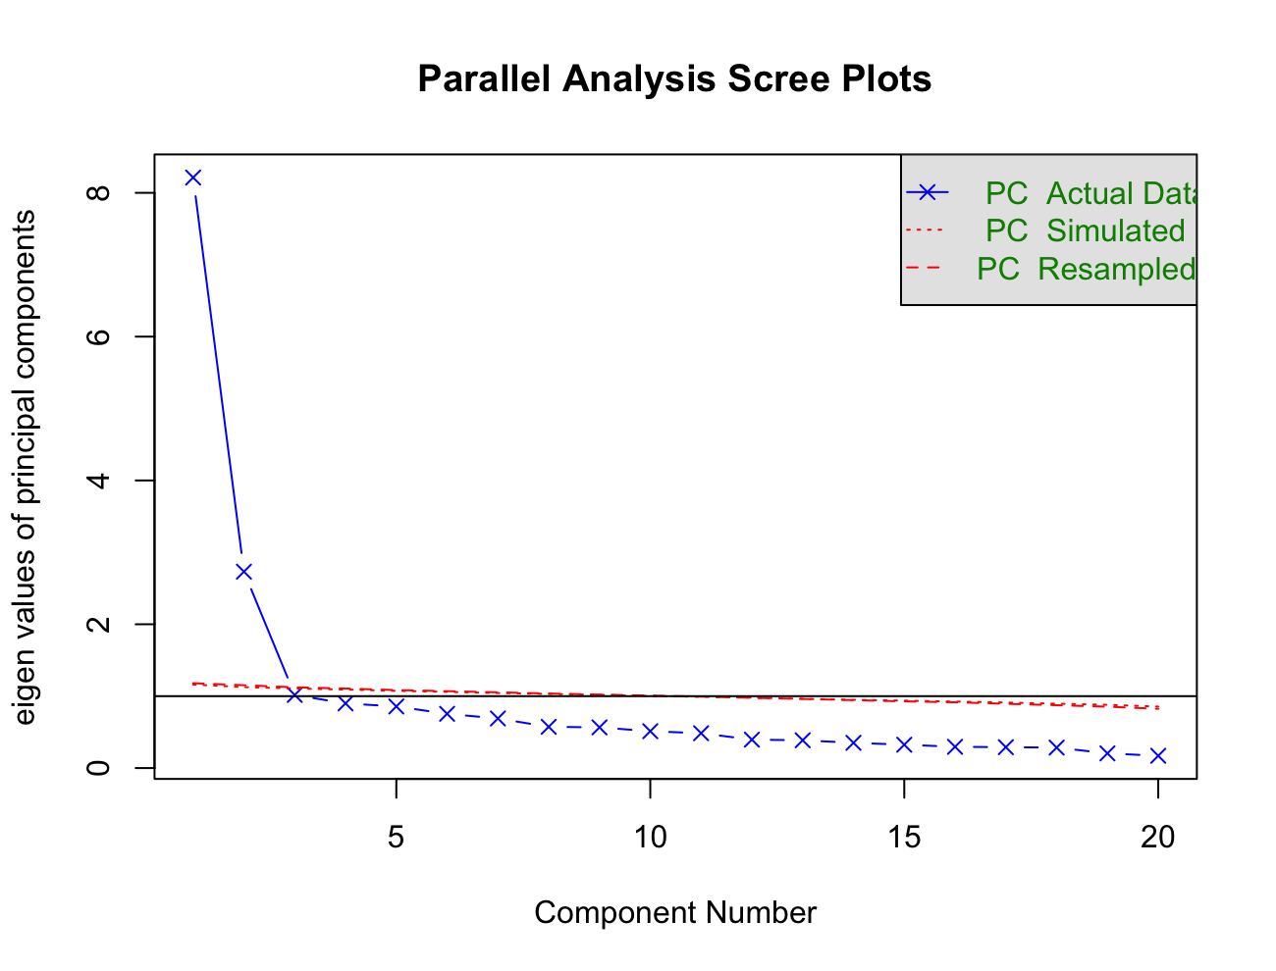 | 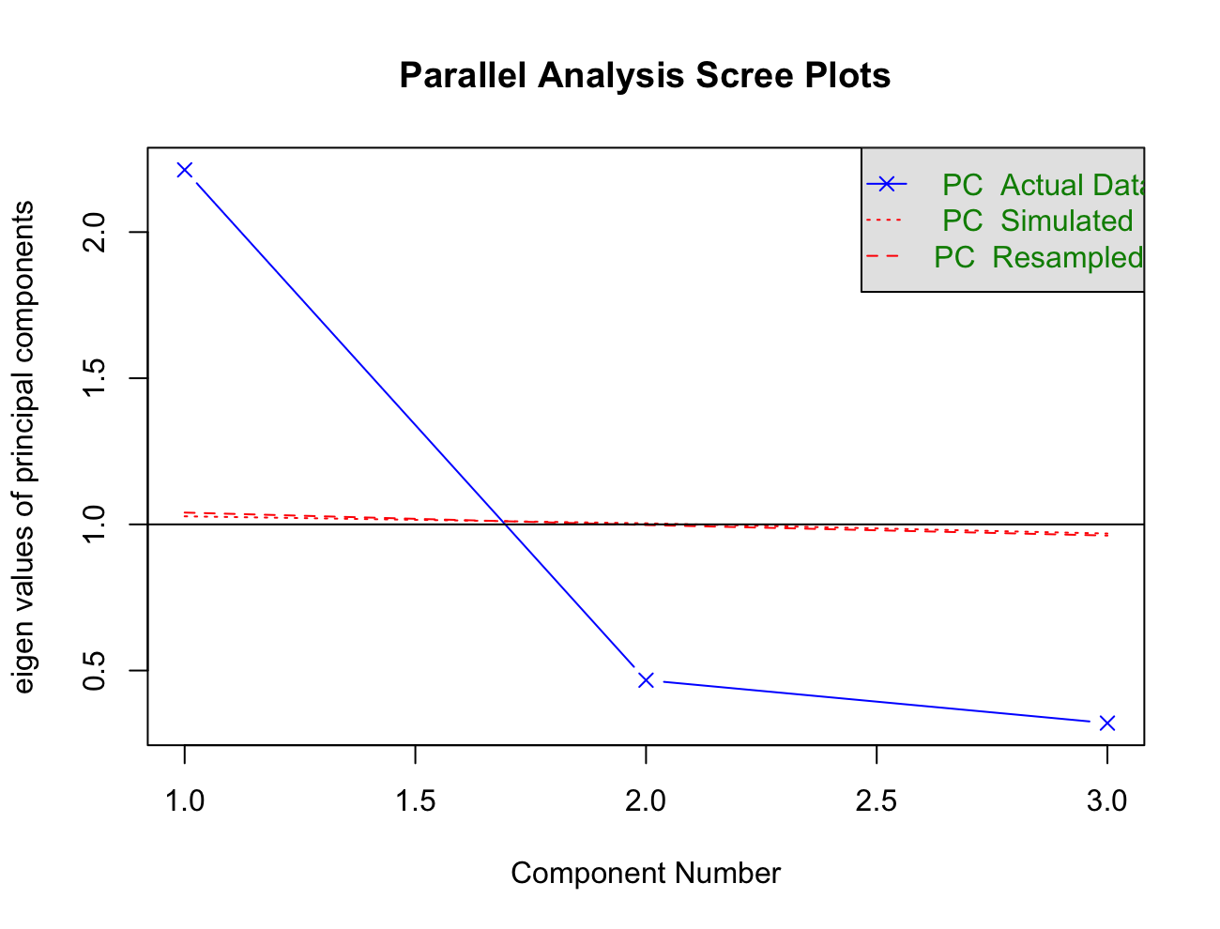
- ULS-6 | - ULS-8
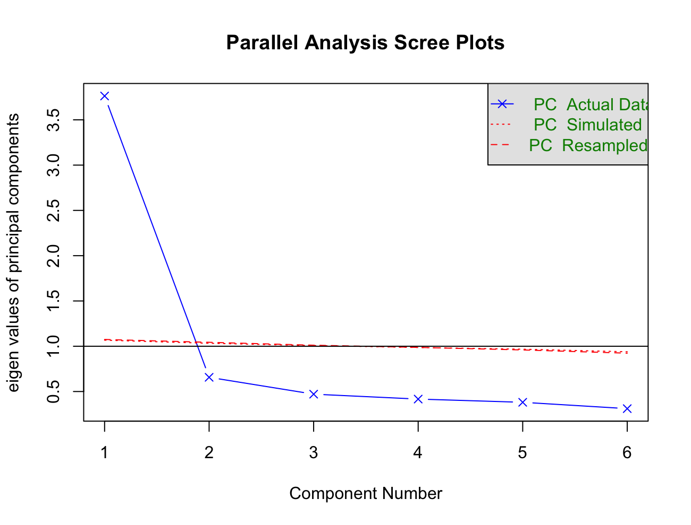 | 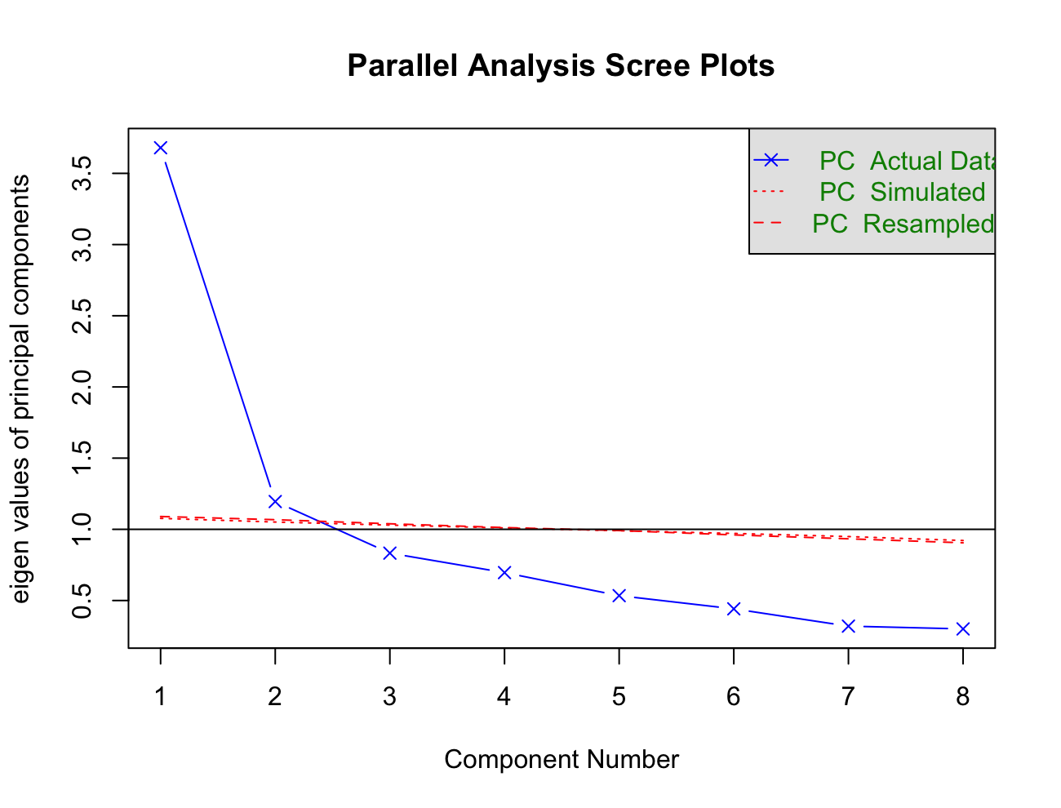
- ULS-10
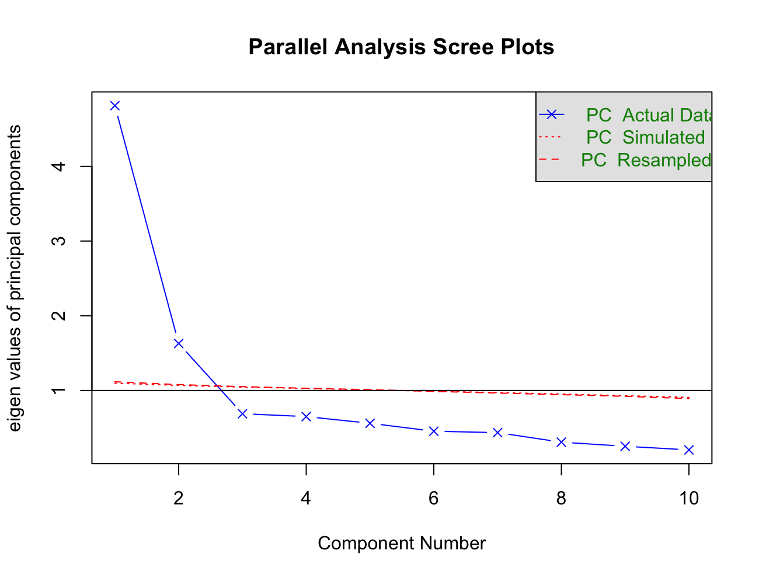

S3. Associations between total scores of various forms of UCLA loneliness scale with mental well-being and psychosocial qualities.
Dependent variables |  | Independent variable
Dependent variables |  | UCLA-LSV3 | ULS-3 | ULS-6 | ULS-8 | ULS-10
Dependent variables | N (%) | Adjusted OR (95%CI) | Adjusted OR (95%CI) | Adjusted OR (95%CI) | Adjusted OR (95%CI) | Adjusted OR (95%CI)
Mental Well-being
Probable depression | 6339 (24.2) | 2.76 (2.46, 3.10)*** | 2.32 (2.09, 2.58)*** | 2.63 (2.35, 2.95)*** | 2.62 (2.34, 2.93)*** | 2.55 (2.28, 2.86)***
Probable anxiety | 752 (28.5) | 2.37 (2.14, 2.64)*** | 2.28 (2.06, 2.53)*** | 2.49 (2.24, 2.77)*** | 2.43 (2.19, 2.70)*** | 2.22 (2.00, 2.46)***
Probable social anxiety disorder | 659 (24.9) | 2.55 (2.28, 2.86)*** | 2.21 (1.99, 2.46)*** | 2.22 (1.99, 2.46)*** | 2.75 (2.45, 3.08)*** | 2.29 (2.06, 2.56)***
Probable mania | 28 (1.1) | 1.10 (0.76, 1.60) | 1.18 (0.81, 1.72) | 1.34 (0.92, 1.96) | 1.21 (0.83, 1.76) | 1.01 (0.70, 1.47)
Severe distress | 415 (15.6) | 3.47 (3.00, 4.01)*** | 2.90 (2.54, 3.30)*** | 3.44 (2.98, 3.96)*** | 3.39 (2.94, 3.91)*** | 3.09 (2.69, 3.55)***
Probable clinical high risk for psychosis | 355 (13.4) | 2.10 (1.85, 2.39)*** | 1.90 (1.68, 2.14)*** | 2.05 (1.81, 2.32)*** | 2.03 (1.79, 2.31)*** | 1.98 (1.75, 2.24)***
Probable schizotypal personality disorders | 76 (2.9) | 5.23 (3.89, 7.04)*** | 3.41 (2.62, 4.42)*** | 3.57 (2.73, 4.67)*** | 4.78 (3.58, 6.38)*** | 4.52 (3.41, 5.99)***
Excessive sleepiness | 482 (18.2) | 1.41 (1.27, 1.56)*** | 1.33 (1.20, 1.47)*** | 1.42 (1.28, 1.57)*** | 1.42 (1.28, 1.57)*** | 1.32 (1.20, 1.47)***
Higher productivity loss | 651 (24.6) | 1.75 (1.58, 1.93)*** | 1.72 (1.56, 1.90)*** | 1.84 (1.67, 2.04)*** | 1.72 (1.56, 1.90)*** | 1.69 (1.53, 1.86)***
Low quality of life | 1304 (49.3) | 2.28 (2.08, 2.51)*** | 1.99 (1.82, 2.18)*** | 2.21 (2.01, 2.42)*** | 2.11 (1.92, 2.31)*** | 2.17 (1.97, 2.38)***
Pooled | n/a | 2.30 (1.76, 2.99)*** | 2.04 (1.69, 2.47)*** | 2.23 (1.83, 2.70)*** | 2.27 (1.78, 2.90)*** | 2.12 (1.65, 2.72)***
Psychosocial Qualities
Higher hopelessness | 829 (31.4) | 2.51 (2.26, 2.79)*** | 1.81 (1.65, 1.99)*** | 1.94 (1.76, 2.13)*** | 2.30 (2.08, 2.54)*** | 2.30 (2.07, 2.54)***
Higher aggression | 1217 (46.0) | 2.41 (2.19, 2.65)*** | 2.27 (2.06, 2.49)*** | 2.45 (2.23, 2.70)*** | 2.32 (2.11, 2.55)*** | 2.24 (2.04, 2.46)***
Higher impulsivity | 4 (0.2) | 1.83 (0.67, 5.05) | 1.58 (0.60, 4.19) | 1.86 (0.69, 5.00) | 1.92 (0.72, 5.16) | 1.71 (0.62, 4.74)
More negative to online communication | 1305 (49.4) | 1.35 (1.24, 1.46)*** | 1.33 (1.23, 1.45)*** | 1.36 (1.25, 1.47)*** | 1.37 (1.26, 1.48)*** | 1.33 (1.23, 1.44)***
Poorer family relationship | 1170 (44.3) | 1.84 (1.68, 2.01)*** | 1.57 (1.45, 1.71)*** | 1.64 (1.51, 1.78)*** | 1.66 (1.52, 1.80)*** | 1.81 (1.66, 1.98)***
Low resilience | 1255 (47.5) | 2.20 (2.00, 2.41)*** | 1.73 (1.59, 1.88)*** | 1.79 (1.64, 1.95)*** | 2.04 (1.87, 2.24)*** | 2.05 (1.87, 2.25)***
Lower self-esteem | 507 (19.2) | 1.34 (1.21, 1.48)*** | 1.15 (1.05, 1.27)** | 1.18 (1.07, 1.30)** | 1.29 (1.17, 1.43)*** | 1.33 (1.20, 1.47)***
Poorer goal commitment | 1109 (42.0) | 1.85 (1.69, 2.02)*** | 1.60 (1.47, 1.74)*** | 1.64 (1.51, 1.79)*** | 1.74 (1.60, 1.90)*** | 1.82 (1.66, 1.98)***
Greater procrastination | 1313 (49.74) | 1.42 (1.31, 1.54)*** | 1.37 (1.26, 1.48)*** | 1.41 (1.30, 1.53)*** | 1.43 (1.32, 1.55)*** | 1.39 (1.28, 1.50)***
Pooled | n/a | 1.81 (1.54, 2.13)*** | 1.57 (1.38, 1.80)*** | 1.64 (1.42, 1.90)*** | 1.73 (1.49, 2.01)*** | 1.74 (1.50, 2.02)***
Abbreviations: UCLA-LSV3, 20-item UCLA Loneliness Scale Version 3; ULS, UCLA Loneliness Scale; OR, Odds Ratio. CI, Confidence Interval; n/a, not applicable. ***p < 0.001, and **p < 0.01.

