relationshipS between capnogram parameters by Mainstream and sidestream TECHNIQUES at different breathing frequencies

József Tolnai¹, Ferenc Rárosi¹, Ibolya Tóth¹, Barna Babik², Zoltán Novák³, Ferenc Peták^{1*},
Gergely H. Fodor^{1*}
*: equal contributions

ONLINE DATA SUPPLEMENT

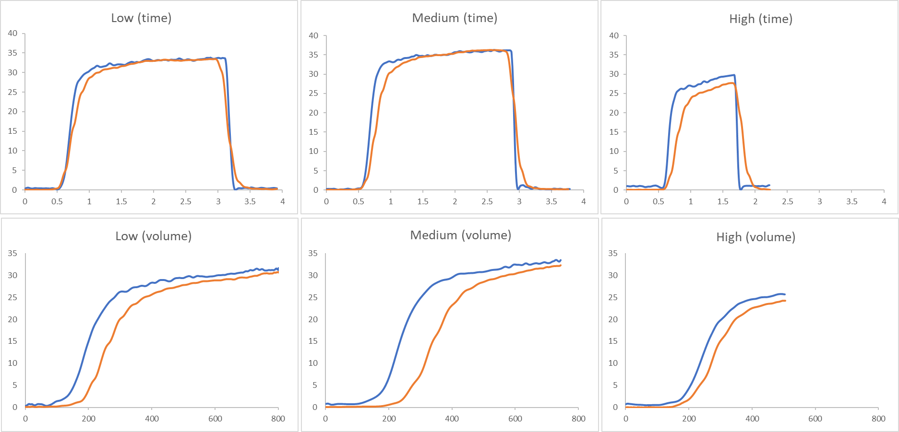
Figure S1: Time domain (top panels) and volumetric (bottom panels) capnograms obtained simultaneously using mainstream (blue) and sidestream (orange) techniques at low (panels A and D), medium (panels B and E), and high (panels C and F) breathing frequencies. Blunting of the transition zones between phases 2 and 3 is apparent when using sidestream capnography, with these distortions becoming more pronounced at the highest breathing rate.
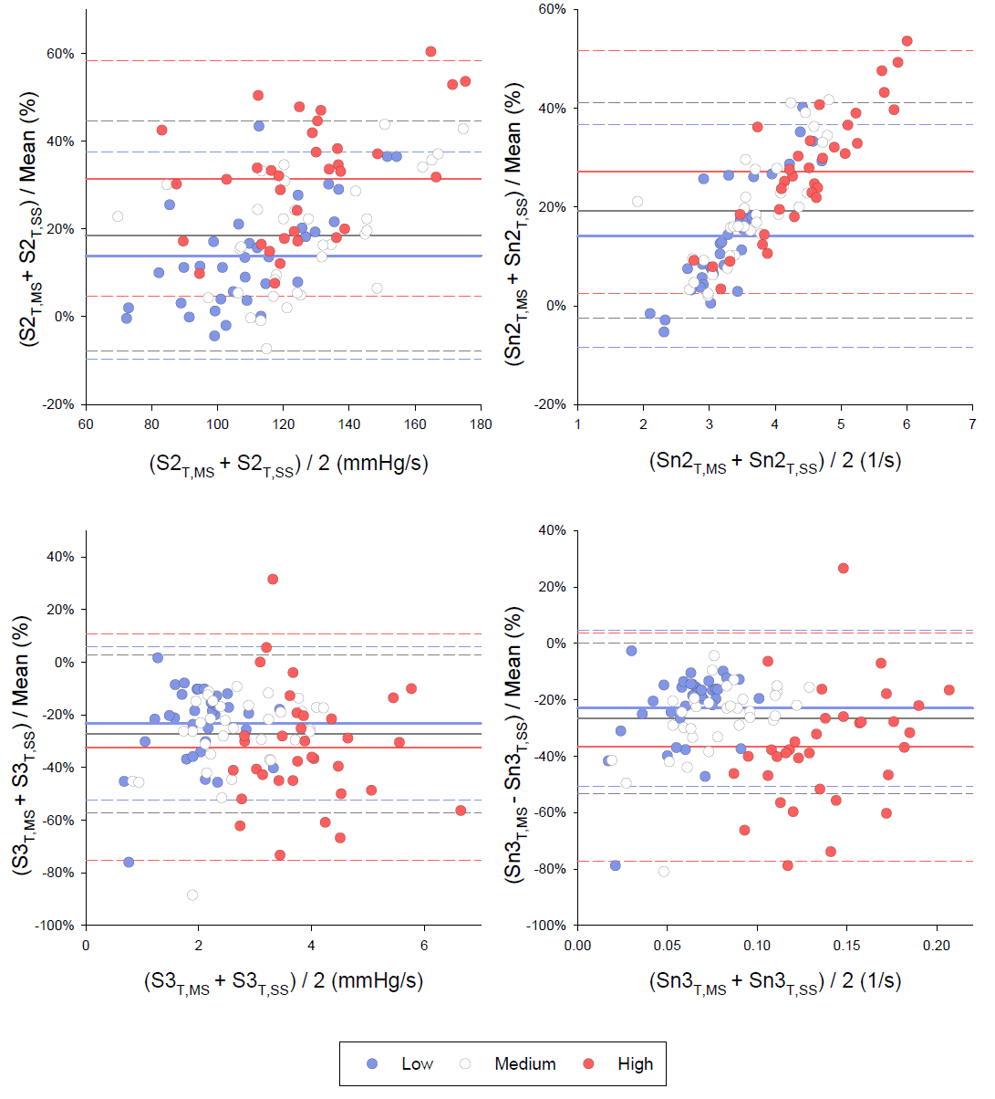
Figure S2: Bland-Altman plots for the time domain measurement of the phase 2 and phase 3 slopes assessed by mainstream (S2_{T,MS} and S3_{T,MS}) and sidestream (S2_{T,SS} and S3_{T,SS}) capnography techniques. Measurements were obtained at low (blue), medium (white) and high (red) breathing frequencies. Continuous horizontal lines with the corresponding colors denote the mean bias values; dashed lines with the corresponding colors indicate the 95% limits of agreements.

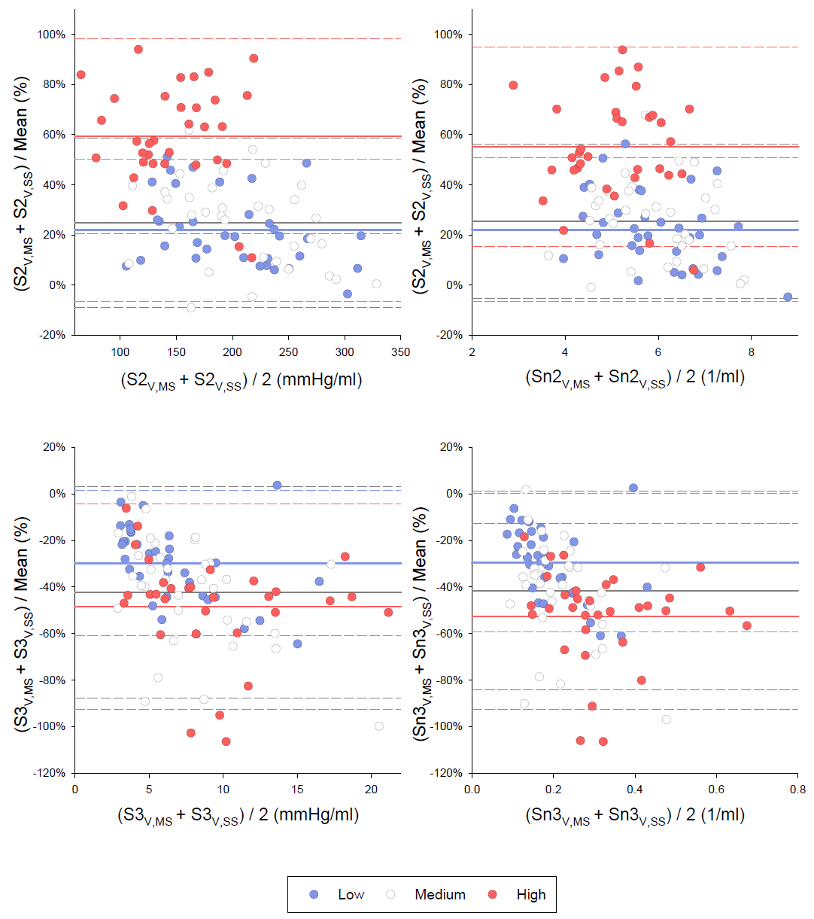
Figure S3: Bland-Altman plots for phase 2 and phase 3 slopes of the volumetric capnogram assessed by mainstream (S2_{V,MS} and S3_{V,MS}) and sidestream (S2_{V,SS} and S3_{V,SS}) techniques. Measurements were obtained at low (blue), medium (white) and high (red) breathing frequencies. Continuous horizontal lines with the corresponding colors denote the mean bias values; dashed lines with the corresponding colors indicate the 95% limits of agreements.

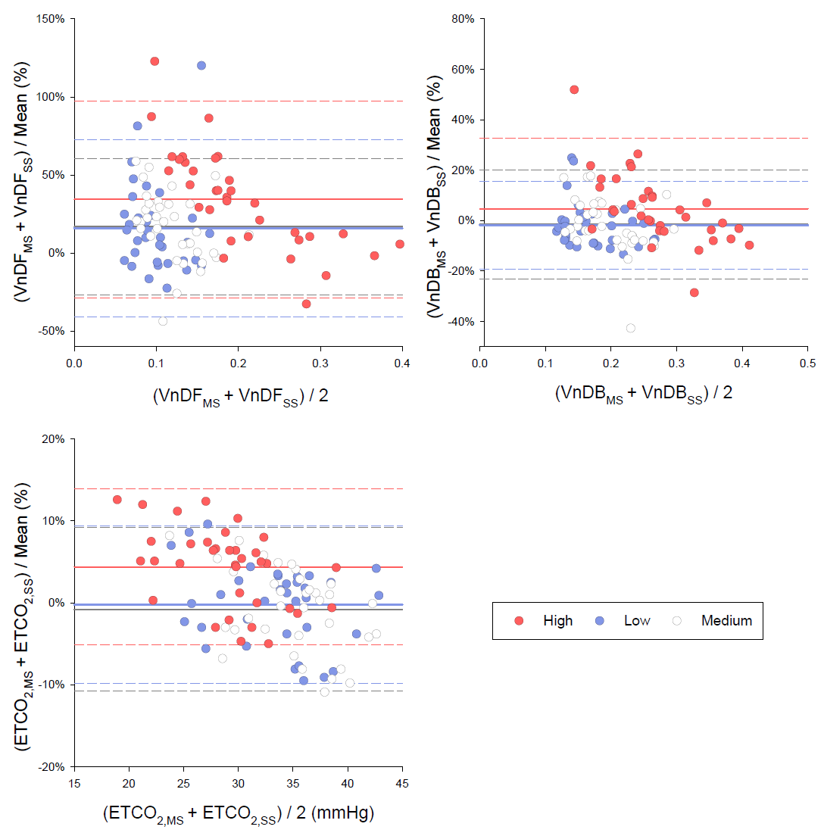
Figure S4: Bland-Altman plots for Fowler’s anatomical dead space fraction, Bohr’s physiological dead phase fraction, and the end-tidal CO₂ concentration measured by mainstream (VDF_{MS}, VDB_{MS} and ETCO_{2,MS}) and sidestream (VDF_{SS} , VDB_{SS} and ETCO_{2,SS}) techniques. Measurements were obtained at low (blue), medium (white) and high (red) breathing frequencies. Continuous horizontal lines with the corresponding colors denote the mean bias values; dashed lines with the corresponding colors indicate the 95% limits of agreements.

