A Comprehensive Study of AFM Stiffness Measurements on Inclined Surfaces: Theoretical, Numerical, and Experimental Evaluation using a Hertz Approach.

Anis Nassim Ahmine¹, Myriam Bdiri², Sophie Féréol¹, Redouane Fodil¹
¹ Univ Paris-Est Créteil, INSERM, U955 IMRB, "Biology of the Neuromuscular System" Team, F-94010 Créteil, France.
² Univ Paris-Est Créteil, CNRS, UMR 7182, Institut de Chimie et des Matériaux Paris-Est (ICMPE), F-94320 Thiais, France.
Address correspondence to Redouane Fodil, Univ Paris-Est Créteil, INSERM, U955 IMRB, "Biology of the Neuromuscular System" Team, 94010, Créteil, France. E-mail : redouane.fodil@u-pec.fr

Appendix A
The approximation to equation (18), leading to equation (19), was used to analyze the force curves obtained for a spherical probe.
Sneddon had proposed an exact solution for the spherical probe in the form [²¹]:
$F_{Sn}=\frac{E}{1-ν^{2}}\left[\frac{a^{2}+R^{2}}{2}ln\frac{a+R}{a-R}-aR\right]$ (A1)
where $E$ is Young's modulus, $R$ is the sphere radius, $ν$ is Poisson's ratio, and $δ$, the indentation depth, given by:
$δ=\frac{a}{2}ln\frac{a+R}{a-R}$ (A2)
Assuming that the sphere of radius $R$ conforms to the elastic solid along a circle of radius $a$.
To evaluate the discrepancy between the force $F$ obtained from equation (19) and $F_{Sn}$, we calculated the deviation below and presented the results in Fig. A1.
$Deviation(\%)=\frac{F-F_{Sn}}{F}$ (A3)
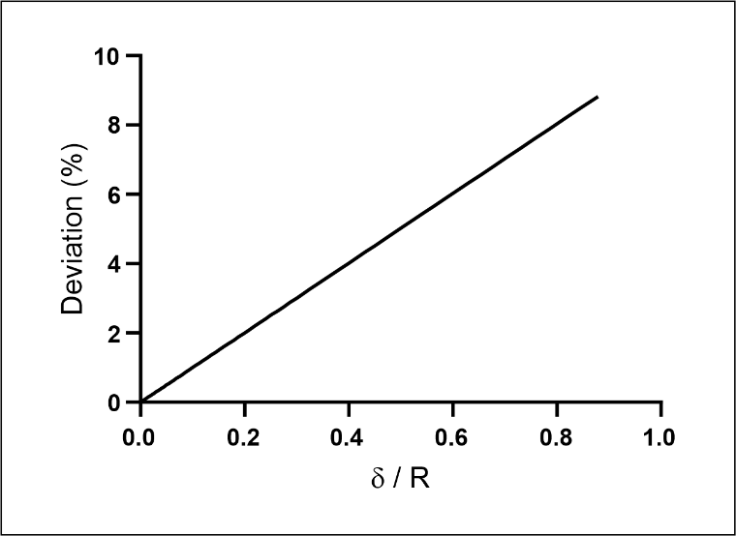
Figure A1: Percentage variation between the force $F$ calculated by equation (19) and the force $F_{Sn}$ according to Sneddon's formulation, shown as a function of the indentation $δ$, normalized by the radius $R$ of the spherical probe.

Appendix B
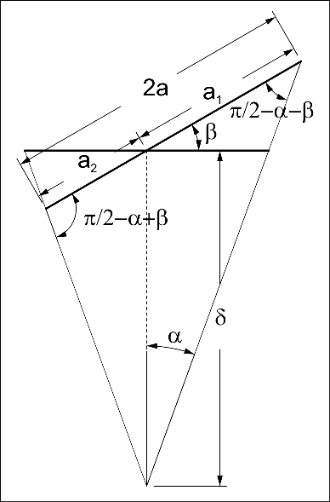
Figure B1: Sketch of a tilted cone
According to the sine law, we have:
$\frac{δ}{sin⁡(\frac{π}{2}-α-β)}=\frac{a_{1}}{sin⁡(α)}$ (B1)
Rearranging equation (B1), we find:
$a_{1}=δ⋅sin⁡(α)⋅\frac{1}{sin⁡(\frac{π}{2}-α-β)}$ (B2)
Similarly, for the second segment, we derive:
$a_{2}=δ⋅sin⁡(α)⋅\frac{1}{sin⁡(\frac{π}{2}-α+β)}$ (B3)
Adding the two segments, we get:
$2⋅a=a_{1}+a_{2}= δ⋅\sin\left(α\right)⋅\left(\frac{1}{\sin\left(\frac{π}{2}-α-β\right)}+\frac{1}{\sin\left(\frac{π}{2}-α+β\right)}\right)$ (B4)
Recognizing the trigonometric identity $\sin\left(π/2-x\right)=cos⁡(x)$, Equation (B4) simplifies to:
$a= δ⋅\frac{\sin\left(α\right)}{2}⋅\left(\frac{1}{cos⁡(α+β)}+\frac{1}{cos⁡(α-β)}\right)$ (B5)
The latter expression calculates the resulting length $a$ as a function of $δ$, $α$, and $β$, capturing the relationships within the geometry influenced by these angles.

Appendix C
To calculate the semi-minor axis $b$ of an ellipse formed by a cone intersecting an inclined plane, define $b_{0}=δ⋅tan⁡(α)$, the radius of the cone's contact with a horizontal surface (see Fig. C1).
The eccentricity of the ellipse $e$ is:
$e=\frac{sin⁡(β)}{cos⁡(α)}$ (C1)
This calculates $b$ from the semi-major axis $a$ (see Fig. C1):
$b=a⋅\sqrt{1-e^{2}}$ (C2)
The plot data in Fig. C2 suggests that $b$ is approximately $b_{0}$, which simplifies the expression to
$b≃δ⋅tan⁡(α)$ (C3)
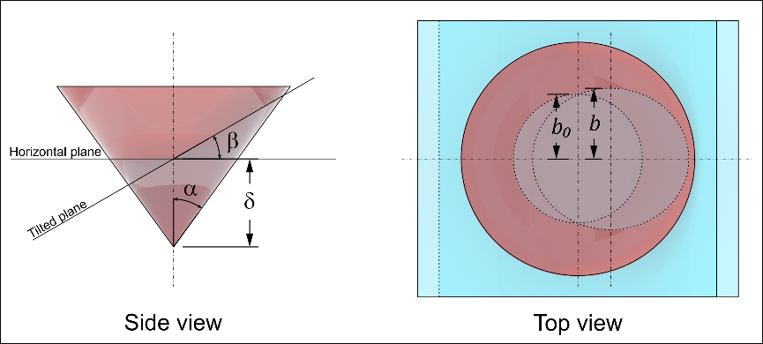
Figure C1: Side view illustrates the intersection of a cone of semi-opening angle $α$ with a horizontal plane on one side and an inclined plane at angle $β$ on the other. The top view shows the circle of radius $b_{0}$ resulting from the intersection of the cone with the horizontal plane and the ellipse characterized by the semi-minor axis $b$ resulting from the intersection of the cone with the inclined plane.
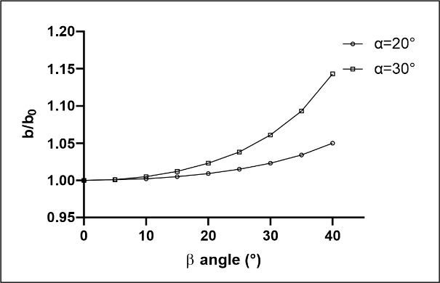
Figure C2: Ratio of the semi-minor axis $b$ of the ellipse formed by the intersection of a cone with an oblique plane to the radius $b_{0}$ of the circle formed by the intersection of the cone with a horizontal plane.

