Supplementary Files

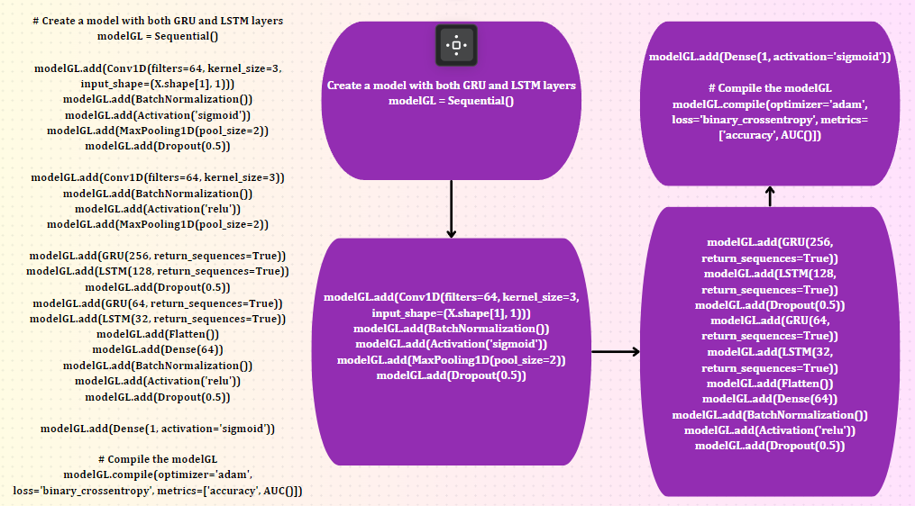
Figure S1. GRU and LSTM based hybrid model architecture

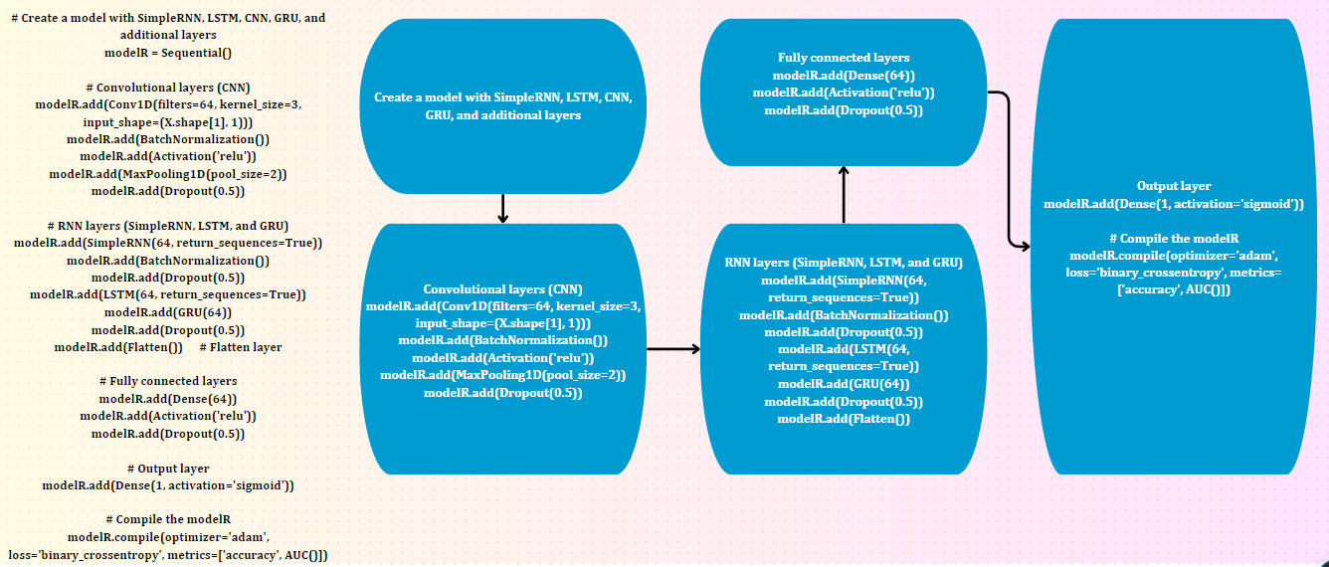
Figure S2. RNN+CNN+GRU+LSTM models overview and the architecture
In Figure S1 and Figure S2, we illustrate the figures The model built with GRU with LSTM layer consists of convolutional layers (Conv1D), subsequently followed by Batch Normalization, activation functions (sigmoid and ReLU), max pooling, and dropout layers. The architecture of the network additionally involves frequent layers, particularly GRU and LSTM neurons, to capture the sequential correlations in the input data. The last layers are a flattened representation, followed by dense layers with batch normalization, ReLU activation, and dropout for non-linearity and regularization. A sigmoid activation function is used in the output layer for binary classification. The model is built using the Adam optimizer and binary cross-entropy loss, with accuracy and the Area Under the ROC Curve (AUC) used as evaluation metrics.
Moreover, we developed another model with RNN, CNN, LSTM, and GRU model, where all the layers are the same as GRU-LSTM, we just applied here RNN layer where we used a simple RNN function. Lastly, we designed our model only for the GRU-based model called GRUpred-m5U, which is our proposed model, where this model achieved higher accuracy than the other models. In the subsection, we highlighted the proposed model formulation with proper exploration.

Table S1. Performance analysis on independent test approach in two modes.
Mode | Classifier | ACC | MCC | Kp | Sp | Sn | AUC | AP
Full transcript RNA | RNN-CNN-GRU-LSTM | 64.01 | 0.00 | 0.00 | 1.00 | 0.00 | 93.03 | 84.52
Full transcript RNA | GRU-LSTM | 90.76 | 79.47 | 78.35 | 95.14 | 82.62 | 96.22. | 93.74
Full transcript RNA | GRUpred-m5U | 64.01 | 0.00 | 0.00 | 1.00 | 0.00 | 91.70 | 84.19
Mature RNA | RNN-CNN-GRU-LSTM | 5.20 | 0.00 | 0.00 | 1.00 | 0.00 | 97.05 | 97.14
Mature RNA | GRU-LSTM | 55.49 | 23.72 | 10.65 | 1.00 | 10.61 | 1.00 | 1.00
Mature RNA | GRUpred-m5U | 52.44 | 15.18 | 40.51 | 1.00 | 4.49 | 1.00 | 1.00

Table S2. Performance analysis on individuals features extraction approach in two modes.
Mode | Feature Extractions | Classifier | ACC | MCC | Kp | Sp | Sn | AUC | AP
Mature RNA | DPCP type 2 | RNN-CNN-GRU-LSTM | 75.85 | 44.37 | 38.57 | 97.83 | 37.07 | 89.15 | 82.91
Mature RNA | DPCP type 2 | GRU-LSTM | 89.06 | 76.15 | 75.69 | 93.73 | 80.91 | 94.53 | 91.18
Mature RNA | DPCP type 2 | GRUpred-m5U | 95.44 | 91.39 | 90.78 | 94.85 | 96.41 | 98.35 | 97.11
Mature RNA | DPCP | RNN-CNN-GRU-LSTM | 70.81 | 41.37 | 31.53 | 91.30 | 26.07 | 85.21 | 80.03
Mature RNA | DPCP | GRU-LSTM | 90.06 | 71.15 | 72.68 | 85.13 | 81.99 | 91.55 | 91.18
Mature RNA | DPCP | GRUpred-m5U | 93.78 | 91.77 | 75.18 | 78.85 | 91.11 | 94.45 | 93.12
Mature RNA | Enac | RNN-CNN-GRU-LSTM | 71.91 | 51.37 | 81.23 | 90.35 | 62.08 | 86.28 | 81.13
Mature RNA | Enac | GRU-LSTM | 72.66 | 61.15 | 82.38 | 81.16 | 88.99 | 96.55 | 91.68
Mature RNA | Enac | GRUpred-m5U | 75.28 | 81.77 | 85.88 | 75.81 | 96.14 | 92.46 | 98.82
Mature RNA | Kmer | RNN-CNN-GRU-LSTM | 70.81 | 41.37 | 31.53 | 91.30 | 26.07 | 85.21 | 80.03
Mature RNA | Kmer | GRU-LSTM | 75.06 | 71.15 | 72.68 | 85.13 | 81.99 | 91.55 | 91.18
Mature RNA | Kmer | GRUpred-m5U | 94.78 | 82.77 | 75.18 | 78.85 | 91.11 | 94.45 | 97.12
Mature RNA | PseDNC | RNN-CNN-GRU-LSTM | 23.72 | 10.65 | 1.00 | 30.12 | 26.07 | 85.21 | 1.00
Mature RNA | PseDNC | GRU-LSTM | 75.81 | 96.14 | 82.88 | 80.08 | 75.81 | 91.55 | 91.18
Mature RNA | PseDNC | GRUpred-m5U | 75.81 | 96.14 | 92.46 | 98.82 | 75.81 | 94.45 | 93.12
Full Transcript RNA | DPCP type 2 | RNN-CNN-GRU-LSTM | 64.01 | 0.00 | 0.00 | 1.00 | 0.00 | 91.70 | 84.19
Full Transcript RNA | DPCP type 2 | GRU-LSTM | 5.20 | 0.00 | 0.00 | 1.00 | 0.00 | 97.05 | 97.14
Full Transcript RNA | DPCP type 2 | GRUpred-m5U | 55.49 | 23.72 | 10.65 | 1.00 | 10.61 | 1.00 | 1.00
Full Transcript RNA | DPCP | RNN-CNN-GRU-LSTM | 75.06 | 71.15 | 72.68 | 85.13 | 81.99 | 91.55 | 91.18
Full Transcript RNA | DPCP | GRU-LSTM | 90.06 | 71.15 | 72.68 | 85.13 | 81.99 | 91.55 | 91.18
Full Transcript RNA | DPCP | GRUpred-m5U | 89.06 | 76.15 | 75.69 | 93.73 | 80.91 | 94.53 | 91.18
Full Transcript RNA | Enac | RNN-CNN-GRU-LSTM | 64.01 | 0.00 | 0.00 | 1.00 | 0.00 | 93.03 | 84.52
Full Transcript RNA | Enac | GRU-LSTM | 90.76 | 79.47 | 78.35 | 95.14 | 82.62 | 96.22. | 93.74
Full Transcript RNA | Enac | GRUpred-m5U | 64.01 | 0.00 | 0.00 | 1.00 | 0.00 | 91.70 | 84.19
Full Transcript RNA | Kmer | RNN-CNN-GRU-LSTM | 94.78 | 82.77 | 75.18 | 78.85 | 91.11 | 94.45 | 97.12
Full Transcript RNA | Kmer | GRU-LSTM | 75.06 | 71.15 | 72.68 | 85.13 | 81.99 | 91.55 | 91.18
Full Transcript RNA | Kmer | GRUpred-m5U | 94.78 | 82.77 | 75.18 | 78.85 | 91.11 | 94.45 | 97.12
Full Transcript RNA | PseDNC | RNN-CNN-GRU-LSTM | 23.72 | 10.65 | 1.00 | 30.12 | 26.07 | 85.21 | 1.00
Full Transcript RNA | PseDNC | GRU-LSTM | 75.81 | 96.14 | 82.88 | 80.08 | 75.81 | 91.55 | 91.18
Full Transcript RNA | PseDNC | GRUpred-m5U | 75.81 | 96.14 | 92.46 | 98.82 | 75.81 | 94.45 | 93.12

- Description of the Applied Feature Extraction Methods

  - Enhanced Nucleic Acid Composition (ENAC)
ENAC is a kind of “NAC” termed a nucleic acid composition embedding approach where it measures the four distinct types of nucleotides (i.e., A, G, C, and U) from the sequence format [55]. This method includes aspects of the sequence; therefore, it is used to extract features from similar types of data [56]. In this study, we selected the window sliding of ENAC to be 5. The formula for this approach is expressed as:
$E\left(x\right)={(f}_{x1}f_{x2}…f_{xn})= \frac{X\left(x_{1}x_{2}…x_{n}\right)}{\left(L-N+1\right)}, x n∈(A,C,G,U)$ (1)
Where E(X) is the nucleotide predictor, $f_{x1}f_{x2}…f_{xn}$ represents the nucleotide fragment, $X\left(x_{1}x_{2}…x_{n}\right)$ is the number of aspects in the RNA sequence, and x n∈ denotes the 4-dimensional feature vector.
  - Basic Kmer (Kmer)
Kmer is a popular method in biological fields [57]. This method produced a relationship between molecules such as AG, AT/AU, GA for 3-mers, AAG, AAT/U, AAC for 3-mers, and others [58]. The formulation of Kmer can be stated as:
$Kmer= \frac{b×(r-l+1)}{r}$ (2)
Where b is the kmer's base the length is denoted by r, and the kmer length is denoted by l. In this work, we have selected the kmer parameter size of 3.

  - Dinucleotide Physicochemical Properties (DPCP and DPCP type 2)
The DPCP feature incorporates physicochemical properties produced by groups of nucleotides that appear in RNA genomes. Based on the inherent properties of dinucleotides, these features enable precise distinction between the geometric and biological components of the genome [59,60]. The equation of the DPCP can be stated as:
$DPCP(k)= f(k)× d(k)$ (3)
Where d(k) is the dpcp of kth dinucleotides, f(k) is the frequency of the molecules. In this work, the DPCP feature is represented by 22 physicochemical elements. In this work, DPCP type 2 can be embedded as:
$DPCP2=Pc1(T_{1}T_{2})......pc1(T_{n-1}T_{n}) , pci(T_{1,}T_{2})......pci(T_{n-1}T_{n})$ (4)
where $pci(T_{n-1}T_{n})$ denotes the ith property value of the nucleotide $T_{n-1}T_{n}$, n is the length of RNA, DPCP type 2 is represented by 22 physicochemical properties [61].
  - Pseudo Dinucleotide Composition (PseDNC)
PseDNC is created based on the PseAAC algorithm; Chen et al. proposed the PseDNC method in 2013 [62]. This study has used a weight factor of 0.1 and a lambda value is 2 parameters with 22 properties to represent the sequence as a vector. This method efficiently includes both local and global sequence-order material into the nucleotide sequence's vector-based feature accountability, providing an accurate and comprehensive storage of its structure and spatial features [63]. The formula can be stated as:
$PseDNC= [p1,p2,....,pn, pn+1,pn+2,.....,pn+α]^{T}$ (5)
Where $α$ denotes the rank of the correlation between the molecules. $p1,p2,....,pn,$ is the number of nucleotides.

