10 SNPs associated with prostatitis
SNP | Chromosome | Effect  allele | Other allele | Eaf | Beta | Se | P | Sample  size
rs10915225 | 1 | T | G | 0.605 | 0.1685 | 0.0345 | 1.06E-06 | 74658
rs4953907 | 2 | C | T | 0.1026 | -0.2655 | 0.0565 | 2.64E-06 | 74658
rs9789699 | 2 | G | A | 0.3082 | 0.1748 | 0.0369 | 2.10E-06 | 74658
rs114884055 | 3 | A | G | 0.0166 | 0.6434 | 0.1382 | 3.23E-06 | 74658
rs76569337 | 3 | C | T | 0.2038 | 0.2328 | 0.0425 | 4.21E-08 | 74658
rs117901033 | 10 | T | C | 0.01233 | 0.841 | 0.1683 | 5.83E-07 | 74658
rs79554384 | 10 | T | C | 0.0674 | 0.3171 | 0.0691 | 4.40E-06 | 74658
rs79165844 | 11 | A | C | 0.1173 | 0.2459 | 0.0534 | 4.11E-06 | 74658
rs35521406 | 11 | G | A | 0.1923 | 0.2159 | 0.0433 | 6.18E-07 | 74658
rs66617371 | 12 | T | C | 0.377 | 0.1627 | 0.0352 | 3.90E-06 | 74658

Prostatitis and prostate cancer Mendelian randomization results

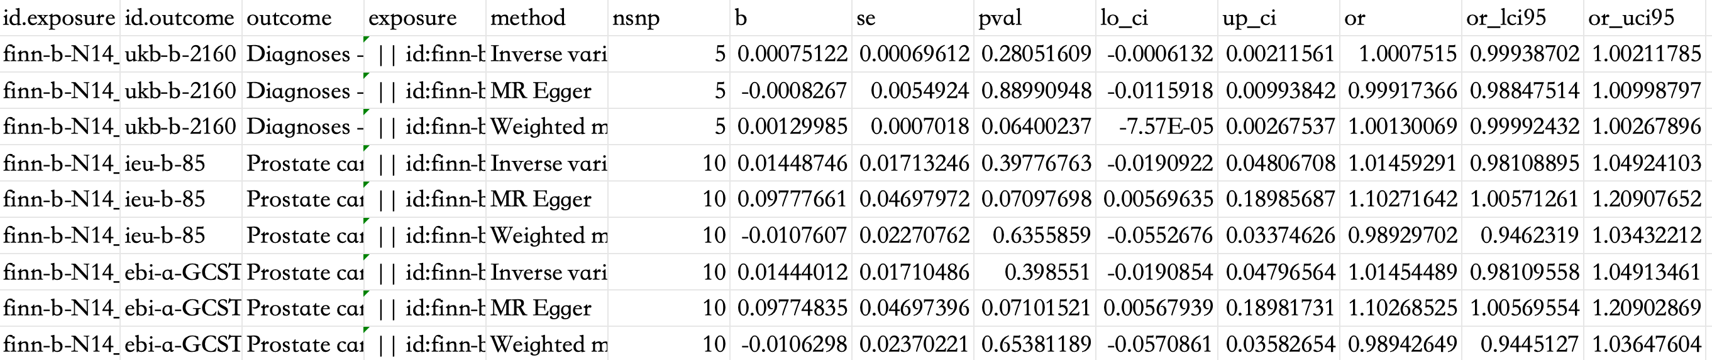

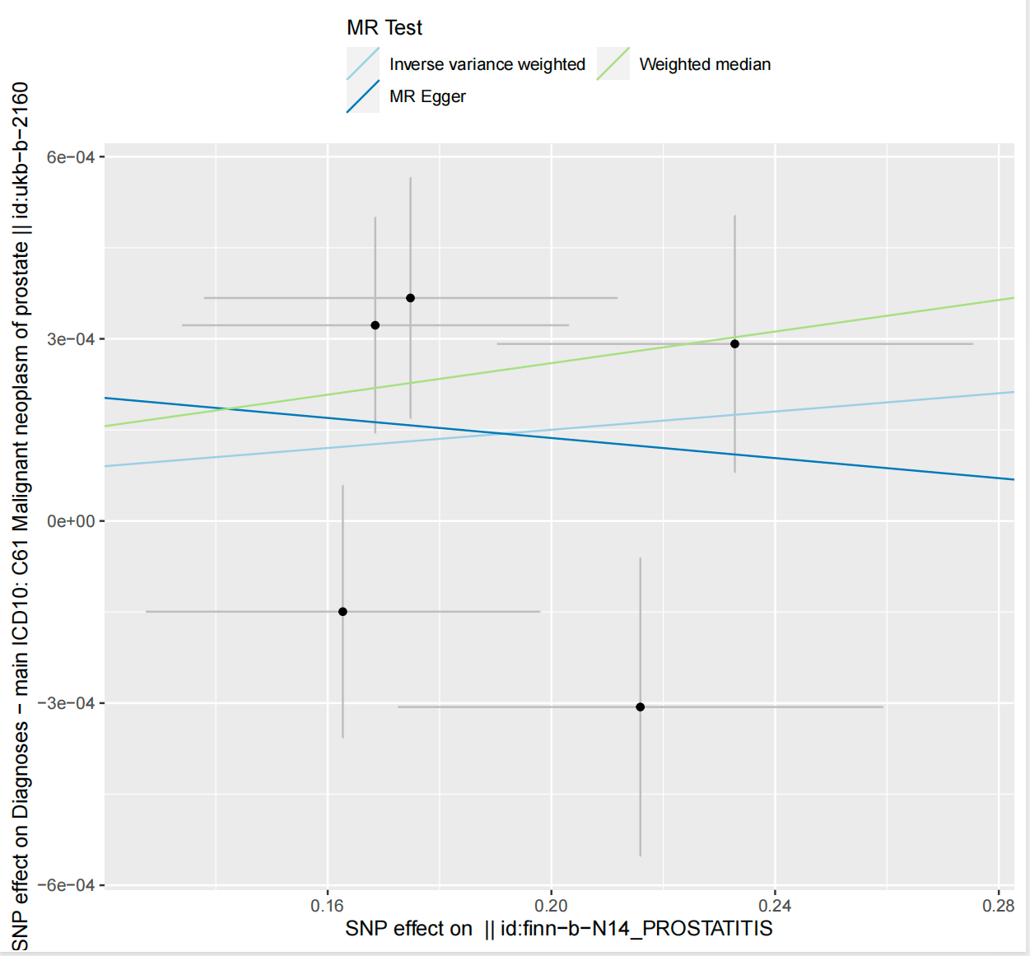

Scatter plot of SNPs associated with prostatitis and their risk of prostate cancer. (prostate cancer dataset : ukb-b-2160)
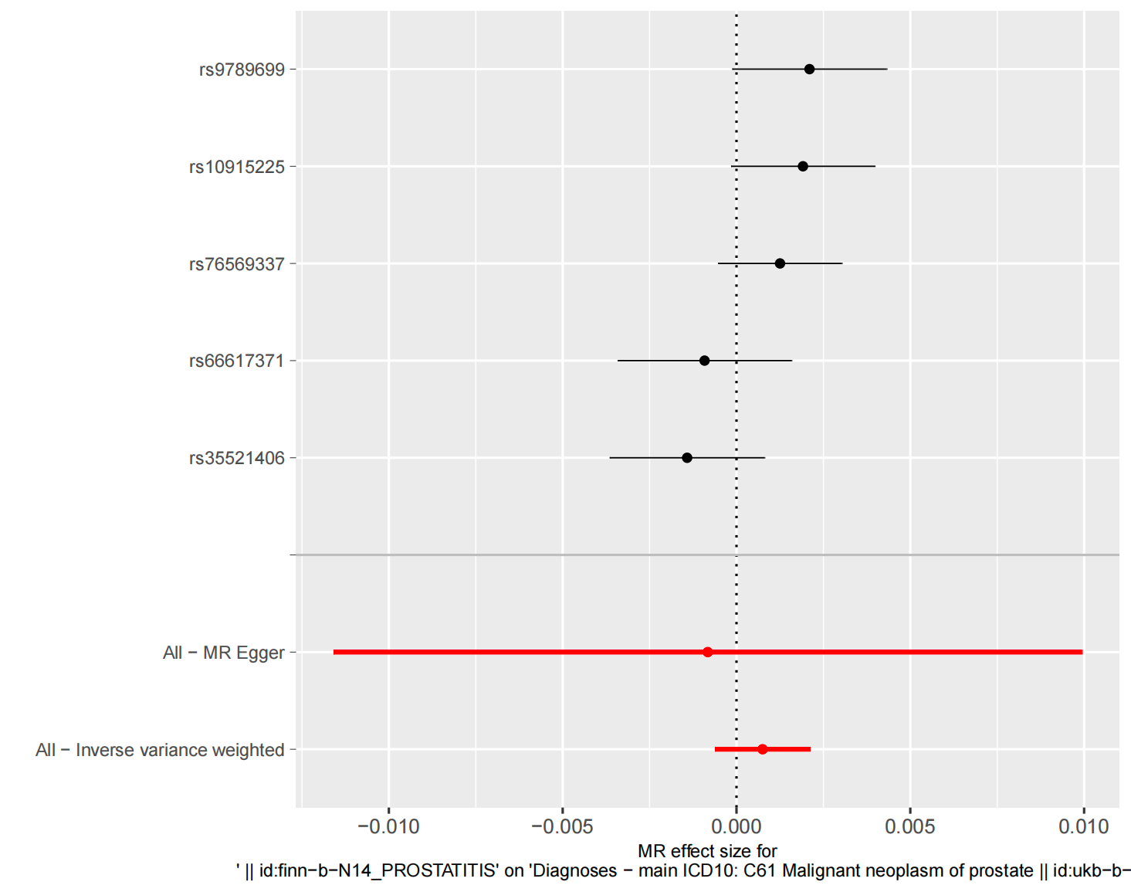

Forest plot of SNPs associated with prostatitis and their risk of prostate cancer. (prostate cancer dataset : ukb-b-2160)

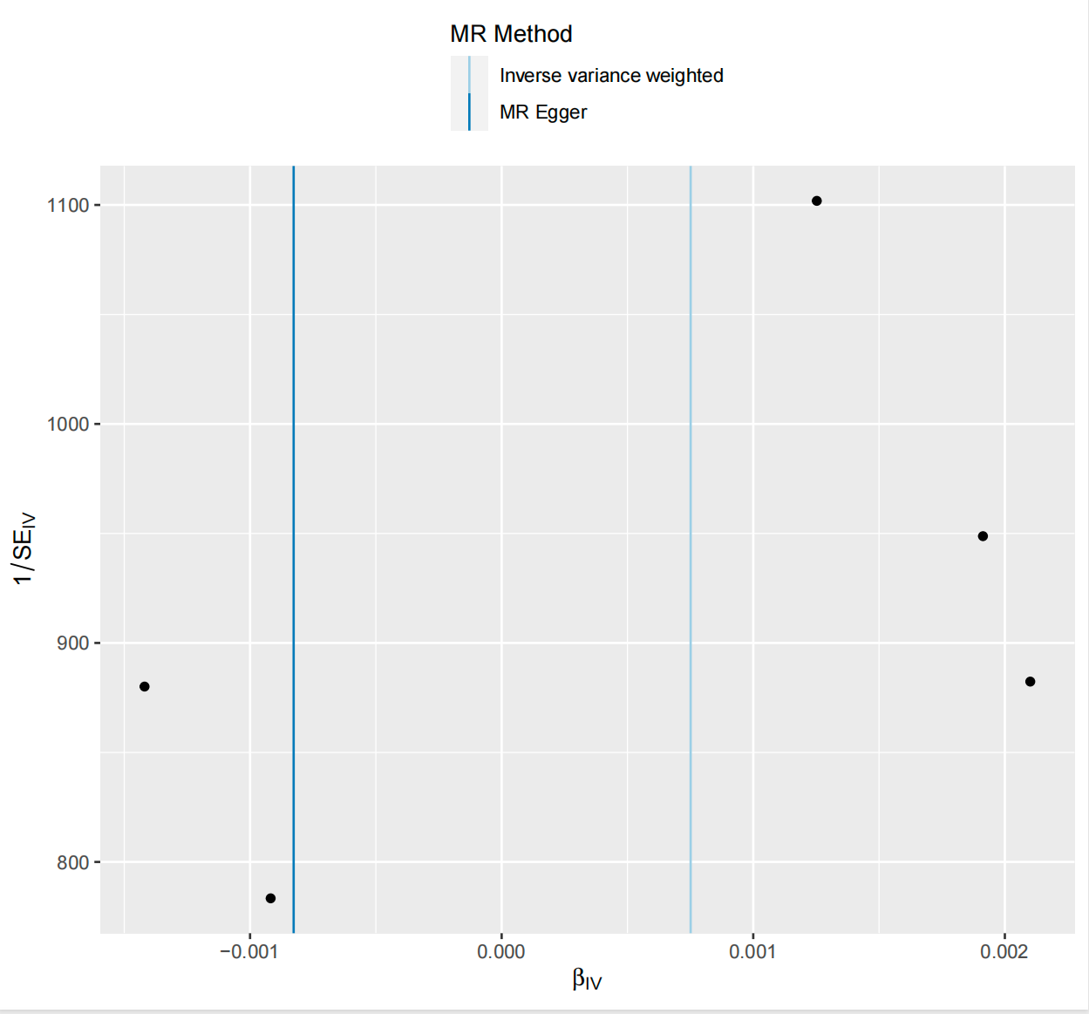

Funnel plot of SNPs associated with prostatitis and their risk of prostate cancer. (prostate cancer dataset : ukb-b-2160)

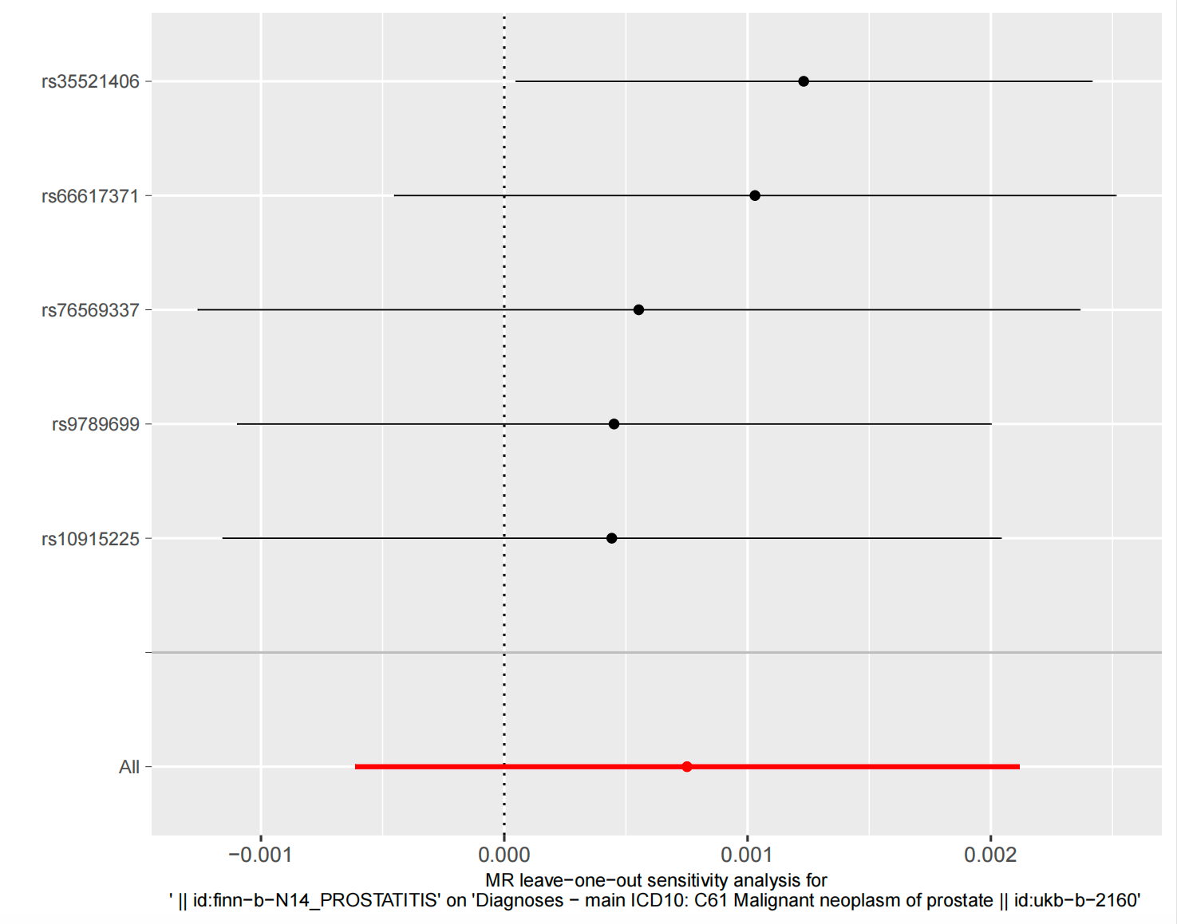

Leave-one-out plot of SNPs associated with prostatitis and their risk of prostate cancer. (prostate cancer dataset : ukb-b-2160)

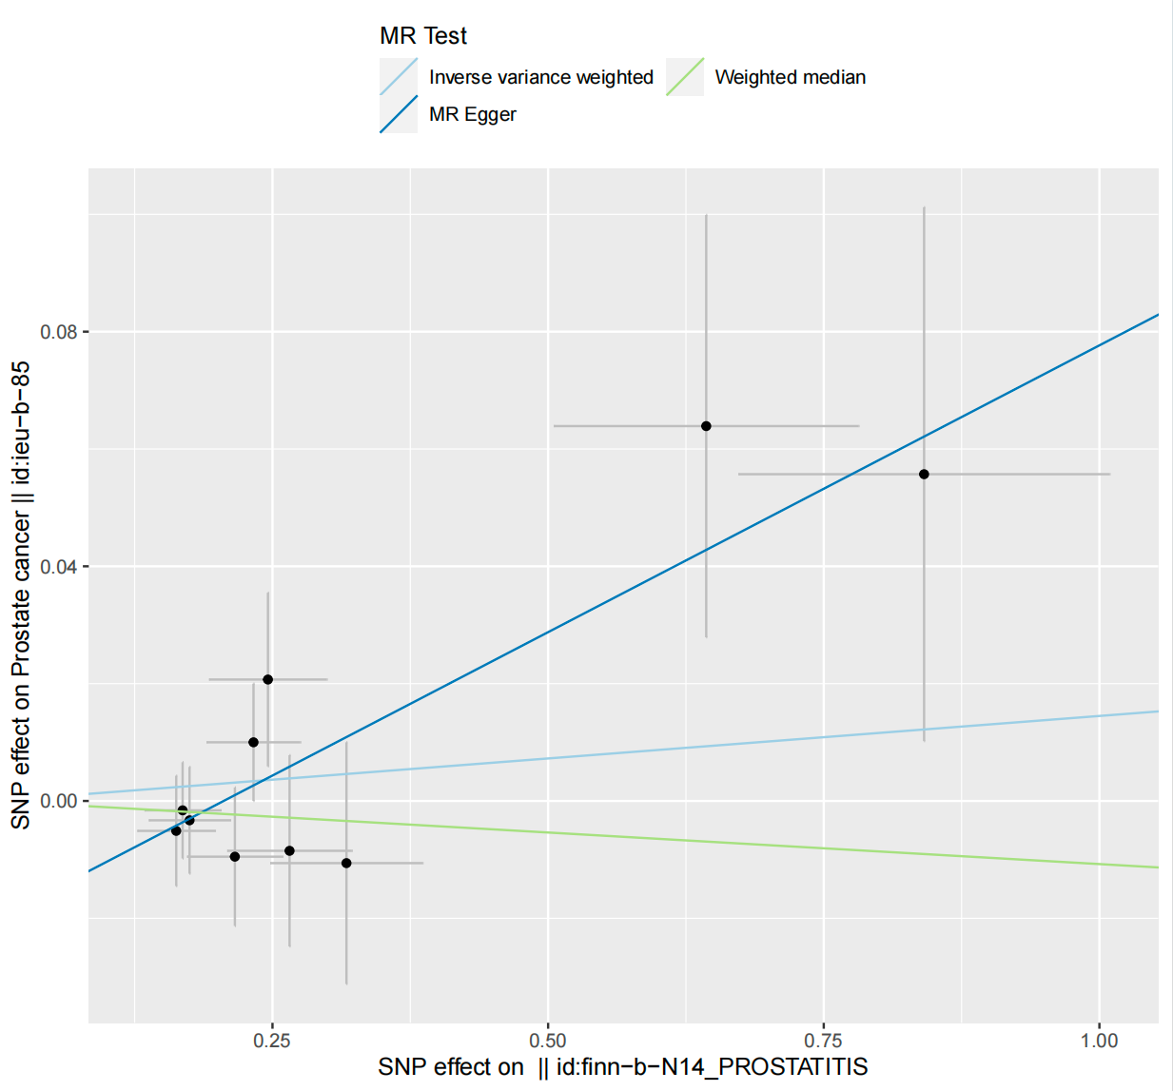

Scatter plot of SNPs associated with prostatitis and their risk of prostate cancer. (prostate cancer dataset : ieu-b-85)
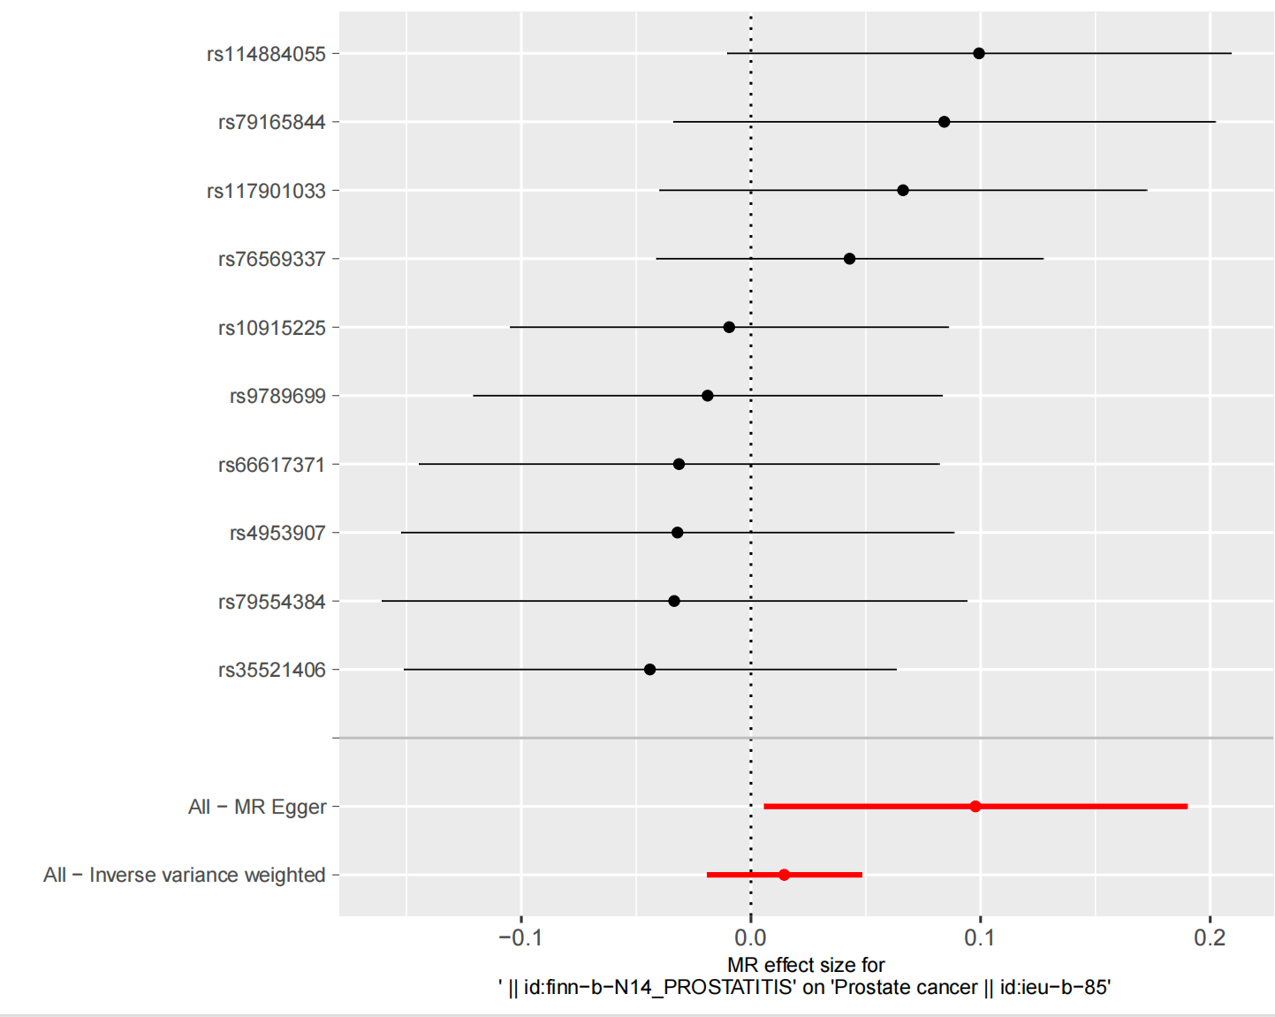

Forest plot of SNPs associated with prostatitis and their risk of prostate cancer. (prostate cancer dataset : ieu-b-85)
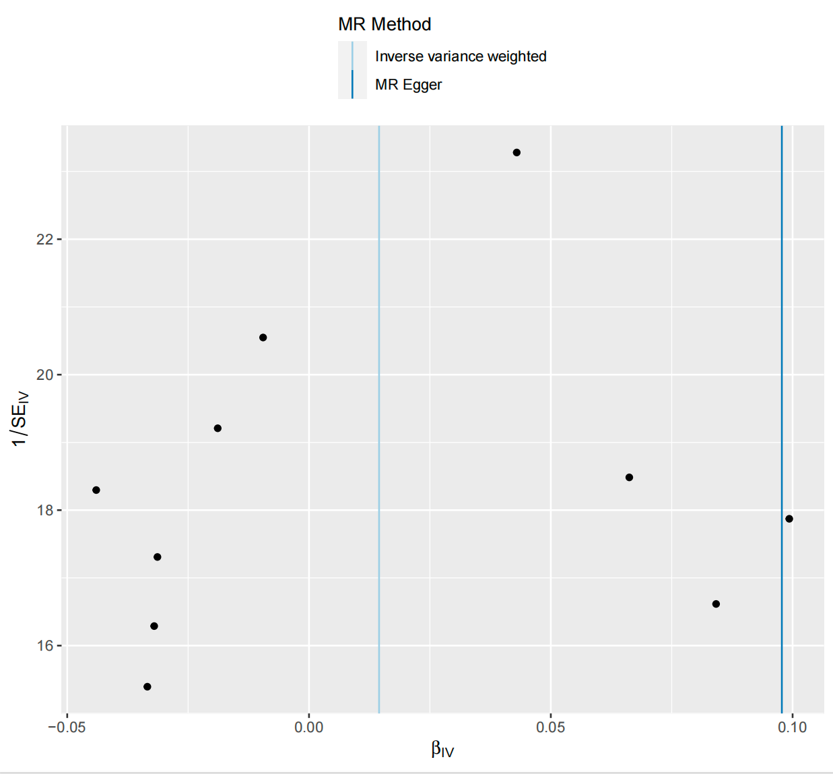

Funnel plot of SNPs associated with prostatitis and their risk of prostate cancer. (prostate cancer dataset : ieu-b-85)
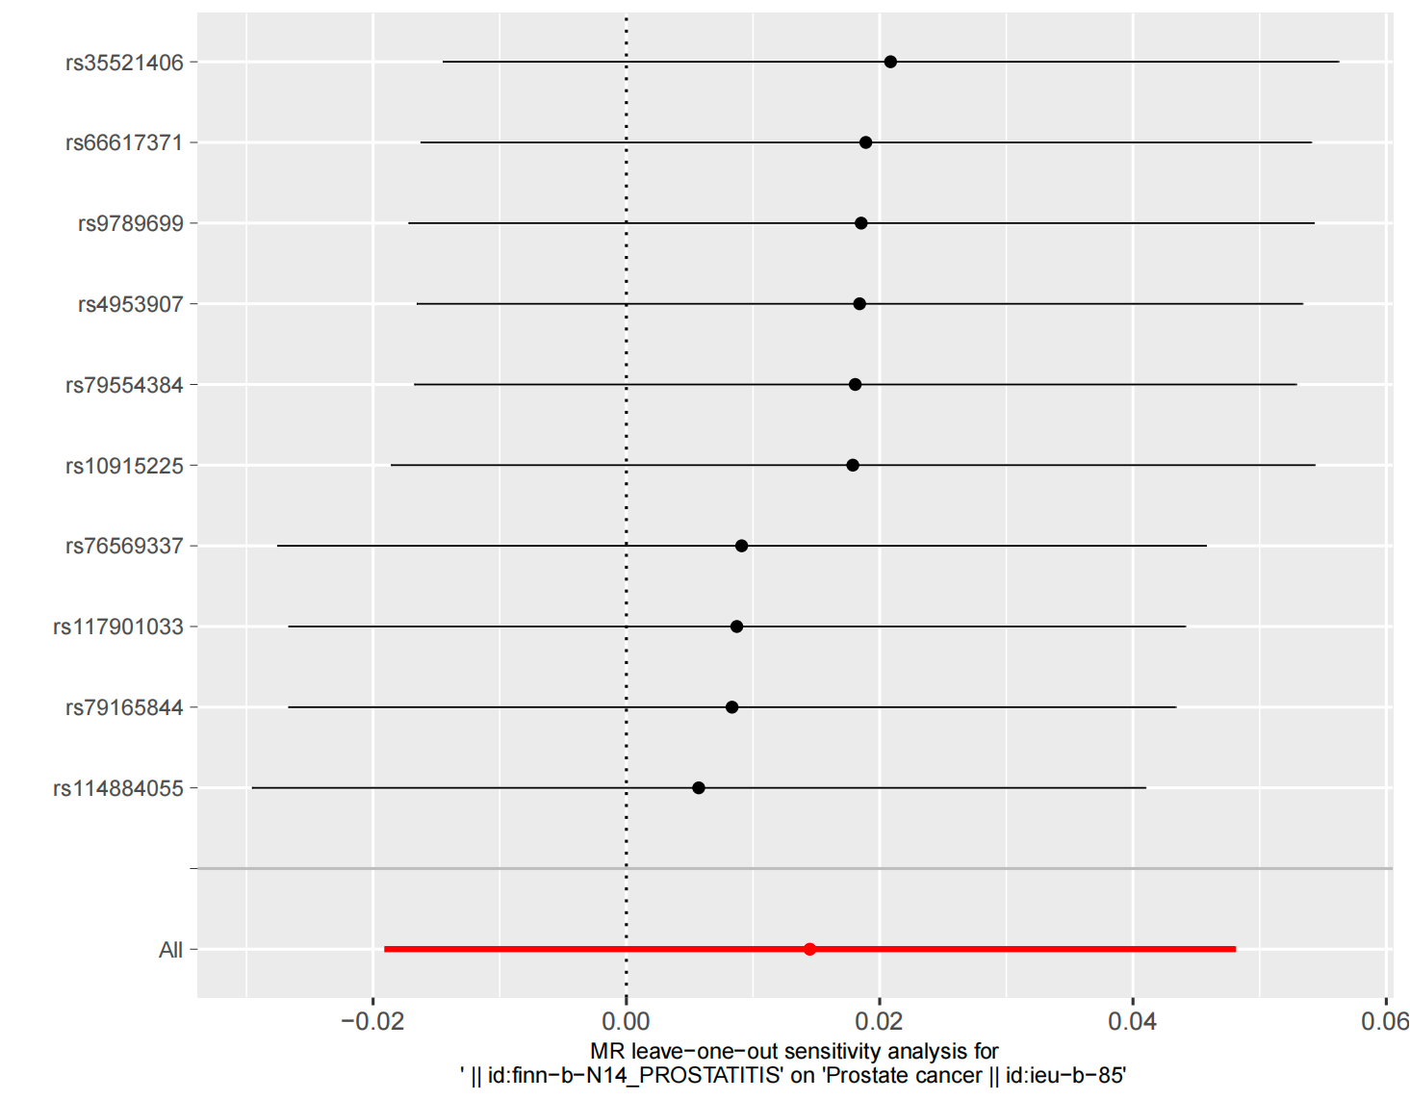

Leave-one-out plot of SNPs associated with prostatitis and their risk of prostate cancer. (prostate cancer dataset : ieu-b-85)

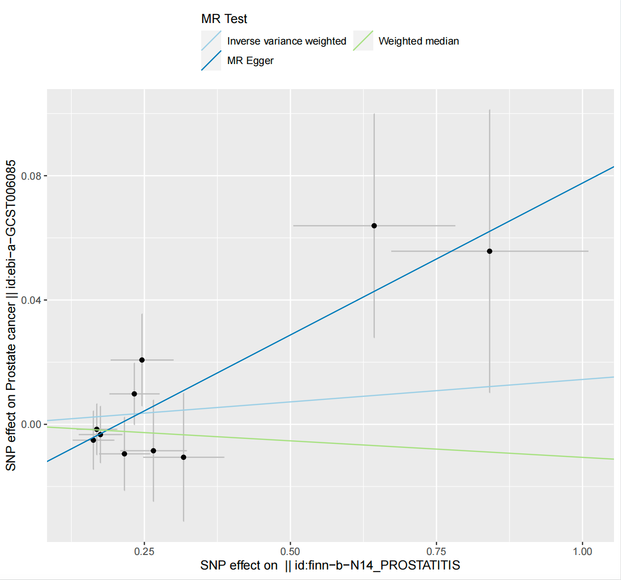

Scatter plot of SNPs associated with prostatitis and their risk of prostate cancer. (prostate cancer dataset : ebi-a-GCST006085)
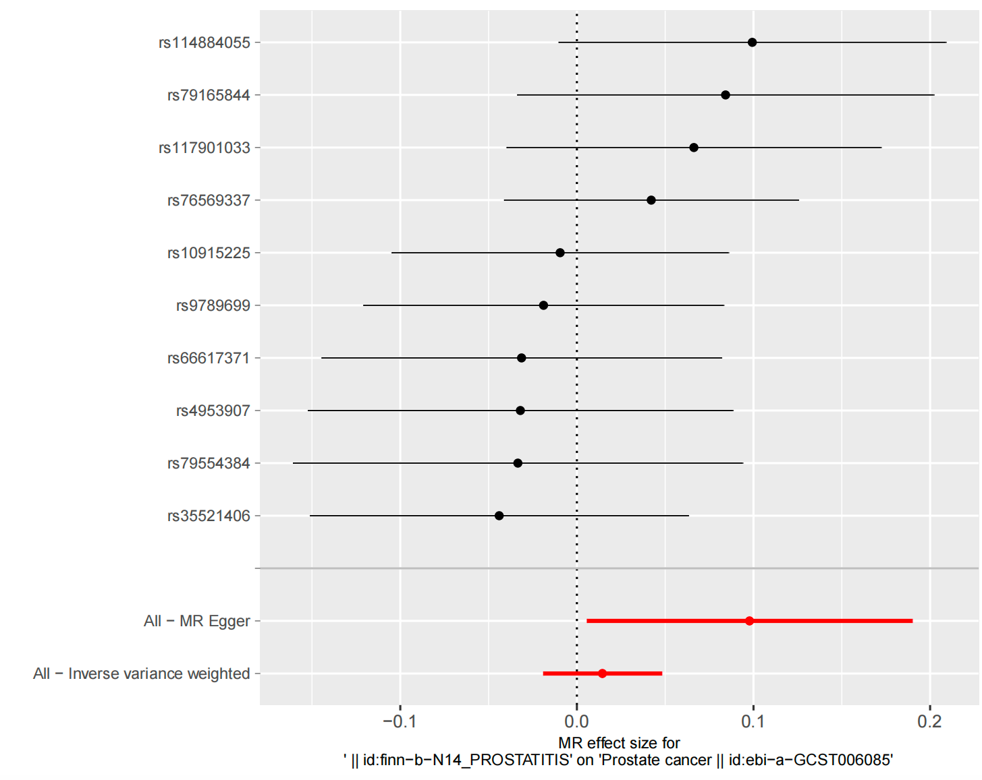
Forest plot of SNPs associated with prostatitis and their risk of prostate cancer. (prostate cancer dataset : ebi-a-GCST006085)

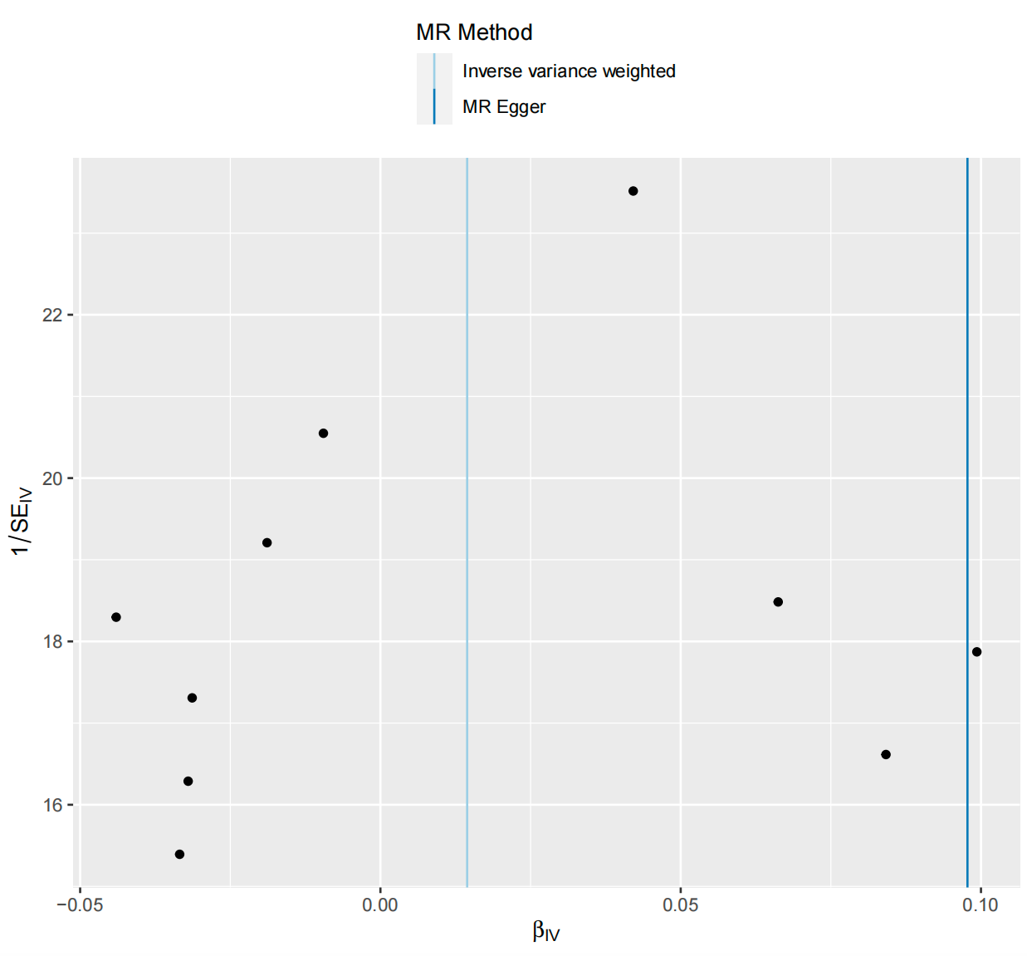

Funnel plot of SNPs associated with prostatitis and their risk of prostate cancer. (prostate cancer dataset : ebi-a-GCST006085)

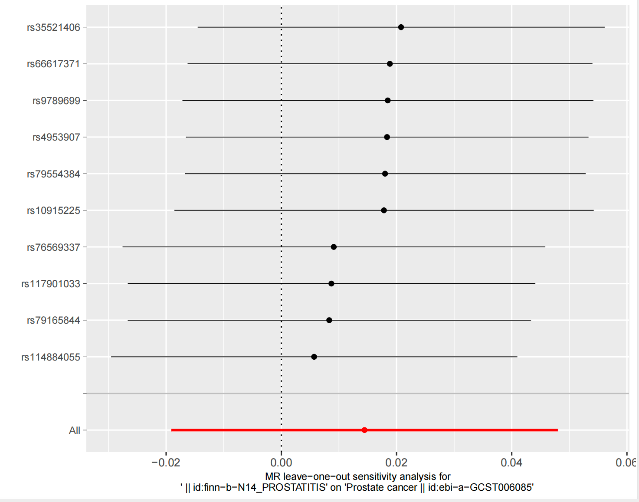

Leave-one-out plot of SNPs associated with prostatitis and their risk of prostate cancer. (prostate cancer dataset : ebi-a-GCST006085)

