STROBE-MR checklist of recommended items to address in reports of Mendelian randomization studies¹ ²

Item No. | Section | Checklist item | Page No. | Relevant text from manuscript
1 | TITLE and ABSTRACT | Indicate Mendelian randomization (MR) as the study’s design in the title and/or the abstract if that is a main purpose of the study | 1-2 | The association of prostatitis with prostate cancer risk: a Mendelian randomized study  In our endeavor to scrutinize the conceivable causal nexus between prostatitis and PCa, we embarked upon a Mendelian randomization study (MR).  FinGen Consortium data were used for the prostatitis genome-wide association study (GWAS). UK biobank baseline data, European Bioinformatics Institute Database, and IEU openGWAS database were used for PCa outcomes. Data from the GWAS for prostatitis were compared with data from the three GWAS for PCa, respectively, in an analysis of an MR. Utilizing the inverse variance weighting (IVW) methodology as our primary analytical framework, we delved into a meticulous exploration of the conceivable causal association between prostatitis and PCa. Furthermore, we deployed supplementary methodologies, including Maximum Likelihood, MR-Egger, weighted median, and MR-PRESSO, to thoroughly assess and scrutinize the causality aspect comprehensively. Cochran's Q statistic is employed as a metric to quantify the heterogeneity inherent in instrumental variables.
 | INTRODUCTION
2 | Background | Explain the scientific background and rationale for the reported study. What is the exposure? Is a potential causal relationship between exposure and outcome plausible? Justify why MR is a helpful method to address the study question | 3 | The exposure is prostatitis.  In the intricate process of tumorigenesis, inflammation assumes a pivotal role, orchestrating diverse pathways that intricately mediate the progression of tumors. For instance, infiltration of macrophages and T cells has been identified as key elements in this context5. In the context of prostatitis, the onset of this ailment progressively rises with advancing age, and it has been demonstrated that T-cell infiltration is present in chronic prostatitis6. In a review article, data suggest that chronic inflammation leads to PCa; for example, Within the realm of epidemiological investigations, the prolonged utilization of nonsteroidal anti-inflammatory drugs has demonstrated efficacy in hindering the progression of PCa. This implies that chronic prostatitis is a risk factor for PCa8–10  This study can effectively eliminate other risk factors for the disease, thus more precisely exploring the potential risk between prostatitis and PCa.
3 | Objectives | State specific objectives clearly, including pre-specified causal hypotheses (if any). State that MR is a method that, under specific assumptions, intends to estimate causal effects | 3 | In our pursuit to unravel the causal connection between these two ailments, a MR was executed. This study can effectively eliminate other risk factors for the disease, thus more precisely exploring the potential risk between prostatitis and PCa.
 | METHODS
4 | Study design and data sources | Present key elements of the study design early in the article. Consider including a table listing sources of data for all phases of the study. For each data source contributing to the analysis, describe the following:
 | a) | Setting: Describe the study design and the underlying population, if possible. Describe the setting, locations, and relevant dates, including periods of recruitment, exposure, follow-up, and data collection, when available. | 10 | N.A.
 | b) | Participants: Give the eligibility criteria, and the sources and methods of selection of participants. Report the sample size, and whether any power or sample size calculations were carried out prior to the main analysis | 4 | The primary genetic instrument for prostatitis was derived from pooled data on prostatitis from the FinnGen Research Program, which is a GWAS conducted on 74,658 European adult men.GWAS summary data for PCa were extracted from three consortia, which were UK biobank baseline data (ncase = 3436, ncontrol = 459574) (ukb-b-2160)19, European Bioinformatics Institute Database (ncase = 79148, ncontrol = 61106) (ebi-a-GCST006085)20, and IEU openGWAS database (ncase = 79148, ncontrol = 61106)(ieu-b-85)21.  To identify SNPs strongly associated with prostatitis, the inclusion criterion for SNPs was p < 5×10−8, which resulted in no associated SNPs being found. To enroll more SNPs contributing to prostatitis, a more lenient threshold was applied (p< 5×10−6)15. Ten SNPs demonstrated a robust association with prostatitis (p < 5 × 10-6, linkage disequilibrium [LD] r2 < 0.001, kb = 10000)16. The mean F-statistic value was 1074 [F=(N-K-1/K)*(R²/(1-R²))], which is much stronger than the regular value of 10, indicating that these SNPs have a strong predictive ability17,18.
 | c) | Describe measurement, quality control and selection of genetic variants | 4 | To identify SNPs strongly associated with prostatitis, the inclusion criterion for SNPs was p < 5×10−8, which resulted in no associated SNPs being found. To enroll more SNPs contributing to prostatitis, a more lenient threshold was applied (p< 5×10−6)15. Ten SNPs demonstrated a robust association with prostatitis (p < 5 × 10-6, linkage disequilibrium [LD] r2 < 0.001, kb = 10000)16. The mean F-statistic value was 1074 [F=(N-K-1/K)*(R²/(1-R²))], which is much stronger than the regular value of 10, indicating that these SNPs have a strong predictive ability17,18.
 | d) | For each exposure, outcome, and other relevant variables, describe methods of assessment and diagnostic criteria for diseases | 4-5 | We harmonized effector alleles between prostatitis and GWAS of PCa before using MR methods. We used a couple of MR methods to determine MR estimates of prostatitis in PCa, which are the inverse variance weighted (IVW) method, the MR-Egger method, and the weighted median method. The F-statistic was applied to evaluate the strength of an individual instrument. The Wald ratio method was used to calculate exposure-outcome effect values for each SNP22. Additionally, we validated the results obtained through the IVW method by employing the MR-Egger method and the weighted median method, thereby complementing the IVW estimates. We tested for possible heterogeneity and directed multivalence using the Cochrane Q test (p < 0.05) and the MR-Egger intercept (MR-Egger p < 0.05 is indicative of the presence of directed polyvalence), respectively17,23. Horizontal polyvalence was detected using the MR-Polyvalent Residuals and Outliers method (MR-PRESSO). Moreover, a leave-one-out analysis was executed.
 | e) | Provide details of ethics committee approval and participant informed consent, if relevant |  | N.A.
5 | Assumptions | Explicitly state the three core IV assumptions for the main analysis (relevance, independence and exclusion restriction) as well assumptions for any additional or sensitivity analysis | 4-5 | The principles of MR follow three main assumptions  (i) Hypothesis of Association: A robust correlation exists between exposure factors and Single Nucleotide Polymorphisms (SNPs).  (ii) Assumption of Independence: SNPs are presumed to exhibit independence from confounding variables.  (iii) Exclusivity Assumption: SNPs exert their influence on outcomes solely through the mediation of exposure factors12.  Based on the above hypotheses, utilizing summary statistics derived from the GWAS of prostatitis and PCa, we employed MR studies to unveil the causal relationship between prostatitis and the risk of PCa13.  The Wald ratio method was used to calculate exposure-outcome effect values for each SNP22.  Additionally, we validated the results obtained through the IVW method by employing the MR-Egger method and the weighted median method, thereby complementing the IVW estimates. We tested for possible heterogeneity and directed multivalence using the Cochrane Q test (p < 0.05) and the MR-Egger intercept (MR-Egger p < 0.05 is indicative of the presence of directed polyvalence), respectively17,23. Horizontal polyvalence was detected using the MR-Polyvalent Residuals and Outliers method (MR-PRESSO). Moreover, a leave-one-out analysis was executed.
6 | Statistical methods: main analysis | Describe statistical methods and statistics used
 | a) | Describe how quantitative variables were handled in the analyses (i.e., scale, units, model) | 4-5 | We harmonized effector alleles between prostatitis and GWAS of PCa before using MR methods. We used a couple of MR methods to determine MR estimates of prostatitis in PCa, which are the inverse variance weighted (IVW) method, the MR-Egger method, and the weighted median method. The F-statistic was applied to evaluate the strength of an individual instrument. The Wald ratio method was used to calculate exposure-outcome effect values for each SNP22. Additionally, we validated the results obtained through the IVW method by employing the MR-Egger method and the weighted median method, thereby complementing the IVW estimates. We tested for possible heterogeneity and directed multivalence using the Cochrane Q test (p < 0.05) and the MR-Egger intercept (MR-Egger p < 0.05 is indicative of the presence of directed polyvalence), respectively17,23. Horizontal polyvalence was detected using the MR-Polyvalent Residuals and Outliers method (MR-PRESSO). Moreover, a leave-one-out analysis was executed.
 | b) | Describe how genetic variants were handled in the analyses and, if applicable, how their weights were selected | 5 | We tested for possible heterogeneity and directed multivalence using the Cochrane Q test (p < 0.05) and the MR-Egger intercept (MR-Egger p < 0.05 is indicative of the presence of directed polyvalence), respectively17,23. Horizontal polyvalence was detected using the MR-Polyvalent Residuals and Outliers method (MR-PRESSO).
 | c) | Describe the MR estimator (e.g. two-stage least squares, Wald ratio) and related statistics. Detail the included covariates and, in case of two-sample MR, whether the same covariate set was used for adjustment in the two samples | N.A. | N.A.
 | d) | Explain how missing data were addressed | N.A. | There is no missing data.
 | e) | If applicable, indicate how multiple testing was addressed | 5 | we validated the results obtained through the IVW method by employing the MR-Egger method and the weighted median method, thereby complementing the IVW estimates. We tested for possible heterogeneity and directed multivalence using the Cochrane Q test (p < 0.05) and the MR-Egger intercept (MR-Egger p < 0.05 is indicative of the presence of directed polyvalence), respectively17,23. Horizontal polyvalence was detected using the MR-Polyvalent Residuals and Outliers method (MR-PRESSO).
7 | Assessment of assumptions | Describe any methods or prior knowledge used to assess the assumptions or justify their validity | 5 | we validated the results obtained through the IVW method by employing the MR-Egger method and the weighted median method, thereby complementing the IVW estimates. We tested for possible heterogeneity and directed multivalence using the Cochrane Q test (p < 0.05) and the MR-Egger intercept (MR-Egger p < 0.05 is indicative of the presence of directed polyvalence), respectively17,23. Horizontal polyvalence was detected using the MR-Polyvalent Residuals and Outliers method (MR-PRESSO).
8 | Sensitivity analyses and additional analyses | Describe any sensitivity analyses or additional analyses performed (e.g. comparison of effect estimates from different approaches, independent replication, bias analytic techniques, validation of instruments, simulations) | 5 | we validated the results obtained through the IVW method by employing the MR-Egger method and the weighted median method, thereby complementing the IVW estimates. We tested for possible heterogeneity and directed multivalence using the Cochrane Q test (p < 0.05) and the MR-Egger intercept (MR-Egger p < 0.05 is indicative of the presence of directed polyvalence), respectively17,23. Horizontal polyvalence was detected using the MR-Polyvalent Residuals and Outliers method (MR-PRESSO). Moreover, a leave-one-out analysis was executed.
9 | Software and pre-registration
 | a) | Name statistical software and package(s), including version and settings used | 5 | Utilizing R software, precisely version 4.3.1, MRPRESSO version 1.0, and the TwoSampleMR software package version 0.5.7, we performed the analyses. We established statistical significance at a threshold of P< 0.05.
 | b) | State whether the study protocol and details were pre-registered (as well as when and where) | N.A. | N.A.
 | RESULTS
10 | Descriptive data
 | a) | Report the numbers of individuals at each stage of included studies and reasons for exclusion. Consider use of a flow diagram | 4 | To identify SNPs strongly associated with prostatitis, the inclusion criterion for SNPs was p < 5×10−8, which resulted in no associated SNPs being found. To enroll more SNPs contributing to prostatitis, a more lenient threshold was applied (p< 5×10−6)15. Ten SNPs demonstrated a robust association with prostatitis (p < 5 × 10-6, linkage disequilibrium [LD] r2 < 0.001, kb = 10000)16
 | b) | Report summary statistics for phenotypic exposure(s), outcome(s), and other relevant variables (e.g. means, SDs, proportions) | N.A. | N.A.
 | c) | If the data sources include meta-analyses of previous studies, provide the assessments of heterogeneity across these studies | N.A. | N.A.
 | d) | For two-sample MR:  i. Provide justification of the similarity of the genetic variant-exposure associations between the exposure and outcome samples  ii. Provide information on the number of individuals who overlap between the exposure and outcome studies | 4 | To identify SNPs strongly associated with prostatitis, the inclusion criterion for SNPs was p < 5×10−8, which resulted in no associated SNPs being found. To enroll more SNPs contributing to prostatitis, a more lenient threshold was applied (p< 5×10−6)15. Ten SNPs demonstrated a robust association with prostatitis (p < 5 × 10-6, linkage disequilibrium [LD] r2 < 0.001, kb = 10000)16. The mean F-statistic value was 1074 [F=(N-K-1/K)*(R²/(1-R²))], which is much stronger than the regular value of 10, indicating that these SNPs have a strong predictive ability17,18.
11 | Main results
 | a) | Report the associations between genetic variant and exposure, and between genetic variant and outcome, preferably on an interpretable scale | 4 | To identify SNPs strongly associated with prostatitis, the inclusion criterion for SNPs was p < 5×10−8, which resulted in no associated SNPs being found. To enroll more SNPs contributing to prostatitis, a more lenient threshold was applied (p< 5×10−6)15. Ten SNPs demonstrated a robust association with prostatitis (p < 5 × 10-6, linkage disequilibrium [LD] r2 < 0.001, kb = 10000)16. The mean F-statistic value was 1074 [F=(N-K-1/K)*(R²/(1-R²))], which is much stronger than the regular value of 10, indicating that these SNPs have a strong predictive ability17,18.
 | b) | Report MR estimates of the relationship between exposure and outcome, and the measures of uncertainty from the MR analysis, on an interpretable scale, such as odds ratio or relative risk per SD difference | 5 | The IVW results of the prostatitis genomics analysis database and the three PCa genomics analysis databases are as follows (OR: 1.001, 95% CI: 0.999-1.002, p=0.28), (OR: 1.015, 95% CI: 0.981-1.050, p=0.40), (OR: 1.015, 95% CI: 0.981- 1.050, p=0.40).
 | c) | If relevant, consider translating estimates of relative risk into absolute risk for a meaningful time period |  | No relevant
 | d) | Consider plots to visualize results (e.g. forest plot, scatterplot of associations between genetic variants and outcome versus between genetic variants and exposure) |  | 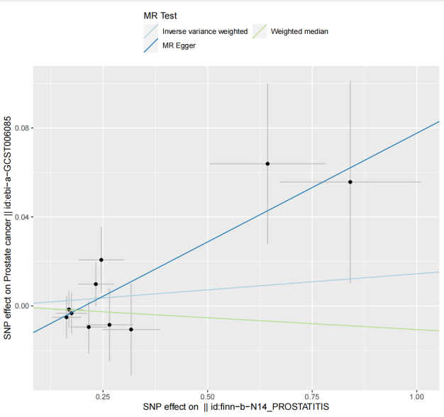  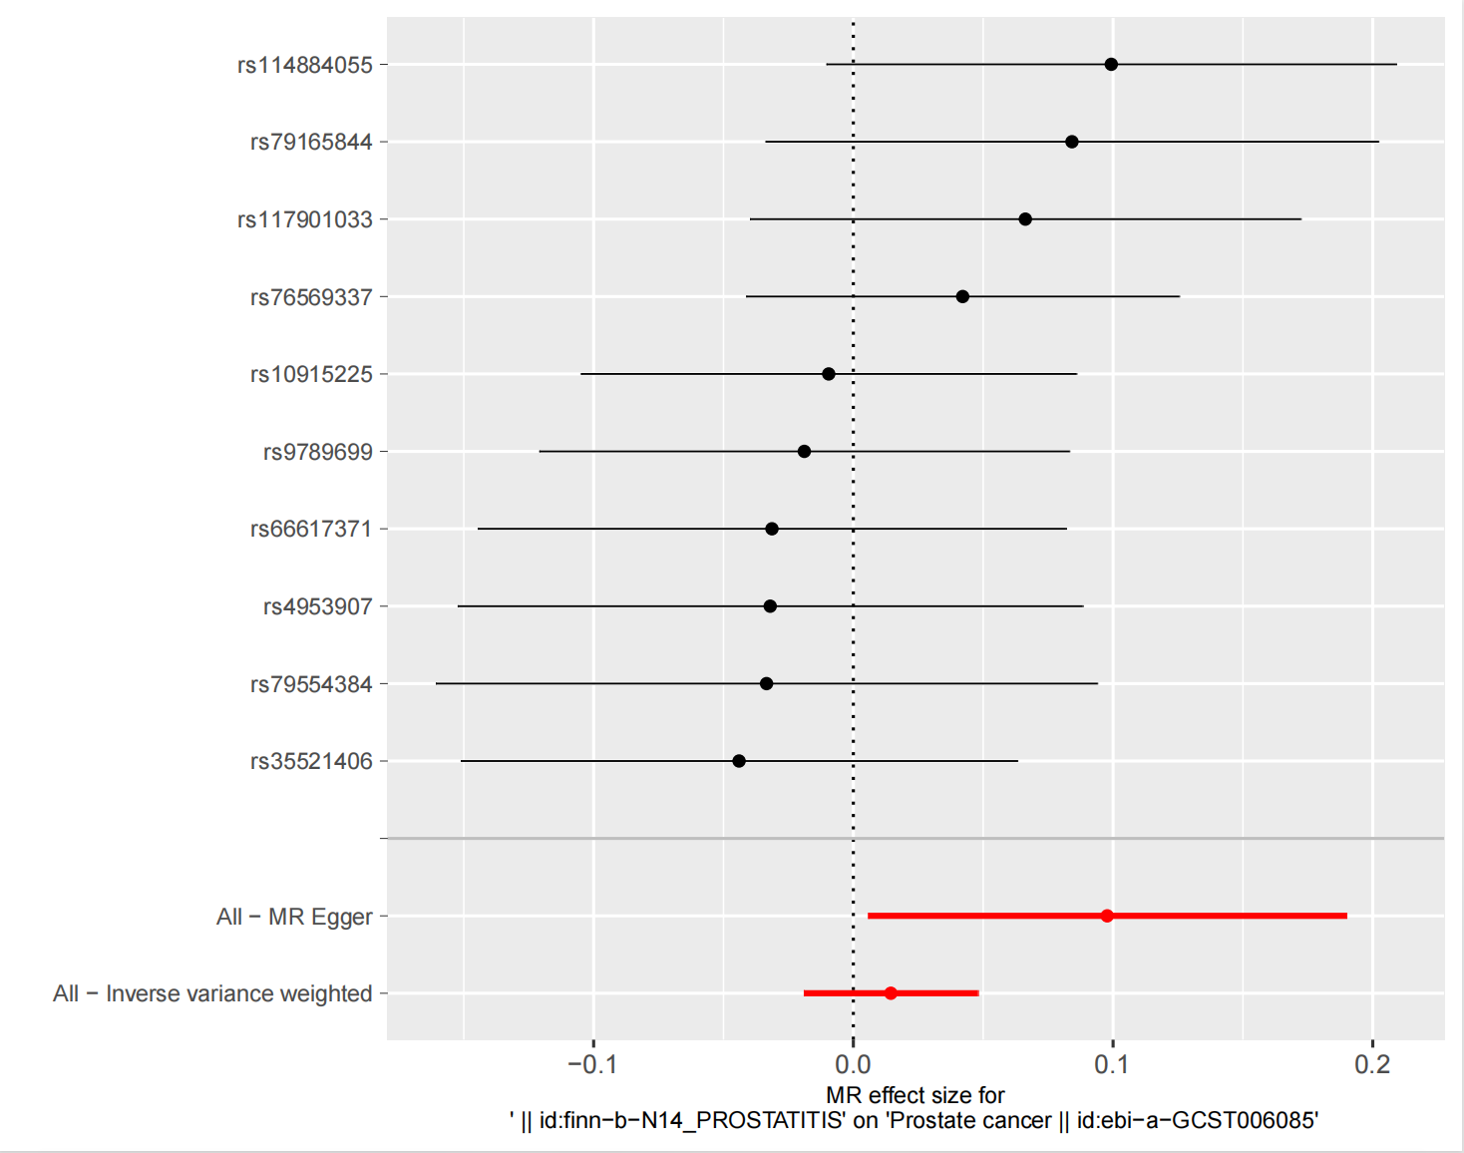  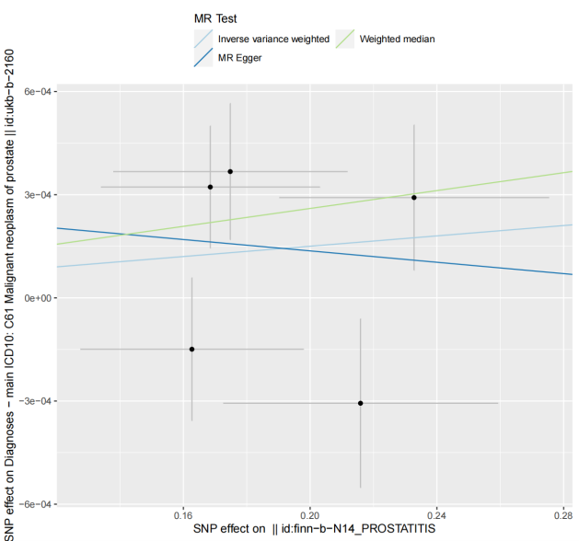  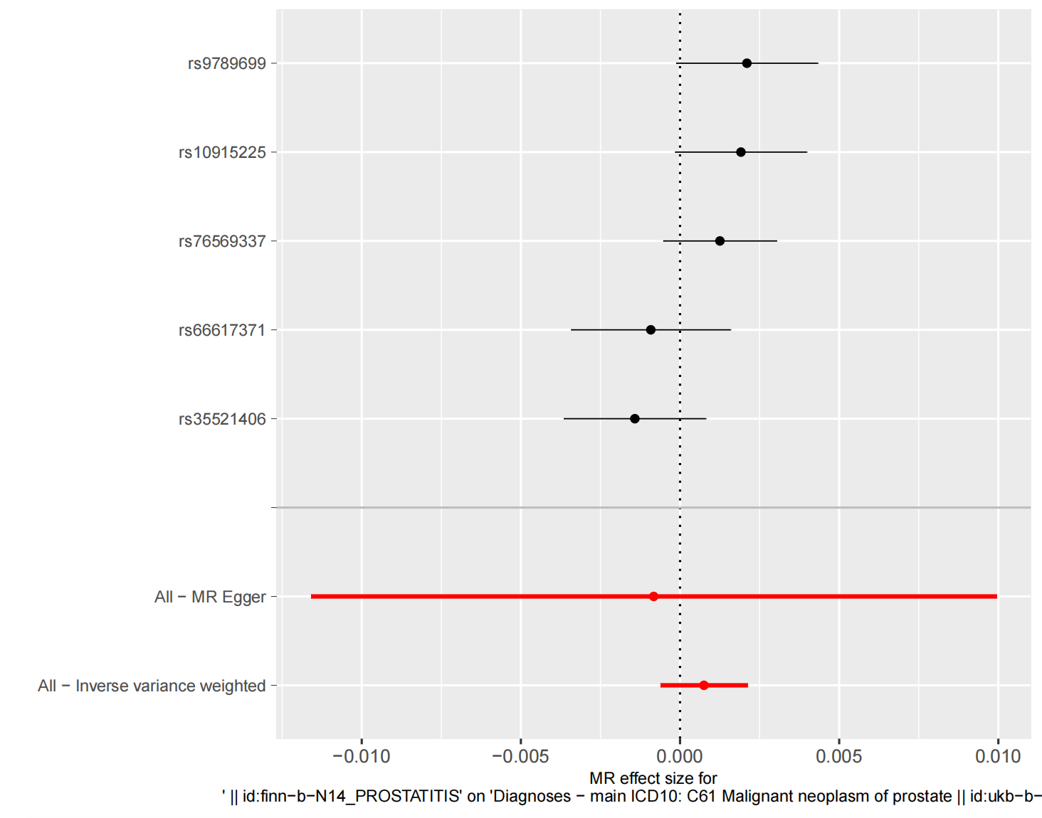
12 | Assessment of assumptions
 | a) | Report the assessment of the validity of the assumptions | 5 | Among the 10 SNPs significantly associated with prostatitis, we found no significant causal relationship between prostatitis and PCa. The IVW results of the prostatitis genomics analysis database and the three PCa genomics analysis databases are as follows (OR: 1.001, 95% CI: 0.999-1.002, p=0.28), (OR: 1.015, 95% CI: 0.981-1.050, p=0.40), (OR: 1.015, 95% CI: 0.981- 1.050, p=0.40). The Cochran Q-test yielded p-values of 0.081, 0.481, and 0.483, signifying the absence of significant heterogeneity in the observed data.
 | b) | Report any additional statistics (e.g., assessments of heterogeneity across genetic variants, such as I², Q statistic or E-value) |  | 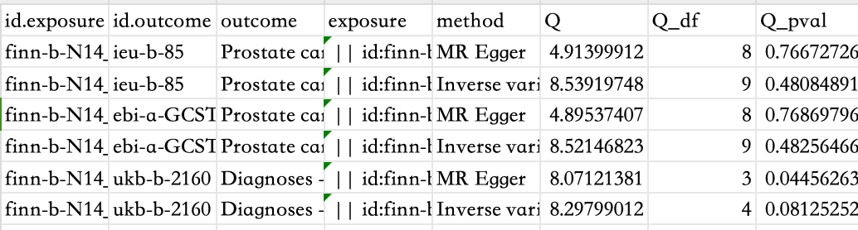
13 | Sensitivity analyses and additional analyses
 | a) | Report any sensitivity analyses to assess the robustness of the main results to violations of the assumptions | 5 | The P-values for the three MR-PRESSOs were 0.154, 0.491, and 0.484, respectively, indicating no indication of the existence of horizontal pleiotropy.  The Cochran Q-test yielded p-values of 0.081, 0.481, and 0.483, signifying the absence of significant heterogeneity in the observed data.  An analysis of leave-one-out demonstrated that after phasing out individual SNPs in the UK Biobank Database (ukb-b-2160), the overall when eliminating rs35521406 results may change24.  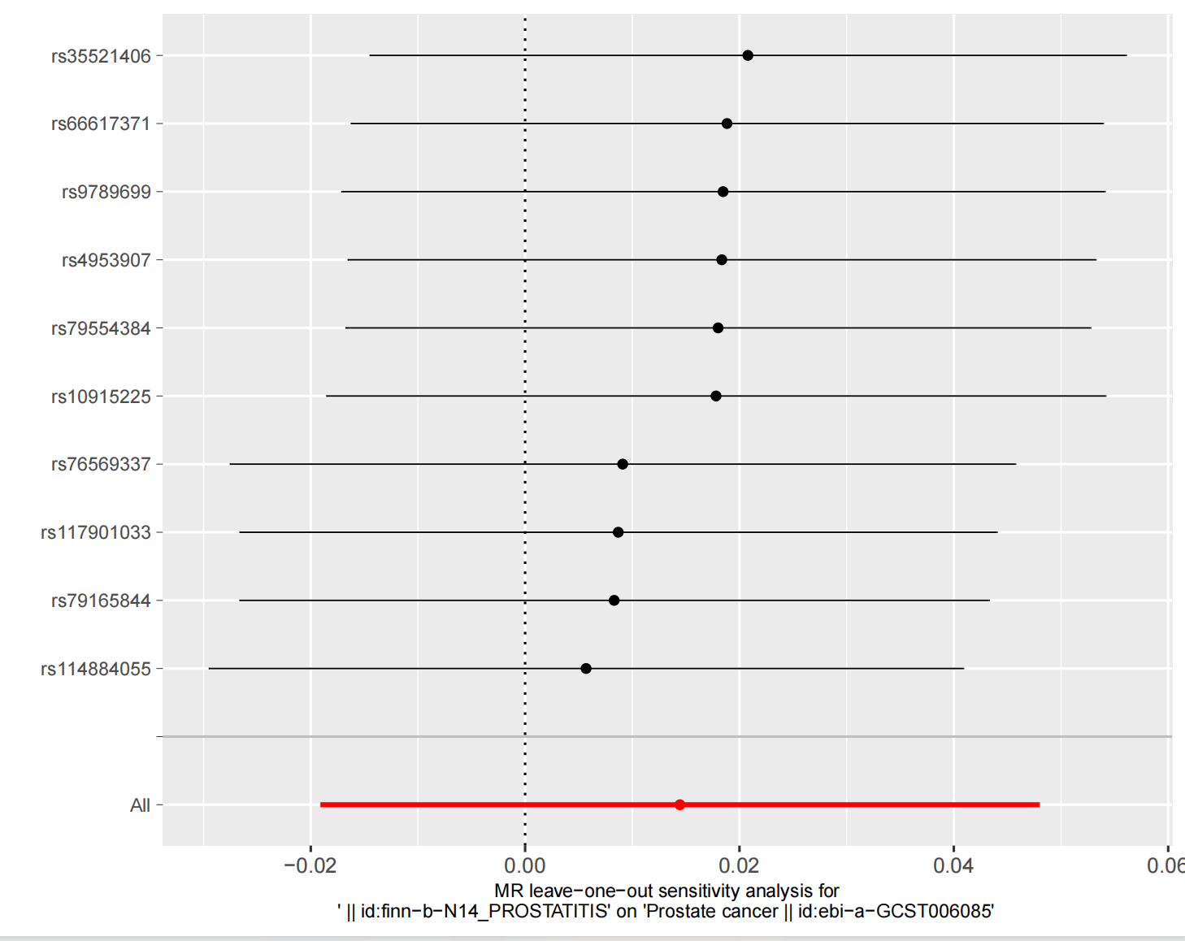  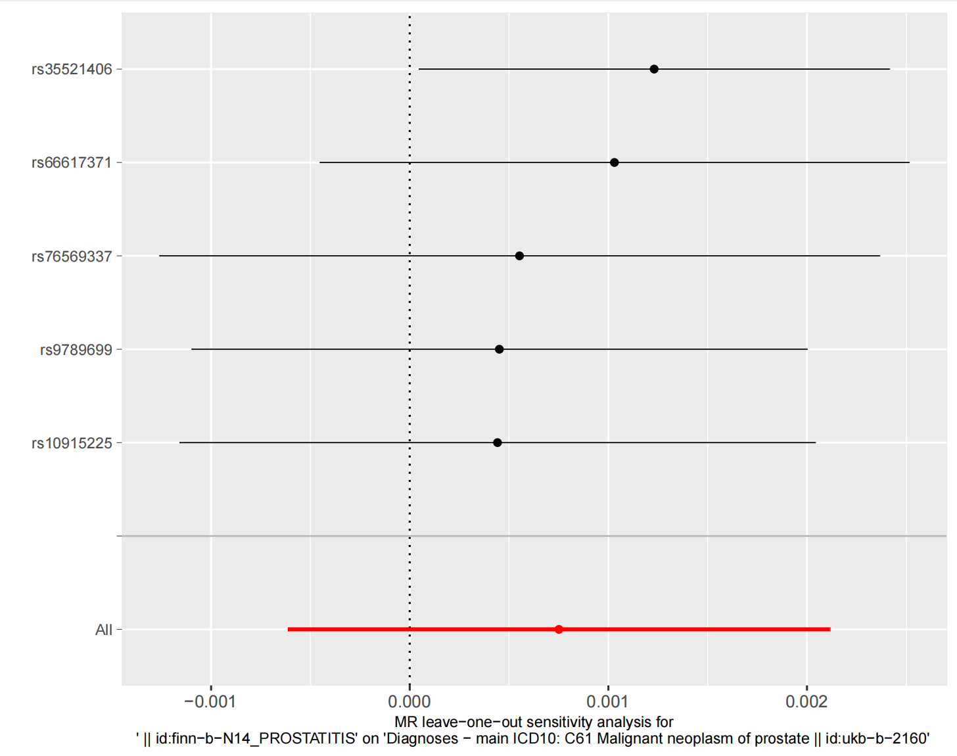
 | b) | Report results from other sensitivity analyses or additional analyses | 5 | 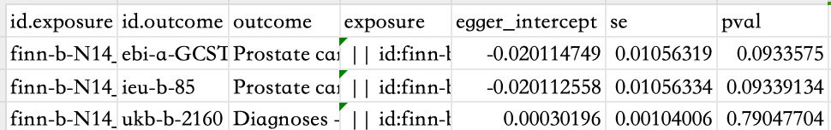  Although there was one MR-Egger p-value of less than 0.05, it did not have much impact on the overall conclusions of the study. The p-values for the test of multiplicity were 0.79, 0.09, and 0.09, indicating that SNPs were not directionally pleiotropy for the three outcomes. The P-values for the three MR-PRESSOs were 0.154, 0.491, and 0.484, respectively, indicating no indication of the existence of horizontal pleiotropy. An analysis of leave-one-out demonstrated that after phasing out individual SNPs in the UK Biobank Database (ukb-b-2160), the overall when eliminating rs35521406 results may change24.
 | c) | Report any assessment of direction of causal relationship (e.g., bidirectional MR) |  | 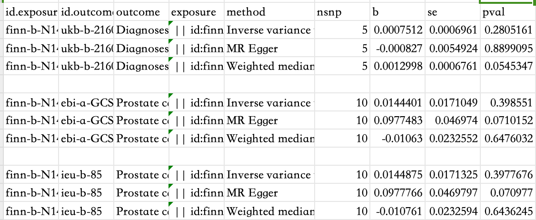
 | d) | When relevant, report and compare with estimates from non-MR analyses |  | No relevant
 | e) | Consider additional plots to visualize results (e.g., leave-one-out analyses)
 | DISCUSSION
14 | Key results | Summarize key results with reference to study objectives | 6 | Currently, no MR has provided credible evidence for the causal causal association of prostatitis with PCa. Thus, we systematically analyzed the results of three GWAS databases, each considering a common exposure factor. These three GWAS databases yielded similar results for the same exposure factor. In conclusion, our analysis indicates no apparent causal link between prostatitis and PCa.
15 | Limitations | Discuss limitations of the study, taking into account the validity of the IV assumptions, other sources of potential bias, and imprecision. Discuss both direction and magnitude of any potential bias and any efforts to address them | 8 | There are also unavoidable limitations to our results52. Although the MR method yielded a negative result, this result only shows that from a purely disease perspective, prostatitis is not a risk factor for PCa. The link from prostatitis to PCa has long been discussed, but the potential causal relationship is still unknown due to conflicting evidence between the two disease53,54.  For the current experiment, an enhancement could be achieved by seeking SNP data related to chronic prostatitis and subsequently conducting additional MR. This would further elucidate whether prostatitis constitutes one of the risk factors for PCa. Furthermore, some circulating inflammatory factors associated with inflammation provide a tumor microenvironment suitable for tumorigenesis for the survival of tumor cells57. Conducting an MR using reextracted prostatitis-associated circulating inflammatory factor SNPs will illustrate the causal link between prostatitis and PCa at the molecular mechanism level58.
16 | Interpretation
 | a) | Meaning: Give a cautious overall interpretation of results in the context of their limitations and in comparison with other studies | 5-6，8 | Conventional observational studies are prone to the influences of selection bias and information bias. To mitigate the inherent limitations of these observational studies, we opted for MR analysis to draw relatively reliable conclusions12,25. Currently, no MR has provided credible evidence for the causal causal association of prostatitis with PCa  This study marks the initial utilization of MR to investigate the risk relationship between prostatitis and PCa. Due to the inherent advantages of MR in exploring the causality of exposure and outcome, the conclusions derived from this study are considered relatively reliable. The connection between prostatitis and PCa remains unclear, warranting further investigation.
 | b) | Mechanism: Discuss underlying biological mechanisms that could drive a potential causal relationship between the investigated exposure and the outcome, and whether the gene-environment equivalence assumption is reasonable. Use causal language carefully, clarifying that IV estimates may provide causal effects only under certain assumptions | 6-7 | Infiltrating inflammatory cells can stimulate various reactive substances, such as reactive oxygen and reactive nitrogen29. These substances can directly or indirectly lead to single-strand or double-strand DNA breaks, damaging protein products in proliferating cells and thereby promoting the growth of cancer cells30,31. There is evidence indicating a close association between prostatitis and PCa. In a comprehensive multi-ethnic and racial cohort study led by Iona Cheng et al., findings revealed that men with a history of prostatitis exhibited a heightened risk of developing PCa in comparison to those devoid of such a medical history (RR = 1.30; 95% CI: 1.10-1.54)32. The risk of PCa demonstrated an escalation with the duration of prostatitis symptoms (P = 0.003)32. Roberts et al. discovered a vital relationship between a history of prostatitis (Types I-III) and PCa, although this association was weaker in a case-control study33. Additionally, there is literature substantiating the early involvement of prostatitis in the development of presumed risk factors/pre-neoplastic lesions for PCa, specifically proliferative inflammatory atrophy (PIA). Within PIA, the proliferating atrophic epithelial cells manifest a regenerative response to cellular injury, exhibiting conspicuous indicators of oxidative stress. It is posited that these cells may occasionally act as direct precursor cells for prostatic intraepithelial neoplasia (PIN) and/or PCa34,35. Prostatitis often instigates the activation of the NF-κB signaling pathway, with this activation recognized as a pivotal mechanism contributing to the initiation and progression of PCa36. The activated NF-κB pathway additionally stimulates the production of a myriad of pro-inflammatory cytokines, encompassing chemokines, interleukin (IL)-8, and vascular endothelial growth factor (VEGF)37,38. This cascade of events facilitates the growth and invasion of tumor cells.  However, some other studies suggested that inflammation has a protective effect on the incidence of PCa44,45. Vasavada and colleagues assessed the relationship between inflammation and the risk of prostate needle biopsy and PCa through a comprehensive literature review and meta-analysis. The findings unveiled a notable association, indicating that the presence of any inflammation was linked to a reduced risk of PCa (OR 0.455, 95% CI 0.337-0.573). Subgroup analysis based on inflammation types indicated that chronic inflammation from 15 studies and acute inflammation from four studies were correlated with a reduced risk of PCa (OR 0.499, 95% CI 0.334-0.665, and OR 0.681, 95% CI 0.450-0.913)44. Another meta-analysis assessed the severity of baseline acute and chronic prostate inflammation, along with inflammation in initially negative prostate biopsies, and the risk of subsequent detection of PCa45. The results revealed a significant correlation between acute and chronic prostate inflammation and a reduced risk of PCa45. Moreira and colleagues assessed the relationship between the presence of prostate atrophy (PA) and chronic prostate inflammation (CPI) within the same biopsy and core, and its association with the risk and grading of PCa in subsequent biopsies. The findings indicate that both PA and CPI are linked to reduced risk and lower grading of PCa46.  Research has found that inflammatory cells can also destroy tumor cells. Activated macrophages, when appropriately stimulated, are a typical component of cancer-related inflammation47. They have the capability to eliminate tumor cells and initiate a destructive inflammatory response concentrated around the walls of blood vessels47,48. Furthermore, there is evidence suggesting the pivotal role of NF-κB in balancing the pro-tumor and anti-tumor characteristics of macrophages49,50. For instance, in a skin tumor model, it was discovered that overexpression of NF-κB inhibited invasive epidermal neoplasia. 51.
 | c) | Clinical relevance: Discuss whether the results have clinical or public policy relevance, and to what extent they inform effect sizes of possible interventions | 8 | This study marks the initial utilization of MR to investigate the risk relationship between prostatitis and PCa. Due to the inherent advantages of MR in exploring the causality of exposure and outcome, the conclusions derived from this study are considered relatively reliable. The connection between prostatitis and PCa remains unclear, warranting further investigation.
17 | Generalizability | Discuss the generalizability of the study results (a) to other populations, (b) across other exposure periods/timings, and (c) across other levels of exposure |  | The GWAS data for this article was taken from a European population and therefore applies primarily to European populations.
 | OTHER INFORMATION
18 | Funding | Describe sources of funding and the role of funders in the present study and, if applicable, sources of funding for the databases and original study or studies on which the present study is based | 10 | This research was funded by the Zhejiang Medical Science and Technology Project (Grant No. 2022507093, and Grant No. 2024KY230), and Hangzhou Health and Technology Project (Grant No. ZD20210043).
19 | Data and data sharing | Provide the data used to perform all analyses or report where and how the data can be accessed, and reference these sources in the article. Provide the statistical code needed to reproduce the results in the article, or report whether the code is publicly accessible and if so, where | 10 | The research uses data that are publicly accessible and can be obtained via references in the manuscript.
20 | Conflicts of Interest | All authors should declare all potential conflicts of interest | 9 | The author of the article affirms the absence of any conflict of interest.
This checklist is copyrighted by the Equator Network under the Creative Commons Attribution 3.0 Unported (CC BY 3.0) license.
1. Skrivankova VW, Richmond RC, Woolf BAR, Yarmolinsky J, Davies NM, Swanson SA, et al. Strengthening the Reporting of Observational Studies in Epidemiology using Mendelian Randomization (STROBE-MR) Statement. JAMA. 2021;under review.
2. Skrivankova VW, Richmond RC, Woolf BAR, Davies NM, Swanson SA, VanderWeele TJ, et al. Strengthening the Reporting of Observational Studies in Epidemiology using Mendelian Randomisation (STROBE-MR): Explanation and Elaboration. BMJ. 2021;375:n2233.

