Supplementary information

First detection of industrial hydrogen emissions using high precision mobile measurements in ambient air
Iris M. Westra^{1,*}, Hubertus A. Scheeren¹, Firmin T. Stroo¹, Steven M.A.C. van Heuven¹, Bert A.M. Kers¹, Wouter Peters^{1,2}, Harro A.J. Meijer¹
¹Centre for Isotope Research (CIO), Energy and Sustainability Research Institute Groningen (ESRIG), University of Groningen, Nijenborgh 6, 9747 AG Groningen, The Netherlands.
²Meteorology and Air Quality, Wageningen University and Research Center, Wageningen, The Netherlands.
Corresponding author* email: i.m.westra@rug.nl

Supplementary information 1
First detection of industrial hydrogen emissions using high-precision mobile measurements in ambient air 1
1: Methods & Materials 2
The GC-PDHID system set-up 2
Flask analysis of H2 on the GC-PDHID 4
Flask analysis of CO2, CH4, and CO on the CRDS-system 5
Road vehicle (passenger car) active AirCore system details 5
Unmanned Aerial Vehicle (UAV) active AirCore system details 7
Active AirCore sample storage and resolution tests 7
Storage time of the car and UAV active AirCore samples 9
Car active AirCore 2-D spatial distribution of a discrete sample 10
UAV active AirCore 2-D spatial distribution of a discrete sample 10
Daily H2 production and emission rates from the Chemical Park Delfzijl 11
Estimating emissions: The Mass Balance approach 11
The inverse Gaussian approach 16
2: Results & Discussion 17
Overview of field campaigns 17
Flask sampling results for H2 25
Selection of photographs taken at the field campaigns 26

1: Methods & Materials

The GC-PDHID system set-up
A schematic view of the gas chromatographic set-up used in this study is shown in Figure S1.
The sample inlet of the Agilent 8890 Gas Chromatograph (GC) is regulated by a switching valve positioned between a 16-port multivalve (Valco Instrument Company (VICI), UW type, ⅛” ports, with M-type rotor) and a direct line to the AirCore. There are three types of samples connected to the 16-port multivalve (see Figure S1). Port 16 facilitates continuous sampling of ambient air via a pump + drier system. Ports 7 through 15 accommodate glass flasks obtained from field campaigns, used for storage experiments, or other purposes. Additionally, ports 1-6 are linked to working (WS) standards or primary standards (PS).
Our GC-system is fitted with two analysis lines, one for H₂ and a separate analysis line with a 5 ml sample loop and specific columns for measuring N₂O and SF₆, those are Agilent S.S. packed pre-column, 4 ft x ³/₁₆" OD x 3 mm, Hayesep-Q, 80-100 mesh, followed by an Agilent S.S. packed analytical column, 6 ft x ³/₁₆" OD x 3 mm, Hayesep-Q, 80-100 mesh equipped with a micro electron capture detector (µECD, Agilent) similar to Van der Laan et al. (2009). Our working standards used for calibration of N₂O are linked to the World Meteorological Organization (WMO) 2006A scale for N₂O. The GC measurements for N₂O have a precision of <0.2 nmol mol⁻¹ or ppb and an absolute accuracy of <0.3 nmol mol⁻¹. We used GC N₂O measurements in the laboratory to study the “Active AirCore sample storage and resolution tests” described further on in the Section 1 of the Supplementary information.

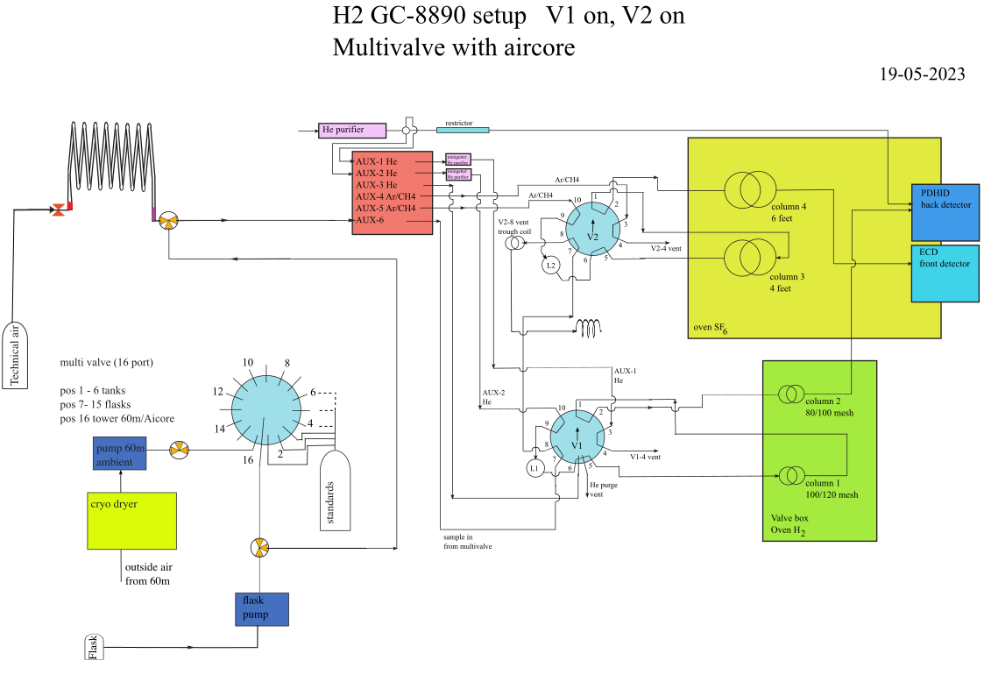
Figure S1: Schematic overview of the GC system with dual detector (PDHID and micro-ECD). For further explanation see text.
The PDHID system functions on pure helium (Helium 5.0, 99.9999% Vol. %, Westfalen) continuously being passed through a heated helium puriﬁer (Model HP-1, Valco Instrument Co. Inc.), and then split by a tee connector into discharge and carrier gas for the GC. Both column sets are positioned in a separate oven at constant temperature (72 ºC for N₂O/SF₆, and at 40 ºC for H₂), through which the sample (Table S1) is absorbed for a certain amount of time before it passes through to the next stage. The retention time (t_{r}), expressed in seconds, corresponds to the time taken by each specific compound to pass through the GC with a certain volume of carrier gas [ml] and flow rate [ml s⁻¹] (Agilent, 2019; McNair et al., 2019). The retention time can be divided into the time passed through the mobile phase and the time spent being absorbed through the stationary phase.

Table S1: Event Table of valve settings for H₂ measurement at inlet position 16. _______________________________________________
Time (min) Event type Position Setpoint
_______________________________________________
0 Multivalve Valve 7 16
1.9 Valve Valve 1/2 ON
4.05 Valve Valve 1 OFF
4.2 Valve Valve 2 OFF
_______________________________________________

After direct ionisation by the voltage pulse or by the liberated electrons of the He carrier gas in the discharge electrode of the PDHID, the resulting electric current is translated into a response signal by the electrometer (Wentworth et al., 1992, 1994). The analog signal produced by the detector is digitised at a sampling frequency of 10 Hz using the Agilent 35900E 24-bit analog-to-digital converter. The final outcome of the detector is visualised as a peak in a chromatogram, shown in Figure S2. The desired mole fraction is thereafter obtained by either integrating the area or calibrating the height of the individual peak and calibrating them to a series of known standards.
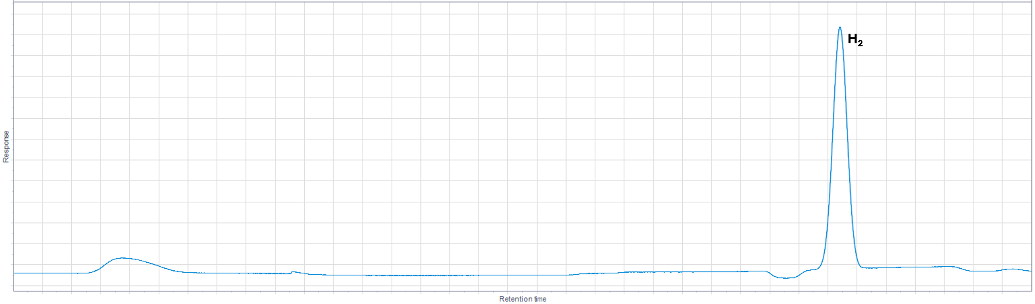
Figure S2: Example chromatogram of the hydrogen mole fraction measurement.

Flask analysis of H₂ on the GC-PDHID
In the field, glass flasks were filled using an inlet drier tube (magnesium perchlorate drier tube of 10 cm x 1 cm diameter), eliminating the need for additional drying before analysis. Connected to our GC-system we deploy a VICI 16-port rotation valve to select between flasks and reference tank samples. Before analysis, the line between the flask and the inlet of the GC is evacuated. Since the flasks are filled at ambient pressure, the sample is delivered to the GC by use of a small KNF pump with a Teflon membrane (PM21972-86, KNF Neuberger Freiburg, DE). A pressure control valve regulates the pressure supplied to the GC set at 0.5 hPa generating a sample flow of 52 ± 2 ml min⁻¹. The flasks are measured in triplicate to achieve optimal precision and accuracy, resulting in an uncertainty of <3 ppb.

Flask analysis of CO₂, CH₄, and CO on the CRDS-system
All mole fraction analyses of CO₂, CH₄, and CO in glass flask air samples were conducted with a cavity ring-down spectrometer (CRDS, Picarro, Inc., CA, USA, model G2401) (Crosson, 2008). To reduce the sample flow for minimal sample consumption the cavity pressure was maintained at 53 hPa (40 Torr) which resulted in a sample flow rate of ~47.5 ml min⁻¹. A flask measurement lasts 8 minutes of which the last 4 minutes is averaged for defining the mole fractions. A VICI 16-port rotation valve is used to select between up to 10 flasks and calibration standards. The CRDS measurements are calibrated using in-house made whole dry air working standards linked to the World Meteorological Organisation X2019 CO₂ scale, the X2004A CH₄ scale for CH₄, and the X2014A CO scale. Typical CRDS measurement precisions are <0.1 μmol mol⁻¹ or ppm, <0.5 ppb, and <1.5 ppb for CO₂, CH₄, and CO, respectively. The absolute scale uncertainties are <0.07 ppm for CO₂, <1 ppb for CH₄ and <2 ppb for CO.

Road vehicle (passenger car) active AirCore system details
For our passenger car experiments, we used a similar AirCore as designed and described by Andersen et al. (2021) and Tong et al. (2023), and for more information, the reader is referred to these papers. During sampling of the AirCore, the online interface can be used to change settings e.g. sampling flow. Furthermore, several parameters are being continuously logged i.e. GPS logging in Latitude-Longitude- coordinates, altitude, height, date and time (with millisecond precision), pump pressure, coil pressure, flow setting, volume sampled, volume in coil and the volume fraction remaining to be filled.
The car Active AirCore consists of three different settings (Figure S3) of operation: analysis & fill, lock, and sampling & cal. In the analysis and fill mode, the pump and dryer inlet are bypassed, for which directly a fill tank is attached to the AirCore to push the gas to the detector. Then turning the 6-port valve one step to the right, the AirCore is locked with none of the valves connected to the inlet and outlet, locking the gathered air in the AirCore. Then during the sampling & calibration (cal) mode, the inlet of the AirCore is connected via a dryer and pump system with a mass flow controller (Bronkhorst IQFlow-200C-AAD-11-V-S). The air passes through the AirCore with a constant sampling flow of either 45 or 60 ml min⁻¹ and is directed to the outlet, filling the total sample volume of ~4.1 L of the AirCore. The orifice on the outlet of the AirCore makes the air leave the AirCore slower than the filling velocity, causing a slow buildup in pressure in the AirCore, resulting in a filled AirCore to an end-pressure of up to 1600 hPa over the course of about 2 hours of sampling, resulting in up to 38 useful discrete samples on the GC-PDHID.
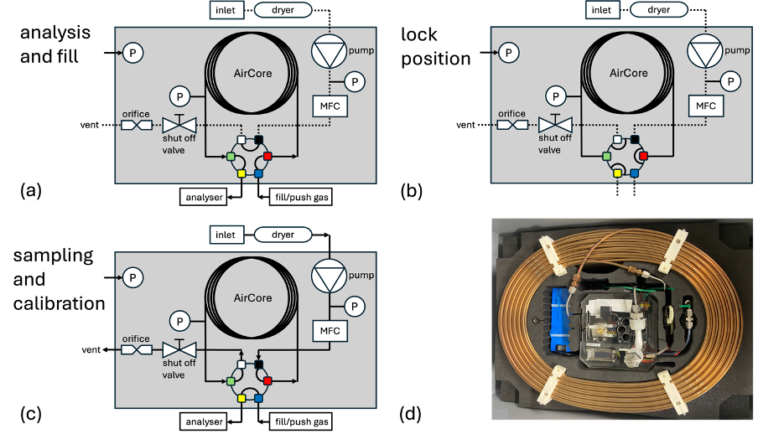
Figure S3: (a) Schematic of UAV AirCore in analysis & fill mode, (b) lock mode (c) sampling & cal mode (d) photograph of the car AirCore.
The Aircore is transported to the laboratory in lock mode and connected to the GC. The inlet of the GC is controlled by a pressure regulator, meaning that always an overpressure needs to be supplied to the GC to keep an internal constant flow. Since the air in the AirCore needs to move at a stable and laminar flow to prevent mixing, the synthetic air (UN1956; 20.5 Vol. % O₂, rest N₂) supplied as push gas is set to a pressure of 2000 hPa during analysis by the GC. The analysis can start when the AirCore pressure is in equilibrium with the push gas at this pressure of 2000 hPa. Synthetic air is chosen for its lack of hydrogen, creating a clear starting and end point of the measurement sequence. The total analysis time by the GC is on average 5.75 h.
During the bracketing of three samples (equation S1), there is a slight pressure gradient in the AirCore due to the delay of the push gas needing to travel through the core. At the third measurement, the AirCore pressure is around 1800 hPa, but during the 7 min sampling time of the standard, the push gas can equilibrate with the AirCore pressure again, to achieve the 2000 hPa pressure before the next sample is taken. This process repeats itself until the AirCore is fully measured. Any potential accordion effect arising from this analysis technique has been thoroughly investigated during the step function storage experiment, which is discussed further in Section 1 under “Active AirCore sample storage and resolution tests”.
1x Tank_{Working Low} - 3x Sample _{AirCore} - 1x Tank_{Working High} - 3x Sample _{AirCore} (S1)

Unmanned Aerial Vehicle (UAV) active AirCore system details
The UAV AirCore is a large version of the one originally described by Andersen et al., 2018. The coil has a volume of 3700 cm³ and is slightly shorter (245 m) than, but otherwise identical to, that of the car AirCore. Pump flow (200 ml min⁻¹) and duration (13 minutes) are set such to almost fill – but never overfill – the AirCore during the expected flight time (12 minutes), for a total sample size of 3250 ml. The sampling rate is regulated by a Swagelok SS-SS2 needle valve that acts as a critical orifice (at the selected flow rate the KNF NMP015 pump can maintain a pressure of <400 hPa downstream of the needle valve). To minimise mass, no active control or logging functionality is included. However, during sampling the UAV itself can register parameters like e.g. GPS signal and battery capacity. Pump start and stop are performed manually just before and after a flight. For the UAV AirCore, there are two settings in which the system can be operated (Figure S4); sampling and analysis. During sampling, air first passes through a drier containing ~10 cm³ of granular magnesium perchlorate. After the flight, the in- and outlet valves are closed, and the UAV AirCore is returned to the lab for analysis. In the lab, the AirCore can be set to analysis mode meaning that the sampling inlet and vent are being bypassed, and the push gas (synthetic air) is attached directly to the AirCore which slowly pushes the air through the analyser. The GC analysis and bracketing methods used for the UAV AirCore are identical to those of the car AirCore.
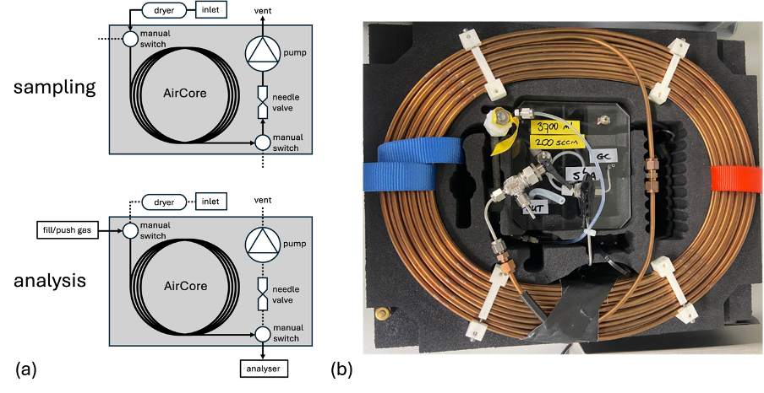
Figure S4: (a) Schematic of the UAV AirCore in sampling and analysis mode, (b) Photograph of the UAV AirCore.

Active AirCore sample storage and resolution tests
Taking molecular and Taylor dispersion into account, as stated in Andersen et al. (2018), the diffusivity within the AirCore is determined by the physical parameters of the AirCore, the sampling flow (laminar vs turbulent), and the molecular diffusivity. Assuming the sampling flow is laminar, and the physical parameters are the same independent of the sampled compound, the only parameter influencing the molecular diffusivity is the effective diffusion coefficient.
The importance of this theoretically determined molecular diffusivity of hydrogen for the trace gas profile was tested via the use of a dual cylinder filling (Figure S5) (step function) test. For the step function, the AirCore was filled step-wise with a zero gas and a dry ambient air sample. After which for a period of 0, 24 and 65 hours the AirCore was closed, to see the remaining resolution in trace gas profile. We chose these time frames because the AirCore in practice is never stored longer than 65 hours (and usually much shorter than 24 hours).
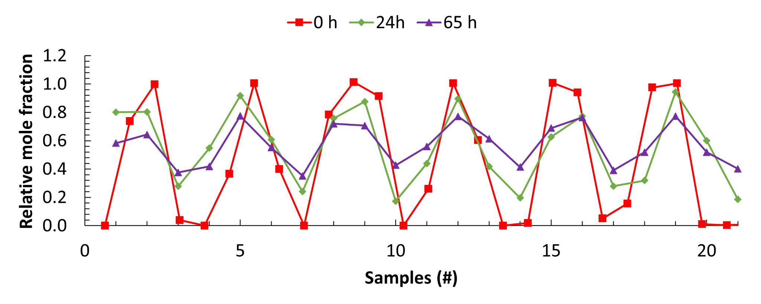
Figure S5: Step function storage experiment, with in red the step function after no storage time, in green after 1 day (24 h) and for purple after 65 h, shown as a relative ratio on the y-axis.
To show the precision of the sample’s resolution, a comparison of a discrete profile could be made with a continuous profile. For the continuous measurements, we used a quantum cascade laser spectrometer (QCLS; Aerodyne Inc., Billerica, MA, USA) that has a similar precision (for N₂O: 1σ = 0.12 ppb at 1 Hz) as the GC but a much higher time resolution. This can be done for any trace gas of interest, in this case, due to instrumental limitations, the N₂O data is used to represent conclusions about H₂. We found that the discrete sampling profile of the GC data follows well along the line of the continuous profile obtained by the QCLS, with two similar fillings, as shown in Figure S6, when plotting the fill duration over time for both profiles. The median difference between the QCLS profile and the corresponding time and mole fractions found for the GC data was 1.2%.
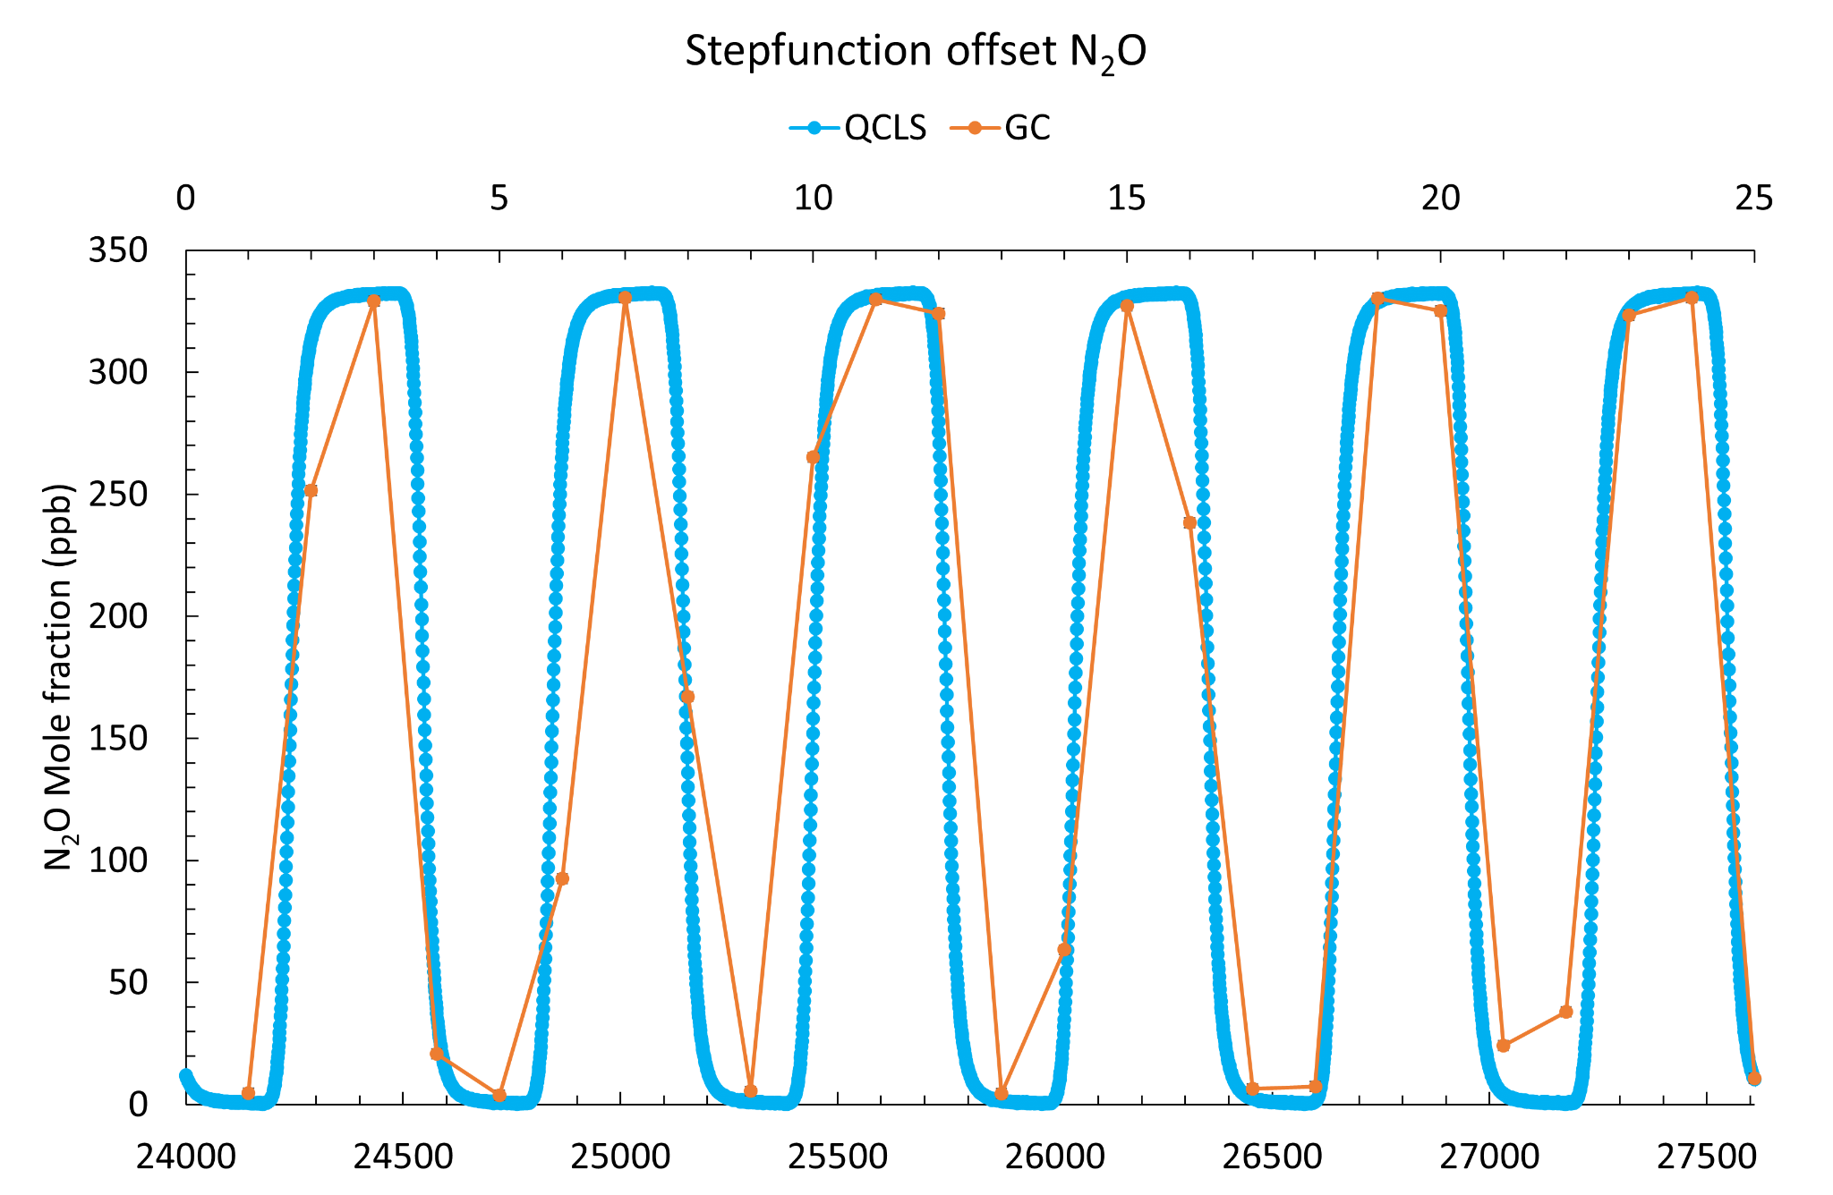
Figure S6: QCLS profile in blue of N₂O (ppb) mole fraction plotted on the y-axis together with the GC resolution of N₂O in orange of the same step function on a similar time scale on the x-axis (in seconds).

Storage time of the car and UAV active AirCore samples
After each field campaign the AirCore sample is brought to the lab to be analysed. Table S2 shows the storage time of the active AirCore samples used in this study before analysis. The shorter the storage time the better the sample is preserved. In the case that both the UAV and the car AirCore were filled, first the UAV was measured as the UAV AirCore volume is smaller and not filled with overpressure, therefore having a shorter analysis time than the car AirCore. For all dates, the storage time was kept to such a minimum, that the enhancement loss was negligible, and no correction factor was necessary.
Table S2: Storage time of the car and UAV active AirCore samples
day | Date  (dd-mm) | Storage time AirCore car  (hours) | Storage time AirCore UAV  (hours)
1 | 04-08 | 0.16
2 | 06-09 | 0.67
3 | 11-09 | 0.75
4 | 05-10 |  | 1.67
5 | 12-10 | 8.33 | 2.5
6 | 17-10 |  | 1.0
7 | 06-12 | 16.83 | 1.16
 | median | 0.75 | 1.42

Car active AirCore 2-D spatial distribution of a discrete sample
For the 2-D spatial interpretation, a translation step is required for going from discrete to continuous samples (and vice versa). The measurement type can be divided into two samples: stationary and mobile. The analysis for the stationary samples is straightforward: the GPS location at which the car stood still for at least a period of one sample is the location of the discrete sample over that sampling time period without any uncertainty.
The analysis of the mobile samples needs some interpretation. Since the car was moving while the sample was collected, the time period corresponding to one discrete sample correlates to a series of different GPS coordinates. The spatial resolution is not only determined by the flight/driving speed during sampling but also by the analysis technique, mainly depending on sampling plus dead volume of the GC. For the H₂ sample loop, we have a volume of 2 ml and a 5 ml sample loop for N₂O-SF₆. The dead volume estimate is 2 ml filled up with a pressure of 1500 hPa. Our total sampling volume is, with a flow of 52 ± 2 ml min⁻¹, 72.4 ml. So in percentage, the spatial allocation of H₂ has a 17% offset.
During the field campaigns in total 76 stationary samples, of which 36 downwind and 40 upwind were collected, and 36 mobile samples consisting of 23 downwind and 13 upwind.

UAV active AirCore 2-D spatial distribution of a discrete sample
For 3 out of 4 days, the UAV flight trajectory was a rapid ascent to maximum altitude followed by a descent in steps of 10 metres to ground level while moving horizontally for ~100 m at each level. With a constant sampling flow of 200 ml min⁻¹, an average over the span of the horizontal distance is correlated back to one discrete data point at each vertical height point, considering the same spatial distribution as for the mobile passenger car samples.
For one specific day (06-12-2023), the UAV flew solely on two heights (40 and 80 m) a horizontal trajectory (of length ~1.8 km) to provide more information about the plume width and the distribution in atmospheric hydrogen mole fractions along this line. For the UAV profiles, the same spatial allocation analysis was performed as for the mobile car samples.

Daily H₂ production and emission rates from the Chemical Park Delfzijl
Through personal communication, a daily H₂ production and consumption rate for each measurement day is given in Table S3, which can be used together with the emission estimate to determine the loss rate.
Table S3: Overview of the estimated production and emission rates used in this study, production rates in g s⁻¹ were deducted from annual numbers.
 | Industry 1 | Industry 1 | Industry 2 | Industry 2 | Industry 3 | Industry 3 | Industry 4
Measure- ment day | Emissions  (g H₂ s⁻¹) | Production/ usage  (g H₂ s⁻¹) | Emissions  (g H₂ s⁻¹) | Production/ usage  (g H₂ s⁻¹) | Emissions  (g H₂ s⁻¹) | Production/ usage  (g H₂ s⁻¹) | Emissions  (g H₂ s⁻¹)
1 | 8 | 127 ± 23 | 0.1 | 110 ± 34 | 0.004 | 0.7 | Unknown
2- 8 | 0 | 127 ± 23 | 0.1 | 110 ± 34 | 0.004 | 0.7 | Unknown

Estimating emissions: The Mass Balance approach
The Mass Balance emission estimate is based on the baseline emissions continuously emitting from the park, so outliers (unrepresentative high values) in the data gathered during the field campaign were discarded based on several parameters. For the Mass Balance emission estimate data points gathered outside the area of interest (the Chemical Park Delfzijl) were excluded from the data set. Furthermore, when we detected short purging/venting events close to a known point source (the hydrogen refuelling station), they were considered unrepresentative for the baseline emission of the park and were therefore excluded. Additionally, the time and location in which the sample was collected was used to filter out data that was collected outside our area of interest (i.e., the Chemical Park Delfzijl), hence not providing any useful information to the emission estimate. We assumed that measured enhancements are well-mixed along a vertical grid perpendicular to the wind direction with a fixed plume height and width. We also assumed that emissions, wind speed and direction remained constant during the measurements.
The atmospheric stability class was determined according to the Pasquill-Gifford scheme, which relies on surface wind speed and solar radiation for daytime sampling (Gifford, 1975). To meet optimal stable atmospheric conditions, we performed our measurements in the early afternoon when the planetary boundary layer is typically at its maximum height and not developing further.
Furthermore, the estimated plume mixing layer depth (m) downwind of the park was based on the mean of different height estimates. Firstly, we used the potential temperature profile inversion height of soundings launched from the nearby German Wadden Sea island of Norderney (~46 km by air) (provided by the University of Wyoming, https://weather.uwyo.edu/upperair/europe.html). Secondly, we used the optical plume dispersion height from various visual smokestacks (photographs in Section 3 of the Supplementary Information) on the park relative to the height of the 150 m high wind turbines around the park. The average of these observation-based approximations yields plume heights between 90 - 200 m on all days (Table S4).
The plume width was defined by the observation-based assumptions using two methods. Firstly, based on the park’s dimensions, dividing it into approximately two sections: part one 1.72 km x 0.69 km and part two 1.27 km x 1.73 km, resulting in a total surface area of 3.38 km². Assuming a fixed park length of 3.45 km, the average park width and subsequently the plume width were calculated to be 0.98 km. We estimated a general plume width for the whole park from the gradient in the data points towards background levels along the measurement trajectory, perpendicular to the wind direction. As such, we yielded a mean plume width of 1.25 ± 0.25 km for all days. Combining the two approaches, the lower limit of method 1 was in accordance with the estimation of method 2. Given the uncertainty in both methods, a plume width of 1.00 km was considered to be a reasonable estimate.
We had no on-site wind speed and direction observations. Instead, for the wind speed (m s⁻¹), i.e. the refresh rate, we used the mean from data collected at 3-metre asl from the nearby KNMI (Royal Netherlands Meteorological Institute) meteorological stations Lauwersoog (53.413 ºN, 6.200 ºE) and Nieuw Beerta (53.196 ºN, 7.150 ºE), from measurements at 20 metre from class 2 ICOS atmospheric measurement station Lutjewad (53.404 ºN, 6.353 ºE) and from the nearby DWD (Deutscher Wetterdienst) Emden meteorological station (53.388 ºN, 7.229 ºE). The meteorological data used in this study can be found in the Supplementary files. As depicted in table S4, the four data sources show a relatively high degree of coherence per day for the daily mean wind speeds. We note that wind speed uncertainty is due to the variability over horizontal distance from the meteorological stations and the wind profile extrapolation considering the power law over vertical distance.
To also account for the influence of obstacles in our study area, we assume a 50% uncertainty for wind speed. This is the maximum value of the range specified by WMO for class 3 meteorological stations, which are required to be at least five times the height of surrounding obstacles. We chose this uncertainty based on an analysis of remote sensing data from 3DBAG (Peters et al., 2022), which revealed that most observations (95 out of 123) within the study area had a minimum distance-to-obstacle-height ratio of 5 compared to surrounding obstacles. The remaining (28 out of 123) observations had a median ratio of 3.83, as shown in Figure S7.

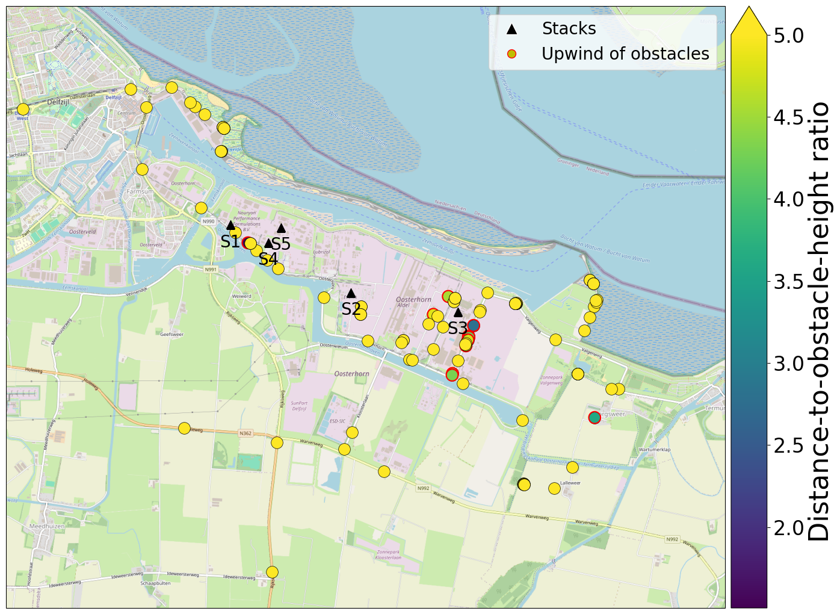
Figure S7: Distance-to-obstacle-height ratio for passenger car Active AirCore observations ranging from purple to yellow. Samples with a minimum ratio below 5, only due to downwind obstacles (within 180 degrees opposite of the wind direction), are encircled in red (N=11) since their wind speed is unlikely to have been affected. The H₂-related industry is denoted with black triangles named stacks.

We have performed an additional sensitivity analysis to assess the impact of excluding the 28 observations, which revealed only minor differences, mostly on 06-09-2023 and 11-09-2023, as shown in Figure S8. Specifically, we found mean median emission rates of 0.84 g/s (inverse Gaussian) and 1.03 g/s (mass balance), compared to the original values of 0.79 and 1.19, respectively. Because the impact of filtering on the mean median emission rates (< 0.2 g/s) is relatively small compared to the error bars in Figure 9, we decided to retain the 28 samples in our emission quantification. This decision was also motivated by our relatively small sample size (N=123), and avoids, for instance, losing the emission estimates for 06-09-2023 due to insufficient measurements meeting the WMO criteria, as seen in Figure S8(b).
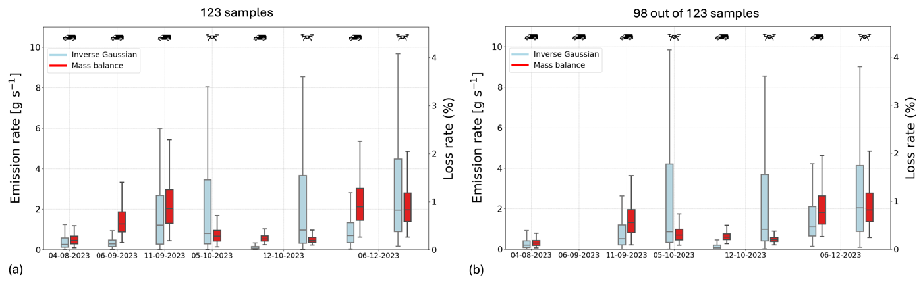
Figure S8: Emission rate estimates and calculated loss rate for H₂ mole fraction from the inverse Gaussian and Mass Balance approach, calculated (a) without WMO-criteria filtering (b) using the distance-to-obstacle-height ratio of 5 (98 out of 123 samples) filtering. Boxplots show the distribution of solutions for each day and data type (car or UAV). Boxes cover the first (Q1) to the third (Q3) quartile of solutions, with the median (Q2) solution in between. The whiskers extend to the rest of the data (except outliers). We define outliers as data points more than 1.5 times the interquartile range (IQR) below Q1 or above Q3. These are not shown to improve readability.
The wind direction was based on the same data as the wind speed. For the mass balance, we assume a wind direction perpendicular to the mixing layer plane, to which we assign a random deviation of ±30 degrees for crosswind correction (cosine(θ) in equation (1)). Furthermore, we assumed the emissions to be well mixed throughout the mixing layer plane downwind of the park.
We run the Mass Balance model using a Monte Carlo approach to account for uncertainties within the selected parameter ranges. We used the wind speed and direction from Table S4. Furthermore, we used plume widths of 1.00 ± 0.25 km combined with the mean plume heights from Table S5 with a random uniform uncertainty of ± 20% (Gerbig et al., 2008). Finally, we applied jack-knifing to our Mass Balance approach, by randomly removing 20% of the samples if at least 3 samples were present in a dataset, and then taking the mean enhancement from which we calculated the Mass Balance emission estimate. For all samples, we ran the simulation 500 times to sufficiently explore parameter space. We also tested larger sample sizes but found no significant impact on the distribution.
Table S4: During the field campaigns different sampling devices were used, AirCore UAV means the active AirCore system combined with the UAV, and AirCore car means the active AirCore system sampling via the use of a passenger car. Furthermore, the environmental conditions, id est the mean wind speed, the atmospheric stability class, the mean wind direction and solar radiation are given.

Measure-ment day | Date  (dd-mm)  (year: 2023) | Sampling device used | Mean wind speed (m s⁻¹) | Atmospheric stability class | Mean Wind direction  (degrees) | Solar radiation  (W m⁻²)
1 | 04-08 | AirCore car | 6.2 ± 1.3 | D | 312 ± 28 | 493.7
2 | 06-09 | AirCore car | 4.6 ± 1.1 | B-C | 140 ± 48 | 643.6
3 | 11-09 | AirCore car, Flasks | 5.8 ± 1.7 | C-D | 242 ± 34 | 576.0
4 | 05-10 | AirCore UAV, Flasks | 5.4 ± 1.0 | D | 280 ± 14 | 200.7
5 | 12-10 | AirCore UAV & car, Flasks | 1.8 ± 0.6 | B | 355 ± 63 | 273.8
6 | 17-10 | AirCore UAV | 3.3 ± 1.1 | B-C | 128 ± 35 | 392.3
7 | 06-12 | AirCore UAV & car, Flasks | 3.9 ± 1.8 | C | 308 ± 40 | 37.3
Table S5: For each of the field campaigns, input parameters for the inverse Gaussian and Mass Balance approach were determined, mean MBL (sounding, visual), plume width and mixing height.

Measurement day | Date  (dd-mm) | Mean MBL  (m)  visual | Mean MBL  (m)  sounding | Plume width  (km) | Mixing height (m)  (± 20%)
1 | 04-08 | no plume visible | 105 | 1.25 ± 0.25 | 90 ± 18
2 | 06-09 | no plume visible | 187 | 1.12 ± 0.25 | 200 ± 40
3 | 11-09 | no plume visible | 100 | 1.25 ± 0.25 | 110 ± 22
4 | 05-10 | > 120m  From measurement UAV | 183 | n.a. | 120 ± 24
5 | 12-10 | > 140m  From measurement UAV | 117 | 0.99 ± 0.25 | 150 ± 30
6 | 17-10 | n.a. | n.a. | n.a. | n.a.
7 | 06-12 | 90 | 95 | 1.6 ± 0.25 | 90 ± 20
8 | 20-12 | 80 | 62 | n.a. | n.a.

The inverse Gaussian approach
With the inverse Gaussian approach the emission rate was calculated for each passenger car (N=5) and UAV dataset (N=3), by optimising Q for the 5 emission sources, under the requirement that emissions always must be positive (Q>0). We did this by minimising a cost function (equation S3) with the optimize.minimize function from the SciPy library.

$J(x)=\frac{(C(x)-Y)^{2}}{(Error_{min} + (Y ⋅ Error_{obs})^{2}}$ (S3)

In the cost function (J), x is the state vector which contains emission rates for the 5 point sources (Q₁, Q₂, Q₃, Q₄, Q₅,) in [g s⁻¹], and C (x) and Y are the modelled and measured enhancements in [ppb], respectively. We calculated the observed enhancements by subtracting the background from the measured mole fractions. The background was defined as the 10th percentile of upwind measurements for passenger car data and the 10th percentile of the entire vertical profile for UAV data. To mimic the active section “Car active AirCore 2-D spatial distribution of a discrete sample” in Section 1 of the Supplementary information, we ran the Gaussian Plume dispersion model over the 73-93th time coordinate per sample (see “Car active AirCore 2-D spatial distribution of a discrete sample” in section 1: Methods & Materials), we took the average over this, and assigned it to the 83th time coordinate to obtain C. Finally, Error_{min} [ppb] and Error_{obs} [1] are the minimum and relative error (i.e. slope) of the observations, with values of 10 ppb and 0.05, respectively.
We run the optimization in a Monte Carlo approach (N=500 simulations) to account for parameter uncertainties and to ensure not only local minima are found. We randomly draw parameters from a uniform distribution within specified ranges. In the Monte Carlo simulation, we include two emission height classes which we assign to sources (Q₁, Q₂, Q₃) and (Q₄, Q₅) based on the AHN3 digital elevation model, and randomly assign values between 5-20 and 50-100 m for these classes, respectively. We also randomly attribute unstable, slightly unstable or neutral atmospheric conditions, given the uncertainty in atmospheric stability. Similar to the Mass Balance approach, we use the mean wind speeds from Table S4 combined with a random uncertainty of 50%. We also use the wind directions from Table S4, to which we assign a random deviation of ±30, which is close to the mean wind direction standard deviation of 37 degrees in Table S4. Finally, we apply jackknifing to all of our data by randomly selecting 20% of the samples and removing them, as long as at least 3 samples are present in a dataset. We keep optimising each car and drone dataset until we find 500 solutions with a positive correlation between measured and simulated enhancements. This criterion prevented single outliers that were poorly simulated from dominating the fit.
We report emissions for the total park (Q1, Q2, Q3, Q4 and Q5) as we could not constrain individual emission sources. Key sources of uncertainty for the inverse Gaussian approach include the meteorological conditions such as wind speed, wind direction and stability class (see e.g. Andersen et al., 2018; Vinković et al., 2022), source locations and emission height. Emission height is likely also subject to temporal variation since venting and purging are known to occur via dedicated flare towers, and high mole fractions of H₂ are possibly self-buoyant (McCarty et al., 1981), although little research has been done on the latter.

2: Results & Discussion

Overview of field campaigns
In this section we give an overview of all the gathered data at the Chemical Park Delfzijl sampled with the car AirCore and UAV AirCore. The trace gas profile per sampling day was given in Figures S9-S17.
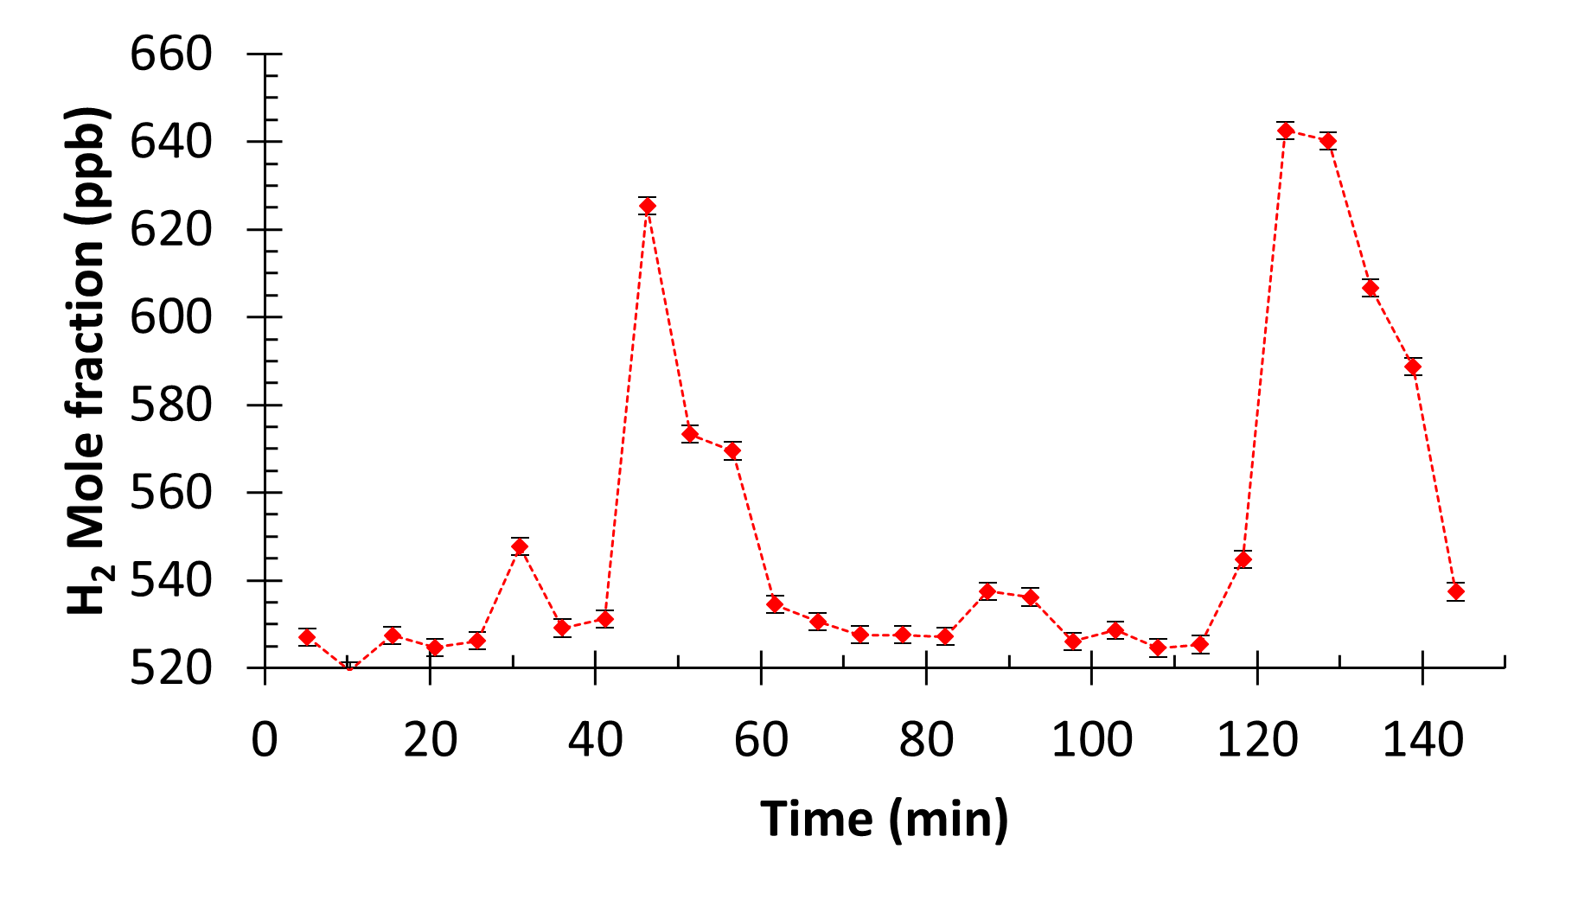
Figure S9: Trace gas profile from the AirCore (car) sampled on 04-08-2023, with the H₂ mole fraction (in ppb) plotted on the y-axis and the sampling time (minutes) on the x-axis. The error bar denotes the measurement precision of 2 ppb.
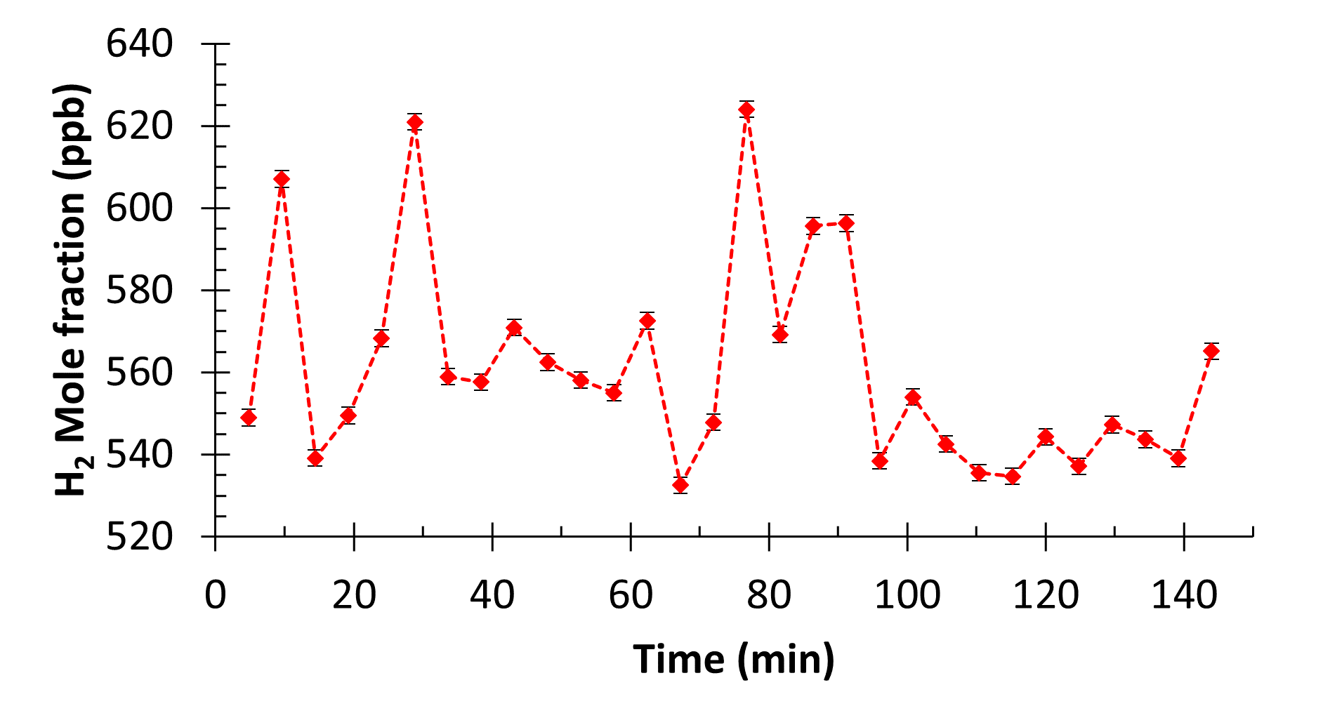
Figure S10: Trace gas profile from the AirCore (car) sampled on 06-09-2023, with the H₂ mole fraction (in ppb) plotted on the y-axis and the sampling time (minutes) on the x-axis. The error bar denotes the measurement precision of 2 ppb.
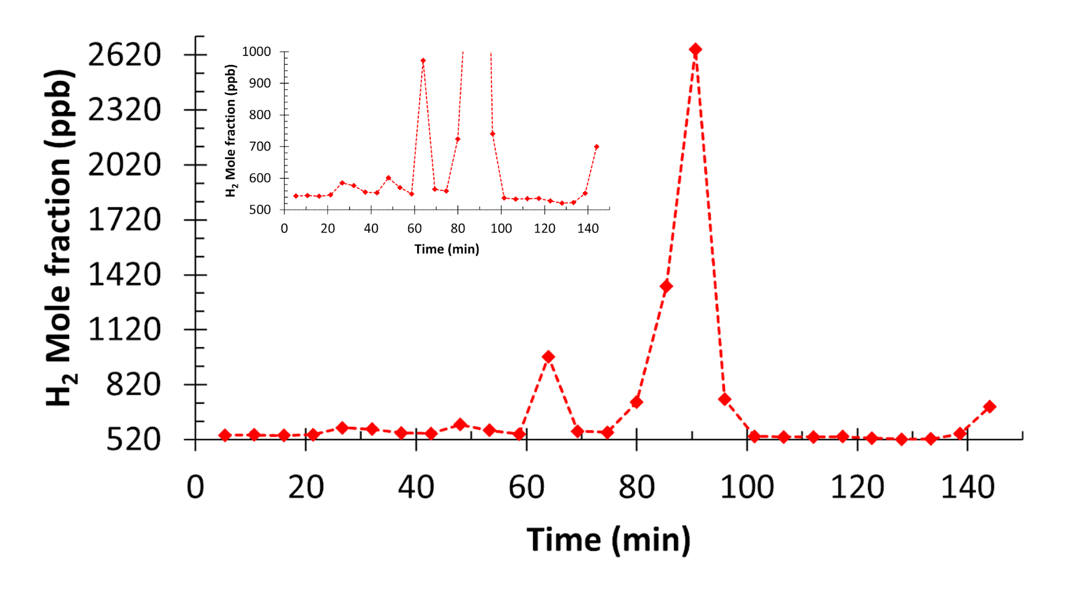
Figure S11: Trace gas profile from the AirCore (car) sampled on 11-09-2023, with the H₂ mole fraction (in ppb) plotted on the y-axis and the sampling time (minutes) on the x-axis. Within the figure there is an inlay graph zoomed upon the first 1 ppm H₂ mole fraction. The measurement precision error of 2 ppb falls within the data point.
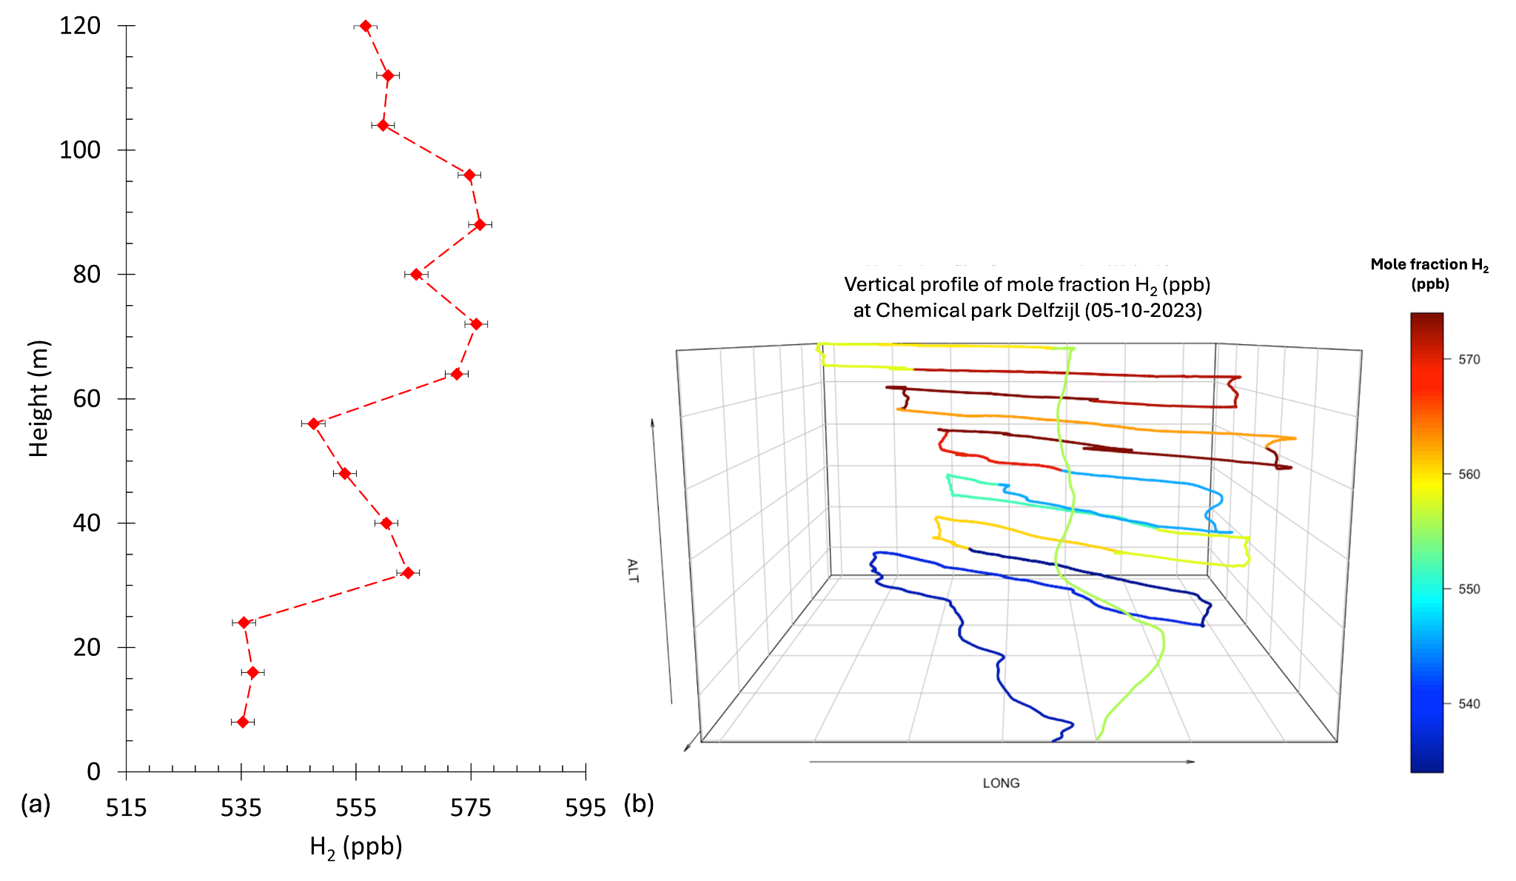
Figure S12: Trace gas profile from the AirCore (UAV) sampled on 05-10-2023, (a) with the H₂ mole fraction (in ppb) plotted on the x-axis and the height of the y-axis, (b) the H₂ mole fraction (in ppb) from background (blue) to enhanced (red) along the Long-Lat and altitude coordinates. The error bar denotes the measurement precision of 2 ppb.
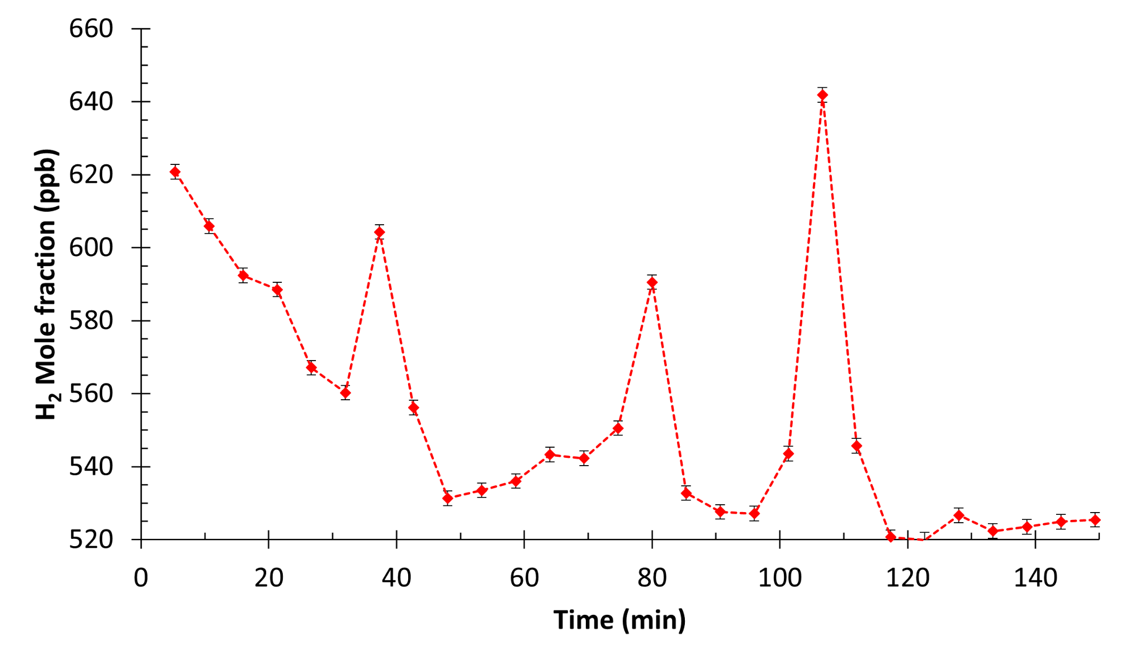
Figure S13: Trace gas profile from the AirCore (car) sampled on 12-10-2023, with the H₂ mole fraction (in ppb) plotted on the y-axis and the sampling time (minutes) on the x-axis. The error bar denotes the measurement precision of 2 ppb.
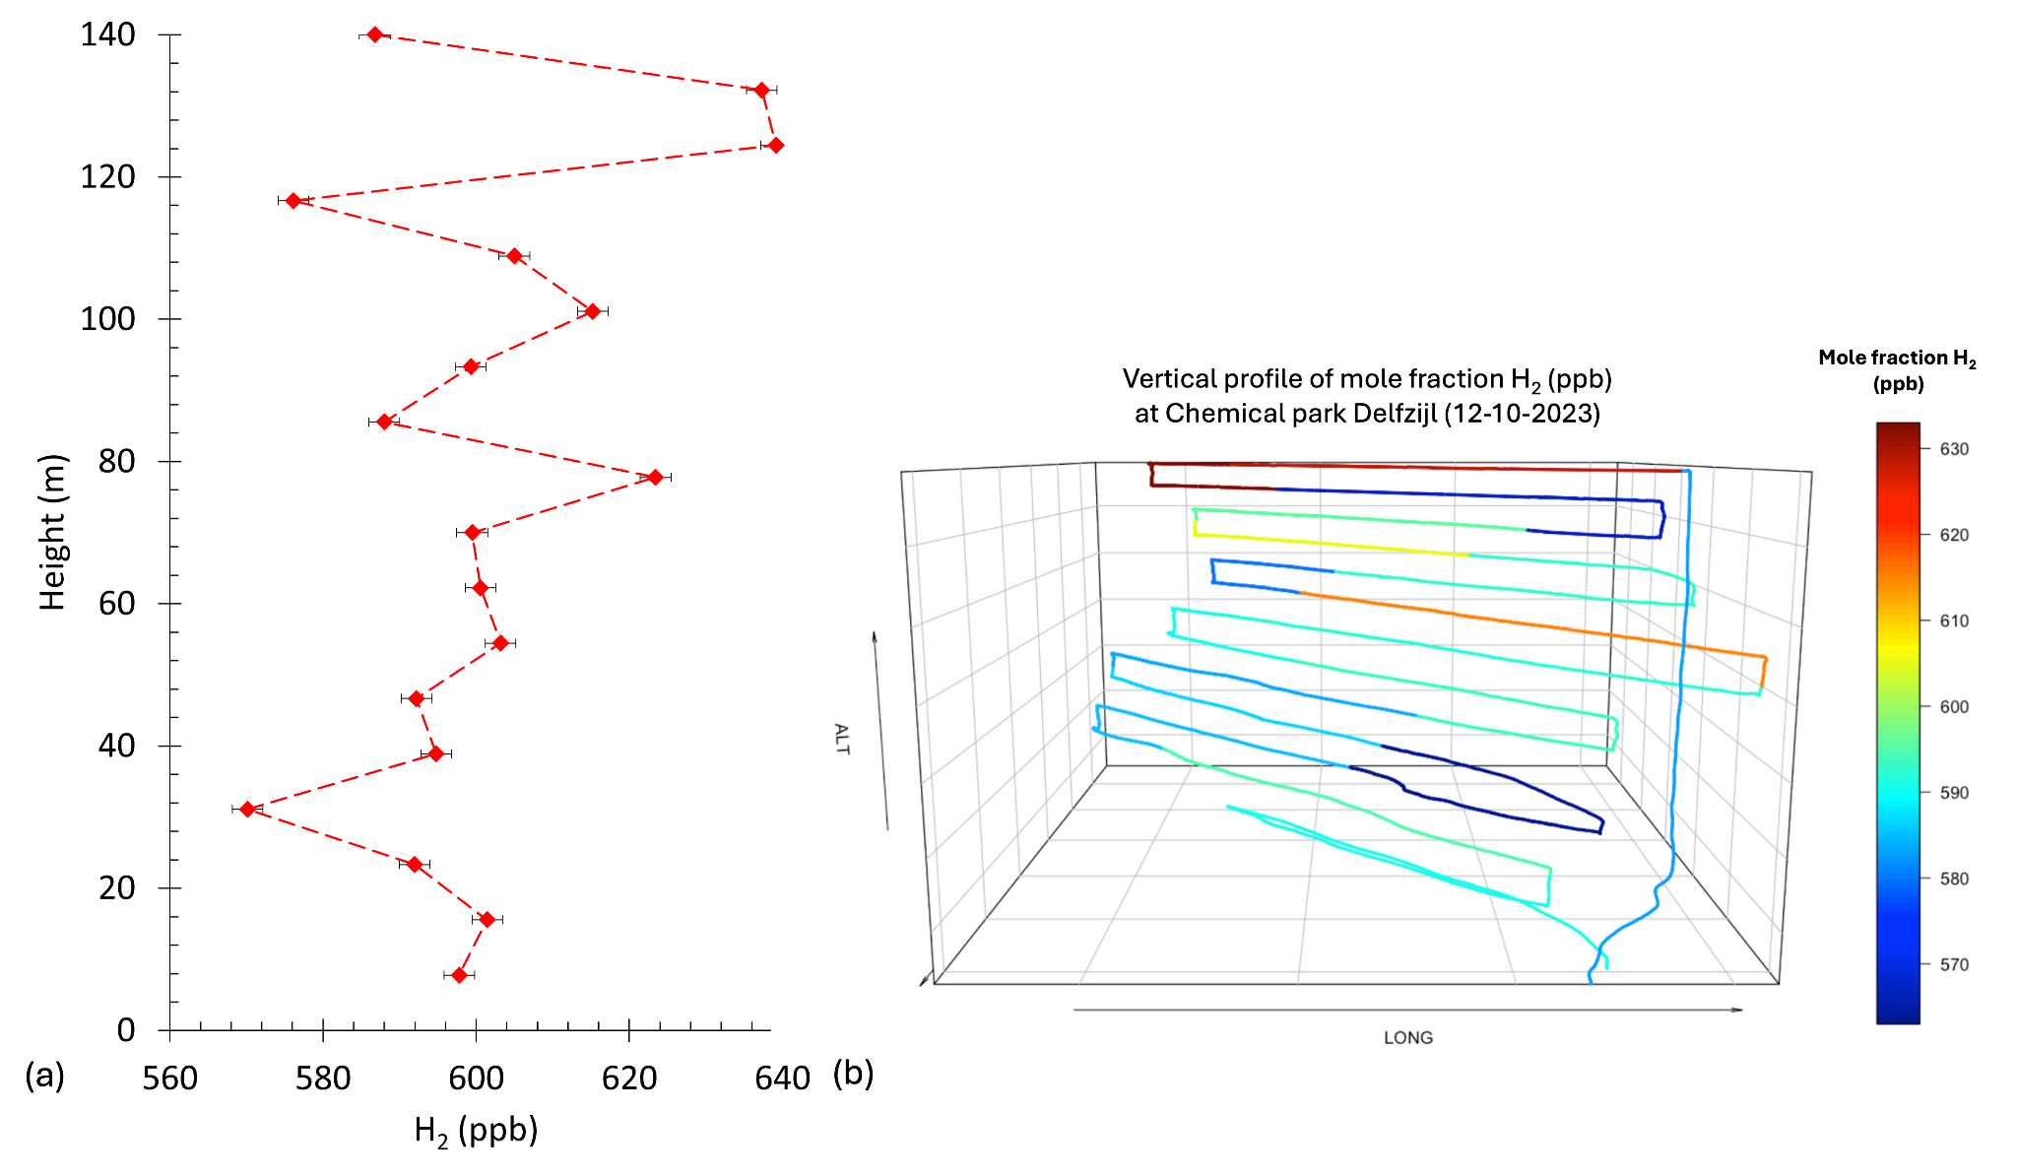
Figure S14: Trace gas profile from the AirCore (UAV) sampled on 12-10-2023, (a) with the H₂ mole fraction (in ppb) plotted on the x-axis and the height of the y-axis, (b) the H₂ mole fraction (in ppb) from background (blue) to enhanced (red) along the Long-Lat and altitude coordinates. The error bar denotes the measurement precision of 2 ppb.
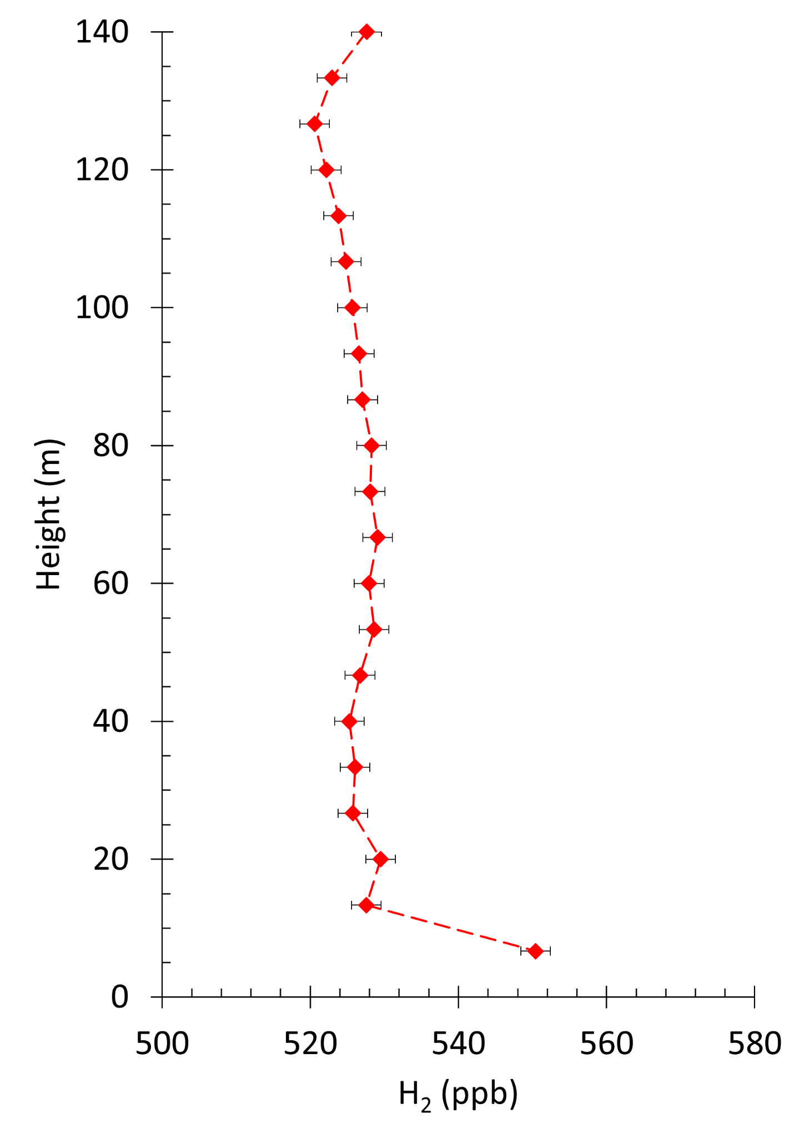
Figure S15: Trace gas profile from the AirCore (UAV) sampled on 17-10-2023, with the H₂ mole fraction (in ppb) plotted on the y-axis and the sampling time (minutes) on the x-axis. The error bar denotes the measurement precision of 2 ppb.
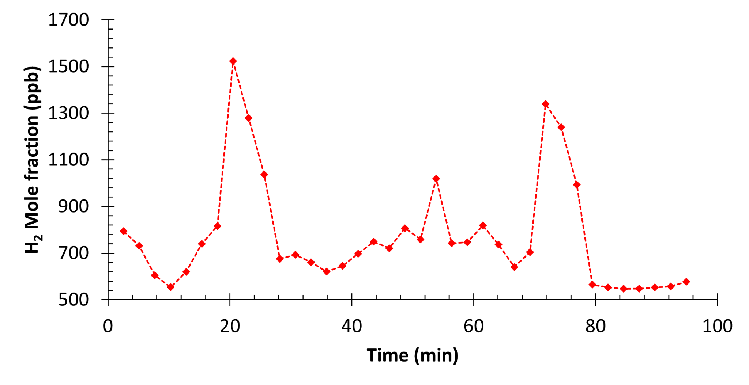
Figure S16: Trace gas profile from the AirCore (car) sampled on 06-12-2023, with the H₂ mole fraction (in ppb) plotted on the y-axis and the sampling time (minutes) on the x-axis. The measurement precision of 2 ppb falls within the data point.
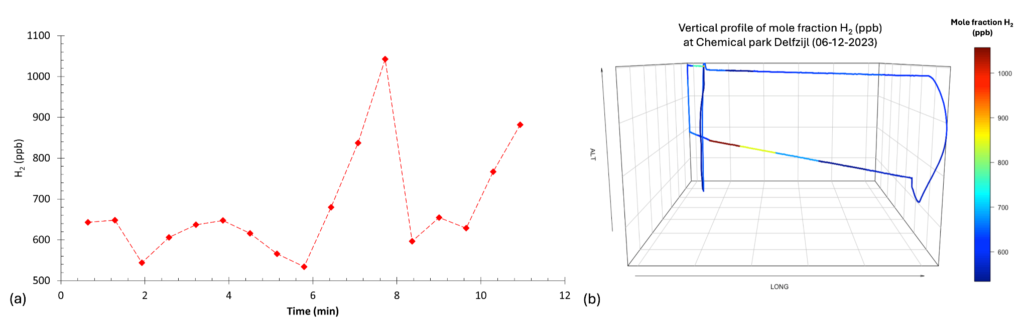
Figure S17: Trace gas profile from the AirCore (UAV) sampled on 06-12-2023, (a) with the H₂ mole fraction (in ppb) plotted on the y-axis and the time (minutes) on the x-axis, (b) the H₂ mole fraction (in ppb) from background (blue) to enhanced (red) along the Long-Lat and altitude coordinates. The measurement precision of 2 ppb falls within the data point.

As described in section 1 of the Supplementary information (Estimating emissions: The Mass Balance approach), from the figures given above some data points are filtered out, according to a given set of constraints as described earlier. The resulting data points eliminated from the data sets (UAV and car) are given in Table S6. The total data set can be found in the supplementary information, for which in column “Filtered_mass_balance” the 0 indicates not filtered and vice versa for 1.
Table S6: Filtered data used for the emission estimate calculated by the Mass Balance approach.
Date  (dd:mm) | Time  (hh:mm:ss) | Number of sample (#) | Mole fraction (ppb) | Reason | Type of measurement
04-08 | 11:49:14 | 21 | 522.2 | Outside area of interest | car
04-08 | 11:53:29 | 22 | 523.9 | Outside area of interest | car
04-08 | 11:57:43 | 23 | 544.4 | Outside area of interest | car
04-08 | 12:01:58 | 24 | 646.3 | Outside area of interest | car
04-08 | 12:06:12 | 25 | 643.8 | Outside area of interest | car
04-08 | 12:10:27 | 26 | 608.1 | Outside area of interest | car
04-08 | 12:14:41 | 27 | 589.5 | Outside area of interest | car
04-08 | 12:18:56 | 28 | 536.9 | Outside area of interest | car
06-09 | 12:46:27 | 1 | 546.7 | Outside area of interest | car
06-09 | 12:50:39 | 2 | 610.1 | Outside area of interest | car
06-09 | 12:54:51 | 3 | 537.8 | Outside area of interest | car
06-09 | 12:59:03 | 4 | 548.5 | Outside area of interest | car
06-09 | 14:31:33 | 26 | 535.3 | Outside area of interest | car
06-09 | 14:35:45 | 27 | 545.8 | Outside area of interest | car
06-09 | 14:39:57 | 28 | 541.6 | Outside area of interest | car
06-09 | 14:44:09 | 29 | 537.3 | Outside area of interest | car
06-09 | 14:48:21 | 30 | 563.6 | Outside area of interest | car
11-09 | 13:32:48 | 1 | 543.7 | Outside area of interest | car
11-09 | 13:37:36 | 2 | 546.0 | Outside area of interest | car
11-09 | 13:42:25 | 3 | 544.4 | Outside area of interest | car
11-09 | 13:47:13 | 4 | 546.9 | Outside area of interest | car
11-09 | 13:52:02 | 5 | 584.6 | Outside area of interest | car
11-09 | 13:56:51 | 6 | 575.9 | Outside area of interest | car
11-09 | 14:01:39 | 7 | 555.8 | Outside area of interest | car
11-09 | 14:06:28 | 8 | 555.7 | Outside area of interest | car
11-09 | 14:11:16 | 9 | 600.5 | Outside area of interest | car
11-09 | 14:16:05 | 10 | 570.9 | Outside area of interest | car
11-09 | 14:20:53 | 11 | 551.2 | Outside area of interest | car
11-09 | 14:25:42 | 12 | 975.4 | No baseline emissions (event; possible venting) | car
11-09 | 14:44:56 | 16 | 1362.6 | No baseline emissions (event; possible venting) | car
11-09 | 14:49:44 | 17 | 2679.5 | No baseline emissions (event; possible venting) | car
11-09 | 15:42:38 | 28 | 495.3 | Technical air contamination | car
06-12 | 13:57:10 | 8 | 1527.7 | No baseline emissions (event; possible venting) | car
06-12 | 13:59:35 | 9 | 1280.7 | No baseline emissions (event; possible venting) | car
06-12 | 14:02:00 | 10 | 1034.0 | No baseline emissions (event; possible venting) | car
06-12 | 14:28:35 | 21 | 1014.4 | No baseline emissions (event; possible venting) | car
06-12 | 14:45:30 | 28 | 1346.3 | No baseline emissions (event; possible venting) | car
06-12 | 14:47:55 | 29 | 1242.7 | No baseline emissions (event; possible venting) | car
06-12 | 14:50:20 | 30 | 992.2 | No baseline emissions (event; possible venting) | car
06-12 | 13:50:09 | 11 | 847.6 | Contamination from industrial plant outside area of interest | UAV
06-12 | 13:50:44 | 12 | 1057.9 | Contamination from industrial plant outside area of interest | UAV

Flask sampling results for H₂
Consistent with the AirCore data (UAV and passenger car), the flasks data show a clear atmospheric background hydrogen mole fraction for the upwind data (539 ± 5 ppb) and enhanced atmospheric hydrogen mole fraction for the downwind locations with mole fractions up to 562 ± 15 ppb.
The data points from the AirCore car and flasks with matching spatial coordinates have been averaged into downwind and upwind H₂ mole fractions. The variability in the downwind H₂ mole fractions (Figure S18) is mostly from the variability in the signal spread out over the park, while the low variability for the upwind H₂ mole fractions shows the consistency and stability of the atmospheric hydrogen background mole fraction.
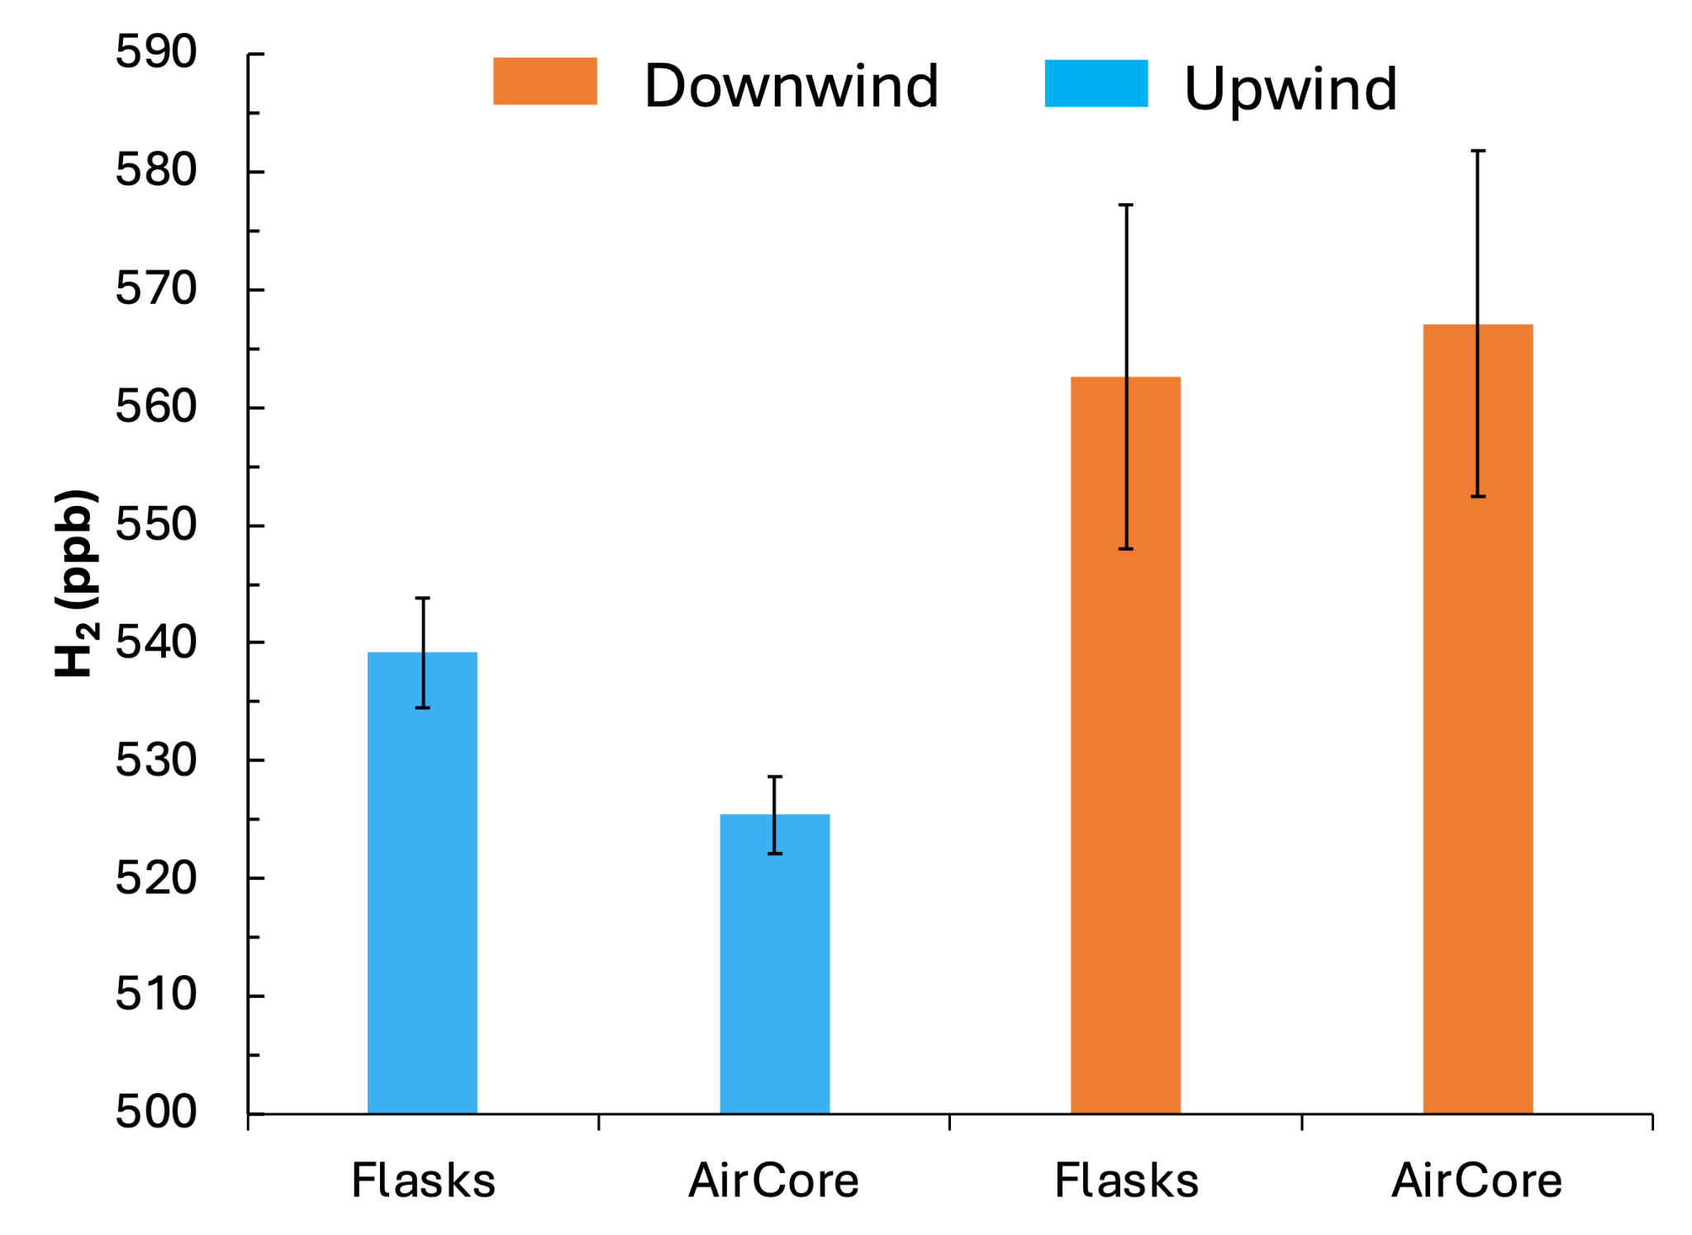
Figure S18: Median H₂ mole fraction expressed on the y-axis derived from the flasks and active AirCore passenger car data for downwind conditions in orange and upwind in blue. The error bars denote the measurement variability given by the 1σ standard deviation.

Selection of photographs taken at the field campaigns
For the days on which it was possible photographs (Figure S20-S26) were taken to give an indication of a visually determined BML or plume height originating from the Chemical Park Delfzijl.

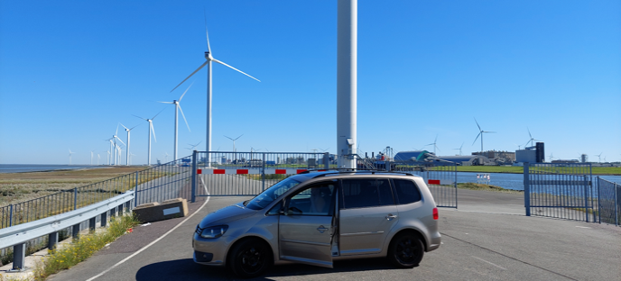Figure S19: Day 06-09-2023; main upwind sampling position catching background air, with the windmills at 150 metre height.

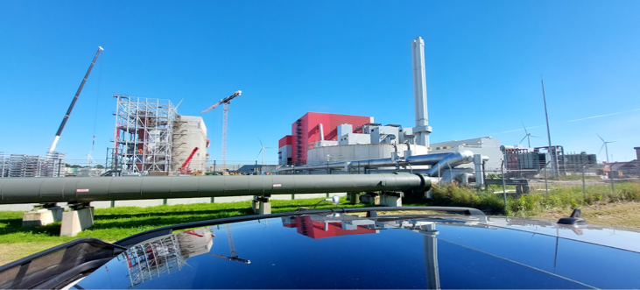Figure S20: Day 06-09-2023; downwind sampling position.

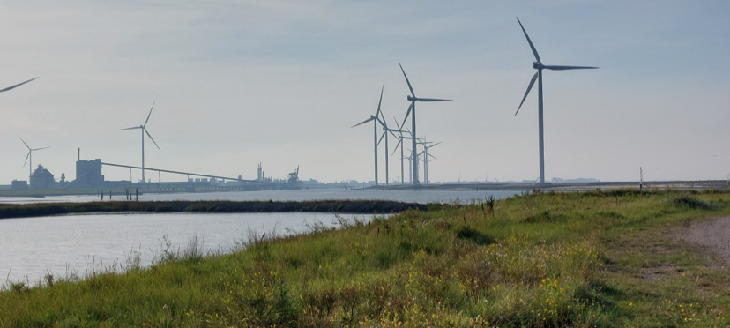
Figure S21: Day 11-09-2023; upwind sampling position on a sea-side dike outside the industrial plume.
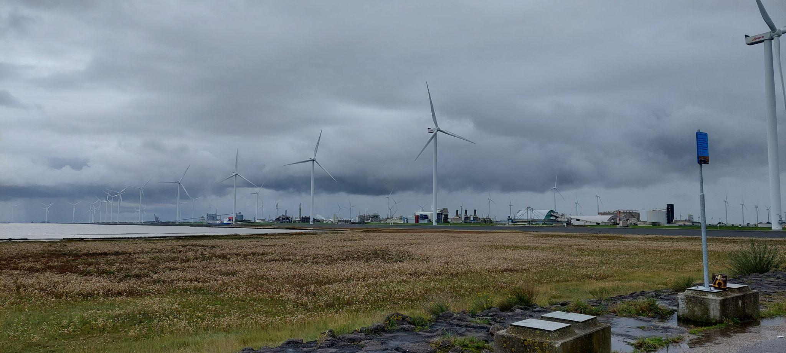Figure S22: Day 05-10-2023; measuring further downwind west of the chemical park.
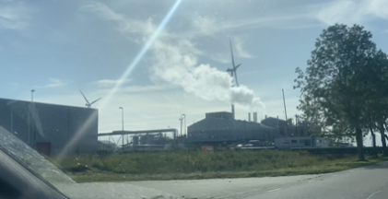
Figure S23: Day 05-10-2023; visual plume stacks at the chemical park.
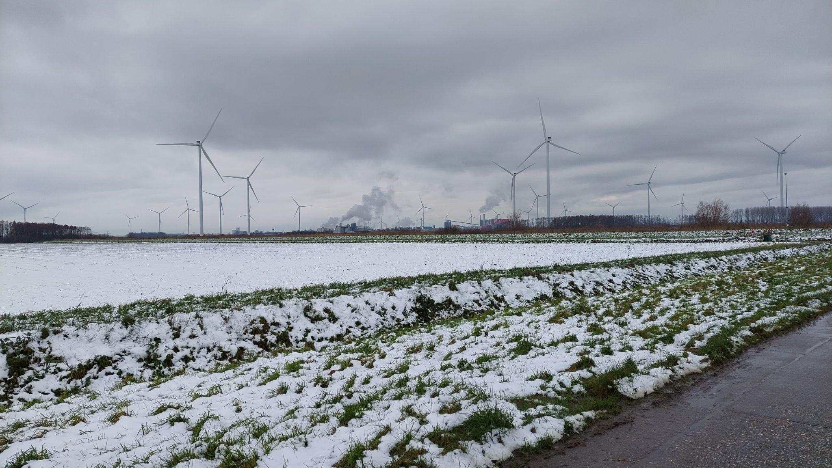
Figure S24: Day 06-12-2023; visual plume stacks southwest of the chemical park.
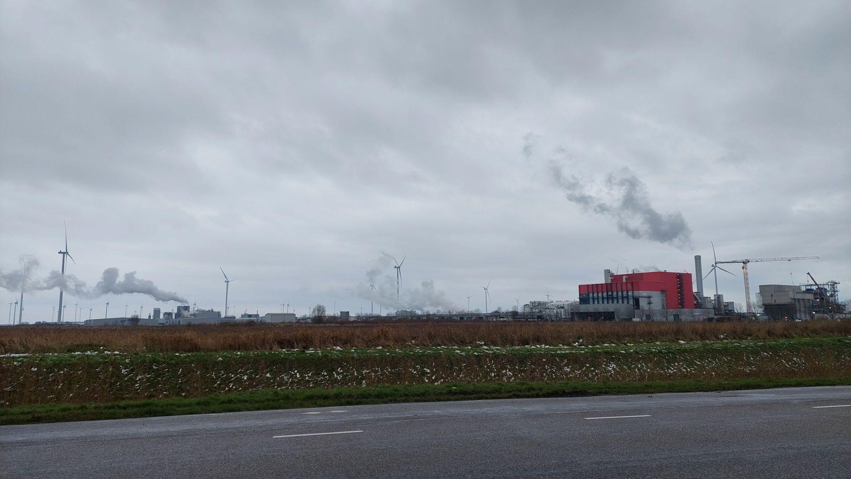
Figure S25: Day 06-12-2023; visual plume stacks northwest of the chemical park.
References
Actueel Hoogtebestand Nederland (AHN) DTM. (2019). https://data.overheid.nl/en/dataset/11513-actueel-hoogtebestand-nederland-3--ahn3-#description
Andersen, T., Vinkovic, K., de Vries, M., Kers, B., Necki, J., Swolkien, J., ... & Chen, H. (2021). Quantifying methane emissions from coal mining ventilation shafts using an unmanned aerial vehicle (UAV)-based active AirCore system. Atmospheric Environment: X, 12, 100135.
Caulton, D. R., Li, Q., Bou-Zeid, E., Fitts, J. P., Golston, L. M., Pan, D., ... & McSpiritt, J. (2018). Quantifying uncertainties from mobile-laboratory-derived emissions of well pads using inverse Gaussian methods. Atmospheric Chemistry and Physics, 18(20), 15145-15168.
Gerbig, C., Körner, S., & Lin, J. C. (2008). Vertical mixing in atmospheric tracer transport models: error characterization and propagation. In Atmos. Chem. Phys (Vol. 8). www.atmos-chem-phys.net/8/591/2008/
Green, A. E. S., Singhal, R. P., and Venkateswar, R. (1980). Analytic Extensions of the Gaussian Plume Model. Journal of the Air Pollution Control Association, 30(7):773– 776.
McCarty, R. D., J. Hord, and H. M. Roder, Selected Properties of Hydrogen (Engineering Design Data), NBS Monograph 168, National Bureau of Standards, Boulder, CO (1981).
Peters, R., Dukai, B., Vitalis, S., van Liempt, J., & Stoter, J. (2022). Automated 3D reconstruction of LoD2 and LoD1 models for all 10 million buildings of the Netherlands. Photogrammetric Engineering and Remote Sensing, 88(3), 165–170. https://doi.org/10.14358/PERS.21-00032R2
Ražnjevic, A., van Heerwaarden, C., & Krol, M. (2022). Evaluation of two common source estimation measurement strategies using large-eddy simulation of plume dispersion under neutral atmospheric conditions, Atmos. Meas. Tech., 15, 3611–3628, https://doi.org/10.5194/amt-15-3611-2022
Sharan, M., Yadav, A. K., and Singh, M. P. (1995). Comparison of sigma schemes for estimation of air pollutant dispersion in low winds. Atmospheric Environment, 29(16):2051–2059.
Van Der Laan, S., R. E. Neubert, and H. A. Meijer, A single gas chromatograph for accurate atmospheric mixing ratio measurements of CO₂, CH₄, N₂O, SF₆ and CO. Atmos. Meas. Tech., 2(2):549–559, 2009, doi: 10.5194/amt-2-549-2009.
Vinković, K., Andersen, T., de Vries, M., Kers, B., van Heuven, S., Peters, W., ... & Chen, H. (2022). Evaluating the use of an Unmanned Aerial Vehicle (UAV)-based active AirCore system to quantify methane emissions from dairy cows. Science of The Total Environment, 831, 154898.

World Meteorological Organization. (2023). Surface wind. In Guide to meteorological instruments and methods of observation (2023 ed., Chap. 4). World Meteorological Organization.

