Supplementary Information

Self-rated health and the risk of incident atrial fibrillation in general population
†Yonggu Lee,¹ †Jae Han Kim,² and *Jin-Kyu Park³

¹ Division of Cardiology, Hanyang University Guri Hospital, Guri, Republic of Korea
² Division of Cardiology, Asan Medical Center, University of Ulsan College of Medicine, Seoul, Republic of Korea
³ Division of Cardiology, Department of Internal Medicine, Hanyang University Medical Center, Seoul, Republic of Korea
*cardiohy@gmail.com
†Yonggu Lee and Jae Han Kim have contributed equally to this work.

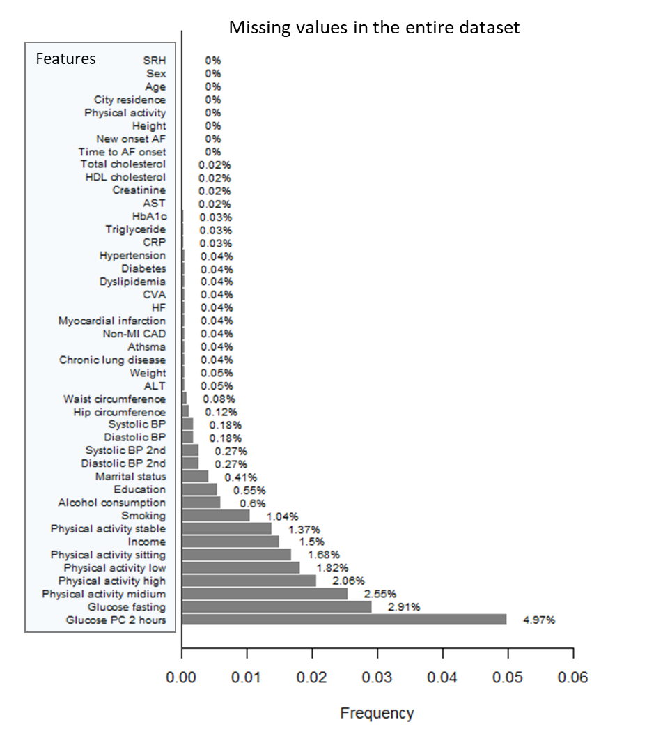

Supplementary Fig S1. Frequency of missing values in the dataset
The proportion of missing values in the individual variables ranged from 0% to 4.97%, while that in the entire dataset was less than 1%. The variable with the highest missing rate was pc 2-h glucose, and most comorbidities had missing values of less than 0.1%.
SRH, self-rated health; AF, atrial fibrillation; AST, aspartate aminotransferase; CRP, C-reactive protein; CVA, cerebrovascular accident; HF, heart failure; MI, myocardial infarction, CAD, coronary artery disease; ALT, Alanine Aminotransferase; BP, blood pressure.

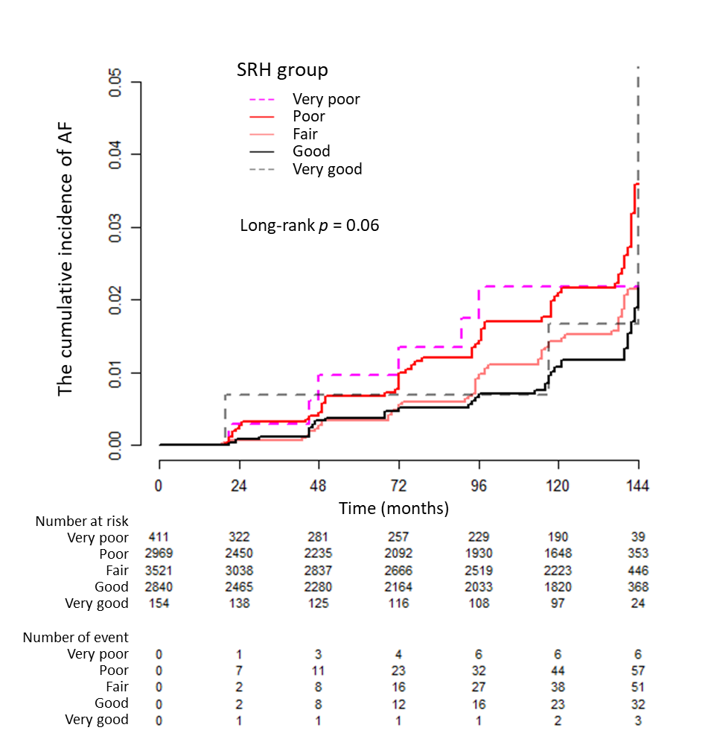

Supplementary Fig. S2. Cumulative incidence of AF based on the original SRH response
The numbers of participants at risk of “very poor” and “very good” SRH were significantly smaller than those in other categories, with only six and three patients with new-onset AF belonging to these categories. Nevertheless, a strong trend was observed, indicating that the incidence of AF increased when SRH worsened.
AF, atrial fibrillation; SRH, self-rated health

Table S1. Significant predictors for new-onset AF in the multivariate CPH model with original SRH responses
 |  |  |  | ANOVA
Model summary | Predictors | HR (95% CI) | P value | ꭓ2 | d.f | P value
C-index* | SRH |  |  | 9.11 | 4 | 0.0585
0.716 (0.676–0.756) | Very good vs. good | 1.84 (0.56–6.03) | 0.3121
 | Fair vs. good | 1.41 (0.91–2.20) | 0.1271
AIC: 2541.0 | Poor vs. good | 1.86 (1.20–2.90) | 0.0059
 | Very poor vs. good | 1.56 (0.64–3.79) | 0.3302
 | Age (every 10 years) | 1.75 (1.43–2.16) | 0.0000 | 25.82 | 1 | 0.0000
 | Male sex | 1.87 (1.33–2.61) | 0.0003 | 16.03 | 1 | 0.0001
 | Urban residential area | 1.96 (1.38–2.78) | 0.0002 | 12.56 | 1 | 0.0004
 | Hypertension | 1.56 (1.12–2.19) | 0.0095 | 7.73 | 1 | 0.0054
 | Myocardial infarction | 3.53 (1.54–8.11) | 0.0029 | 6.30 | 1 | 0.0121
- The model covariates included SRH with original responses, age, sex, residence and education, BMI, physical activity, alcohol, smoking, eGFR, HTN, DM, dyslipidaemia, heart failure, MI, non-MI CAD, asthma, chronic lung disease, stroke, LDL cholesterol levels, and CRP levels.
- The model was reduced to the best-fit model using a backward variable selection procedure (criterion, P>0.05)
CI, confidence interval; AIC, Akaike’s information criterion; HR, hazard ratio; SRH, self-rated health index; C-index, concordance index; BMI, body mass index; eGFR, estimated glomerular filtration rate; HTN, hypertension; DM, diabetes mellitus; MI, myocardial infarction; CAD, coronary artery disease; LDL, low-density lipoprotein; CRP, C-reactive protein

